ECTE364 – LAB 1  
  
Dev Bhodia   
8233202  
ECTE364 LAB 1  
Ms. Nayab Nadeem  
Dr. Mohd Farek Malek  
 **Task 1 :**  
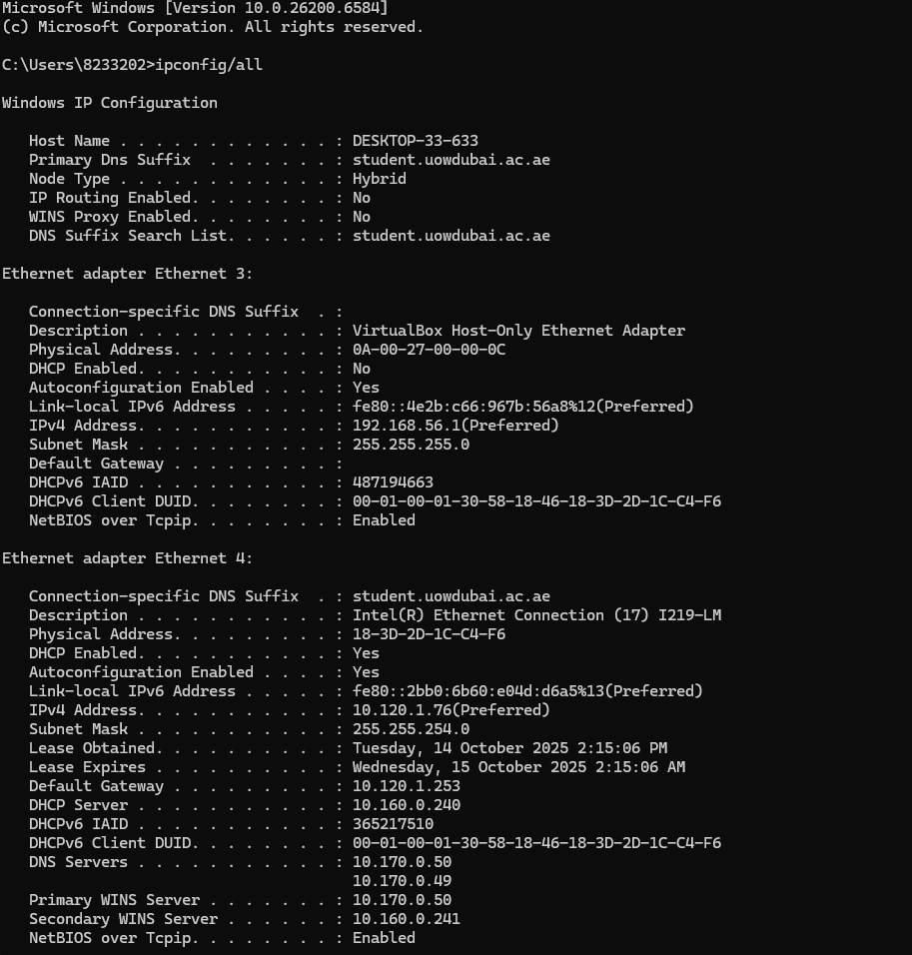  
**1-3.**  
 **Host Name:** The network-assigned name used to identify a specific device.

* 1. **Physical Address:** Also called the MAC address; a unique hardware identifier for the device’s network adapter.
  2. **DHCP Enabled:** Shows whether the device automatically obtains its IP configuration from a DHCP server.
  3. **IPv4 Address:** The numeric address assigned to the device for network communication.
  4. **Subnet Mask:** Determines the network’s range and separates the network portion from the host portion of the IP address.
  5. **Lease Obtained:** The exact time and date when the device was assigned its IP information by the DHCP server.
  6. **All DHCP Values:** Refers to the full set of configuration details provided by the DHCP server, including IP address, subnet mask, default gateway, lease duration, and DNS details.
  7. **DNS Server:** Converts website or domain names into corresponding IP addresses to enable access.

### 4. The VirtualBox adapter has DHCP Enabled: No, meaning the configuration was set manually:

1. **Administrator/User Configuration**: Someone (or VirtualBox software during installation) manually configured:
   * IP address: 192.168.56.1
   * Subnet mask: 255.255.255.0
   * No default gateway (intentionally isolated)
2. **Autoconfiguration (APIPA)**: If no static IP was set, Windows could also self-assign a link-local address (169.254.x.x range), though that's not the case here since 192.168.56.1 is configured statically.

The IPv6 link-local addresses on both adapters were generated automatically using **stateless address autoconfiguration (SLAAC)** based on the MAC address and random numbers.

**TASK 2**1-5.  
  
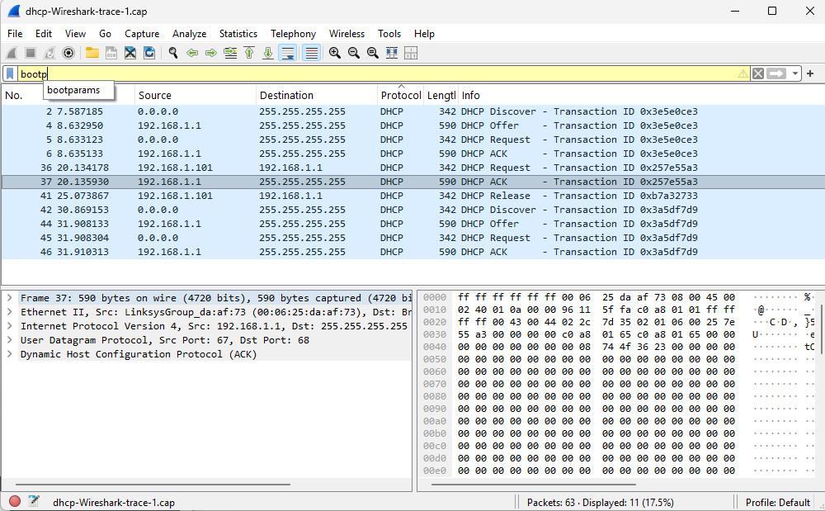  
  
**DORA PROTOCOL**

1. **DISCOVER** - Client broadcasts: "I need an IP address!"
2. **OFFER** - Server responds: "Here's an available IP and configuration for you"
3. **REQUEST** - Client broadcasts: "I accept this offer and want this IP"
4. **ACKNOWLEDGE (ACK)** - Server confirms: "IP is yours, configuration complete"
5. 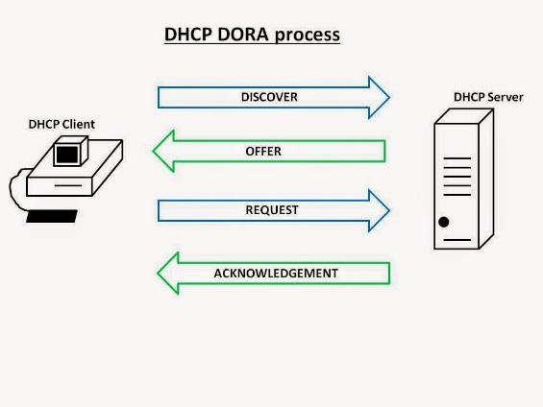**RELEASE** - Client tells server: "I'm giving back this IP address"

.

**7. TIMING DIAGRAM**

Discover

Offer

Request



Acknowledge

Server

Client

**8.**

**a.  
  
Source**

**0.0.0.0** - The client hasn't been assigned an IP address yet, so it uses 0.0.0.0 as a temporary placeholder for its source address.  
 **Destination**

**255.255.255.255** - This represents the broadcast address, indicating the packet is transmitted to every device on the local network.

**b.  
  
Sent over UDP  
  
c.  
**

**d.  
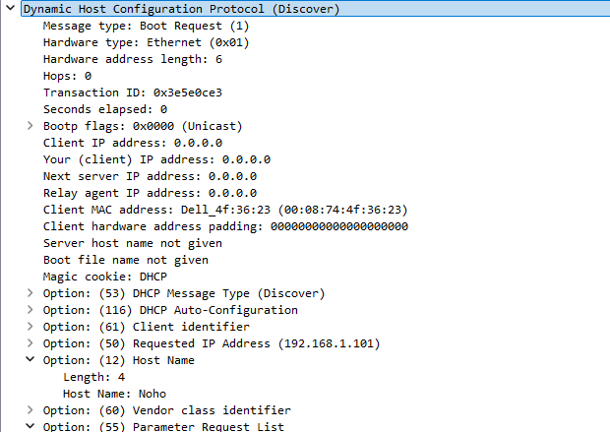  
e.  
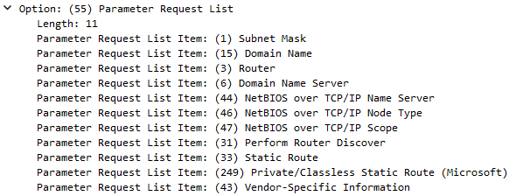  
  
9)  
  
  
10)  
a.  
**

**b.  
  
c.  
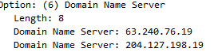**

**d.  
  
  
e.  
  
  
11.**The Validity period of the IP assignment is defined as Lease Time

**12.**



**Task 3:**  
1.  
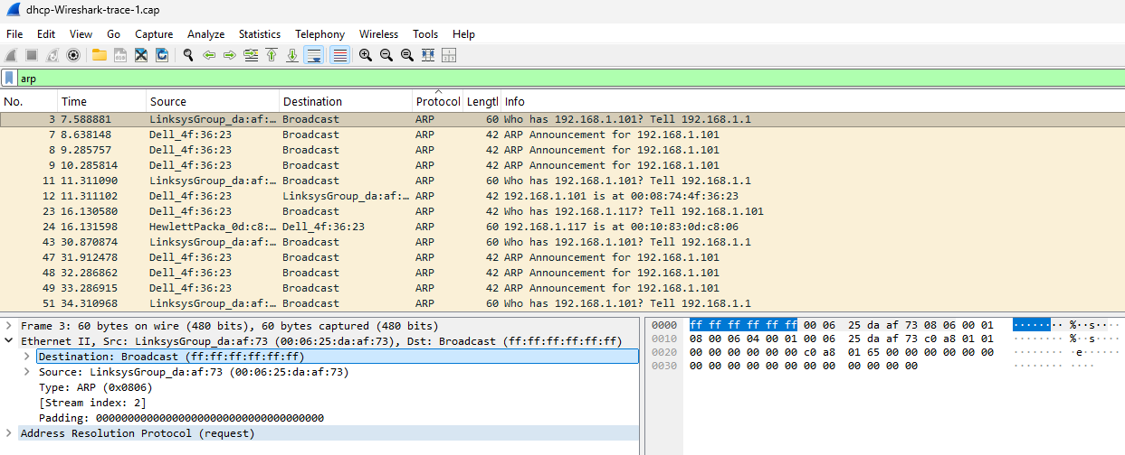  
  
2.  
  
**TIMING DIAGRAM**

Request



Response

Server

Client

3.  
A host uses ARP (Address Resolution Protocol) to find the MAC address that matches a known IP address so it can send data to the correct device on the local network.  
  
  
4.Gratuitous ARP messages are sent by a device to announce or update its IP–MAC address mapping without being asked, helping detect IP conflicts and update other devices’ ARP tables  
  
5.  
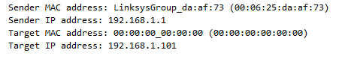

**TASK 4**  
  
**DNS** is the internet's directory, translating website names like "[google.com](https://google.com/)" into numerical IP addresses that computers use to locate each other.

**HTTP** is the communication protocol for the web. It defines how browsers request web pages from servers and how servers deliver the content back. HTTPS is its secure, encrypted version

2.  
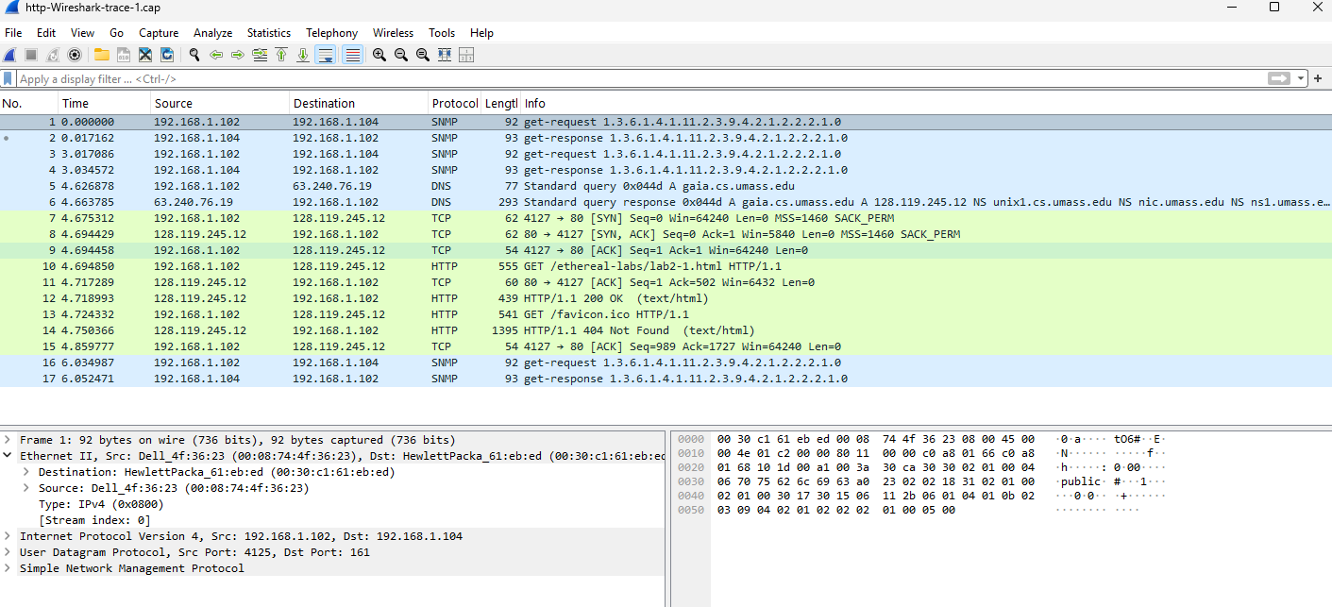

3.  
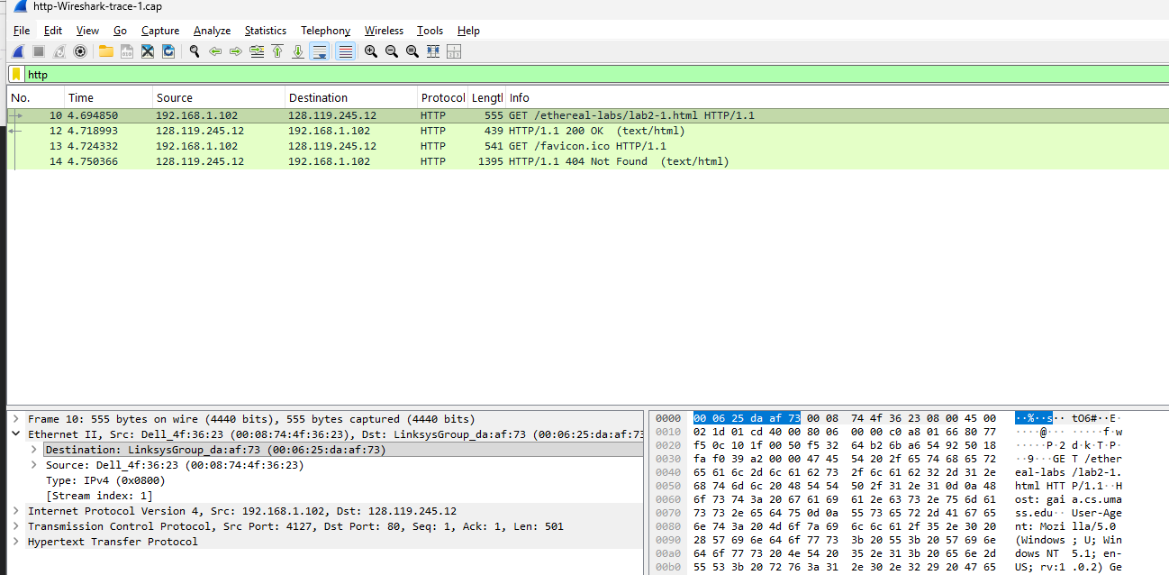  
  
4.  
  
  
5.  


6.  


7.  
**TIMING DIAGRAM**

Request



Response

Server

Client

8.  
a,b,c  
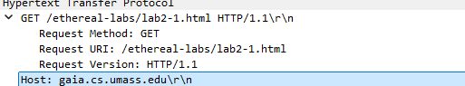  
  
d.  
  
**Host:** Specifies the domain name of the server being requested.

**Accept:** Indicates what media types (like text/html) the client can understand.

**Keep-Alive:** Sets parameters for how long a persistent connection should remain open.

**Connection:** Controls whether the network connection stays open after the transaction.

13.  
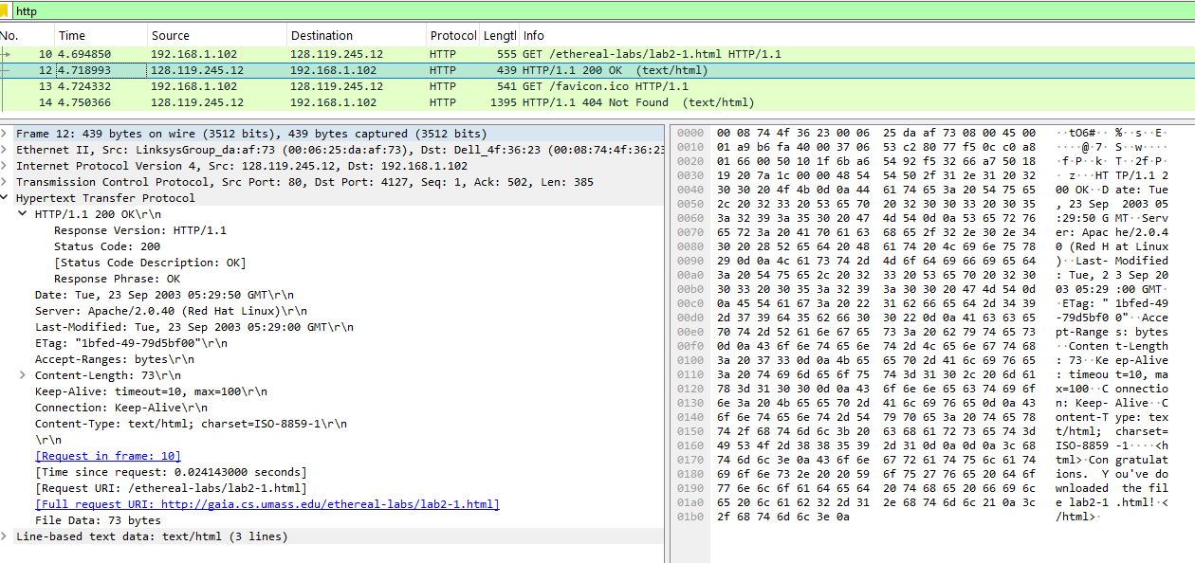

**TASK 5**  
1.  
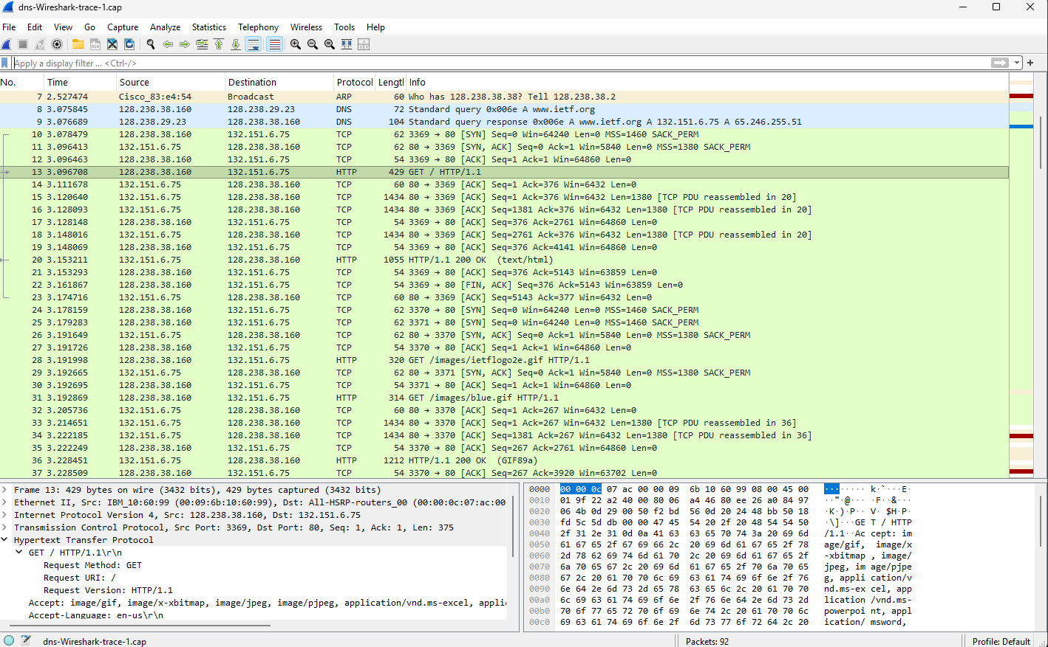2.  
a)  


b, c :



3.  
a)  
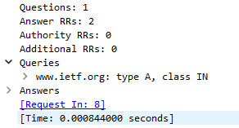  
b)  
A Resource Record (RR) is a single entry in the DNS that stores information, like a domain's IP address.

4.  
a, b)  
Total : 2 Answers  
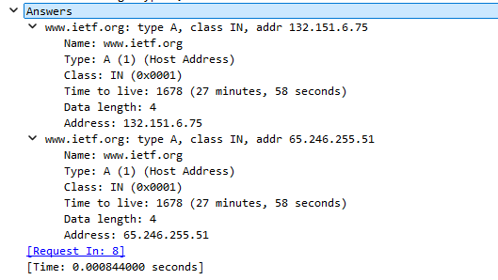

5.

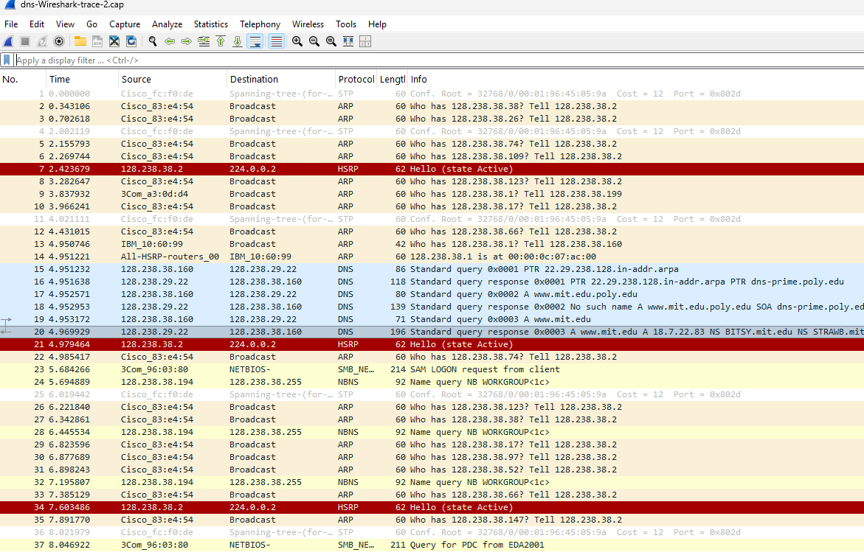  
6.  
a)  
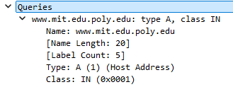  
b)  
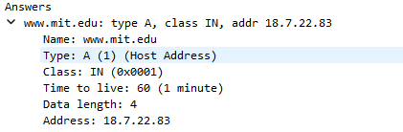

c)  
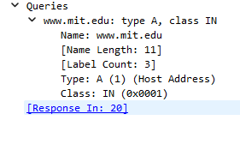  
On investigation, as no answers are found  
The client was unsuccessful in solving the query.

7.  
a)  
  
The **SOA (Start of Authority) record** identifies the main authoritative DNS server for a domain and contains key administrative details such as the domain’s serial number, refresh rate, and administrator contact email.

b)  
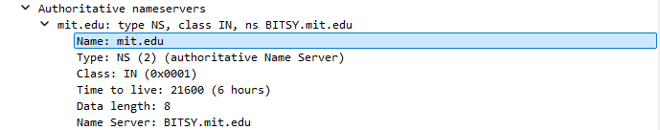

***************** ***END OF REPORT ***********************