ECTE364 – LAB 2  
  
Dev Bhodia   
8233202  
ECTE364 LAB 2  
Ms. Nayab Nadeem  
Dr. Mohd Farek Malek  
 **Task 1 :**  
  
1-3.  
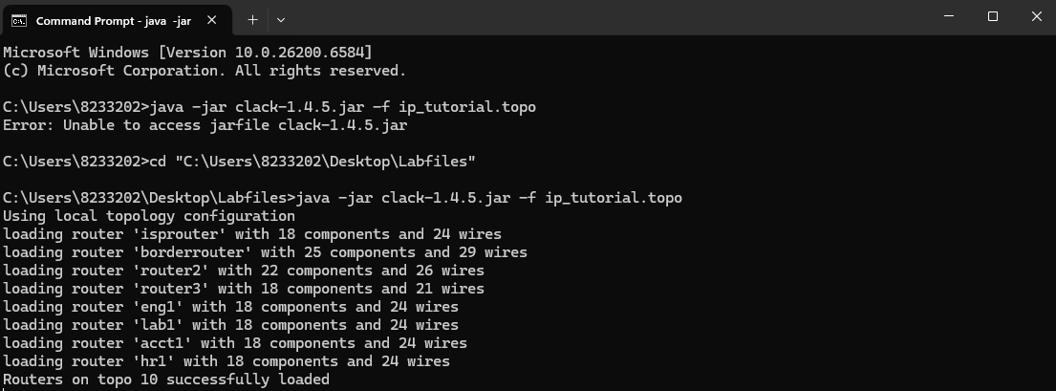

4.  
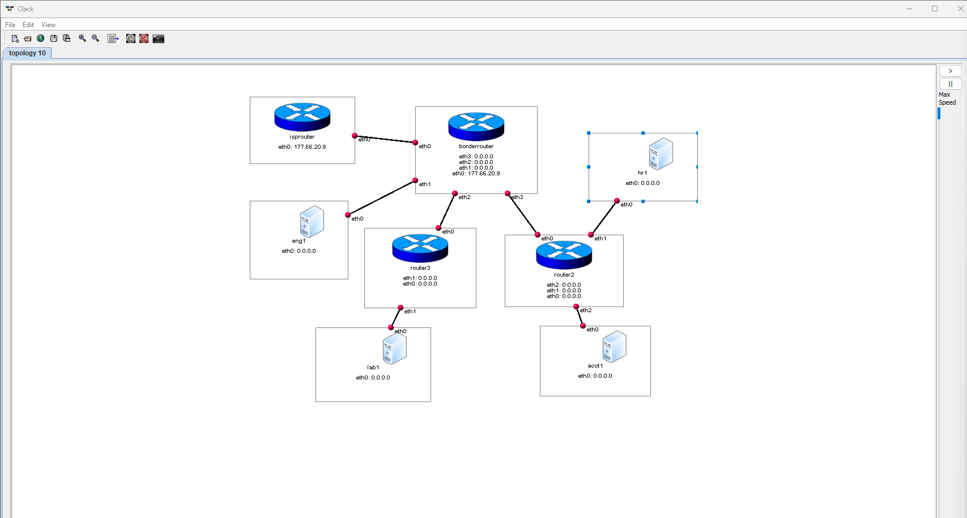

**Task 2:**  
1-3.  
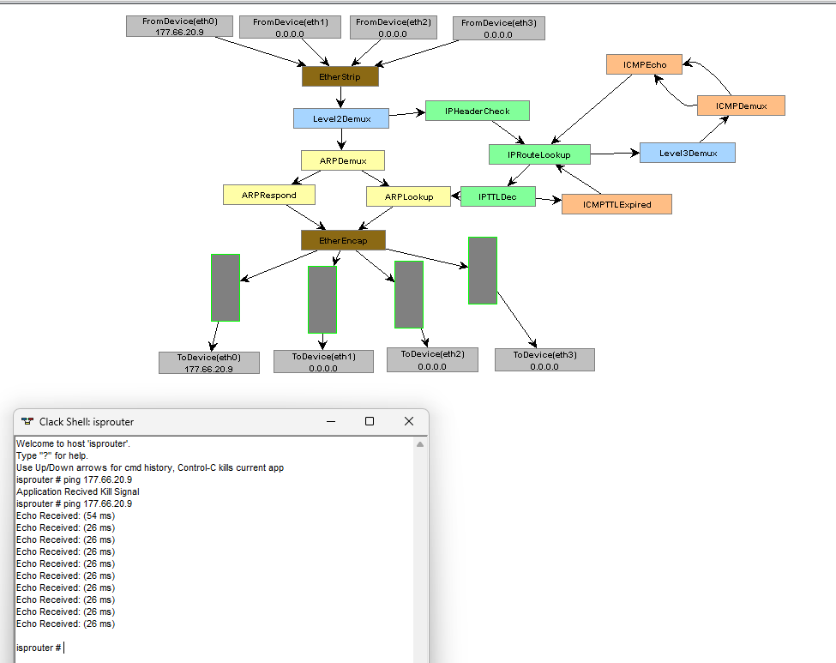  
  
4.

|  |  |  |  |
| --- | --- | --- | --- |
| Packet Number | MAC Source | MAC Destination | EtherType |
| 1 | 10:20:30:40:50:00 | FF:FF:FF:FF:FF:FF | ARP |
| 2 | 10:20:30:40:50:01 | 10:20:30:40:50:00 | ARP |
| 3 | 10:20:30:40:50:00 | 10:20:30:40:50:01 | IPv4 |
| 4 | 10:20:30:40:50:01 | FF:FF:FF:FF:FF:FF | ARP |
| 5 | 10:20:30:40:50:00 | 10:20:30:40:50:01 | ARP |
| 6 | 10:20:30:40:50:01 | 10:20:30:40:50:00 | IPv4 |
| 7 | 10:20:30:40:50:00 | 10:20:30:40:50:01 | IPv4 |

**TASK 3**  
  
1.  
  
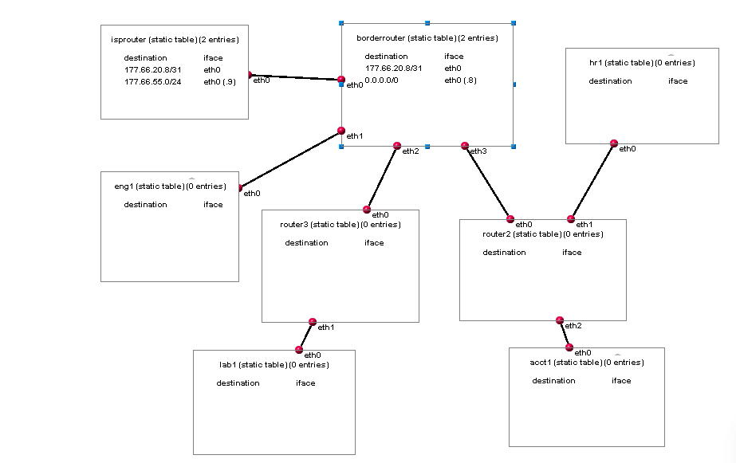  
2.

|  |  |
| --- | --- |
| isprouter | Borderrouter |
|  |  |

3.  
  
Explanation:  
For ISPROUTER  
  
Entry 1 : 177.66.20.8/31   
Tells isprouter that the network is directly connected to eth0 interface .  
masked by /31  
IP : 177.66.20.8  
Entry 2: 177.66.55.0/24  
Is a static route, can be used to send packet to any device in the this network via again eth0  
the .9 is the distance for this route.  
  
For BORDERROUTER  
  
Entry 1 : 177.66.20.8/31  
Just as isprouter entry 1, this tells borderrouter it is directly connected to this network via eth0 interface.  
masked by /31  
IP : 177.66.20.9  
  
Entry 2: 0.0.0.0/0  
Is a default route, instructs borderrouter to send out packets that have no specific route via eth0 towards isprouter  
the .8 again, distance for this route  
  
 4.   
  
Routes Used :   
isprouter → borderrouter: 177.66.20.8/31 via eth0 (direct route)  
borderrouter → isprouter: 177.66.20.8/31 via eth0 (direct route)  
  
Both routers use their directly connected network route because it's the most specific match

**TASK 4**  
  
1.  
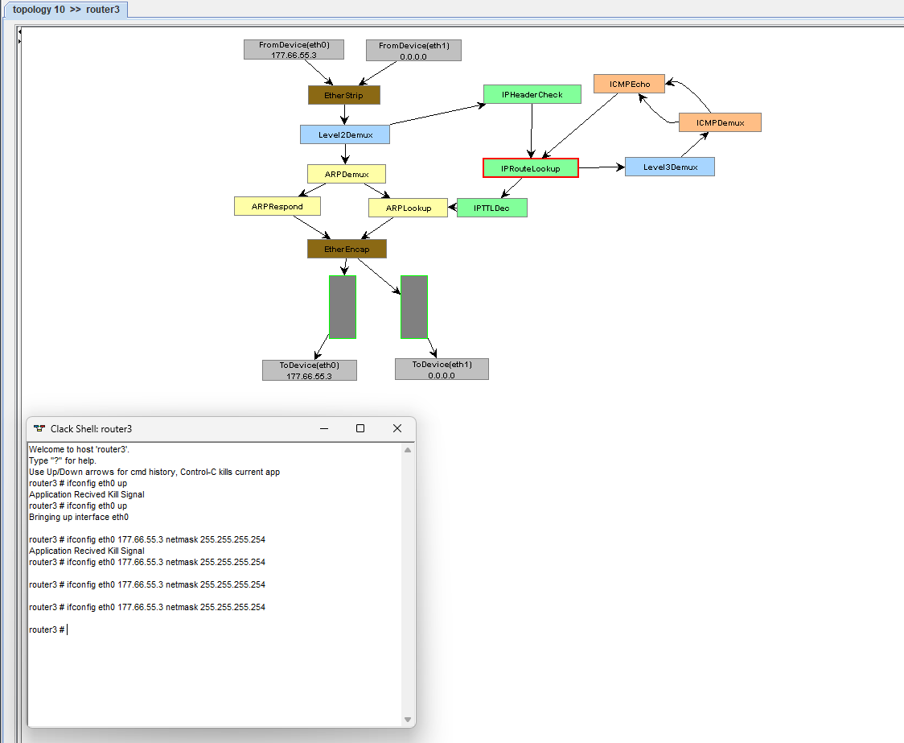

2.   
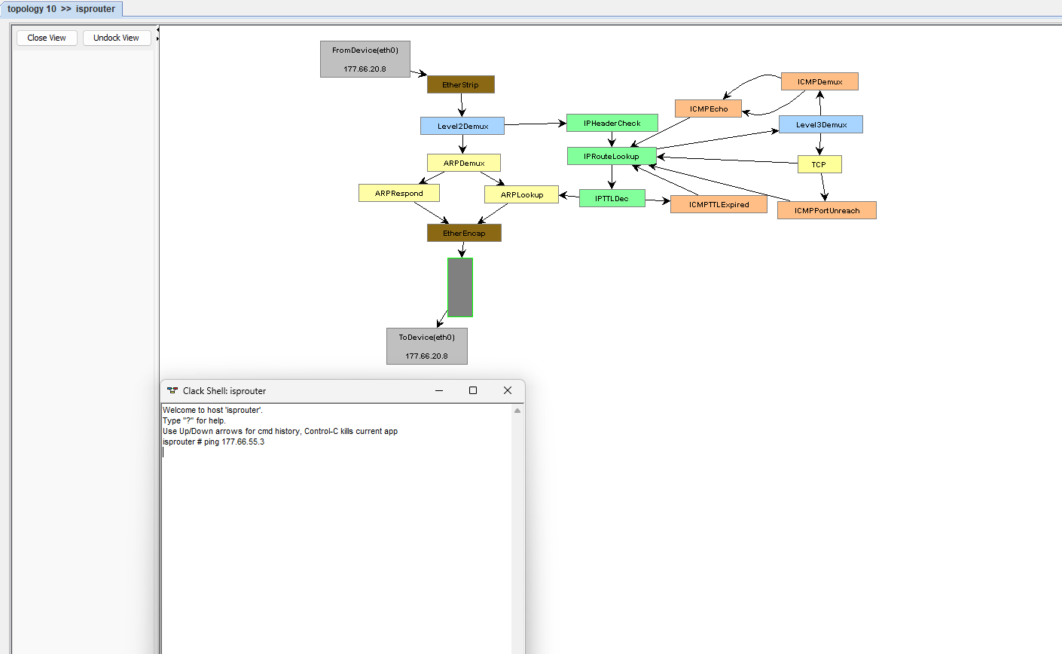  
No Reply  
  
isprouter has no route to the destination network 177.66.55.3. When it tries to send the ping packet, it performs a route lookup, finds no matching entry (not even a default route, unlike borderrouter)  
  
cmd :  
isprouter: Error: ICMPDemux 7 pushed packet out unconnected port 4(TTL exceeded packets)

3.  
  
  
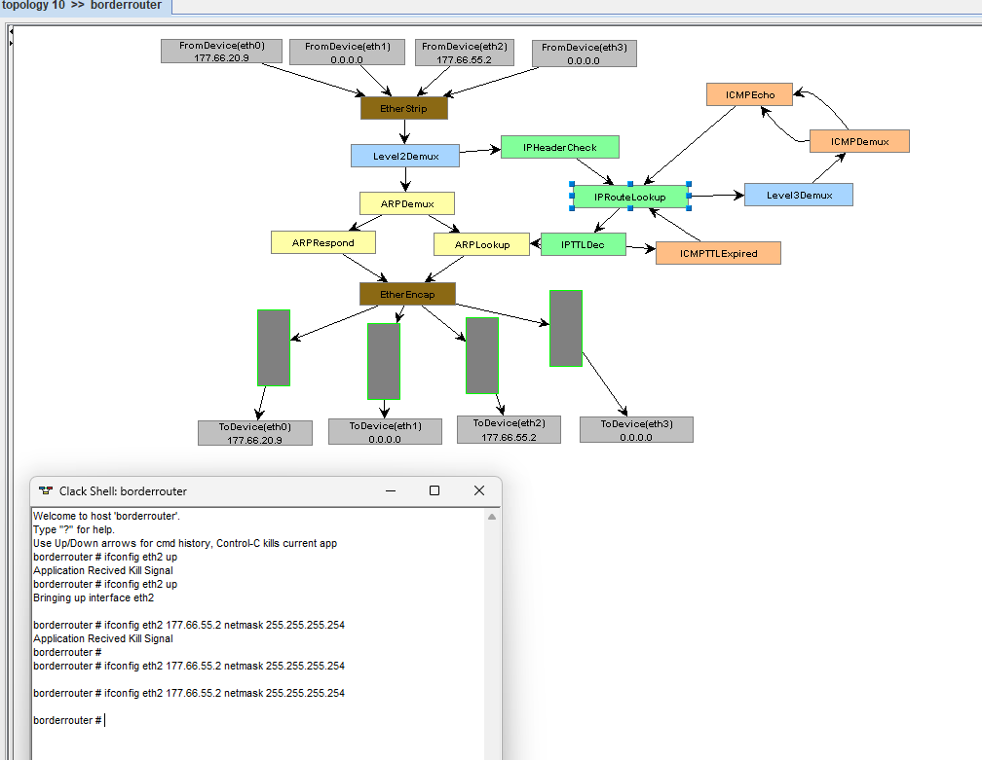  
4.  
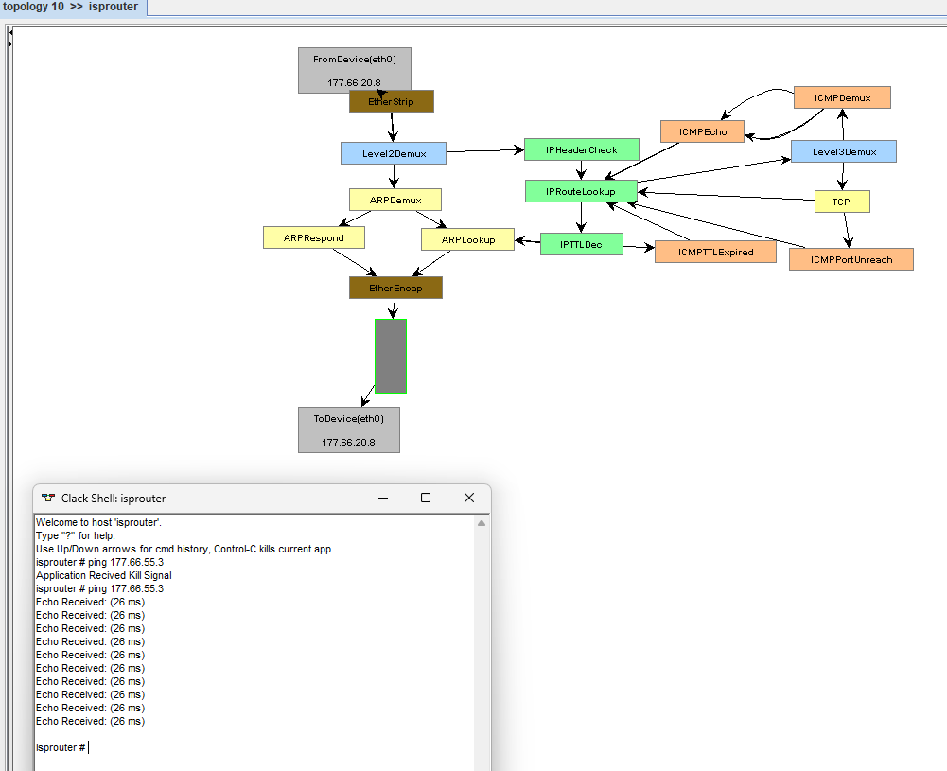

Yes, Received.

**TASK 5**  
1-5.  
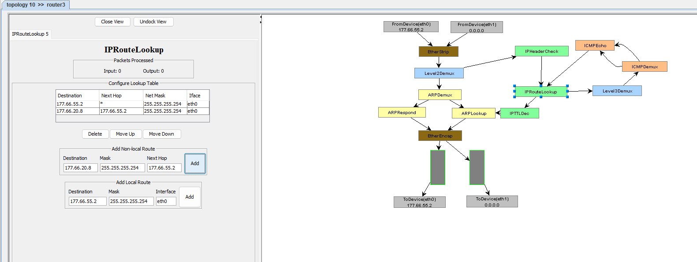

6.  
  
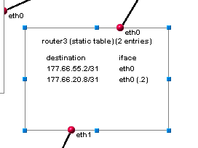

7-8.  
  
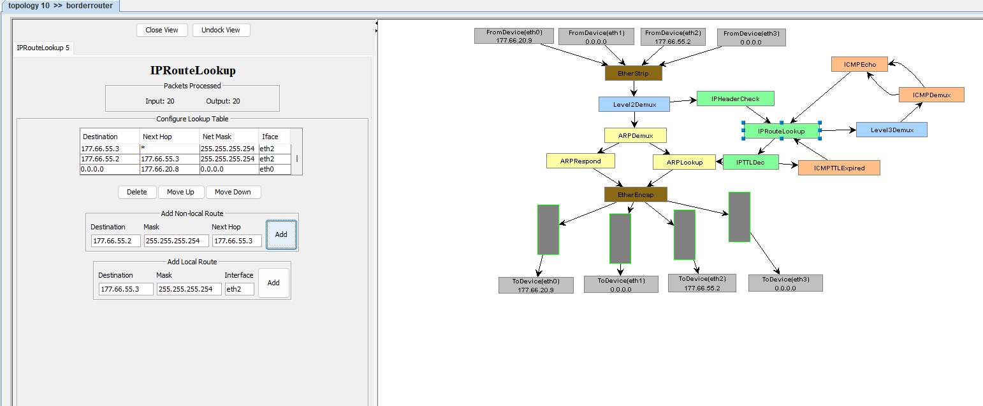  
  
9.  
router3 knows how to reach the network between isprouter and borderrouter (177.66.20.8/31).

Now, borderrouter and router3 know their directly connected routes to each other.

This two-way routing allows a ping from isprouter to router3 to be forwarded by borderrouter and replied back via the reverse path.

**TASK 6**  
  
1.  
Reply RECEIVED  
  
  
  
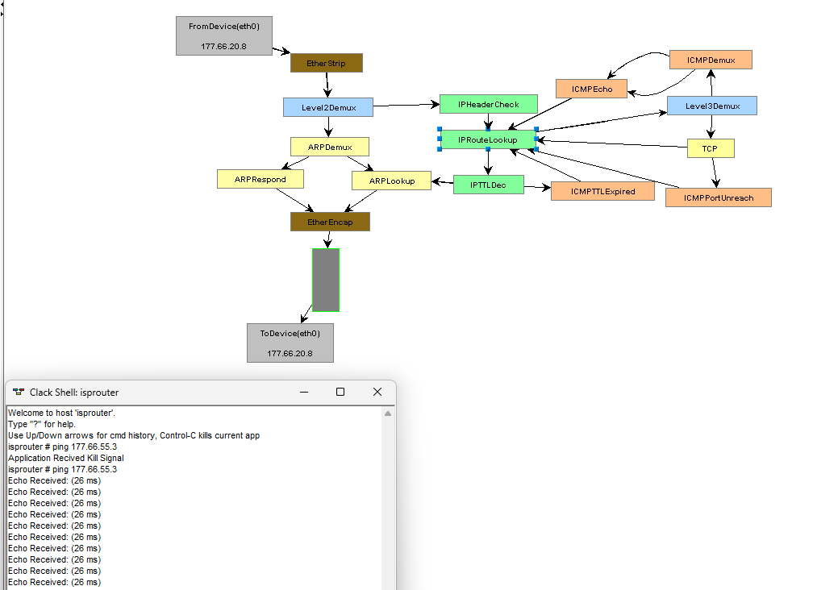

2.  
Reply RECEIVED  
  
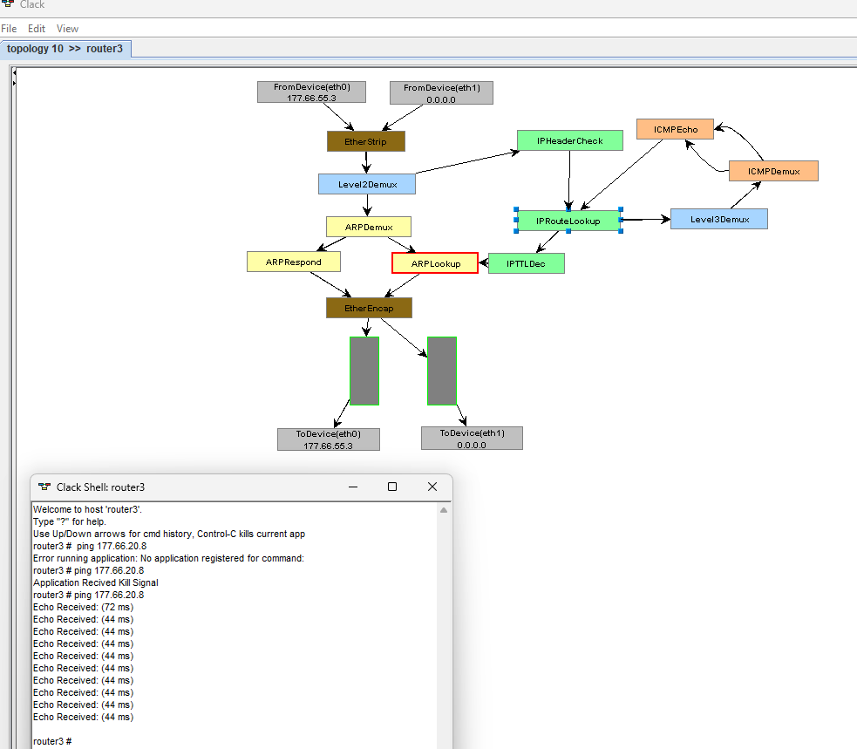  
  
  
3.  
  
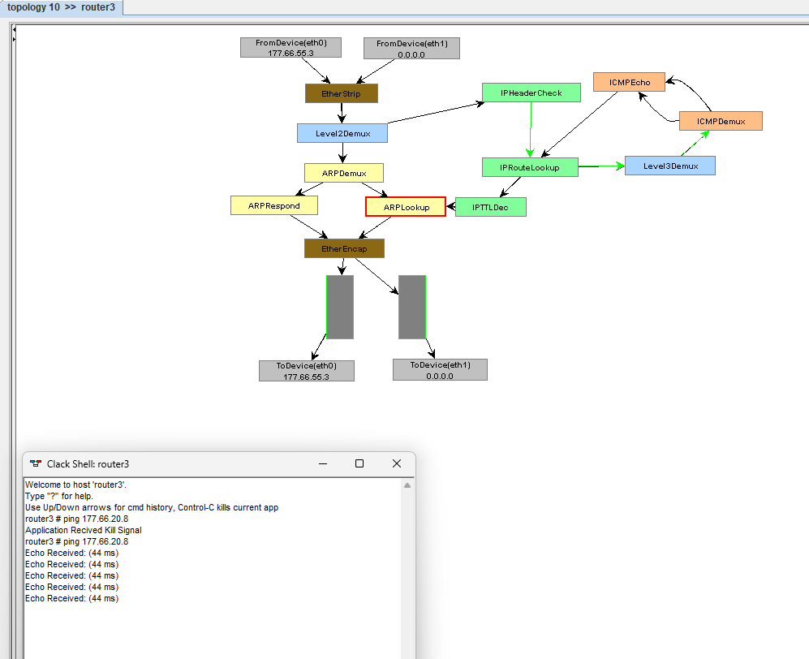  
  
4.  
  
Route **:** 177.66.56.0/21 interface eth0

Path flow:

* ICMP echo request from router3 to 177.66.56.1
* IPRouteLookup matches direct network routePacket sent via eth0 to
* isprouter (177.66.56.1)

5.

Route : 177.66.56.0/21 interface eth0  
  
Path flow:

* ICMP echo reply from isprouter (177.66.56.1) to router3 (177.66.56.3)
* IPRouteLookup matches direct network route on isprouter
* Packet sent via eth0 directly to router3
* No gateway needed (same subnet)

6.  
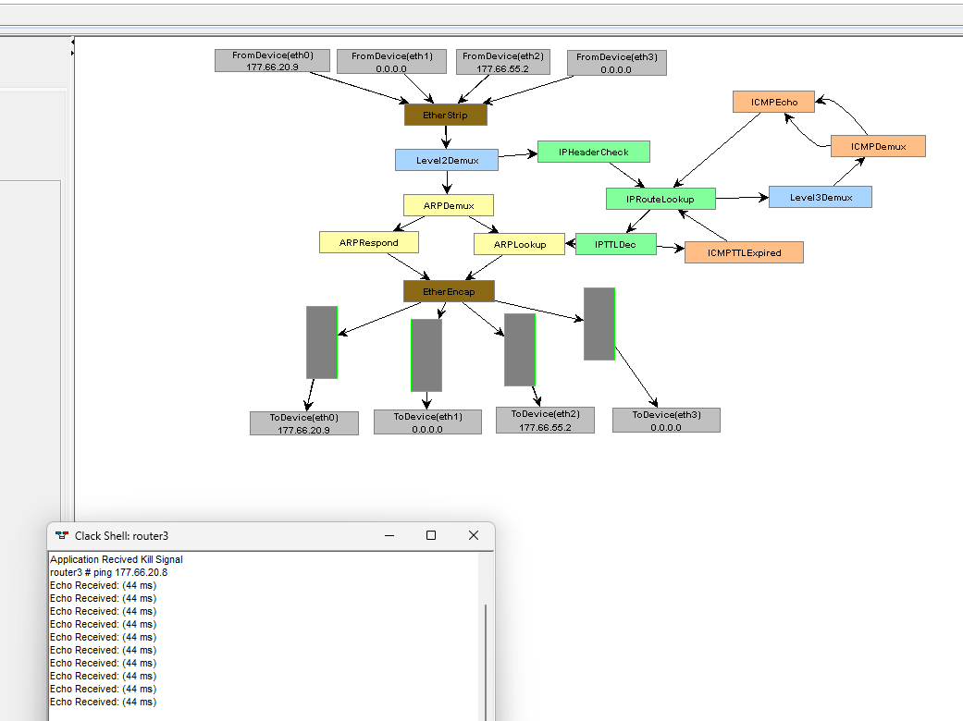  
  
  
7.  
**IPRouteLookup** - Performs routing table lookups to determine the next hop for IP packets based on their destination address.

**ARPLookup** - Handles Address Resolution Protocol (ARP) to map IP addresses to MAC addresses for Ethernet communication.

**Level2Demux** - Demultiplexes packets at the data link layer (Ethernet), separating them based on Ethernet type field for processing by higher layers.

**TASK 7**  
  
1-2.  
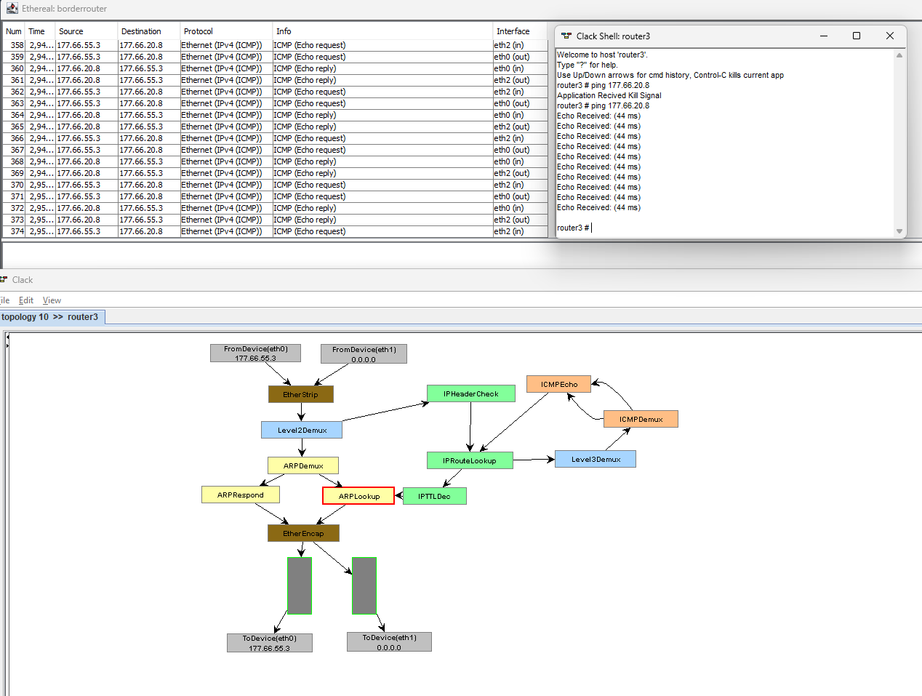  
  
3.  
  


4.

|  |  |
| --- | --- |
| **Ethernet Packet Header Fields** | **Changed (Yes/No)** |
| Source Address: | YES |
| Destination Address: | YES |
| EtherType: | NO |

|  |  |
| --- | --- |
| **IP Packet Header Fields** | **Changed (Yes/No) Version:** |
| Version: | NO |
| Header Length: | NO |
| Type of Service (ToS): | NO |
| Total Length: | NO |
| Identification: | YES |
| Flags and Frag Offset: | NO |
| Time to Live (TTL): | YES |
| Protocol: | NO |
| Header Checksum: | YES |
| Source IP Address: | YES |
| Destination IP Address: | YES |

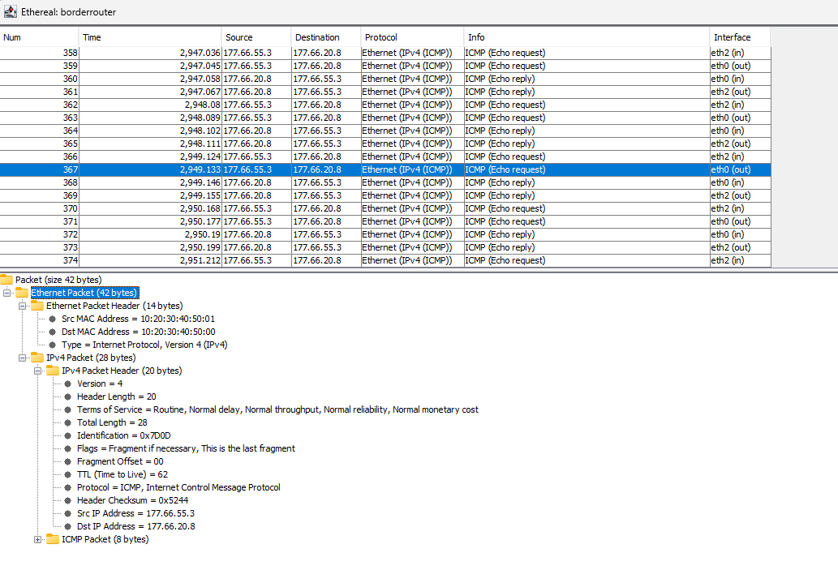

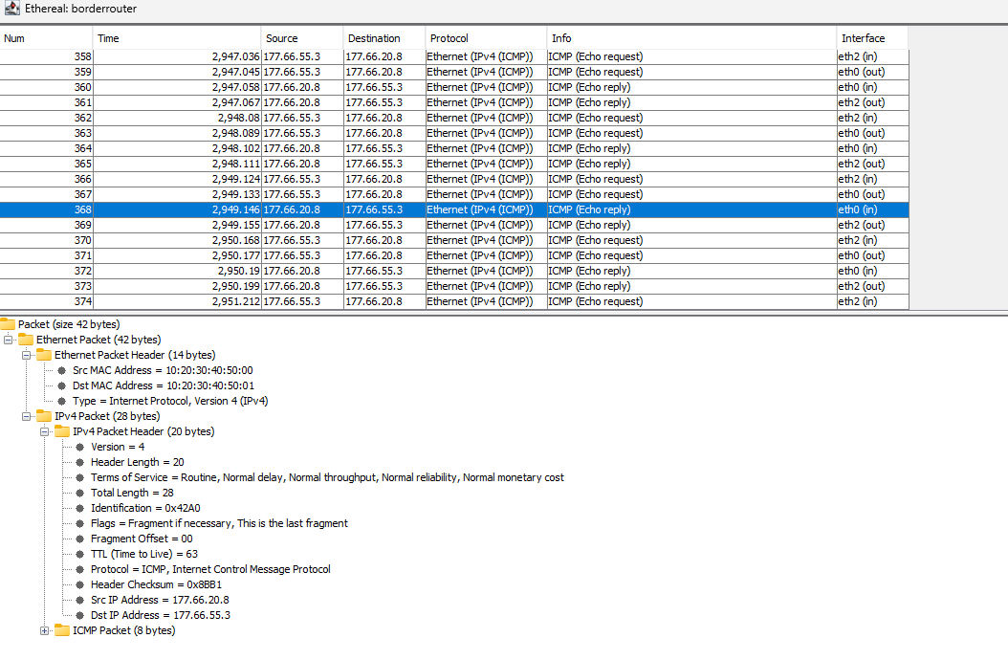  
  
  
  
5.  
Bridge pushes frames forward based on the MAC address without modifying them, so the packet would pass through exactly as it is. None of the ethernet or IP headers will have any affect or change.  
  
  
  
  
  
  
***************** ***END OF REPORT ***********************