
Lab Report Cover Sheet

Student name | Student number
Dev Bhodia | 8233202

Subject code and name: | ECTE331 - Real Time Embedded Systems
Subject coordinator: | Prof. Abdsamad Benkrid
Part number: | 2
Date and time due: | Monday, 6th July 2026, 11:55 PM
Lab tutor name: | Prof. Kiyan Afsari
Total number of pages | 6 pages

Table Of Contents

-Threads Synchronization and communication
Introduction 1
Final Values and Synchronization Design 2
Verification and Testing 3
Conclusion 4

Threads Synchronisation

and Communication

Introduction
This report explains my implementation of Problem 2, Threads Synchronisation and Communication. The application runs two cooperating threads, A and B. Each thread performs three functions in sequence (FuncA1–FuncA3 and FuncB1–FuncB3) that read and update the shared integer variables A1–A3 and B1–B3. Because some functions depend on values produced by the other thread, the two threads must be synchronised so that the functions run in the correct order no matter how the operating system schedules them.

Final Values and Synchronization Design
Every function adds a triangular sum Σ(i = 0..n) i, which equals n(n+1)/2. Applying the function definitions in dependency order gives the final values in Table 1. These match the expected values that the program prints and verifies.
Variable | Expression | Final value
A1 | A1 = Σ(i=0 to 500) i | 125250
B1 | B1 = Σ(i=0 to 250) i | 31375
B2 | B2 = A1 + Σ(i=0 to 200) i | 145350
A2 | A2 = B2 + Σ(i=0 to 300) i | 190500
B3 | B3 = A2 + Σ(i=0 to 400) i | 270700
A3 | A3 = B3 + Σ(i=0 to 400) i | 350900
Table 1 — Final correct values of the shared variables.
The function definitions create four cross-thread dependencies: FuncB2 needs A1, FuncA2 needs B2, FuncB3 needs A2, and FuncA3 needs B3. Combined with the natural in-thread order (A1→A2→A3 and B1→B2→B3), this forces the global order A1 → B2 → A2 → B3 → A3, while B1 may run at any time before B2. These dependencies are shown in Figure 1.
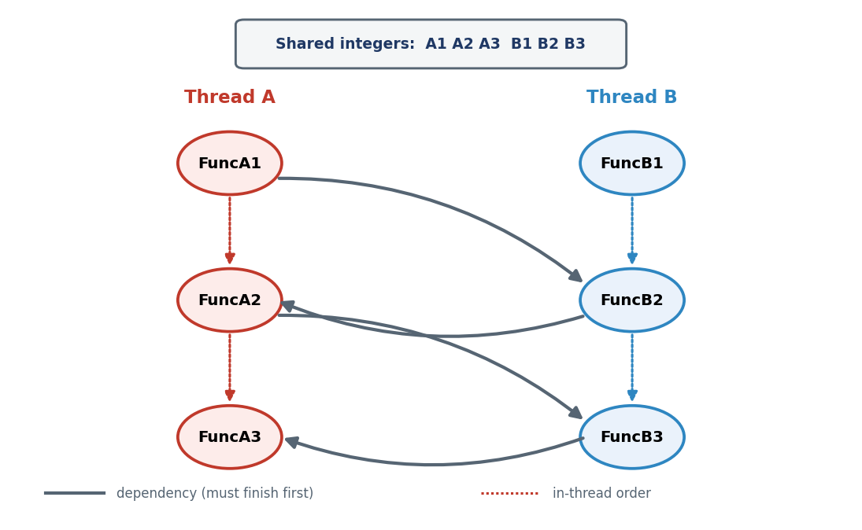
Figure 1 — Function execution dependencies between Thread A and Thread B.

To enforce this order without active waiting or Thread.sleep(), a shared SyncCoordinator object uses guarded blocks based on wait() and notifyAll(). For each produced value there is a boolean flag (for example a1Ready). A function that produces a value sets its flag and calls notifyAll(); a function that needs that value calls a guarded await method that loops on the flag and calls wait() while it is still false. Because wait() releases the monitor lock and suspends the thread until it is notified, the waiting thread uses no CPU cycles, which satisfies the requirement to avoid active wait and sleep. The core of the coordinator is shown below.
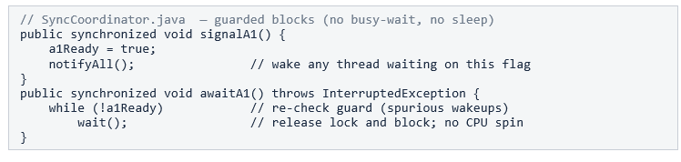
The same await/signal pair is repeated for the flags b2Ready, a2Ready and b3Ready — one gate per dependency. The flags are reset at the start of every iteration, so the ordering is re-enforced on each run.

Verification and Testing

To confirm correctness independently of scheduling, Problem2App runs the full two-thread sequence for a large number of iterations (100000). At the start of each iteration the shared data and the coordinator flags are reset, both worker threads are started, and the main thread joins them before comparing all six results with the expected values. Running many iterations exercises many different thread interleavings; if the synchronisation were wrong, at least some iterations would produce incorrect values. As Figure 2 shows, all 100000 iterations passed with zero failures, the final shared values match the expected values, and the verification reports PASSED.
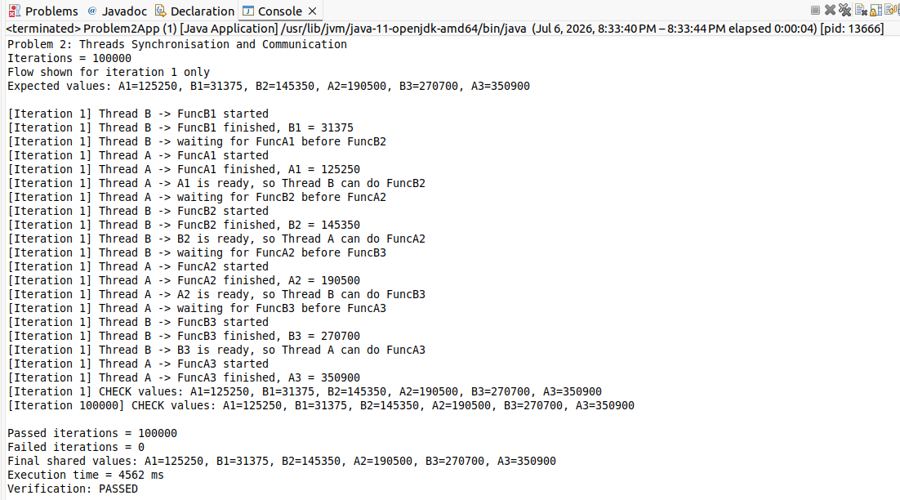
Figure 2 — Console output: iteration-1 execution order and the 100000-iteration verification (PASSED).

Conclusion

The implementation meets all four parts of the task. The correct final values were derived and confirmed (a); the required execution order is enforced using wait()/notifyAll() guarded blocks with no active wait or sleep (b); the sum is collected from a static loop-based utility method (c); and correctness is verified over 100000 iterations with zero failures (d).

