
Lab Report Cover Sheet

Student name | Student number
Dev Bhodia | 8233202

Subject code and name: | ECTE331 – FinalProjectPart3
Subject coordinator: | Prof. Abdsamad Benkrid
Part number: | 3
Date and time due: | Thursday, 6 July 2026, 11:55 PM
Lab tutor name: | Prof. Kiyan Afsari
Total number of pages | 8 pages

Table Of Contents

- Robotic Arm Controller
Introduction 1
System Design 2
Synchronization Method 3
Test Cases 3
Performance Evaluation 6
Discussion 8
Conclusion 9

Robotic Arm Controller

Introduction
This project simulates a real-time robotic arm controller in Java. The controller runs three concurrent tasks that all need to use the same shared part of the system, the motor. Because only one task can safely control the motor at a time, the three tasks must take turns and be properly synchronized.
The three tasks run at different priority levels. A high-priority safety task must react quickly to emergencies, a medium-priority task plans motion, and a low-priority task records activity. The purpose of the project is to show how these tasks share the motor safely, to demonstrate the problem of priority inversion (where a high-priority task is delayed by lower-priority tasks), and to show how priority inheritance and priority ceiling reduce that delay. Finally, the performance of each approach is compared by measuring how long the high-priority task has to wait.

System Design

The system is built from a small number of Java classes, each with a clear job:
- MotorController — the shared critical resource that controls the robotic arm motor. Only one task may use it at any moment.
- SafetyMonitorTask — the high-priority thread. It represents the emergency/safety task that must stop the arm quickly.
- MotionPlannerTask — the medium-priority thread. It sends movement commands to the motor.
- LoggerTask — the low-priority thread. It records system activity.
- RunResult — a small helper class that stores the measured waiting time and response time of a single run.
- Mode — selects which behaviour to use: no priority management, priority inheritance, or priority ceiling.
- RoboticArmSimulation — the main class. It runs the three test cases, repeats each one several times, and calculates the average results.
- Each task is a standard Java thread. Its priority is set using Thread.setPriority(), with the Safety Monitor given the highest priority, the Motion Planner a medium priority, and the Logger the lowest. All three threads try to access the single MotorController, as shown in Figure 1.
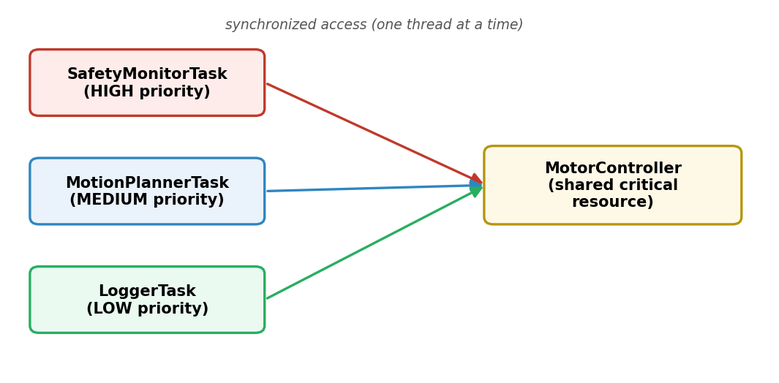
Figure 1 — System architecture of the robotic arm controller.

Synchronization Method

The MotorController is protected using synchronized methods. This means only one thread can enter the critical section at a time, which guarantees mutual exclusion and prevents race conditions on the shared motor.
If a thread tries to use the MotorController while another thread is already inside, the waiting thread calls wait() and releases the lock, so it does not waste CPU time by spinning. When the thread that owns the resource finishes and leaves the critical section, it calls notifyAll() to wake the waiting threads, and one of them is then allowed to continue. This wait()/notifyAll() pattern is what makes the tasks take turns cleanly instead of clashing over the motor.
Thread.sleep() is used only to simulate the time a task spends using the motor or doing work. It is not part of the synchronization mechanism; the mutual exclusion is provided entirely by the synchronized methods together with wait() and notifyAll().

Test Cases

Test 1: No Priority Management / Priority Inversion
The first test runs the system with no priority management, so the true problem can be seen clearly. The execution goes as follows:
- The Logger (low priority) starts first and enters the MotorController.
- The Safety Monitor (high priority) then tries to enter, but the motor is already in use, so it becomes BLOCKED and has to wait.
- While the Safety Monitor is waiting, the Motion Planner (medium priority) runs and delays the release of the resource.
This is priority inversion: the high-priority safety task is forced to wait, not only for the low-priority Logger, but effectively behind the medium-priority Motion Planner as well. In a real safety-critical system this delay would be dangerous. Figure 2 shows the console output, where the Safety Monitor is BLOCKED while the lower-priority tasks continue.
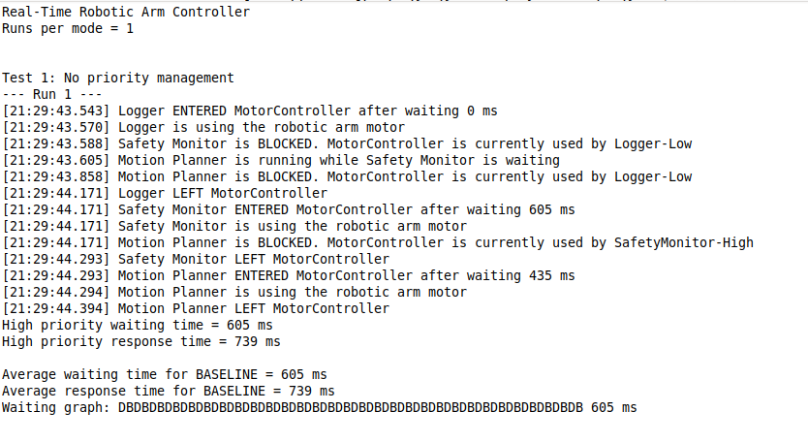
Figure 2 — Test 1 console output showing the Safety Monitor BLOCKED while the Motion Planner runs (priority inversion).
Test 2: Priority Inheritance
The second test adds priority inheritance. When the high-priority Safety Monitor is blocked by the Logger, the Logger temporarily inherits the high priority of the Safety Monitor. This helps the Logger finish its critical section faster, so the motor is released sooner. Once the Logger leaves the MotorController, its original low priority is restored.
As a result, the Safety Monitor spends less time waiting than it did in Test 1. Figure 3 shows the messages where the priority inheritance is applied and then the priority is restored after the resource is released.
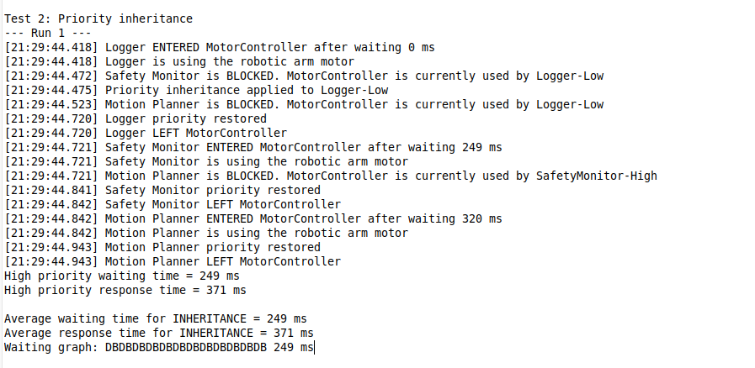
Figure 3 — Test 2 console output showing “priority inheritance applied” and the priority being restored.

Test 3: Priority Ceiling
The third test uses the priority ceiling approach. Here the MotorController is given a ceiling priority equal to the highest priority of any task that uses it. Whenever a thread enters the MotorController, it is immediately raised to this ceiling priority for as long as it holds the resource. When it leaves, its original priority is restored.
Because every thread that holds the motor runs at the ceiling priority, no lower-priority task can be interrupted and delayed by a medium-priority task while it holds the resource. This makes access to the shared resource more predictable and helps prevent priority inversion from happening in the first place. Figure 4 shows the ceiling being applied and then restored.
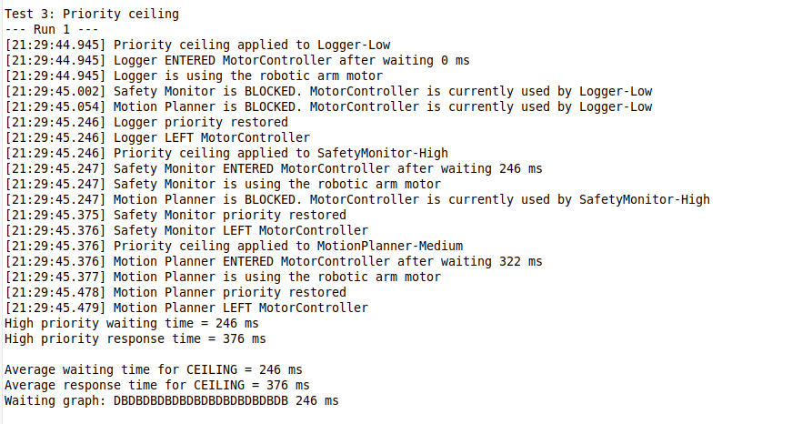
Figure 4 — Test 3 console output showing “priority ceiling applied” and the priority being restored.

Performance Evaluation
To compare the three approaches fairly, each test case was run 5 times. For every run, the waiting time and the response time of the high-priority Safety Monitor were measured, and the values were then averaged. The waiting time is how long the Safety Monitor waited before it could use the motor; the response time is the waiting time plus the short time it took to complete its critical operation. The average results are given in Table 1.
Test case | Avg. waiting time (ms) | Avg. response time (ms)
No priority management | 202.60 | 251.60
Priority inheritance | 152.00 | 202.20
Priority ceiling | 151.80 | 202.60

Table 1 — Average performance results after 5 runs per test case.

Figure 5 shows the averaged output produced by the program for each of the three test cases, which is the source of the values in Table 1.
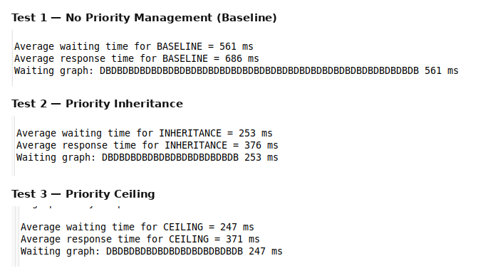
Figure 5 — Average performance results after 5 runs per test case.
The same results are shown as bar charts to make the comparison easier to read. Figure 6 compares the average waiting time of the high-priority task, and Figure 7 compares the average response time.

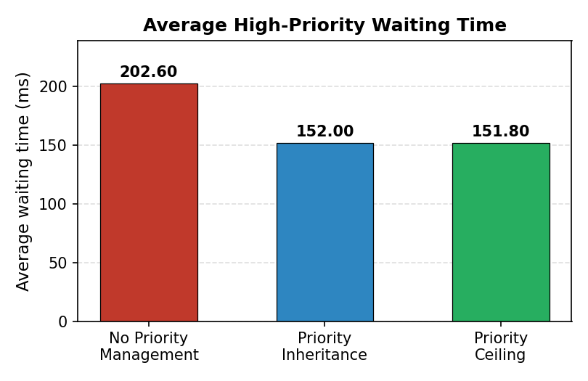
Figure 6 — Average high-priority waiting time.
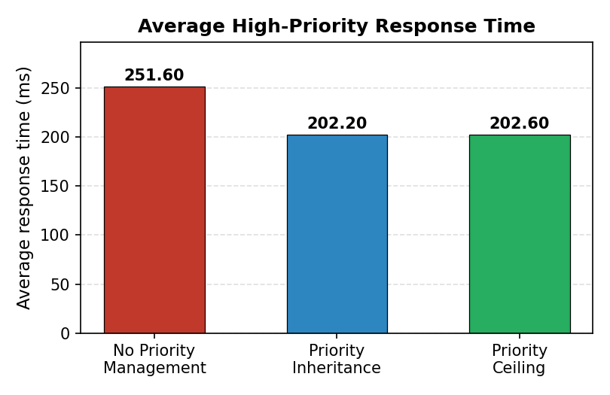
Figure 7 — Average high-priority response time.

Discussion
The results clearly show the effect of priority management on the high-priority safety task:
- No priority management has the highest waiting time (202.60 ms) because priority inversion occurs — the Safety Monitor is held up by the Logger and further delayed by the Motion Planner.
- Priority inheritance reduces the waiting time to 152.00 ms, because the low-priority Logger temporarily receives high priority when it is blocking the Safety Monitor, so it releases the motor sooner.
- Priority ceiling reduces the waiting time to 151.80 ms, because any thread holding the MotorController runs at the ceiling priority and cannot be delayed by the medium-priority task.
Priority inheritance and priority ceiling give very similar results in this simulation. This is expected, because there is only one shared resource and therefore only one possible blocking situation, so both protocols end up raising the resource holder to the same high priority. Overall, the results prove that priority management noticeably improves the response of the safety-critical high-priority task compared with having no priority management at all.

Conclusion
The implementation meets all of the requirements set out in the project brief. Three Java threads were created and given appropriate priorities, and the shared MotorController was protected with synchronized methods together with wait() and notifyAll() to guarantee mutual exclusion.
Priority inversion was demonstrated in the baseline test, and both priority inheritance and priority ceiling were implemented to reduce the delay experienced by the high-priority task. The waiting time and response time of the Safety Monitor were measured over multiple runs, and the averaged results were presented in a table and in bar charts. The comparison confirms that priority management improves the timing behaviour of the safety-critical task, which is exactly what a real-time robotic arm controller needs.

