
Lab Report Cover Sheet

Student name | Student number
Dev Bhodia | 8233202

Subject code and name: | ECTE331 - Real Time Embedded Systems
Subject coordinator: | Prof. Abdsamad Benkrid
Part number: | 1
Date and time due: | Thursday, 29 June 2026, 11:55 PM
Lab tutor name: | Prof. Kiyan Afsari
Total number of pages | 8 pages

Table Of Contents

- Drone Navigation System
Introduction 1
System Architecture 2
Sensor Reading and Fault Simulation 3
Majority Voting and Fallback 4
Reliability Monitoring and SAFE MODE 5
Test Cases and Figures 6
Conclusion 11

Fault-Tolerant Autonomous

Drone Navigation System

Introduction
This report explains my implementation of Project Part 1, a Fault-Tolerant Autonomous Drone Navigation System written in Java. The program simulates how a drone estimates its altitude using three redundant sensors. Because a single sensor can fail or return corrupted data, the system uses redundancy and majority voting to decide on a reliable altitude instead of trusting any one sensor on its own.
The project demonstrates several real-time and fault-tolerance ideas: redundancy through three sensors, majority voting using Triple Modular Redundancy (TMR), reliability monitoring, exception handling with custom exception classes, a safe fallback to the last known good altitude, and file logging of all important events. If the system becomes unreliable two cycles in a row, it enters SAFE MODE and stops, which is the safe behaviour for a real drone.

System Architecture
The drone reads its altitude from three sensors: Sensor A, Sensor B, and Sensor C. Each sensor returns an integer altitude, where a valid value is in the range 0 to 200 metres. The three readings are passed to the controller, which applies majority voting to choose the final altitude. The controller also monitors reliability, falls back to the previous valid altitude when needed, and writes every important event to a log file. Figure 1 shows this architecture.
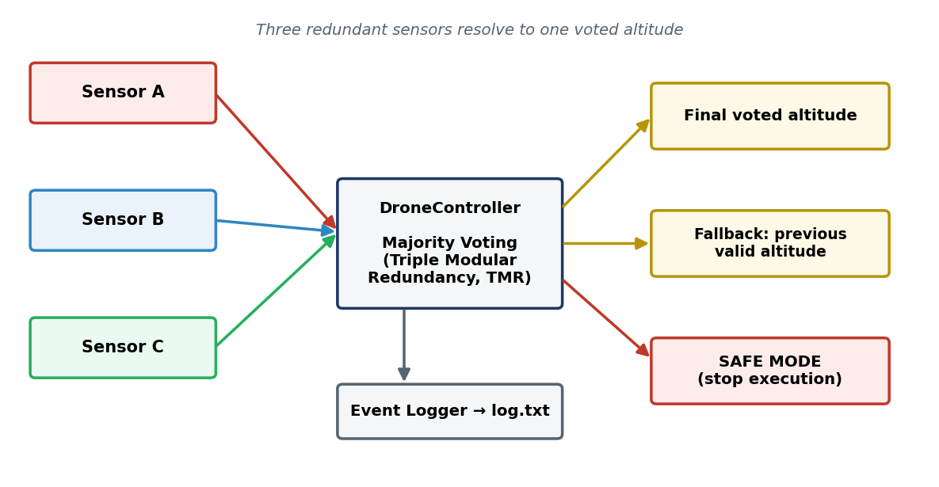
Figure 1 — Triple Modular Redundancy (TMR) system architecture
Random range | Behaviour | Details
0 – 14 | Sensor failure | A SensorReadException is thrown
15 – 29 | Corrupted reading | A value is generated outside the valid 0 – 200 range
30 – 99 | Valid reading | A value within the valid 0 – 200 m range is returned
Each sensor reading is simulated randomly so that the program can produce failures, corrupted values, and valid readings during a run. The behaviour of a single reading is decided by a random “chance” value between 0 and 99, as summarised in Table 1.

Table 1 — Sensor fault-simulation behaviour by random range.

Sensor Reading and Fault Simulation

The application is organised into a small set of Java classes inside the Part1_Drone package: the main application, the controller, the sensor simulation, a class that holds a single sensor result, an event logger, and the two required custom exception classes. The main design ideas are described below.
Each sensor reading is generated by a readSensor method. First a random chance value from 0 to 99 is produced. If the chance is below 15, the sensor is treated as failed and a SensorReadException is thrown. If the chance is below 30, the sensor returns a corrupted reading, which is a value deliberately placed outside the valid 0 to 200 range. Otherwise, the sensor returns a normal valid altitude. This logic is shown in Figure 2.

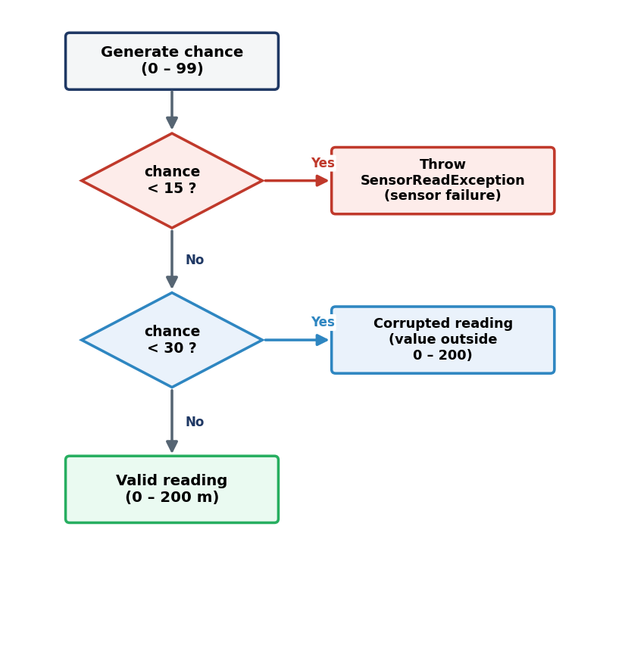
Figure 2 — Sensor reading and fault-simulation logic.

Majority Voting and Fallback

After the three sensors are read, the controller keeps only the valid readings and applies the majority voting rule. If two of the valid readings are equal, that value is used as the final altitude. If all the readings differ, or if fewer than two valid readings are available, the controller cannot trust the sensors, so it falls back to the previous valid altitude. This keeps the drone using a known good value instead of corrupted or unreliable data. Figure 3 shows this decision process.

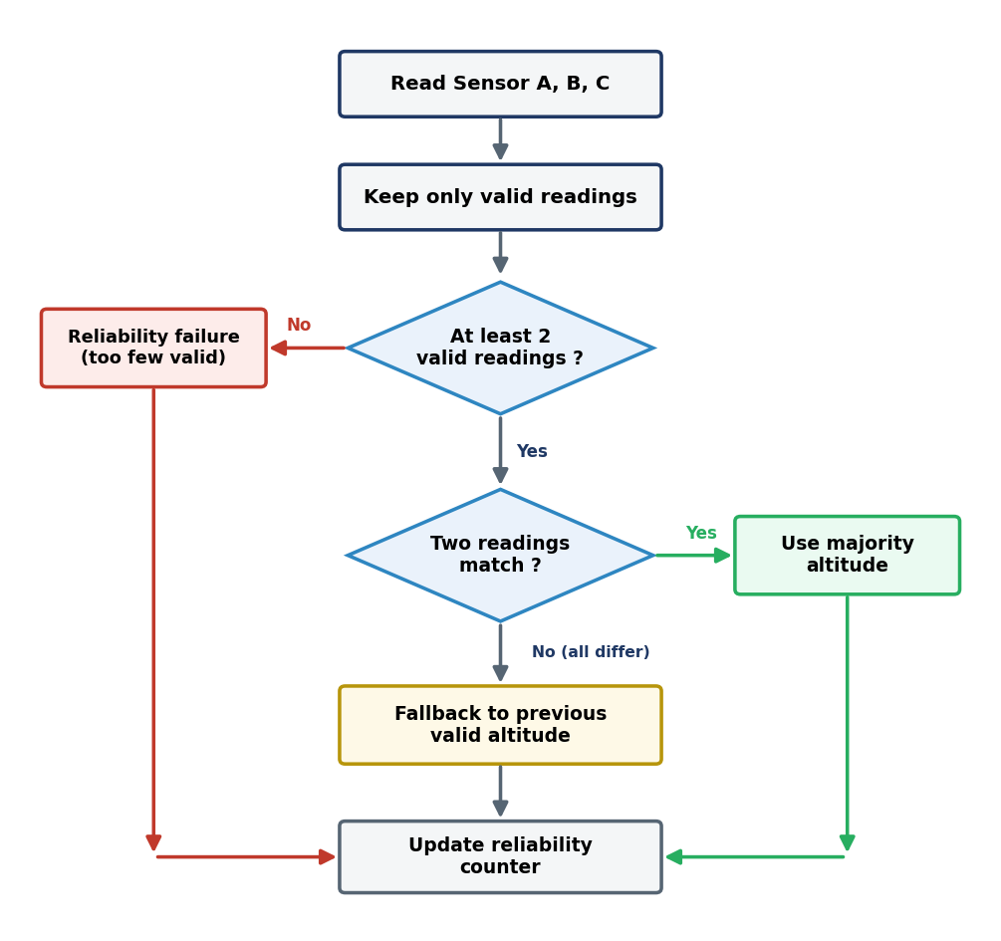
Figure 3 — Majority voting and fallback logic.

Reliability Monitoring and SAFE MODE

A reliability failure is recorded when fewer than two valid sensor readings exist, or when no majority can be found. The controller keeps a counter of consecutive reliability failures. If a cycle produces a good majority, the counter is reset to zero. If two reliability failures happen one after another, the counter reaches two, and the controller throws a SystemReliabilityException. The main method catches this exception, logs the transition to SAFE MODE, prints a warning, and stops execution. This behaviour is summarised in Figure 4.
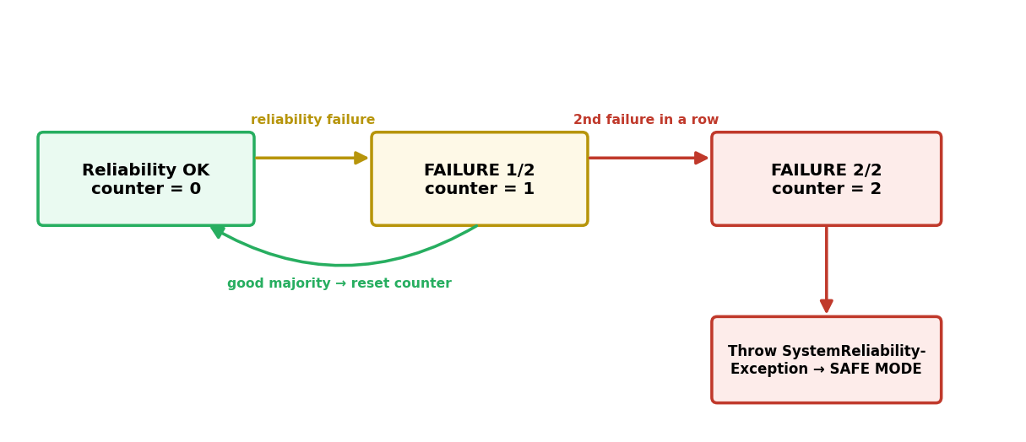
Figure 4 — Reliability counter and SAFE MODE state diagram.

Test Cases and Figures
Running the Application
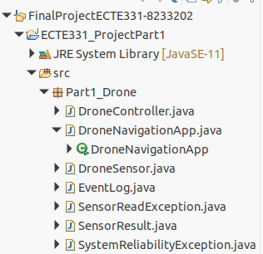
Figure 5 — Eclipse project structure.
Three test cases were used to demonstrate all the important behaviours of the application: majority voting, fallback, corrupted and failed sensor handling, file logging, and SAFE MODE after two consecutive reliability failures. The input for each test is only the number of iterations, as shown in Table 2.
Table 2 — Required test cases.
Test case | Argument | Purpose | What to look for
TC1 | 5 | General run with valid readings and majority voting | Majority altitude selected, reliability status OK
TC2 | 20 | Fallback decision and reliability failure | No majority or fewer than 2 valid sensors, then fallback altitude
TC3 | 50 | SAFE MODE after two consecutive reliability failures | FAILURE 2/2 and SAFE MODE ACTIVATED

Test Case 1 — Majority Voting
Test Case 1 was run with 5 iterations. The console output shows the three sensor values, any corrupted or failed sensors, and the voting decision for each cycle. When two valid sensors match, the controller selects that value as the majority altitude and the reliability status stays OK. Figure 6 shows this output.
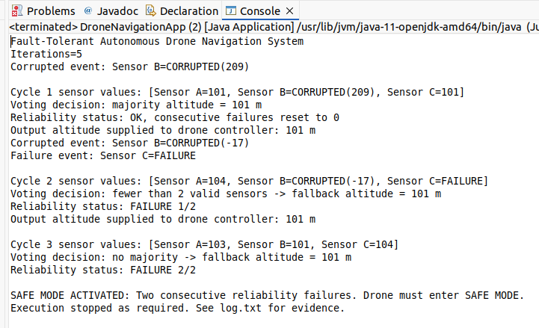
Figure 6 — Test Case 1 console output (majority voting).

Test Case 2 — Fallback Decision
Test Case 2 was run with 20 iterations. This run shows the fallback behaviour: when the sensors do not produce a reliable majority, or when fewer than two valid sensors are available, the controller uses the previous valid altitude instead of a corrupted value. Figure 7 shows the fallback decisions and the reliability failures.
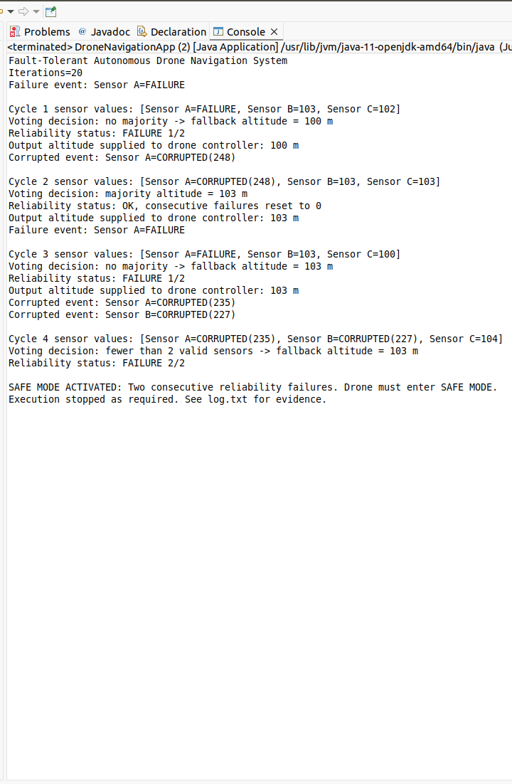
Figure 7 — Test Case 2 console output (fallback decision and reliability failure).

Test Case 3 — SAFE MODE Activation
Test Case 3 was run with 50 iterations, but the program stopped early because two reliability failures occurred one after another. After FAILURE 2/2, the controller throws SystemReliabilityException. The main method catches it, logs SAFE MODE, prints the warning, and stops execution. Figure 8 shows this output.
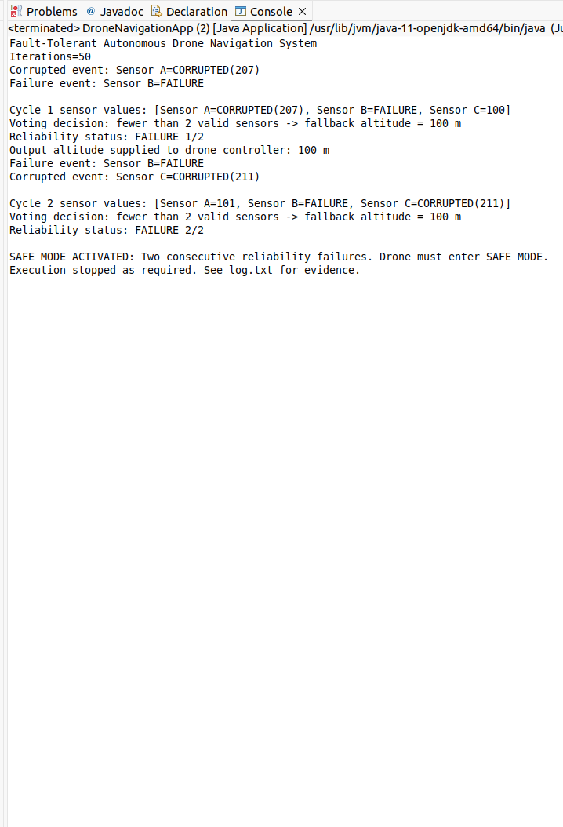
Figure 8 — Test Case 3 console output (SAFE MODE activation).

Log File Evidence
Figure 9 shows the generated log.txt file after the SAFE MODE test. The log records the application start, the iterations, corrupted sensor readings, sensor failures, sensor values, voting decisions, reliability status, SAFE MODE activation, and the final stop message. Each line is prefixed with a date and time, which satisfies the file logging requirement of the project.
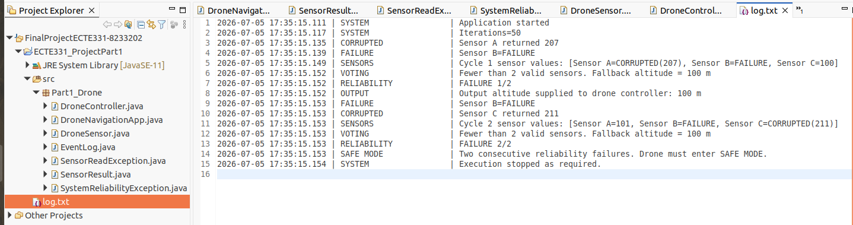
Figure 9 — log.txt recorded events, including SAFE MODE logging.
JavaDoc Documentation
Figure 10 shows the JavaDoc documentation generated from the Java source files. It lists the Part1_Drone package and the main classes used in the project. Generating this documentation satisfies the requirement for detailed solution documentation produced with JavaDoc.
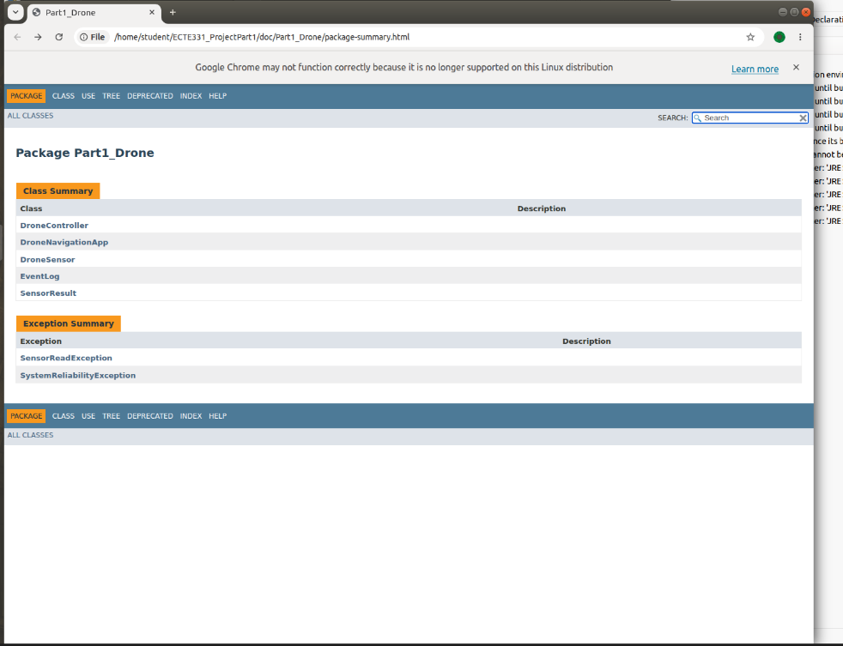
Figure 10 — Generated JavaDoc documentation.

Conclusion

The program meets all of the Project Part 1 requirements. It simulates three redundant sensors, detects sensor failures and corrupted readings, and applies majority voting using Triple Modular Redundancy. When the sensors cannot be trusted, it falls back to the previous valid altitude, and it records every important event to a log file with a date and time. Finally, it monitors reliability and enters SAFE MODE after two consecutive reliability failures, throwing a SystemReliabilityException and stopping execution. Together, these features show a simple but complete fault-tolerant design for an autonomous drone altitude system.

