
K J Somaiya Institute of Technology
An Autonomous Institute Permanently Affiliated to the University of Mumbai DEPARTMENT OF INFORMATION TECHNOLOGY
Name of Student : Aditya Bali
Roll No : B - 71
Batch : SB4
EXPERIMENT 9
Aim:
Implementation of Binary Search Technique considering a real-world application.
Objective :
1. To implement the Binary Search algorithm using C programming. 2. To accept temperature readings from the user for different weather stations. 3. To search for a specific temperature efficiently.
4. To understand the application of searching techniques in temperature monitoring systems.
Software Used:
● Turbo C / Turbo C++
● DOSBox
Theory :
Binary Search is a searching technique used to find a specific element in a sorted array. It compares the search value with the middle element of the array. If the value matches, the search is successful. If the search value is greater than the middle element, the left half is ignored. If it is smaller, the right half is ignored. This process continues until the element is found or the search range becomes empty.
In this application, temperature readings from different weather stations are first arranged in ascending order. Binary Search is then used to find a particular temperature reading.
The time complexity of Binary Search is ��(log ��), and its space complexity is ��(1) for this iterative implementation.
Program :
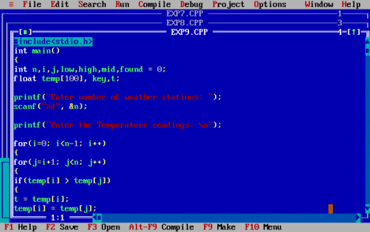
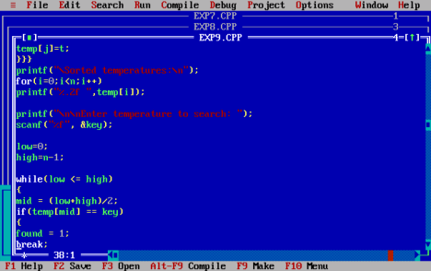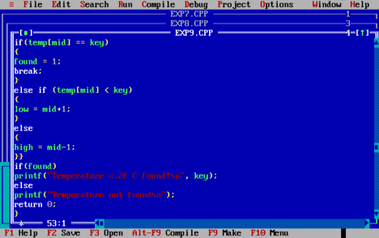
Output :
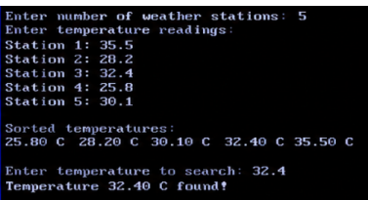
Algorithm :
1. Start.
2. Accept the number of weather stations.
3. Input the temperature readings.
4. Sort the temperature readings in ascending order.
5. Accept the temperature to be searched.
6. Initialize low = 0 and high = n - 1.
7. Calculate mid = (low + high) / 2.
8. If the middle element equals the search value, display that the temperature is found.
9. If the search value is greater than the middle element, set low = mid + 1. 10.Otherwise, set high = mid - 1.
11. Repeat Steps 7–10 while low <= high.
12.If the temperature is not found, display an appropriate message. 13.Stop.
Outcome :
Binary Search was successfully implemented in C to search for a specific temperature reading after sorting the user-entered temperatures.
Conclusion :
Thus, Binary Search was successfully implemented for a real-world temperature monitoring application. It provides an efficient way to search for a particular temperature in sorted readings by repeatedly dividing the search range into two halves.

