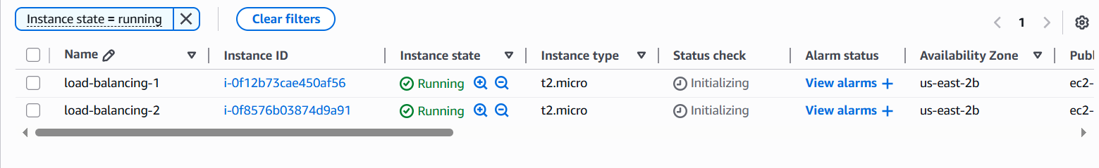

Public ip -18.224.6.23

52.14.254.52

Public DNS-ec2-18-224-6-23.us-east-2.compute.amazonaws.com

ec2-52-14-254-52.us-east-2.compute.amazonaws.com

We installing sample application on both ec2 server.

# Update package lists and upgrade packages

sudo apt update -y

sudo apt upgrade -y

# Install Apache web server

sudo apt install apache2 -y

# Start Apache service

sudo systemctl start apache2

# Enable Apache to start at boot

sudo systemctl enable apache2

# Create a sample web page

echo '<h1>Hello from EC2 Instance 1 (Ubuntu)</h1>' | sudo tee /var/www/html/index.html



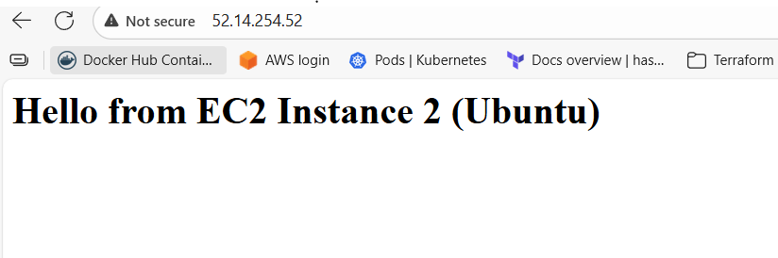

Create target group

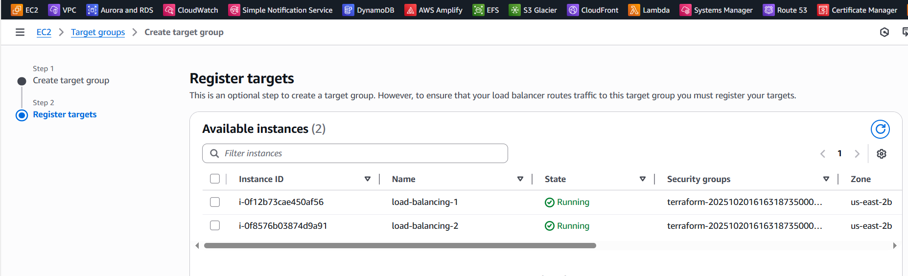

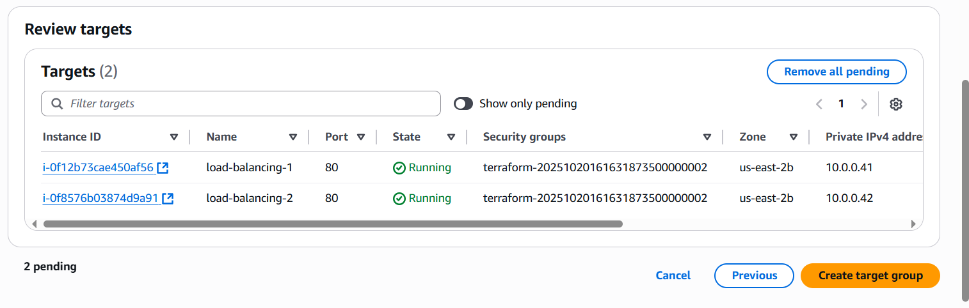

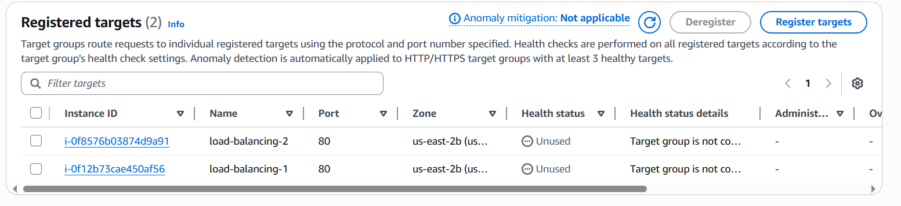

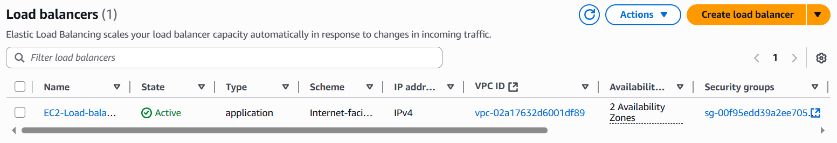

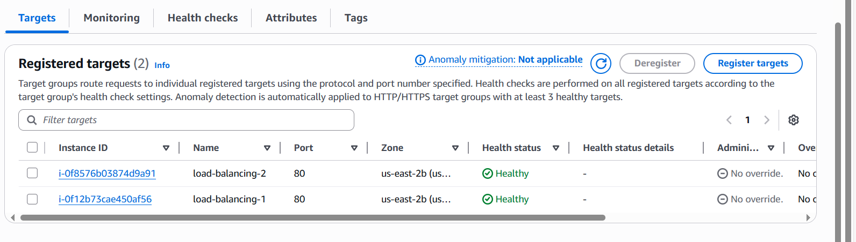

Targeted instance health check showing healthy after attaching target group to load balancer.

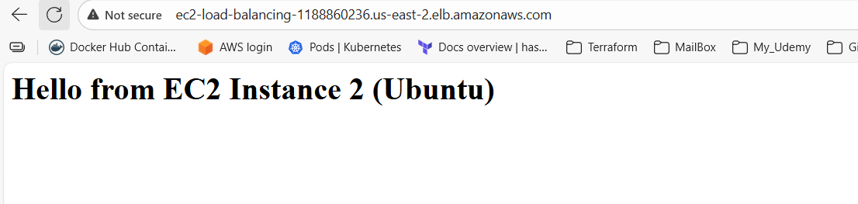

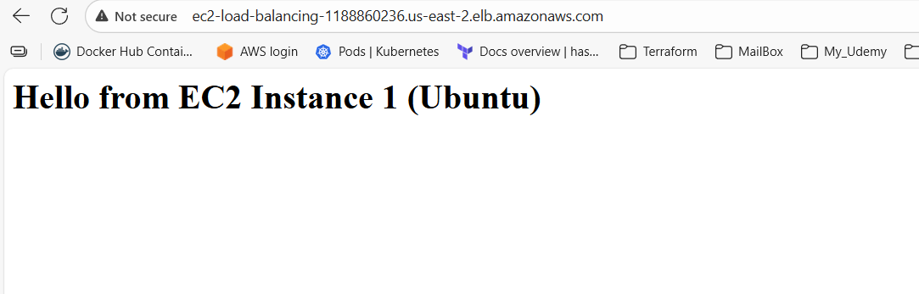

Issues if we do wrong configuration-

Application listen on port 80 but we mapped wrong port in load balancer.

Application will be not accessible if we change HTTP:80 to any other port like HTTP:8080.-

Application running inside EC2 stopped.

Then we will get 502 Bad Gateway.

Health check interval too short will cause issue.

Wrong health check path will cause problem.