**SERVIÇOS**

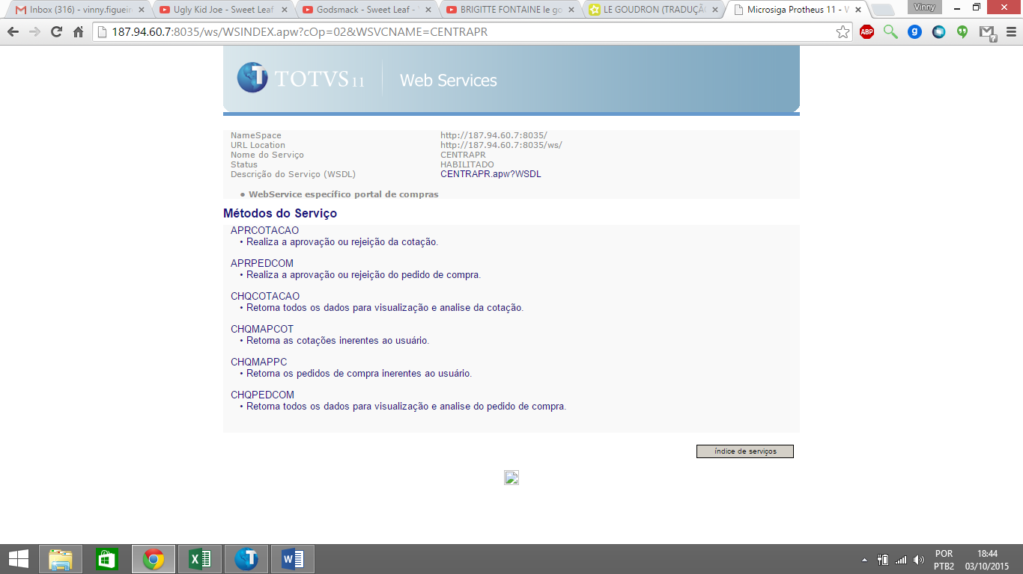

**CHQMAPCOT**

|  |  |  |  |  |  |  |  |  |  |  |  |  |  |  |  |
| --- | --- | --- | --- | --- | --- | --- | --- | --- | --- | --- | --- | --- | --- | --- | --- |
| |  |  |  | | --- | --- | --- | | **Requisição SOAP** | | | | http://187.94.60.7:8035/ws/images/transparente.gif | | | | http://187.94.60.7:8035/ws/images/transparente.gif | |  | |  | Parte superior do formulário  <?xml version="1.0" encoding="utf-8"?"  <soap:Envelope xmlns:xsi="http://www.w3.org/2001/XMLSchema-instance"  xmlns:xsd="http://www.w3.org/2001/XMLSchema"  xmlns:soap="http://schemas.xmlsoap.org/soap/envelope/">  <soap:Body>  <CRECEB>**STRING**</CRECEB>  </soap:Body>  </soap:Envelope>  CSTRING : String contendo os parâmetros para uso do serviço delimitado por pipe ‘|’  Código do usuário | Código Status(Opcional)Parte inferior do formulário |  | | http://187.94.60.7:8035/ws/images/transparente.gif | |  | |
| |  |  |  | | --- | --- | --- | | http://187.94.60.7:8035/ws/images/transparente.gif | | | | **Resposta da Requisição SOAP** | | | | http://187.94.60.7:8035/ws/images/transparente.gif | | | | http://187.94.60.7:8035/ws/images/transparente.gif | |  | |  | Parte superior do formulário  <?xml version="1.0" encoding="utf-8"?"  <soap:Envelope xmlns:xsi="http://www.w3.org/2001/XMLSchema-instance"  xmlns:xsd="http://www.w3.org/2001/XMLSchema"  xmlns:soap="http://schemas.xmlsoap.org/soap/envelope/">  <soap:Body>  <LISTCOT>  <LISTMAPCOT>  <MAPCOT>  <CCC>**STRING**</CCC>  <CCOMPRADOR>**STRING**</CCOMPRADOR>  <CDTENV>**STRING**</CDTENV>  <CDTVAL>**STRING**</CDTVAL>  <CFIL>**STRING**</CFIL>  <CNUMCOT>**STRING**</CNUMCOT>  <CRANKING>**STRING**</CRANKING>  </MAPCOT>  *<MAPCOT>*  *<CCC>****STRING****</CCC>*  *<CCOMPRADOR>****STRING****</CCOMPRADOR>*  *<CDTENV>****STRING****</CDTENV>*  *<CDTVAL>****STRING****</CDTVAL>*  *<CFIL>****STRING****</CFIL>*  *<CNUMCOT>****STRING****</CNUMCOT>*  *<CRANKING>****STRING****</CRANKING>*  *</MAPCOT>*  </LISTMAPCOT>  </LISTCOT>  </soap:Body>  </soap:Envelope>  Parte inferior do formulário |  | |

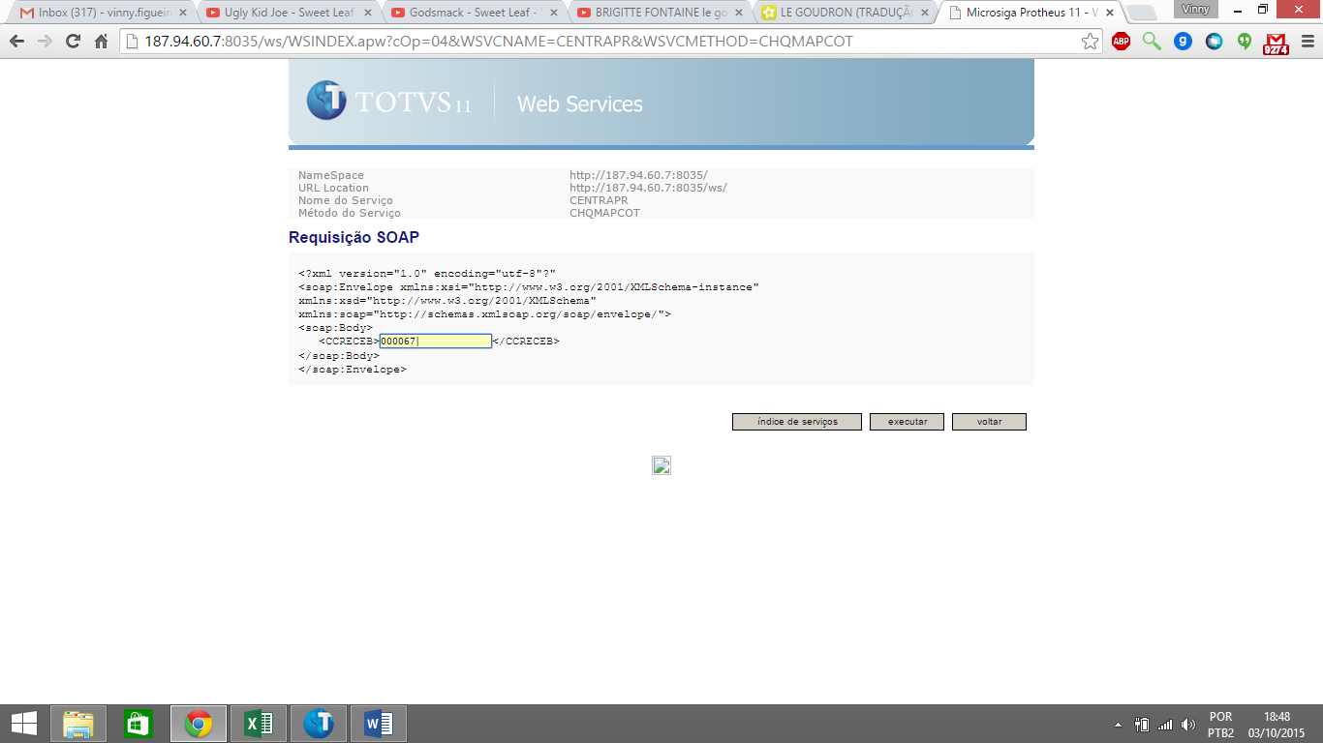

|  |  |  |
| --- | --- | --- |
| **Resposta da Requisição SOAP** | | |
| http://187.94.60.7:8035/ws/images/transparente.gif | | |
| http://187.94.60.7:8035/ws/images/transparente.gif | |  |
|  | <soap:Envelope xmlns:xsi="http://www.w3.org/2001/XMLSchema-instance"  xmlns:xsd="http://www.w3.org/2001/XMLSchema"  xmlns:soap="http://schemas.xmlsoap.org/soap/envelope/">  <soap:Body>  <CHQMAPCOTRESPONSE xmlns="http://187.94.60.7:8035/">  <CHQMAPCOTRESULT>  <LISTMAPCOT>  <MAPCOT>  <CCC>**82206**</CCC>  <CCOMPRADOR>**000086 - Jairo Junior**</CCOMPRADOR>  <CDTENV>**20150227 17:39:17**</CDTENV>  <CDTVAL>**20190205**</CDTVAL>  <CFIL>**0101**</CFIL>  <CNUMCOT>**003353**</CNUMCOT>  <CRANKING>**03**</CRANKING>  </MAPCOT>  <MAPCOT>  <CCC>**82206**</CCC>  <CCOMPRADOR>**000296 - Rafael Luiz do Sacramento**</CCOMPRADOR>  <CDTENV>  </CDTENV>  <CDTVAL>**20190618**</CDTVAL>  <CFIL>**0101**</CFIL>  <CNUMCOT>**003485**</CNUMCOT>  <CRANKING>**02**</CRANKING>  </MAPCOT>  <MAPCOT>  <CCC>**82206**</CCC>  <CCOMPRADOR>**000296 - Rafael Luiz do Sacramento**</CCOMPRADOR>  <CDTENV>**20150714 18:52:16**</CDTENV>  <CDTVAL>**20190618**</CDTVAL>  <CFIL>**0101**</CFIL>  <CNUMCOT>**003490**</CNUMCOT>  <CRANKING>**03**</CRANKING>  </MAPCOT>  <MAPCOT>  <CCC>**82206**</CCC>  <CCOMPRADOR>**000267 - Yttalo Pereira Martins ( Doit Sistemas )**</CCOMPRADOR>  <CDTENV>**20150714 17:59:28**</CDTENV>  <CDTVAL>**20190618**</CDTVAL>  <CFIL>**0101**</CFIL>  <CNUMCOT>**003501**</CNUMCOT>  <CRANKING>**03**</CRANKING>  </MAPCOT>  <MAPCOT>  <CCC>**82206**</CCC>  <CCOMPRADOR>**000227 - Vinicius Figueiredo (Do-IT)**</CCOMPRADOR>  <CDTENV>**20150720 10:14:59**</CDTENV>  <CDTVAL>**20190628**</CDTVAL>  <CFIL>**0101**</CFIL>  <CNUMCOT>**003516**</CNUMCOT>  <CRANKING>**03**</CRANKING>  </MAPCOT>  <MAPCOT>  <CCC>**82206**</CCC>  <CCOMPRADOR>**000227 - Vinicius Figueiredo (Do-IT)**</CCOMPRADOR>  <CDTENV>**20150721 10:53:48**</CDTENV>  <CDTVAL>**20190701**</CDTVAL>  <CFIL>**0101**</CFIL>  <CNUMCOT>**003527**</CNUMCOT>  <CRANKING>**03**</CRANKING>  </MAPCOT>  <MAPCOT>  <CCC>**82206**</CCC>  <CCOMPRADOR>**000073 - Fabio Flores Regueira**</CCOMPRADOR>  <CDTENV>**20150721 15:01:07**</CDTENV>  <CDTVAL>**20150804**</CDTVAL>  <CFIL>**0101**</CFIL>  <CNUMCOT>**003544**</CNUMCOT>  <CRANKING>**03**</CRANKING>  </MAPCOT>  <MAPCOT>  <CCC>**82206**</CCC>  <CCOMPRADOR>**000073 - Fabio Flores Regueira**</CCOMPRADOR>  <CDTENV>**20150721 15:33:13**</CDTENV>  <CDTVAL>**20150804**</CDTVAL>  <CFIL>**0101**</CFIL>  <CNUMCOT>**003553**</CNUMCOT>  <CRANKING>**03**</CRANKING>  </MAPCOT>  <MAPCOT>  <CCC>**82206**</CCC>  <CCOMPRADOR>**000086 - Jairo Junior**</CCOMPRADOR>  <CDTENV>**20150326 10:10:44**</CDTENV>  <CDTVAL>**20190311**</CDTVAL>  <CFIL>**0101**</CFIL>  <CNUMCOT>**003605**</CNUMCOT>  <CRANKING>**03**</CRANKING>  </MAPCOT>  <MAPCOT>  <CCC>**82206**</CCC>  <CCOMPRADOR>**000090 - Cleber Onofre**</CCOMPRADOR>  <CDTENV>**20150402 19:15:46**</CDTENV>  <CDTVAL>**20190318**</CDTVAL>  <CFIL>**0101**</CFIL>  <CNUMCOT>**003656**</CNUMCOT>  <CRANKING>**03**</CRANKING>  </MAPCOT>  <MAPCOT>  <CCC>**82206**</CCC>  <CCOMPRADOR>**000073 - Fabio Flores Regueira**</CCOMPRADOR>  <CDTENV>**20150722 11:27:32**</CDTENV>  <CDTVAL>**20150805**</CDTVAL>  <CFIL>**0101**</CFIL>  <CNUMCOT>**003658**</CNUMCOT>  <CRANKING>**03**</CRANKING>  </MAPCOT>  <MAPCOT>  <CCC>**82206**</CCC>  <CCOMPRADOR>**000073 - Fabio Flores Regueira**</CCOMPRADOR>  <CDTENV>**20150722 16:08:14**</CDTENV>  <CDTVAL>**20150805**</CDTVAL>  <CFIL>**0101**</CFIL>  <CNUMCOT>**003683**</CNUMCOT>  <CRANKING>**03**</CRANKING>  </MAPCOT>  <MAPCOT>  <CCC>**82206**</CCC>  <CCOMPRADOR>**000227 - Vinicius Figueiredo (Do-IT)**</CCOMPRADOR>  <CDTENV>**20150722 16:28:53**</CDTENV>  <CDTVAL>**20190702**</CDTVAL>  <CFIL>**0101**</CFIL>  <CNUMCOT>**003686**</CNUMCOT>  <CRANKING>**03**</CRANKING>  </MAPCOT>  <MAPCOT>  <CCC>**82206**</CCC>  <CCOMPRADOR>**000073 - Fabio Flores Regueira**</CCOMPRADOR>  <CDTENV>**20150724 17:12:54**</CDTENV>  <CDTVAL>**20150807**</CDTVAL>  <CFIL>**0101**</CFIL>  <CNUMCOT>**003708**</CNUMCOT>  <CRANKING>**03**</CRANKING>  </MAPCOT>  <MAPCOT>  <CCC>**82206**</CCC>  <CCOMPRADOR>**000073 - Fabio Flores Regueira**</CCOMPRADOR>  <CDTENV>**20150727 10:02:49**</CDTENV>  <CDTVAL>**20150810**</CDTVAL>  <CFIL>**0101**</CFIL>  <CNUMCOT>**003715**</CNUMCOT>  <CRANKING>**03**</CRANKING>  </MAPCOT>  <MAPCOT>  <CCC>**82206**</CCC>  <CCOMPRADOR>**000073 - Fabio Flores Regueira**</CCOMPRADOR>  <CDTENV>**20150727 14:44:47**</CDTENV>  <CDTVAL>**20190705**</CDTVAL>  <CFIL>**0101**</CFIL>  <CNUMCOT>**003730**</CNUMCOT>  <CRANKING>**03**</CRANKING>  </MAPCOT>  <MAPCOT>  <CCC>**82206**</CCC>  <CCOMPRADOR>**000073 - Fabio Flores Regueira**</CCOMPRADOR>  <CDTENV>**20150727 14:48:22**</CDTENV>  <CDTVAL>**20190705**</CDTVAL>  <CFIL>**0101**</CFIL>  <CNUMCOT>**003731**</CNUMCOT>  <CRANKING>**03**</CRANKING>  </MAPCOT>  <MAPCOT>  <CCC>**82206**</CCC>  <CCOMPRADOR>**000073 - Fabio Flores Regueira**</CCOMPRADOR>  <CDTENV>**20150727 15:26:38**</CDTENV>  <CDTVAL>**20150810**</CDTVAL>  <CFIL>**0101**</CFIL>  <CNUMCOT>**003736**</CNUMCOT>  <CRANKING>**03**</CRANKING>  </MAPCOT>  <MAPCOT>  <CCC>**82206**</CCC>  <CCOMPRADOR>**000073 - Fabio Flores Regueira**</CCOMPRADOR>  <CDTENV>**20150727 16:41:31**</CDTENV>  <CDTVAL>**20150810**</CDTVAL>  <CFIL>**0101**</CFIL>  <CNUMCOT>**003737**</CNUMCOT>  <CRANKING>**03**</CRANKING>  </MAPCOT>  <MAPCOT>  <CCC>**82206**</CCC>  <CCOMPRADOR>**000073 - Fabio Flores Regueira**</CCOMPRADOR>  <CDTENV>**20150728 15:51:20**</CDTENV>  <CDTVAL>**20150811**</CDTVAL>  <CFIL>**0101**</CFIL>  <CNUMCOT>**003843**</CNUMCOT>  <CRANKING>**03**</CRANKING>  </MAPCOT>  <MAPCOT>  <CCC>**82206**</CCC>  <CCOMPRADOR>**000073 - Fabio Flores Regueira**</CCOMPRADOR>  <CDTENV>**20150728 15:51:30**</CDTENV>  <CDTVAL>**20150811**</CDTVAL>  <CFIL>**0101**</CFIL>  <CNUMCOT>**003850**</CNUMCOT>  <CRANKING>**03**</CRANKING>  </MAPCOT>  <MAPCOT>  <CCC>**82206**</CCC>  <CCOMPRADOR>**000061 - Susan Kelly Araujo Pereira Fernandes**</CCOMPRADOR>  <CDTENV>**20150514 16:34:07**</CDTENV>  <CDTVAL>**20190426**</CDTVAL>  <CFIL>**0101**</CFIL>  <CNUMCOT>**003891**</CNUMCOT>  <CRANKING>**03**</CRANKING>  </MAPCOT>  <MAPCOT>  <CCC>**82206**</CCC>  <CCOMPRADOR>**000090 - Cleber Onofre**</CCOMPRADOR>  <CDTENV>**20150525 16:48:40**</CDTENV>  <CDTVAL>**20190507**</CDTVAL>  <CFIL>**0101**</CFIL>  <CNUMCOT>**003939**</CNUMCOT>  <CRANKING>**03**</CRANKING>  </MAPCOT>  <MAPCOT>  <CCC>**82206**</CCC>  <CCOMPRADOR>**000090 - Cleber Onofre**</CCOMPRADOR>  <CDTENV>**20150527 13:40:20**</CDTENV>  <CDTVAL>**20190507**</CDTVAL>  <CFIL>**0101**</CFIL>  <CNUMCOT>**003967**</CNUMCOT>  <CRANKING>**03**</CRANKING>  </MAPCOT>  <MAPCOT>  <CCC>**82206**</CCC>  <CCOMPRADOR>**000090 - Cleber Onofre**</CCOMPRADOR>  <CDTENV>**20150527 13:40:28**</CDTENV>  <CDTVAL>**20190507**</CDTVAL>  <CFIL>**0101**</CFIL>  <CNUMCOT>**003968**</CNUMCOT>  <CRANKING>**03**</CRANKING>  </MAPCOT>  <MAPCOT>  <CCC>**82206**</CCC>  <CCOMPRADOR>**000090 - Cleber Onofre**</CCOMPRADOR>  <CDTENV>**20150624 15:47:55**</CDTENV>  <CDTVAL>**20190604**</CDTVAL>  <CFIL>**0101**</CFIL>  <CNUMCOT>**004101**</CNUMCOT>  <CRANKING>**03**</CRANKING>  </MAPCOT>  <MAPCOT>  <CCC>**82206**</CCC>  <CCOMPRADOR>**000090 - Cleber Onofre**</CCOMPRADOR>  <CDTENV>**20150625 09:18:14**</CDTENV>  <CDTVAL>**20190605**</CDTVAL>  <CFIL>**0101**</CFIL>  <CNUMCOT>**004104**</CNUMCOT>  <CRANKING>**03**</CRANKING>  </MAPCOT>  <MAPCOT>  <CCC>**82206**</CCC>  <CCOMPRADOR>**000090 - Cleber Onofre**</CCOMPRADOR>  <CDTENV>**20150626 17:37:56**</CDTENV>  <CDTVAL>**20190606**</CDTVAL>  <CFIL>**0101**</CFIL>  <CNUMCOT>**004113**</CNUMCOT>  <CRANKING>**03**</CRANKING>  </MAPCOT>  <MAPCOT>  <CCC>**82206**</CCC>  <CCOMPRADOR>**000073 - Fabio Flores Regueira**</CCOMPRADOR>  <CDTENV>**20150804 15:54:10**</CDTENV>  <CDTVAL>**20150818**</CDTVAL>  <CFIL>**0101**</CFIL>  <CNUMCOT>**004151**</CNUMCOT>  <CRANKING>**03**</CRANKING>  </MAPCOT>  <MAPCOT>  <CCC>**82206**</CCC>  <CCOMPRADOR>**000073 - Fabio Flores Regueira**</CCOMPRADOR>  <CDTENV>**20150804 17:05:42**</CDTENV>  <CDTVAL>**20150818**</CDTVAL>  <CFIL>**0101**</CFIL>  <CNUMCOT>**004152**</CNUMCOT>  <CRANKING>**03**</CRANKING>  </MAPCOT>  <MAPCOT>  <CCC>**82206**</CCC>  <CCOMPRADOR>**000073 - Fabio Flores Regueira**</CCOMPRADOR>  <CDTENV>**20150805 13:58:03**</CDTENV>  <CDTVAL>**20150819**</CDTVAL>  <CFIL>**0101**</CFIL>  <CNUMCOT>**004153**</CNUMCOT>  <CRANKING>**03**</CRANKING>  </MAPCOT>  <MAPCOT>  <CCC>**82206**</CCC>  <CCOMPRADOR>**000073 - Fabio Flores Regueira**</CCOMPRADOR>  <CDTENV>**20150811 10:22:55**</CDTENV>  <CDTVAL>**20150825**</CDTVAL>  <CFIL>**0101**</CFIL>  <CNUMCOT>**004176**</CNUMCOT>  <CRANKING>**03**</CRANKING>  </MAPCOT>  <MAPCOT>  <CCC>**82206**</CCC>  <CCOMPRADOR>**000073 - Fabio Flores Regueira**</CCOMPRADOR>  <CDTENV>**20150811 10:23:45**</CDTENV>  <CDTVAL>**20150825**</CDTVAL>  <CFIL>**0101**</CFIL>  <CNUMCOT>**004177**</CNUMCOT>  <CRANKING>**03**</CRANKING>  </MAPCOT>  <MAPCOT>  <CCC>**82206**</CCC>  <CCOMPRADOR>**000073 - Fabio Flores Regueira**</CCOMPRADOR>  <CDTENV>**20150811 11:59:06**</CDTENV>  <CDTVAL>**20150825**</CDTVAL>  <CFIL>**0101**</CFIL>  <CNUMCOT>**004178**</CNUMCOT>  <CRANKING>**02**</CRANKING>  </MAPCOT>  <MAPCOT>  <CCC>**82206**</CCC>  <CCOMPRADOR>**000073 - Fabio Flores Regueira**</CCOMPRADOR>  <CDTENV>**20150908 10:07:39**</CDTENV>  <CDTVAL>**20150922**</CDTVAL>  <CFIL>**0101**</CFIL>  <CNUMCOT>**004193**</CNUMCOT>  <CRANKING>**03**</CRANKING>  </MAPCOT>  <MAPCOT>  <CCC>**82206**</CCC>  <CCOMPRADOR>**000073 - Fabio Flores Regueira**</CCOMPRADOR>  <CDTENV>**20150910 11:51:17**</CDTENV>  <CDTVAL>**20150924**</CDTVAL>  <CFIL>**0101**</CFIL>  <CNUMCOT>**004194**</CNUMCOT>  <CRANKING>**03**</CRANKING>  </MAPCOT>  <MAPCOT>  <CCC>**82206**</CCC>  <CCOMPRADOR>**000073 - Fabio Flores Regueira**</CCOMPRADOR>  <CDTENV>**20150910 13:41:33**</CDTENV>  <CDTVAL>**20150924**</CDTVAL>  <CFIL>**0101**</CFIL>  <CNUMCOT>**004195**</CNUMCOT>  <CRANKING>**03**</CRANKING>  </MAPCOT>  </LISTMAPCOT>  </CHQMAPCOTRESULT>  </CHQMAPCOTRESPONSE>  </soap:Body>  </soap:Envelope> |  |

**CHQMAPPC**

|  |  |  |  |  |  |  |  |  |  |  |  |  |  |  |  |
| --- | --- | --- | --- | --- | --- | --- | --- | --- | --- | --- | --- | --- | --- | --- | --- |
| |  |  |  | | --- | --- | --- | | **Requisição SOAP** | | | | http://187.94.60.7:8035/ws/images/transparente.gif | | | | http://187.94.60.7:8035/ws/images/transparente.gif | |  | |  | Parte superior do formulário  <?xml version="1.0" encoding="utf-8"?"  <soap:Envelope xmlns:xsi="http://www.w3.org/2001/XMLSchema-instance"  xmlns:xsd="http://www.w3.org/2001/XMLSchema"  xmlns:soap="http://schemas.xmlsoap.org/soap/envelope/">  <soap:Body>  <CRECEB>**STRING**</CRECEB>  </soap:Body>  </soap:Envelope>  Parte inferior do formulário |  | | http://187.94.60.7:8035/ws/images/transparente.gif CSTRING : String contendo os parâmetros para uso do serviço delimitado por pipe ‘|’  Código do usuário | Código Status(Opcional)Parte inferior do formulário | |  | |
| |  |  |  | | --- | --- | --- | | http://187.94.60.7:8035/ws/images/transparente.gif | | | | **Resposta da Requisição SOAP** | | | | http://187.94.60.7:8035/ws/images/transparente.gif | | | | http://187.94.60.7:8035/ws/images/transparente.gif | |  | |  | Parte superior do formulário  <?xml version="1.0" encoding="utf-8"?"  <soap:Envelope xmlns:xsi="http://www.w3.org/2001/XMLSchema-instance"  xmlns:xsd="http://www.w3.org/2001/XMLSchema"  xmlns:soap="http://schemas.xmlsoap.org/soap/envelope/">  <soap:Body>  <LISTPC>  <LISTMAPPC>  <MAPPC>  <CCC>**STRING**</CCC>  <CCOMPRADOR>**STRING**</CCOMPRADOR>  <CCOTACAO>**STRING**</CCOTACAO>  <CDTENT>**STRING**</CDTENT>  <CFIL>**STRING**</CFIL>  <CFORNECEDOR>**STRING**</CFORNECEDOR>  <CNUMPC>**STRING**</CNUMPC>  <COBS>**STRING**</COBS>  <CSTATUS>**STRING**</CSTATUS>  <NTOTAL>**FLOAT**</NTOTAL>  </MAPPC>  *<MAPPC>*  *<CCC>****STRING****</CCC>*  *<CCOMPRADOR>****STRING****</CCOMPRADOR>*  *<CCOTACAO>****STRING****</CCOTACAO>*  *<CDTENT>****STRING****</CDTENT>*  *<CFIL>****STRING****</CFIL>*  *<CFORNECEDOR>****STRING****</CFORNECEDOR>*  *<CNUMPC>****STRING****</CNUMPC>*  *<COBS>****STRING****</COBS>*  *<CSTATUS>****STRING****</CSTATUS>*  *<NTOTAL>****FLOAT****</NTOTAL>*  *</MAPPC>*  </LISTMAPPC>  </LISTPC>  </soap:Body>  </soap:Envelope>  Parte inferior do formulário |  | | http://187.94.60.7:8035/ws/images/transparente.gif | |  | |
|  |

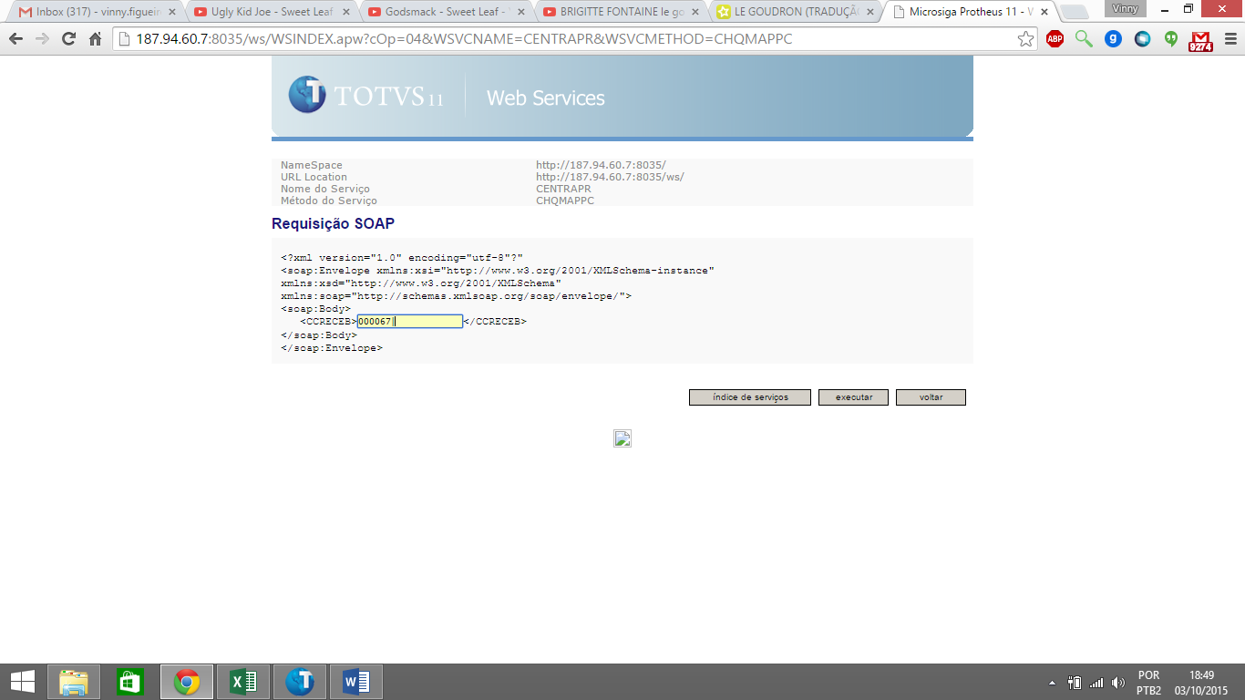

|  |  |  |
| --- | --- | --- |
| **Resposta da Requisição SOAP** | | |
| http://187.94.60.7:8035/ws/images/transparente.gif | | |
| http://187.94.60.7:8035/ws/images/transparente.gif | |  |
|  | <soap:Envelope xmlns:xsi="http://www.w3.org/2001/XMLSchema-instance"  xmlns:xsd="http://www.w3.org/2001/XMLSchema"  xmlns:soap="http://schemas.xmlsoap.org/soap/envelope/">  <soap:Body>  <CHQMAPPCRESPONSE xmlns="http://187.94.60.7:8035/">  <CHQMAPPCRESULT>  <LISTMAPPC>  <MAPPC>  <CCC>**82206**</CCC>  <CCOMPRADOR>**000086 - Jairo Junior**</CCOMPRADOR>  <CCOTACAO>**003359**</CCOTACAO>  <CDTENT>**20150307**</CDTENT>  <CFIL>**0101**</CFIL>  <CFORNECEDOR>**001792/01 - EMPRESA BRASILEIRA DE SOLUCOES E SERVICOS EM TELEA**</CFORNECEDOR>  <CNUMPC>**011171**</CNUMPC>  <COBS>  </COBS>  <CSTATUS>**03**</CSTATUS>  <NTOTAL>**21167.00000000**</NTOTAL>  </MAPPC>  <MAPPC>  <CCC>**82206**</CCC>  <CCOMPRADOR>**000090 - Cleber Onofre**</CCOMPRADOR>  <CCOTACAO>**003353**</CCOTACAO>  <CDTENT>**20150304**</CDTENT>  <CFIL>**0101**</CFIL>  <CFORNECEDOR>**001706/01 - ALL GOOD SUPRIMENTOS E EQUIPAMENTOS LTDA - EPP** </CFORNECEDOR>  <CNUMPC>**011280**</CNUMPC>  <COBS>  </COBS>  <CSTATUS>**03**</CSTATUS>  <NTOTAL>**885.00000000**</NTOTAL>  </MAPPC>  <MAPPC>  <CCC>**82206**</CCC>  <CCOMPRADOR>**000296 - Rafael Luiz do Sacramento**</CCOMPRADOR>  <CCOTACAO></CCOTACAO>  <CDTENT>**20150708**</CDTENT>  <CFIL>**0101**</CFIL>  <CFORNECEDOR>**000004/01 - TELELOK CENTRAL DE LOCACOES E COMERCIO L** </CFORNECEDOR>  <CNUMPC>**011303**</CNUMPC>  <COBS>  </COBS>  <CSTATUS>**03**</CSTATUS>  <NTOTAL>**1.00000000**</NTOTAL>  </MAPPC>  <MAPPC>  <CCC>**82206**</CCC>  <CCOMPRADOR>**000267 - Yttalo Pereira Martins ( Doit Sistemas )**</CCOMPRADOR>  <CCOTACAO>**003490**</CCOTACAO>  <CDTENT>**20150721**</CDTENT>  <CFIL>**0101**</CFIL>  <CFORNECEDOR>**001706/01 - ALL GOOD SUPRIMENTOS E EQUIPAMENTOS LTDA - EPP** </CFORNECEDOR>  <CNUMPC>**011335**</CNUMPC>  <COBS>  </COBS>  <CSTATUS>**02**</CSTATUS>  <NTOTAL>**10000.00000000**</NTOTAL>  </MAPPC>  <MAPPC>  <CCC>**82206**</CCC>  <CCOMPRADOR>**000296 - Rafael Luiz do Sacramento**</CCOMPRADOR>  <CCOTACAO>**003501**</CCOTACAO>  <CDTENT>**20150721**</CDTENT>  <CFIL>**0101**</CFIL>  <CFORNECEDOR>**001291/01 - LENOVO TECNOLOGIA (BRASIL) LIMITADA** </CFORNECEDOR>  <CNUMPC>**011343**</CNUMPC>  <COBS>  </COBS>  <CSTATUS>**02**</CSTATUS>  <NTOTAL>**50000.00000000**</NTOTAL>  </MAPPC>  <MAPPC>  <CCC>**82206**</CCC>  <CCOMPRADOR>**000227 - Vinicius Figueiredo (Do-IT)**</CCOMPRADOR>  <CCOTACAO>**003516**</CCOTACAO>  <CDTENT>**20150809**</CDTENT>  <CFIL>**0101**</CFIL>  <CFORNECEDOR>**000127/01 - PAPER-RIO COMERCIO DE ARTIGOS DE PAPELARIA LTDA.** </CFORNECEDOR>  <CNUMPC>**011350**</CNUMPC>  <COBS>  </COBS>  <CSTATUS>**02**</CSTATUS>  <NTOTAL>**250.00000000**</NTOTAL>  </MAPPC>  <MAPPC>  <CCC>**82206**</CCC>  <CCOMPRADOR>**000227 - Vinicius Figueiredo (Do-IT)**</CCOMPRADOR>  <CCOTACAO></CCOTACAO>  <CDTENT>**20150720**</CDTENT>  <CFIL>**0101**</CFIL>  <CFORNECEDOR>**000004/01 - TELELOK CENTRAL DE LOCACOES E COMERCIO L** </CFORNECEDOR>  <CNUMPC>**011354**</CNUMPC>  <COBS>  </COBS>  <CSTATUS>**02**</CSTATUS>  <NTOTAL>**30.00000000**</NTOTAL>  </MAPPC>  <MAPPC>  <CCC>**82206**</CCC>  <CCOMPRADOR>**000227 - Vinicius Figueiredo (Do-IT)**</CCOMPRADOR>  <CCOTACAO>**003527**</CCOTACAO>  <CDTENT>**20150731**</CDTENT>  <CFIL>**0101**</CFIL>  <CFORNECEDOR>**001849/01 - ATACADAO PAPELEX LTDA** </CFORNECEDOR>  <CNUMPC>**011356**</CNUMPC>  <COBS>  </COBS>  <CSTATUS>**02**</CSTATUS>  <NTOTAL>**20.00000000**</NTOTAL>  </MAPPC>  <MAPPC>  <CCC>**82206**</CCC>  <CCOMPRADOR>**000073 - Fabio Flores Regueira**</CCOMPRADOR>  <CCOTACAO>**003544**</CCOTACAO>  <CDTENT>**20150724**</CDTENT>  <CFIL>**0101**</CFIL>  <CFORNECEDOR>**001193/01 - F. DE ARRUDA SANTOS SUP. E EQUIP. ME** </CFORNECEDOR>  <CNUMPC>**011357**</CNUMPC>  <COBS>  </COBS>  <CSTATUS>**02**</CSTATUS>  <NTOTAL>**45.00000000**</NTOTAL>  </MAPPC>  <MAPPC>  <CCC>**82206**</CCC>  <CCOMPRADOR>**000073 - Fabio Flores Regueira**</CCOMPRADOR>  <CCOTACAO>**003544**</CCOTACAO>  <CDTENT>**20150722**</CDTENT>  <CFIL>**0101**</CFIL>  <CFORNECEDOR>**000148/01 - INGRAM MICRO BRASIL LTDA** </CFORNECEDOR>  <CNUMPC>**011406**</CNUMPC>  <COBS>  </COBS>  <CSTATUS>**03**</CSTATUS>  <NTOTAL>**15.00000000**</NTOTAL>  </MAPPC>  <MAPPC>  <CCC>**82206**</CCC>  <CCOMPRADOR>**000073 - Fabio Flores Regueira**</CCOMPRADOR>  <CCOTACAO>**003553**</CCOTACAO>  <CDTENT>**20150722**</CDTENT>  <CFIL>**0101**</CFIL>  <CFORNECEDOR>**001056/05 - INTERSMART COMERCIO, IMPORTACAO E EXPORTACAO DE EQ**</CFORNECEDOR>  <CNUMPC>**011435**</CNUMPC>  <COBS>  </COBS>  <CSTATUS>**03**</CSTATUS>  <NTOTAL>**150.00000000**</NTOTAL>  </MAPPC>  <MAPPC>  <CCC>**82206**</CCC>  <CCOMPRADOR>**000073 - Fabio Flores Regueira**</CCOMPRADOR>  <CCOTACAO></CCOTACAO>  <CDTENT>**20150721**</CDTENT>  <CFIL>**0101**</CFIL>  <CFORNECEDOR>**000013/01 - FADRIX COMUNICACAO VISUAL LTDA** </CFORNECEDOR>  <CNUMPC>**011453**</CNUMPC>  <COBS>  </COBS>  <CSTATUS>**03**</CSTATUS>  <NTOTAL>**300.00000000**</NTOTAL>  </MAPPC>  <MAPPC>  <CCC>**82206**</CCC>  <CCOMPRADOR>**000073 - Fabio Flores Regueira**</CCOMPRADOR>  <CCOTACAO></CCOTACAO>  <CDTENT>**20150721**</CDTENT>  <CFIL>**0101**</CFIL>  <CFORNECEDOR>**000008/01 - DDE LOCACOES E SERVICOS EM INFORMATICA L** </CFORNECEDOR>  <CNUMPC>**011475**</CNUMPC>  <COBS>  </COBS>  <CSTATUS>**03**</CSTATUS>  <NTOTAL>**300.00000000**</NTOTAL>  </MAPPC>  <MAPPC>  <CCC>**82206**</CCC>  <CCOMPRADOR>**000073 - Fabio Flores Regueira**</CCOMPRADOR>  <CCOTACAO>**003658**</CCOTACAO>  <CDTENT>**20150723**</CDTENT>  <CFIL>**0101**</CFIL>  <CFORNECEDOR>**000148/01 - INGRAM MICRO BRASIL LTDA** </CFORNECEDOR>  <CNUMPC>**011620**</CNUMPC>  <COBS>  </COBS>  <CSTATUS>**03**</CSTATUS>  <NTOTAL>**150.00000000**</NTOTAL>  </MAPPC>  <MAPPC>  <CCC>**82206**</CCC>  <CCOMPRADOR>**000073 - Fabio Flores Regueira**</CCOMPRADOR>  <CCOTACAO></CCOTACAO>  <CDTENT>**20150722**</CDTENT>  <CFIL>**0101**</CFIL>  <CFORNECEDOR>**000011/01 - SUPRIWEB COMERCIO E SERVICOS DE INFORMAT** </CFORNECEDOR>  <CNUMPC>**011631**</CNUMPC>  <COBS>  </COBS>  <CSTATUS>**03**</CSTATUS>  <NTOTAL>**300.00000000**</NTOTAL>  </MAPPC>  <MAPPC>  <CCC>**82206**</CCC>  <CCOMPRADOR>**000073 - Fabio Flores Regueira**</CCOMPRADOR>  <CCOTACAO></CCOTACAO>  <CDTENT>**20150722**</CDTENT>  <CFIL>**0101**</CFIL>  <CFORNECEDOR>**000011/01 - SUPRIWEB COMERCIO E SERVICOS DE INFORMAT** </CFORNECEDOR>  <CNUMPC>**011757**</CNUMPC>  <COBS>  </COBS>  <CSTATUS>**03**</CSTATUS>  <NTOTAL>**1.00000000**</NTOTAL>  </MAPPC>  <MAPPC>  <CCC>**82206**</CCC>  <CCOMPRADOR>**000073 - Fabio Flores Regueira**</CCOMPRADOR>  <CCOTACAO>**003683**</CCOTACAO>  <CDTENT>**20150723**</CDTENT>  <CFIL>**0101**</CFIL>  <CFORNECEDOR>**000178/01 - ALCATEIA DISTRIBUIDORA LTDA** </CFORNECEDOR>  <CNUMPC>**011759**</CNUMPC>  <COBS>  </COBS>  <CSTATUS>**03**</CSTATUS>  <NTOTAL>**500.00000000**</NTOTAL>  </MAPPC>  <MAPPC>  <CCC>**82206**</CCC>  <CCOMPRADOR>**000227 - Vinicius Figueiredo (Do-IT)**</CCOMPRADOR>  <CCOTACAO>**003686**</CCOTACAO>  <CDTENT>**20150802**</CDTENT>  <CFIL>**0101**</CFIL>  <CFORNECEDOR>**002535/01 - NEXTPAPER DISTRIBUIDORA DE INFORMATICA E PAPELARIA**</CFORNECEDOR>  <CNUMPC>**011760**</CNUMPC>  <COBS>  </COBS>  <CSTATUS>**03**</CSTATUS>  <NTOTAL>**44.95000000**</NTOTAL>  </MAPPC>  <MAPPC>  <CCC>**82206**</CCC>  <CCOMPRADOR>**000086 - Jairo Junior**</CCOMPRADOR>  <CCOTACAO>**003605**</CCOTACAO>  <CDTENT>**20150405**</CDTENT>  <CFIL>**0101**</CFIL>  <CFORNECEDOR>**000011/01 - SUPRIWEB COMERCIO E SERVICOS DE INFORMAT** </CFORNECEDOR>  <CNUMPC>**011808**</CNUMPC>  <COBS>  </COBS>  <CSTATUS>**03**</CSTATUS>  <NTOTAL>**150.00000000**</NTOTAL>  </MAPPC>  <MAPPC>  <CCC>**82206**</CCC>  <CCOMPRADOR>**000073 - Fabio Flores Regueira**</CCOMPRADOR>  <CCOTACAO>**003715**</CCOTACAO>  <CDTENT>**20150728**</CDTENT>  <CFIL>**0101**</CFIL>  <CFORNECEDOR>**001238/01 - SUPRICORP SUPRIMENTOS LTDA** </CFORNECEDOR>  <CNUMPC>**011907**</CNUMPC>  <COBS>  </COBS>  <CSTATUS>**03**</CSTATUS>  <NTOTAL>**10.00000000**</NTOTAL>  </MAPPC>  <MAPPC>  <CCC>**82206**</CCC>  <CCOMPRADOR>**000267 - Yttalo Pereira Martins ( Doit Sistemas )**</CCOMPRADOR>  <CCOTACAO>**003716**</CCOTACAO>  <CDTENT>**20150728**</CDTENT>  <CFIL>**0101**</CFIL>  <CFORNECEDOR>**001849/01 - ATACADAO PAPELEX LTDA** </CFORNECEDOR>  <CNUMPC>**011917**</CNUMPC>  <COBS>  </COBS>  <CSTATUS>**02**</CSTATUS>  <NTOTAL>**10.00000000**</NTOTAL>  </MAPPC>  <MAPPC>  <CCC>**82206**</CCC>  <CCOMPRADOR>**000073 - Fabio Flores Regueira**</CCOMPRADOR>  <CCOTACAO>**003730**</CCOTACAO>  <CDTENT>**20150728**</CDTENT>  <CFIL>**0101**</CFIL>  <CFORNECEDOR>**001849/01 - ATACADAO PAPELEX LTDA** </CFORNECEDOR>  <CNUMPC>**011920**</CNUMPC>  <COBS>  </COBS>  <CSTATUS>**03**</CSTATUS>  <NTOTAL>**10.00000000**</NTOTAL>  </MAPPC>  <MAPPC>  <CCC>**82206**</CCC>  <CCOMPRADOR>**000090 - Cleber Onofre**</CCOMPRADOR>  <CCOTACAO>**003656**</CCOTACAO>  <CDTENT>**20150413**</CDTENT>  <CFIL>**0101**</CFIL>  <CFORNECEDOR>**001706/01 - ALL GOOD SUPRIMENTOS E EQUIPAMENTOS LTDA - EPP** </CFORNECEDOR>  <CNUMPC>**011994**</CNUMPC>  <COBS>  </COBS>  <CSTATUS>**03**</CSTATUS>  <NTOTAL>**1138.50000000**</NTOTAL>  </MAPPC>  <MAPPC>  <CCC>**82206**</CCC>  <CCOMPRADOR>**000073 - Fabio Flores Regueira**</CCOMPRADOR>  <CCOTACAO>**003731**</CCOTACAO>  <CDTENT>**20150728**</CDTENT>  <CFIL>**0101**</CFIL>  <CFORNECEDOR>**002535/01 - NEXTPAPER DISTRIBUIDORA DE INFORMATICA E PAPELARIA**</CFORNECEDOR>  <CNUMPC>**012078**</CNUMPC>  <COBS>  </COBS>  <CSTATUS>**03**</CSTATUS>  <NTOTAL>**10.00000000**</NTOTAL>  </MAPPC>  <MAPPC>  <CCC>**82206**</CCC>  <CCOMPRADOR>**000073 - Fabio Flores Regueira**</CCOMPRADOR>  <CCOTACAO>**003736**</CCOTACAO>  <CDTENT>**20150806**</CDTENT>  <CFIL>**0101**</CFIL>  <CFORNECEDOR>**001248/1 - ORGANIZER INFORMATICA LTDA - ME** </CFORNECEDOR>  <CNUMPC>**012079**</CNUMPC>  <COBS>  </COBS>  <CSTATUS>**03**</CSTATUS>  <NTOTAL>**100.00000000**</NTOTAL>  </MAPPC>  <MAPPC>  <CCC>**82206**</CCC>  <CCOMPRADOR>**000073 - Fabio Flores Regueira**</CCOMPRADOR>  <CCOTACAO>**003737**</CCOTACAO>  <CDTENT>**20150730**</CDTENT>  <CFIL>**0101**</CFIL>  <CFORNECEDOR>**002016/01 - TERACOM TELEMATICA S.A.** </CFORNECEDOR>  <CNUMPC>**012091**</CNUMPC>  <COBS>  </COBS>  <CSTATUS>**03**</CSTATUS>  <NTOTAL>**13.00000000**</NTOTAL>  </MAPPC>  <MAPPC>  <CCC>**82206**</CCC>  <CCOMPRADOR>**000272 - Fernanda Zisels Peixoto Fortuna**</CCOMPRADOR>  <CCOTACAO>**003891**</CCOTACAO>  <CDTENT>**20150525**</CDTENT>  <CFIL>**0101**</CFIL>  <CFORNECEDOR>**002758/01 - RTT INFORMATICA E TELECOMUNICACOES LTDA - EPP** </CFORNECEDOR>  <CNUMPC>**012693**</CNUMPC>  <COBS>  </COBS>  <CSTATUS>**03**</CSTATUS>  <NTOTAL>**1750.00000000**</NTOTAL>  </MAPPC>  <MAPPC>  <CCC>**82206**</CCC>  <CCOMPRADOR>**000090 - Cleber Onofre**</CCOMPRADOR>  <CCOTACAO>**003939**</CCOTACAO>  <CDTENT>**20150530**</CDTENT>  <CFIL>**0101**</CFIL>  <CFORNECEDOR>**002506/01 - SOLUTION SYSTEMS COMERCIO E SERVICOS LTDA - ME** </CFORNECEDOR>  <CNUMPC>**012786**</CNUMPC>  <COBS>  </COBS>  <CSTATUS>**03**</CSTATUS>  <NTOTAL>**145.00000000**</NTOTAL>  </MAPPC>  <MAPPC>  <CCC>**82206**</CCC>  <CCOMPRADOR>**000090 - Cleber Onofre**</CCOMPRADOR>  <CCOTACAO>**003968**</CCOTACAO>  <CDTENT>**20150626**</CDTENT>  <CFIL>**0101**</CFIL>  <CFORNECEDOR>**002570/08 - DELL COMPUTADORES DO BRASIL LTDA** </CFORNECEDOR>  <CNUMPC>**012836**</CNUMPC>  <COBS>  </COBS>  <CSTATUS>**03**</CSTATUS>  <NTOTAL>**6656.40000000**</NTOTAL>  </MAPPC>  <MAPPC>  <CCC>**82206**</CCC>  <CCOMPRADOR>**000090 - Cleber Onofre**</CCOMPRADOR>  <CCOTACAO>**003967**</CCOTACAO>  <CDTENT>**20150621**</CDTENT>  <CFIL>**0101**</CFIL>  <CFORNECEDOR>**000328/01 - DELL COMPUTADORES DO BRASIL LTDA** </CFORNECEDOR>  <CNUMPC>**012837**</CNUMPC>  <COBS>  </COBS>  <CSTATUS>**03**</CSTATUS>  <NTOTAL>**6683.60000000**</NTOTAL>  </MAPPC>  <MAPPC>  <CCC>**82206**</CCC>  <CCOMPRADOR>**000073 - Fabio Flores Regueira**</CCOMPRADOR>  <CCOTACAO>**004151**</CCOTACAO>  <CDTENT>**20150805**</CDTENT>  <CFIL>**0101**</CFIL>  <CFORNECEDOR>**001849/01 - ATACADAO PAPELEX LTDA** </CFORNECEDOR>  <CNUMPC>**012902**</CNUMPC>  <COBS>  </COBS>  <CSTATUS>**04**</CSTATUS>  <NTOTAL>**12.00000000**</NTOTAL>  </MAPPC>  <MAPPC>  <CCC>**82206**</CCC>  <CCOMPRADOR>**000073 - Fabio Flores Regueira**</CCOMPRADOR>  <CCOTACAO>**004152**</CCOTACAO>  <CDTENT>**20150805**</CDTENT>  <CFIL>**0101**</CFIL>  <CFORNECEDOR>**000127/01 - PAPER-RIO COMERCIO DE ARTIGOS DE PAPELARIA LTDA.** </CFORNECEDOR>  <CNUMPC>**012969**</CNUMPC>  <COBS>  </COBS>  <CSTATUS>**04**</CSTATUS>  <NTOTAL>**5010.00000000**</NTOTAL>  </MAPPC>  <MAPPC>  <CCC>**82206**</CCC>  <CCOMPRADOR>**000073 - Fabio Flores Regueira**</CCOMPRADOR>  <CCOTACAO>**004153**</CCOTACAO>  <CDTENT>**20150806**</CDTENT>  <CFIL>**0101**</CFIL>  <CFORNECEDOR>**000127/01 - PAPER-RIO COMERCIO DE ARTIGOS DE PAPELARIA LTDA.** </CFORNECEDOR>  <CNUMPC>**013015**</CNUMPC>  <COBS>  </COBS>  <CSTATUS>**04**</CSTATUS>  <NTOTAL>**1.00000000**</NTOTAL>  </MAPPC>  <MAPPC>  <CCC>**82206**</CCC>  <CCOMPRADOR>**000090 - Cleber Onofre**</CCOMPRADOR>  <CCOTACAO>**004101**</CCOTACAO>  <CDTENT>**20150630**</CDTENT>  <CFIL>**0101**</CFIL>  <CFORNECEDOR>**001706/01 - ALL GOOD SUPRIMENTOS E EQUIPAMENTOS LTDA - EPP** </CFORNECEDOR>  <CNUMPC>**013323**</CNUMPC>  <COBS>  </COBS>  <CSTATUS>**03**</CSTATUS>  <NTOTAL>**109.00000000**</NTOTAL>  </MAPPC>  <MAPPC>  <CCC>**82206**</CCC>  <CCOMPRADOR>**000090 - Cleber Onofre**</CCOMPRADOR>  <CCOTACAO>**004104**</CCOTACAO>  <CDTENT>**20150704**</CDTENT>  <CFIL>**0101**</CFIL>  <CFORNECEDOR>**001706/01 - ALL GOOD SUPRIMENTOS E EQUIPAMENTOS LTDA - EPP** </CFORNECEDOR>  <CNUMPC>**013368**</CNUMPC>  <COBS>  </COBS>  <CSTATUS>**03**</CSTATUS>  <NTOTAL>**1197.00000000**</NTOTAL>  </MAPPC>  <MAPPC>  <CCC>**82206**</CCC>  <CCOMPRADOR>**000090 - Cleber Onofre**</CCOMPRADOR>  <CCOTACAO>**004113**</CCOTACAO>  <CDTENT>**20150709**</CDTENT>  <CFIL>**0101**</CFIL>  <CFORNECEDOR>**000011/01 - SUPRIWEB COMERCIO E SERVICOS DE INFORMAT** </CFORNECEDOR>  <CNUMPC>**013371**</CNUMPC>  <COBS>  </COBS>  <CSTATUS>**03**</CSTATUS>  <NTOTAL>**335.00000000**</NTOTAL>  </MAPPC>  <MAPPC>  <CCC>**82206**</CCC>  <CCOMPRADOR>**000073 - Fabio Flores Regueira**</CCOMPRADOR>  <CCOTACAO></CCOTACAO>  <CDTENT>**20150811**</CDTENT>  <CFIL>**0101**</CFIL>  <CFORNECEDOR>**000003/01 - COMUNICACAO MAIS ASSESSORIA LTDA** </CFORNECEDOR>  <CNUMPC>**013490**</CNUMPC>  <COBS>  </COBS>  <CSTATUS>**02**</CSTATUS>  <NTOTAL>**100.00000000**</NTOTAL>  </MAPPC>  <MAPPC>  <CCC>**82206**</CCC>  <CCOMPRADOR>**000073 - Fabio Flores Regueira**</CCOMPRADOR>  <CCOTACAO></CCOTACAO>  <CDTENT>**20150811**</CDTENT>  <CFIL>**0101**</CFIL>  <CFORNECEDOR>**000005/01 - IDEECON CONSULTORIA EMPRESARIAL LTDA.** </CFORNECEDOR>  <CNUMPC>**013491**</CNUMPC>  <COBS>  </COBS>  <CSTATUS>**02**</CSTATUS>  <NTOTAL>**200.00000000**</NTOTAL>  </MAPPC>  <MAPPC>  <CCC>**82206**</CCC>  <CCOMPRADOR>**000073 - Fabio Flores Regueira**</CCOMPRADOR>  <CCOTACAO>**004176**</CCOTACAO>  <CDTENT>**20150811**</CDTENT>  <CFIL>**0101**</CFIL>  <CFORNECEDOR>**001238/01 - SUPRICORP SUPRIMENTOS LTDA** </CFORNECEDOR>  <CNUMPC>**013492**</CNUMPC>  <COBS>  </COBS>  <CSTATUS>**02**</CSTATUS>  <NTOTAL>**10.00000000**</NTOTAL>  </MAPPC>  <MAPPC>  <CCC>**82206**</CCC>  <CCOMPRADOR>**000073 - Fabio Flores Regueira**</CCOMPRADOR>  <CCOTACAO>**004177**</CCOTACAO>  <CDTENT>**20150811**</CDTENT>  <CFIL>**0101**</CFIL>  <CFORNECEDOR>**000127/01 - PAPER-RIO COMERCIO DE ARTIGOS DE PAPELARIA LTDA.** </CFORNECEDOR>  <CNUMPC>**013493**</CNUMPC>  <COBS>  </COBS>  <CSTATUS>**02**</CSTATUS>  <NTOTAL>**20.00000000**</NTOTAL>  </MAPPC>  <MAPPC>  <CCC>**82206**</CCC>  <CCOMPRADOR>**000227 - Vinicius Figueiredo (Do-IT)**</CCOMPRADOR>  <CCOTACAO></CCOTACAO>  <CDTENT>**20150819**</CDTENT>  <CFIL>**0101**</CFIL>  <CFORNECEDOR>**000005/01 - IDEECON CONSULTORIA EMPRESARIAL LTDA.** </CFORNECEDOR>  <CNUMPC>**013498**</CNUMPC>  <COBS>  </COBS>  <CSTATUS>**02**</CSTATUS>  <NTOTAL>**1000.00000000**</NTOTAL>  </MAPPC>  <MAPPC>  <CCC>**82206**</CCC>  <CCOMPRADOR>**000227 - Vinicius Figueiredo (Do-IT)**</CCOMPRADOR>  <CCOTACAO></CCOTACAO>  <CDTENT>**20150819**</CDTENT>  <CFIL>**0101**</CFIL>  <CFORNECEDOR>**000011/01 - SUPRIWEB COMERCIO E SERVICOS DE INFORMAT** </CFORNECEDOR>  <CNUMPC>**013499**</CNUMPC>  <COBS>  </COBS>  <CSTATUS>**03**</CSTATUS>  <NTOTAL>**120000.00000000**</NTOTAL>  </MAPPC>  <MAPPC>  <CCC>**82206**</CCC>  <CCOMPRADOR>**000227 - Vinicius Figueiredo (Do-IT)**</CCOMPRADOR>  <CCOTACAO></CCOTACAO>  <CDTENT>**20150819**</CDTENT>  <CFIL>**0101**</CFIL>  <CFORNECEDOR>**000019/01 - AGENCIA MODERNA TECNOLOGIA LTDA** </CFORNECEDOR>  <CNUMPC>**013500**</CNUMPC>  <COBS>  </COBS>  <CSTATUS>**03**</CSTATUS>  <NTOTAL>**60000.00000000**</NTOTAL>  </MAPPC>  <MAPPC>  <CCC>**82206**</CCC>  <CCOMPRADOR>**000073 - Fabio Flores Regueira**</CCOMPRADOR>  <CCOTACAO></CCOTACAO>  <CDTENT>**20150827**</CDTENT>  <CFIL>**0101**</CFIL>  <CFORNECEDOR>**000019/01 - AGENCIA MODERNA TECNOLOGIA LTDA** </CFORNECEDOR>  <CNUMPC>**013503**</CNUMPC>  <COBS>  </COBS>  <CSTATUS>**04**</CSTATUS>  <NTOTAL>**10.00000000**</NTOTAL>  </MAPPC>  <MAPPC>  <CCC>**82206**</CCC>  <CCOMPRADOR>**000073 - Fabio Flores Regueira**</CCOMPRADOR>  <CCOTACAO>**004193**</CCOTACAO>  <CDTENT>**20150908**</CDTENT>  <CFIL>**0101**</CFIL>  <CFORNECEDOR>**000178/01 - ALCATEIA DISTRIBUIDORA LTDA** </CFORNECEDOR>  <CNUMPC>**013504**</CNUMPC>  <COBS>  </COBS>  <CSTATUS>**03**</CSTATUS>  <NTOTAL>**15.00000000**</NTOTAL>  </MAPPC>  <MAPPC>  <CCC>**82206**</CCC>  <CCOMPRADOR>**000073 - Fabio Flores Regueira**</CCOMPRADOR>  <CCOTACAO>**004195**</CCOTACAO>  <CDTENT>**20150910**</CDTENT>  <CFIL>**0101**</CFIL>  <CFORNECEDOR>**000011/01 - SUPRIWEB COMERCIO E SERVICOS DE INFORMAT** </CFORNECEDOR>  <CNUMPC>**013505**</CNUMPC>  <COBS>  </COBS>  <CSTATUS>**03**</CSTATUS>  <NTOTAL>**10.00000000**</NTOTAL>  </MAPPC>  </LISTMAPPC>  </CHQMAPPCRESULT>  </CHQMAPPCRESPONSE>  </soap:Body>  </soap:Envelope> |  |

**CHQCOTACAO**

|  |  |  |  |  |  |  |  |  |  |  |  |  |  |  |  |
| --- | --- | --- | --- | --- | --- | --- | --- | --- | --- | --- | --- | --- | --- | --- | --- |
| |  |  |  | | --- | --- | --- | | **Requisição SOAP** | | | | http://187.94.60.7:8035/ws/images/transparente.gif | | | | http://187.94.60.7:8035/ws/images/transparente.gif | |  | |  | Parte superior do formulário  <?xml version="1.0" encoding="utf-8"?"  <soap:Envelope xmlns:xsi="http://www.w3.org/2001/XMLSchema-instance"  xmlns:xsd="http://www.w3.org/2001/XMLSchema"  xmlns:soap="http://schemas.xmlsoap.org/soap/envelope/">  <soap:Body>  <CRECEB>**STRING**</CRECEB>  </soap:Body>  </soap:Envelope>  Parte inferior do formulário |  | | http://187.94.60.7:8035/ws/images/transparente.gif CSTRING : String contendo os parâmetros para uso do serviço delimitado por pipe ‘|’  Código Empresa Filial | Código da cotação | Código UsuárioParte inferior do formulário | |  | |
| |  |  |  | | --- | --- | --- | | http://187.94.60.7:8035/ws/images/transparente.gif | | | | **Resposta da Requisição SOAP** | | | | http://187.94.60.7:8035/ws/images/transparente.gif | | | | http://187.94.60.7:8035/ws/images/transparente.gif | |  | |  | Parte superior do formulário  <?xml version="1.0" encoding="utf-8"?"  <soap:Envelope xmlns:xsi="http://www.w3.org/2001/XMLSchema-instance"  xmlns:xsd="http://www.w3.org/2001/XMLSchema"  xmlns:soap="http://schemas.xmlsoap.org/soap/envelope/">  <soap:Body>  <COTACAO>  <CAPROVADOR>**STRING**</CAPROVADOR>  <CCC>**STRING**</CCC>  <CCOMPRADOR>**STRING**</CCOMPRADOR>  <CDTENV>**STRING**</CDTENV>  <CDTVAL>**STRING**</CDTVAL>  <CFIL>**STRING**</CFIL>  <CNUMCOT>**STRING**</CNUMCOT>  <COBS>**STRING**</COBS>  <COBSCOMP>**STRING**</COBSCOMP>  <CSOLIC>**STRING**</CSOLIC>  <FORN>  <LISTFORN>  <FORNECEDOR>  <CCODIGO>**STRING**</CCODIGO>  <CCONDPAG>**STRING**</CCONDPAG>  <CCONTATO>**STRING**</CCONTATO>  <CNOTA>**STRING**</CNOTA>  <CPRAZO>**STRING**</CPRAZO>  <CRANKING>**STRING**</CRANKING>  <CUF>**STRING**</CUF>  <NFRETE>**FLOAT**</NFRETE>  <NICMS>**FLOAT**</NICMS>  <NIPI>**FLOAT**</NIPI>  <NTOTAL>**FLOAT**</NTOTAL>  </FORNECEDOR>  *<FORNECEDOR>*  *<CCODIGO>****STRING****</CCODIGO>*  *<CCONDPAG>****STRING****</CCONDPAG>*  *<CCONTATO>****STRING****</CCONTATO>*  *<CNOTA>****STRING****</CNOTA>*  *<CPRAZO>****STRING****</CPRAZO>*  *<CRANKING>****STRING****</CRANKING>*  *<CUF>****STRING****</CUF>*  *<NFRETE>****FLOAT****</NFRETE>*  *<NICMS>****FLOAT****</NICMS>*  *<NIPI>****FLOAT****</NIPI>*  *<NTOTAL>****FLOAT****</NTOTAL>*  *</FORNECEDOR>*  </LISTFORN>  </FORN>  <ITENSCOT>  <LISTITEMCOT>  <ITEMCOT>  <CDESC>**STRING**</CDESC>  <CFORN1>**STRING**</CFORN1>  <CFORN2>**STRING**</CFORN2>  <CFORN3>**STRING**</CFORN3>  <CFORN4>**STRING**</CFORN4>  <CFORN5>**STRING**</CFORN5>  <CITEM>**STRING**</CITEM>  <CUM>**STRING**</CUM>  <NPRCUN1>**FLOAT**</NPRCUN1>  <NPRCUN2>**FLOAT**</NPRCUN2>  <NPRCUN3>**FLOAT**</NPRCUN3>  <NPRCUN4>**FLOAT**</NPRCUN4>  <NPRCUN5>**FLOAT**</NPRCUN5>  <NQTD>**FLOAT**</NQTD>  </ITEMCOT>  *<ITEMCOT>*  *<CDESC>****STRING****</CDESC>*  *<CFORN1>****STRING****</CFORN1>*  *<CFORN2>****STRING****</CFORN2>*  *<CFORN3>****STRING****</CFORN3>*  *<CFORN4>****STRING****</CFORN4>*  *<CFORN5>****STRING****</CFORN5>*  *<CITEM>****STRING****</CITEM>*  *<CUM>****STRING****</CUM>*  *<NPRCUN1>****FLOAT****</NPRCUN1>*  *<NPRCUN2>****FLOAT****</NPRCUN2>*  *<NPRCUN3>****FLOAT****</NPRCUN3>*  *<NPRCUN4>****FLOAT****</NPRCUN4>*  *<NPRCUN5>****FLOAT****</NPRCUN5>*  *<NQTD>****FLOAT****</NQTD>*  *</ITEMCOT>*  </LISTITEMCOT>  </ITENSCOT>  <RANK>  <LISTRANKING>  <RANKING>  <CAPROVADOR>**STRING**</CAPROVADOR>  <COBS>**STRING**</COBS>  <CPRIMEIRO>**STRING**</CPRIMEIRO>  <CQUARTO>**STRING**</CQUARTO>  <CQUINTO>**STRING**</CQUINTO>  <CSEGUNDO>**STRING**</CSEGUNDO>  <CTERCEIRO>**STRING**</CTERCEIRO>  </RANKING>  *<RANKING>*  *<CAPROVADOR>****STRING****</CAPROVADOR>*  *<COBS>****STRING****</COBS>*  *<CPRIMEIRO>****STRING****</CPRIMEIRO>*  *<CQUARTO>****STRING****</CQUARTO>*  *<CQUINTO>****STRING****</CQUINTO>*  *<CSEGUNDO>****STRING****</CSEGUNDO>*  *<CTERCEIRO>****STRING****</CTERCEIRO>*  *</RANKING>*  </LISTRANKING>  </RANK>  </COTACAO>  </soap:Body>  </soap:Envelope>  Parte inferior do formulário |  | |

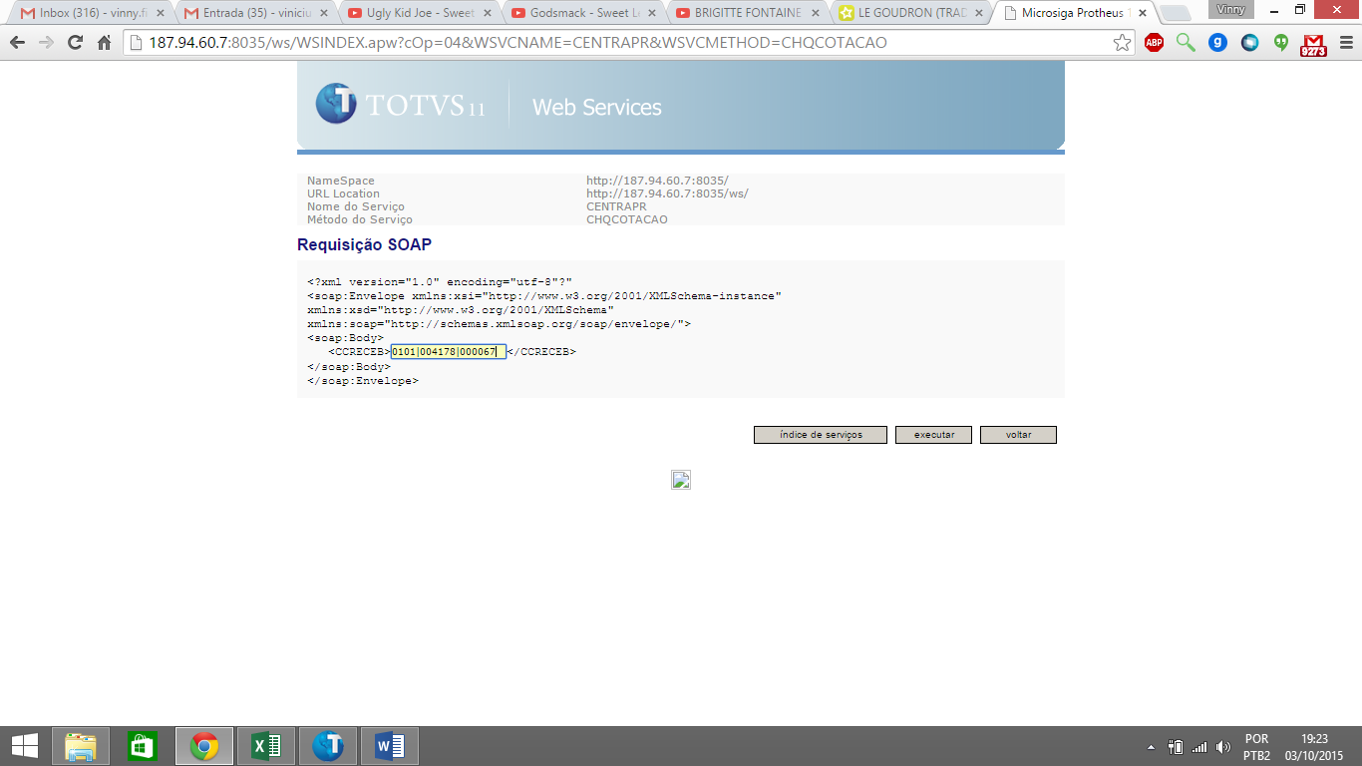

|  |  |  |  |  |  |  |  |  |  |  |  |  |  |  |  |
| --- | --- | --- | --- | --- | --- | --- | --- | --- | --- | --- | --- | --- | --- | --- | --- |
| |  |  |  | | --- | --- | --- | | **Resposta da Requisição SOAP** | | | | http://187.94.60.7:8035/ws/images/transparente.gif | | | | http://187.94.60.7:8035/ws/images/transparente.gif | |  | |  | <soap:Envelope xmlns:xsi="http://www.w3.org/2001/XMLSchema-instance"  xmlns:xsd="http://www.w3.org/2001/XMLSchema"  xmlns:soap="http://schemas.xmlsoap.org/soap/envelope/">  <soap:Body>  <CHQCOTACAORESPONSE xmlns="http://187.94.60.7:8035/">  <CHQCOTACAORESULT>  <CAPROVADOR>**Leonardo de Jesus Freire**</CAPROVADOR>  <CCC>**82206**</CCC>  <CCOMPRADOR>**033 - Fabio Flores Regueira**</CCOMPRADOR>  <CDTENV>**20150811 11:59:06**</CDTENV>  <CDTVAL>**20150825**</CDTVAL>  <CFIL>**0101**</CFIL>  <CNUMCOT>**004178**</CNUMCOT>  <COBS>  </COBS>  <COBSCOMP>**verificar se a cotaÃ§Ã£o na central de aprovaÃ§Ã£o possui o campo frete e verificar se o mesmo foi informado.TESTE**</COBSCOMP>  <CSOLIC>**Fabio Flores Regueira**</CSOLIC>  <FORN>  <LISTFORN>  <FORNECEDOR>  <CCODIGO>**000148/01 - INGRAM MICRO**</CCODIGO>  <CCONDPAG>**004 - A VISTA**</CCONDPAG>  <CCONTATO>**TST** </CCONTATO>  <CNOTA>**0**</CNOTA>  <CPRAZO>**1**</CPRAZO>  <CRANKING>  </CRANKING>  <CUF>**SP**</CUF>  <NFRETE>**5.00000000**</NFRETE>  <NICMS>**0.00000000**</NICMS>  <NIPI>**0.00000000**</NIPI>  <NTOTAL>**15.00000000**</NTOTAL>  </FORNECEDOR>  <FORNECEDOR>  <CCODIGO>**000200/01 - OFFICER**</CCODIGO>  <CCONDPAG>**004 - A VISTA**</CCONDPAG>  <CCONTATO>**TST** </CCONTATO>  <CNOTA>**0**</CNOTA>  <CPRAZO>**2**</CPRAZO>  <CRANKING>  </CRANKING>  <CUF>**PR**</CUF>  <NFRETE>**3.00000000**</NFRETE>  <NICMS>**0.00000000**</NICMS>  <NIPI>**0.00000000**</NIPI>  <NTOTAL>**18.00000000**</NTOTAL>  </FORNECEDOR>  <FORNECEDOR>  <CCODIGO>**001291/01 - LENOVO**</CCODIGO>  <CCONDPAG>**004 - A VISTA**</CCONDPAG>  <CCONTATO>**TST** </CCONTATO>  <CNOTA>**0**</CNOTA>  <CPRAZO>**1**</CPRAZO>  <CRANKING>  </CRANKING>  <CUF>**SP**</CUF>  <NFRETE>**5.00000000**</NFRETE>  <NICMS>**0.00000000**</NICMS>  <NIPI>**0.00000000**</NIPI>  <NTOTAL>**16.00000000**</NTOTAL>  </FORNECEDOR>  </LISTFORN>  </FORN>  <ITENSCOT>  <LISTITEMCOT>  <ITEMCOT>  <CDESC>**TECLADO USB LENOVO**</CDESC>  <CFORN1>**000148/01 - INGRAM MICRO**</CFORN1>  <CFORN2>**000200/01 - OFFICER**</CFORN2>  <CFORN3>**001291/01 - LENOVO**</CFORN3>  <CFORN4>  </CFORN4>  <CFORN5>  </CFORN5>  <CITEM>**0001**</CITEM>  <CUM>**UN**</CUM>  <NPRCUN1>**10.00000000**</NPRCUN1>  <NPRCUN2>**15.00000000**</NPRCUN2>  <NPRCUN3>**11.00000000**</NPRCUN3>  <NPRCUN4>**0.00000000**</NPRCUN4>  <NPRCUN5>**0.00000000**</NPRCUN5>  <NQTD>**1.00000000**</NQTD>  </ITEMCOT>  </LISTITEMCOT>  </ITENSCOT>  <RANK>  <LISTRANKING>  <RANKING>  <CAPROVADOR>  </CAPROVADOR>  <COBS>  </COBS>  <CPRIMEIRO>  </CPRIMEIRO>  <CQUARTO>  </CQUARTO>  <CQUINTO>  </CQUINTO>  <CSEGUNDO>  </CSEGUNDO>  <CTERCEIRO>  </CTERCEIRO>  </RANKING>  </LISTRANKING>  </RANK>  </CHQCOTACAORESULT>  </CHQCOTACAORESPONSE>  </soap:Body>  </soap:Envelope> |  | | http://187.94.60.7:8035/ws/images/transparente.gif | |  | |
|  |

**CHQPEDCOM**

|  |  |  |  |  |  |  |  |  |  |  |  |  |  |  |  |
| --- | --- | --- | --- | --- | --- | --- | --- | --- | --- | --- | --- | --- | --- | --- | --- |
| |  |  |  | | --- | --- | --- | | **Requisição SOAP** | | | | http://187.94.60.7:8035/ws/images/transparente.gif | | | | http://187.94.60.7:8035/ws/images/transparente.gif | |  | |  | Parte superior do formulário  <?xml version="1.0" encoding="utf-8"?"  <soap:Envelope xmlns:xsi="http://www.w3.org/2001/XMLSchema-instance"  xmlns:xsd="http://www.w3.org/2001/XMLSchema"  xmlns:soap="http://schemas.xmlsoap.org/soap/envelope/">  <soap:Body>  <CRECEB>**STRING**</CRECEB>  </soap:Body>  </soap:Envelope>  Parte inferior do formulário |  | | http://187.94.60.7:8035/ws/images/transparente.gifhttp://187.94.60.7:8035/ws/images/transparente.gif CSTRING : String contendo os parâmetros para uso do serviço delimitado por pipe ‘|’  Código Empresa Filial | Código da cotação | Código Usuário | |  | |
| |  |  |  | | --- | --- | --- | | http://187.94.60.7:8035/ws/images/transparente.gif | | | | **Resposta da Requisição SOAP** | | | | http://187.94.60.7:8035/ws/images/transparente.gif | | | | http://187.94.60.7:8035/ws/images/transparente.gif | |  | |  | Parte superior do formulário  <?xml version="1.0" encoding="utf-8"?"  <soap:Envelope xmlns:xsi="http://www.w3.org/2001/XMLSchema-instance"  xmlns:xsd="http://www.w3.org/2001/XMLSchema"  xmlns:soap="http://schemas.xmlsoap.org/soap/envelope/">  <soap:Body>  <PEDCOM>  <APROVS>  <LISTAPROV>  <APROV>  <CAPROVADOR>**STRING**</CAPROVADOR>  <CDTLIB>**STRING**</CDTLIB>  <CNOME>**STRING**</CNOME>  <COBSLIB>**STRING**</COBSLIB>  <CSTATUS>**STRING**</CSTATUS>  </APROV>  *<APROV>*  *<CAPROVADOR>****STRING****</CAPROVADOR>*  *<CDTLIB>****STRING****</CDTLIB>*  *<CNOME>****STRING****</CNOME>*  *<COBSLIB>****STRING****</COBSLIB>*  *<CSTATUS>****STRING****</CSTATUS>*  *</APROV>*  </LISTAPROV>  </APROVS>  <CCC>**STRING**</CCC>  <CCOMPRADOR>**STRING**</CCOMPRADOR>  <CCONDPAG>**STRING**</CCONDPAG>  <CDESCCC>**STRING**</CDESCCC>  <CDTPREV>**STRING**</CDTPREV>  <CFIL>**STRING**</CFIL>  <CFORNECEDOR>**STRING**</CFORNECEDOR>  <CNUMCOT>**STRING**</CNUMCOT>  <CNUMPC>**STRING**</CNUMPC>  <COBSAPR>**STRING**</COBSAPR>  <COBSCOMP>**STRING**</COBSCOMP>  <ITENS>  <LISTITEMPC>  <ITEMPC>  <CCODPROD>**STRING**</CCODPROD>  <CDESC>**STRING**</CDESC>  <CDTULCOM>**STRING**</CDTULCOM>  <CITEM>**STRING**</CITEM>  <CUM>**STRING**</CUM>  <NPRCUN>**FLOAT**</NPRCUN>  <NQTD>**FLOAT**</NQTD>  <NTOTAL>**FLOAT**</NTOTAL>  <NTULTCOM>**FLOAT**</NTULTCOM>  </ITEMPC>  *<ITEMPC>*  *<CCODPROD>****STRING****</CCODPROD>*  *<CDESC>****STRING****</CDESC>*  *<CDTULCOM>****STRING****</CDTULCOM>*  *<CITEM>****STRING****</CITEM>*  *<CUM>****STRING****</CUM>*  *<NPRCUN>****FLOAT****</NPRCUN>*  *<NQTD>****FLOAT****</NQTD>*  *<NTOTAL>****FLOAT****</NTOTAL>*  *<NTULTCOM>****FLOAT****</NTULTCOM>*  *</ITEMPC>*  </LISTITEMPC>  </ITENS>  <NTOTAL>**FLOAT**</NTOTAL>  <NVALACU>**FLOAT**</NVALACU>  </PEDCOM>  </soap:Body>  </soap:Envelope>  Parte inferior do formulário |  | |

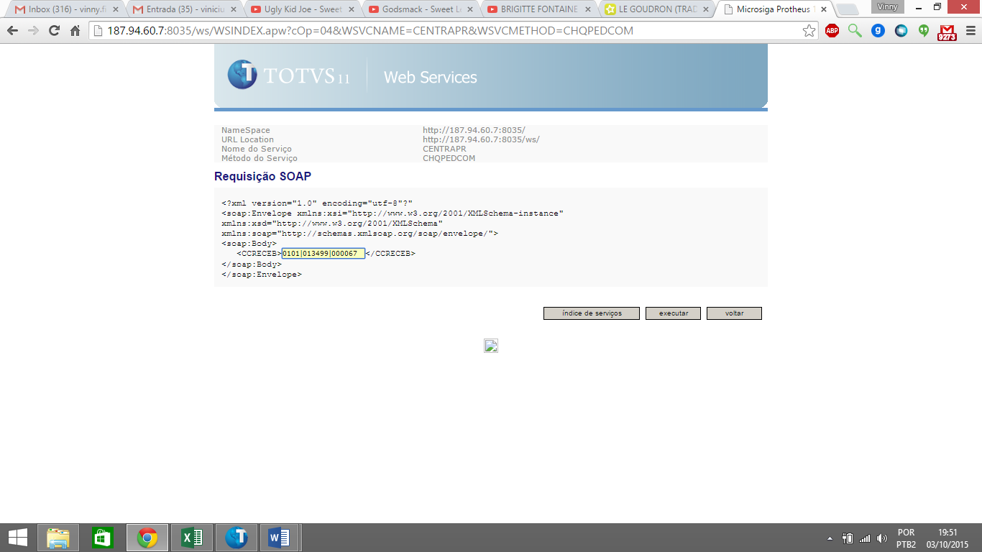

|  |  |  |  |  |  |  |  |  |  |  |  |  |  |  |  |
| --- | --- | --- | --- | --- | --- | --- | --- | --- | --- | --- | --- | --- | --- | --- | --- |
| |  |  |  | | --- | --- | --- | | **Resposta da Requisição SOAP** | | | | http://187.94.60.7:8035/ws/images/transparente.gif | | | | http://187.94.60.7:8035/ws/images/transparente.gif | |  | |  | <soap:Envelope xmlns:xsi="http://www.w3.org/2001/XMLSchema-instance"  xmlns:xsd="http://www.w3.org/2001/XMLSchema"  xmlns:soap="http://schemas.xmlsoap.org/soap/envelope/">  <soap:Body>  <CHQPEDCOMRESPONSE xmlns="http://187.94.60.7:8035/">  <CHQPEDCOMRESULT>  <APROVS>  <LISTAPROV>  <APROV>  <CAPROVADOR>**000100**</CAPROVADOR>  <CDTLIB>**20150819**</CDTLIB>  <CNOME>**Leonardo de Jesus Freire**</CNOME>  <COBSLIB>**TESTANDO A OBSERVACAO QUE APARECER PRO NIVEL 02**</COBSLIB>  <CSTATUS>**LIBERADO**</CSTATUS>  </APROV>  <APROV>  <CAPROVADOR>**000063**</CAPROVADOR>  <CDTLIB>**20150819**</CDTLIB>  <CNOME>**Alexandre Varanda**</CNOME>  <COBSLIB>  </COBSLIB>  <CSTATUS>**LIBERADO**</CSTATUS>  </APROV>  </LISTAPROV>  </APROVS>  <CCC>**82206** </CCC>  <CCOMPRADOR>**049 - Vinicius Figueiredo (Do-IT)**</CCOMPRADOR>  <CCONDPAG>**004 - A VISTA**</CCONDPAG>  <CDESCCC>**TECNOLOGIA DA INFORMACAO**</CDESCCC>  <CDTPREV>**20150819**</CDTPREV>  <CFIL>**0101**</CFIL>  <CFORNECEDOR>**000011/01 - SUPRIWEB COMERCIO E SERVICOS DE INFORMAT** </CFORNECEDOR>  <CNUMCOT></CNUMCOT>  <CNUMPC>**013499**</CNUMPC>  <COBSAPR>  </COBSAPR>  <COBSCOMP>**RETESTE 13499 PC** </COBSCOMP>  <ITENS>  <LISTITEMPC>  <ITEMPC>  <CCODPROD>**000000000002843**</CCODPROD>  <CDESC>**SERVIDOR DE REDE IBM X3200**</CDESC>  <CDTULCOM>**20141017**</CDTULCOM>  <CITEM>**0001**</CITEM>  <CUM>**UN**</CUM>  <NPRCUN>**60000.00000000**</NPRCUN>  <NQTD>**2.00000000**</NQTD>  <NTOTAL>**120000.00000000**</NTOTAL>  <NTULTCOM>**22137.76000000**</NTULTCOM>  </ITEMPC>  </LISTITEMPC>  </ITENS>  <NTOTAL>**120000.00000000**</NTOTAL>  <NVALACU>**186340.00000000**</NVALACU>  </CHQPEDCOMRESULT>  </CHQPEDCOMRESPONSE>  </soap:Body>  </soap:Envelope> |  | | http://187.94.60.7:8035/ws/images/transparente.gif | |  | |
|  |