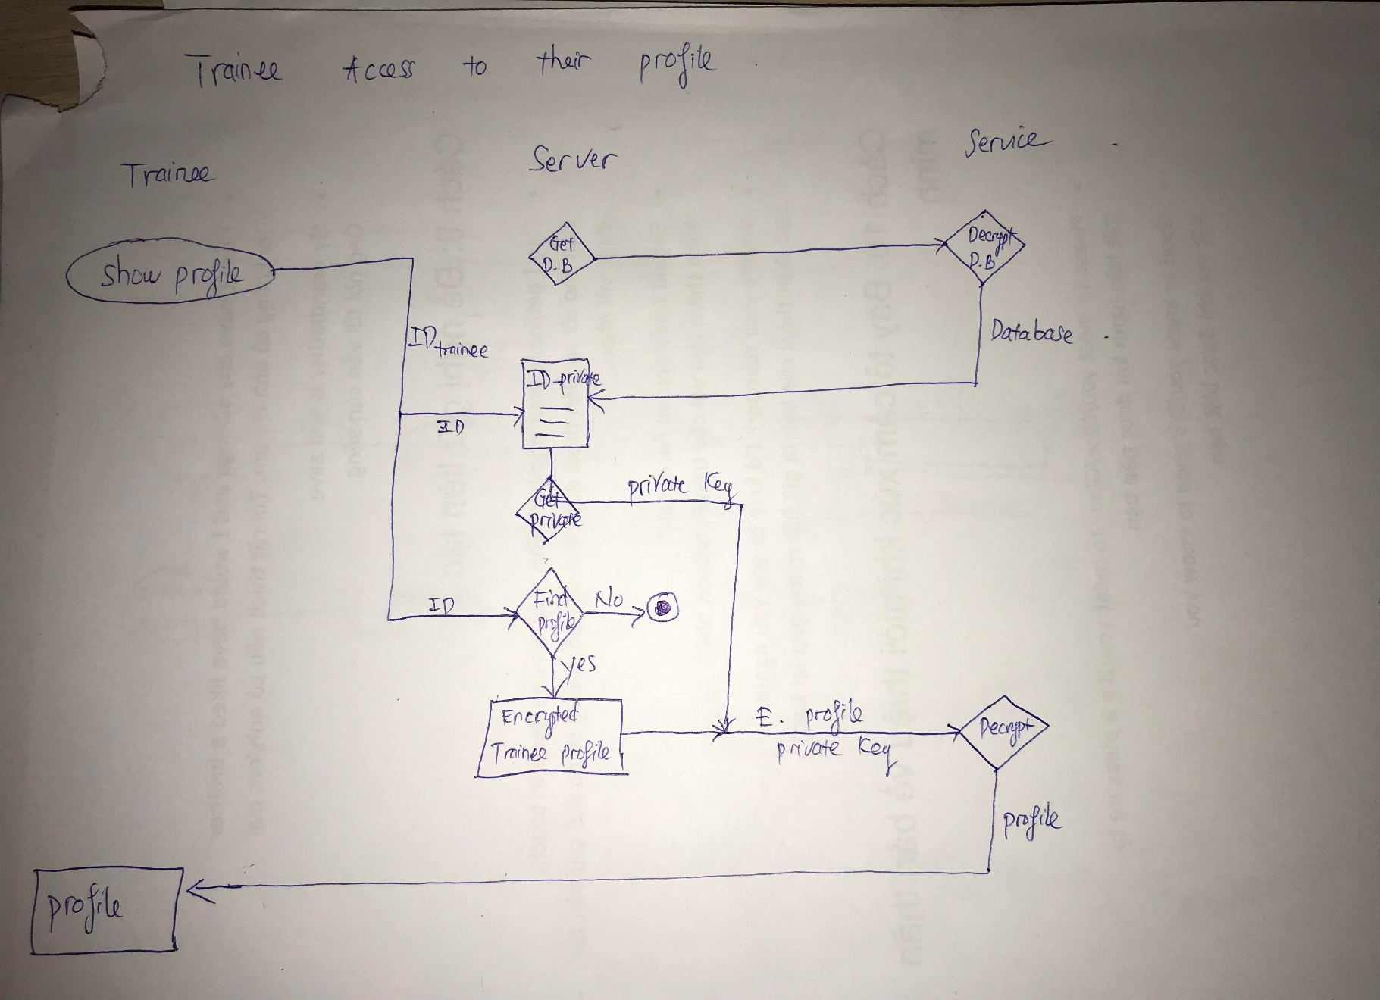

1. Trainee clicks show the profile on their phones.
2. The server will call a decryption function from external service to decrypt and get the database containing ID of the trainee and their private key used for decrypting their profile
3. Then the server will take the ID trainee to look for its private key
4. Next step, the server will find the trainee’s encrypted profile. The system checks and if it is match with the trainees ID, it will return their encrypted profile
5. Combining Private key and encrypted profile, the server will call external service to decrypt the profile and then send it to the trainee’s phone screen.

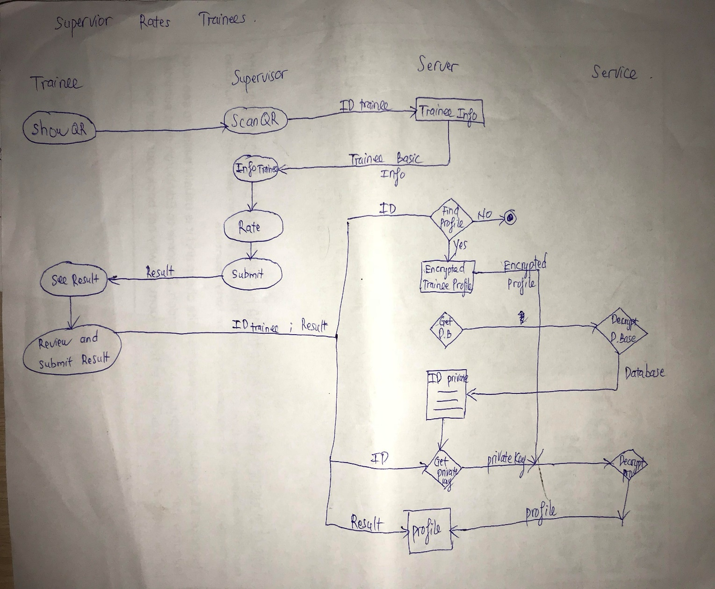

1. Trainee shows their QR code to the supervisor to scan
2. After scanning the trainee QR code, the system will take the trainee ID to send back some basic information of the trainee to the supervisor.
3. Then the supervisor will rate the trainee task has done and click submit
4. The result will send to the trainee for a final review.
5. After reviewing, the trainee agrees the rating and clicks submit in order to send the rating to their profile
6. The system takes the ID to find the encrypted profile of the trainee.
7. Then the system gets the database from external service. The external service decrypts the database and send it back to the server.
8. The system now takes the trainee ID to get the private key from the database
9. Combining private key and encrypted profile, the server will call a decryption function from external service to decrypt the profile
10. Now the system will store the result into the trainee’s profile