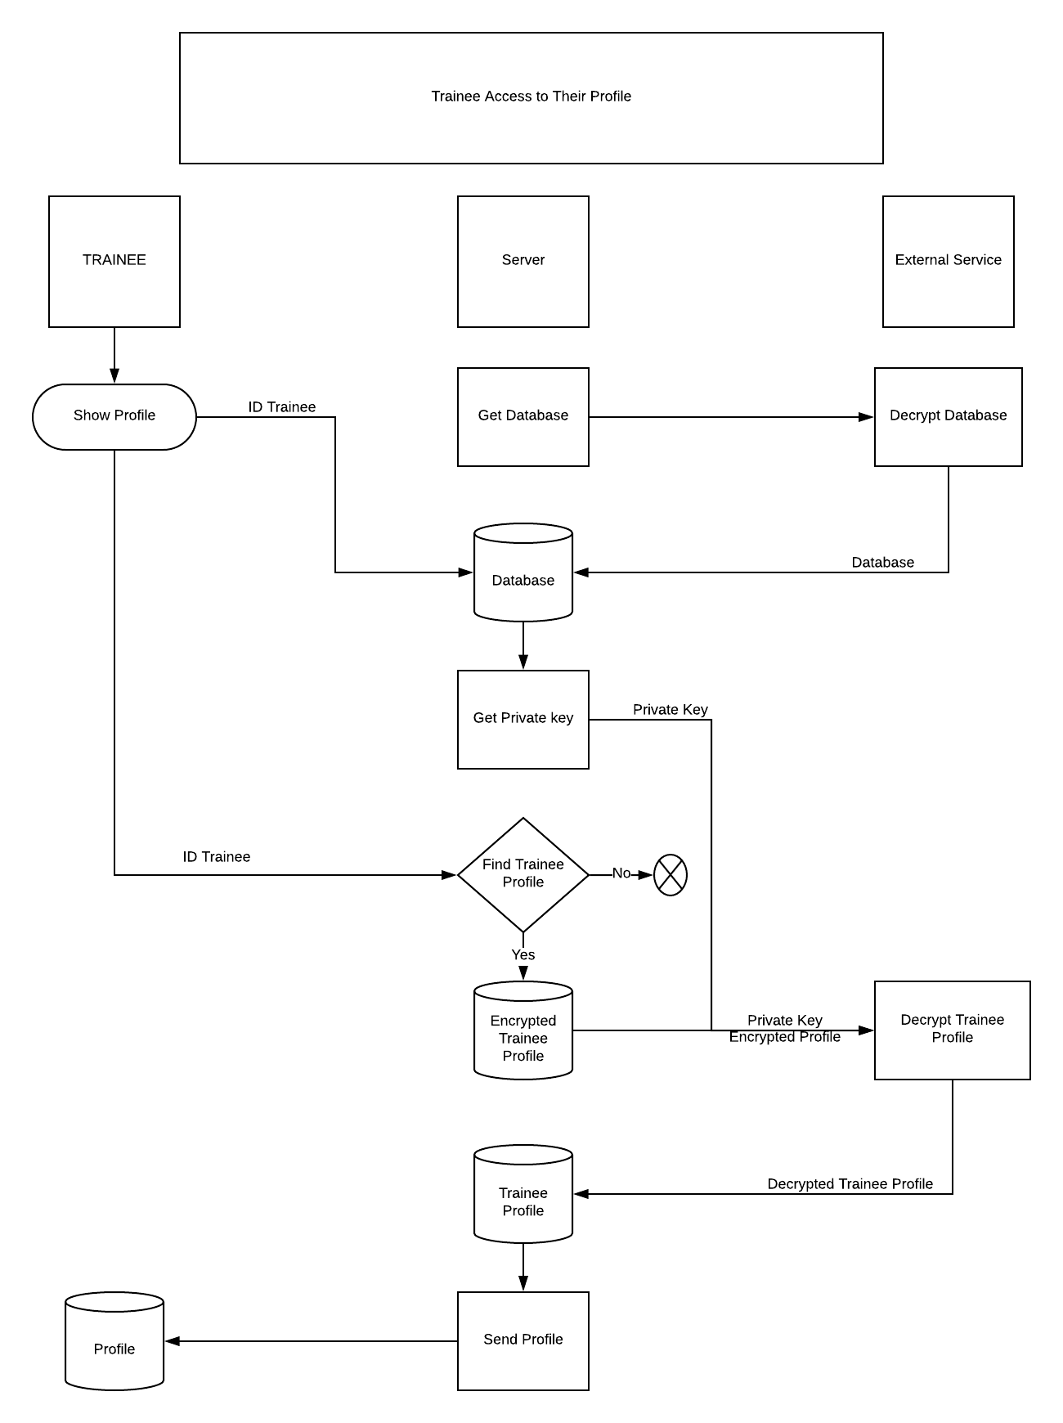

1. Trainee clicks show the profile on their phones.
2. The server will call a decryption function from external service to decrypt and get the database containing ID of the trainee and their private key used for decrypting their profile
3. Then the server will take the ID trainee to look for its private key
4. Next step, the server will find the trainee’s encrypted profile. The system checks and if it is match with the trainees ID, it will return their encrypted profile. If not, it will report problem.
5. Combining Private key and encrypted profile, the server will call external service to decrypt the profile and then send it to the trainee’s phone screen.

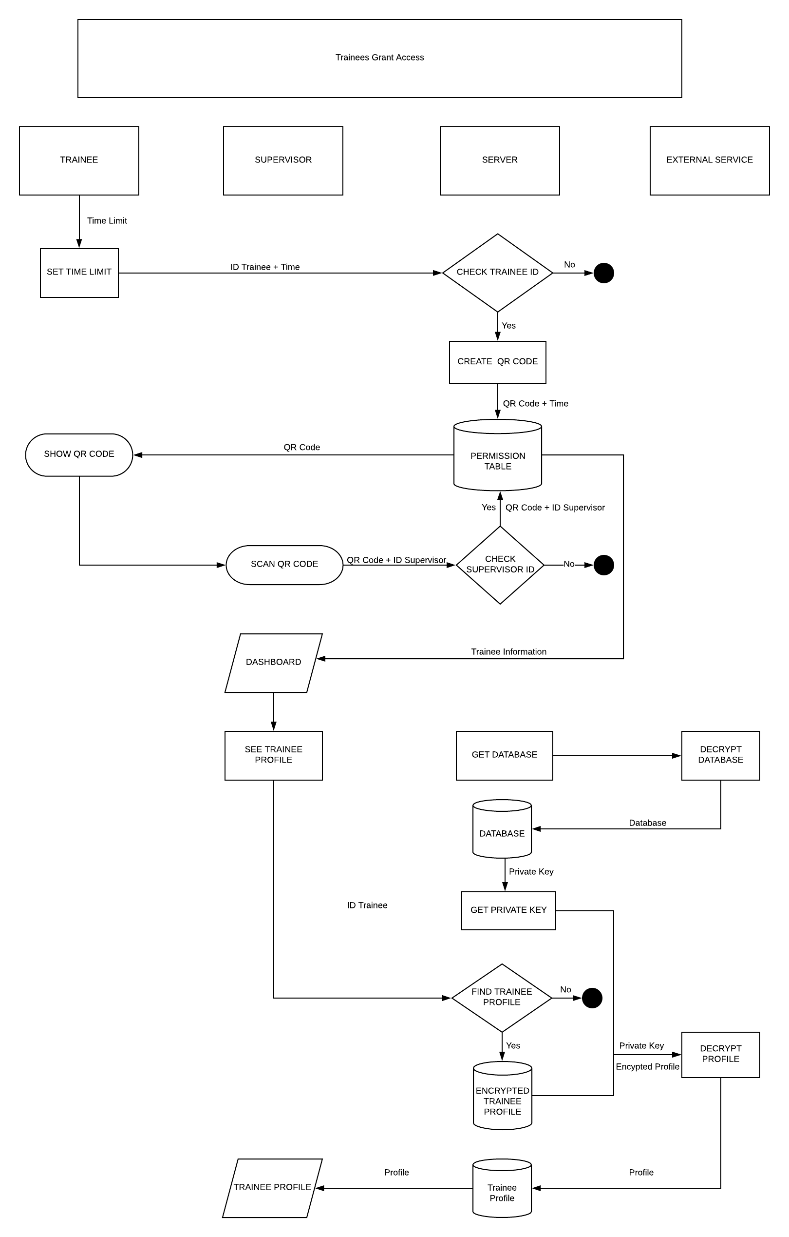

1. Trainees give permission to their supervisor to access their profile. Firstly, trainees will set the limited time to access their profile.
2. The system will check the ID trainee and then creates a QR code so that the supervisor can scan it.
3. The QR code created and the time set will go to the permission table. Then the system will send that QR code created to trainee to show that to their supervisor to scan.
4. After scanning the QR code, the system will take the QR code that has been scanned and the ID of supervisor to check if it is the supervisor. If yes, the QR code and ID of supervisor who scanned will go to the permission table which means that supervisor now is authorized to access the trainee’s profile.
5. Meanwhile, the system will show Dashboard to supervisor’s phone screen. Now supervisor is able to access to trainee’s profile by clicking at the trainee they want to see the profile.
6. Now the system will get the database which containing Trainee ID and their private key to open their encrypted profile by decrypting it from external service.
7. And the system will get the private from the returned database
8. Using trainee ID to find their encrypted profile and combine that with the private key. The system then calls decrypting function from external service to decrypt the profile.
9. After decrypting the trainee’s profile, it will return the profile and send that to supervisor’s phone for them to see.

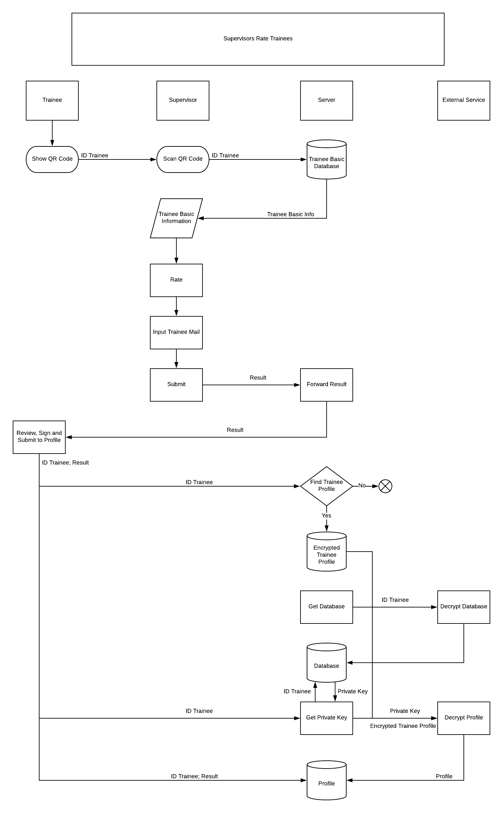

1. Trainee shows their QR code to the supervisor to scan
2. After scanning the trainee QR code, the system will take the trainee ID to send back some basic information of the trainee to the supervisor.
3. Then the supervisor will rate the trainee task has done and fill in the trainee’s mail and click submit
4. The result will send to the trainee’s mail for a final review.
5. After reviewing, the trainee agrees the rating and clicks submit in order to send the rating to their profile
6. The system takes the ID to find the encrypted profile of the trainee.
7. Then the system gets the database from external service. The external service decrypts the database and sends it back to the server.
8. The system now takes the trainee ID to get the private key from the database
9. Combining private key and encrypted profile, the server will call a decryption function from external service to decrypt the profile
10. Now the system will store the result into the trainee’s profile