**PizzaNook House**

**Case Study**

**In Partial Fulfillment of the Requirements of the Subject “System Administration Maintenance”**

By:

Cezar Sadio

Dherwin Ladon

College for Research & Technology

2024

INTRODUCTION

Pizza Nook House was established in 2017 by Mr. Rolando Callo, a resident of Cuyapo, Nueva Ecija. The business started as a small photocopying shop catering to students and professionals in the area. With only one printer and a desktop computer, the shop initially offered basic photocopying, printing, and scanning services.

Over the years, Pizza Nook House expanded its services to include digital printing for tarpaulins, business cards, and invitations, which attracted local businesses and event organizers. The shop also introduced document editing and online submissions to accommodate customers needing assistance with digital documents, particularly during the rise of remote learning and online work during the pandemic.

To keep up with increasing demand and improve operations, Pizza Nook House invested in better equipment and a reliable internet connection. The shop now uses a networked system that supports multiple computers, a WiFi-enabled printer, and an access point for customer use. It has become a go-to hub for printing needs in Cuyapo and continues to grow, driven by its commitment to quality service and affordability.

NETWORK STRUCTURE

Pizza Nook House has a well-organized network structure designed to meet the demands of its operations. At the core of the network is a PLDT Home Fibr modem router, which serves as the gateway to the internet. The router is connected to a TP-Link TL-SF1008D switch, which distributes the network connection to multiple devices. The switch supports three desktop computers used for document editing, design, and general operations.

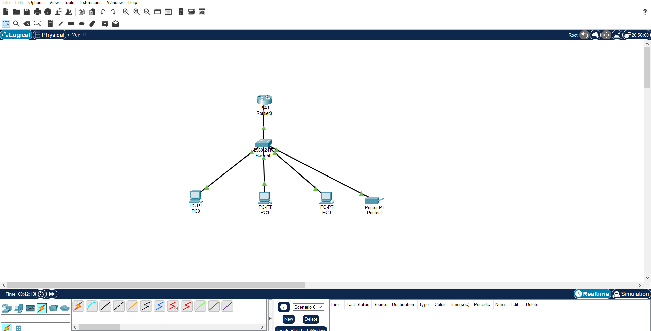Additionally, a WiFi-enabled Epson L3110 printer is part of the network, allowing wireless printing for efficiency and convenience. To provide wireless connectivity for mobile devices and customers, the network includes a TP-Link RE450 wireless access point. This setup ensures that both wired and wireless devices can seamlessly connect to the internet and communicate with each other. The PLDT Home Fibr service, with a 100 Mbps plan, ensures stable and high-speed internet access for the business's daily activities. This network layout provides a robust and efficient system to support Pizza Nook House operations and customer needs.

RECOMMENDATION

1. **Upgrade the Switch**: Replace the TP-Link TL-SF1008D with a gigabit switch to support faster data transfer between devices.
2. **Enhance Network Security**:
   * Install a hardware firewall to protect against external threats.
   * Use WPA3 encryption for WiFi to enhance security for connected devices.
3. **Add a Backup ISP**: Install a secondary internet connection (e.g., Converge ICT) for redundancy in case of outages.