**Group 1**

**Flow Chart of E-Commerce System for Cake**

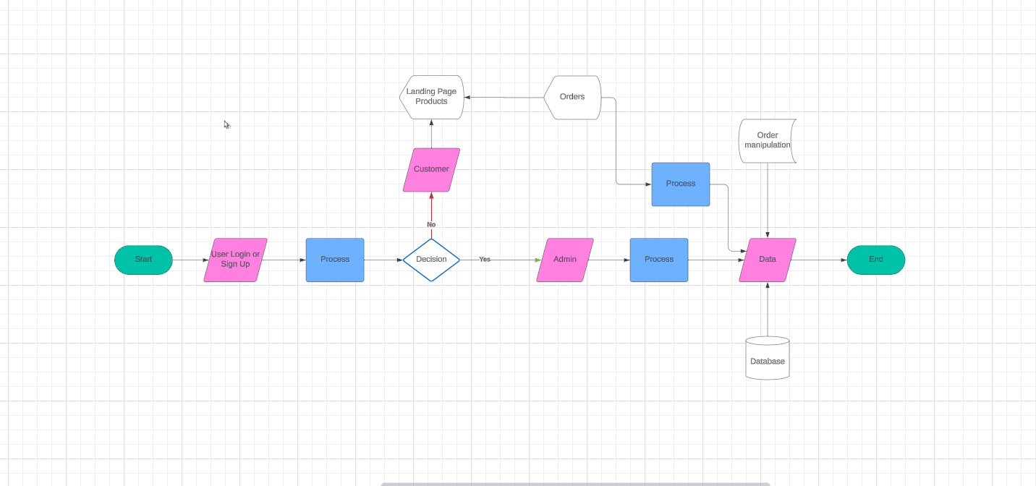

**Members:**

Leomar Abad

Aldrin Cachuela

Fesalonica Exija

Santos Garcia

Angelo Mendoza

Nikka Parungao