Use case Diagram of CareerPath:
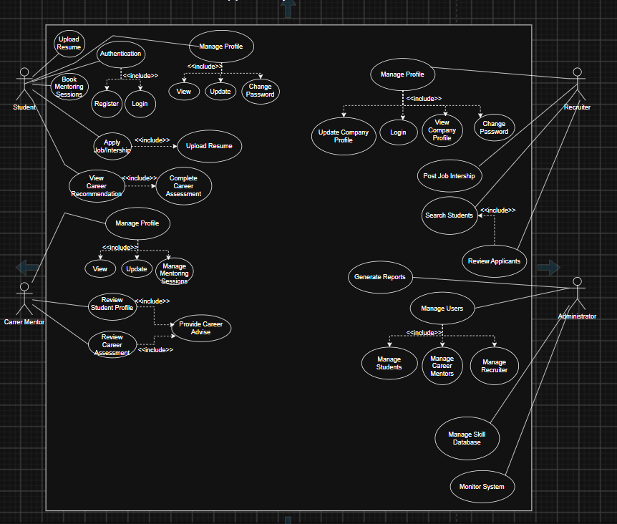

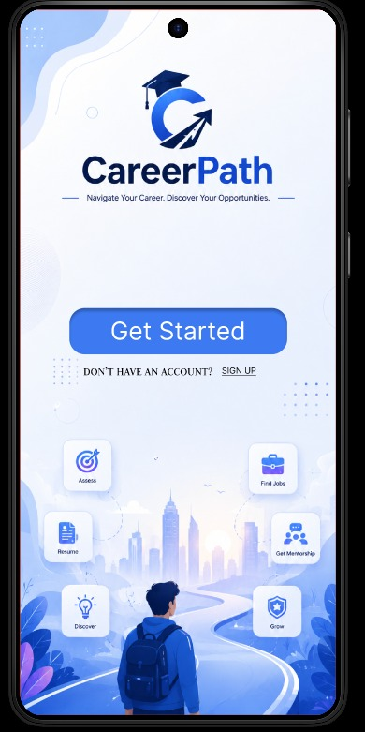
Figma Design :
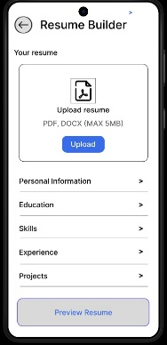
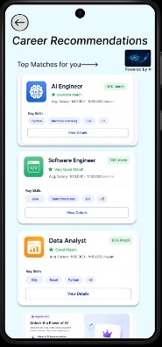
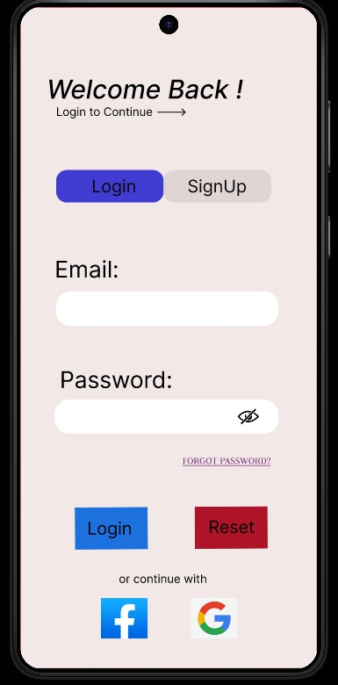
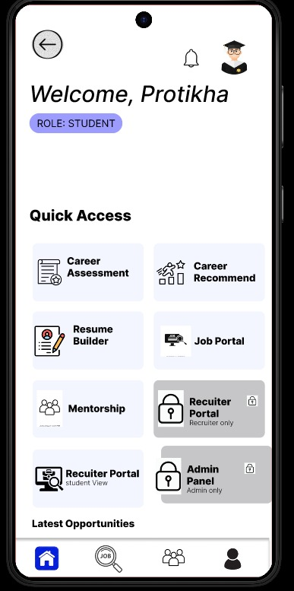
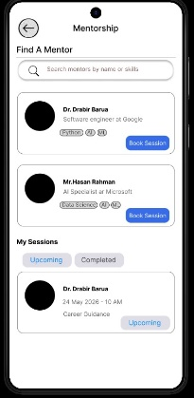
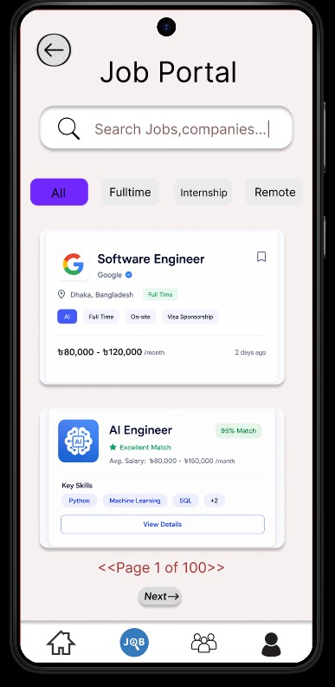
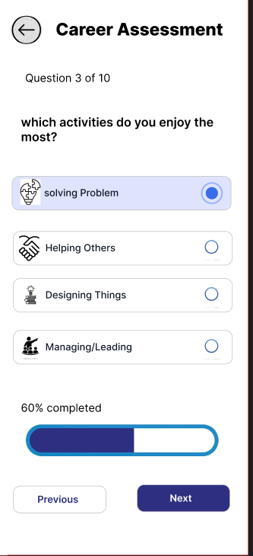
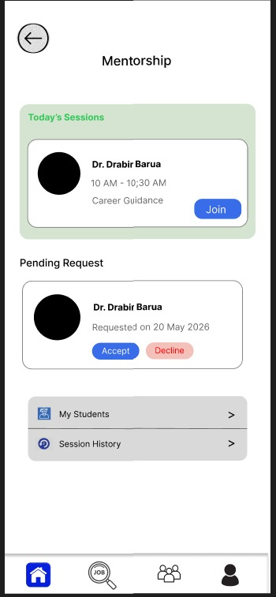
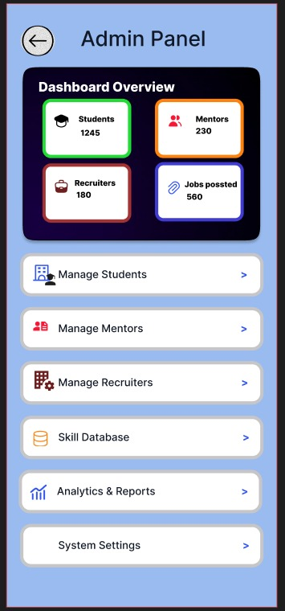

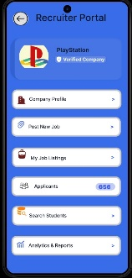
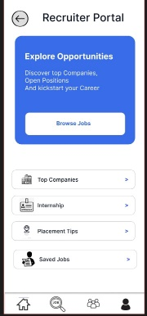
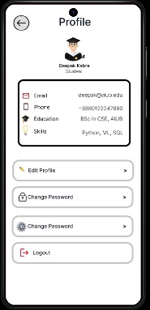

Final Trello Board Screenshot:
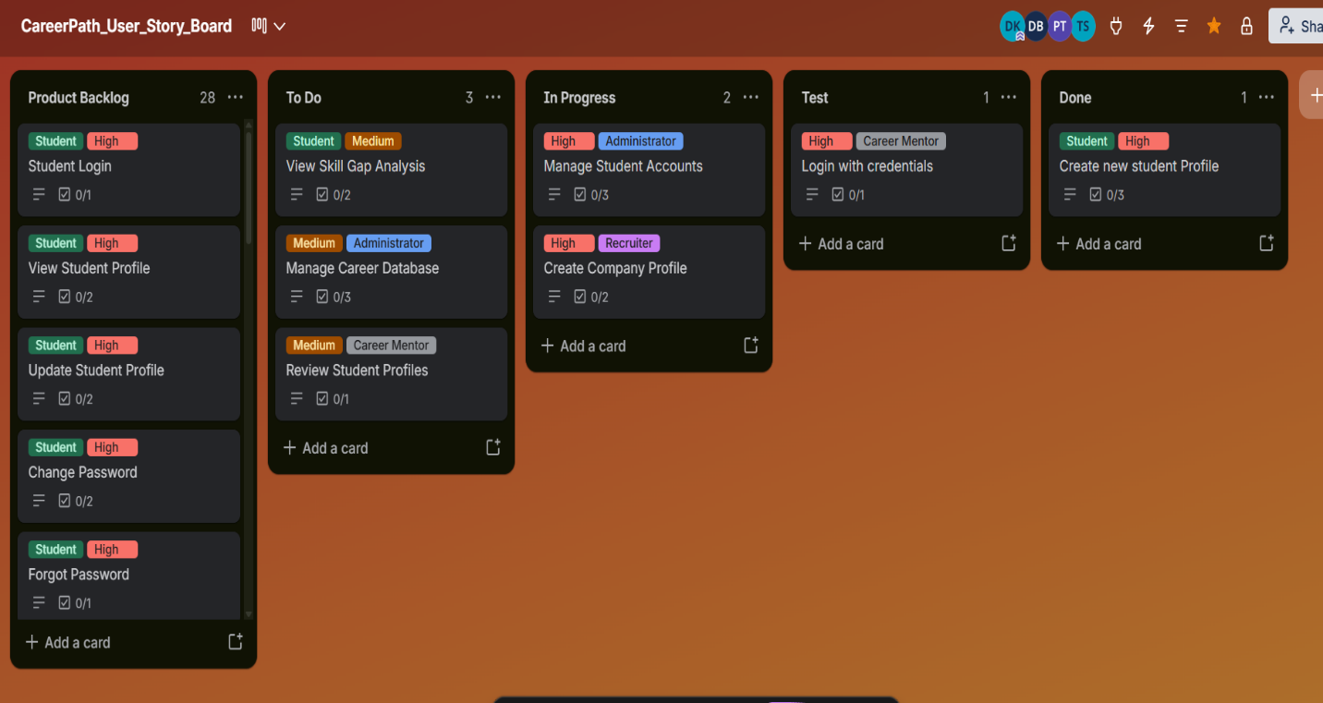

Conclusion
The CareerPath project successfully demonstrates the design and planning of an AI-powered career guidance and recruitment platform aimed at bridging the gap between students, mentors, and recruiters. Through a structured software engineering approach, the project incorporates role-based access control for four distinct user types — Student, Career Mentor, Recruiter, and Administrator — ensuring each user interacts only with features relevant to their role. Key modules such as Career Assessment, Career Recommendation, Resume Builder, Job Portal, Mentorship, and Admin Panel were identified and translated into detailed user stories, functional requirements, and non-functional requirements covering performance, security, usability, and scalability.
The development process followed Scrum methodology, supported by proper requirement analysis, use case modeling, Figma-based UI/UX design, and a well-defined project timeline. These artifacts collectively ensure that the system is technically feasible, user-centered, and aligned with real-world career guidance needs.
Overall, CareerPath lays a strong foundation for a scalable platform capable of helping students make informed career decisions through personalized recommendations and skill-gap analysis, while enabling mentors and recruiters to engage meaningfully with the student community. Future work can extend this foundation into a fully implemented and deployed system.

