Background:
Choosing the right career is one of the most important decisions in a student's life, yet many students make this decision with limited guidance and incomplete information. They often rely on advice from family members, friends, or social media trends instead of understanding their own interests, abilities, personality, and long-term career goals. As a result, students may select academic programs or career paths that do not align with their strengths, leading to dissatisfaction, poor academic performance, reduced motivation, and difficulty securing suitable employment after graduation. CareerPath is proposed as an AI powered career guidance platform that provides personalized career recommendations using data-driven analysis. The system collects information about a user's educational background, skills, interests, personality, projects, certifications, and career preferences to generate suitable career suggestions. It also identifies skill gaps and recommends learning resources, certifications, and development roadmaps that help users prepare for their desired professions. Students also get the opportunity to directly connect with industry leaders and apply for desired job. By providing personalized career guidance, structured learning pathways, and continuous progress tracking, our intelligent system aims to reduce career uncertainty, improve employability, and help students make informed decisions that align with both their personal strengths and current industry demands.

Selected Process Model: Scrum (Agile)
Scrum is an Agile software development process model in which software is developed through short iterations called sprints. Each sprint includes planning, designing, development, testing, review and feedback. This iterative approach helps deliver working software continuously while allowing improvements based on stakeholder feedback.

Scrum Process Visualization

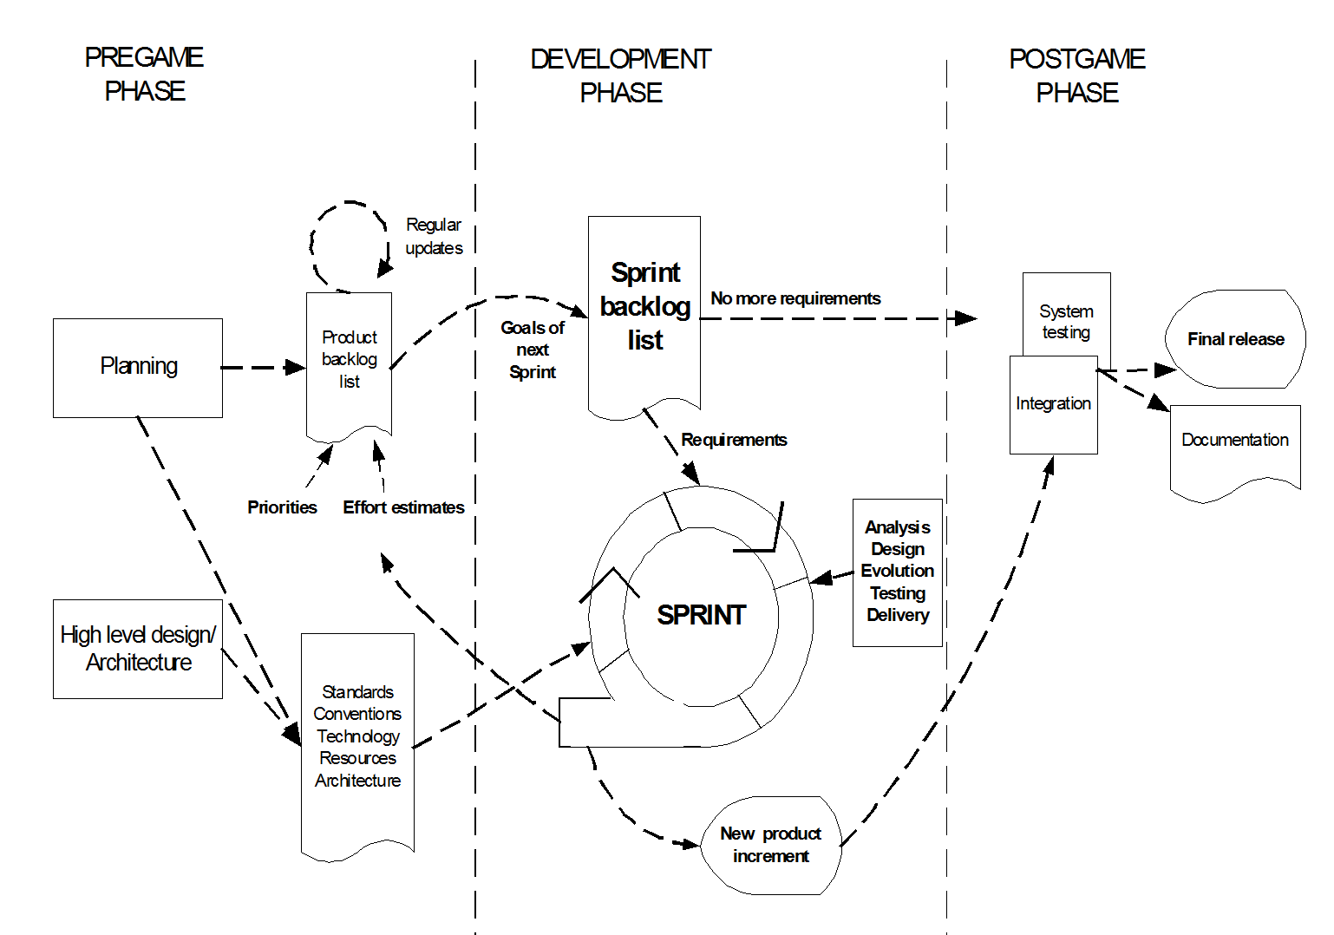
Our CareerPath software contains several independent modules, including Career Assessment, Career Recommendation, Resume Builder, Job Portal, Mentorship, Recruiter Portal, and Admin Panel. These modules must be developed in separate sprints so that there is no scope of any bug or problem during the development process. Scrum supports continuous feedback, frequent testing, flexibility for requirement changes, and better team collaboration, making it the most suitable process model for a module based complex project like CareerPath.

