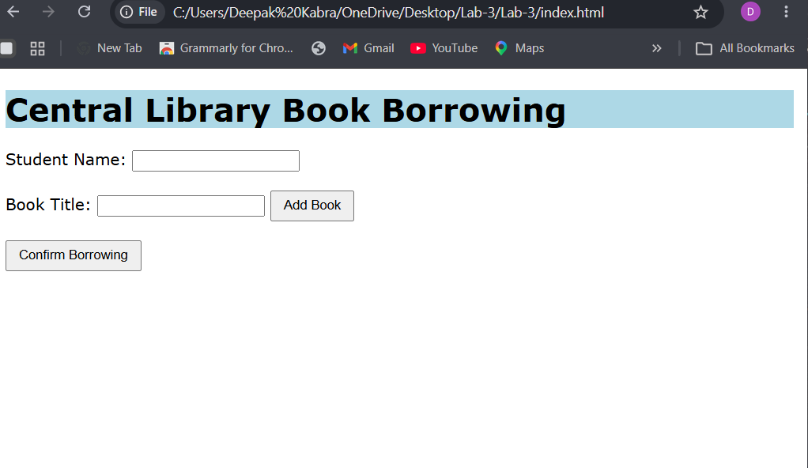
Output 1: Borrow page (initial view)
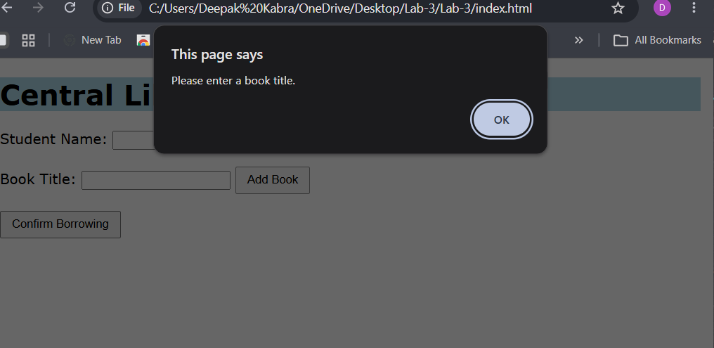
Output 2: Empty book title - "Please enter a book title."
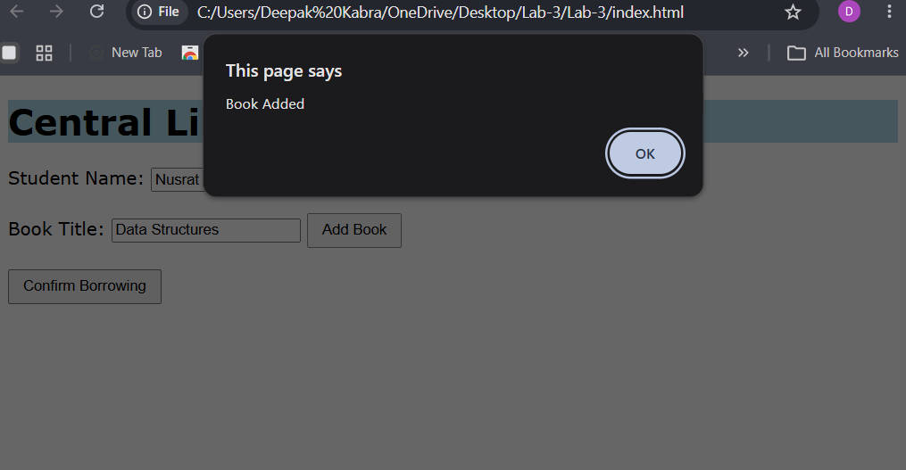
Output 3: Book added - "Book Added"
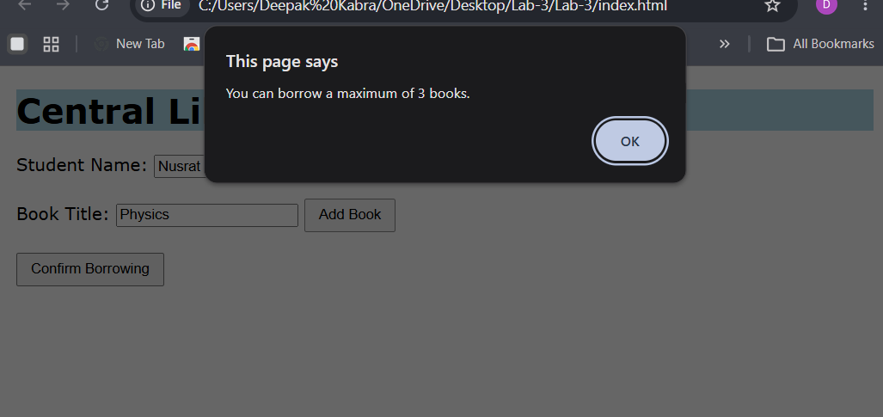
Output 4: Fourth book - "You can borrow a maximum of 3 books."
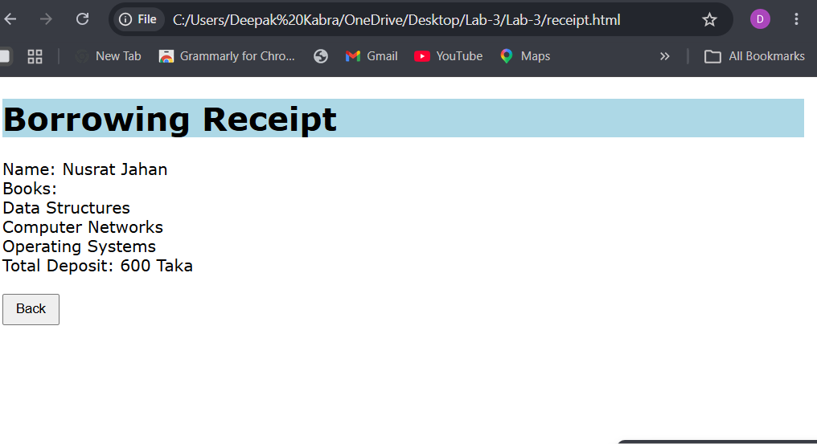
Output 5: Receipt page

