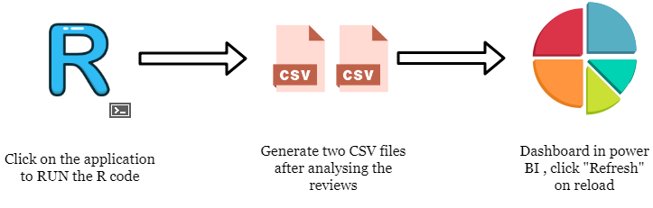

*Sentiment Percentages*

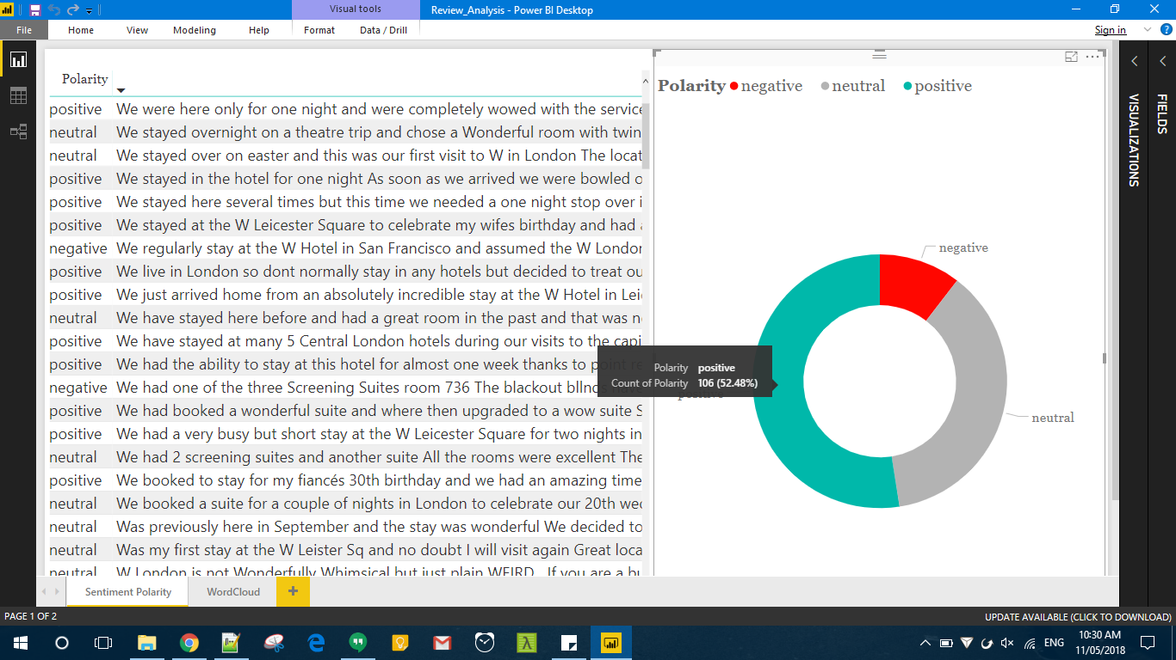

*Wordcloud*

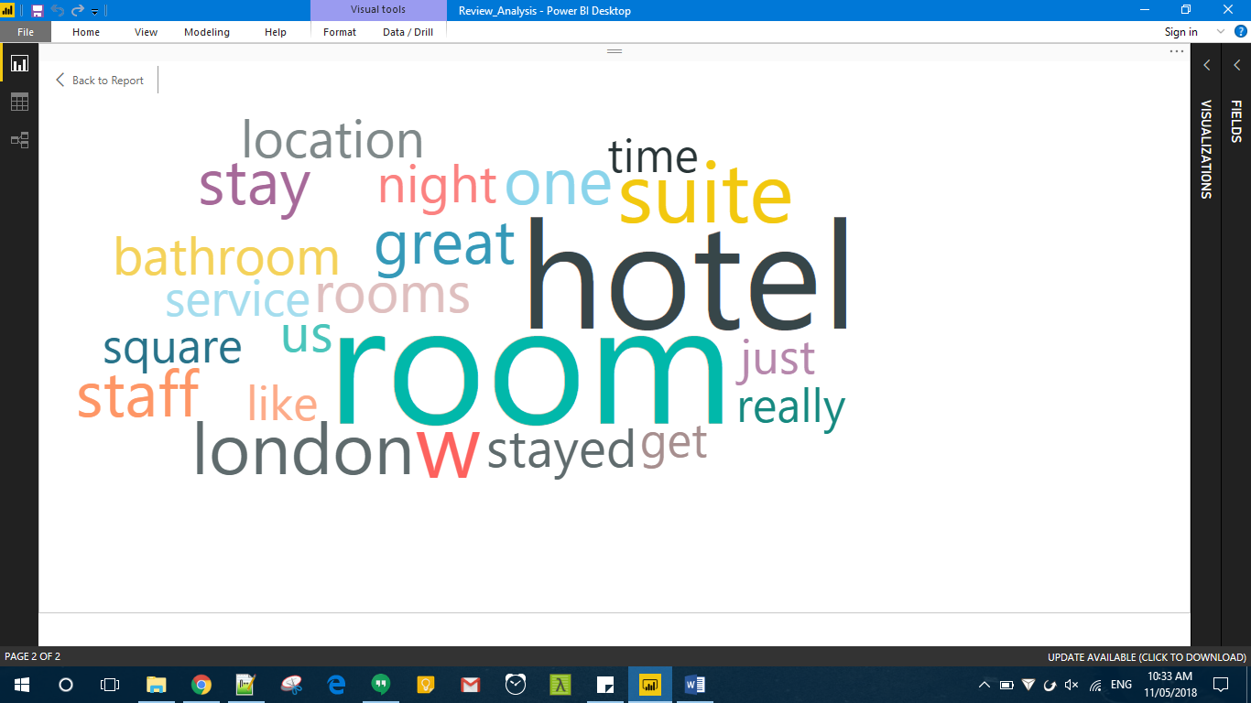

Feedback: deliverable part 2

Heeey!! I am ok, could be better though.. on a beach, tropical destination, drinking some coconut milk ... but it is what it is... how have you been?? I bet you are very busy with work + freelancing..

I looked briefly at the document you sent me and I liked it! Thank you for integrating my feedback into your work!

Guest type & traveler type tabs were really nice.

With the ratings_sentiment I struggled a bit understanding the second overall rating number, but it's certainly interesting!

Pos_neg_word i don't know what to say about the negative top words because i mostly see prepositions, adverbs and doesn't seem insightful..

Top positive reviews really nice! For the top negative reviews I saw that the second one listed at 0.93 is not really negative.. I can see why the algorithm identified it as such, but maybe this is something that I should discuss further in my report when it comes to limitations. Because I am sure that there are many reviews that contains double negation, subtle comments, ironies, inverted word orders etc. that affect the outcomes. Also, there are many spelling errors. Should I go over the reviews one more time and correct them?

Year ratings are also very nice! Please try to work on the geo location. One observation: I have seen that the first value for location is not the city but the title "reviewer origin".

I was also thinking about corellating the device type with polarity.

Also, there are two things that I read online and were pretty inspiring. I don't know if you can actually do it, but it would be really nice if you could give it a try:

1. Intent analysis: I will send you a photo with the example. I think for us it would only be interesting to see the percentage for suggestion, feedback, complaint and opinion.

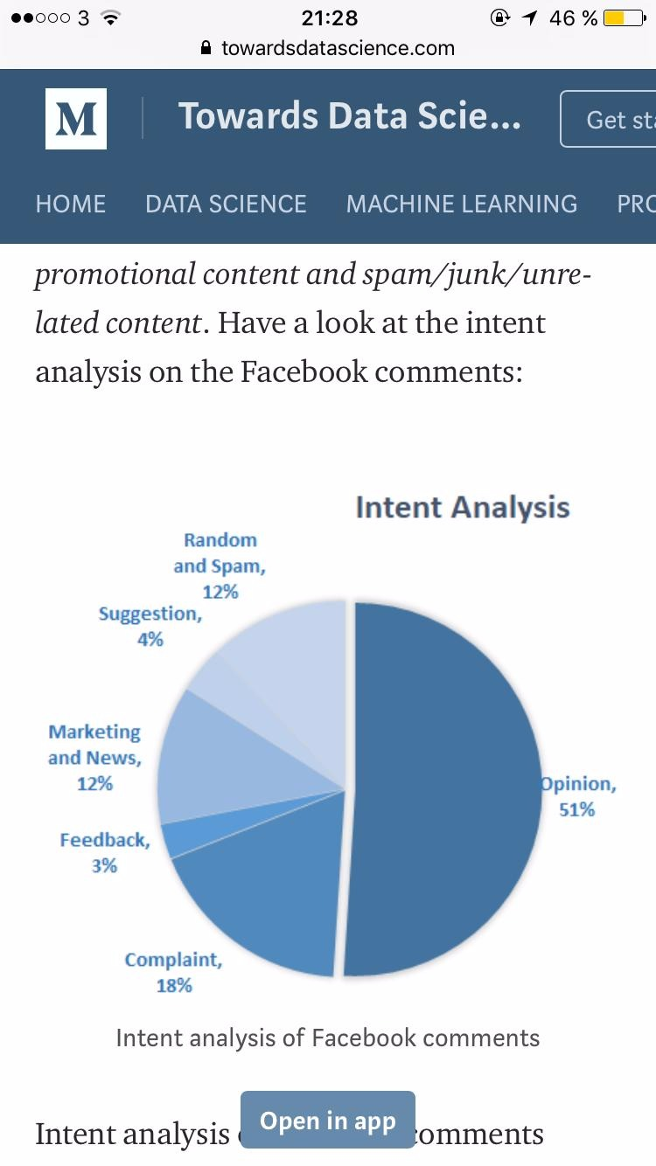

1. This one would be amazing if you could work it out: Content-based filtering (see the sentiment of the reviewers for each individual aspect: location, rooms, clealiness, value etc.) and link it with the individual aspect ratings. See picture below for some inspiration, but i think that it would be really relevant for our reviews.

