Dev.Dhapodkar
24070521505_Dev Dilip Dhapodkar.docx
Quick Submit Quick Submit
Symbiosis International University

Document Details

Submission ID trn:oid:::1:3074812954

6 Pages

2371 Words

15,582 Characters

Submission Date
Oct 29, 2026, 9:30 AM GMT+5:30

Download Date
oct 29, 2026, 9:56 AM GMT+5:30

File Name
24070521505_Dev Dilip Dhapodkar.docx

File Size
2.5 MB

3% Overall Similarity
Thecombinedtotalofallmatches,includingoverlappingsources, for each database.

Filtered from the Report
Bibliography Quoted Text Cited Text
Small Matches (less than 14 words)




Match Groups Top Sources

7 Not Cited or Quoted 3% | 1% | Internet sources
Matches with neither in-text citation nor quotation marks | 1% | Publications
0 Missing Quotations 0%  Matches that are still very similar to source material | 1% | Submitted works (Student Papers)
0 Missing Citation 0%
Matches that have quotation marks, but no in-text citation
0 Cited and Quoted 0%
Matches with in-text citation present, but no quotation marks


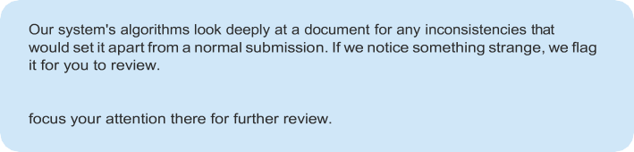
Integrity Flags

A Flag is not necessarily an indicator of a problem. However, we'd recommend you
0 Integrity Flags forReview
No suspicious text manipulations found.




*% detected as AI
The percentage indicates the combined amount of likely AI-generated text as wellas likely AI-generated text that was also likely AI-paraphrased.

Detection Groups
1 AI-generated only *%
Likely AI-generated text from a large-language model.

2 AI-generated text that was AI-paraphrased1%
Likely AI-generated text that was likely revised using an AI-paraphrase tool or word spinner.

Disclaimer
Our AI writing assessment is designed to help educators identify text that might be prepared by a generative AI tool. Our AI writing assessment may not always be accurate (it may misidentify writing that is likely AI generated as AI generated and AI paraphrased or likely AI generated and AI paraphrased writing as only AI generated) so it should not be used as the sole basis for adverse actions against a student. It takes further scrutiny and human judgment in conjunction with an organization's application of its specific academic policies to determine whether any academic misconduct has occurred.

Frequently Asked Questions


Hows hould I interpretTurnitin'sAIwritingpercentageandfalsepositives?
The percentage shown in the AI writing report is the amount of qualifying text within the submission that Turnitin’s AI writing detection model determines was either likely AI-generated text from a large-language model or likely AI-generated text that was likely revised using an AI-paraphrase tool or word spinner.

False positives (incorrectly flagging human-written text as AI-generated) are a possibility in AI models.

AI detection scores under 20%, which we do not surface in new reports, have a higher likelihood of false positives. To reduce the likelihood of misinterpretation, no score or highlights are attributed and are indicated with an asterisk in the report (*%).

The AI writing percentage should not be the sole basis to determine whether misconduct has occurred. The reviewer/instructor should use the percentage as a means to start a formative conversation with their student and/or use it to examine the submitted assignment in accordance with their school's policies.

Whatd oes'qualifyingtext'mean?
Our model only processes qualifying text in the form of long-form writing. Long-form writing means individual sentences contained in paragraphs that make up a longer piece of written work, such as an essay, a dissertation, or an article, etc. Qualifying text that has been determined to be likely AI-generated will be highlighted in cyan in the submission, and likely AI-generated and then likely AI-paraphrased will be highlighted purple.

Non-qualifying text, such as bullet points, annotated bibliographies, etc., will not be processed and can create disparity between the submission highlights and the percentage shown.

