**Graph Theory Term Assignment**

Jaival Chhag 21BCE039

Krisha Darji 21BCE043

Dev Doshi 21BCE064

**Introduction:**

In today's interconnected world, efficient management of airports and airlines is crucial for ensuring smooth travel experiences and optimizing operational efficiency. A graph-based approach offers a powerful framework for modelling the complex network of relationships between airlines, airports, and routes. By representing airports and flights as vertices and edges in a graph, we can leverage graph theory to address various challenges, including flight scheduling, route optimization, and user-centric functionalities. This system aims to integrate both airport-side and user-side functionalities, providing stakeholders with tools for viewing existing flights, scheduling operations, managing runways, and offering passengers dynamic pricing and route optimization options. Through the utilization of graph algorithms and data structures, this system endeavours to enhance decision-making processes, streamline operations, and ultimately improve the overall experience for both airlines and passengers in the aviation industry.

**Problem Definition:**

A graph-based airport and airline management system that encompasses both user-side and airport-side functionalities. This system enables operations such as graph traversal to view existing flights, graph manipulation for scheduling flights and managing runways, and graph analysis for determining shortest paths based on time, cost, and dynamic pricing over a network of vertices representing airlines and airports.

**Algorithm:**

1. Graph Representation: Airports, runways, taxiways, gates, and other facilities within an airport can be represented as nodes in a graph. Connections between these facilities such as taxiways and runways are represented as edges.
2. Network Flow Problems and Congestion Control: Graph theory is used to model flow of resources such as passengers, baggage, fuel, and vehicles within the airport. Max flow algorithms help optimize the flow of these resources through the airport infrastructure.
3. Minimum Spanning Trees (MST): MST algorithms help in designing efficient layouts for airport infrastructure, minimizing the total length of taxiways or communication lines while ensuring connectivity between all facilities.
4. Graph-based Scheduling: Scheduling aircraft arrivals and departures, gate assignments, and maintenance activities involves modeling these tasks as graph-based scheduling problems. Techniques like topological sorting and critical path analysis are used to optimize scheduling.
5. Optimized Transit Connections: For airports with integrated transit systems (e.g., trains, buses), graph theory concepts are used to optimize connections between the airport and surrounding transportation networks. This ensures seamless transfers for passengers traveling to and from the airport.

**Result and Discussion:**

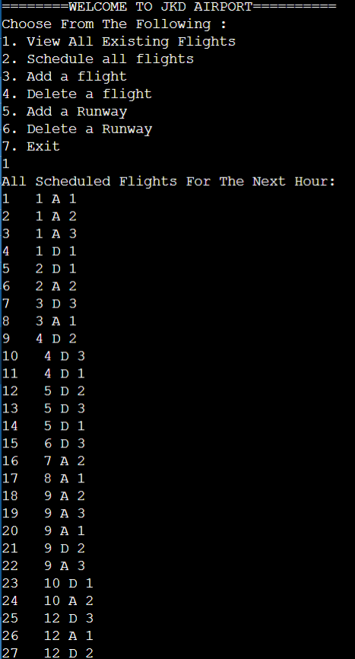

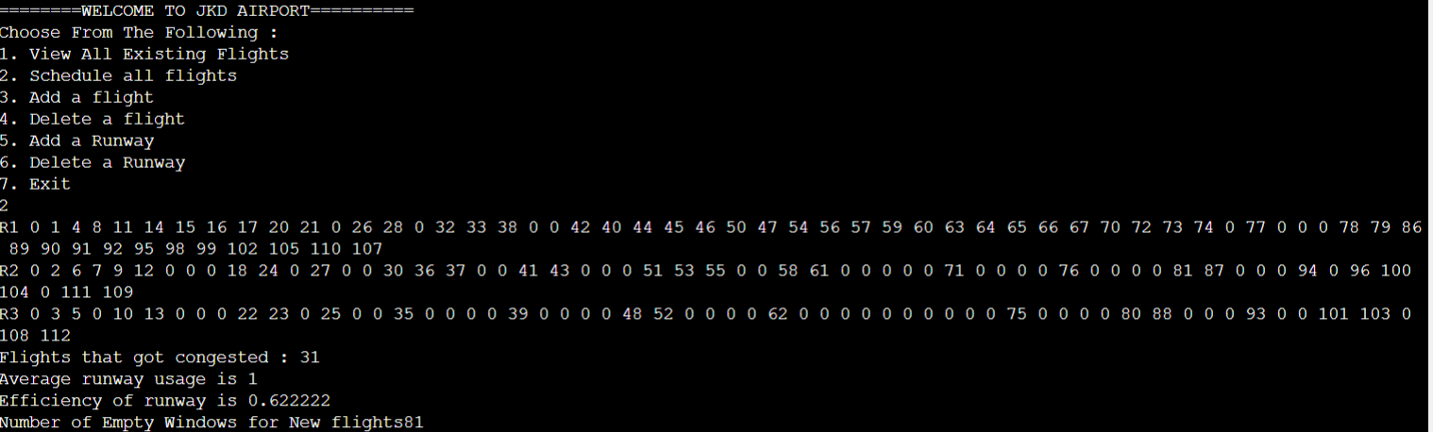

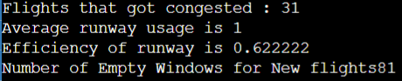

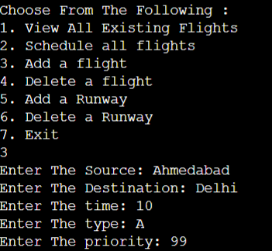



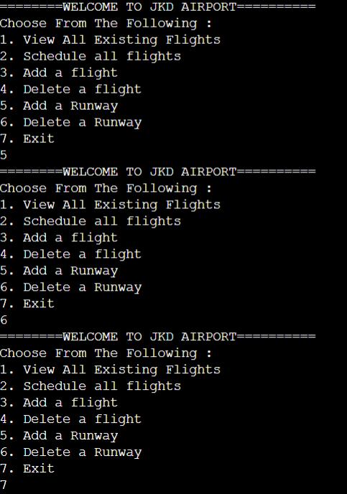

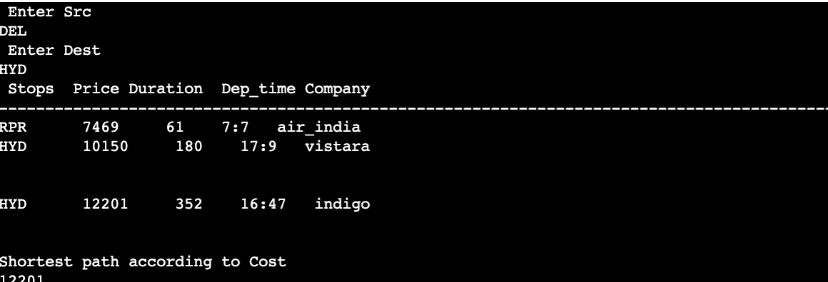

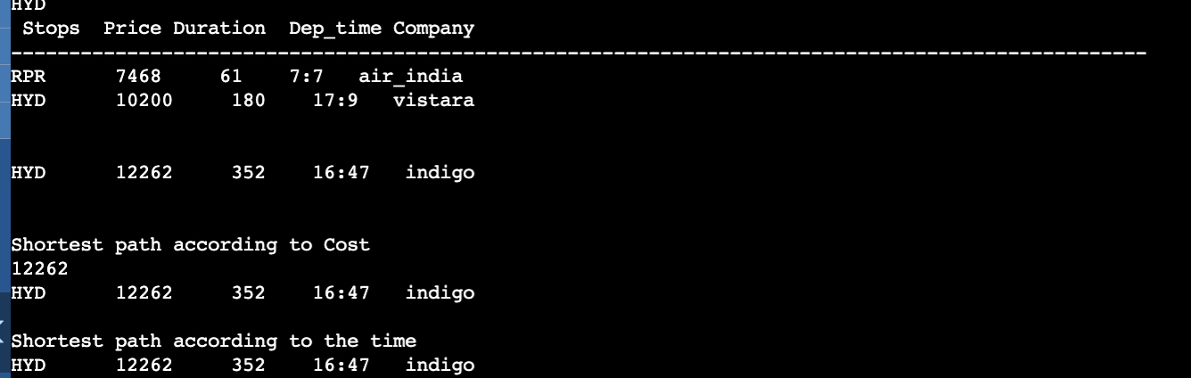

**Limitation:**

The system's computational complexity, particularly with algorithms poses a limitation, especially with large datasets and dense graphs. Handling negative cycles and ensuring real-time updates for flight scheduling and runway management add further challenges, emphasizing the necessity for efficient algorithms and robust data management to maintain reliability and responsiveness.

**Conclusion:**

The utilization of graph theory offers a powerful framework for addressing various challenges in airport and airline management systems, from optimizing routes and schedules to facilitating user interactions and dynamic pricing. However, effective implementation requires careful consideration of algorithmic complexities, data quality issues, and scalability concerns to ensure robustness and reliability in real-world applications. Future enhancements could focus on refining algorithmic efficiency, enhancing dynamic pricing models, and integrating real-time data sources for more accurate decision-making and system performance.

**References:**

<https://www.youtube.com/watch?v=Nh6MEokyaSM&pp=ygUTZGhydXYgcmF0aGVlIGFpcG9ydA%3D%3D>

<https://www.youtube.com/watch?v=wdU1WTBJMl0&pp=ygURYWlwb3J0IG1ha2UgbW9uZXk%3D>

<https://github.com/VeritasYin/STGCN_IJCAI-18/blob/master/dataset/>

<https://arxiv.org/abs/1709.04875>