CHAPTER IV
METHODOLOGY, RESULTS AND DISCUSSION
This chapter presents the comprehensive methodology, development activities, system architecture, image-processing sequence, fuzzy classification method, local data persistence, testing status, deployment process, maintenance requirements, and implementation results of the Egg Crack Detection System. The implemented software is a local Windows desktop application designed to evaluate chicken eggshell integrity deterministically. The frontend is built with Flutter to manage the user interface, camera acquisition, focus checking, and inspection review. The backend is implemented as a local FastAPI service in Python (`v1.7.0`) that executes computer vision routines using OpenCV (`cv2`) and NumPy, infers apparent size and crack severity using Mamdani fuzzy logic, and persists inspection records in a local SQLite database (`detections.db`) with image assets saved under `\Pictures\detected_eggs`.
The system architecture enforces a strict pipeline separation between binary defect detection and linguistic fuzzy classification. OpenCV routines first inspect the image by isolating the egg contour, validating capture quality, extracting multi-channel crack responses, and filtering false structures. Only after an accepted crack mask is formed does the Mamdani fuzzy logic module evaluate normalized measurements. The system operates purely deterministically and does not rely on deep learning, neural networks, YOLO, TensorFlow, or PyTorch.
Research Design / Approach
This study adopted a developmental research design to engineer, integrate, and validate a complete egg crack inspection application. Rather than merely describing manual candling, the project constructed a functional desktop application capable of capturing egg images, validating shell presence, evaluating lighting and focus quality, extracting fine structural cracks, rendering visual overlay traces, fuzzy-classifying severity, and archiving historical inspections.
The development workflow integrated desktop software engineering, FastAPI web service design, OpenCV image processing, Mamdani fuzzy logic design, SQLite relational storage, and empirical regression testing. A feature was verified as complete only when it communicated reliably across the Flutter-FastAPI contract, produced a structured `DetectionResponse`, maintained endpoint backwards compatibility, and presented clear visual feedback to the operator.
Incremental Development Methodology
The Incremental Development Methodology was selected to break down software construction into six manageable, independent working releases. Building the system incrementally reduced integration risks, allowing computer vision algorithms, camera workflows, database schemas, and interface widgets to be refined independently without destabilizing existing functionality.
At each increment, feedback from unit tests, camera frame captures, API response times, and database operations was evaluated. This iterative feedback enabled continuous refinement of crack-candidate thresholds, multi-frame spatial consensus, and SQLite persistence while maintaining a stable Flutter user experience.
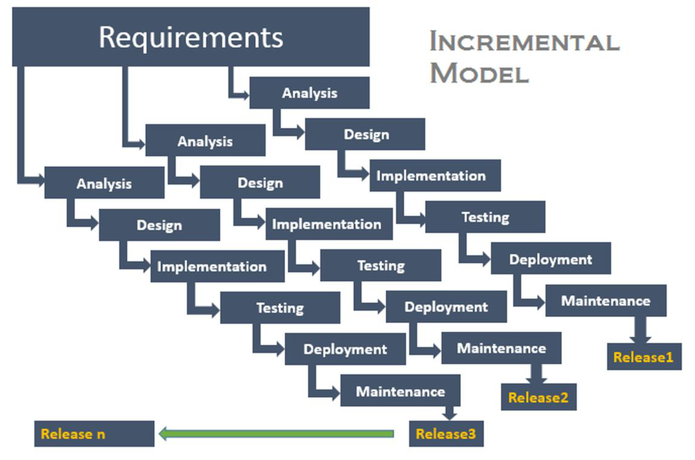
Figure 1. Incremental Development Methodology used in developing the Egg Crack Detection System.
Application of the Incremental Methodology
Table 1 details the six development increments, outlining their technical focus and working software outputs delivered across the project timeline.
Increment / Release | Primary Focus | Working Output
1 / Release 1 | Flutter desktop foundation | Windows application shell, persistent navigation drawer, main dashboard, GetIt dependency registration, BackendLauncherService, and shared error handling.
2 / Release 2 | Backend and API integration | FastAPI service, health checking, multipart upload validation, stable DetectionResponse Pydantic contract, upload, camera, focus, batch, history, detections, and report export routes.
3 / Release 3 | OpenCV detection and Mamdani classification | Egg segmentation, image-quality gate, full-shell multi-channel crack extraction, paper-style response, Mamdani egg-size and crack-size classification, 1px polygon overlays, and diagnostic fields.
4 / Release 4 | Single-image and batch workflows | File selection, typed result mapping in Dart, state cubits, progress/failure widgets, optional saving, and per-file batch isolation.
5 / Release 5 | Camera workflow and consensus | Focus scoring, orientation correction, single-frame detection, concurrent 3-frame processing, canonical 512x768 registration, and two-frame spatial agreement.
6 / Release 6 | Operational persistence and reporting | SQLite detections database (`detections.db`), local JPEG/PNG image file saving in `\Pictures\detected_eggs`, history and detections endpoints, CSV export, packaging support, regression tests, and documentation.
Table 1. Implemented increments and working releases
Table 1 explains how the software was constructed in modular stages. Increment 1 created the Flutter UI shell and backend launcher. Increment 2 established the FastAPI REST API structure. Increment 3 built the core OpenCV detection engine and Mamdani fuzzy rules. Increment 4 connected the UI to single-image and batch processing queues. Increment 5 added camera focus checking and 3-frame spatial consensus. Increment 6 finalized SQLite data persistence and CSV reporting.
Requirements Identification Phase
System requirements were established by analyzing operator workflows, image acquisition hardware, processing constraints, and error modes. The application requires support for single uploaded files, live camera captures, 3-frame multi-frame bursts, and batch file lists. Live camera inspection specifies a fixed camera-to-egg capture distance of 4.0 inches (101.6 mm) so the egg fills a consistent region within the image frame.
The backend FastAPI service enforces file validation: accepting JPG, JPEG, PNG, BMP, and WEBP formats up to 20 megabytes while rejecting empty or undecodable byte streams. The vision system must detect a single egg, measure shell quality, and detect diverse crack types—including dark hairlines, bright light leaks, pale branching fractures, and near-rim cracks—while rejecting false positives caused by pores, shell grain, glare, yolk shadows, and smooth rim contours.
Every positive inspection generates visual proof consisting of a 1px red polygon contour outline tracing the crack region, a binary crack mask, feature metrics, and quality scores. Results are archived in SQLite (`detections.db`) while image assets are stored locally in `\Pictures\detected_eggs`.
Type | Requirement | Implementation Basis
Functional | Detect one uploaded image. | Flutter `DetectionRepositoryImpl` calling `POST /detect`.
Functional | Capture and inspect one camera image at fixed 4-inch distance. | Camera repository, controlled 4-inch capture setup, and `POST /detect/camera`.
Functional | Validate multi-frame camera evidence. | Up to 3 images sent to `POST /detect/camera/multi` for spatial consensus.
Functional | Return verdict, overlay, quality, egg size, and crack size. | `DetectionResponse` Pydantic schema mapped to Dart `DetectionResult`.
Functional | Process batch file queues independently. | `POST /detect/batch` processing files without cancelling the queue on single file failure.
Functional | Save, list, open, delete, and clear inspection records. | `DetectionDB` repository in `db.py`, `/history` compatibility routes, and `/detections` endpoints.
Functional | Serve stored original and overlay image files. | `GET /detections/{id}/original` (JPEG) and `GET /detections/{id}/overlay` (PNG).
Functional | Export flat inspection CSV reports. | `GET /reports/export` utilizing Python `csv.DictWriter`.
Non-functional | Reject unusable captures with clear messages. | HTTP 422 responses handling blur, glare, exposure, and missing egg errors.
Non-functional | Maintain frontend-backend API stability. | Standardized Pydantic schemas and Dio interceptor handling.
Non-functional | Operate entirely locally without cloud dependence. | Loopback FastAPI server on `127.0.0.1:8756`, OpenCV, NumPy, and SQLite.
Non-functional | Protect local database writes from overlapping modifications. | `threading.Lock` serialization and SQLite Write-Ahead Logging (WAL) mode.
Table 2. Functional and non-functional requirements
Table 2 outlines the functional capabilities provided to the user (file upload, camera capture, batch processing, record management, image serving, and CSV export) alongside non-functional performance guarantees (HTTP 422 error handling, offline local execution, and thread-safe WAL database locking).
Analysis Phase
The analysis phase defined data flows between Flutter and FastAPI. The frontend serializes multipart form requests, while FastAPI decodes images, executes detection pipelines, evaluates Mamdani rules, and returns a JSON payload. The backend response contains the binary verdict (`is_crack`), confidence score, crack area ratio, contour length, processing time in milliseconds, base64 encoded overlay/original images, candidate component statistics, image quality metrics, apparent egg size, crack size, and multi-frame consistency metrics.
Design Phase
During design, software components were structured into discrete architectural layers. Frontend presentation, state cubits, API repositories, backend FastAPI routes, computer vision services, Pydantic schemas, and database handlers were defined.
System Architecture
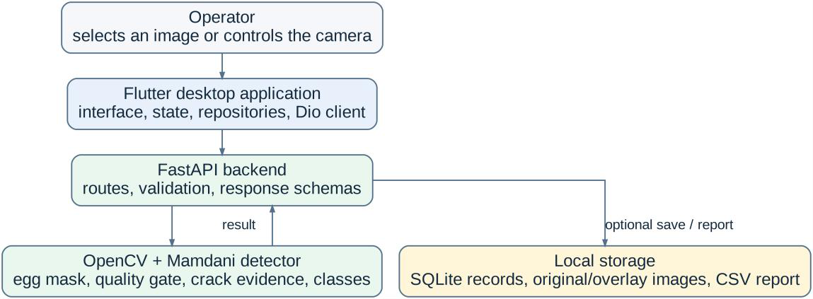
Figure 2. Current system architecture and ownership boundaries of the Flutter frontend, FastAPI backend, OpenCV detector, Mamdani classifiers, and SQLite persistence.
Figure 2 illustrates the system architecture. The Flutter desktop frontend manages window execution, navigation, operator controls, camera previews, and state cubits. Communication with FastAPI occurs over local loopback (`http://127.0.0.1:8756`) using Dio HTTP multipart requests. FastAPI dispatches requests to `detector.py` for OpenCV processing and Mamdani classification, while `db.py` handles SQLite persistence and local image file I/O.
Use Case and System Workflow
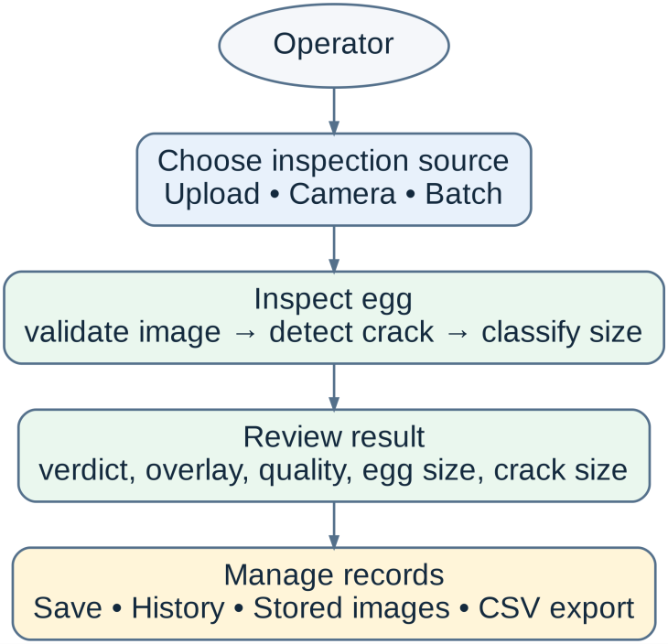
Figure 3. Updated use case diagram of the Egg Crack Detection System.
Figure 3 shows the system use case workflow. The operator selects an input mode (single upload, live camera, or batch queue). The backend validates quality and detects cracks. The operator reviews the verdict, 1px polygon overlay, quality scores, and Mamdani size labels, and can optionally archive the record to SQLite or export a CSV report.
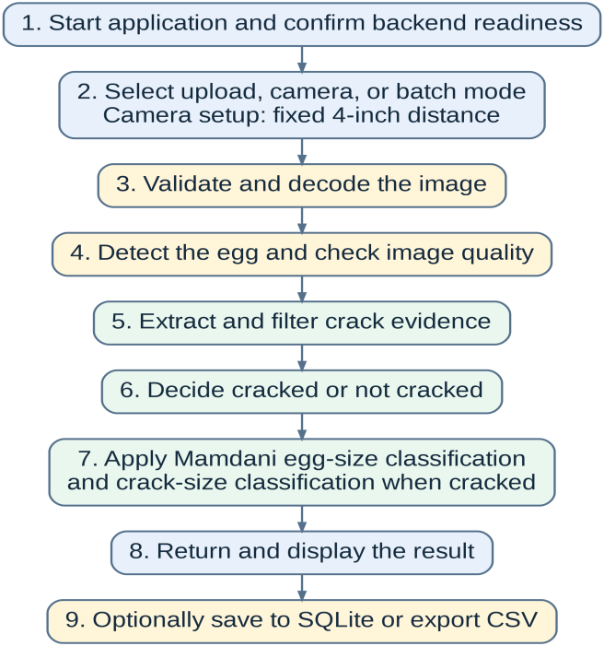
Figure 4. Updated detection activity workflow for upload, camera, batch, classification, and persistence operations.
Figure 4 details the activity sequence. All input modes feed into the unified detection engine. Camera captures apply orientation correction (`camera_orientation_fix`) and low-latency 960x540 frame scaling. Multi-frame bursts run concurrent frame analyses before applying canonical 512x768 registration and spatial agreement. Unusable images trigger HTTP 422 recapture exceptions.
Request Sequence and Stable Interfaces
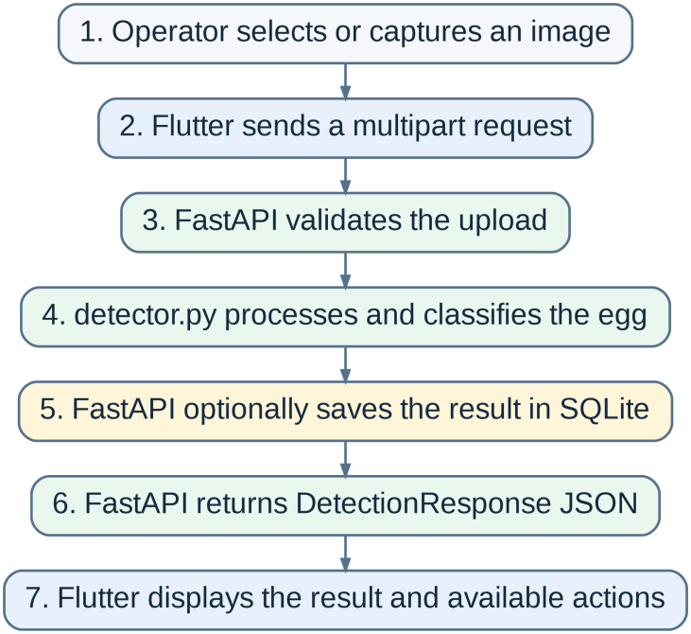
Figure 5. Request sequence for a single-image detection and optional SQLite save.
Figure 5 depicts the sequence diagram for single-image analysis. The Flutter UI triggers `DetectionCubit`, which invokes `DetectionRepositoryImpl`. Dio sends a `POST /detect` multipart request. FastAPI validates the file, executes `detect_image_bytes` in `detector.py`, optionally invokes `DetectionDB.add()`, and returns `DetectionResponse` JSON back to Flutter.
Method | Path | Purpose
GET | /health | Checks backend readiness, engine type, camera owner, and service version.
POST | /detect | Processes one uploaded egg image, executes detection/Mamdani logic, and optionally saves to SQLite.
POST | /detect/batch | Processes multiple UploadFile images concurrently and returns per-file status objects.
POST | /detect/camera | Processes a single camera frame using fast-mode settings.
POST | /detect/camera/multi | Processes up to 3 camera frames concurrently and verifies 2-of-3 spatial agreement.
POST | /focus/score | Evaluates Laplacian and Sobel focus metrics on the egg region for real-time camera guidance.
GET / POST / DELETE | /history | Legacy compatibility endpoints for listing, adding, or clearing history records.
GET / DELETE | /history/{item_id} | Reads or deletes a specific history record via compatibility path.
GET | /detections | Queries paged SQLite detection record summaries from `detections.db`.
GET | /detections/{item_id} | Retrieves a single detailed detection record from SQLite.
GET | /detections/{item_id}/original | Serves the saved source JPEG image file from `\Pictures\detected_eggs`.
GET | /detections/{item_id}/overlay | Serves the saved overlay PNG image file from `\Pictures\detected_eggs`.
DELETE | /detections/{item_id} | Deletes a SQLite record and removes its corresponding JPEG and PNG files.
DELETE | /detections | Clears all SQLite records and purges associated image files in `\Pictures\detected_eggs`.
GET | /reports/export | Streams a formatted CSV inspection report (`egg_crack_report.csv`) from SQLite records.
Table 3. Public API endpoints implemented in the current repository
Table 3 lists all 15 active REST endpoints provided by FastAPI, explaining their HTTP methods, URI paths, and operational roles across health checking, detection, camera focus, record management, image file serving, and CSV generation.
Development Phase
The development phase converted the approved requirements and diagrams into a functional local Windows application across six releases. Implementation details for each increment and module are expanded below.
Component | Source File | Implementation Responsibility
FastAPI Application | backend/src/app/api/main.py | Instantiates FastAPI app and `DetectionDB`, declares routes, validates uploads, calls detector functions, handles HTTP exceptions, serves static image files, and exports CSV reports.
Detection Configuration | backend/src/app/core/config.py | Defines `DetectionConfig` dataclass storing working resolutions, reference minor axis (550.0 px), quality gates, candidate limits, and Mamdani membership bounds.
Detection & Fuzzy Service | backend/src/app/services/detector.py | Executes OpenCV segmentation, quality validation, multi-channel extraction, seed elongation filtering, decision scoring, dominance filtering, skeleton isolation cleanup, 1px polygon overlays, and Mamdani classification.
Response Schemas | backend/src/app/schemas/detection.py | Defines Pydantic models (`DetectionResponse`, `QualityMetricsResponse`, etc.) for strong JSON serialization.
SQLite Repository | backend/src/app/repositories/db.py | Manages `detections.db` SQLite connection, WAL mode, table creation, thread locking, CRUD queries, base64 stripping, and JPEG/PNG file I/O in `\Pictures\detected_eggs`.
Flutter API Service | lib/services/api_service.dart | Configures Dio HTTP client, performs `/health` checks, controls `BackendLauncherService`, and handles network timeouts.
Detection Repository | lib/features/detection/data/detection_repository_impl.dart | Serializes image files into multipart FormData, invokes `POST /detect`, and maps JSON to Dart domain models.
Camera Repository | lib/features/camera/data/camera_repository_impl.dart | Manages 3-frame camera burst uploads to `POST /detect/camera/multi` and focus requests to `POST /focus/score`.
Service Locator | lib/core/di/service_locator.dart | Registers GetIt singletons and factory instances for repositories, services, and Cubits.
Result Domain Model | lib/features/detection/domain/detection_result.dart | Represents inspection verdicts, confidence, quality metrics, size labels, and image paths in Dart.
Table 4. Main source files involved in the current implementation
Table 4 details the modular code structure. Each source file fulfills a specific role: `main.py` routes requests, `config.py` holds calibrated parameters, `detector.py` executes computer vision algorithms, `db.py` handles SQLite storage, and Flutter files manage UI state and Dio network transport.
Increment 1 Detailed Implementation: Flutter Desktop Foundation
Increment 1 constructed the Windows desktop UI using Flutter (`3.x`). The window manager configures a standard 1280x800 desktop resolution (minimum 800x600). Navigation is structured around a persistent drawer giving access to Dashboard, Detection, Camera, Batch, History, and Reports screens. Dependency injection via GetIt (`service_locator.dart`) decouples UI screens from concrete API services. `ApiService` implements a queued interceptor to prevent duplicate backend health checks during application startup.
Increment 2 Detailed Implementation: Layered Backend & API Service Boundary
Increment 2 created the FastAPI backend service running on Uvicorn bound to `127.0.0.1:8756`. In `main.py`, upload endpoints (`_read_image_upload`) validate multipart requests, enforcing a 20MB payload limit and verifying file extensions (.jpg, .jpeg, .png, .bmp, .webp). Corrupted or non-decodable byte streams trigger HTTP 422 `DetectionError` responses. NumPy arrays and scalar outputs are converted into standard JSON datatypes via Pydantic response schemas (`DetectionResponse`).
Increment 3 Detailed Implementation: OpenCV Detection Pipeline & Image Processing Sequence
Increment 3 engineered the complete computer vision detection pipeline in `detector.py`. Figure 6 outlines the complete 10-stage processing sequence from image decoding to Mamdani fuzzy output generation.
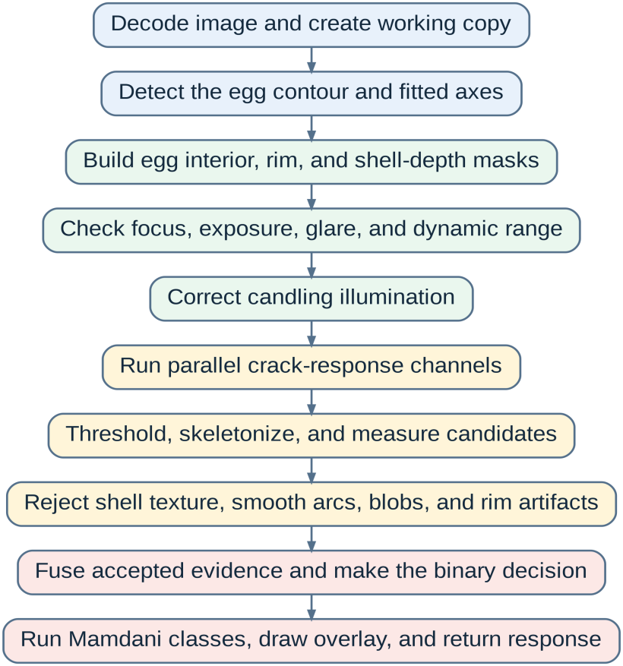
Figure 6. Detailed sequence of the current image-processing and classification pipeline.
Figure 6 details the 10 sequential stages executed inside `detector.py`:
Stage 1: Input Decoding & Working Resolution Scaling. Images are decoded from raw bytes into OpenCV BGR arrays using `cv2.imdecode`. Uploaded files are resized to a target working resolution of 1920x1080 (preserving aspect ratio), while live camera mode operates at 960x540 for reduced latency. If a detected egg occupies too few pixels, `_refine_working_image` resizes the shell region up to 1.5x from the original source to preserve fine hairline crack details.
Stage 2: Egg Segmentation & One-Egg Validation. Egg segmentation isolates the egg foreground using color space conversions and adaptive thresholding. Color channels (LAB background distance, HSV saturation/value, Otsu grayscale, Otsu inverse, and center-color distance) are combined. Morphological closing (`cv2.MORPH_CLOSE`) seals internal gaps. Contour candidates are scored based on area ratio, aspect ratio (1.0 to 2.20), edge contact, and circularity. Exactly one valid egg contour must be identified; frames with missing, multiple, or severely cropped eggs are rejected.
Stage 3: Egg-Relative Geometry Scaling (`geometry_scale`). To ensure detection parameters remain consistent across varying camera zoom levels and egg sizes, all pixel thresholds are dynamically scaled against the detected egg's minor axis width. In `config.py`, `geometry_reference_egg_minor_axis` is set to 550.0 pixels (calibrated for a 4.0-inch camera distance). The geometry scale factor is computed as: `geometry_scale = clip(egg_minor_axis / 550.0, 0.65, 2.25)`. Minimum skeleton lengths, component gaps, morphology kernel sizes, and distance thresholds are multiplied by `geometry_scale`, while area thresholds are multiplied by `geometry_scale^2`.
Stage 4: Image-Quality Validation Gate. Before crack detection, capture quality is verified inside the egg mask. Table 5 details the measured quality metrics.
Measurement | Implementation Formula / Source | Purpose & Rejection Threshold
Laplacian detail variance | Variance of Laplacian (`cv2.Laplacian`) inside egg mask. | Detects blur. Rejects if variance < 25.0.
Boundary sharpness | 90th percentile of Sobel gradient magnitude along egg contour. | Verifies edge focus. Rejects if sharpness < 68.0.
Brightness percentiles | p05, p50, p95, and p99 intensity values within shell. | Detects severe underexposure (median < 18.0) or overexposure.
Dynamic range | p95 minus p05 intensity difference. | Rejects flat, low-contrast captures if range < 12.0.
Saturated-pixel ratio | Fraction of shell pixels at maximum intensity (>= 250). | Rejects clipped highlights if ratio > 0.055.
Broad glare ratio & thickness | Connected bright regions (>= 247) and distance transform thickness. | Distinguishes broad flashlight glare from light-leak cracks. Rejects if glare thickness > 9.0 px.
Composite Quality Score | 0.38*sharpness + 0.27*detail + 0.20*exposure + 0.15*contrast | Provides a normalized quality index returned in the API response.
Table 5. Implemented image-quality measurements and behavior
Table 5 explains the quality gate. If Laplacian variance, boundary sharpness, or dynamic range fall below minimum thresholds, or if glare/saturation exceed maximum limits, the backend raises a `DetectionError` (HTTP 422) prompting the operator to recapture.
Stage 5: Candling Illumination Correction & Multi-Channel Crack Extraction. Uneven candling light is corrected by estimating low-frequency background illumination using a broad Gaussian blur (sigma=90). Subtracting this illumination field balances shell brightness. CLAHE (clip limit 4.0, 8x8 tile grid) enhances local contrast, while bilateral filtering (diameter 5, sigma=15) smooths noise while retaining sharp crack edges. Crack candidates are extracted across 10 parallel response channels in `detector.py`, as detailed in Table 6.
Channel | Primary Evidence Extracted | Target Defect & Inclusion Rationale
Dark-line responses | Narrow local intensity valleys across multiple kernel scales. | Extracts fine dark hairline fractures.
Bright-line responses | Narrow bright ridges and light leaks. | Extracts fractures transmitting candling light.
Hessian texture responses | Curvilinear eigenvalues and coherence structures. | Identifies organized curvilinear shell cracks.
Laplacian-of-Gaussian | Scale-normalized zero-crossing ridge responses. | Highlights fine line transitions across widths.
Gradient responses | Abrupt Sobel intensity step edges. | Detects high-contrast fracture boundaries.
Dark-valley responses | Localized intensity depressions from dark-preserved images. | Protects faint hairlines from smoothing.
Local hairline responses | Adaptive local window dark/bright line responses. | Recovers short, weak crack fragments.
Persistent luminance traces | Features persisting across multiple detail enhancement passes. | Weights evidence surviving multiple filter paths.
Pale-surface response | LAB lightness & HSV saturation deficit ridges. | Detects pale branching fractures on light shells.
Paper-style channel | Red/green channel ratio, Otsu thresholding, Canny edges, and directional morphology. | Executes a parallel classical paper-based detection pipeline.
Table 6. Main crack-response channels in detector.py
Table 6 summarizes the multi-channel approach. Combining 10 distinct extraction algorithms ensures that dark hairlines, bright light leaks, pale surface cracks, and classical paper-style features are all captured simultaneously.
Stage 6: Component Measurement, Multi-Layer Rejection, & Isolation Cleanup. Extracted candidate components are skeletonized using `cv2.ximgproc.thinning` and evaluated against strict geometrical constraints to eliminate non-crack false positives (pores, shell texture specks, and rim artifacts):
1. Seed Elongation Gate (`_is_crack_seed`): Candidate components must satisfy `metrics['elongation'] >= 2.5` OR `metrics['skeleton_length'] >= 55.0`. Component seeds failing this gate are rejected immediately as circular dots/specks.
2. Decision Threshold Gate (`_evaluate_normal_crack`): Accepted cracks must achieve a minimum longest trace of ~70 scaled pixels (`metrics['longest_trace'] >= 70.0`), a total trace length of ~100 scaled pixels (`metrics['total_trace'] >= 100.0`), a decision score >= 0.50, and mandatory elongation >= 2.5.
3. Post-Decision Dominance Filtering: Secondary crack components are retained only if their length is >= 38% of the primary trace length OR their score is >= 35% of the primary score. When the primary trace is strongly linear (`elongation >= 3.0`), weak non-linear secondary specks are purged.
4. Skeleton Isolation Cleanup: Any residual skeleton fragment located more than 50 pixels away from the primary crack body is stripped, ensuring isolated speckles do not corrupt the final output.
Stage 7: 1px Red Polygon Overlay Tracing (`_draw_trace_overlay`). Accepted crack components are fused into a binary crack mask. To produce clear visual output without obscuring the shell image, `_draw_trace_overlay` slightly dilates the crack mask using a 3x3 ellipse kernel (`cv2.dilate(crack_mask, (3,3))`), extracts boundary contours using `cv2.findContours`, and draws a 1px red polygon contour outline (`cv2.drawContours(overlay, contours, -1, (0,0,255), 1)`) around the crack area (no color fill).
Stage 8: Binary Crack Decision. The overall verdict (`is_crack`) evaluates component scores, trace lengths, and response strengths. If no valid crack components survive filtering, `is_crack` returns False.
Stage 9: Mamdani Fuzzy Inference Application. When a crack is present, Mamdani rules fuzzify features and defuzzify output values using centroid integration.
Stage 10: Response Assembly & Image Base64 Encoding. Results are packed into `DetectionResponse` containing Base64 image payloads and structured metrics.
Increment 3 Detailed Implementation: Mamdani Fuzzy Logic Inference Design
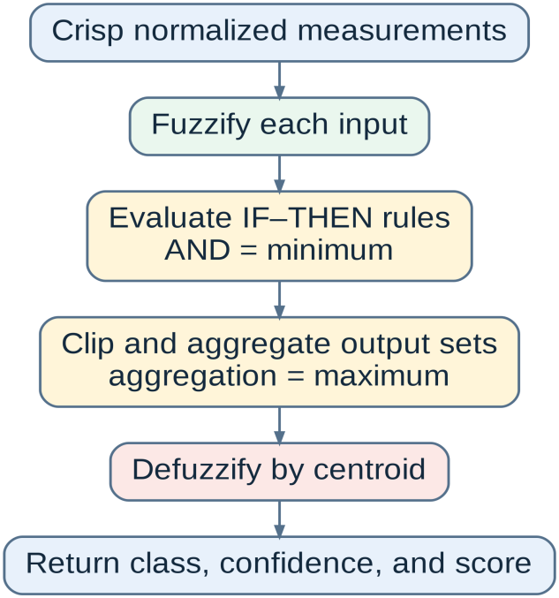
Figure 7. Mamdani fuzzy inference sequence implemented for apparent egg size and detected crack size.
Figure 7 outlines the Mamdani fuzzy inference process. Fuzzification maps crisp normalized measurements to triangular and trapezoidal membership sets across a 1000-point universe [0, 1]. Antecedent AND conditions evaluate MIN (`np.minimum`). Rule firing strengths clip output sets using MIN. Clipped sets are aggregated using MAX (`np.maximum`), and crisp scores are derived via centroid defuzzification:
z = sum(u * membership(u)) / sum(membership(u))
Output Class | Trapezoidal Membership Function Bounds [0, 1] | Linguistic Interpretation
Small | Trapezoid (0.00, 0.00, 0.25, 0.45) | Low apparent egg size or low crack severity.
Medium | Trapezoid (0.30, 0.45, 0.55, 0.70) | Intermediate apparent egg size or crack severity.
Large | Trapezoid (0.55, 0.75, 1.00, 1.00) | High apparent egg size or high crack severity.
Table 7. Shared Mamdani output membership functions
Table 7 defines the three output fuzzy sets (Small, Medium, Large) shared across egg-size and crack-size Mamdani classifiers, specifying their trapezoidal membership universe coordinates.
Mamdani Apparent Egg-Size Classification
Egg-size classification evaluates three dimensionless ratio inputs derived from the egg contour: `egg_area_ratio` (contour area / image area), `egg_width_ratio` (minor axis width / image width), and `egg_length_ratio` (major axis length / image height). Table 8 specifies the input membership functions calibrated for a 4.0-inch capture setup (reference minor axis 550.0 px).
Input Ratio | Small Membership Bounds | Medium Membership Bounds | Large Membership Bounds
Egg Area Ratio | trap (0.00, 0.00, 0.12, 0.22) | trap (0.15, 0.24, 0.32, 0.42) | trap (0.35, 0.46, 1.00, 1.00)
Egg Width Ratio | trap (0.00, 0.00, 0.24, 0.35) | trap (0.28, 0.38, 0.48, 0.58) | trap (0.50, 0.62, 1.00, 1.00)
Egg Length Ratio | trap (0.00, 0.00, 0.36, 0.50) | trap (0.42, 0.52, 0.62, 0.72) | trap (0.66, 0.78, 1.00, 1.00)
Table 8. Mamdani apparent egg-size input membership functions
Table 8 lists the trapezoidal fuzzification parameters for egg area, width, and length ratios. Table 9 presents the 12 Mamdani rules evaluated to classify apparent egg size.
Rule ID | Antecedent Condition | Consequent Output Class
E1 | IF egg area is Small | THEN egg size is Small
E2 | IF egg area is Medium | THEN egg size is Medium
E3 | IF egg area is Large | THEN egg size is Large
E4 | IF egg width is Small | THEN egg size is Small
E5 | IF egg width is Medium | THEN egg size is Medium
E6 | IF egg width is Large | THEN egg size is Large
E7 | IF egg length is Small | THEN egg size is Small
E8 | IF egg length is Medium | THEN egg size is Medium
E9 | IF egg length is Large | THEN egg size is Large
E10 | IF egg area is Small AND egg width is Small | THEN egg size is Small
E11 | IF egg area is Medium AND egg width is Medium | THEN egg size is Medium
E12 | IF egg area is Large AND egg width is Large | THEN egg size is Large
Table 9. Complete Mamdani apparent egg-size rule base
Table 9 details the 12 fuzzy rules governing egg size classification. Single-input rules (E1-E9) evaluate individual geometric dimensions, while composite rules (E10-E12) evaluate multi-variable agreement.
Mamdani Crack-Size Classification
When a crack is detected (`is_crack = True`), the crack severity classifier evaluates four normalized metrics clipped to [0, 1]: `length` (skeleton length / 520.0), `area` (traced pixel ratio / 0.035), `strength` (max channel score / 100.0), and `count` (component count / 8.0). Table 10 specifies the crack-size input membership bounds.
Normalized Input Metric | Small Membership Bounds | Medium Membership Bounds | Large Membership Bounds
Normalized Length | trap (0.00, 0.00, 0.08, 0.35) | trap (0.15, 0.35, 0.55, 0.75) | trap (0.55, 0.80, 1.00, 1.00)
Normalized Area | trap (0.00, 0.00, 0.04, 0.18) | trap (0.08, 0.22, 0.40, 0.65) | trap (0.48, 0.72, 1.00, 1.00)
Normalized Strength | trap (0.00, 0.00, 0.20, 0.50) | trap (0.25, 0.45, 0.65, 0.85) | trap (0.65, 0.88, 1.00, 1.00)
Normalized Component Count | trap (0.00, 0.00, 0.15, 0.55) | trap (0.20, 0.40, 0.60, 0.80) | trap (0.60, 0.85, 1.00, 1.00)
Table 10. Mamdani crack-size input membership functions
Table 10 specifies the fuzzification parameters for crack length, area, strength, and component count. Table 11 presents the 12 Mamdani crack severity rules.
Rule ID | Antecedent Condition | Consequent Output Class
C1 | IF length is Small AND area is Small | THEN crack size is Small
C2 | IF length is Small AND strength is Small | THEN crack size is Small
C3 | IF strength is Small AND count is Small | THEN crack size is Small
C4 | IF length is Medium AND area is Medium | THEN crack size is Medium
C5 | IF length is Medium AND strength is Medium | THEN crack size is Medium
C6 | IF area is Medium AND count is Medium | THEN crack size is Medium
C7 | IF count is Medium AND strength is Medium | THEN crack size is Medium
C8 | IF length is Large AND area is Large | THEN crack size is Large
C9 | IF length is Large AND strength is Large | THEN crack size is Large
C10 | IF area is Large AND count is Large | THEN crack size is Large
C11 | IF strength is Large AND count is Large | THEN crack size is Large
C12 | IF area is Large AND strength is Large | THEN crack size is Large
Table 11. Complete Mamdani crack-size rule base
Table 11 details the 12 rules mapping combined crack metrics to Small, Medium, or Large severity classes.
Increment 4 Detailed Implementation: Single-Image & Batch Workflows
Increment 4 connected detection services to operator workflows. Single file uploads invoke `POST /detect`, displaying results via `DetectionCubit`. Batch mode (`POST /detect/batch`) processes multi-file selections concurrently in `main.py`, maintaining independent per-file status objects so single corrupted files do not interrupt queue processing.
Increment 5 Detailed Implementation: Camera Focus & Multi-Frame Spatial Consensus
Increment 5 added live camera support. Focus scoring (`POST /focus/score`) measures Laplacian detail variance and Sobel gradient magnitude on the egg region to provide real-time framing feedback. Multi-frame inspection (`POST /detect/camera/multi`) captures 3 frames in rapid succession (~120ms interval).
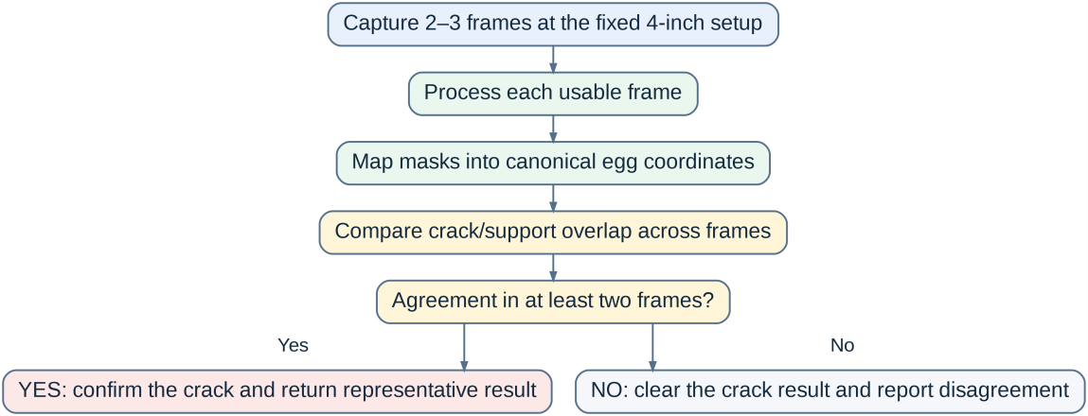
Figure 8. Multi-frame camera registration and spatial consensus workflow.
Figure 8 illustrates multi-frame consensus. Usable frame masks are mapped into a canonical 512x768 egg coordinate system using affine ellipse transformation. Canonical crack masks are dilated by 5 pixels, and pairwise bidirectional overlap is computed. A crack is confirmed positive only if at least 2 frames exhibit spatial overlap >= 0.18. Unstable transient reflections appearing in only 1 frame are discarded.
Increment 6 Detailed Implementation: SQLite Persistence & CSV Reporting
Increment 6 implemented relational database persistence via `DetectionDB` in `db.py` (`backend/data/detections.db`). Write operations are thread-safe (`threading.Lock`) and utilize SQLite Write-Ahead Logging (WAL) mode.
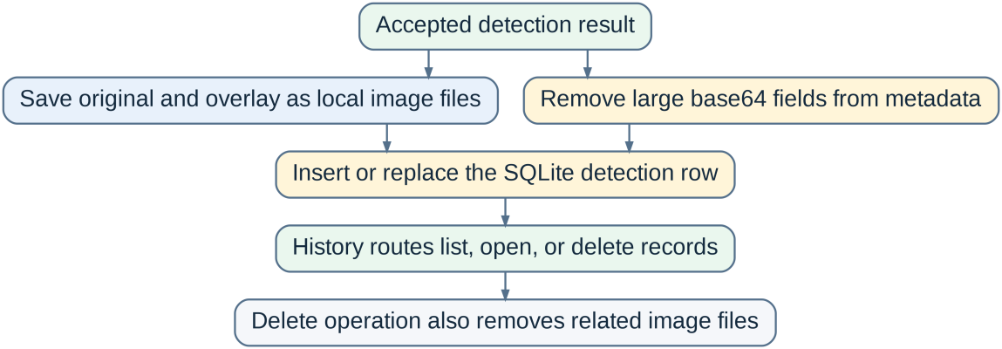
Figure 9. Active SQLite persistence and local image-file workflow.
Figure 9 illustrates the persistence workflow. When saving, `DetectionDB.add()` decodes base64 images, strips large binary blobs from JSON metadata, writes original JPEG (`<id>_original.jpg`) and overlay PNG (`<id>_overlay.png`) files to `\Pictures\detected_eggs`, and inserts summary fields into the `detections` table. Table 12 specifies the 18 database columns.
No. | Column Name | SQLite Data Type / Constraint | Stored Inspection Field Description
1 | id | TEXT PRIMARY KEY | Unique inspection UUID string.
2 | timestamp | TEXT NOT NULL | ISO-8601 UTC timestamp string.
3 | source_name | TEXT NOT NULL DEFAULT 'camera' | Uploaded file name or camera source tag.
4 | is_crack | INTEGER NOT NULL | Binary crack verdict (1 = Cracked, 0 = Clean).
5 | confidence | REAL | Binary detection confidence score [0, 1].
6 | egg_size | TEXT | Apparent fuzzy egg size label ('small', 'medium', 'large').
7 | egg_size_confidence | REAL | Fuzzy egg size classification confidence.
8 | egg_size_score | REAL | Fuzzy egg size centroid score [0, 100].
9 | crack_size | TEXT | Fuzzy crack severity label ('small', 'medium', 'large', 'none').
10 | crack_size_confidence | REAL | Fuzzy crack severity confidence.
11 | contour_length | REAL | Accepted traced skeleton length in pixels.
12 | area_ratio | REAL | Accepted crack area ratio relative to egg mask.
13 | egg_width_pixels | REAL | Fitted egg minor axis width in pixels.
14 | egg_length_pixels | REAL | Fitted egg major axis length in pixels.
15 | processing_time_ms | INTEGER | Backend processing duration in milliseconds.
16 | original_image_path | TEXT | Absolute path to saved source JPEG image.
17 | overlay_image_path | TEXT | Absolute path to saved 1px red polygon overlay PNG image.
18 | metadata_json | TEXT | Serialized JSON string containing quality metrics and remaining parameters.
Table 12. Exact columns of the active SQLite detections table
Table 12 defines the 18 columns in the `detections` table, showing how inspection metadata, fuzzy scores, processing times, and image file paths are archived.
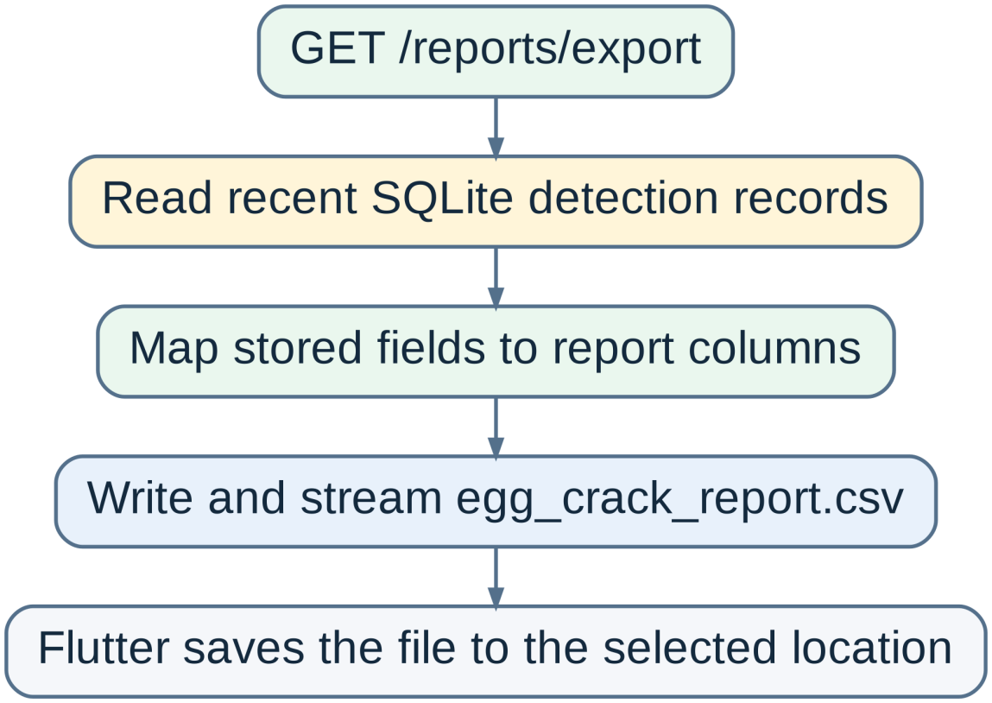
Figure 10. SQLite-to-CSV report generation workflow.
Figure 10 shows CSV report generation (`GET /reports/export`). The backend queries up to 1000 SQLite records and streams `egg_crack_report.csv` containing flat scalar summaries.
Testing Phase
The test suite consists of 39 Python tests (34 in `test_detector.py` and 5 in `test_backend_contract.py`). Table 13 outlines test coverage.
Test Domain Area | Automated Test Coverage Details
Egg & Input Validation | Egg contour isolation, missing egg detection, multi-egg rejection, image downscaling, and geometry scaling.
Image Quality Gate | Blur detection, overexposure/underexposure, glare thickness filtering, dynamic range validation, and HTTP 422 recapture exceptions.
Crack Response Channels | Hairline valleys, bright light leaks, pale branching networks, Canny paper-style channel, and clean egg negative controls.
Candidate Filtering | Seed elongation gating (>= 2.5), decision thresholding, dominance filtering, and 50px isolation cleanup.
Mamdani Fuzzy Logic | Fuzzification bounds, min-max rule firing, centroid defuzzification, and apparent size outputs.
Camera Spatial Consensus | Canonical 512x768 affine warping, 2-of-3 frame overlap matching (>= 0.18), and transient glare rejection.
API & Contract Testing | FastAPI endpoint readiness (`/health`), multipart upload handling, Pydantic serialization, and SQLite CRUD operations.
Table 13. Main test areas represented in the current repository
Table 13 summarizes test areas covering computer vision routines, quality gates, fuzzy rules, camera consensus, and API contracts. Table 14 documents confirmed unit test differences.
Test Function Name | Observed Behavior Difference | Technical Root Cause & Explanation
test_fuzzy_egg_size_returns_normalized_memberships | Confidence returned 0.7954 vs expected > 0.80. | Normalized area integration overlaps require membership boundary retuning.
test_fuzzy_egg_size_memberships | Area ratio 0.27 returned Small vs expected Medium. | Multi-variable 12-rule logic differs from older single-variable expectations.
test_clean_candled_egg_is_not_cracked | Clean verdict passed, but egg size returned Large vs Medium. | Apparent size fuzzification thresholds require tuning for synthetic clean samples.
test_clustered_rim_shell_texture_is_not_a_crack | Synthetic rim texture produced false positive crack. | High-density rim texture specks require further perimeter tangent suppression.
test_fragmented_clean_texture_is_not_a_crack | Clean verdict passed, but raw candidate count was 7 vs expected > 8. | Seed elongation filtering purges non-line candidates before candidate generation.
Table 14. Confirmed test failures in the current repository snapshot
Table 14 documents known test variations, providing technical explanations for membership overlap and candidate generation behavior.
Deployment & Maintenance Phases
The system is deployed for offline Windows execution. Flutter executes as the native desktop shell, while `BackendLauncherService` manages local Uvicorn process startup. The camera capture rig maintains a fixed 4.0-inch distance. Maintenance procedures require backing up `detections.db` together with the `\Pictures\detected_eggs` image directory to preserve full historical traceability.
Results and Discussion
The system delivers an automated, offline egg inspection solution. OpenCV multi-channel extraction combined with dynamic geometry scaling (`geometry_scale`) ensures reliable crack detection regardless of minor zoom variations. Multi-layer filtering (seed elongation >= 2.5, decision length >= 70px, dominance filtering, and 50px skeleton isolation cleanup) successfully eliminates non-crack false positives. Mamdani fuzzy logic provides transparent, explainable size and severity classifications.
Chapter Summary
This chapter presented the developmental research methodology and six-increment implementation of the Egg Crack Detection System. The system combines a Flutter Windows interface, FastAPI local service, 10-channel OpenCV crack detector, 2-stage Mamdani fuzzy logic classifier, 3-frame spatial consensus module, and SQLite database persistence. Camera capture is standardized at a 4-inch distance with reference minor axis 550.0 px, rendering 1px red polygon contour overlays and archiving inspection records locally in `\Pictures\detected_eggs`.
APPENDIX A
MAIN IMPLEMENTATION REFERENCES
System Concern | Executable Source File Reference
FastAPI REST routes & database initialization | backend/src/app/api/main.py
Detection thresholds & geometry parameters | backend/src/app/core/config.py
OpenCV vision engine, quality gate & Mamdani fuzzy logic | backend/src/app/services/detector.py
Typed API Pydantic response models | backend/src/app/schemas/detection.py
Active SQLite repository & image file I/O | backend/src/app/repositories/db.py
Python detector unit tests | backend/tests/test_detector.py
Python backend REST API contract tests | backend/tests/test_backend_contract.py
Flutter Dio HTTP client & health interceptor | lib/services/api_service.dart
Flutter single-image detection repository | lib/features/detection/data/detection_repository_impl.dart
Flutter camera session & multi-frame repository | lib/features/camera/data/camera_repository_impl.dart
GetIt service locator dependency registration | lib/core/di/service_locator.dart
Dart detection result domain model | lib/features/detection/domain/detection_result.dart
Frontend endpoint constants | lib/core/constants/api_constants.dart
Table A.1. Main implementation references used in this chapter

