CHAPTER IV
METHODOLOGY, RESULTS AND DISCUSSION
This chapter presents the methodology, development activities, system design, image-processing sequence, fuzzy classification method, local data persistence, testing status, deployment process, maintenance requirements, and implementation results of the Egg Crack Detection System. The implemented system is a local Windows desktop application that uses Flutter for the operator interface and camera workflow, including a fixed 4-inch camera-to-egg capture distance; FastAPI for the local service boundary; OpenCV and NumPy for deterministic image processing; a Mamdani fuzzy inference procedure for apparent egg-size and crack-size classification; and SQLite for persistent inspection history.
The system architecture strictly separates detection from classification. OpenCV first validates the image, locates one egg, measures capture quality, extracts candidate crack evidence from several response channels, filters false structures, and forms the accepted crack mask. Mamdani fuzzy logic is then applied to normalized measurements from the accepted detection output. It does not replace egg segmentation or crack extraction, and the system operates purely deterministically without requiring a neural network, cloud inference, YOLO, TensorFlow, or PyTorch.
The active FastAPI module constructs DetectionDB with a local detections.db file. Detection records are written to SQLite, while the detector-returned working image and overlay are decoded and saved as local files in \Pictures\detected_eggs.
Research Design / Approach
The study employed a developmental research approach because its primary purpose was to design, implement, integrate, and evaluate a working egg inspection application. The work produced a functional software system that accepts images, determines whether one usable egg is present, evaluates image quality, searches the shell for crack evidence, returns an explainable verdict and overlay, classifies the apparent egg and crack size, and stores accepted records for later review.
The development approach combined desktop application construction, API integration, deterministic computer-vision experimentation, fuzzy-rule implementation, local database design, regression testing, and repeated correction. A feature was treated as complete only when it could operate with the frontend and backend contract, return a typed response, preserve available routes, and provide an understandable operator output.
The current project implementation serves as the authority for this chapter. Current egg-size classification uses normalized image geometry, and current persistence uses DetectionDB and SQLite.
Incremental Development Methodology
The Incremental Development Methodology was selected because the system contains several connected but separable capabilities. Developing the complete application in one attempt would make defects difficult to isolate and would delay the availability of a usable release. The project was therefore organized into six working increments. Each increment passed through requirements identification, analysis, design, implementation, testing, deployment preparation, and maintenance review before it became the foundation for the next release.
Feedback from backend tests, interface integration, camera behavior, sample images, and storage operations was returned to the corresponding phase of the current increment. This allowed the researchers to refine the crack candidate logic, maintain the API response model, improve camera-frame confirmation, implement SQLite persistence, and keep the Flutter workflow operational while later functions were added.
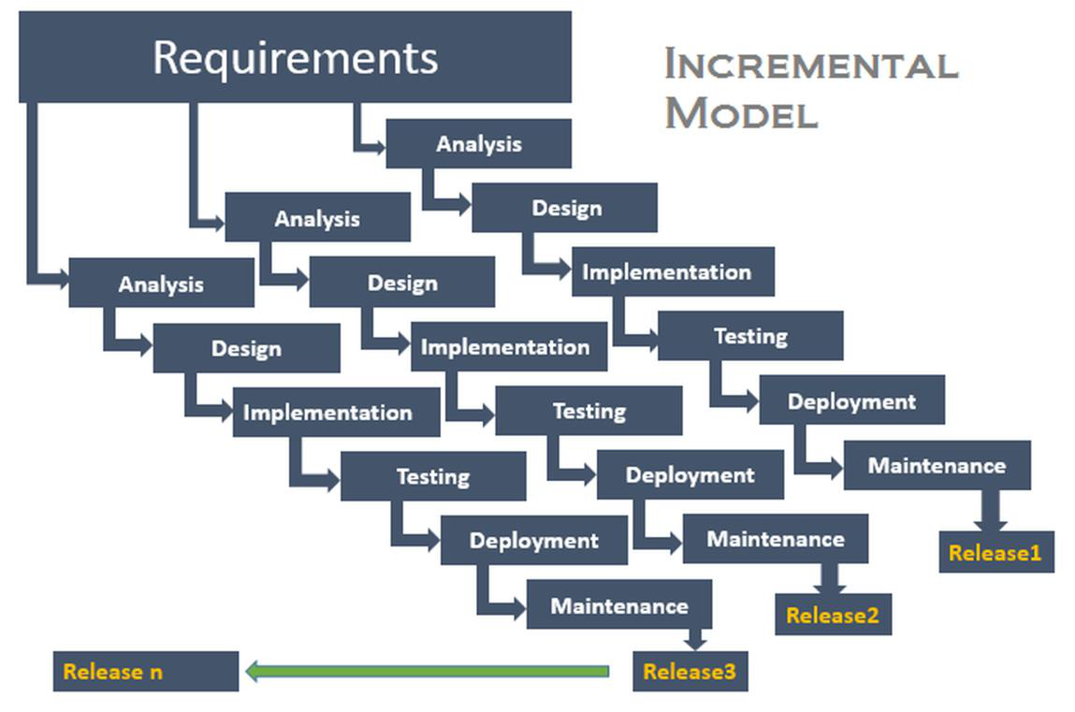
Figure 1. Incremental Development Methodology used in developing the Egg Crack Detection System.
Application of the Incremental Methodology
Increment / Release | Primary Focus | Working Output
1 / Release 1 | Flutter desktop foundation | Windows application shell, persistent navigation, dashboard, dependency registration, backend launcher, and shared error handling.
2 / Release 2 | Backend and API integration | FastAPI service, health checking, multipart validation, stable DetectionResponse contract, upload, camera, focus, batch, history, detections, and report routes.
3 / Release 3 | OpenCV detection and Mamdani classification | Egg segmentation, image-quality gate, full-shell multi-channel crack extraction, paper-style response, fuzzy egg-size and crack-size classification, masks, overlays, and diagnostic fields.
4 / Release 4 | Single-image and batch workflows | File selection, typed result mapping, progress and failure states, optional saving, and per-file batch isolation.
5 / Release 5 | Camera workflow and consensus | Focus scoring, orientation correction, one-frame detection, concurrent three-frame processing, canonical registration, and two-frame spatial agreement.
6 / Release 6 | Operational persistence and reporting | SQLite detections database, local original and overlay image files, history and detections routes, CSV export, packaging support, regression tests, and documentation.
Table 1. Implemented increments and working releases
Requirements Identification Phase
At the beginning of each increment, the researchers identified the operator needs, system boundary, accepted image sources, required response fields, capture risks, persistence requirements, and failure conditions. The application had to support an image selected from storage, a single image captured from a connected camera, a three-frame camera request, and a batch of selected files. Camera-based inspection uses a fixed camera-to-egg distance of 4 inches (101.6 mm) so that the egg occupies a repeatable portion of the frame. The operator also had to complete the workflow through the Flutter application without manually starting several programs.
The backend was required to accept JPG, JPEG, PNG, BMP, and WEBP files, reject empty or undecodable uploads, and limit one upload to 20 megabytes. It also had to reject an image when it could not find exactly one usable egg, when the egg occupied an unsuitable region, or when image quality prevented a defensible crack decision.
The crack detector had to consider dark hairline traces, bright light leaks, pale surface fractures, fragmented branches, horizontal eggs, and valid traces near the perimeter. At the same time, it had to reduce false positives from pores, shell grain, broad glare, yolk-like curves, smooth arcs, shell-contour edges, repeated texture, and temporary camera artifacts.
Every positive result had to contain visible evidence. The response includes an overlay (1px red border polygon contour outline), crack mask, crack locations, component statistics, confidence values, quality measurements, and the detector-returned working image. The active API saves the summary in SQLite and stores that working image and the overlay outside the database in Pictures/detected_eggs. Camera decisions require repeated spatial evidence rather than accepting any one temporary response.
Type | Requirement | Implementation Basis
Functional | Detect one uploaded image. | Flutter detection repository and POST /detect.
Functional | Capture and inspect one camera image at the fixed 4-inch camera-to-egg distance. | Camera repository, controlled 4-inch capture setup, and POST /detect/camera.
Functional | Validate repeated camera evidence. | Up to three image fields sent to POST /detect/camera/multi.
Functional | Return verdict, overlay, quality, egg size, and crack size. | DetectionResponse schema and Flutter DetectionResult mapping.
Functional | Process several files without stopping the complete queue after one failure. | POST /detect/batch and per-file status objects.
Functional | Save, list, open, delete, and clear local inspection records. | DetectionDB, /history compatibility routes, and /detections routes.
Functional | Serve stored original and overlay images. | GET /detections/{id}/original and /detections/{id}/overlay.
Functional | Export a flat inspection report. | GET /reports/export and csv.DictWriter.
Non-functional | Reject unsuitable images with a clear recapture message. | HTTP 422 handling for segmentation and quality failures.
Non-functional | Keep the frontend contract stable. | Shared endpoint paths and typed response fields.
Non-functional | Operate locally without cloud inference. | Loopback FastAPI service, OpenCV, NumPy, Mamdani rules, and SQLite.
Non-functional | Protect local database writes from overlapping modifications. | threading.Lock and SQLite WAL mode.
Table 2. Functional and non-functional requirements
Analysis Phase
The analysis phase examined how every new capability interacts within the system. The researchers traced user actions from file or camera selection through multipart transport, image validation, detector execution, fuzzy classification, result rendering, optional persistence, history review, stored-image retrieval, deletion, and report export.
The shared response model serves as a contract between Python and Dart. The backend returns the final binary verdict, confidence, crack area ratio, contour length, processing time, source and overlay images, candidate statistics, crack locations, image-quality values, apparent egg-size fields, crack-size fields, camera consistency values, termination reason, and optional intermediate images. The frontend maps these values into DetectionResult and uses one result screen for upload and camera workflows.
The analysis also separated binary crack detection from fuzzy size classification. The detector first decides whether accepted crack evidence exists. When no crack is detected, crack_size is returned as none with full confidence. When a crack is present, the fuzzy classifier evaluates normalized length, area, response strength, and component count. Egg size is an apparent image-based class derived from contour area, shell width, and shell length ratios.
Storage analysis established that base64 images should not be stored as database blobs. The active database layer decodes the detector-returned working image and overlay, writes them to the user Pictures/detected_eggs directory, removes the large image and intermediate fields from metadata_json, and stores summary values, image paths, and remaining metadata in the detections table.
Design Phase
During the design phase, the researchers defined component ownership, the request sequence, endpoint behavior, detector stages, Mamdani inputs and rules, camera consensus, SQLite schema, image-file storage, and report projection.
System Architecture
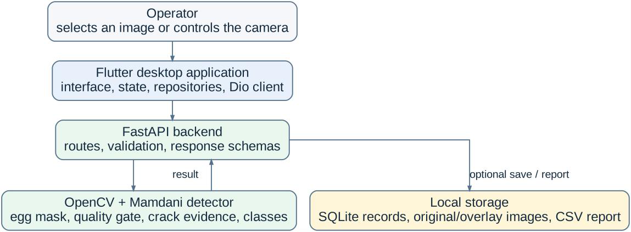
Figure 2. Current system architecture and ownership boundaries of the Flutter frontend, FastAPI backend, OpenCV detector, Mamdani classifiers, and SQLite persistence.
The Flutter frontend owns the desktop window, route shell, operator controls, file selection, camera preview, focus guidance, capture timing, progress state, result presentation, history navigation, stored-image actions, and report saving. Repositories isolate the presentation layer from Dio multipart requests. ApiService performs a health check before normal work and asks BackendLauncherService to start the local service when it is not ready.
The Python backend follows a layered source structure. app/api/main.py defines HTTP behavior and constructs the active DetectionDB. app/services/detector.py contains egg localization, image-quality validation, crack extraction, Mamdani functions, camera registration, consensus, overlay generation, and response construction. app/core/config.py centralizes working sizes and thresholds. app/schemas/detection.py defines the Pydantic response. app/repositories/db.py owns active SQLite persistence and image-file paths.
Use Case and System Workflow
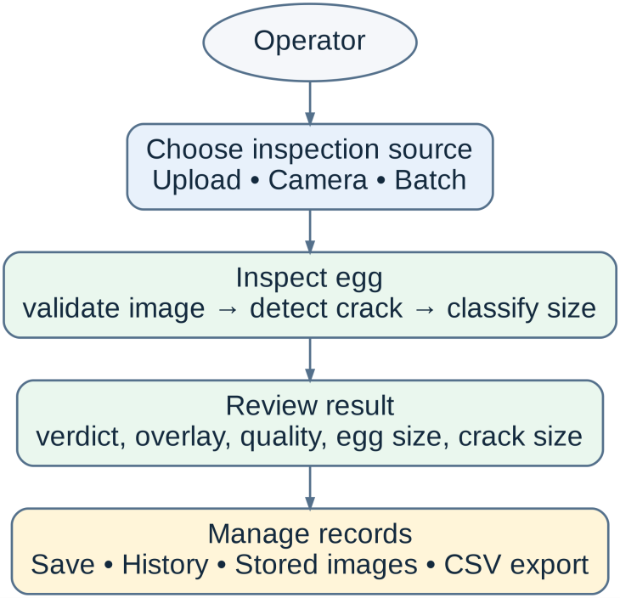
Figure 3. Updated use case diagram of the Egg Crack Detection System.
The primary actor is the egg inspection operator. The operator can upload one image, capture one camera frame, capture a three-frame set, or process several files. The system validates the image and detected egg before crack analysis. After processing, the operator can review the verdict, overlay, quality values, and apparent size labels; save the record; browse or delete detections; open stored source and overlay images; and export a CSV report.
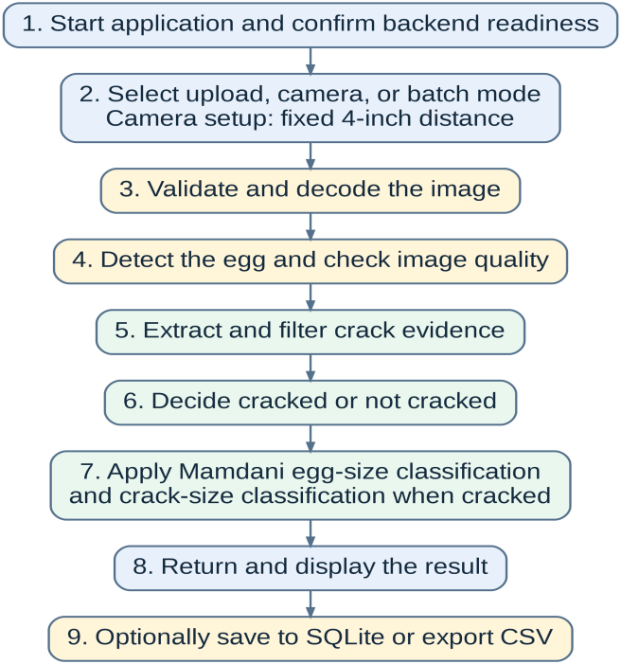
Figure 4. Updated detection activity workflow for upload, camera, batch, classification, and persistence operations.
All modes enter the same detector after route-specific validation. The camera route applies orientation correction and a lower-latency configuration. The multi-frame route processes usable frames concurrently and then applies canonical registration and spatial agreement. A failed quality or egg-segmentation condition becomes an HTTP 422 response that Flutter converts into a recapture or correction message.
Request Sequence and Stable Interfaces
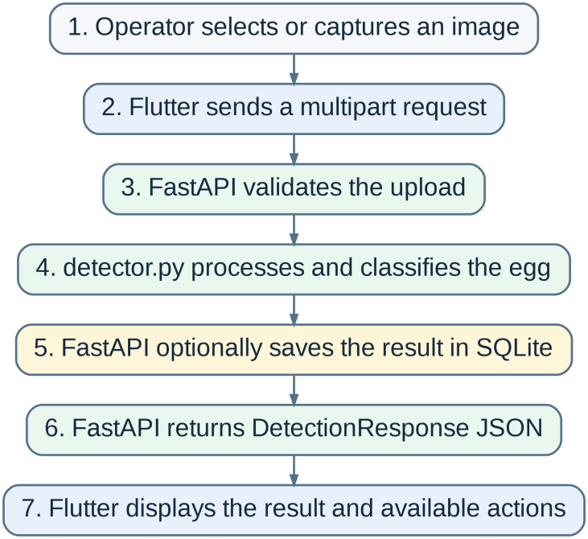
Figure 5. Request sequence for a single-image detection and optional SQLite save.
For single-image detection, the operator selects a file through the Flutter screen. The screen asks the feature Cubit and repository to start detection. The repository creates multipart data and calls ApiService. ApiService verifies backend readiness, sends POST /detect, and waits for the typed JSON response. FastAPI validates the upload, sends decoded bytes to detector.py, optionally calls DetectionDB.add(), and returns DetectionResponse. Flutter maps the fields to DetectionResult and updates the screen state.
The camera workflow uses the same response model and the fixed 4-inch camera-to-egg arrangement. The one-frame route is POST /detect/camera, the multi-frame route is POST /detect/camera/multi, and focus assistance uses POST /focus/score. The three-frame request repeats the image field and uses a longer receive timeout in the camera repository because several images are processed before one decision is returned.
Method | Path | Purpose
GET | /health | Checks backend readiness, engine, owner, and service version.
POST | /detect | Processes one uploaded egg image and optionally saves the record.
POST | /detect/batch | Processes several images and returns independent success or failure entries.
POST | /detect/camera | Processes a compatible one-frame camera request.
POST | /detect/camera/multi | Processes up to three camera frames and validates spatial agreement.
POST | /focus/score | Returns egg-region focus information for camera guidance.
GET / POST / DELETE | /history | Compatibility routes that list, add, or clear records in the active SQLite store.
GET / DELETE | /history/{item_id} | Reads or deletes one record through the compatibility path.
GET | /detections | Lists SQLite detection summaries.
GET | /detections/{item_id} | Returns one stored detection summary.
GET | /detections/{item_id}/original | Serves the stored original JPEG file.
GET | /detections/{item_id}/overlay | Serves the stored overlay PNG file.
DELETE | /detections/{item_id} | Deletes one record and its associated local image files when possible.
DELETE | /detections | Clears all records and associated local image files when possible.
GET | /reports/export | Streams egg_crack_report.csv from up to 1000 stored records.
Table 3. Public API endpoints implemented in the current repository
Development Phase
The development phase converted the approved requirements and diagrams into a local Windows application. Implementation was divided between the Flutter frontend and Python backend. Communication occurs over the local loopback address. This keeps the computer-vision service independent from interface code and allows detector tests to call Python functions without an HTTP request.
Component | Source File | Implementation Responsibility
FastAPI application | backend/src/app/api/main.py | Creates DetectionDB, declares routes, validates uploads, calls detector functions, handles HTTP errors, serves stored images, and creates CSV responses.
Detection configuration | backend/src/app/core/config.py | Stores working resolutions, quality thresholds, candidate limits, fuzzy scales, camera orientation (calibrated for 4-inch camera distance with 550.0 reference minor axis), and multi-frame agreement settings.
Detection and fuzzy service | backend/src/app/services/detector.py | Performs all OpenCV stages, binary crack decision, Mamdani egg/crack classification, focus scoring, canonical registration, dominance & elongation filtering, skeleton isolation cleanup, 1px polygon border overlay drawing, and camera consensus.
Response schemas | backend/src/app/schemas/detection.py | Defines typed Pydantic fields returned to Flutter and accepted by save operations.
Active SQLite repository | backend/src/app/repositories/db.py | Creates the detections table, stores summaries and image paths, handles CRUD, and strips large base64 fields from metadata.
Flutter API service | lib/services/api_service.dart | Creates the shared Dio client, checks /health, coordinates backend startup, sets operation timeouts, and maps backend errors.
Detection repository | lib/features/detection/data/detection_repository_impl.dart | Sends POST /detect and converts the response into the domain result.
Camera repository | lib/features/camera/data/camera_repository_impl.dart | Sends one-frame, multi-frame, focus, and compatible history requests with camera-specific timeouts.
Dependency registration | lib/core/di/service_locator.dart | Registers the backend launcher, API service, file and camera services, repositories, and DetectionCubit.
Result domain model | lib/features/detection/domain/detection_result.dart | Represents verdict, images, quality, candidate, size, location, and camera-consistency fields in Dart.
Table 4. Main source files involved in the current implementation
Increment 1: Flutter Desktop Foundation
The first increment established the Windows desktop shell and shared services. The application initializes Flutter plugins, configures the desktop window, displays persistent navigation, and registers reusable dependencies through GetIt. Feature screens request repository interfaces instead of constructing Dio clients or camera controllers directly.
ApiService uses a queued interceptor so simultaneous feature requests do not create competing readiness checks. Before every non-health request, it confirms backend readiness. A successful health result may be reused for three seconds. Health requests use short connection and receive periods, while normal image operations use longer receive periods. Camera requests use longer limits because multi-frame detection processes several images before a response is available.
DetectionCubit presents a predictable state sequence: initial, loading, success, and failure. This allows the screen to disable repeated actions, display progress, render returned image evidence, or show a correction message without embedding transport logic in the widget tree.
Increment 2: Layered Backend and API Integration
The second increment created the local Python service and request contract. The FastAPI application binds to the configured local address and exposes health, detection, camera, focus, history, explicit detections, stored-image, and report routes. A route reads multipart content, verifies file extensions, enforces the 20-megabyte limit, rejects empty data, and sends bytes to the detector. DetectionError and OpenCV errors become HTTP 422 responses so that the operator can correct the capture.
The health response identifies the engine as opencv-image-processing-only, identifies the camera owner as flutter-frontend, and reports service version 1.7. The response schema converts NumPy arrays and scalars into transport-safe strings, lists, integers, and floating-point values. Base64 images are returned for immediate display, while the database layer separately converts saved source and overlay images into files.
The active startup path constructs DetectionDB at backend/data/detections.db. This confirms that normal operation uses SQLite. Route functions call the db object created from db.py.
Increment 3: Full-Shell OpenCV Detection and Mamdani Classification
The third increment implements the main image-processing and classification engine. The detector is a deterministic sequence. A strong pixel response is not automatically accepted as a crack. Candidate evidence must survive image-quality validation, shell masking, component geometry rules, perimeter checks, channel fusion, decision scoring, and the final binary verdict before fuzzy crack-size classification is performed.
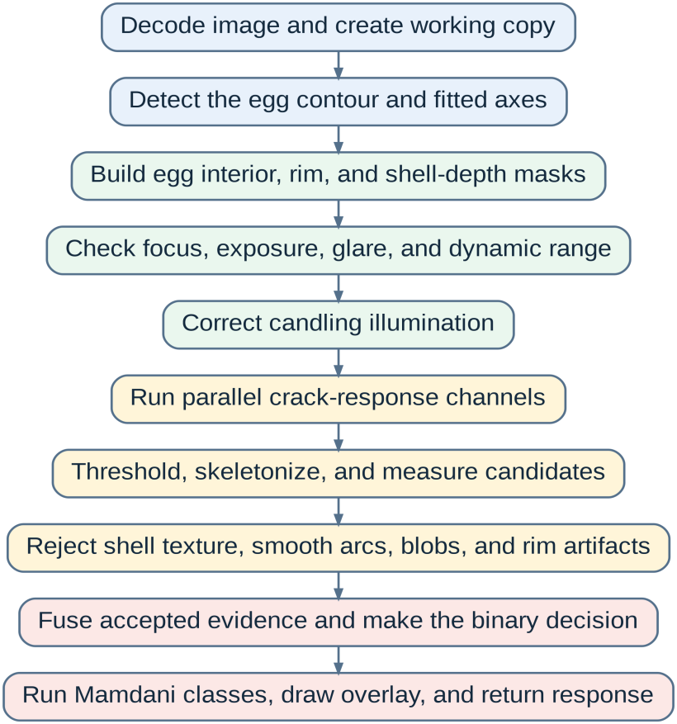
Figure 6. Detailed sequence of the current image-processing and classification pipeline.
Input Decoding and Working Resolution
OpenCV decodes the uploaded byte sequence into a BGR source array. That decoded source is retained for possible detail refinement, while detection proceeds on a prepared working image. Uploaded images are downscaled only when they exceed the configured 1920 by 1080 working target, and aspect ratio is preserved. Camera analysis uses a 960 by 540 target through a faster configuration because several frames are processed for one decision. The response field original_image_b64 encodes the final working image used by the detector.
After the first egg contour is found, the detector may return to the original source when the apparent egg minor axis is below the detail target. Refinement is bounded to a maximum scale of 1.5. This avoids processing every camera image at maximum resolution while preserving source detail when a small egg would otherwise lose faint fractures.
Egg Segmentation and One-Egg Validation
Egg segmentation generates several foreground masks instead of relying on one global threshold. The detector uses LAB distance from border-estimated background, grayscale difference, HSV value and saturation, separate gray, red, and green channels, Otsu binary and inverse masks, and a center-color mask. Morphological closing and opening reduce holes and isolated noise before external contours are evaluated.
A contour candidate is scored using image-area ratio, width and height, edge contact, center distance, aspect ratio, fill, and egg-like shape. The accepted contour is rasterized as a filled egg mask, and fitted dimensions provide major and minor axes. Images with no reliable egg, several plausible eggs, a severely cropped egg, or an egg occupying an unsuitable portion of the frame are rejected.
Egg-Relative Geometry Scaling and Shell Zones
Pixel-based geometry rules are scaled from the apparent egg minor axis. The reference is 550 pixels (calibrated for 4-inch camera distance), and the scale is clipped from 0.65 to 2.25 (`geometry_scale = clip(egg_minor_axis / 550.0, 0.65, 2.25)`). Lengths, gaps, morphology kernels, component areas, and perimeter distances change with apparent shell size instead of remaining fixed.
A narrow inner boundary guard equal to approximately one percent of the egg dimension removes uncertain background pixels. A distance transform assigns each shell pixel a depth from the nearest boundary. Depth values divide the shell into perimeter and interior zones and support rejection of smooth candidates that merely follow the shell tangent. A valid near-rim fracture remains accepted when it penetrates inward rather than tracking the contour.
Image-Quality Gate
Image quality is measured inside the detected egg. The detector uses Laplacian variance for local detail, Sobel boundary gradient statistics for edge sharpness, brightness percentiles, dynamic range, saturated-pixel ratio, and broad glare component thickness. This prevents background objects from dominating decisions and allows the backend to return a specific recapture error before fuzzy classification.
Measurement | Implementation | Purpose
Laplacian detail variance | Variance of the Laplacian within the shell. | Detects loss of fine detail from blur.
Boundary sharpness | Ninetieth percentile of Sobel gradient magnitude near the egg boundary. | Confirms that the shell edge contains usable focus evidence.
Brightness percentiles | p05, p50, p95, and p99 values inside the egg. | Identifies severe underexposure, clipping, and abnormal illumination.
Dynamic range | p95 minus p05. | Rejects flat captures that do not preserve shell contrast.
Saturated-pixel ratio | Share of shell pixels at or above 250. | Measures clipped highlight coverage.
Broad glare ratio and thickness | Connected bright components at or above 247 and their distance-transform thickness. | Distinguishes broad flashlight glare from narrow bright crack evidence.
Quality score | 0.38 sharpness + 0.27 detail + 0.20 exposure + 0.15 contrast. | Provides a normalized review value; hard failures still stop processing.
Table 5. Implemented image-quality measurements and behavior
The quality gate differentiates a difficult but informative image from an unusable image. Strong blur, severe overexposure, broad glare, severe darkness, or insufficient contrast raises DetectionError. The FastAPI route returns HTTP 422, and Flutter presents the explanation.
Candling Correction and Local Detail Preparation
Candling creates a bright central field, darker shell edges, and gradual illumination change. The detector estimates a broad flat-field with a Gaussian operation. For large inputs, the illumination source is reduced to a maximum dimension near 480, blurred, and expanded again. The broad sigma is 90 and correction strength is 0.82.
Contrast Limited Adaptive Histogram Equalization uses a clip limit of 4 and an 8 by 8 tile grid to strengthen local structures. A light bilateral filter with diameter 5 and color/spatial sigma values of 15 reduces noise while preserving line boundaries. A separate median-blurred dark-preserved image retains weak dark hairlines.
Parallel Crack-Response Channels
The detector runs related response channels because visible cracks do not have a uniform appearance. Each channel creates a response image, adaptive weak and strong masks, candidate components, and channel-specific geometry measurements. Accepted evidence is fused after separate filtering.
Channel | Primary Evidence | Reason for Inclusion
Dark-line responses | Narrow local valleys at several scales. | Finds dark hairlines and transmitted-light reductions.
Bright-line responses | Narrow bright ridges and light leaks. | Finds cracks that transmit more candling light.
Hessian texture responses | Dark, bright, anomaly, and coherence structures. | Measures curvilinear shell texture and line organization.
Laplacian-of-Gaussian response | Zero-crossing and local ridge behavior. | Highlights fine line transitions at several widths.
Gradient response | Abrupt local intensity change. | Supports fracture boundaries that are not purely dark or bright.
Dark-valley response | Local dark evidence from the preserved detail image. | Protects faint hairlines from aggressive smoothing.
Local hairline responses | Localized dark and bright line evidence. | Recovers short shell traces missed by broad responses.
Persistent luminance traces | Dark or bright structures remaining through related preprocessing. | Rewards evidence that survives more than one enhancement path.
Pale-surface response | Pale ridges, broad support, and skeleton-first recovery. | Finds branching fractures that appear lighter than their surroundings.
Paper-style channel | Red blur, green shell ROI, contrast, Canny, directional morphology, and component filters. | Maintains a parallel classical route based on the paper-style sequence.
Table 6. Main crack-response channels in detector.py
Paper-Style Crack Channel
The paper-style path resizes its working image to 1147 by 633, separates red and green channels, and applies an 11 by 11 Gaussian blur to the red channel. An Otsu mask is inverted when the foreground occupies more than half the image. The binary region is combined with the resized egg mask and closed with a 9 by 9 operation to create a safe green-channel shell region.
Within that region, a local Gaussian background with sigma 9 produces bright and dark contrast responses; dark contrast is multiplied by 1.8. Adaptive percentiles near 95.5 or 96.8 choose strong evidence. Directional line openings use a length of 21 at 0, 30, 60, 90, 120, and 150 degrees. Canny thresholds are derived from the median green value, and a 3 by 3 cross kernel closes short edge gaps.
The resulting contrast, morphology, directional, and edge masks are combined. Connected components are retained when their area is at least 7 pixels but no more than 1.2 percent of egg area, span is at least 28 pixels, and elongation, perimeter, density, and thickness rules remain crack-like. A depth-core rule with a minimum shell-depth ratio of 0.05 reduces boundary artifacts.
Component Measurement, Multi-Layer Rejection, and Isolation Cleanup
Every candidate component is skeletonized and evaluated. In `_is_crack_seed`, a multi-layer line-shape elongation filter enforces that candidate seeds must satisfy `metrics['elongation'] >= 2.5` or `metrics['skeleton_length'] >= 55.0`. Candidate components failing this seed gate are discarded as non-line specks.
In `_evaluate_normal_crack`, decision rules require a minimum longest trace near 70 scaled pixels (`metrics['longest_trace'] >= 70.0`), a total trace length near 100 scaled pixels (`metrics['total_trace'] >= 100.0`), a decision score >= 0.50, and mandatory elongation >= 2.5.
Furthermore, a post-decision dominance filter retains secondary co-components only if their length is >= 38% of the primary trace or score is >= 35% of the primary score. When the primary trace is strongly linear (`elongation >= 3.0`), non-linear co-components are stripped. Finally, a pixel-level skeleton isolation cleanup removes residual fragments separated by more than 50 pixels from the main crack body, eliminating isolated speckle dots.
Pale Crack Network Recovery and Evidence Fusion
The pale-surface path separates a broad support region from the thin centerline. The recovery path preserves the skeleton before broad masks are evaluated. Candidates satisfy minimum length, span, response strength, branch ratio, axis deviation, smooth-arc rejection, rim-overlap, and shell-depth requirements.
A strong, long interior candidate becomes an anchor. Nearby fragments join the network when endpoint distance, axis alignment, connector direction, fragment strength, and branch evidence are compatible. Returned overlays use actual skeleton pixels.
Binary Crack Decision
The binary verdict is formed before fuzzy crack-size classification. Decision scores combine longest accepted trace, total trace length, strongest response, best component score, and accepted pixel count. The final binary result is positive when component logic or paper-style channels are positive. If no accepted crack remains, crack_size is returned as none.
Mamdani Fuzzy Inference Design
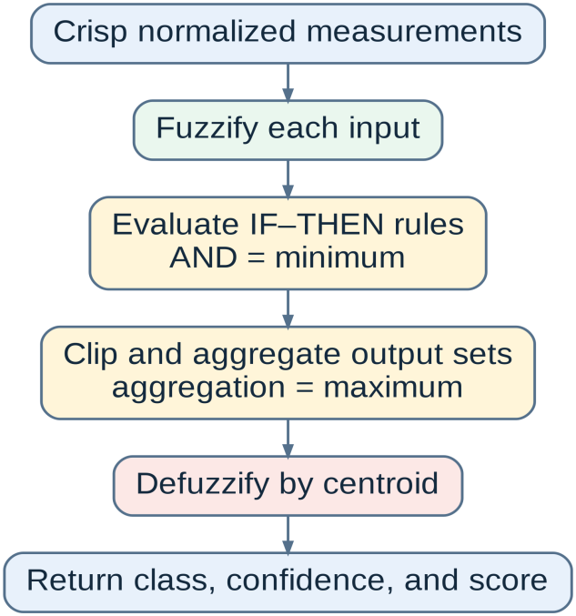
Figure 7. Mamdani fuzzy inference sequence implemented for apparent egg size and detected crack size.
Both classifiers use a pure NumPy Mamdani procedure. The output universe contains 1000 evenly spaced values from 0 to 1. For each rule, antecedent AND is evaluated with minimum membership. Rule firing strength clips the consequent output set with a minimum operation. All clipped output sets are aggregated through a pointwise maximum. Final crisp scores represent the centroid of the aggregated area: z = sum(u x membership(u)) / sum(membership(u)).
The shared inference engine calculates the area contributed by each output class after aggregation. The class with the largest normalized contribution area becomes the label. Its contribution fraction becomes confidence, while normalized class contribution areas form the membership dictionary.
Output Class | Membership Function on [0, 1] | Meaning
Small | Trapezoid (0.00, 0.00, 0.25, 0.45) | Low apparent size or low crack severity.
Medium | Trapezoid (0.30, 0.45, 0.55, 0.70) | Intermediate apparent size or crack severity.
Large | Trapezoid (0.55, 0.75, 1.00, 1.00) | High apparent size or crack severity.
Table 7. Shared Mamdani output membership functions
Mamdani Apparent Egg-Size Inputs and Rules
The egg-size classifier uses three dimensionless measurements from the accepted egg contour: egg_area_ratio (contour area / full image area), egg_width_ratio (fitted minor axis / image width), and egg_length_ratio (fitted major axis / image height). All inputs are clipped to the 0 to 1 universe.
These values describe apparent geometry under the fixed 4-inch (101.6 mm) camera-to-egg setup (calibrated with 550.0 px minor axis reference). For consistent labels, camera distance (4 inches), resolution, zoom, crop, orientation, and egg placement remain fixed.
Input | Small | Medium | Large
Egg area ratio | trap (0.00, 0.00, 0.12, 0.22) | trap (0.15, 0.24, 0.32, 0.42) | trap (0.35, 0.46, 1.00, 1.00)
Egg width ratio | trap (0.00, 0.00, 0.24, 0.35) | trap (0.28, 0.38, 0.48, 0.58) | trap (0.50, 0.62, 1.00, 1.00)
Egg length ratio | trap (0.00, 0.00, 0.36, 0.50) | trap (0.42, 0.52, 0.62, 0.72) | trap (0.66, 0.78, 1.00, 1.00)
Table 8. Mamdani apparent egg-size input membership functions
Rule | Antecedent | Consequent
E1 | IF egg area is Small | THEN egg size is Small
E2 | IF egg area is Medium | THEN egg size is Medium
E3 | IF egg area is Large | THEN egg size is Large
E4 | IF egg width is Small | THEN egg size is Small
E5 | IF egg width is Medium | THEN egg size is Medium
E6 | IF egg width is Large | THEN egg size is Large
E7 | IF egg length is Small | THEN egg size is Small
E8 | IF egg length is Medium | THEN egg size is Medium
E9 | IF egg length is Large | THEN egg size is Large
E10 | IF egg area is Small AND egg width is Small | THEN egg size is Small
E11 | IF egg area is Medium AND egg width is Medium | THEN egg size is Medium
E12 | IF egg area is Large AND egg width is Large | THEN egg size is Large
Table 9. Complete Mamdani apparent egg-size rule base
Mamdani Crack-Size Inputs and Rules
The crack-size classifier executes when the binary detector reports a crack. Four normalized measurements are clipped from 0 to 1: length (traced skeleton length / 520), area (traced pixel ratio / 0.035), strength (strongest response / 100), and count (component count / 8).
Input | Small | Medium | Large
Normalized length | trap (0.00, 0.00, 0.08, 0.35) | trap (0.15, 0.35, 0.55, 0.75) | trap (0.55, 0.80, 1.00, 1.00)
Normalized area | trap (0.00, 0.00, 0.04, 0.18) | trap (0.08, 0.22, 0.40, 0.65) | trap (0.48, 0.72, 1.00, 1.00)
Normalized strength | trap (0.00, 0.00, 0.20, 0.50) | trap (0.25, 0.45, 0.65, 0.85) | trap (0.65, 0.88, 1.00, 1.00)
Normalized component count | trap (0.00, 0.00, 0.15, 0.55) | trap (0.20, 0.40, 0.60, 0.80) | trap (0.60, 0.85, 1.00, 1.00)
Table 10. Mamdani crack-size input membership functions
Rule | Antecedent | Consequent
C1 | IF length is Small AND area is Small | THEN crack size is Small
C2 | IF length is Small AND strength is Small | THEN crack size is Small
C3 | IF strength is Small AND count is Small | THEN crack size is Small
C4 | IF length is Medium AND area is Medium | THEN crack size is Medium
C5 | IF length is Medium AND strength is Medium | THEN crack size is Medium
C6 | IF area is Medium AND count is Medium | THEN crack size is Medium
C7 | IF count is Medium AND strength is Medium | THEN crack size is Medium
C8 | IF length is Large AND area is Large | THEN crack size is Large
C9 | IF length is Large AND strength is Large | THEN crack size is Large
C10 | IF area is Large AND count is Large | THEN crack size is Large
C11 | IF strength is Large AND count is Large | THEN crack size is Large
C12 | IF area is Large AND strength is Large | THEN crack size is Large
Table 11. Complete Mamdani crack-size rule base
Output Mapping and Visual Overlay Tracing
The detector draws a green contour around the accepted egg and a 1px red border polygon contour outline (no fill) over accepted crack evidence in working-image coordinates using `_draw_trace_overlay`. In `_draw_trace_overlay`, `cv2.dilate(crack_mask, (3,3))` is called followed by `cv2.findContours` and `cv2.drawContours(overlay, contours, -1, (0, 0, 255), 1)`. The response includes original_image_b64, overlay, base64 crack mask, crack locations, candidate counts, longest candidate, primary channel, quality values, fuzzy classes/confidences, processing time, and camera consistency fields.
Before a SQLite save, the database repository removes base64 images from metadata_json because source and overlay images are saved directly in \Pictures\detected_eggs as `<id>_original.jpg` and `<id>_overlay.png`.
Increment 4: Single-Image and Batch Workflows
The fourth increment connected the detector to operator workflows. DetectionRepositoryImpl sends selected files to POST /detect and maps JSON responses into DetectionResult. Batch routes process UploadFile items independently.
Increment 5: Camera Focus, Orientation, and Multi-Frame Consensus
The fifth increment added camera-specific controls. Focus scoring measures Laplacian detail variance and Sobel gradient strength before capture. Supported orientation transformations include 0, 180-degree rotation, vertical flip, and horizontal flip.
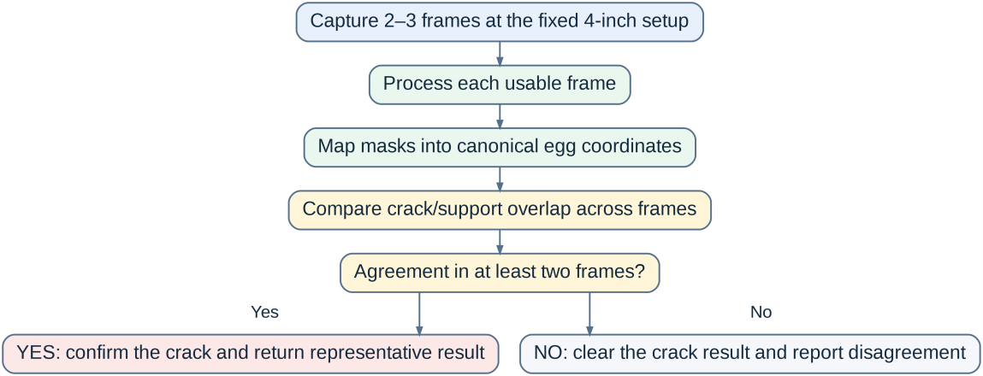
Figure 8. Multi-frame camera registration and spatial consensus workflow.
Multi-frame routes accept up to three frames concurrently. Usable frames map egg and crack masks into a canonical 512 by 768 coordinate system. Pairwise agreement dilates canonical crack masks by size 5 and measures bidirectional overlap. Pairs are stable when smaller bidirectional overlap reaches 0.18.
Increment 6: SQLite Persistence, Stored Images, and Reporting
The sixth increment established SQLite persistence. DetectionDB constructs detections.db with WAL mode and threading.Lock serialization. Working images and overlays are saved to \Pictures\detected_eggs as `<id>_original.jpg` and `<id>_overlay.png`.
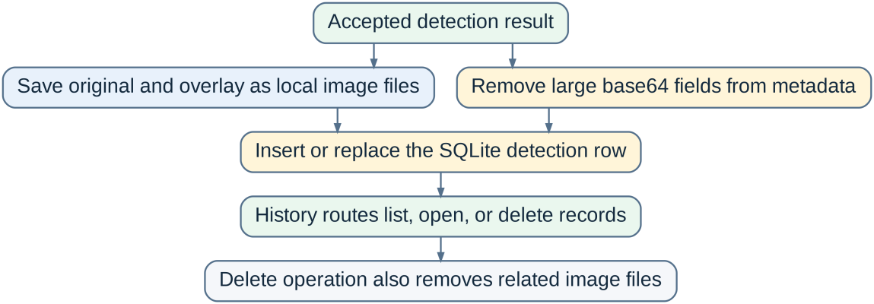
Figure 9. Active SQLite persistence and local image-file workflow.
No. | Column | Type / Constraint | Stored Meaning
1 | id | TEXT PRIMARY KEY | Detection identifier.
2 | timestamp | TEXT NOT NULL | ISO timestamp of the detection record.
3 | source_name | TEXT NOT NULL DEFAULT camera | Uploaded filename or camera source label.
4 | is_crack | INTEGER NOT NULL | Binary crack verdict stored as 0 or 1.
5 | confidence | REAL | Binary detection confidence.
6 | egg_size | TEXT | Apparent fuzzy egg-size label.
7 | egg_size_confidence | REAL | Fuzzy egg-size confidence.
8 | egg_size_score | REAL | Fuzzy egg-size centroid score.
9 | crack_size | TEXT | Fuzzy crack-size label or none.
10 | crack_size_confidence | REAL | Fuzzy crack-size confidence.
11 | contour_length | REAL | Accepted traced crack length value.
12 | area_ratio | REAL | Accepted crack area or trace ratio returned by the detector.
13 | egg_width_pixels | REAL | Fitted egg minor-axis width in pixels.
14 | egg_length_pixels | REAL | Fitted egg major-axis length in pixels.
15 | processing_time_ms | INTEGER | Backend processing time in milliseconds.
16 | original_image_path | TEXT | Path of saved source JPEG.
17 | overlay_image_path | TEXT | Path of saved overlay PNG.
18 | metadata_json | TEXT | Remaining response fields serialized as JSON.
Table 12. Exact columns of the active SQLite detections table
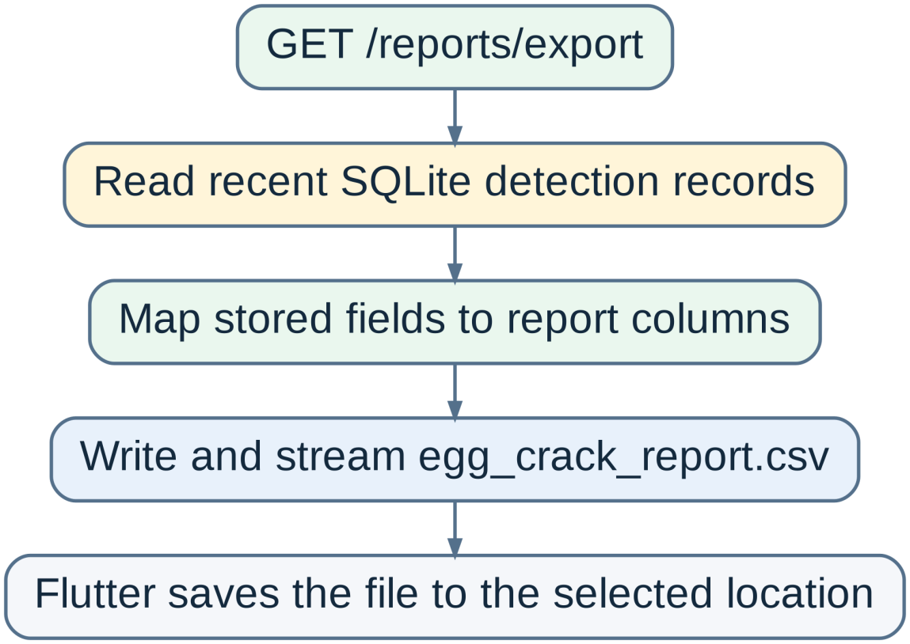
Figure 10. SQLite-to-CSV report generation workflow.
The report route reads detection records and projects summary values into egg_crack_report.csv.
Testing Phase
Testing is organized into detector tests (34 tests) and backend contract tests (5 tests) in Python. Cases cover segmentation, quality, channels, geometry scaling, fuzzy behavior, camera agreement, routes, and serialization.
Test Area | Examples of Covered Behavior
Egg and input validation | Egg mask detection, missing egg, multiple eggs, source resizing, and geometry scaling.
Image quality | Blur, glare, exposure, weak contrast, focus score, and recapture messages.
Crack responses | One-pixel cracks, low-contrast traces, bright light leaks, pale fractures, smooth arcs, rim texture, and clean-shell negatives.
Candidate geometry | Component filtering, skeleton behavior, fragmentation, shell depth, and resolution-relative thresholds.
Mamdani logic | Normalized memberships, apparent egg-size classes, crack-size classes, and no-crack behavior.
Camera consensus | Frame motion, canonical registration, overlap agreement, weak support, and disagreement clearing.
API contract | Health response, supported routes, upload errors, response fields, and history/report compatibility.
Table 13. Main test areas represented in the current repository
Test | Observed Difference | Meaning
test_fuzzy_egg_size_returns_normalized_memberships | Returned confidence was approximately 0.7954 while the test expected a value greater than 0.80. | The rule output is normalized, but the confidence boundary in the test and current membership overlap do not agree.
test_fuzzy_egg_size_memberships | A direct fuzzy call with area ratio 0.27 returned small while the test expected medium. | The active 12-rule area, width, and length behavior differs from an older one-input expectation.
test_clean_candled_egg_is_not_cracked | The binary result was clean, but egg_size was large while the test expected medium. | The apparent egg-size memberships require retuning for the synthetic clean sample.
test_clustered_rim_shell_texture_is_not_a_crack | A synthetic rim-texture case produced a crack false positive. | Perimeter and texture rejection still needs correction for clustered rim patterns.
test_fragmented_clean_texture_is_not_a_crack | The result was no crack, but raw candidate count was 7 while the test expected more than 8. | The output verdict is correct, but the regression expectation for entering the fragmentation path does not match current candidate generation.
Table 14. Confirmed test failures in the current repository snapshot
Deployment Phase
The system is deployed for local Windows execution. Flutter is the operator-facing interface, while BackendLauncherService manages local backend execution and checks /health. Deployment uses a controlled capture station at a fixed 4-inch (101.6 mm) camera distance.
Maintenance Phase
Maintenance includes reviewing rejected captures, updating configuration thresholds, monitoring database/image growth, and backing up detections.db together with Pictures/detected_eggs.
Results and Discussion
The system provides an end-to-end local workflow combining OpenCV detection, Mamdani classification, and SQLite storage. Egg-relative scaling maintains consistency across image sizes, while 4-inch capture distance provides stable framing.
Known Limitations
• Real-egg labeled evaluation datasets are required to compute accuracy, precision, and recall metrics.
• Camera positioning must remain at 4 inches for stable ratio-based apparent egg sizes.
• Microcracks lacking candling contrast may remain undetected.
• Database backups must include Pictures/detected_eggs along with detections.db.
Chapter Summary
This chapter presented the developmental research approach and Incremental Development Methodology for the Egg Crack Detection System. Six releases established Flutter desktop interfaces, FastAPI services, OpenCV crack detection, camera multi-frame consensus, Mamdani fuzzy classification, SQLite persistence, and CSV reporting. Camera capture operates at a fixed 4-inch distance with reference minor axis 550.0 px, 1px red border polygon crack overlays, and local SQLite image storage in Pictures/detected_eggs.
APPENDIX A
MAIN IMPLEMENTATION REFERENCES
Concern | Current Source Reference
FastAPI routes and active database creation | backend/src/app/api/main.py
Detection configuration and thresholds | backend/src/app/core/config.py
OpenCV detector, fuzzy functions, focus, and camera consensus | backend/src/app/services/detector.py
Typed backend response | backend/src/app/schemas/detection.py
Active SQLite schema, CRUD, image paths, and metadata handling | backend/src/app/repositories/db.py
Python detector tests | backend/tests/test_detector.py
Python backend contract tests | backend/tests/test_backend_contract.py
Dio readiness and transport | lib/services/api_service.dart
Single-image Flutter repository | lib/features/detection/data/detection_repository_impl.dart
Camera and focus Flutter repository | lib/features/camera/data/camera_repository_impl.dart
Dependency registration | lib/core/di/service_locator.dart
Dart result fields | lib/features/detection/domain/detection_result.dart
Frontend endpoint constants | lib/core/constants/api_constants.dart
Table A.1. Main implementation references used in this chapter

