CHAPTER IV
METHODOLOGY, RESULTS AND DISCUSSION
This chapter presents the methodology, development activities, testing procedures, deployment process, maintenance activities, and results of the Egg Crack Detection System. The researchers used the Incremental Development Methodology. Under this methodology, the system was divided into a series of working increments. Each increment passed through requirements identification, analysis, design, implementation, testing, deployment, and maintenance before it became a usable release. The output of one release served as the working foundation for the next increment. The completed system is a local Windows desktop application that uses Flutter for the user interface and camera workflow, while Python FastAPI, OpenCV, and NumPy perform input validation, egg segmentation, full-shell crack detection, feature extraction, two-stage Mamdani fuzzy classification, multi-frame validation, SQLite record storage, and CSV report generation.
Research Design / Approach
The study employed a developmental research approach because its primary purpose was to design, implement, and evaluate a working egg crack inspection system. This approach was appropriate because the study did not only describe an existing process; it produced a functional software solution that could accept an egg image, analyze the shell, identify possible cracks, display the detected trace, and provide a decision that could be reviewed by the operator.
The development process combined software construction, image-processing experimentation, integration testing, and repeated evaluation. Each function was examined based on its practical contribution to the inspection workflow. A feature was considered complete only when it could operate together with the existing application, produce understandable output, and maintain the required response structure. This approach allowed the researchers to improve the detector while preserving the functions already available to the user.
The system was designed as a local desktop application for Windows. Flutter manages the application window, navigation, image selection, camera discovery, preview, focus checking, image capture, result display, history viewing, and report access. The Python backend manages input validation, egg segmentation, image-quality checking, multi-channel crack extraction, final-mask measurement, Mamdani crack and egg-size classification, camera-frame comparison, SQLite history persistence (storing image files locally in \Pictures\detected_eggs and file paths in SQLite), and CSV report generation. Separating the two parts reduces the responsibility of each component and keeps the image-processing and fuzzy-classification logic independently testable.
Incremental Development Methodology
The Incremental Development Methodology was selected because the Egg Crack Detection System contains several related but separable capabilities. Developing the complete application in one attempt would make defects difficult to isolate and would delay the availability of a working system. The researchers therefore divided the project into six increments. Every increment followed the same sequence:
requirements, analysis, design, implementation, testing, deployment, and maintenance. At the end of the sequence, the increment produced a working release that remained available while the next capability was developed.
The methodology supported continuous improvement because feedback from testing and actual use was returned to the appropriate phase of the current increment. Problems identified in a release were corrected before the next increment was integrated. This process reduced late-stage integration risk and allowed the researchers to confirm that the Flutter interface, backend service, camera workflow, detection algorithm, history functions, and reporting features continued to operate after each addition.
The phases shown in Figure 1 were repeated for every system increment rather than performed only once for the entire project. To avoid repeating the same procedural explanation six times, the succeeding sections present the consolidated requirements, analysis, design, implementation, testing, deployment, and maintenance activities applied across all increments.
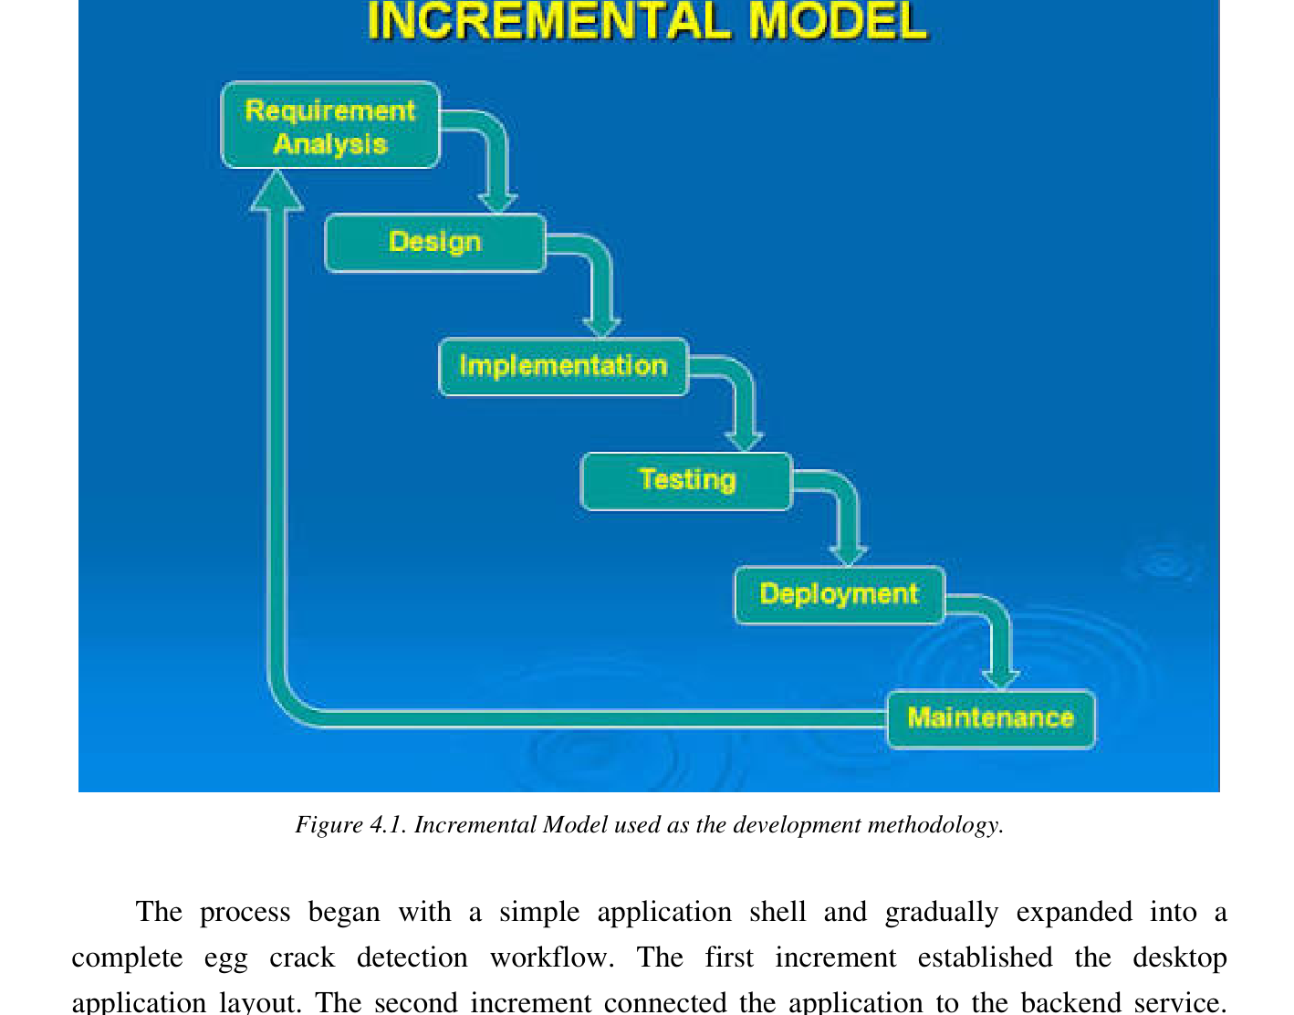
Figure 1. Incremental Development Methodology used in developing the Egg Crack Detection System.
Application of the Incremental Methodology
Increment / Release | Primary Focus | Working Output
1 / Release 1 | Flutter desktop foundation | Window configuration, application shell, navigation, dashboard, theme, and dependency registration.
2 / Release 2 | Backend and API integration | FastAPI service, backend launcher, readiness checking, multipart requests, and a stable response model.
3 / Release 3 | Crack detection and Mamdani classification | Egg segmentation, quality validation, full-shell multi-channel detection, accepted-mask feature extraction, two-stage crack classification, diameter-first egg-size classification, and result overlay.
4 / Release 4 | Single-image workflow | Image selection, state management, result mapping, image comparison, and optional history saving.
5 / Release 5 | Camera workflow | Focus scoring, three-frame capture, canonical egg registration, and two-of-three spatial agreement.
6 / Release 6 | Operational support and local persistence | Batch processing, SQLite history, CSV export, packaging, testing, calibration status, and documentation.
Table 1. Implemented increments and working releases
Requirements Identification Phase
At the beginning of every increment, the researchers identified the operator needs, system boundaries, image sources, processing requirements, acceptance criteria, and major accuracy risks related to the capability being added. The application was required to support an image selected from local storage, three images captured from a connected camera, and a group of files submitted for batch processing. The operator also needed to complete the inspection without manually starting several programs; therefore, Flutter had to start or locate the local backend and confirm its readiness before sending a request. The updated requirements also included explainable small, medium, or large classifications for accepted cracks, a clearly identified basis for egg-size classification, and local SQLite storage for inspection history.
The researchers also identified the shell conditions that the detector had to recognize. These included faint dark hairline cracks, bright light leaks, pale surface fractures, fragmented traces, horizontal egg positions, and cracks near the shell perimeter. At the same time, the system had to avoid treating pores, repeated shell texture, fibers, yolk boundaries, glare bands, shell-contour edges, and temporary camera artifacts as cracks.
The accuracy plan emphasized visible and repeatable evidence. Every positive result had to include a crack mask and an overlay showing the location of the accepted trace as a 1px red border polygon contour tracing the crack region. Camera-based decisions had to be supported by more than one frame so that a temporary reflection or shell texture appearing in a single image would not immediately produce a positive result. Raw images were retained as the valid basis for regression testing because images that already contained colored annotations could change the pixels processed by the detector.
The researchers established target response times for normal operation. A single uploaded image was expected to complete within approximately three seconds, while a three-frame camera decision was expected to complete within approximately eight seconds on the development machine. These values served as development targets rather than universal guarantees because camera drivers, processor speed, image resolution, and the number of accepted crack candidates can affect processing time.
Analysis Phase
After the requirements of an increment were identified, the researchers analyzed how the new capability would interact with the existing release. The analysis covered the inspection workflow, required inputs and outputs, API behavior, user actions, error conditions, fuzzy-classification inputs, calibration state, and compatibility with the implemented Flutter application and Python backend. The operator needed to select or capture an egg image, receive a clear crack verdict, review the accepted trace and measurements, see the Mamdani size classifications and memberships, save valid results,
process several files, and export stored data. The backend also needed to reject unsuitable images and return a clear explanation when recapture was required.
The analysis identified both functional and non-functional requirements. Functional requirements describe the operations available to the user, while non-functional requirements describe the expected quality, compatibility, response behavior, and maintainability of those operations.
Type | Requirement | Implementation Basis
Functional | Detect one uploaded egg image. | Flutter detection repository and POST /detect.
Functional | Capture an egg image using a connected camera. | CameraSessionService and the Flutter camera screen.
Functional | Validate camera evidence using several captures. | Three images submitted to POST /detect/camera/multi.
Functional | Display the verdict, trace, fuzzy classes, memberships, and measurements. | DetectionResponse, polygon overlay, crack mask, crack features, Mamdani scores, and calibration fields.
Functional | Process a group of selected images. | Batch queue and POST /detect/batch.
Functional | Save, review, delete, and export inspection results. | SQLite HistoryStore, history endpoints, and GET /reports/export.
Non-functional | Reject unsuitable images with an understandable message. | HTTP 422 responses for blur, glare, exposure, and weak contrast.
Non-functional | Preserve compatibility among existing screens and routes. | Stable API paths and DetectionResponse fields.
Non-functional | Use the declared local processing dependencies only. | OpenCV, NumPy, FastAPI, Pydantic, SQLite standard library support, Dio, and existing Flutter packages.
Non-functional | Maintain an interactive response time. | Development targets of three seconds for upload and eight seconds for the camera burst.
Table 2. Functional and non-functional requirements
The response model was analyzed as a shared contract between the frontend and backend. It contains the final
verdict, confidence, accepted crack area ratio, centerline length, processing time, source and overlay images, candidate statistics, image-quality values, crack mask, crack locations, termination reason, and multi-frame consistency values. The updated contract also carries the Mamdani version, crack-size score, crack-size memberships, crack-extent score, extracted crack features, egg-size score, egg-size memberships, egg-size basis, calibration status, physical measurements when calibration is verified, and a flag indicating whether a deterministic fallback was used. Optional diagnostic images are returned only when requested.
Design Phase
During the design phase of each increment, the researchers defined the component responsibilities, data flow, interface behavior, API contracts, storage boundaries, and expected outputs before implementation. New designs were required to fit the existing working release so that the addition of one capability would not break previously completed functions.
System Architecture
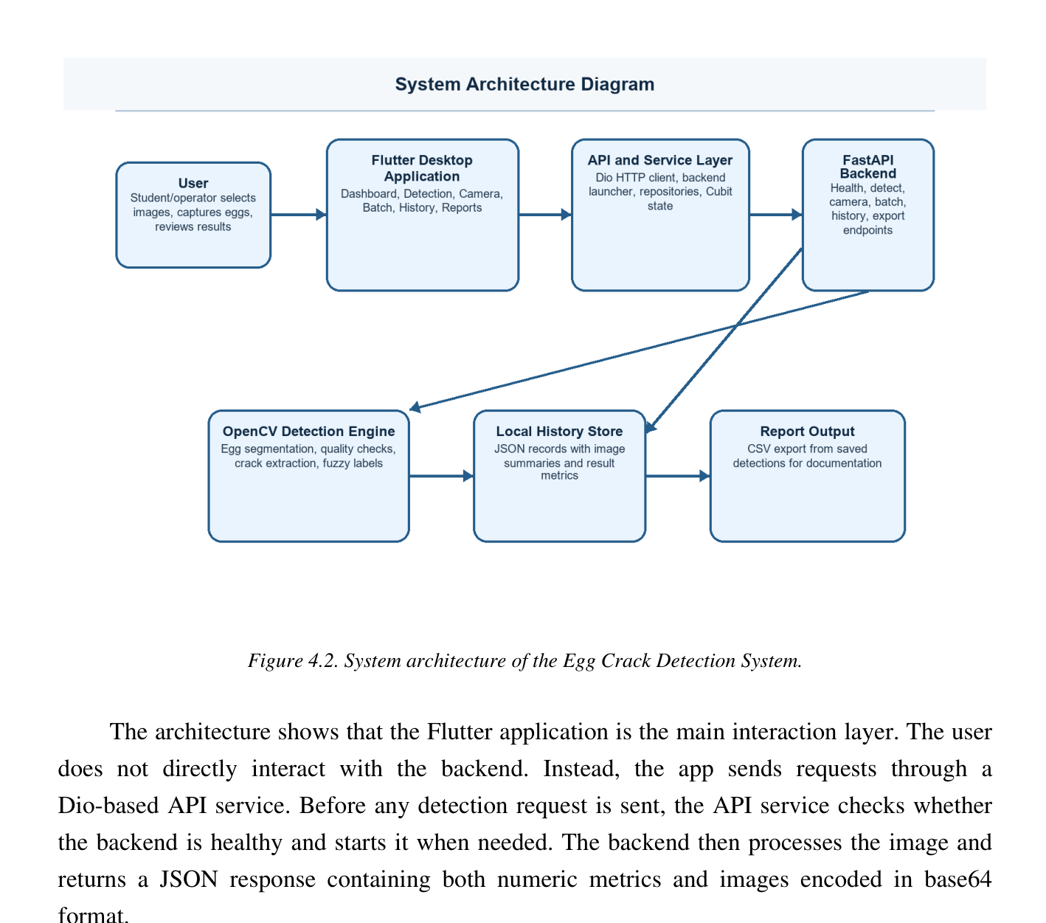
Figure 2. Updated system architecture showing OpenCV detection, Mamdani classification, and local SQLite persistence.
The system architecture is divided into frontend and backend responsibilities. The Flutter frontend follows a feature-oriented structure. Presentation screens and state-management components depend on repository interfaces, while concrete repositories send requests through the shared Dio API service. A backend launcher starts or locates the local Python process, and the API service checks the /health endpoint before a normal request is sent. Flutter owns camera discovery, preview, image capture, and operator interaction; it does not reimplement the detector or fuzzy rules.
The Python backend follows a layered source structure. The API layer handles HTTP requests and upload validation. detector.py performs egg segmentation, image-quality checking, full-shell crack extraction, camera consensus,
and result construction. mamdani.py keeps the unskeletonized crack mask and its centerline measurements separate, extracts classification features, applies the rule matrices, aggregates the clipped output sets, and calculates centroid scores. The core layer stores detector, calibration, membership, and rule-version settings. The schemas layer defines Pydantic contracts, while HistoryStore isolates SQLite persistence from the routes. This division keeps the user interface, computer vision, fuzzy inference, and storage concerns separate.
Use Case and System Workflow
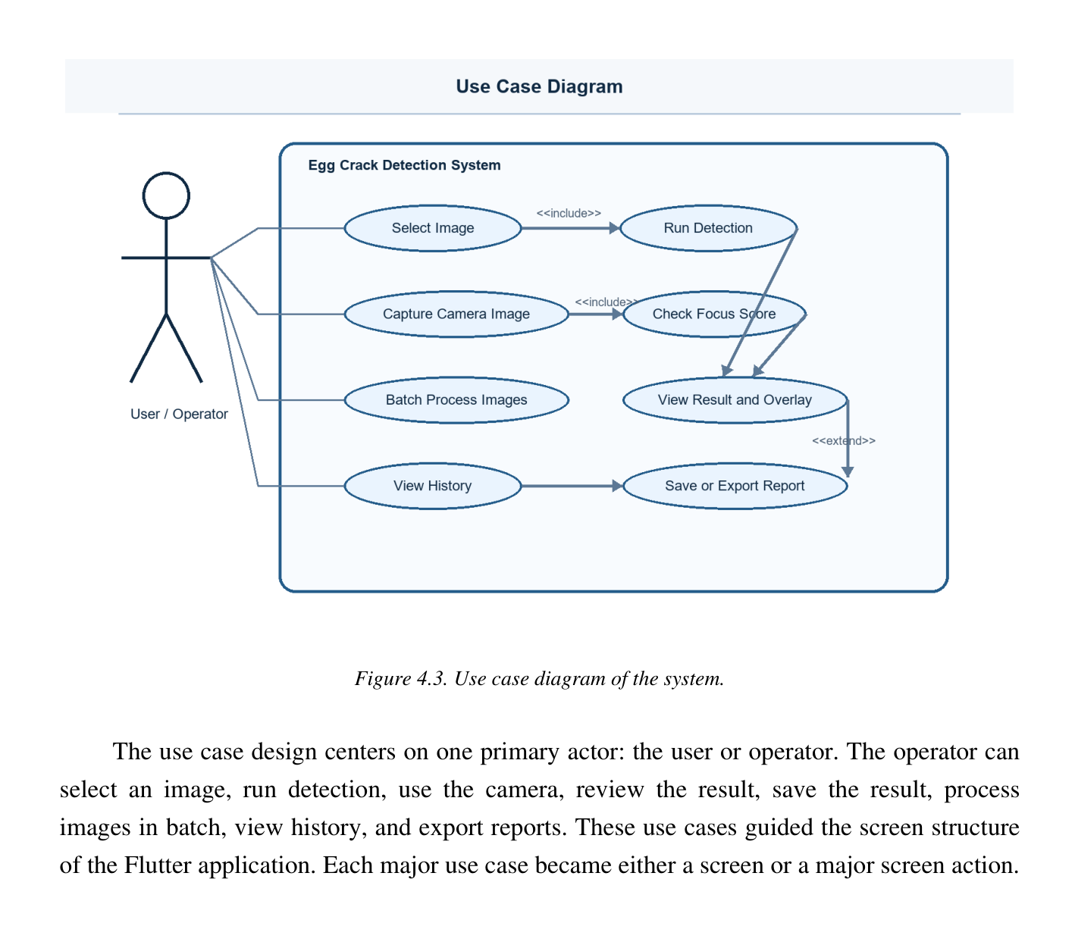
Figure 3. Updated use case diagram of the Egg Crack Detection System.
The primary actor is the operator. The operator can upload one image, capture camera frames, or select several images for batch processing. Before classification, the system validates the input, locates one usable egg, and checks focus, exposure, glare, and shell detail. Accepted images pass through OpenCV crack detection and then through Mamdani classification. The operator can view the verdict,
overlay, extracted features, fuzzy scores, memberships, egg-size basis, and calibration state. A valid result can be saved to SQLite, reviewed or deleted from history, and projected into a CSV report.
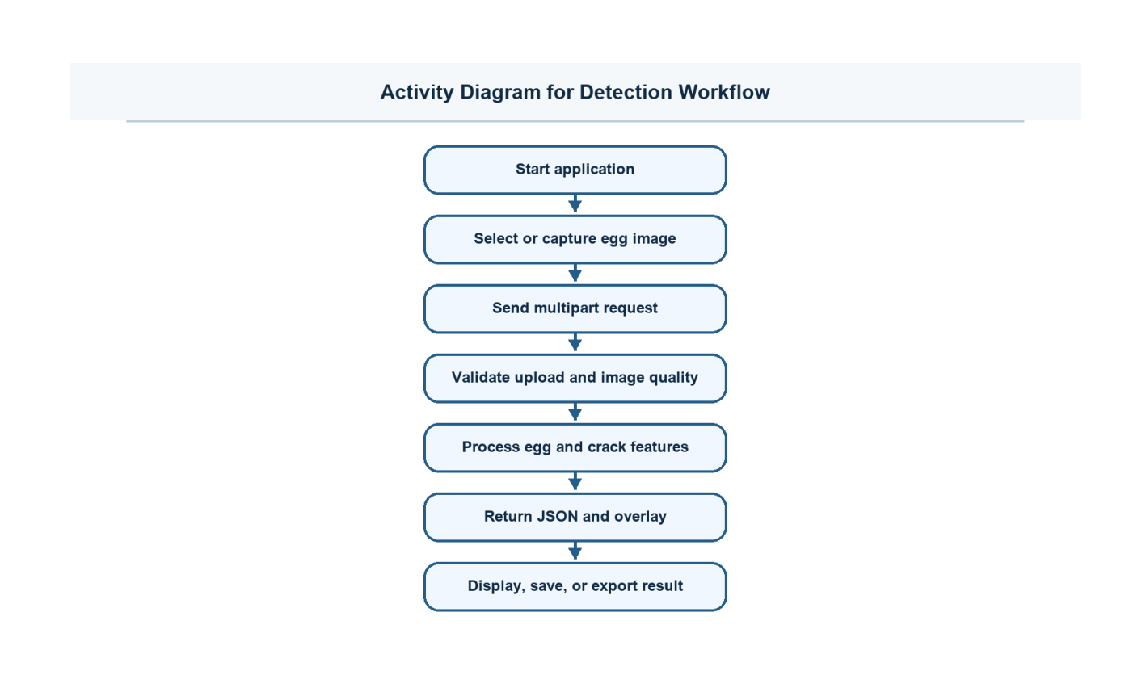
Figure 4. Updated detection activity workflow for uploaded images, camera captures, Mamdani inference, and optional SQLite persistence.
The activity workflow begins when the application starts and the operator chooses an input mode. Upload and batch paths submit multipart files, while the camera path performs focus guidance and sends repeated image fields. Every accepted image uses the same normalized detector. After the final crack mask is produced, the backend extracts full-mask and skeleton features, runs the Mamdani crack classifier, runs calibrated diameter-based egg classification or the explicit uncalibrated fallback, and returns either a structured result or a recapture error. Saving to SQLite and CSV export occur after a valid result exists and do not change the detector decision.
Request Sequence and Stable Interfaces
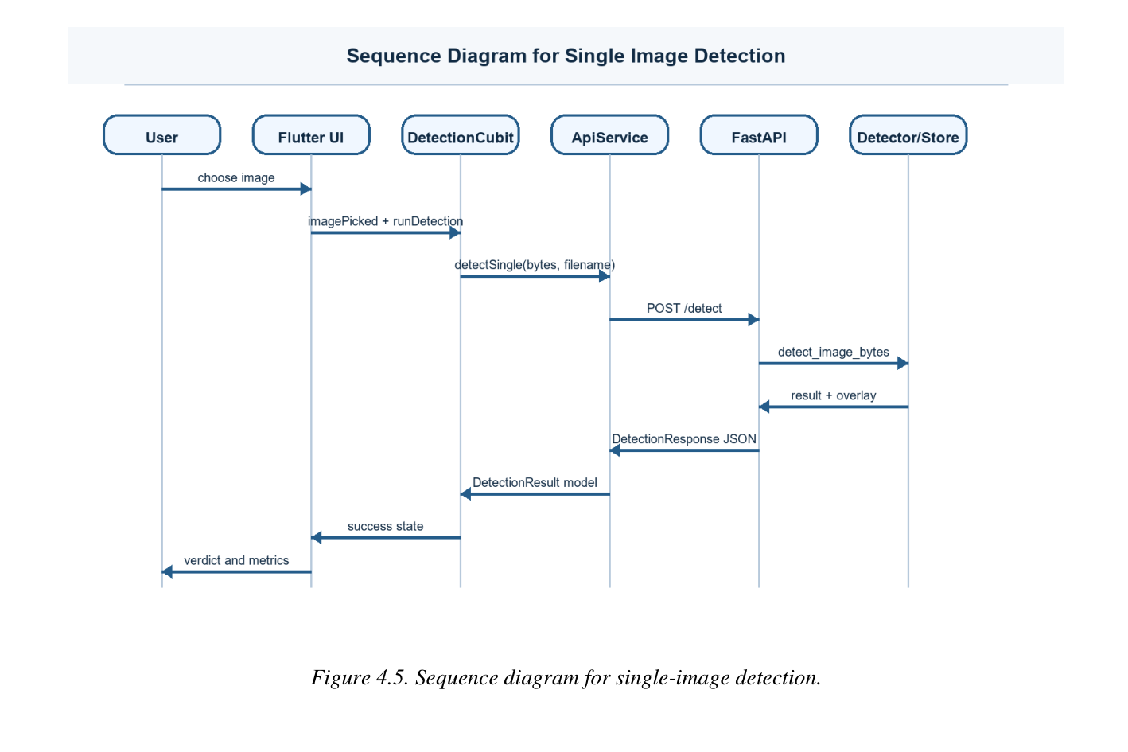
Figure 5. Updated request sequence for single-image detection, fuzzy classification, and optional SQLite saving.
For single-image detection, the operator selects an image through the Flutter screen. DetectionCubit requests the repository to start detection, the repository converts the file into multipart form data, and Dio sends POST /detect. FastAPI validates the upload and forwards the bytes to detect_image_bytes. The OpenCV service returns an accepted crack mask, trace mask, egg contour, and geometry. The Mamdani service extracts classification features and returns scores, labels, memberships, confidence values, and fallback status. FastAPI serializes the combined DetectionResponse, optionally asks HistoryStore to save the result to SQLite, and returns JSON that Flutter converts into the typed result model.
The camera workflow uses the same result model but submits repeated image fields to POST /detect/camera/multi. The compatible one-frame route remains available. Multi-frame registration is completed before the representative result is returned, but the accepted representative mask still passes through the same feature extraction and Mamdani output fields. Keeping one response contract prevents a separate result screen or a second classification rule set from being required.
Method | Path | Purpose
GET | /health | Checks backend readiness, classifier identity, fuzzy version, and camera ownership information.
GET | /calibration | Returns calibration ID, verification state, reference resolution, millimetres-per-pixel values, camera distance, and current egg-size basis.
POST | /detect | Processes one uploaded egg image and may save the valid result.
POST | /detect/batch | Processes several uploaded images and returns per-file status.
POST | /detect/camera | Provides compatible one-frame camera detection.
POST | /detect/camera/multi | Processes registered multi-frame camera evidence.
POST | /focus/score | Returns a focus score based on the detected egg region.
GET/POST/DELETE | /history | Lists, saves, or clears local SQLite history records.
GET/DELETE | /history/{item_id} | Reads or deletes a selected SQLite history record.
GET | /reports/export | Projects stored records into egg_crack_report.csv.
Table 3. Public API endpoints used by the implementation
Development Phase
The development phase converted the approved requirements and designs into a functional Windows desktop application. Development was performed through six increments. Each increment added a defined group of capabilities to the previous working release, passed through implementation and verification, and produced an updated release that retained earlier functions. The updated source adds a pure NumPy Mamdani inference service and replaces the earlier JSON history description with SQLite-backed local persistence (storing image files locally in \Pictures\detected_eggs and paths in SQLite) while preserving the public detection and history routes.
The implementation is divided between Flutter and a local Python backend. Flutter manages the window, navigation, user actions, file selection, camera preview, focus guidance, image capture, state presentation, result review, history access, and report download. Python manages upload validation, image decoding, egg segmentation, quality assessment, crack-response construction, candidate evaluation, accepted-mask fusion, Mamdani feature extraction and classification, camera-frame agreement, SQLite persistence, and CSV generation. Communication uses HTTP over the loopback address.
The following discussion describes the implemented components, the exact order in which image data moves through the system, the controls used to reject invalid inputs, the feature values supplied to Mamdani inference, the complete rule matrices, and the output produced by each increment. Function names, routes, response fields, and source-file responsibilities are included where they explain the implemented behavior. The chapter does not invent an unverified physical SQLite column schema; it
documents the logical records and repository operations exposed by the implementation.
Component | Source File | Implementation Responsibility
FastAPI routes | backend/src/app/api/main.py | Defines health, calibration, detection, camera, focus, history, and report endpoints; validates uploads and converts detector errors into HTTP responses.
Detection configuration | backend/src/app/core/config.py | Stores working resolutions, quality limits, geometry rules (calibrated for 4-inch camera distance with geometry reference minor axis 550.0), crack-candidate settings, Mamdani membership breakpoints, calibration values, and rule version.
Detection service | backend/src/app/services/detector.py | Performs egg segmentation, image-quality checking, full-shell crack extraction, response fusion, dominance and elongation filtering, skeleton isolation cleanup, 1px polygon border overlay drawing, coordinate mapping, fuzzy-service integration, and multi-frame consensus.
Mamdani service | backend/src/app/services/mamdani.py | Extracts full-mask and skeleton features; performs min-max rule inference, centroid defuzzification, confidence calculation, and deterministic fallback.
Response schemas | backend/src/app/schemas/detection.py | Defines the stable Pydantic response, including fuzzy labels, scores, memberships, features, calibration state, and storage fields.
History persistence | backend/src/app/repositories/history_store.py | Provides one repository interface for local SQLite save, list, read, delete, clear, and idempotent record handling.
Flutter API service | lib/services/api_service.dart | Creates the shared Dio client, checks readiness, applies timeouts, and converts backend errors into application messages.
Dependency registration | lib/core/di/service_locator.dart | Registers shared services, repositories, and feature state objects used by the desktop application.
Camera screen | lib/features/camera/presentation/screens/camera_screen.dart | Controls preview, focus guidance, repeated capture, progress display, and result navigation.
Camera repository | lib/features/camera/data/camera_repository_impl.dart | Creates repeated multipart image fields and sends the camera burst to the consensus endpoint.
Table 4. Main source files involved in the development phase
Increment 1: Flutter Desktop Foundation
The first increment established the Windows desktop application and provided the common structure required by all later features. Its output was a working application shell that could start, display the dashboard, move between feature screens, create shared services, and check whether the local Python backend was available. At this stage, the researchers focused on application stability and separation of responsibilities before connecting the complete image-processing workflow.
Application Initialization and Window Control
The Flutter entry point initializes the Flutter binding before any plugin is accessed. The window manager is then initialized so that the Windows application can define its desktop dimensions and behavior. The default window is configured at 1280 by 800 pixels, while the minimum size is restricted to 800 by 600 pixels. The minimum boundary prevents the navigation panel, image preview, result cards, and action controls from collapsing into an unusable layout when the operator resizes the window.
Dependency registration is completed before feature screens request services. The application is displayed as soon as the main setup is ready, while backend readiness
checking continues without blocking the first visible frame. This ordering improves startup behavior because the operator can see the application shell even while the local backend process is being located or started.
Routing and Persistent Desktop Shell
Navigation is organized through a persistent shell so that the sidebar, application title, active-route indicator, and common layout remain visible while the main content changes. Routes are provided for the dashboard, single-image detection, camera inspection, batch processing, history, and reports. Keeping the shell outside the individual feature screens prevents repeated construction of the desktop frame and gives every workflow the same navigation behavior.
Navigation was implemented through a persistent application shell. The dashboard, single-image detection, camera, batch processing, history, and reports screens are displayed within the same desktop frame. Dependency registration uses GetIt so that screens request repository interfaces and services rather than creating HTTP clients or camera controllers directly. State changes in the detection workflow are handled through Cubit so that loading, success, and failure conditions are presented consistently.
Dependency Injection and Service Ownership
GetIt is used as the service locator for application-wide dependencies. BackendLauncherService and ApiService are registered as shared services because every feature may require backend access. File-selection and camera-session services are also shared so that device ownership and file operations are controlled from one place. Repository
interfaces are bound to concrete implementations, which allows presentation components to request a detection or camera operation without knowing how Dio, multipart data, or local files are handled internally.
DetectionCubit is created for the feature that requests it rather than being treated as a permanent global object. This limits stale state between screens. The Cubit exposes a small and predictable state sequence: an initial state before processing, a loading state while the request is active, a success state containing the typed result, and a failure state containing a user-readable explanation. The interface reacts to those states by disabling repeated actions, showing progress, presenting the returned result, or asking the operator to correct the input.
Backend Readiness and Shared Error Handling
The frontend does not assume that the Python process is already running. BackendLauncherService first checks the configured loopback address. When the service is unavailable, the launcher starts the development script or packaged backend executable and waits for the health route to respond. ApiService performs the readiness check before normal feature requests and uses a queued process so that simultaneous screens do not start several backend checks or processes at the same time.
Dio timeouts are set according to the expected operation. Health checks use a short connection period, while image detection and camera consensus use longer receive periods because image processing requires more time than a status request. Network failures, backend startup failures, upload validation errors, and detector recapture
messages are translated into clear application messages instead of exposing a raw stack trace to the operator.
The main Flutter dependencies include flutter_bloc and equatable for predictable state transitions, go_router for desktop navigation, get_it for dependency registration, Dio for multipart HTTP requests, camera and camera_windows for device access, and file_selector and path for local file operations.
At the completion of Release 1, the application could open as a Windows desktop program, maintain a stable navigation frame, create its shared dependencies, and report whether the backend was ready. Crack analysis was not yet the focus of this increment. The purpose of the release was to provide a tested foundation on which the API, detector, camera, storage, and reporting capabilities could be added without changing the basic application structure.
Increment 2: Layered Backend and API Integration
The second increment created the local Python service and established the communication contract between Flutter and the detector. Its working output was an application that could locate or start the backend, confirm its readiness, submit multipart image data, receive typed JSON, and present validation failures consistently. The researchers kept the API layer separate from the image-processing layer so that route handling could be tested without placing HTTP responsibilities inside the detector.
Backend Startup and Layered Source Structure
The backend entry script adds the backend/src directory to the Python module path and starts Uvicorn with app.api.main:app. The service is bound to 127.0.0.1 on port
8756. Binding to the loopback interface restricts normal access to the same computer and matches the intended local desktop deployment. The API package owns route declarations, multipart reading, validation, response serialization, and HTTP status codes. The services package owns the computer-vision operations, while configuration, schemas, and persistence are kept in their corresponding layers.
This organization prevents the FastAPI route from becoming the detector itself. A route reads and validates the request, forwards image bytes and configuration to a service function, receives a plain result structure, and returns it through the Pydantic response model. Because the detection service can be called without HTTP, detector tests can execute directly and API contract tests can separately verify route behavior.
Upload Validation and Supported Image Types
The second increment established the local Python service and connected it to the Flutter application. The backend starts Uvicorn on 127.0.0.1:8756 and exposes the required routes through FastAPI. The API accepts JPG, JPEG, PNG, BMP, and WEBP image files, rejects empty uploads, applies a 20-megabyte limit, and returns validation errors when the submitted file cannot be processed.
For every uploaded file, the API verifies that a filename and supported extension are present, reads the multipart stream, checks that the byte sequence is not empty, and rejects content that exceeds the configured size limit. The byte sequence is then decoded by OpenCV. A file that has a permitted extension but does not contain a valid decodable image is treated as an invalid input. Detector
and OpenCV failures are converted into HTTP 422 responses because the operator must correct or recapture the image rather than retry the same invalid data unchanged.
Stable Response Contract
The DetectionResponse model serves as the stable contract used by upload, camera, history, and reporting workflows. Internal arrays created during image processing are converted into serializable values before the response is returned. This prevents the frontend from depending on OpenCV or NumPy objects and allows all detection modes to use the same result presentation.
The response includes the crack verdict, confidence, area ratio, contour or skeleton length, processing time, source and overlay images, quality measurements, candidate statistics, apparent egg-size and crack-size labels, crack-mask data, crack locations, termination reason, and camera-consistency values when applicable. Images are encoded into transport-safe values, coordinates are converted into standard lists, and NumPy scalar values are converted into normal Python numbers. This serialization step ensures that the JSON returned by FastAPI can be parsed directly into Dart types.
The same response structure is used by the upload, compatible camera, multi-frame camera, history, and report workflows. Maintaining one contract reduces duplicated parsing logic in Flutter and ensures that the result screen does not need separate display rules for every input mode. New internal registration arrays and temporary processing masks are removed unless they are intentionally exposed as diagnostic images.
Configuration and API Readiness
The backend configuration contains the working image sizes, quality limits, geometry scaling references, crack-candidate rules, camera-frame count, overlap threshold, and diagnostic options. Configuration values are centralized so that detector behavior can be adjusted without changing the API routes or user-interface code.
The health route provides a lightweight readiness response and backend ownership information. Flutter calls this route before sending normal work. A recent successful result may be reused briefly so that consecutive operations do not perform unnecessary startup checks. When the health request fails, the launcher verifies the executable or development script path, starts the backend, and polls until the service responds or the startup period expires.
At the end of Release 2, Flutter and Python communicated through a stable local API. The release could validate image uploads, return structured errors, preserve endpoint compatibility, and deliver a typed result contract even before all crack-response channels were finalized. This allowed the detector to be improved in the next increment without changing the public workflow.
Increment 3: Full-Shell Crack Detection Engine
The third increment implements the main computer-vision and classification engine. It transforms image bytes into a defensible crack verdict, a visible trace, and explainable fuzzy size outputs. The controlled stages are decoding, working-resolution selection, egg localization, quality validation, geometry normalization, shell-zone creation, candling correction, multi-channel response extraction, component measurement, false-positive
rejection, response fusion, full-mask preservation, skeleton feature extraction, Mamdani crack inference, diameter-based egg inference, confidence adjustment, output mapping, and optional persistence. Pixel detection remains an OpenCV task; Mamdani logic is used only after accepted evidence exists.
The detector decodes the image once, preserves the original source, locates one egg, validates capture quality, scales geometric rules using the apparent egg size (calibrated for 4-inch camera distance with reference minor axis 550.0), extracts several types of crack evidence, evaluates and links components, and produces both an unskeletonized accepted crack mask and a one-pixel trace. The full mask supplies area and width information, while the trace supplies length and topology information. The fuzzy service then converts these measurements into crack extent, crack severity, and egg-size outputs without changing which pixels were accepted as a crack.
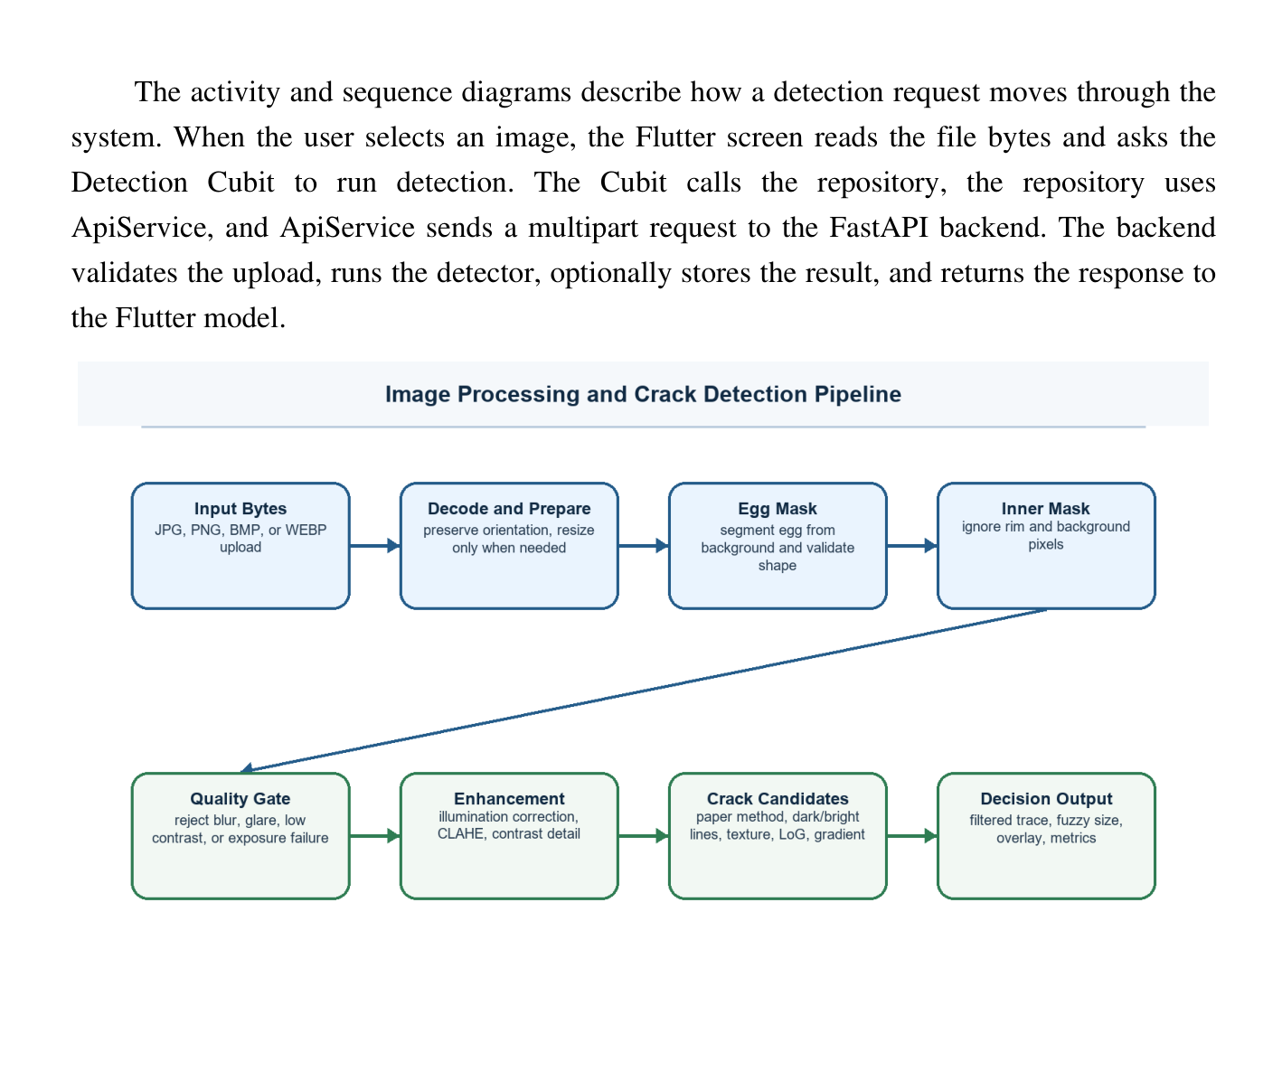
Figure 6. Updated full image-processing and Mamdani classification sequence.
Implemented Image-Processing Sequence
Stages 1 to 4 prepare and validate the input. OpenCV decodes the bytes into BGR form, stores the original dimensions, selects the upload or camera working resolution, and refines source detail only when the segmented egg is too small. Candidate foreground masks are scored using area, center position, contour dimensions, aspect ratio, and shape. The accepted contour becomes the binary egg mask. Sharpness, local detail variance, saturation, glare, median brightness, and dynamic range are measured inside that mask; an unusable capture stops with an HTTP 422 recapture explanation.
Stages 5 to 8 prepare the shell and produce crack evidence. The fitted major and minor axes establish egg-relative geometry. A narrow boundary guard, distance transform, perimeter zone, and deeper interior zone preserve near-rim fractures while supporting rim-artifact rejection. A broad illumination field corrects uneven candling. CLAHE, bilateral filtering, median-preserved detail, red/green paper-method processing, dark-line, bright-line, texture, Laplacian-of-Gaussian, gradient, valley, local-hairline, persistent-luminance, and pale-surface responses produce candidate masks for different crack appearances.
Stages 9 to 12 convert responses into accepted crack evidence. Connected components are skeletonized and measured for length, span, elongation, thickness, density, strength, direction, branching, perimeter overlap, and inward penetration. Smooth shell arcs, fibers, yolk boundaries, broad glare, compact texture, tiny speckle dots (filtered by minimum skeleton length 35px, span 28px, and mandatory elongation gate >= 2.5), and contour-
parallel rim evidence are rejected. Dominance filtering and skeleton isolation cleanup remove weak, disconnected secondary noise clusters. Pale fragments can be recovered as a network only after individual eligibility and endpoint geometry checks. Accepted channels are fused and deduplicated. The unskeletonized final mask is retained; a separate trace mask is used for length and topology. Mamdani stage one infers extent from normalized length and full-mask area, and stage two infers the final crack class from extent, apparent width, and clustered branches.
Stages 13 to 16 form the remaining result. When millimetre calibration is verified, egg size uses maximum breadth as the dominant input, supported by geometric mean diameter and projected area. Without verified calibration, the response is explicitly marked geometric_fixed_camera_uncalibrated and uses reference-frame pixel geometry instead of claiming a physical diameter. The backend calculates membership values, centroid scores, confidence and fallback status, maps masks and coordinates back to the source image, draws the red 1px polygon border overlay tracing the crack area and green egg contour, serializes the response, and optionally saves the valid summary through HistoryStore to SQLite.
Input Decoding and Working Resolution
The original image is retained after decoding. Uploaded images may be processed at a working size of up to 1920 by 1080 pixels, while camera frames use a 960 by 540 working image to reduce latency. When the egg occupies too few pixels for fine-detail analysis, the system may refine the working image from the original source so that weak or fragmented traces are not permanently lost during the first resize operation.
OpenCV decodes the byte sequence into a BGR image and records the original width and height. The detector creates a working copy while preserving the source array for final output and optional detail refinement. Resizing maintains the aspect ratio so that the egg is not geometrically stretched. The chosen working size balances trace visibility and processing cost: uploaded images may use the larger target, while camera images use the smaller target because three frames must be processed during one decision.
After the first egg contour is located, the detector measures the apparent minor axis. When that axis remains below the configured detail target and the original image contains additional resolution, a bounded refinement scale is calculated. Refinement is skipped when the expected increase is too small to provide meaningful detail. This selective strategy avoids processing every camera frame at maximum resolution while still recovering source detail for a small egg or weak fracture.
Egg Segmentation and Coordinate Normalization
Egg candidates are produced from threshold and color information and are evaluated using area, center position, contour dimensions, aspect ratio, and shape. After an egg contour is accepted, the detector determines the apparent major and minor axes. Measurements used by the detector are then scaled relative to the minor axis so that the same rules can be applied to eggs appearing at different image sizes.
Segmentation begins by producing possible foreground regions from intensity and color information. Morphological operations remove isolated noise and close small gaps in the shell region. External contours are collected and
scored. A useful egg candidate must occupy a meaningful part of the image, remain reasonably centered, have plausible width and height, and show an aspect ratio and contour shape consistent with an egg rather than a rectangular background object or a small bright spot.
The accepted contour is converted into a filled binary egg mask. An ellipse or equivalent axis measurement provides the major and minor shell dimensions. The minor axis is used as the geometry reference because it represents shell width regardless of whether the egg is upright, tilted, or horizontal. The contour and mask are retained for quality measurement, shell-depth analysis, overlay drawing, and camera registration.
The geometry scale is limited to a practical range before it is applied to lengths, areas, gaps, kernels, and perimeter widths. Length measurements use the scale directly, while area measurements use the square of the scale. Kernel and window sizes are rounded to valid odd values when required by the OpenCV operation.
The reference minor axis is 550.0 pixels (calibrated for 4-inch camera distance). A detected egg narrower than the reference reduces length-based thresholds, while a larger egg increases them. The scale is clipped between 0.65 and 2.25 so that an unusually small or large segmentation cannot create unreasonable thresholds. Minimum skeleton lengths, fragment gaps, boundary margins, decision lengths, and related pixel distances use the linear scale. Minimum component areas use the squared scale. Median filters and morphology kernels are rounded and corrected to valid odd sizes.
This normalization improves consistency when the operator changes the camera distance or submits an image with a different resolution. It does not replace proper
capture conditions, but it prevents a fixed ten-pixel rule, for example, from having a completely different physical meaning when the egg appears twice as large.
geometry scale = clip(egg minor axis / 550.0, 0.65, 2.25)
Complete Shell Masks and Perimeter Geometry
The accepted egg mask excludes only a one-percent boundary guard to prevent the background from entering the shell analysis. The remaining interior and perimeter zones are both examined. A distance transform measures shell depth and separates the outer perimeter zone from the deeper interior. This arrangement allows valid near-rim cracks to be considered while still identifying components that merely follow the egg outline.
Earlier center-only processing can miss valid traces close to the shell edge. The implemented mask therefore preserves almost the complete egg. A narrow guard equal to approximately one percent of the shell dimension is removed to avoid including background pixels created by segmentation uncertainty. The rest of the shell remains available for candidate extraction.
A distance transform assigns every shell pixel a depth measured from the nearest boundary. The outer range becomes the perimeter zone, while larger depth values form the interior. Candidate skeleton pixels are compared with this depth map. The detector measures how much of a candidate overlaps the perimeter, how far its pixels penetrate toward the interior, and whether its dominant direction follows the shell tangent. These measurements allow a radial or oblique near-rim fracture to remain valid while a smooth line that simply follows the egg contour is rejected.
Figure 7. Full-shell analysis zones and near-rim acceptance geometry.
Perimeter overlap indicates how much of a candidate lies in the outer shell zone. Penetration describes whether the trace moves inward through changing shell depth, while tangent alignment compares the direction of the candidate with the local shell boundary. A component that remains highly tangent to the contour and does not penetrate inward is treated as likely shell-edge texture rather than a crack.
Image-Quality Validation
Image quality is evaluated inside the detected egg instead of across the whole background. The measurements include Laplacian variance, local detail variance, saturated-pixel ratio, glare ratio, median brightness, and dynamic range. Images that are severely blurred, overexposed, underexposed, dominated by glare, or lacking shell detail are rejected with a recapture message. Minor defects are not rejected automatically when useful shell evidence remains available.
The quality gate runs after egg localization so that background objects do not dominate the measurements. Laplacian variance estimates sharpness, while local detail variance checks whether shell texture remains visible. Median brightness and dynamic range identify severe underexposure or flat illumination. Saturated-pixel and glare ratios measure how much of the shell has lost useful information because of intense candling or reflection.
Quality rules distinguish an unusable capture from a difficult but still informative capture. When the shell is strongly blurred, clipped by exposure, dominated by glare, or lacking measurable contrast, the detector raises a recapture error and stops before producing a confident crack verdict. The error reason is passed through FastAPI and shown by Flutter. If the defect is minor and enough shell detail remains, processing continues and the quality values are included in the response for review.
Candling Correction and Local Detail
Uneven candling illumination is estimated through a broad Gaussian field. For large images, the illumination source is temporarily reduced, blurred, and restored to the working size to preserve the flat-field effect while controlling processing cost. Local shell detail is strengthened through bounded normalization so that faint lines can be examined without excessively amplifying pores and background noise.
Candled eggs commonly contain a bright central field, darker edges, and local glare. A broad Gaussian estimate represents the low-frequency illumination field. For large working images, the source used to estimate this field is reduced before blurring and then expanded again, which
lowers processing cost without changing the purpose of the correction. Subtracting or normalizing against the field reduces gradual brightness variation and makes local shell structures easier to compare.
Contrast Limited Adaptive Histogram Equalization strengthens local detail without applying one global contrast change to the entire shell. Bilateral filtering reduces noise while preserving line boundaries. A median-based dark-preserved image is also retained so that aggressive smoothing does not remove faint dark hairlines. The detector uses these related detail images as inputs to different response channels rather than expecting one preprocessing method to support every crack appearance.
Multi-Channel Crack Responses
A single image response is not sufficient for all shell conditions. The detector therefore combines several channels that respond to dark lines, bright lines, texture ridges, local valleys, abrupt gradients, and pale low-saturation fractures. Each channel is evaluated separately before accepted evidence is fused. This structure allows the system to detect different crack appearances while applying channel-specific controls for common false positives.
The dark-line channel searches for narrow local valleys that may represent hairline fractures. The bright-line channel responds to narrow light leaks and bright ridges. Texture, Laplacian-of-Gaussian, gradient, dark-valley, local-hairline, persistent-luminance, and pale-surface channels provide additional evidence for shell conditions that are not reliably represented by ordinary edge detection. Each response is masked to the egg,
normalized within the useful shell region, thresholded according to its own behavior, and converted into candidate components.
Channel-specific filtering is important because the strongest response is not always the most trustworthy. A yolk boundary may create a strong gradient, glare may create a bright ridge, and repeated pores may create texture responses. These pixels are not accepted directly. They enter the same component-measurement process and must satisfy crack-favoring geometry, local strength, continuity, thickness, and perimeter conditions.
Channel | Primary Evidence | Common Risk Controlled
Paper method | Red/green processing, edge response, and morphology. | Egg boundary and broad contours.
Dark line | Narrow local intensity valleys. | Dark pores and broad shadow bands.
Bright line | Light leaks and narrow bright ridges. | Glare and paired edges around dark cracks.
Texture ridge | Shell-detail ridge structures. | Repeated pores and fragmented grain.
Laplacian of Gaussian | Scale-normalized zero crossings. | Dense edge clutter.
Gradient | Abrupt step edges. | Yolk boundaries and strong shell contours.
Dark valley | Faint valleys in preserved detail. | Low-frequency shading.
Local hairline | Fine dark or bright traces in local windows. | Short isolated fragments.
Persistent luminance | Traces stable across local response construction. | Duplicate evidence.
Pale surface | Bright, low-saturation shell ridges. | Fibers and diffuse shell texture.
Table 5. Crack-response channels and their roles
Pale Low-Saturation Fracture Extraction
A pale fracture may have weak grayscale contrast but
may still appear lighter and less saturated than the surrounding shell. To address this condition, the detector converts the image to LAB and HSV color spaces. It compares local lightness with the surrounding median lightness and compares local saturation with the surrounding median saturation. The positive responses are combined into a pale-fracture score.
The LAB lightness channel provides a more direct representation of local brightness, while HSV saturation helps identify a whitish trace that has less color than its surrounding shell. Median-filtered backgrounds are calculated for both channels. The detector keeps only positive lightness ridges and positive saturation deficits, multiplies them by their configured weights, clips the result to the image range, and masks the score to the analyzed shell.
A directional top-hat response emphasizes thin linear structures at several directions. The threshold is selected from the configured minimum and a high percentile of the response values inside the egg. This approach adapts the pale threshold to the current shell while maintaining a lower bound that prevents ordinary weak texture from flooding the candidate mask.
pale score = clip(1.4 x max(L - median(L), 0) + 1.1 x max(median(S) - S, 0), 0, 255)
Pale fragments must meet rules for skeleton length, thinness, density, branch ratio, extent, local strength, axis consistency, and perimeter behavior. Fragments that are separated by a small gap may be linked when their endpoints and directions agree. This allows one physical fracture to be reconstructed even when candling or shell texture breaks the visible line into several pieces.
Fragment Linking and Group Reconstruction
Visible fractures may be interrupted by shell pores, illumination changes, or low-response sections. The detector therefore does not require one physical crack to appear as one connected binary component. Qualifying fragments expose endpoint positions, dominant axes, lengths, and thickness values. Two fragments may be grouped when the shortest endpoint gap is below the egg-scaled limit, their axes are sufficiently aligned, the connector direction agrees with at least one fragment direction, and their thickness ratio remains plausible.
Linking is applied only after the individual fragments pass their basic quality rules. This prevents a large collection of random shell specks from being joined into an artificial crack. Every qualifying group is retained for final evaluation, not only the strongest group, because an egg may contain more than one real fracture.
Candidate Measurement and Texture Rejection
Every connected component is skeletonized and measured before it is accepted. The evaluation considers centerline length, span, elongation, average and maximum thickness, density, extent, branch frequency, response strength, axis deviation, and perimeter geometry. A crack-favoring candidate is generally thin, extended, directionally continuous, and stronger than its local shell background. Compact clusters, broad filled regions, smooth arcs, and contour-parallel structures are rejected.
Skeletonization reduces each component to an approximate centerline. Skeleton length estimates trace extent without allowing a thick region to gain an unfairly large area. Span and elongation compare the overall
dimensions of the component. Average and maximum thickness are obtained from the component area and distance information. Density and bounding-box extent distinguish a line from a filled patch. Branch ratio identifies heavily clustered structures, while local response percentiles compare the candidate with its surrounding shell.
The dominant axis is estimated from component coordinates, and individual skeleton segments are compared with that direction. Excessive axis deviation suggests a compact irregular texture rather than a continuous fracture. Smooth arcs and broad boundaries are rejected through curvature, thickness, gradient, and perimeter behavior. The final candidate score combines these measurements, but mandatory rejection rules are still applied so that one high response value cannot override clearly non-crack geometry.
Measurement | Interpretation | Crack-Favoring Behavior
Skeleton length | Centerline extent. | Long enough to represent a meaningful trace.
Span and elongation | Overall line geometry. | Extended rather than compact.
Average and maximum thickness | Width of the candidate. | Thin and reasonably consistent.
Density and extent | Occupancy inside the bounding region. | Line-like rather than a filled patch.
Branch and endpoint topology | Skeleton junction clusters and endpoints. | Valid network structure without counting disconnected components as branches.
Strength percentile | High local response value. | Distinct from the surrounding shell.
Axis deviation | Departure from the dominant direction. | Continuous directional structure.
Perimeter geometry | Rim overlap and inward penetration. | Not merely tracing the egg contour.
Table 6. Principal measurements used in crack-candidate evaluation
Response Fusion, Accepted-Mask Preservation, and Coordinate Mapping
A physical crack may activate more than one response channel. The detector removes redundant bright edge pixels beside an accepted dark centerline, combines accepted channel masks, and groups overlapping traces so that the same crack is not counted repeatedly. The fused unskeletonized mask is preserved as the full crack region. A separate one-pixel skeleton is derived for trace measurements. This distinction is required because skeleton pixels represent centerline length and must not be used as the physical crack-area input to fuzzy classification.
Accepted masks from the paper, dark, bright, texture, Laplacian, gradient, valley, local, persistent, and pale channels are merged. A combined response-strength image keeps the strongest supported response at each shell location. Overlapping components are grouped and deduplicated. The final decision is created only from accepted components; raw threshold pixels and rejected candidates never enter the final crack mask, fuzzy feature dictionary, overlay, history, or report.
The OpenCV decision considers total and longest accepted trace length, component strength, geometry, and special rules for dominant hairlines or sparse coherent networks. After this binary crack decision is formed, the system calls _classify_crack_size with the final full mask, trace mask, egg area, egg axes, quality score, and accepted components. The fuzzy classifier therefore classifies accepted damage severity; it does not replace the detector or rescue rejected raw pixels.
Accepted crack coordinates are mapped back to the original image size before the response is returned. The binary crack mask uses nearest-neighbor resizing to preserve labels. Bounding boxes and centers use the same coordinate ratios. When diagnostics are requested, the response can also include shell zones, candling detail, channel responses, candidate masks, fused response, full trace, and paper-method images.
Mamdani Feature Extraction
The fuzzy service receives the accepted crack mask and its skeleton. weighted_skeleton_length constructs an eight-neighbor graph but avoids diagonal double counting when an orthogonal bridge exists. It sums a minimum-spanning length for every connected skeleton fragment. longest_skeleton_fragment returns the largest fragment length. clustered_branch_count marks skeleton nodes with at least three graph neighbors, dilates adjacent junction pixels, and counts connected junction clusters rather than treating every branch pixel or every disconnected component as a separate branch. The distance transform of the full crack mask is sampled on the skeleton to obtain median and 95th-percentile apparent width.
length_ratio = weighted total skeleton length / egg major axis
crack_area_percent = 100 x full accepted crack-mask pixels / egg-mask area
apparent_width_percent = 100 x width p95 / egg minor axis
The crack feature dictionary includes total_skeleton_length_px, longest_fragment_px, length_ratio, crack_area_pixels, crack_area_percent, apparent_width_median_px, apparent_width_p95_px,
apparent_width_percent, branch_count, endpoint_count, and longest_fragment_fraction. If accepted components are available, the detector replaces the raw graph branch value with a component-network junction estimate and calculates the longest-fragment fraction from accepted component lengths. Endpoint count and fragmentation are diagnostic and confidence features; they are not direct severity antecedents.
Input / output | Small or low membership | Medium membership | Large or high membership
Normalized skeleton length | Trapezoid (0, 0, 0.20, 0.40) | Triangle (0.25, 0.60, 0.95) | Trapezoid (0.75, 1.10, 2.00, 2.00)
Full-mask area, percent | Trapezoid (0, 0, 0.08, 0.22) | Triangle (0.12, 0.35, 0.75) | Trapezoid (0.55, 0.90, 2.00, 2.00)
Apparent width, percent | Trapezoid (0, 0, 0.25, 0.55) | Triangle (0.35, 0.80, 1.40) | Trapezoid (1.10, 1.70, 3.00, 3.00)
Clustered branch count | Trapezoid (0, 0, 1, 2) | Triangle (1, 3, 5) | Trapezoid (4, 6, 10, 10)
Output universe, 0-100 | Trapezoid (0, 0, 25, 40) | Triangle (30, 50, 70) | Trapezoid (60, 75, 100, 100)
Table 7. Mamdani crack inputs and membership functions
Two-Stage Mamdani Crack Inference
Stage one fuzzifies normalized length and full-mask area. For each rule, the antecedent strength is the minimum of the active memberships. The indicated output membership is clipped by that strength. All rule outputs are aggregated using maximum. The centroid of the aggregated 0-to-100 universe becomes crack_extent_score. The complete nine-rule matrix is shown below; rows are length and columns are area.
Length membership | Area Small | Area Medium | Area Large
Small | Small extent | Medium extent | Medium extent
Medium | Medium extent | Medium extent | Large extent
Large | Medium extent | Large extent | Large extent
Table 8. Stage-one Mamdani rules for crack extent
Stage two fuzzifies the stage-one extent score against the same output sets, then combines extent, apparent width, and clustered branch count. CRACK_RULES is indexed as [extent, width, branch]. The following compact table expresses all 27 rules. Each row fixes the branch and extent memberships; the last three cells are the outputs for small, medium, and large width memberships.
Branch | Extent | Width Small | Width Medium | Width Large
Small | Small | Small | Small | Medium
Small | Medium | Medium | Medium | Large
Small | Large | Large | Large | Large
Medium | Small | Small | Medium | Medium
Medium | Medium | Medium | Large | Large
Medium | Large | Large | Large | Large
Large | Small | Medium | Medium | Large
Large | Medium | Large | Large | Large
Large | Large | Large | Large | Large
Table 9. Complete 27-rule matrix for final crack-size classification
The centroid score is converted to a crisp label: below 40 is small, 40 to below 65 is medium, and 65 or above is large. If no crack was detected, the classifier returns crack_size = none, score 0, and confidence 1 without running the severity rules. If an aggregated set has zero area, deterministic fallback thresholds are used and classification_fallback_used is set. A crack is forced large when length ratio is at least 0.95, area is at least 0.75 percent, apparent width is at least 1.40 percent, or branch count is at least 5. It is small only when length is below 0.35, area below 0.20 percent, width below 0.55 percent, and branches no more than 1; otherwise it is medium.
decode_mamdani measures the membership values at the centroid, normalizes them, and calculates confidence from the winning membership and its margin over the second value. Crack confidence is then multiplied by the image-quality score and a fragmentation factor. The factor is 1.00 when the longest fragment contains at least 50 percent of total length, 0.85 from 35 to below 50 percent, and 0.65
below 35 percent. This reduces certainty for a highly fragmented mask without changing the centroid class.
Diameter-First Mamdani Egg-Size Classification
Egg-size classification is separate from crack detection. When calibration_verified is true and both millimetres-per-pixel values are positive, estimate_egg_geometry converts the fitted axes from pixels to millimetres at the current image resolution. The primary input is the maximum breadth, which is the fitted minor axis and is returned as egg_diameter_mm. Supporting inputs are the geometric mean diameter and the calibrated projected shell area. Estimated volume and mass are returned only as information; estimated mass is not an antecedent of the diameter-first classifier.
geometric mean diameter = (egg length x maximum breadth^2)^(1/3)
projected area in mm2 = egg-mask pixels x mm-per-pixel-x x mm-per-pixel-y
Calibrated input | Small membership | Medium membership | Large membership
Maximum breadth / diameter, mm | Trapezoid (38.0, 39.0, 41.4, 42.2) | Triangle (41.0, 42.6, 44.1) | Trapezoid (43.2, 44.0, 47.0, 48.0)
Geometric mean diameter, mm | Trapezoid (42.0, 43.0, 45.5, 46.3) | Triangle (45.0, 46.9, 48.8) | Trapezoid (47.8, 48.4, 52.0, 53.0)
Projected shell area, mm2 | Trapezoid (1450, 1550, 1800, 1875) | Triangle (1750, 1910, 2075) | Trapezoid (1980, 2050, 2350, 2450)
Table 10. Calibrated diameter-based egg inputs and membership functions
EGG_DIAMETER_RULES is indexed as [maximum breadth, geometric mean diameter, projected area]. Maximum breadth is deliberately dominant. The two supporting inputs may move the result by at most one class, which prevents an area or length anomaly from overriding a clearly small or large breadth. The following compact matrix contains all 27 rules; each row fixes breadth and geometric mean diameter,
while the last three cells show the outputs for small, medium, and large projected area.
Breadth | Geometric mean | Area Small | Area Medium | Area Large
Small | Small | Small | Small | Medium
Small | Medium | Small | Medium | Medium
Small | Large | Medium | Medium | Medium
Medium | Small | Small | Medium | Medium
Medium | Medium | Medium | Medium | Medium
Medium | Large | Medium | Medium | Large
Large | Small | Medium | Medium | Large
Large | Medium | Medium | Large | Large
Large | Large | Large | Large | Large
Table 11. Complete 27-rule matrix for calibrated egg-size classification
The egg output uses the same 0-to-100 sets, min rule strength, maximum aggregation, centroid calculation, and crisp boundaries as the crack classifier. A camera distance of 101.6 mm or approximately 4.0 inches is stored in configuration (calibrated with reference minor axis 550.0), but distance alone is not a millimetre calibration. The scale must be measured at the egg plane for the exact camera, resolution, focus, zoom, and orientation. Until both scale values are verified, the backend returns egg_size_basis = geometric_fixed_camera_uncalibrated, egg_size_primary_input = reference_geometry, and zero for physical diameter fields. The uncalibrated fallback uses normalized egg area and reference-frame length and width pixels; it must not be described as an official weight grade.
Final Output Construction, Fuzzy Fields, and Diagnostics
Working-image coordinates are transformed back to the source-image dimensions. The final crack mask is resized with nearest-neighbor interpolation, and crack locations use the same scale factors. The overlay draws accepted crack pixels as a 1px red border polygon contour outline tracing the crack area and the egg contour in green. The response therefore shows the same evidence used by the classifier rather than a separately reconstructed line.
The final response includes the binary verdict, confidence, area ratio, contour length, image-quality values, accepted candidate statistics, processing time, source and overlay images, crack mask, and locations. Mamdani fields include crack_size, crack_size_score, crack_size_confidence, crack_size_memberships, crack_extent_score, crack_features, egg_size, egg_size_score, egg_size_confidence, egg_size_memberships, egg_size_basis, egg_size_primary_input, egg_size_inputs, fuzzy_version, calibration_id, calibrated, camera_distance_mm, mm-per-pixel values, and classification_fallback_used. Calibrated responses can also include egg length, breadth, geometric mean diameter, projected area, estimated volume, and informational estimated mass.
When diagnostic mode is enabled, the response can contain egg and inner masks, perimeter zone, candling illumination and detail, channel response images, weak and strong candidates, accepted channel traces, fused response, full trace, visible overlay mask, and the intermediate paper-method images. These diagnostics explain where evidence was created or rejected; the final verdict and fuzzy inputs still use the post-filtered accepted masks.
At the completion of Release 3, the backend could accept a valid egg image, inspect almost the full shell, recover pale branching evidence without drawing artificial connector lines, reject common false-positive structures, return a crack or no-crack result, classify accepted crack severity through two-stage Mamdani inference, classify egg geometry through calibrated diameter rules or an explicit uncalibrated fallback, and draw a source-aligned trace. The
next increments connect these outputs to operator workflows and local persistence.
Increment 4: Single-Image Detection Workflow
The fourth increment connects the detector and Mamdani outputs to the complete uploaded-image workflow. The operator can choose a local egg image, submit it, observe processing state, review the crack verdict and overlay, inspect crack and egg-size scores and memberships, and optionally save the valid record. All pixel detection, feature extraction, and fuzzy inference remain in Python; Flutter only coordinates actions and presents the returned evidence.
Image Selection and Request Preparation
The file-selection service opens the Windows image picker using the supported image extensions. After the operator selects a file, Flutter verifies that a usable path and filename are available. The selected file is not interpreted as a detection result on the client. The concrete detection repository reads or references the file, creates Dio FormData, adds the image as a MultipartFile, and includes the optional diagnostic flag when intermediate images are requested.
State Management and Result Mapping
The Flutter repository creates multipart form data containing the image, the optional diagnostic flag, and the save-history choice. DetectionCubit emits loading and then success or failure. DetectionResult.fromJson maps the verdict, confidence, processing time, images, trace mask, locations, quality measurements, crack features, Mamdani scores, memberships, egg-size basis, calibration state, and
fallback status into typed Dart values used by the result screen.
Before the request begins, the Cubit clears or separates the previous transient state and emits loading. The screen disables duplicate submission controls and displays progress. On success, DetectionResult.fromJson converts Boolean, numeric, list, text, and encoded-image fields into typed Dart values. Optional fields are handled safely because a no-crack result, a quality rejection, and a camera result do not always contain the same internal measurements.
When FastAPI returns a 422 validation response, Dio exposes the returned detail value. ApiService and the repository convert this value into a readable failure message. Connection refusal, timeout, missing backend executable, unsupported file, empty file, and decode failure are handled separately from a valid no-crack decision. This distinction prevents an operational error from being displayed as though the egg had been inspected successfully.
Result Review and Optional History Saving
The operator can compare the original image with the returned overlay and may save the result to local history. The screen does not make an independent crack decision; it presents the decision and evidence returned by the backend so that the same rules are used for every input mode.
The result interface displays the verdict, confidence evidence, processing time, image-quality values, trace measurements, crack-size class, crack-extent score, crack memberships, egg-size class, egg memberships, egg-size basis, calibration state, and termination reason. The
original image and returned overlay can be reviewed together. Physical millimetre values are shown only when the backend marks calibration as verified; otherwise the interface presents the explicit uncalibrated geometric basis.
Saving is performed only after a valid response exists. The history request sends the result summary and the source information required by the record workflow. The user interface does not recalculate the verdict or edit the crack mask. This preserves one detection rule across upload, camera, batch, history, and reports. Release 4 therefore produced a complete single-image inspection path from local file selection to evidence review and optional record storage.
Increment 5: Camera Focus, Capture, and Consensus
The fifth increment implemented live-camera acquisition and repeatable multi-frame confirmation. Camera inspection required additional controls because a camera frame may be blurred, temporarily affected by glare, or shifted slightly between captures. The release therefore combined preview management, focus scoring, a three-image burst, concurrent backend processing, canonical egg registration, and two-of-three spatial agreement.
Camera Discovery, Preview, and Lifecycle
CameraSessionService requests the list of available devices and creates the selected controller. It owns initialization, preview state, still-image capture, disposal, and recovery after a device or driver error. Central ownership prevents two screens from opening the same camera simultaneously. The camera screen reacts to
initialization status and gives the operator a retry action when no device is available or the controller cannot start.
The preview is used only to position the egg and guide focus. The backend does not directly control the camera. This boundary keeps platform-specific camera code in Flutter and allows the Python detector to receive ordinary image bytes from either the camera or a selected file.
Focus-Scoring Workflow
During focus checking, the application captures or samples a frame and sends it to POST /focus/score. The backend detects the egg and calculates detail measurements inside the shell instead of using the entire preview background. The returned focus value is used to show whether the egg should be moved, the camera should be adjusted, or capture can continue. A frame without a detectable egg does not produce a focus lock.
Three-Frame Burst Capture and Multipart Submission
The fifth increment implemented camera-based inspection. CameraSessionService manages device discovery, controller creation, preview recovery, still-image capture, and focus status. During focus checking, sample frames are sent to the focus endpoint. The backend locates the egg and compares local detail measurements so that the interface can guide the operator before the final capture is made.
After focus is accepted, the application captures three still images. Each image is submitted under the same multipart field name images to the multi-frame endpoint. The backend processes the selected frames concurrently. A frame that cannot be decoded, does not contain a valid egg, or fails the image-quality check is excluded. At least two
usable frames are required; otherwise, the operator receives a recapture message.
The camera screen captures three original still images with a short interval of approximately 120 milliseconds. Each temporary capture is read into memory and checked for empty content. The temporary file is then deleted in a cleanup block so that repeated inspection does not leave unnecessary camera files on the computer. The first filename is retained only as request metadata.
CameraRepositoryImpl creates one FormData object and adds every byte array under the repeated field name images. Each part receives a distinct prefixed filename. The request is sent to POST /detect/camera/multi with a longer receive timeout because three frames must be inspected. The endpoint accepts at most the configured frame count and calls the normal detector for every selected image.
Concurrent Per-Frame Processing
The backend uses a thread pool to process the selected frames concurrently. Each worker performs normal decoding, egg localization, quality validation, and crack extraction. A frame that fails those steps is excluded from agreement rather than being counted as a no-crack vote. At least two usable frames are required because the system cannot establish two-frame spatial agreement from one valid capture. When the usable-frame count is insufficient, the endpoint returns a recapture explanation.
Canonical Egg Registration
Direct pixel comparison is unreliable because the camera or egg may move slightly between captures. For every usable frame, the backend fits an ellipse to the detected egg contour and establishes consistent major-axis and
minor-axis directions. The crack mask is then transformed into a canonical egg coordinate system. This step aligns the shell region before the crack traces from separate frames are compared.
For each usable cracked frame, the detector fits an ellipse to the egg contour. It resolves stable major-axis and minor-axis directions and creates three control points from the ellipse center and half-axis directions. Matching target points are defined in a canonical frame measuring 512 by 768 pixels. OpenCV calculates an affine transform from the source control points to the target points and warps the binary crack mask using nearest-neighbor interpolation.
The canonical representation normalizes translation, moderate rotation, and ordinary differences in apparent shell size. It does not compare the raw camera pixels or require the entire frames to be identical. Only the accepted crack evidence is aligned to the normalized egg coordinate system, which makes the agreement calculation focus on the location of the shell trace.
Two-of-Three Spatial Agreement
Registered crack masks are dilated using a small odd kernel to tolerate minor localization differences. Pairwise overlap is measured in both directions, and the lower directional overlap must reach 0.18. A trace is considered stable when it agrees spatially in at least two of the three captures. Evidence appearing in only one frame is cleared and reported as multi-frame disagreement.
Before comparison, each registered mask is dilated by a small odd kernel. Dilation creates a limited tolerance around the skeleton because the same real fracture may be
localized a few pixels differently after independent preprocessing. For every pair of candidate masks, the detector measures the portion of the left mask covered by the dilated right mask and the portion of the right mask covered by the dilated left mask. The lower of the two directional values is used so that a very large noisy mask cannot appear to match a much smaller trace merely by covering it.
A pair matches when the lower overlap reaches the configured 0.18 threshold. Frame indices participating in a matching pair are marked stable. When at least two stable results exist, the best-quality stable result becomes the representative response and retains its source overlay and measurements. When fewer than two frames agree, the backend clears crack-specific fields, replaces the positive overlay, and returns multi_frame_disagreement as the termination reason.
Figure 8. Canonical egg registration and two-of-three camera consensus.
The multi-frame process provides protection against transient glare, small moving shadows, and temporary shell details. A genuine crack can remain in the same canonical shell position despite minor movement, while an unstable artifact is less likely to appear in the corresponding location in another frame.
The camera result also records the number of submitted and usable frames, the agreement count, and related consistency information. Flutter maps this response through the same DetectionResult model used for uploaded images and opens the standard result view. Release 5 therefore added repeatability to the camera decision instead of accepting a positive response from one isolated frame.
Increment 6: Batch Processing, SQLite History, Reports, and Deployment Support
The sixth increment completes operational functions for repeated use. The release adds batch processing, local SQLite history, CSV reporting, backend packaging, and final integration support. These features do not modify the crack pixels or fuzzy rule result; they organize inspections, preserve result summaries and classification evidence, and allow the application to run as one local desktop workflow.
Batch Queue and Per-File Isolation
The sixth increment completed the operational functions of the application. Batch processing maintains a queue and records success or failure for each selected file. A single invalid image does not stop the remaining files from being processed. Accepted results may be saved
to local history, reviewed later, or deleted by the operator.
The batch feature accepts several selected images and creates a queue entry for each file. The interface records waiting, processing, completed, or failed status independently. The backend batch route processes the submitted files and preserves per-file status so that an unsupported, empty, blurred, or otherwise invalid image does not terminate the full group. Successful items retain their result summaries and can be opened for review or saved according to the workflow.
SQLite Local History Persistence
The updated persistence design uses SQLite through HistoryStore (storing image files locally in \Pictures\detected_eggs and paths in SQLite) instead of rewriting a JSON history file. FastAPI routes do not execute storage logic directly. They pass valid result dictionaries to the repository, request paged lists or one item, and request delete or clear operations. This keeps the route contract unchanged while allowing storage to be replaced without changing the detector, Mamdani service, Flutter result model, or report screen.
The logical stored record contains identity and source values, timestamp, binary verdict, detection confidence, crack measurements, image-quality values, Mamdani version, crack-size label and score, crack memberships, crack-extent score, extracted feature values, egg-size label and score, egg memberships, egg-size basis, calibration state, processing time, and report-related fields. Nested memberships and feature dictionaries remain part of the logical result even when the physical SQLite representation stores them in a serialized form. Large source, overlay,
mask, and intermediate-image payloads are not required for the CSV summary.
HistoryStore exposes save, list, get, delete, and clear operations. Saving the same record identifier is handled idempotently so that retrying the history request does not create uncontrolled duplicates. GET /history returns a limited collection, GET /history/{item_id} reads one record, DELETE routes remove one or all records, and GET /reports/export reads through the same repository before projecting fixed CSV fields. The chapter documents these verified logical operations rather than inventing unverified database column names.
Operation | Route / repository action | Result
Save | POST /history or save_history on /detect -> HistoryStore.add | Creates or idempotently preserves the valid inspection record.
List | GET /history?limit=... -> HistoryStore.list | Returns recent local inspection summaries up to the requested limit.
Read one | GET /history/{item_id} -> HistoryStore.get | Returns the selected record or HTTP 404 when absent.
Delete one | DELETE /history/{item_id} -> HistoryStore.delete | Removes one record or returns HTTP 404 when absent.
Clear | DELETE /history -> HistoryStore.clear | Removes the local history collection and returns the deleted count.
Export | GET /reports/export -> HistoryStore.list | Projects selected scalar result fields into egg_crack_report.csv.
Table 12. SQLite history and reporting operations
CSV Report Generation from SQLite History
The reports endpoint writes a CSV file containing explicit columns for record identity, image source, verdict, egg-size label and confidence, egg-size score and basis, calibrated diameter-related measurements, crack-size label and confidence, crack-size and extent scores, fuzzy version, calibration state, fallback status, trace measurements, quality values, processing time, and timestamp. The Flutter reports screen downloads the streamed file to a folder selected by the operator.
The report route reads saved summaries through HistoryStore and uses a fixed header rather than writing a raw nested database record. The current projection includes egg_diameter_mm, egg_geometric_mean_diameter_mm, egg_projected_area_mm2, egg_size_primary_input, crack_size_score, crack_extent_score, fuzzy_version, calibration_id, calibrated, camera_distance_mm, and classification_fallback_used in addition to the existing detection and quality fields. Missing optional values are written safely for no-crack or uncalibrated records.
Flutter receives the streamed response and writes egg_crack_report.csv to the selected destination. The report is intended for inspection summaries and analysis. It does not contain every base64 image, internal OpenCV matrix, or full diagnostic mask stored in a live response.
Packaging and Integrated Desktop Execution
During development, run_server.py starts the local Uvicorn service. For the Windows release, the backend is packaged as an executable and copied into the desktop output structure expected by BackendLauncherService. Flutter remains the only user-facing program. When the application opens, the launcher checks the packaged backend path, starts the process when necessary, and waits for the health route before allowing detection requests.
Local SQLite history and exported reports remain on the same computer. The backend does not require a remote cloud database and Flutter remains the camera owner. At the completion of Release 6, the operator could inspect one image, camera evidence, or a batch; review OpenCV and Mamdani outputs; preserve valid results in SQLite; and export the stored scalar fields to CSV.
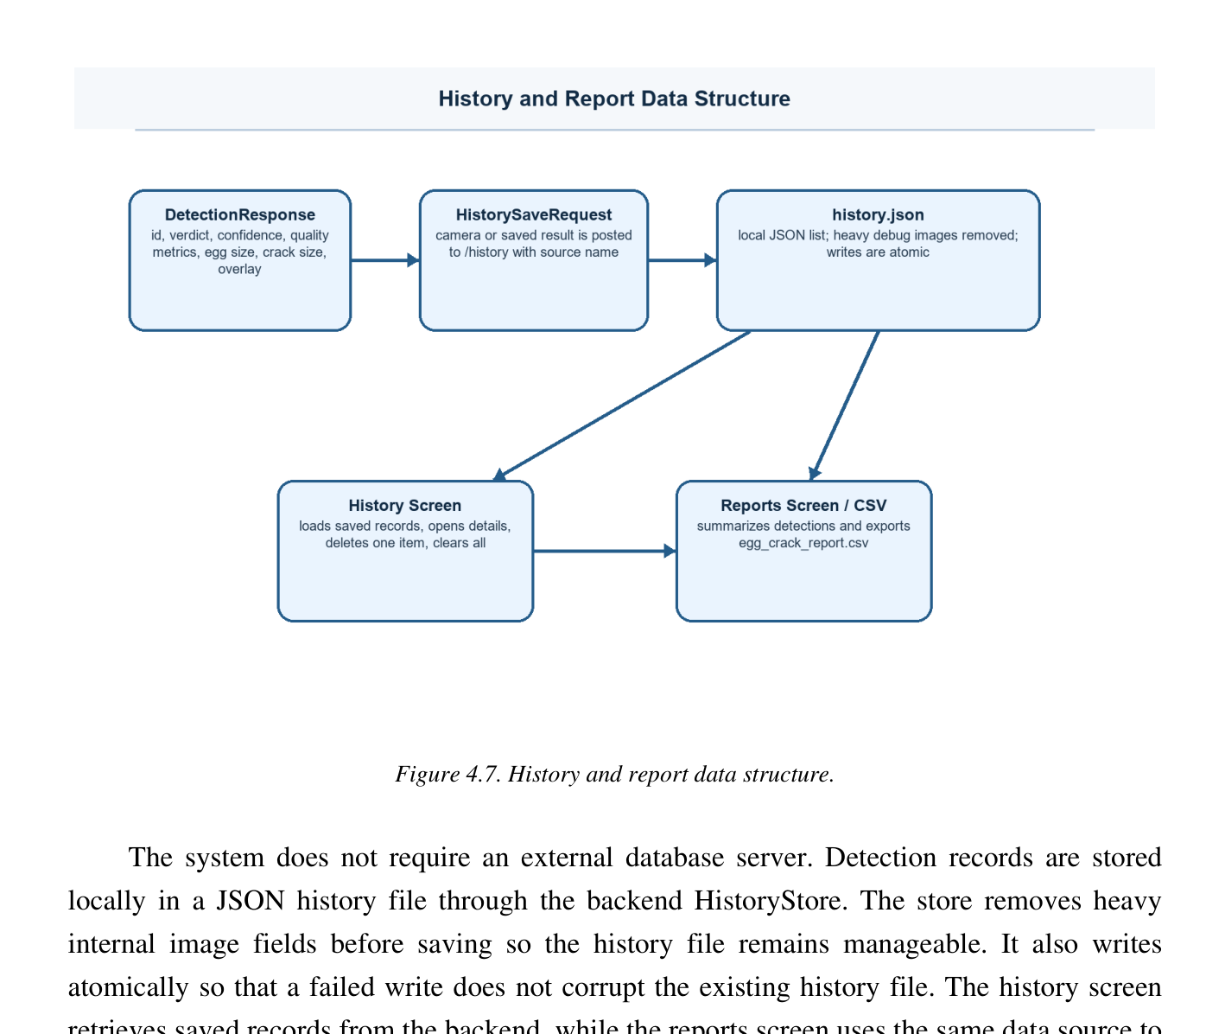
Figure 9. Updated local SQLite history and CSV reporting data flow.
Testing Phase
Verification was conducted at detector, fuzzy-service, API-contract, Flutter, and integration levels. The updated source test inventory contains 46 methods. It includes tests for small, medium, and large crack severity; no-crack handling; full-mask area rather than skeleton area; clustered T-junction counting; fixed-camera Mamdani egg classification; verified calibration; calibrated diameter classes; existing crack fixtures; camera registration; image-quality rejection; endpoint compatibility; normalized memberships; and idempotent history saving. This chapter does not claim a new complete 46-test pass result because a full current run record was not included with the document source; the earlier recorded execution results remain identified separately below.
Fixture Class | Expected Result | Primary Assertion
Dark hairline | Crack | A thin trace remains after texture filtering.
Bright light leak | Crack | The bright-line channel returns a trace.
Pale surface fracture | Crack | At least 70 percent of the reference skeleton is recalled within five pixels.
Near-rim crack | Crack | The candidate penetrates inward or is not contour-tangent.
Horizontal egg | Correct decision | Segmentation and normalization remain axis-independent.
Double resolution | Stable decision | Egg-relative geometry preserves the classification.
Clean shell | No crack | No crack component is accepted.
Shell fiber | No crack | The smooth fiber is rejected.
Yolk boundary | No crack | The broad smooth arc is rejected.
Clustered rim texture | No crack | Contour-parallel texture is rejected.
Broad glare or blur | Recapture | The quality error explains why a new image is required.
Three moved frames | Crack | A registered matching trace appears in at least two frames.
One transient frame | No crack | Multi-frame disagreement clears the unstable evidence.
Full accepted mask | Feature correctness | Crack area uses unskeletonized accepted pixels rather than the one-pixel trace.
T-junction skeleton | One clustered branch | Adjacent junction pixels count as one branch cluster.
Crack severity fixtures | Small, medium, large | Two-stage Mamdani outputs follow the configured rule matrices.
Calibrated egg fixtures | Small, medium, large | Diameter-first rules use breadth, geometric mean diameter, and projected area.
Uncalibrated egg geometry | Explicit fallback basis | Response reports geometric_fixed_camera_uncalibrated and no physical diameter claim.
Repeated history save | Idempotent result | The same record ID does not create uncontrolled duplicate records.
Table 13. Crack-detection, fuzzy-classification, and camera regression matrix
Spatial Regression Criterion
The pale-fracture test used a spatial criterion rather than checking only the final Boolean verdict. The reference crack skeleton was compared with a five-pixel dilation of
the returned mask. The fixture passed when at least 70 percent of the reference skeleton was covered and unrelated center specks were absent from the accepted mask:
recall = count(reference skeleton AND dilated returned mask) / count(reference skeleton)
Camera Motion and Transient Rejection
Camera regression tests applied small translation and rotation changes to controlled frames. The expected crack remained positive when the registered masks agreed in at least two images. A crack-like mark appearing in only one frame was expected to produce a no-crack result with a multi-frame disagreement reason. These tests verified that the camera decision depended on spatial repeatability rather than frame votes alone.
Check | Recorded Result | Interpretation
Earlier Python backend test snapshot | 36 tests passed | Historical execution result retained; the updated source now contains 46 test methods.
Flutter widget test | Passed | The application dashboard started correctly.
Flutter static analysis | No issues | No analysis findings were reported.
Single 960 x 540 representative image | Approximately 2.95 seconds | The result was within the three-second development target.
Three-frame representative burst | Approximately 4.75 seconds | The result was within the eight-second camera target.
Updated source test inventory | 46 test methods present | Includes new Mamdani, calibration, feature extraction, and idempotent history tests; no new full suite pass claim is made here.
Table 14. Testing results recorded for the earlier verified implementation snapshot
The recorded processing times are observations from the development machine and should not be interpreted as
fixed performance for every computer. Actual time can change according to the processor, camera driver, image size, number of detected components, and whether diagnostic images are requested.
Deployment Phase
After an increment passed testing, it was integrated into the current desktop build as a working release. During development, the Python backend is started through run_server.py and listens on http://127.0.0.1:8756. The Flutter API service checks the /health endpoint before a normal request is processed. A queued interceptor prevents several screens from starting duplicate readiness checks at the same time and allows a recent successful health result to be reused for a short period.
For packaged Windows use, the build process creates the backend executable and places it in the desktop output folder expected by BackendLauncherService. Flutter remains the only user-facing program. The backend runs locally, does not own the camera, exposes calibration state through GET /calibration, stores history in local SQLite (with image files stored in \Pictures\detected_eggs), and requires no internet connection or cloud database for the documented workflow.
Maintenance Phase
Maintenance follows every working release. Findings from testing, newly collected images, camera behavior, false-positive and false-negative cases, fuzzy boundary cases, calibration drift, and SQLite history behavior are returned to the appropriate increment. Detector thresholds and Mamdani membership breakpoints are centralized in configuration and versioned through mamdani_version so that a result can identify which rule set produced it. Changes
to fuzzy memberships must be validated against labeled eggs rather than adjusted only to improve one sample.
The source-resolution strategy should remain selective. Processing every frame at the highest possible resolution would increase memory use and delay without guaranteeing a better decision. Refinement should be applied only when the detected egg is too small or when a weak candidate requires additional source detail. Maintenance should also include periodic verification of the backend launcher, camera drivers, local history file, report export, and installer contents.
Results and Discussion
The incremental methodology produced a usable release after each completed increment. The updated release retains the integrated Flutter workflow while adding explainable post-detection classification and SQLite persistence. An accepted image now produces not only a crack verdict and trace, but also a structured feature dictionary, a two-stage crack-size score, output memberships, an egg-size score and basis, calibration metadata, fallback status, and a locally stored record when saving is enabled.
The full-shell analysis addresses pale and near-rim fractures without limiting processing to the center. The revised pale-network recovery selects eligible fragments by length, span, strength, thickness, shell depth, branch ratio, axis deviation, rim overlap, endpoint gap, and directional alignment. It retains the actual accepted fragments in the final mask instead of drawing unsupported connector lines. The same final mask becomes the source of fuzzy area and width features, preventing the classifier from measuring rejected evidence.
Egg-relative geometry improves detection consistency when the egg occupies different pixel sizes. For crack classification, length and width are normalized by the fitted egg axes and area is normalized by the egg mask. For egg-size classification, a verified scale changes the basis to maximum_breadth_mm and enables the diameter rule matrix. When calibration is absent, the application clearly marks the result as uncalibrated fixed-camera geometry and returns zero physical dimensions rather than presenting an invented millimetre value.
The camera workflow added a second protection layer through canonical registration and two-of-three spatial agreement. A temporary reflection or texture response that appears in only one capture is removed. A genuine crack can remain positive when its registered position agrees in at least two frames, even when the egg moves slightly between captures. The recorded regression tests confirmed the intended behavior for small motion and transient evidence.
The source structure demonstrates separation between detection and classification. OpenCV decides which pixels form the accepted crack; Mamdani logic converts measurements into linguistic classes. This makes the small, medium, and large outputs inspectable through membership functions and rule matrices. SQLite persistence similarly remains behind HistoryStore, so storage changes do not alter image processing. Broader evaluation using unique physical eggs, controlled calibration, several shell colors, and ground-truth crack annotations is still required before the system can be treated as a production grading instrument.
The confidence values represent fuzzy output strength, image quality, and fragmentation consistency under
configured conditions. They are not food-safety or physical-integrity guarantees. Crack size is an operational image-based severity label, not a universal eggshell standard. Egg size is a calibrated geometric estimate only when the response marks calibrated = true; official market classes are weight-based and are not reproduced by an uncalibrated camera image.
Known Limitations
• A raw and unannotated image is required for faithful regression testing because colored traces and contours alter the pixels processed by the detector.
• Strong reflections that resemble narrow fractures may still require recapture or improved lighting control.
• Physical egg-diameter classification requires measured millimetres per pixel at the exact egg plane; the stored 4.0-inch distance alone is not calibration.
• Large movement between camera frames can prevent the registered masks from reaching the required overlap.
• The membership functions and rule matrices are explainable engineering settings, but they require validation with labeled eggs from the intended camera, shell colors, suppliers, and crack types.
• SQLite stores local inspection history (storing images in \Pictures\detected_eggs), but the system remains an image-based inspection aid and should not be the only basis for commercial grading or food-safety decisions.
• Uncalibrated egg-size output is fixed-camera geometry, not an official weight class or verified physical diameter.
• Fuzzy classification depends on the correctness of the accepted OpenCV mask; Mamdani rules cannot repair a
missed crack or remove an already accepted false-positive pixel.
Chapter Summary
This chapter presented the developmental research approach and Incremental Development Methodology used for the Egg Crack Detection System. Six releases established the Flutter desktop foundation, local FastAPI integration, full-shell OpenCV detector, single-image workflow, camera focus and multi-frame consensus, and operational support for batch processing, SQLite history, CSV reports, packaging, and testing.
The updated detector preserves almost the complete shell, scales geometry from the fitted egg (calibrated for 4-inch camera distance with 550.0 reference minor axis), corrects candling variation, combines multiple response channels, recovers eligible pale fracture networks, and rejects rim, texture, glare, fiber, and yolk-like artifacts. The final unskeletonized mask and trace are measured separately. A pure NumPy Mamdani service uses normalized length and full-mask area to infer crack extent, then uses extent, apparent width, and clustered branches to classify crack severity. Verified egg calibration enables a diameter-first classifier using maximum breadth, geometric mean diameter, and projected area; otherwise the response is explicitly uncalibrated. The result includes scores, memberships, features, calibration and fallback status, and can be stored through HistoryStore in local SQLite before CSV export.

