**2025年度第二学期《智能芯片设计》第一次作业**

**1.以LeNet-5网络模型为例子，定量分析网络模型复杂度。如下图所示，LeNet-5规定输入为32×32（ MNIST手写数字28×28， 需Resize适配），第一层卷积核为6个5×5×1，经过2×2池化，第二层卷积核为16个5×5×6 ，经过2×2池化。然后经过两层全连接层，分别为120个和84个神经元，最后输出10类。**

**（1）请以表格形式，给出计算模型的参数量与计算量。（注意偏置b也需考虑）**

**（2）如果考虑使用Padding，保持每一层特征尺寸不损失，网络整体架构不变，请估算模型参数和计算量。**

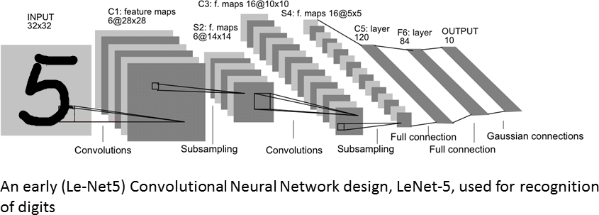

**2.一维时间序列x=[1 0 2 3 -1 5]，一维滤波器h=[1 0 3 2]，请按卷积的原始定义分步骤写出x*h的计算过程（*表示卷积）。**

**3．对于一个通道的输入特征图X矩阵（5×5，如左图），卷积核W（3×3，如右图），设定卷积步长为2、边界补0扩展长度为1，请分别写出直接计算、矩阵向量乘计算卷积的过程，并对比其计算特性差异。**

|  |  |  |  |  |  |  |  |  |  |  |  |  |  |  |  |  |  |  |  |  |  |  |  |  |  |  |  |  |  |  |  |  |  |  |  |
| --- | --- | --- | --- | --- | --- | --- | --- | --- | --- | --- | --- | --- | --- | --- | --- | --- | --- | --- | --- | --- | --- | --- | --- | --- | --- | --- | --- | --- | --- | --- | --- | --- | --- | --- | --- |
| |  |  |  |  |  | | --- | --- | --- | --- | --- | | 1 | 1 | 1 | 1 | 2 | | 1 | 1 | 2 | 1 | 1 | | 0 | 0 | 2 | 1 | 2 | | 0 | 0 | 0 | 1 | 2 | | 1 | 2 | 1 | 1 | 1 | | |  |  |  | | --- | --- | --- | | 1 | 0 | 1 | | 0 | 0 | -1 | | 0 | 0 | -1 | |

**4.对于一个3通道输入特性图X（5×5×3，如左图）, 2组3通道卷积核W（3×3×3，如中、右图），设定卷积步长为2、边界补0扩展长度为1，请分步骤写出卷积计算过程。**

|  |  |  |  |  |  |  |  |  |  |  |  |  |  |  |  |  |  |  |  |  |  |  |  |  |  |  |  |  |  |  |  |  |  |  |  |  |  |  |  |  |  |  |  |  |  |
| --- | --- | --- | --- | --- | --- | --- | --- | --- | --- | --- | --- | --- | --- | --- | --- | --- | --- | --- | --- | --- | --- | --- | --- | --- | --- | --- | --- | --- | --- | --- | --- | --- | --- | --- | --- | --- | --- | --- | --- | --- | --- | --- | --- | --- | --- |
| |  |  |  |  |  | | --- | --- | --- | --- | --- | | 1 | 0 | 1 | 0 | 1 | | 1 | 2 | 2 | 2 | 2 | | 2 | 1 | 0 | 2 | 1 | | 0 | 1 | 2 | 1 | 2 | | 1 | 1 | 0 | 1 | 2 | | |  |  |  | | --- | --- | --- | | 1 | 1 | -1 | | -1 | 0 | -1 | | 1 | 0 | 0 | | |  |  |  | | --- | --- | --- | | 0 | 0 | 1 | | 1 | 1 | -1 | | 0 | -1 | -1 | |
|  |  |  |
| |  |  |  |  |  | | --- | --- | --- | --- | --- | | 0 | 0 | 2 | 2 | 1 | | 2 | 2 | 0 | 1 | 0 | | 0 | 2 | 0 | 1 | 1 | | 0 | 2 | 1 | 0 | 0 | | 2 | 0 | 2 | 2 | 0 | | |  |  |  | | --- | --- | --- | | -1 | -1 | -1 | | -1 | 0 | -1 | | 1 | 1 | 1 | | |  |  |  | | --- | --- | --- | | 0 | 1 | 0 | | -1 | 0 | -1 | | 1 | 1 | 1 | |
|  |  |  |
| |  |  |  |  |  | | --- | --- | --- | --- | --- | | 1 | 2 | 2 | 2 | 1 | | 0 | 1 | 1 | 0 | 1 | | 1 | 1 | 0 | 0 | 0 | | 1 | 2 | 0 | 1 | 1 | | 2 | 1 | 0 | 1 | 0 | | |  |  |  | | --- | --- | --- | | -1 | -1 | -1 | | -1 | 0 | 1 | | 1 | -1 | 1 | | |  |  |  | | --- | --- | --- | | 0 | 1 | 1 | | -1 | 0 | 1 | | 0 | -1 | 1 | |