1. 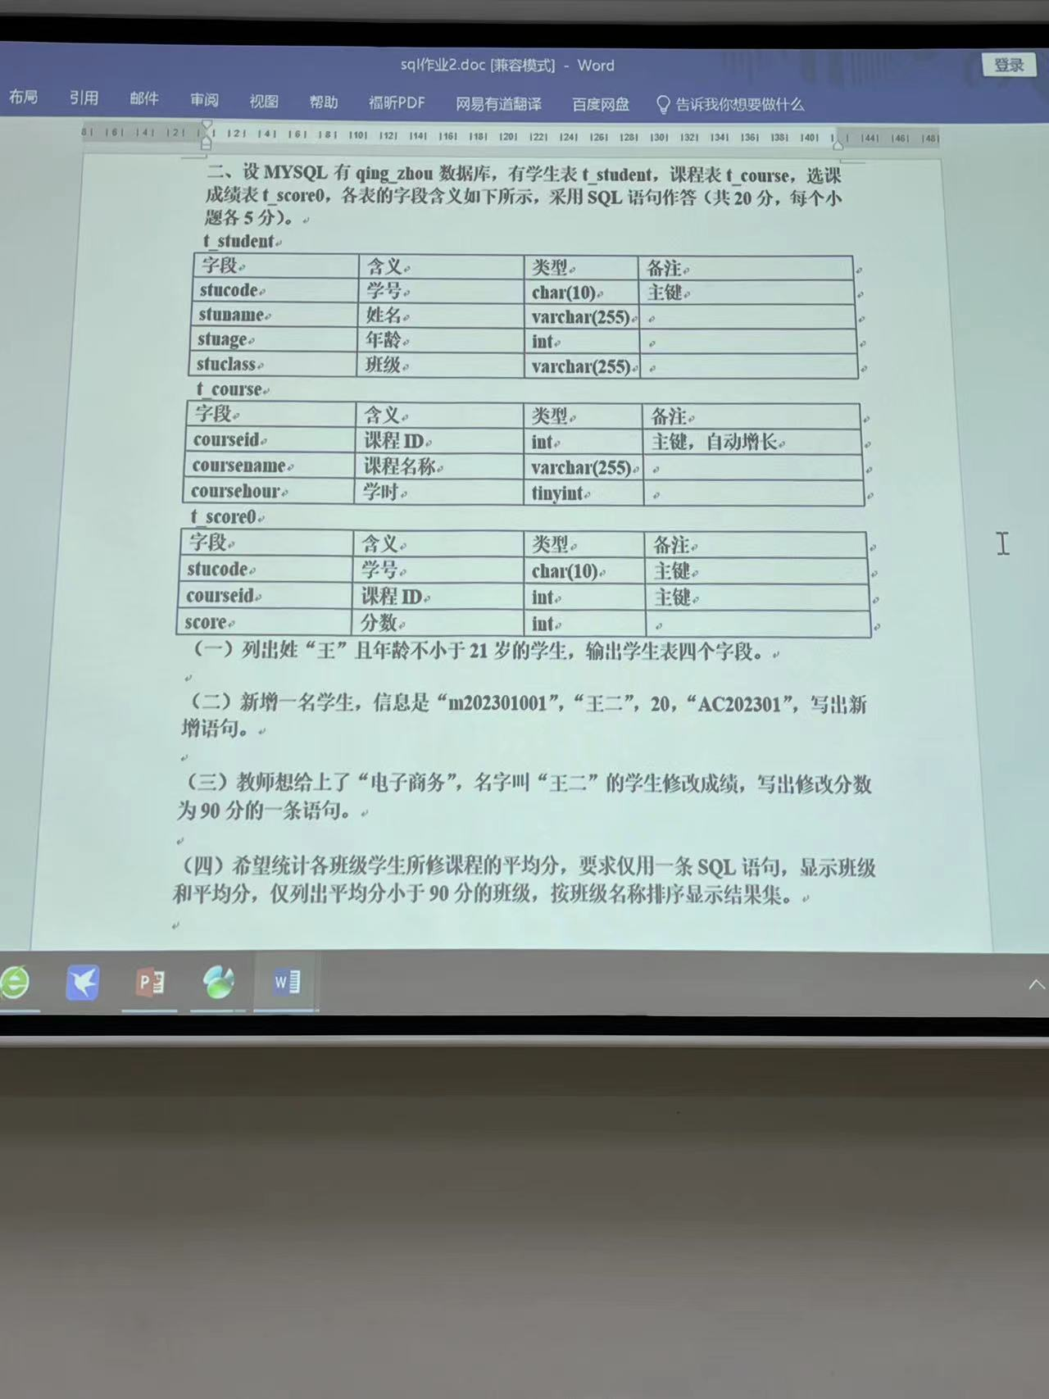select * from t_student where stuage >= 21 and stuname like ‘王%’
2. insert into t_student values (stucode, stuname, stuage, stuclass) values (“m202301001”,“王二”,20,“AC202301”);
3. 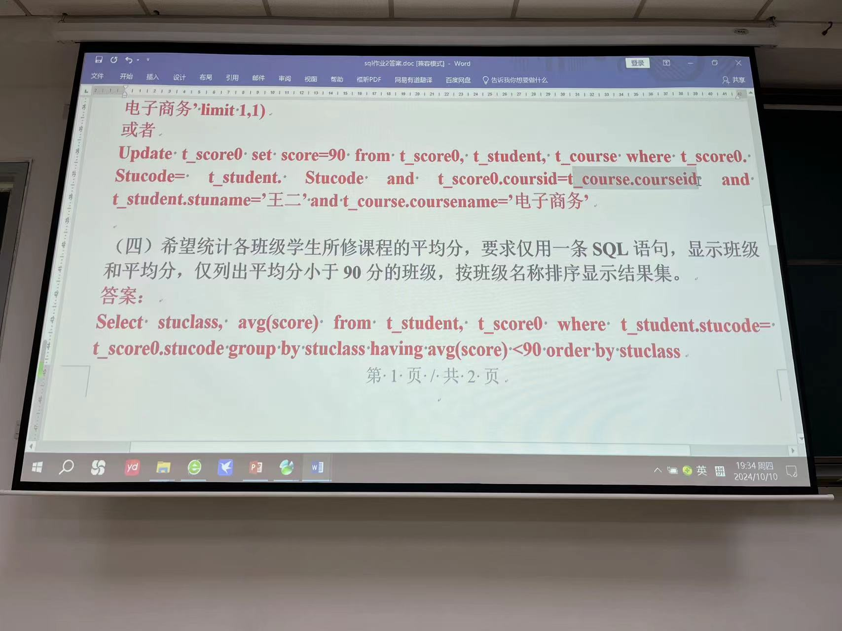

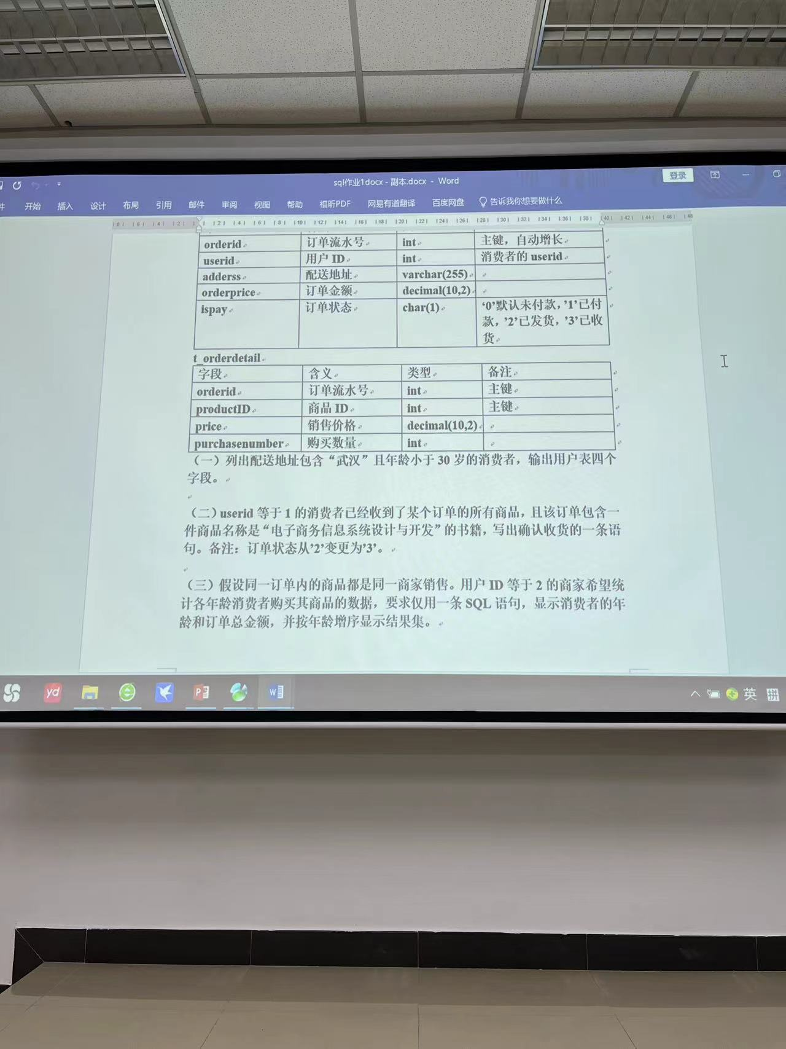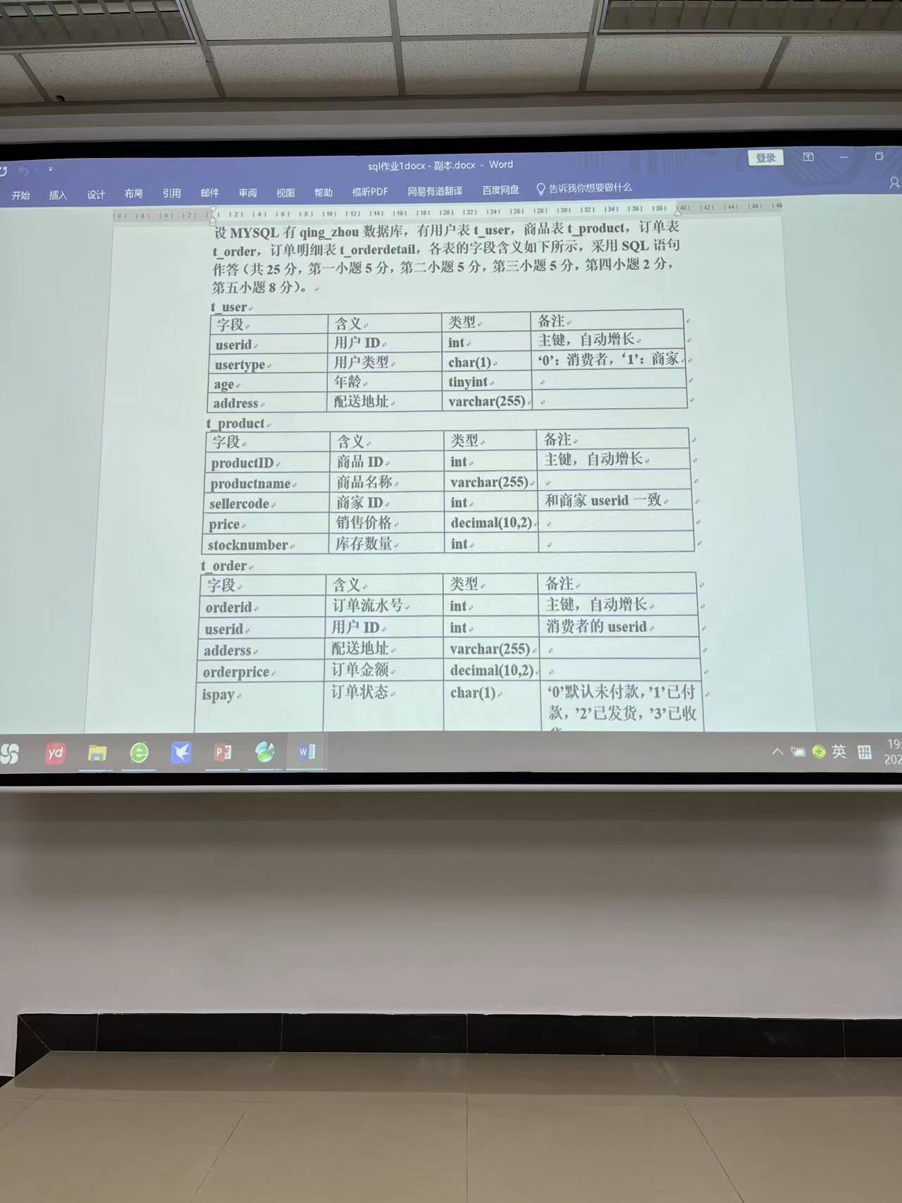

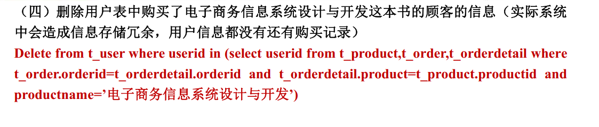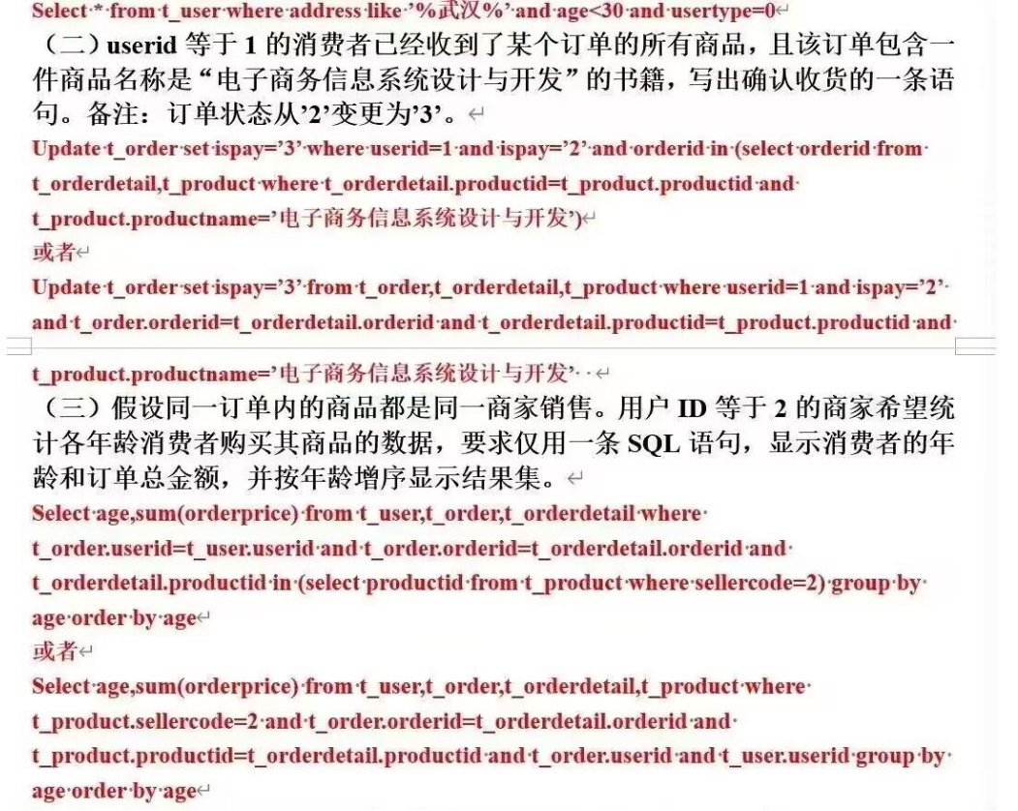也可以

Delete 目标表 from 表1，表2… where 内联加索引