Case Study

1. **Business Task (Ask):**

Find how annual members and casual riders use Cyclistic bike differently and aimed to convert casual riders into Annual members

1. **Data Source (Prepare):**

Download the last 12 months of trip data from Divvy data portal.

1. **Clean Data Using Python** **(Process):**

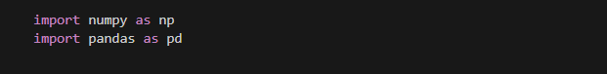Import Packages -

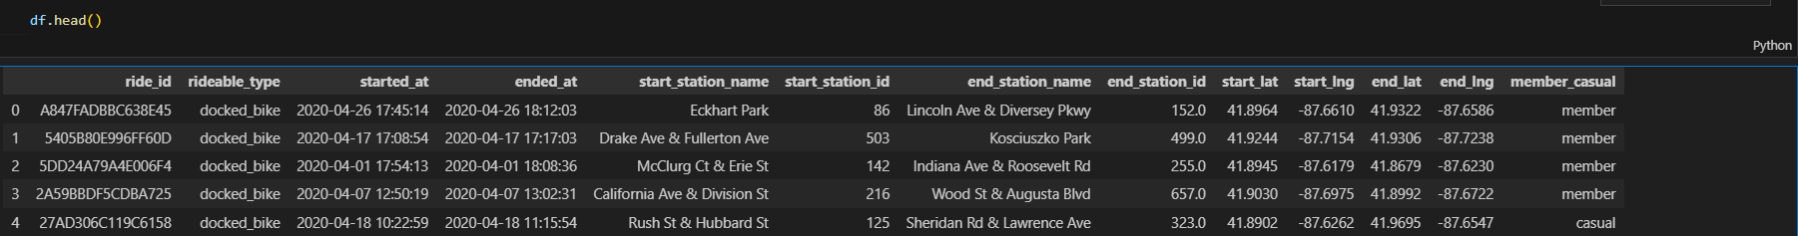Read Dataset -

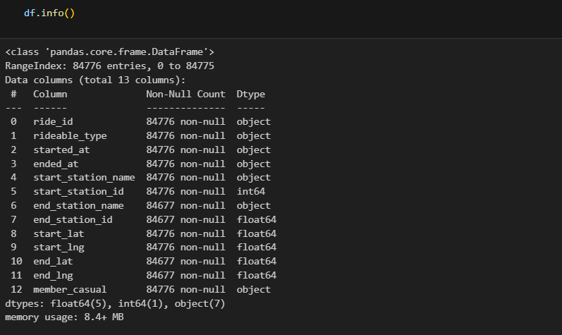Check Data types -

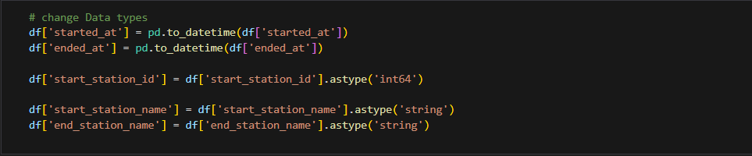 Change Data Types:

Check Null Values and drop it

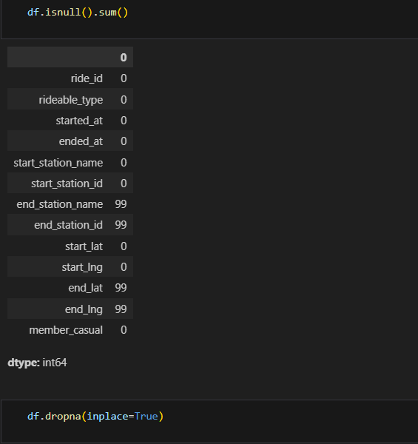

1. 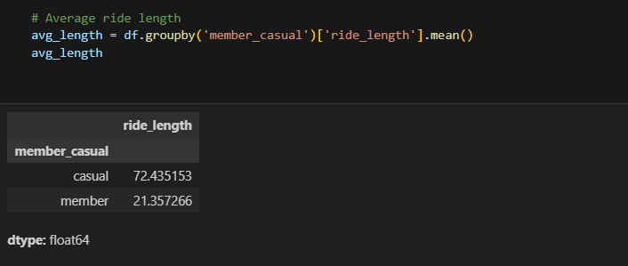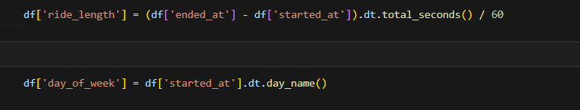**Summary of Analyzing:**

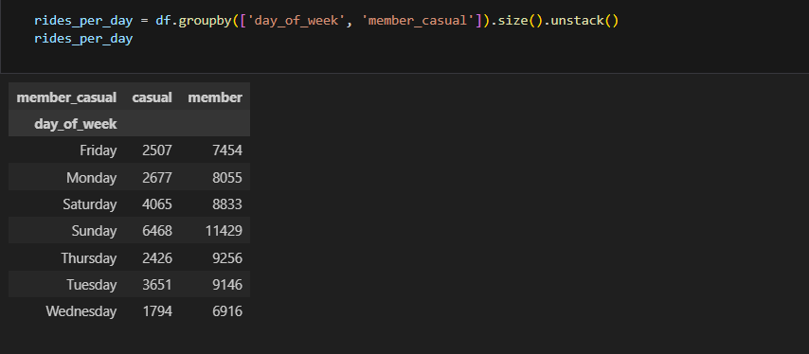

1. 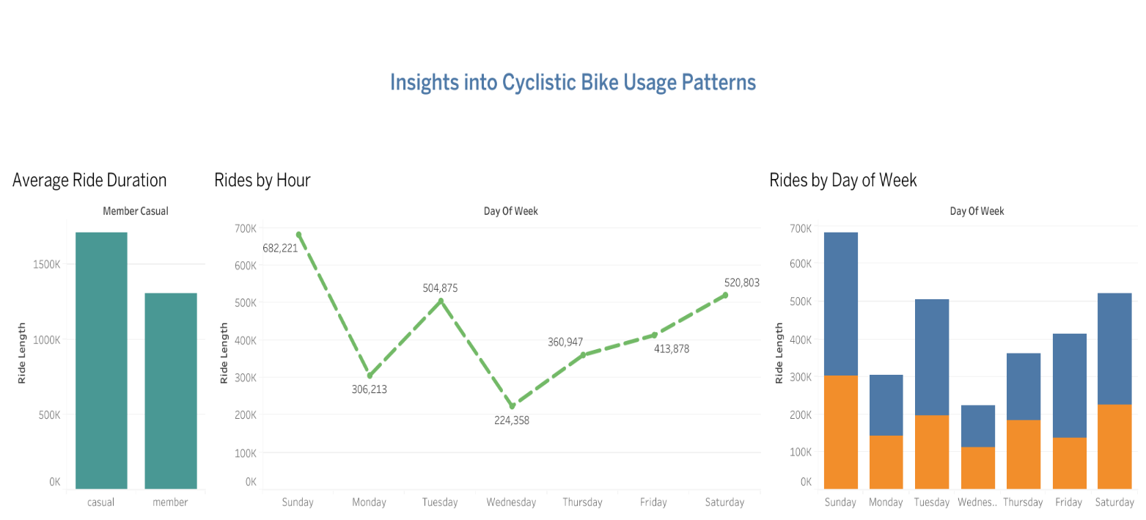**Supporting visualizations and key findings**
2. **Recommendations based on your analysis**

* Launch weekend-focused promotions for casual riders (e.g., discounted monthly membership or referral bonuses). Position these offers directly through the app or bike stations on high-traffic weekend hours.
* Investigate potential reasons (weather, station availability, commute patterns), and test **midweek incentives** like “Wednesday Free Ride Hour” or in-app gamification for casual users.