Customer Shopping Behavior Analysis

Project overview
The company is experiencing shifts in purchasing patterns across demographics, product categories, and sales channels. Analysis of 3,900 customer transactions revealed key behavioral trends influencing purchasing decisions, repeat buying, and subscription engagement. Insights highlight critical drivers such as reviews, discounts, shipping preferences, and age-based spending tendencies. Leveraging these insights can significantly enhance customer retention, sales conversion, and marketing efficiency.

Business Context & Problem Statement
The management team has observed changes in consumer behavior and needs clarity on what factors are influencing purchasing decisions. The primary business question is: “How can the company leverage consumer shopping data to identify trends, improve customer engagement, and optimize marketing and product strategies?”

Insights & Analysis
- Gender Revenue Gap: Untapped Potential in the Female Segment
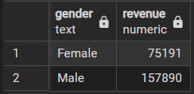
Male customers generate more than double the total revenue of female customers ($157,890 vs. $75,191). This disparity highlights a significant growth opportunity within the female segment, suggesting the need for targeted marketing and product positioning strategies to capture underleveraged demand.
- High-Spending Discount Users: The Premium-Value Hybrid Segmentigh-Spending Discount Users – Identified customers who used discounts but still spent above the average purchase amount.

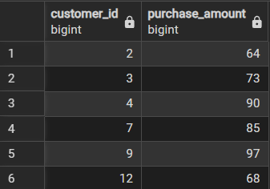
A distinct group of customers uses discounts consistently yet still maintains above-average purchase amounts. These high-value shoppers represent a prime segment for upselling via curated bundles, premium add-ons, or exclusive product lines that reduce reliance on discounts while increasing customer lifetime value.
- High-Rated Products as Satisfaction Drivers
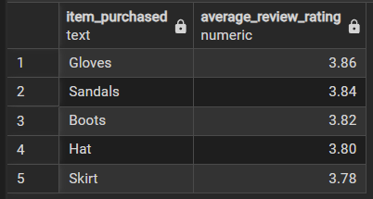
Products with the highest average review ratings—including Gloves, Sandals, and Boots—are not necessarily the top sellers but play a crucial role in customer satisfaction. Their strong rating performance positions them as high-trust items that should be amplified in marketing messaging and cross-selling strategies.
- Express Shipping Correlates with Higher Spending
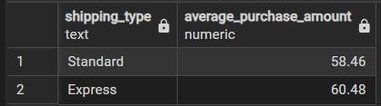
Customers choosing Express Shipping show a higher average purchase amount ($60.48) compared to Standard Shipping users ($58.46). This indicates a segment with greater willingness to pay and an elevated perception of value, supporting initiatives such as shipping upgrades, premium service tiers, or convenience-focused product bundles.
- Subscription Paradox: Low Adoption Among High-Revenue Customers
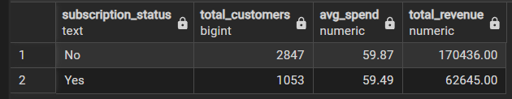
Non-subscribers generate significantly higher total revenue ($170,436) than subscribers ($62,645), even though average spend per customer remains nearly identical. This suggests that the current subscription offering is not compelling enough for high-value buyers, indicating the need to redefine subscription benefits to attract top-spending segments.

- Margin Risk: High Discount Dependency on Key Products
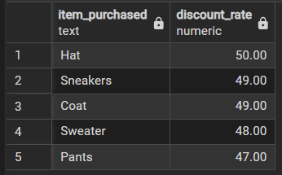
Several top-selling items—such as Hats, Sneakers, and Coats—are purchased with discounts in nearly half of all transactions (49–50%). This level of discount dependency indicates strong price sensitivity and poses a direct margin risk, requiring a refined promotional strategy to protect profitability without compromising conversion.
- Customer Base Composition Shows Strong Loyalty Potential
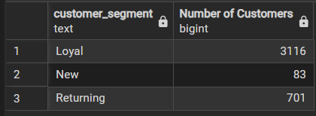
The customer base is predominantly composed of Loyal customers (3,116), followed by Returning (701) and New customers (83). Growth efforts should prioritize converting Returning customers into Loyal ones, as they represent the segment closest to reaching high-value repeat behavior.
- Category Top Sellers Define Inventory and Marketing Priorities
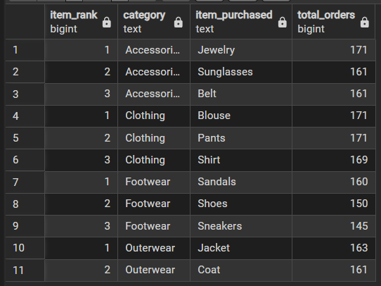
The top-selling items—Jewelry (Accessories), Blouses (Clothing), Sandals (Footwear), and Jackets (Outerwear)—represent essential products for revenue stability. These items should anchor inventory planning, promotional campaigns, and category-specific strategies due to their consistent demand.
- Subscription Likelihood Increases With Repeat Purchases

Customers with more than five purchases are more likely to be subscribers, yet the majority (2,518) of these repeat buyers remain unsubscribed. This group represents a high-potential audience for targeted subscription campaigns, leveraging demonstrated loyalty and purchase frequency.
- Age-Based Revenue Distribution Prioritizes Young Adults
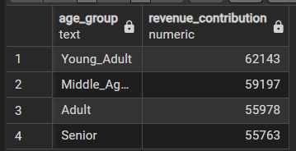
Young Adults generate the highest total revenue ($62,143), followed by Middle-Aged customers ($59,197) and Adults ($55,978). Marketing investments, personalized offers, and product development should prioritize these high-value age groups to maximize ROI and long-term retention.

Dashboard
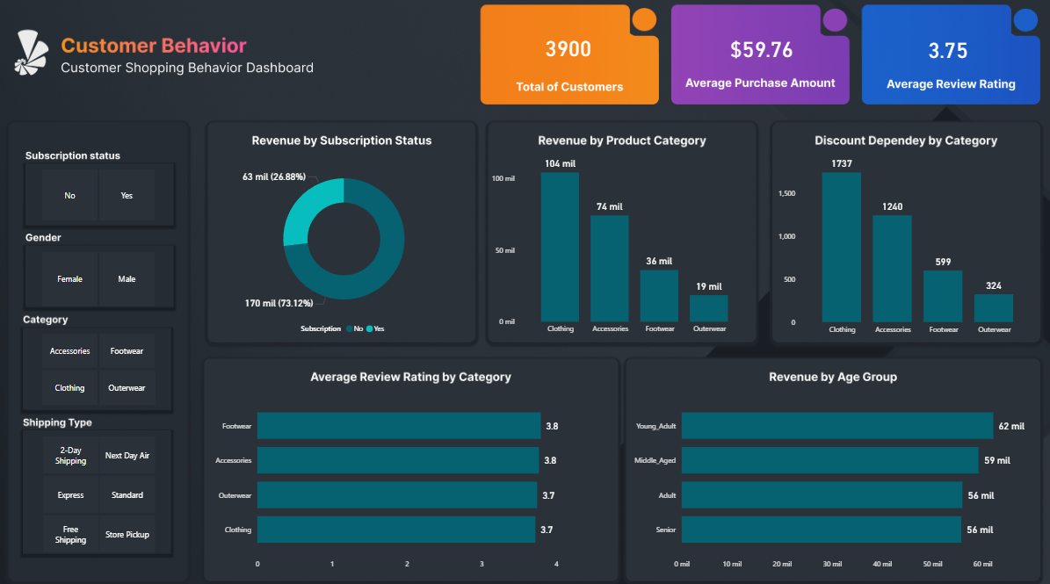

Business recommendations
- Prioritize personalized campaigns for the 25–34 age group and female customers, supported by tailored product assortments and targeted messaging.
- Reduce margin exposure by adjusting discounts on price-sensitive SKUs, implementing differentiated promotions, and reinforcing premium positioning for high-rated products.
- Introduce enhanced subscription benefits—such as shipping perks, exclusive offers, or tiered rewards—to attract high-value and repeat customers.
- Deploy loyalty programs, milestone rewards, and personalized re-engagement strategies to transition Returning customers into the Loyal segment.
- Ensure stock availability and give high visibility to top-selling items in each category, while leveraging high-rated products to boost trust, engagement, and cross-sell opportunities.

