# Software Development for Gaming 3 Project

## Team: David Ward, Ciaran Tone, Dimitrije Sreckovic, Eoin Geoghegan

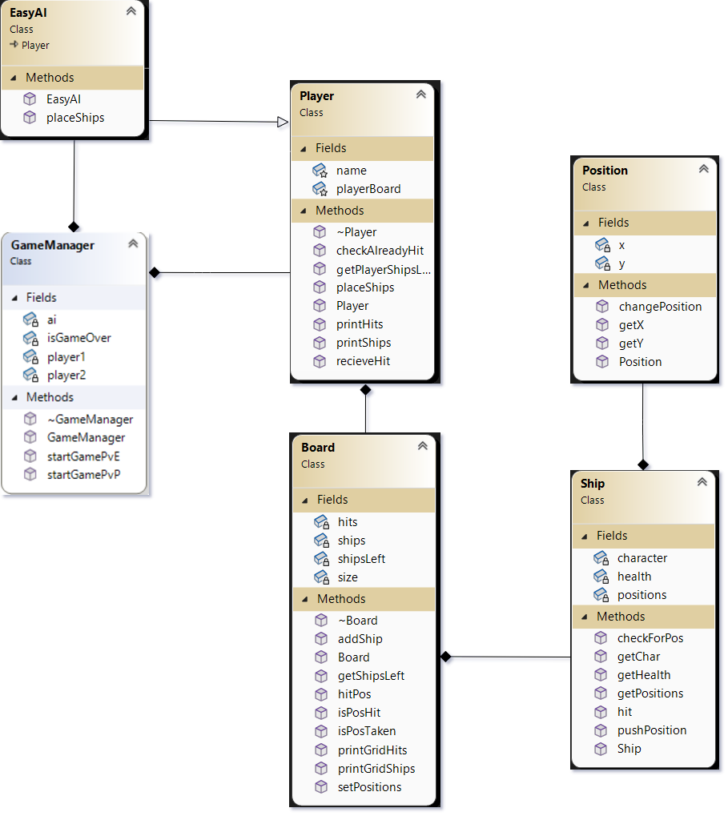

*UML Diagram*

# Inheritance

* Easy AI class inherits from Player class

# Composition

* Player has a Board
* GameManager references Player objects (player1, player2) and AI(EasyAI)
* Board has Ship objects
* Ship has position

# Dependencies

* GameManager relies on methods and objects from Player and Board
* Player interacts with Board and Ships for gameplay

**Contributions Breakdown**

# Dimitrije

* Designed Player class
* Designed Board class
* Designed AI
* Code Integration

# David

* Designed Position class
* Designed UML document
* Code Integration

# Ciarán

* Designed Game Manager class
* Write up of player contribution and OOP documentation
* Code Integration

# Eoin

* Designed Ship class
* User Manual write up
* Code Integration

**Battleship – User Manual**

On opening the game, you can choose to play against a basic AI or against another person. The gameplay for each person is the same: For each ship, ranging in size from 2 to 5 squares (one 2 square ship, two 3 square ships, one 4 square ship, and one 5 square ship), you select its first position followed by its last position according to where you want to place it on the board.

1 Note that the 'x' position in this case refers to the row numbers and the ‘y’ to the columns.

Once you have entered all your positions a new board is printed and you must attempt to locate the opponent’s ships by inserting the x and y values, like how you placed your own ships. On a successful hit a ‘X’ will be shown on the coordinate you selected; you will thus be allowed to attempt to fire until you miss. On a miss an ‘O’ will be shown on the coordinate you selected, and your opponent will take their turn.

The game continues until one player has no ships remaining.