Albert Einstein
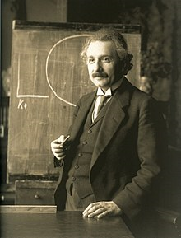
Albert Einstein (14 March 1879 – 18 April 1955) was a German-born theoretical physicist, widely acknowledged to be one of the greatest physicists of all time. Einstein is known for developing the theory of relativity, but he also made important contributions to the development of the theory of quantum mechanics.
Throughout his life, Einstein published hundreds of books and articles. He published more than 300 scientific papers and 150 non-scientific ones. On 5 December 2014, universities and archives announced the release of Einstein's papers, comprising more than 30,000 unique documents. Einstein's intellectual achievements and originality have made the word "Einstein" synonymous with "genius".
In 1905, a year sometimes described as his annus mirabilis ('miracle year'), Einstein published four groundbreaking papers. These outlined the theory of the photoelectric effect, explained Brownian motion, introduced special relativity, and demonstrated mass-energy equivalence. Einstein thought that the laws of classical mechanics could no longer be reconciled with those of the electromagnetic field, which led him to develop his special theory of relativity.
He extended the theory to gravitational fields; he published a paper on general relativity in 1916, introducing his theory of gravitation. In 1917, he applied the general theory of relativity to model the structure of the universe. He continued to deal with problems of statistical mechanics and quantum theory, which led to his explanations of particle theory and the motion of molecules. He also investigated the thermal properties of light and the quantum theory of radiation, which laid the foundation of the photon theory of light. However, for much of the later part of his career, he worked on two ultimately unsuccessful endeavors. First, despite his great contributions to quantum mechanics, he opposed what it evolved into, objecting that nature "does not play dice". Second, he attempted to devise a unified field theory by generalizing his geometric theory of gravitation to include electromagnetism. As a result, he became increasingly isolated from the mainstream of modern physics.
Source: Wikipedia (Albert Einstein)

