Beverages  Soft drinks, coffees, teas, beers, and ales |  | 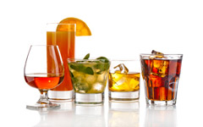

ProductName | ProductID |  | QuantityPerUnit | UnitPrice
Chai | 1 |  | 10 boxes x 20 bags | 18
Chang | 2 |  | 24 - 12 oz bottles | 19
Guaraná Fantástica | 24 |  | 12 - 355 ml cans | 4.5
Sasquatch Ale | 34 |  | 24 - 12 oz bottles | 14
Steeleye Stout | 35 |  | 24 - 12 oz bottles | 18
Côte de Blaye | 38 |  | 12 - 75 cl bottles | 263.5
Chartreuse verte | 39 |  | 750 cc per bottle | 18
Ipoh Coffee | 43 |  | 16 - 500 g tins | 46
Laughing Lumberjack Lager | 67 |  | 24 - 12 oz bottles | 14
Outback Lager | 70 |  | 24 - 355 ml bottles | 15
Rhönbräu Klosterbier | 75 |  | 24 - 0.5 l bottles | 7.75
Lakkalikööri | 76 |  | 500 ml | 18

Condiments  Sweet and savory sauces, relishes, spreads, and seasonings |  | 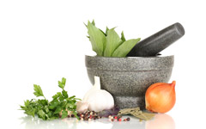

ProductName | ProductID |  | QuantityPerUnit | UnitPrice
Aniseed Syrup | 3 |  | 12 - 550 ml bottles | 10
Chef Anton's Cajun Seasoning | 4 |  | 48 - 6 oz jars | 22
Chef Anton's Gumbo Mix | 5 |  | 36 boxes | 21.35
Grandma's Boysenberry Spread | 6 |  | 12 - 8 oz jars | 25
Northwoods Cranberry Sauce | 8 |  | 12 - 12 oz jars | 40
Genen Shouyu | 15 |  | 24 - 250 ml bottles | 15.5
Gula Malacca | 44 |  | 20 - 2 kg bags | 19.45
Sirop d'érable | 61 |  | 24 - 500 ml bottles | 28.5
Vegie-spread | 63 |  | 15 - 625 g jars | 43.9
Louisiana Fiery Hot Pepper Sauce | 65 |  | 32 - 8 oz bottles | 21.05
Louisiana Hot Spiced Okra | 66 |  | 24 - 8 oz jars | 17
Original Frankfurter grüne Soße | 77 |  | 12 boxes | 13

Confections  Desserts, candies, and sweet breads |  | 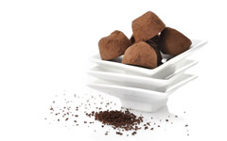

ProductName | ProductID |  | QuantityPerUnit | UnitPrice
Pavlova | 16 |  | 32 - 500 g boxes | 17.45
Teatime Chocolate Biscuits | 19 |  | 10 boxes x 12 pieces | 9.2
Sir Rodney's Marmalade | 20 |  | 30 gift boxes | 81
Sir Rodney's Scones | 21 |  | 24 pkgs. x 4 pieces | 10
NuNuCa Nuß-Nougat-Creme | 25 |  | 20 - 450 g glasses | 14
Gumbär Gummibärchen | 26 |  | 100 - 250 g bags | 31.23
Schoggi Schokolade | 27 |  | 100 - 100 g pieces | 43.9
Zaanse koeken | 47 |  | 10 - 4 oz boxes | 9.5
Chocolade | 48 |  | 10 pkgs. | 12.75
Maxilaku | 49 |  | 24 - 50 g pkgs. | 20
Valkoinen suklaa | 50 |  | 12 - 100 g bars | 16.25
Tarte au sucre | 62 |  | 48 pies | 49.3
Scottish Longbreads | 68 |  | 10 boxes x 8 pieces | 12.5

Dairy Products  Cheeses |  | 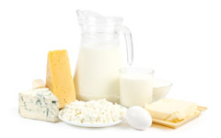

ProductName | ProductID |  | QuantityPerUnit | UnitPrice
Queso Cabrales | 11 |  | 1 kg pkg. | 21
Queso Manchego La Pastora | 12 |  | 10 - 500 g pkgs. | 38
Gorgonzola Telino | 31 |  | 12 - 100 g pkgs | 12.5
Mascarpone Fabioli | 32 |  | 24 - 200 g pkgs. | 32
Geitost | 33 |  | 500 g | 2.5
Raclette Courdavault | 59 |  | 5 kg pkg. | 55
Camembert Pierrot | 60 |  | 15 - 300 g rounds | 34
Gudbrandsdalsost | 69 |  | 10 kg pkg. | 36
Fløtemysost | 71 |  | 10 - 500 g pkgs. | 21.5
Mozzarella di Giovanni | 72 |  | 24 - 200 g pkgs. | 34.8

Grains/Cereals  Breads, crackers, pasta, and cereal |  | 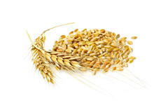

ProductName | ProductID |  | QuantityPerUnit | UnitPrice
Gustaf's Knäckebröd | 22 |  | 24 - 500 g pkgs. | 21
Tunnbröd | 23 |  | 12 - 250 g pkgs. | 9
Singaporean Hokkien Fried Mee | 42 |  | 32 - 1 kg pkgs. | 14
Filo Mix | 52 |  | 16 - 2 kg boxes | 7
Gnocchi di nonna Alice | 56 |  | 24 - 250 g pkgs. | 38
Ravioli Angelo | 57 |  | 24 - 250 g pkgs. | 19.5
Wimmers gute Semmelknödel | 64 |  | 20 bags x 4 pieces | 33.25

Meat/Poultry  Prepared meats |  | 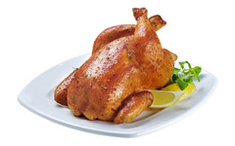

ProductName | ProductID |  | QuantityPerUnit | UnitPrice
Mishi Kobe Niku | 9 |  | 18 - 500 g pkgs. | 97
Alice Mutton | 17 |  | 20 - 1 kg tins | 39
Thüringer Rostbratwurst | 29 |  | 50 bags x 30 sausgs. | 123.79
Perth Pasties | 53 |  | 48 pieces | 32.8
Tourtière | 54 |  | 16 pies | 7.45
Pâté chinois | 55 |  | 24 boxes x 2 pies | 24

Produce  Dried fruit and bean curd |  | 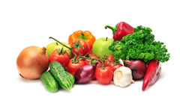

ProductName | ProductID |  | QuantityPerUnit | UnitPrice
Uncle Bob's Organic Dried Pears | 7 |  | 12 - 1 lb pkgs. | 30
Tofu | 14 |  | 40 - 100 g pkgs. | 23.25
Rössle Sauerkraut | 28 |  | 25 - 825 g cans | 45.6
Manjimup Dried Apples | 51 |  | 50 - 300 g pkgs. | 53
Longlife Tofu | 74 |  | 5 kg pkg. | 10

Seafood  Seaweed and fish |  | 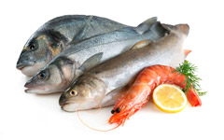

ProductName | ProductID |  | QuantityPerUnit | UnitPrice
Ikura | 10 |  | 12 - 200 ml jars | 31
Konbu | 13 |  | 2 kg box | 6
Carnarvon Tigers | 18 |  | 16 kg pkg. | 62.5
Nord-Ost Matjeshering | 30 |  | 10 - 200 g glasses | 25.89
Inlagd Sill | 36 |  | 24 - 250 g jars | 19
Gravad lax | 37 |  | 12 - 500 g pkgs. | 26
Boston Crab Meat | 40 |  | 24 - 4 oz tins | 18.4
Jack's New England Clam Chowder | 41 |  | 12 - 12 oz cans | 9.65
Røgede sild | 45 |  | 1k pkg. | 9.5
Spegesild | 46 |  | 4 - 450 g glasses | 12
Escargots de Bourgogne | 58 |  | 24 pieces | 13.25
Röd Kaviar | 73 |  | 24 - 150 g jars | 15

