Charting: Moving Averages
Below is an example of the simple moving average (SMA) trend line for a set of stock prices.
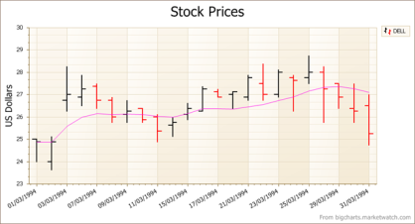
As its name suggests: a simple moving average. The chart calculates the average price over a period of time (here, 10 days) for each date. So for day 10, the average for days 1 through 10 is calculated, for day 11 you use days 2 to 11, and so on. Pretty easy.

Next up is the triangular moving average (TMA).
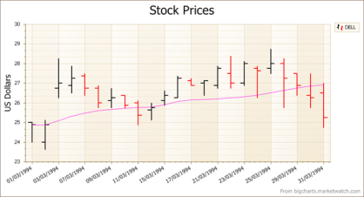
If you describe the SMA as a smoothing operation on prices, so that overall trends can more easily be seen (rather than the spiky day by day prices), you could describe a TMA as a double smoothing operation. Here the chart calculates the simple moving average of all the SMAs previously calculated.

