# Tutorial: How to Create a WPF Application

This tutorial demonstrates how to create a WPF application that implements the MVVM pattern.

The application displays a grid with tracks. You can select a track and change its data in the right panel. The application allows you to save your changes or cancel them.

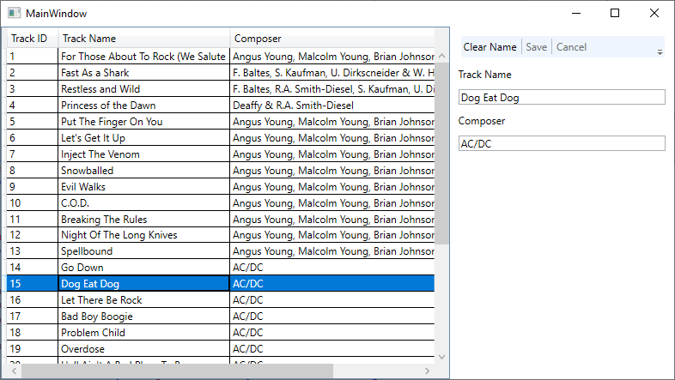

# Steps 1-3. Create a WPF Application

1. Run Visual Studio and choose **Create a new project**.
2. Select the **WPF App (.NET Framework)** template and click **Next**.

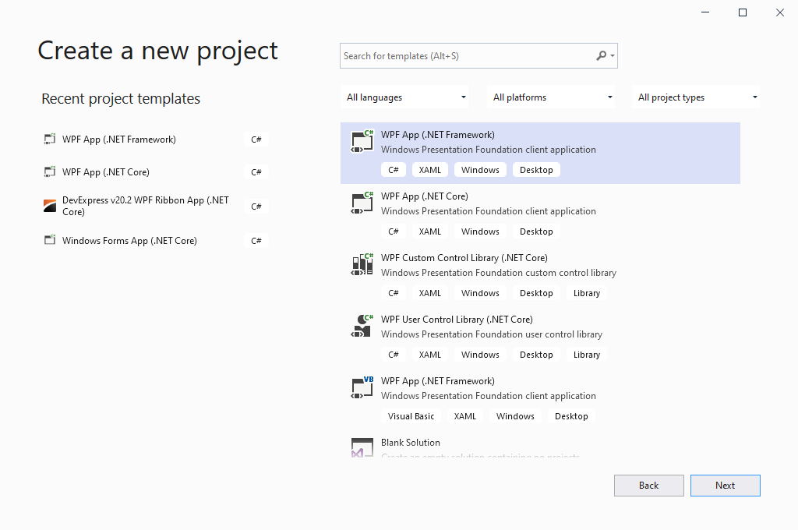

1. Name your project, choose a disk location, and click **Create**.

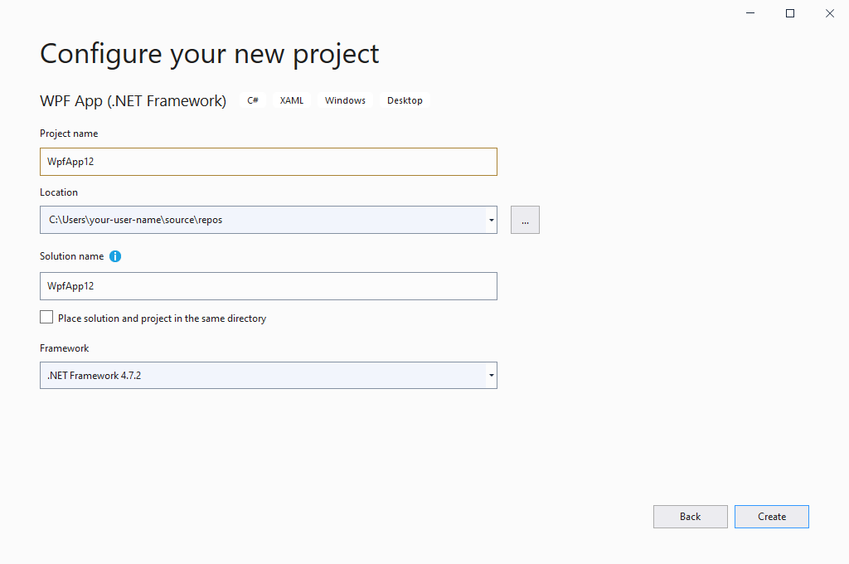

# Steps 4-5. Add a Data Model

1. Add the **Data** folder to your project.
2. Add a **TrackInfo** class to the **Data** folder. Paste the following code into the class.

public class TrackInfo : INotifyPropertyChanged {

public TrackInfo() { }

public TrackInfo(int trackId, string name, int albumId, int mediaTypeId, int genreId, string composer, double milliseconds, double bytes) {

TrackId = trackId;

Name = name;

AlbumId = albumId;

MediaTypeId = mediaTypeId;

GenreId = genreId;

Composer = composer;

Milliseconds = milliseconds;

Bytes = bytes;

}

int trackId;

public int TrackId {

get { return trackId; }

set {

if (trackId == value)

return;

trackId = value;

OnPropertyChanged();

}

}

string name;

public string Name {

get { return name; }

set {

if (name == value)

return;

name = value;

OnPropertyChanged();

}

}

int albumId;

public int AlbumId {

get { return albumId; }

set {

if (albumId == value)

return;

albumId = value;

OnPropertyChanged();

}

}

int mediaTypeId;

public int MediaTypeId {

get { return mediaTypeId; }

set {

if (mediaTypeId == value)

return;

mediaTypeId = value;

OnPropertyChanged();

}

}

int genreId;

public int GenreId {

get { return genreId; }

set {

if (genreId == value)

return;

genreId = value;

OnPropertyChanged();

}

}

string composer;

public string Composer {

get { return composer; }

set {

if (composer == value)

return;

composer = value;

OnPropertyChanged();

}

}

double milliseconds;

public double Milliseconds {

get { return milliseconds; }

set {

if (milliseconds == value)

return;

milliseconds = value;

OnPropertyChanged();

}

}

double bytes;

public double Bytes {

get { return bytes; }

set {

if (bytes == value)

return;

bytes = value;

OnPropertyChanged();

}

}

public override string ToString() {

return String.Format("Name: {0}, Milliseconds: {1}, Composer: {2}",

Name, Milliseconds, Composer);

}

public event PropertyChangedEventHandler PropertyChanged;

void OnPropertyChanged([CallerMemberName] string propertyName = null) {

PropertyChanged?.Invoke(this, new PropertyChangedEventArgs(propertyName));

}

}

1. Add a **TrackList** class to the **Data** folder. Paste the following code into the class.

public static class TrackList {

public static ObservableCollection<TrackInfo> CreateTrackList() {

var list = new ObservableCollection<TrackInfo>();

list.Add(new TrackInfo(1, "For Those About To Rock (We Salute You)", 1, 1, 1, "Angus Young, Malcolm Young, Brian Johnson", 343719, 11170334));

list.Add(new TrackInfo(2, "Fast As a Shark", 3, 2, 1, "F. Baltes, S. Kaufman, U. Dirkscneider & W. Hoffman", 230619, 3990994));

list.Add(new TrackInfo(3, "Restless and Wild", 3, 2, 1, "F. Baltes, R.A. Smith-Diesel, S. Kaufman, U. Dirkscneider & W. Hoffman", 252051, 4331779));

list.Add(new TrackInfo(4, "Princess of the Dawn", 3, 2, 1, "Deaffy & R.A. Smith-Diesel", 375418, 6290521));

list.Add(new TrackInfo(5, "Put The Finger On You", 1, 1, 1, "Angus Young, Malcolm Young, Brian Johnson", 205662, 6713451));

list.Add(new TrackInfo(6, "Let's Get It Up", 1, 1, 1, "Angus Young, Malcolm Young, Brian Johnson", 233926, 7636561));

list.Add(new TrackInfo(7, "Inject The Venom", 1, 1, 1, "Angus Young, Malcolm Young, Brian Johnson", 210834, 6852860));

list.Add(new TrackInfo(8, "Snowballed", 1, 1, 1, "Angus Young, Malcolm Young, Brian Johnson", 203102, 6599424));

list.Add(new TrackInfo(9, "Evil Walks", 1, 1, 1, "Angus Young, Malcolm Young, Brian Johnson", 263497, 8611245));

list.Add(new TrackInfo(10, "C.O.D.", 1, 1, 1, "Angus Young, Malcolm Young, Brian Johnson", 199836, 6566314));

list.Add(new TrackInfo(11, "Breaking The Rules", 1, 1, 1, "Angus Young, Malcolm Young, Brian Johnson", 263288, 8596840));

list.Add(new TrackInfo(12, "Night Of The Long Knives", 1, 1, 1, "Angus Young, Malcolm Young, Brian Johnson", 205688, 6706347));

list.Add(new TrackInfo(13, "Spellbound", 1, 1, 1, "Angus Young, Malcolm Young, Brian Johnson", 270863, 8817038));

list.Add(new TrackInfo(14, "Go Down", 4, 1, 1, "AC/DC", 331180, 10847611));

list.Add(new TrackInfo(15, "Dog Eat Dog", 4, 1, 1, "AC/DC", 215196, 7032162));

list.Add(new TrackInfo(16, "Let There Be Rock", 4, 1, 1, "AC/DC", 366654, 12021261));

list.Add(new TrackInfo(17, "Bad Boy Boogie", 4, 1, 1, "AC/DC", 267728, 8776140));

list.Add(new TrackInfo(18, "Problem Child", 4, 1, 1, "AC/DC", 325041, 10617116));

list.Add(new TrackInfo(19, "Overdose", 4, 1, 1, "AC/DC", 369319, 12066294));

list.Add(new TrackInfo(20, "Hell Ain't A Bad Place To Be", 4, 1, 1, "AC/DC", 254380, 8331286));

list.Add(new TrackInfo(21, "Whole Lotta Rosie", 4, 1, 1, "AC/DC", 323761, 10547154));

list.Add(new TrackInfo(22, "Walk On Water", 5, 1, 1, "Steven Tyler, Joe Perry, Jack Blades, Tommy Shaw", 295680, 9719579));

list.Add(new TrackInfo(23, "Love In An Elevator", 5, 1, 1, "Steven Tyler, Joe Perry", 321828, 10552051));

list.Add(new TrackInfo(24, "Rag Doll", 5, 1, 1, "Steven Tyler, Joe Perry, Jim Vallance, Holly Knight", 264698, 8675345));

list.Add(new TrackInfo(25, "What It Takes", 5, 1, 1, "Steven Tyler, Joe Perry, Desmond Child", 310622, 10144730));

list.Add(new TrackInfo(26, "Dude (Looks Like A Lady)", 5, 1, 1, "Steven Tyler, Joe Perry, Desmond Child", 264855, 8679940));

list.Add(new TrackInfo(27, "Janie's Got A Gun", 5, 1, 1, "Steven Tyler, Tom Hamilton", 330736, 10869391));

list.Add(new TrackInfo(28, "Cryin'", 5, 1, 1, "Steven Tyler, Joe Perry, Taylor Rhodes", 309263, 10056995));

list.Add(new TrackInfo(29, "Amazing", 5, 1, 1, "Steven Tyler, Richie Supa", 356519, 11616195));

list.Add(new TrackInfo(30, "Blind Man", 5, 1, 1, "Steven Tyler, Joe Perry, Taylor Rhodes", 240718, 7877453));

return list;

}

}

# Steps 7- … . Add a View Model

1. Add a **MainViewModel** class to the root folder.
2. Add the **Tracks** property and initialize it with data from the data model.

public ObservableCollection<TrackInfo> Tracks { get; set; }

public MainViewModel() {

Tracks = TrackList.CreateTrackList();

}

1. Add the **SelectedTrack** property and initialize it to the first track. You will use this property to get a track selected in the data grid.

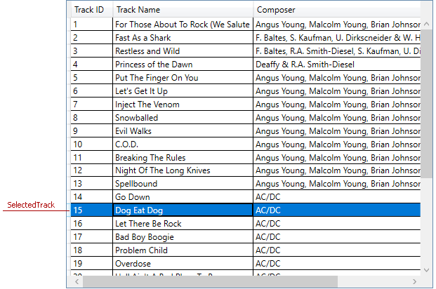

TrackInfo selectedTrack;

public TrackInfo SelectedTrack {

get { return selectedTrack; }

set {

selectedTrack = value;

OnPropertyChanged();

}

}

1. Add the **Name** and **Composer** properties. You will use them to change data of a selected track.

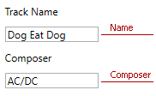

string name;

public string Name {

get { return name; }

set {

name = value;

OnPropertyChanged();

}

}

string composer;

public string Composer {

get { return composer; }

set {

composer = value;

OnPropertyChanged();

}

}

1. Add the **Load** method. This method allows you to take a track and use the track’s data to specify the **Name** and **Composer** properties.

void Load(TrackInfo track) {

if (track != null) {

Name = track.Name;

Composer = track.Composer;

}

}

1. Call the **Load** method in the **SelectedTrack** property’s set accessor.

public TrackInfo SelectedTrack {

get { return selectedTrack; }

set {

selectedTrack = value;

Load(value);

OnPropertyChanged();

}

}

1. Add a **RelayCommand** class into the root folder. Paste the following code in the class.  
   The view uses **RelayCommand** instances as command objects to call methods. The **execute** field is the command’s method. The **canExecute** field checks whether to execute the method.

public class RelayCommand : ICommand {

private Action<object> execute;

private Func<object, bool> canExecute;

public event EventHandler CanExecuteChanged {

add { CommandManager.RequerySuggested += value; }

remove { CommandManager.RequerySuggested -= value; }

}

public RelayCommand(Action<object> execute, Func<object, bool> canExecute = null)

{

this.execute = execute;

this.canExecute = canExecute;

}

public bool CanExecute(object parameter) {

return this.canExecute?.Invoke(parameter) != false;

}

public void Execute(object parameter) {

this.execute(parameter);

}

}

1. // Add the remaining steps.

# Steps … - … . Add a View

...