Recommendation Letter

3/10/2025
To Whom It May Concern:
My name is Steven Buchanan, and I am the HR Manager at Ryder System Inc. I am pleased to recommend FirstName «LastName» for the position of «Title» at Linn Co.
Over the past years, FirstName «LastName» proved themselves to be highly motivated, hard-working employee who displayed great dedication to our company mission and toward their| professional duties. Our company benefited greatly from FirstName 's time with us; we consider ourselves fortunate to have had them as a team member. I strongly believe that FirstName «LastName» will be a valuable addition to your company and will exceed expectations as «Title».
Please do not hesitate to contact me should you require any additional information.
Sincerely,
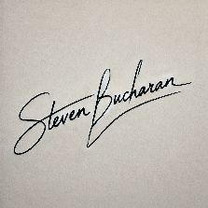

HR Manager
hrmanager@rydersystems.com
Photo

