Beverages | 
Soft drinks, coffees, teas, beers, and ales

Condiments | 
Sweet and savory sauces, relishes, spreads, and seasonings

Confections | 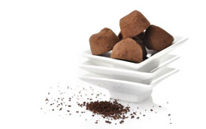
Desserts, candies, and sweet breads

Dairy Products | 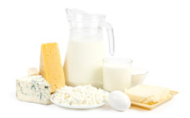
Cheeses

Grains/Cereals | 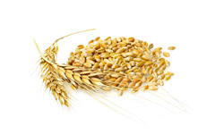
Breads, crackers, pasta, and cereal

Meat/Poultry | 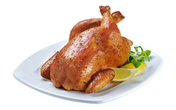
Prepared meats

Produce | 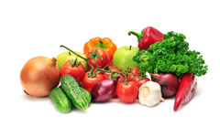
Dried fruit and bean curd

Seafood | 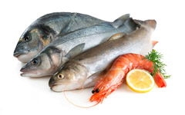
Seaweed and fish

