Hyperlinks and bookmarks
Table of Contents
How to add a bookmark and a hyperlink to the document using the toolbar
How to add a bookmark and a hyperlink to the document via code
Document model and API
Bookmark
Hyperlink
Additional Web Resources

How to add a bookmark and a hyperlink to the document using the toolbar
- From the Toolbox expand the DX.10.2: Rich Text Editor tab and drag and drop a RichEditControl onto the form.
- From the DX.10.2: Navigation & Layout tab of the Toolbox add a BarManager component to the form.
- Click the RichEditControl’s Tasks menu and click Create Links Bar; this will add the Bookmark and Hyperlink toolbar items to the form. 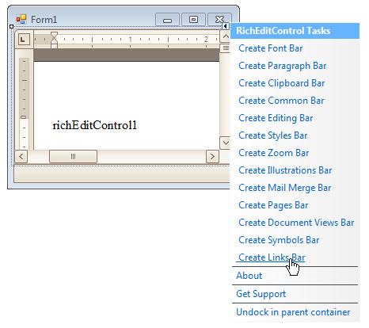This step is not required since Bookmark and Hyperlink commands are accessible via the run-time context menu.
- Compile and run the project. Add some text to the RichEditControl, i.e. type 'Bookmark is here' .
- Select the text that represents the bookmark area - the word 'here' - and click the Bookmark toolbar button (upper left). Provide a Bookmark name, for example, Bookmark01 and click Add.
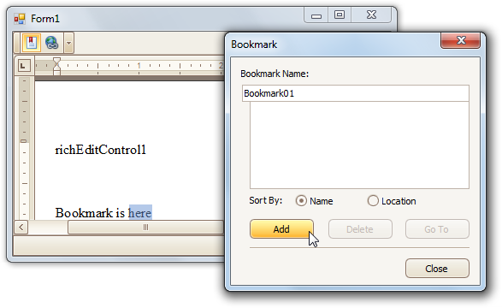
You can use the context menu command instead:
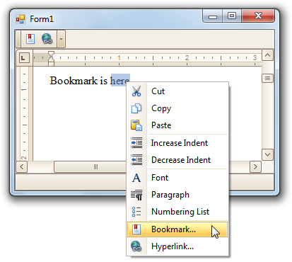
- Close the Bookmark dialog.
- To add a hyperlink in the text to the bookmark select the text for the hyperlink and click the Insert Hyperlink button or right-click and select Hyperlink from the RichEditControl’s runtime context menu, or use the CTRL + K key combination. 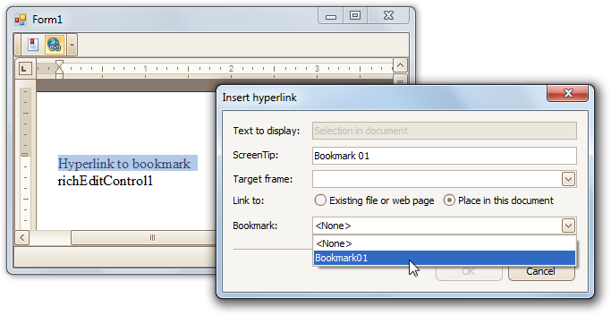Add the text to display—which will be the selected text by default—provide a ScreenTip, in the Link to region select the “Place in this document” radio button and select the Bookmark01 from the drop down list.
The hyperlink will be visible at the selected location, and holding the CTRL key while clicking will jump the focus from the hyperlink to the defined bookmark.

◄◄ back to the Table of Contents

How to add a bookmark and a hyperlink to the document via code
The following code can be used instead of the keyboard and mouse manipulation described above and results in the hyperlink pointing to the newly created bookmark.
C#
using DevExpress.XtraRichEdit.API.Native;
// ...

Document doc = richEditControl1.Document;
ISearchResult searchResult = doc.StartSearch("here", SearchOptions.WholeWord, SearchDirection.Forward);
if (searchResult.FindNext())
{
doc.CreateBookmark(searchResult.CurrentResult, "Bookmark01");
DocumentRange range = doc.InsertSingleLineText(doc.CreatePosition(0), "Hyperlink to bookmark");
Hyperlink hlink = doc.CreateHyperlink(range);
hlink.Anchor = doc.Bookmarks[0].Name;
hlink.ToolTip = "Bookmark 01";
}

VB .NET
Imports DevExpress.XtraRichEdit.API.Native
' ...
Dim doc As Document = richEditControl1.Document
Dim searchResult As ISearchResult = doc.StartSearch("here", SearchOptions.WholeWord, SearchDirection.Forward)
If searchResult.FindNext() Then
doc.CreateBookmark(searchResult.CurrentResult, "Bookmark01")
Dim range As DocumentRange = doc.InsertSingleLineText(doc.CreatePosition(0), "Hyperlink to bookmark")
Dim hlink As Hyperlink = doc.CreateHyperlink(range)
hlink.Anchor = doc.Bookmarks(0).Name
hlink.ToolTip = "Bookmark 01"
End If

◄◄ back to the Table of Contents

Document model and API

Bookmark
A Bookmark exposes a document range with a name. The range can have a zero length and the name should start with a letter and does not have to be unique in the collection of bookmarks of the current document. This collection is accessible via the Document.Bookmarks property.
To create a new bookmark and add it to the bookmark collection, use the Document.CreateBookmark method. The Document.SelectBookmark method is helpful if you want to select a bookmark. The Document.RemoveBookmark method deletes the specified bookmark.
Apart from the Document methods, the XtraRichEdit provides several commands for bookmarks - the CreateBookmarkCommand that creates a bookmark for the selected range and the ShowBookmarkFormCommand that invokes the Bookmark form, illustrated in the following picture.
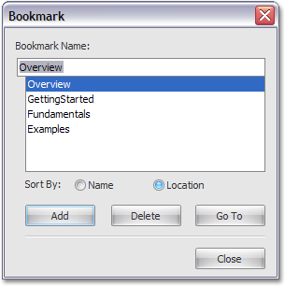
Bookmark in the document can be referenced by a Hyperlink. The Hyperlink.Anchor property specifies the bookmark to which the hyperlink is pointing.

Hyperlink
The Hyperlink marks the document range as the hot spot in the document. It can be activated by clicking or pressing Enter (note that the EnterKeyCommand does exactly the same) to navigate the location specified by NavigateUri (or Anchor if it is linked to a Bookmark). The link is opened in the frame specified by the Target property. Hyperlink has a ToolTip and can be marked as Visited.
Hyperlinks are contained in the Document.Hyperlinks collection of the document. To create a new hyperlink and add it to the collection, use the Document.CreateHyperlink method or invoke the end-user form via the ShowHyperlinkFormCommand command. The Edit hyperlink form is illustrated in the following picture:
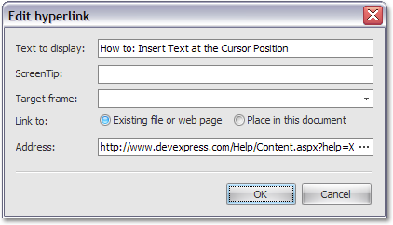
When clicked (or activated by another means), a hyperlink fires the RichEditControl.HyperlinkClick event.
Common hyperlink characteristics, such as the key modifier, required for activating the hyperlink by mouse click, as well as tooltip visibility, can be specified via the RichEditControlOptions.Hyperlinks options of the RichEditControl. For example, to activate a hyperlink with a simple mouse click, without having to hold CTRL key, set the HyperlinkOptions.ModifierKeys to the System.Windows.Forms.Keys.None value.
◄◄ back to the Table of Contents

Additional Web Resources

To help you better use our software, we provide numerous resources describing the best practices for embedding our XtraRichEdit Suite in your real-life applications.
Online Documentation
On the Developer Express Web Site, you have permanent access to the XtraRichEdit's online documentation. The online documentation is easy to use and navigate, and contains the most recent changes which may not yet be included in the offline documentation shipped with the product.
Support Center & Code Central
Support Center is the primary channel where you can get answers to your questions, report bugs and make suggestions. Whenever you want to create a new issue (ask a question, post a bug or a request) we advise that you look through the currently posted issues. A similar issue may already have been reported, so you'll find a quick answer.
The Code Central is designed to make it easier for you to locate sample code, knowledgebase code, code provided by us as part of solving a support incident, etc. It is a web application that lets you search our sample code database, sort or group or filter the results, view a preview of the sample in the grid, or click on it to see the whole thing. All you need to do is click on the sample download button on the website, answer the browser's "what should I do with this file?" security dialog, and after a moment or two, you'll be presented with the sample project in Visual Studio ready for you to peruse the code, or compile and run it.
◄◄ back to the Table of Contents

