**Matric Number:** 249074041

**Name:** Faleye, Opeoluwa Emmanuel

**Course Code:** MIT802

**Course:** Introduction to Database Management Systems

**Assignment on:**

**Pick a case study of a business process and**

1. **Describe it**
2. **Do a conceptual model (ER)**
3. **Do a logical model**
4. **Do a physical model**
5. **Come up with DDL to create the tables**
6. **Come up with DML to add data into the tables**
7. **Query the database (Show the query and output)**

SOLUTION:

**Airline Ticket Booking System**

The Airline Ticket Booking System facilitates the seamless booking and management of airline tickets for passengers. The system ensures efficient flight scheduling, passenger booking, ticket issuance, and real-time flight management while maintaining a smooth customer experience.

**Key Stakeholders:**

* **Passengers:** This are individuals who book and travel on flights.
* **Airline Staff:** The pilots, cabin crew, ground staff, and customer service representatives.
* **Aircraft Management Team:** Oversees fleet maintenance and scheduling.
* **Ticketing and Booking System:** Manages reservations, payments, and ticket issuance.
* **Airport Authorities:** Handle check-in, security, and boarding processes.

**Main Activities and Workflows:**

**1. Flight Scheduling and Planning**

* Airlines create flight schedules based on demand, routes, and aircraft availability.
* Flight details include departure/arrival times, flight numbers, aircraft type, and assigned crew.

**2. Passenger Booking and Ticketing**

* Passengers book tickets through websites, mobile apps, or travel agencies.
* Secure payment processing ensures booking confirmation.
* A ticket with a unique ID and flight details is issued.

**3. Check-in and Boarding**

* Passengers check in online or at airport kiosks.
* Boarding passes are issued, and seat numbers are assigned.
* Identity verification and baggage handling are completed.

**4. Flight Operations**

* Crew members are assigned to flights.
* Pre-flight safety checks and refueling occur.
* Passengers board, and the flight takes off as scheduled.

**5. Flight Monitoring and Updates**

* Real-time flight tracking by airline control.
* Notifications on delays or schedule changes sent to passengers.

**6. Post-Flight Operations**

* Arrival and passenger disembarkation.
* Baggage claim and customs processing.
* Aircraft maintenance and preparation for the next flight.

**2. Conceptual Model (ER)**

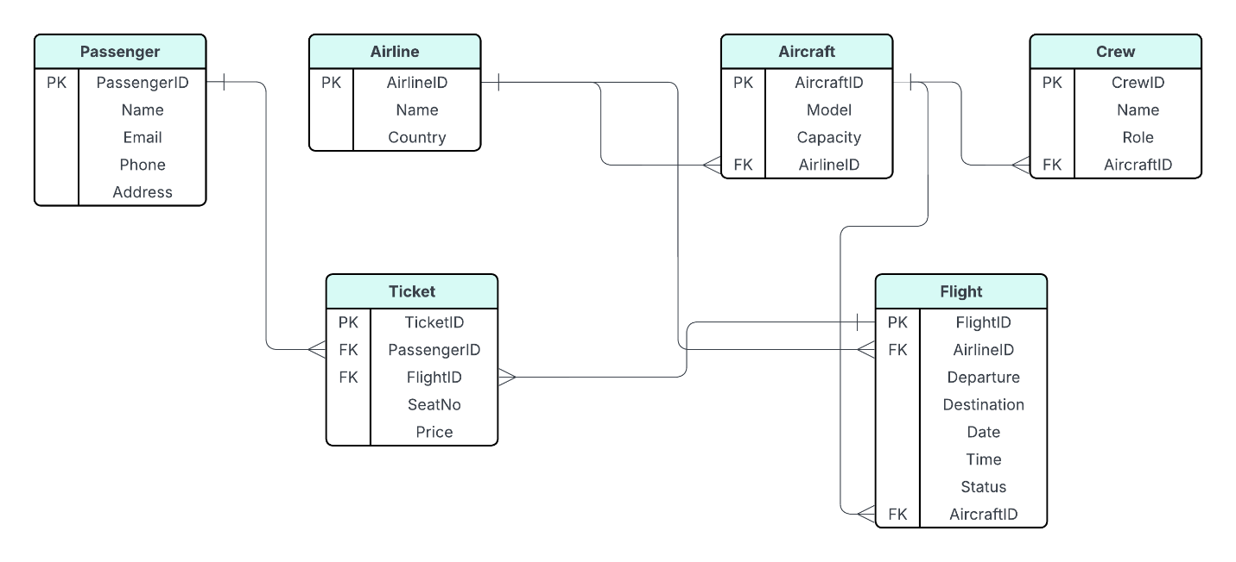

**Entities and Attributes:**

* **Passenger** (PassengerID, Name, Email, Phone, Address)
* **Airline** (AirlineID, Name, Country)
* **Aircraft** (AircraftID, Model, Capacity, AirlineID)
* **Flight** (FlightID, AirlineID, Departure, Destination, Date, Time, Status, AircraftID)
* **Ticket** (TicketID, PassengerID, FlightID, SeatNo, Price)
* **Crew** (CrewID, Name, Role, AircraftID)

**Relationships**

* One passenger can have multiple tickets, but each ticket is linked to only one passenger.
* One airline operates many aircraft, but each aircraft belongs to one airline.
* One airline operates many flights, but each flight is operated by one airline.
* One aircraft can serve multiple flights over time, but each flight uses one aircraft.
* One flight can have many tickets booked, but each ticket is for one specific flight.
* One aircraft has multiple crew members assigned, but each crew member works on one aircraft per entry.

**3. Logical Model**

The logical model involves structuring these entities into tables, specifying attributes, primary keys (PK), and foreign keys (FK).

**Table Definitions:**

**Passengers Table**

* PassengerID (PK)
* Name
* Email
* Phone Number
* Address

**Flights Table**

* FlightID (PK)
* AirlineID (FK)
* Destination
* Departure
* Time
* Date
* Status
* AircraftID (FK)

**Tickets Table**

* TicketID (PK)
* PassengerID (FK)
* FlightID (FK)
* Price
* SeatNo

**Aircraft Table**

* AircraftID (PK)
* Model
* Capacity
* AirlineID (FK)

**Crew Table**

* CrewID (PK)
* Name
* Role
* AircraftID (FK)

**Airline Table**

* AirlineID (PK)
* Name
* Country

### ****4-5. Physical Model:****

The physical model specifies how the data is stored in the database, including data types and storage mechanisms. This will also be used as the DDL (Data Definition Language) to the create tables in the database.

-- Creating Passenger Table

CREATE TABLE Passenger (

PassengerID INT (10) PRIMARY KEY AUTO_INCREMENT,

Name VARCHAR(100) NOT NULL,

Email VARCHAR(100) UNIQUE NOT NULL,

Phone VARCHAR(20) NOT NULL,

Address TEXT

);

-- Creating Airline Table

CREATE TABLE Airline (

AirlineID INT (10) PRIMARY KEY AUTO_INCREMENT,

Name VARCHAR(100) NOT NULL,

Country VARCHAR(50) NOT NULL

);

-- Creating Aircraft Table

CREATE TABLE Aircraft (

AircraftID INT (10) PRIMARY KEY AUTO_INCREMENT,

Model VARCHAR (100) NOT NULL,

Capacity INT (10) NOT NULL,

AirlineID INT (10),

FOREIGN KEY (AirlineID) REFERENCES Airline(AirlineID) ON DELETE SET NULL

);

-- Creating Flight Table

CREATE TABLE Flight (

FlightID INT (10) PRIMARY KEY AUTO_INCREMENT,

AirlineID INT (10),

Departure VARCHAR(100) NOT NULL,

Destination VARCHAR(100) NOT NULL,

Date DATE NOT NULL,

Time TIME NOT NULL,

Status VARCHAR(50) DEFAULT 'Scheduled',

AircraftID INT (10),

FOREIGN KEY (AircraftID) REFERENCES Aircraft(AircraftID) ON DELETE SET NULL,

FOREIGN KEY (AirlineID) REFERENCES Airline(AirlineID) ON DELETE CASCADE

);

-- Creating Ticket Table

CREATE TABLE Ticket (

TicketID INT (10) PRIMARY KEY AUTO_INCREMENT,

PassengerID INT (10),

FlightID INT (10),

SeatNo VARCHAR(10) NOT NULL,

Price DECIMAL(10,2) NOT NULL,

FOREIGN KEY (PassengerID) REFERENCES Passenger(PassengerID) ON DELETE CASCADE,

FOREIGN KEY (FlightID) REFERENCES Flight(FlightID) ON DELETE CASCADE

);

-- Creating Crew Table

CREATE TABLE Crew (

CrewID INT (10) PRIMARY KEY AUTO_INCREMENT,

Name VARCHAR(100) NOT NULL,

Role VARCHAR(50) NOT NULL,

FlightID INT (10),

FOREIGN KEY (FlightID) REFERENCES Flight(FlightID) ON DELETE CASCADE

);

### ****6. The Data Manipulation Language (DML):** This showcases the way data is being inserted into the tables.**

### -- Insert into Airline

### INSERT INTO Airline (Name, Country) VALUES ('Air Nigeria', 'Nigeria'), ('Ethiopian Airlines', 'Ethiopia');

### -- Insert into Aircraft

### INSERT INTO Aircraft (Model, Capacity, AirlineID) VALUES ('Boeing 737', 180, 1), ('Airbus A320', 160, 2);

### -- Insert into Passenger

### INSERT INTO Passenger (Name, Email, Phone, Address) VALUES (‘Faleye Opeoluwa’, ‘faleyeopeoluwa7@gmail.com’, ' 08105386988', 'Lagos, Nigeria'), (‘Aminat Alli’, ‘aminatalli@gmail.com’, '07015382288', 'Kaduna, Nigeria');

### -- Insert into Flight

### INSERT INTO Flight (AirlineID, Departure, Destination, Date, Time, Status, AircraftID) VALUES

### (1, 'Lagos', 'Abuja', '2025-04-01', '10:00:00', 'Scheduled', 1),

### (2, 'Addis Ababa', 'Lagos', '2025-04-02', '14:30:00', 'Scheduled', 2);

### -- Insert into Ticket

### INSERT INTO Ticket (PassengerID, FlightID, SeatNo, Price) VALUES (1, 1, '12A', 50000.00);

### -- Insert into Crew

### INSERT INTO Crew (Name, Role, FlightID) VALUES ('James Smith', 'Pilot', 1), ('Sarah Johnson', 'Flight Attendant', 2);

### ****7. Querying the Database and showing its outputs:****

Query 1: Query the DB to get the Passengers Flight Details

SELECT p.Name,f.Departure, f.Destination, f.Time, f.Date, t.SeatNo

FROM Passenger p

JOIN Ticket t ON p.PassengerID = t.PassengerID

JOIN Flight f ON t.FlightID = f.FlightID;

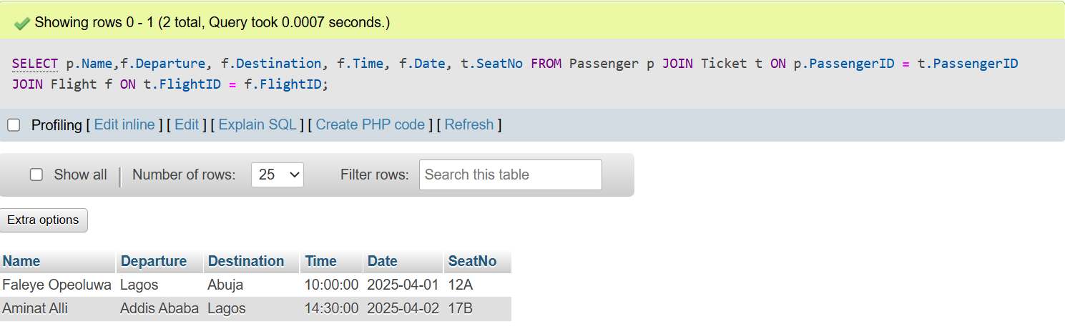

Query 2: Query the DB to get the aircraft details with airline information

SELECT A.Model, A.Capacity, L.Name AS Airline

FROM Aircraft A

JOIN Airline L ON A.AirlineID = L.AirlineID;

