EMBEDDED SYSTEMS PROJECT REPORT

Smart Density-Based Traffic Control System
Using IR Sensors and Adaptive Signal Scheduling

Submitted in partial fulfilment of the requirements for the

Embedded Systems Course

Submitted By

Nishit Gupta(24BEC034) Riti Joshi(24BCS120) Namita Wayal(24BCS081)

Submitted To

Prof. Sibasankar Padhy

Academic Year 2024 – 2025

Abstract

This project presents the design and implementation of a Smart Density-Based Traffic Control System using IR sensors and an embedded microcontroller. Conventional traffic signals operate on fixed time cycles that are inefficient during varying traffic conditions, leading to unnecessary congestion and delays. The proposed system addresses this limitation by dynamically adjusting signal durations based on real-time traffic density measured using two infrared sensors per lane.

The system controls three lanes, each equipped with a red, yellow, and green traffic light. A priority scoring algorithm — combining queue level, vehicle arrival rate, and waiting time — determines which lane receives the green signal next. The 16×2 LCD display provides real-time feedback including the active lane, countdown timer, traffic density, and the next predicted lane. The system ensures fairness by penalizing lanes that have been waiting too long, while maximising intersection throughput.

Introduction

Traffic congestion is a growing problem in urban areas worldwide. Traditional traffic light systems use pre-programmed fixed time cycles that do not adapt to real-time road conditions. During peak hours this results in longer wait times for densely occupied lanes, while during off-peak hours, signals continue to follow the same rigid pattern leading to unnecessary idling.

The Smart Density-Based Traffic Control System proposes an intelligent, adaptive alternative. Using infrared (IR) sensors placed at strategic points in each lane, the system detects queue length and the rate at which vehicles are entering the lane. A microcontroller processes this data and computes a congestion-based priority score for each lane. The lane with the highest score receives the green signal, and the green duration is dynamically allocated based on how congested that lane is.

The system operates on a continuous loop, re-evaluating priorities after every signal cycle, ensuring that no lane is starved of service while still prioritising heavily congested lanes first.

Objectives

- To design an adaptive traffic signal system that responds to real-time vehicle density.
- To implement a two-sensor setup per lane for detecting queue level and vehicle arrival rate.
- To develop a priority score algorithm that fairly allocates green signal time.
- To ensure no lane is indefinitely starved by incorporating waiting time into the score.
- To display system status on a 16×2 LCD for demonstration and monitoring purposes.
- To implement the Red → Green → Yellow signal transition sequence correctly for all
three lanes.

Components Used

Component | Quantity | Purpose
Microcontroller (Arduino / 8051) | 1 | Central processing and control
IR Sensors | 6 (2 per lane) | Detect vehicle presence and arrival
LEDs (Red, Yellow, Green) | 9 (3 per lane) | Represent traffic signal lights
16×2 LCD Display | 1 | Real-time status output
Breadboard / PCB | 1 | Circuit assembly
Power Supply (5V DC) | 1 | Power to microcontroller and peripherals
Connecting Wires | As needed | Electrical connections

- System Architecture

Lane and Sensor Configuration
The system manages three lanes — L1, L2, and L3. Each lane contains:
    - One near sensor S1 — placed close to the stop line to detect vehicles already waiting in queue.
    - One far sensor S2 — placed a few meters upstream to detect vehicles approaching and entering the queue.

With three lanes and two sensors each, the system uses six IR sensors in total. The sensor readings are binary: logic 1 when a vehicle is detected, logic 0 when the path is clear.

Queue Level Detection
The combination of S1 and S2 readings determines the queue level for each lane:

S1 (Near) | S2 (Far) | Queue Level | Interpretation
0 | 0 | 0 | No vehicles in the lane
1 | 0 | 1 | Small queue near the signal
1 | 1 | 2 | Long queue extending backward

Arrival Rate Calculation
Every time a vehicle crosses S2, an internal counter is incremented. The arrival rate is computed over a fixed time window (typically 10 seconds):

Arrival Rate = Vehicles detected at S2 ÷ Time interval (seconds)

A higher arrival rate indicates the lane is filling up quickly and must be accounted for in the priority calculation.

Waiting Time Tracking
Each lane maintains a timer that tracks how long it has been waiting since it last received a green signal. This timer is reset to zero whenever a lane gets its green turn. The waiting time grows continuously for lanes that are waiting, ensuring that even lightly loaded lanes eventually receive service.

Control Algorithm

Priority Score Formula
The microcontroller computes a priority score for each lane using the following formula:

Priority Score =(Queue Level × 5) + (Arrival Rate × 2) + Waiting Time×2

This Formula calculation will be displayed on the Serial Monitor

The weights assigned to each factor reflect their relative importance:
    - Queue Level (weight 5) — Highest priority. Vehicles already waiting at the signal must be cleared first.
    - Arrival Rate (weight 2) — Moderate priority. Anticipates incoming congestion before it builds up.
    - Waiting Time (weight 2) — Fairness factor. Prevents any lane from being ignored indefinitely.

Example Priority Calculation

Lane | Queue Level | Arrival Rate (v/s) | Waiting Time (s) | Priority Score
L1 | 2 | 0.5 | 15 | (2×5)+(0.5×2)+15 = 26.0
L2 | 1 | 0.8 | 40 | (1×5)+(0.8×2)+40 = 46.6
L3 | 2 | 0.3 | 20 | (2×5)+(0.3×2)+20 = 30.6

In this example, Lane L2 receives the green signal despite having a smaller queue level, because its high waiting time elevated its score. This demonstrates fairness in the algorithm.

Dynamic Green Time Allocation
Once a lane is selected, the duration of its green signal is determined dynamically based on queue level:

Green Time = 10 + (Queue Level × 5) seconds

Queue Level | Green Duration
0 (No vehicles) | 10 seconds
1 (Small queue) | 15 seconds
2 (Long queue) | 20 seconds

Signal Transition Sequence

Every lane cycle follows a strict signal transition order to ensure safety and prevent intersection collisions:

- Green Phase — The selected lane receives the green signal. Vehicles pass through the intersection for the dynamically allocated green duration.
- Yellow Phase — The green lane switches to yellow for 2–3 seconds. This warns drivers that the signal is about to turn red.
- All-Red Safety Phase — All lanes display red for 1–2 seconds. This clears the intersection before the next lane is activated.
- Next Cycle — The system recalculates priority scores and selects the next lane to receive green.

This sequence ensures safe signal transitions and gives drivers adequate warning before the signal changes.

System Operation Cycle

The microcontroller continuously executes the following steps in a loop:

- Read all six sensor values (S1 and S2 for each lane).
- Determine the queue level for each lane based on sensor states.
- Count vehicles crossing S2 over the time window and compute arrival rates.
- Update the waiting time counter for each lane.
- Compute the priority score for all three lanes.
- Select the lane with the highest priority score.
- Allocate the green signal to the selected lane for the dynamically computed duration.
- Activate the yellow signal for 2–3 seconds after the green phase ends.
- Apply the all-red safety interval for 1–2 seconds.
- Reset the waiting time of the lane that just received green. Begin the next cycle.

LCD Display Interface

A 16×2 LCD (16 characters × 2 lines) provides real-time status information. The display cycles between two screens every 3–4 seconds, and switches to transition screens during signal changes.

Screen 1 — Signal Status (Primary Screen)

LN:B T:12 Q 0 2 1
LN:B = Lane B is currently active | T:12s = 12 seconds remaining | NX:C = Lane C is predicted next.

8.4 Startup Screen

SMART TRAFFIC
Displayed for 2 seconds when the system is powered on.

- Circuit Simulation

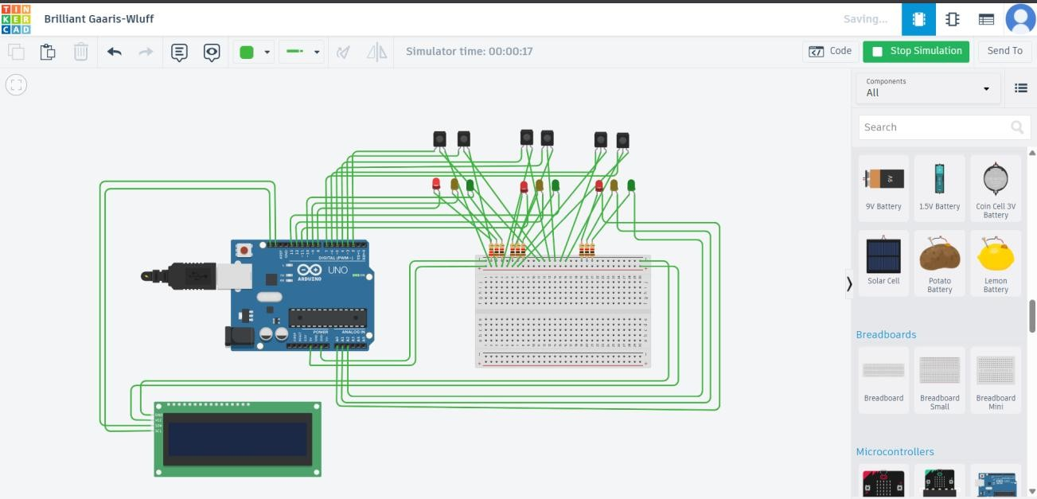

- Block Diagram

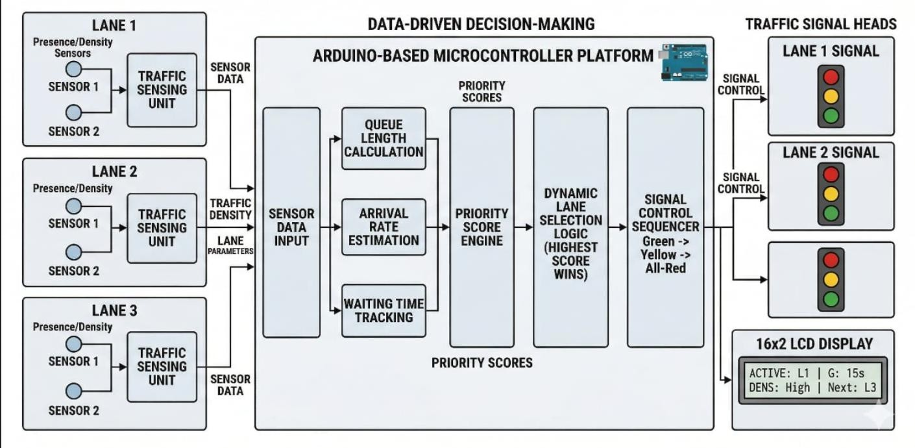

10.Prototype Design

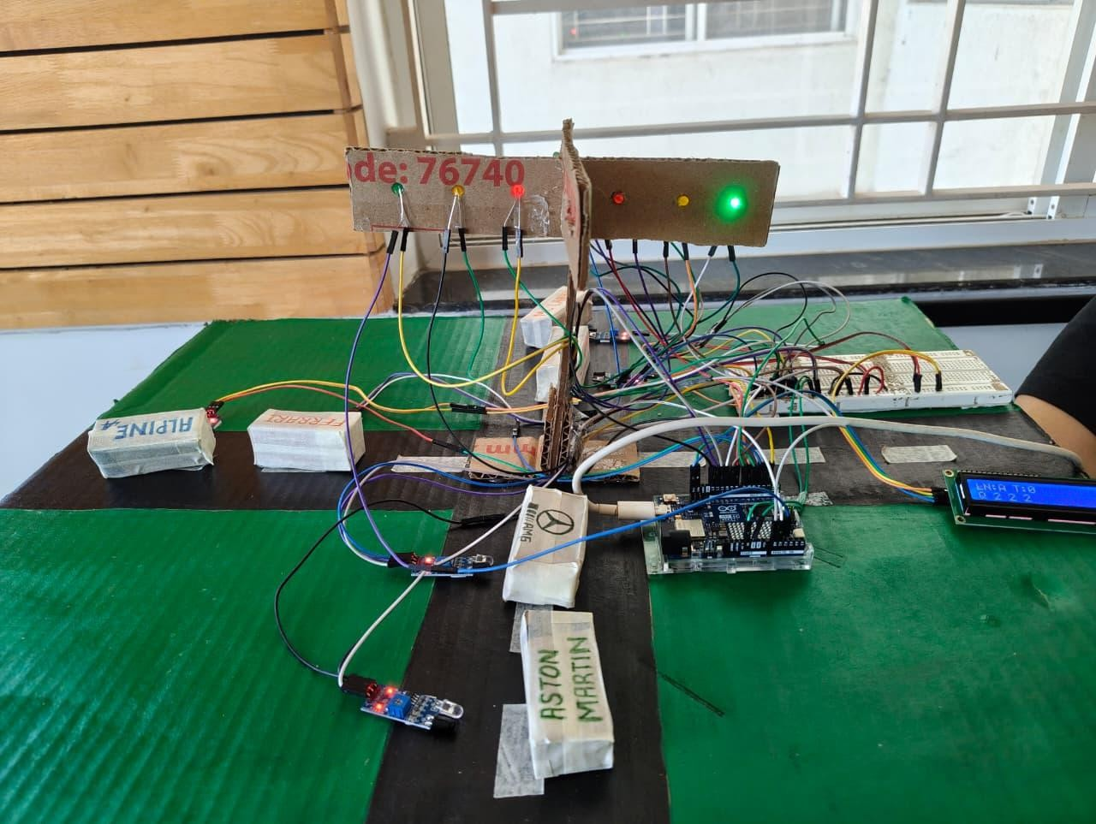

- Results and Observations

The system was tested under simulated traffic conditions with varying vehicle densities across the three lanes. The following observations were recorded:

- The priority scoring algorithm correctly identified the most congested lane in all test cases.
- Dynamic green time allocation reduced unnecessary waiting for low-density lanes.
- The waiting time component prevented any single lane from being skipped repeatedly, ensuring fairness.
- The yellow and all-red transition phases executed correctly, preventing simultaneous green signals across lanes.
- The LCD display accurately reflected the active lane, countdown timer, queue levels, and next predicted lane in real time.
- Arrival rate detection via S2 allowed the system to anticipate growing congestion before it reached the stop line.

Advantages Over Conventional Systems

Feature | Conventional System | Proposed Smart System
Signal timing | Fixed, pre-programmed | Dynamic, based on real-time data
Congestion handling | Ignores actual traffic density | Prioritises denser lanes automatically
Fairness | Rigid round-robin | Weighted score with waiting time factor
Starvation prevention | Not guaranteed | Built into the priority formula
Hardware complexity | Simple timers | Sensors + microcontroller logic
Display feedback | None | 16×2 LCD with live data

- Limitations and Future Scope

Current Limitations
    - IR sensors assume a single lane (one-dimensional queue) and cannot count vehicles in multi-lane wide roads.
    - The system does not account for pedestrian signals or emergency vehicle priority.
    - Environmental factors such as rain, dust, or strong light may affect IR sensor accuracy.
    - The arrival rate window is fixed and may not adapt well to sudden traffic bursts.

Future Enhancements
    - Integration of camera-based computer vision to count vehicles regardless of lane width.
    - Addition of an emergency vehicle detection module to override signals when ambulances or fire trucks approach.
    - IoT connectivity to share traffic data across multiple intersections for city-wide adaptive control.
    - Implementation of machine learning models trained on historical traffic patterns to pre- emptively adjust signal plans.
    - Pedestrian push-button integration for safer road-crossing functionality.

Conclusion

The Smart Density-Based Traffic Control System successfully demonstrates that a simple yet effective adaptive traffic management solution can be implemented using low-cost IR sensors and a microcontroller. By replacing fixed-time cycles with a congestion score driven algorithm — combining queue level, arrival rate, and waiting time — the system dynamically allocates green signal time to where it is needed most.

The priority formula ensures both efficiency and fairness: heavily congested lanes are cleared first, while lighter lanes are guaranteed service within a reasonable time. The 16×2 LCD interface makes the system transparent and suitable for live demonstrations, clearly showing the decision- making process in real time.

This project lays a solid foundation for more advanced smart city traffic management solutions and demonstrates the practical application of embedded systems in solving real-world urban problems.

References

- Arduino Official Documentation — https://www.arduino.cc/reference/en/
- IR Sensor Datasheet — TCRT5000 Reflective Optical Sensor
- YouTube Reference: Density Based Traffic Control System using IR Sensors —
https://www.youtube.com/watch?v=ap-BApsDpT4
- Adaptive Traffic Signal Control — Transportation Research Board, National Academies Press.

