A Project Report
On
"GYM AND FITNESS"

(CE255 – Software Group Project)

Prepared by -
20CS006 - Kunj Bapodariya
20CS010 - Meet Butani
20CS018 - Dev Halvawala

Under the Supervision of
Dr. Amit Thakkar

Submitted to
Charotar University of Science & Technology (CHARUSAT)
for the Partial Fulfillment of the Requirements for the
Degree of Bachelor of Technology (B.Tech.)
in Computer Science & Engineering (CSE)
for 4th semester B.Tech.

Submitted at


Accredited with Grade A by NAAC
Accredited with Grade A by KCG



DEPARTMENT OF COMPUTER SCIENCE & ENGINEERING
Chandubhai S. Patel Institute of Technology (CSPIT)
Faculty of Technology & Engineering (FTE), CHARUSAT
At: Changa, Dist: Anand, Pin: 388421.
April 2022


Accredited with Grade A by NAAC
Accredited with Grade A by KCG

CERTIFICATE

This is to certify that the report entitled “GYM AND FITNESS” is a bonafied work carried out by 20CS006-Kunj Bapodariya, 20CS010-Meet Butani, 20CS018-Dev Halvawala under the guidance and supervision of Dr. Amit Thakkar for the subject Software Group Project (CE255) of 4th Semester of Bachelor of Technology in Computer Science & Engineering at Chandubhai S. Patel Institute of Technology (CSPIT), Faculty of Technology & Engineering (FTE) – CHARUSAT, Gujarat.

To the best of my knowledge and belief, this work embodies the work of candidate himself/herself, has duly been completed, and fulfills the requirement of the ordinance relating to the B.Tech. Degree of the University and is up to the standard in respect of content, presentation and language for being referred by the examiner(s).

Under the supervision of,

Dr./Prof. Amit Thakkar
(Head of Department)
Dept. of Computer Science & Engineering.
CSPIT/FTE, CHARUSAT, Changa, Gujarat
Dr. Amit Thakkar
Head - Department of Computer Science & Engineering,
CHARUSAT, Changa, Gujarat.

Chandubhai S. Patel Institute of Technology (CSPIT)
Faculty of Technology & Engineering (FTE), CHARUSAT
At: Changa, Ta. Petlad, Dist. Anand, Pin:388421. Gujarat.

Software Requirements Specification
for

Gym & Fitness Website
Version 1.1 approved
Prepared by 20CS006, 20CS010, 20CS018
CSPIT-CSE
18-02-21
Table of Contents

Revision History
1. Introduction 1
1.1 Objective 1
1.2 Document Conventions 1
1.3 Intended Audience and Reading Suggestions 1
1.4 Project Scope 1
1.5 References 2
2. Overall Description 2
2.1 Product Perspective 2
2.2 Product Features 2
2.3 User Classes and Characteristics 2
2.4 Operating Environment 2
2.5 Design and Implementation Constraints 3
2.6 User Documentation 3
2.7 Assumptions and Dependencies 3
3. System Features 3
3.1 System Feature 1 3
4. External Interface Requirements 4
4.1 User Interfaces 4
4.2 Hardware Interfaces 4
4.3 Software Interfaces 5
4.4 Communications Interfaces 5
5. Other Nonfunctional Requirements 5
5.1 Performance Requirements 5
5.2 Safety Requirements 6
5.3 Security Requirements 6
5.4 Software Quality Attributes 6
6. Other Requirements 6
Appendix A: Glossary 6
Appendix B: Analysis Models 7
Appendix C: Issues List Error! Bookmark not defined.

Revision History
Name | Date | Reason For Changes | Version

1) Introduction

1.1) Introduction
We are designing a website for a person who is either seeking for gym and fitness help or who wants to become a Trainer. The basic motto for this project is to provide all the gym and fitness facilities online like personal trainer for both home and gym, etc. This website will help our customers to improve their health in the way they want by sitting at home.

1.2) Document Conventions
We have chosen the font and highlighted certain information which will be reader friendly and we have a very good and attractive GUI design.

1.3) Intended Audience and Reading Suggestions
This website is intended for those people who are looking for the gym facilities. It includes everything from a gym membership, to Equipment rental services, Diet plans, Home workout schedules and much more. Also, there is room for all the people who have right knowledge of this field and want to spread their knowledge by becoming a Trainer.

1.4) Project Scope
The basic motto of this project is to give all the possible physical health related help they want in the way they want at a reasonable price.
Our website provides all the necessary details needed by the customer and help them select the right plans from various available options, diets according to their day-to-day schedule and much more.

1.5) References
We have taken Reference from the websites given below-
- Fitnessfirst.net.in
- Goldsgym.in
- Bootstrap.com
- Web development tutorials
- YouTube videos
- W3schools

2) Overall Description

2.1) Product Perspective
Our Gym and Fitness website basically contains the following products.
Product details: The website shows all the memberships/various plans (including both home and gym), diet plans, personal trainer, become a trainer option and Rental services for small equipments (like dumbles).
Product quotation: Provides the various plans showing what is all included in the plan. There is a payment page which shows the plan selected and the amount to be paid to buy that plan/membership and it varies as per the requirements of the client.

2.2) Product features
- Equipment rental service
- Chatbot assistance
- 24*7 customer service
- Secure and User friendly

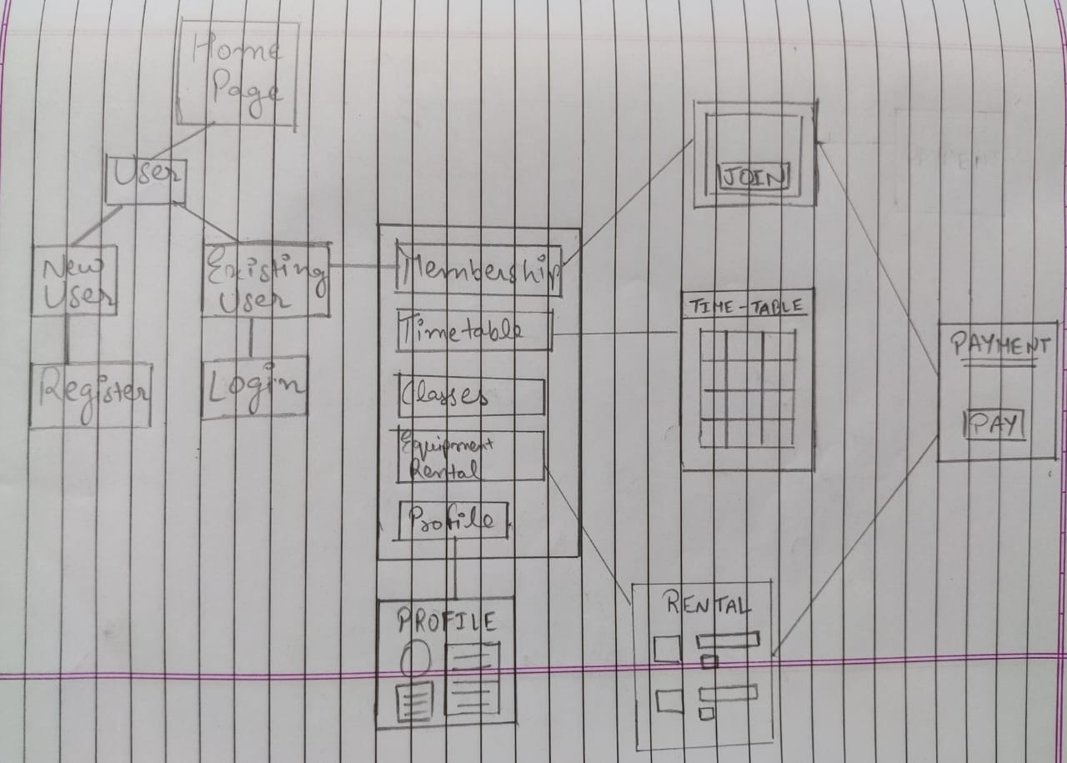

2.3) User Classes and Characteristics
User of the system will be able to retrieve vital information regarding the Gyms and Fitness. Customers will also be able to compare prices for a certain plans/product from the prices offered. The system will support two types of user privileges, Customer, and Employee. Customers will have access to customer functions, and the employees will have access to both customer and product management function.

2.4) Operating Environment
Operating environment for our retailed website is as listed below:
- Client / Server system
- Operating system: Windows, MacOS.
- Platform: HTML, JavaScript, CSS, XAMPP
- Database: MySQL Apache server

2.5) Design and Implementation Constraints
From the client’s side English language and even a low-end PC will do the work. We will take all the responsibility for any payment failures and dissatisfaction from the client’s side. In case of rental equipments if any harm happens to the equipment, then it will not be the responsibility of us.

2.6) User Documentation
We have many connections with local gyms and have hired certain number of trainers. We also provide a kind of insurance for any kind of harm that is caused due to problems on our end.

2.7) Assumptions and Dependencies
The main assumption of this project is that the user will be provided with an ample information related to fitness diet and many other things for building a good body. This will help the clients choose what they need for them and then the expenditure will be provided accordingly.

3) System Features
3.1) Description and Priority
Our first priority is customer satisfaction. In today’s world of staying at home people need to take care of their physical and mental health. We take care of each of our customer personally and help them be physically and mentally fit.

3.2) Stimulus / Responsive
The website is responsive and is power and resource efficient. It has a very quick response time and works with multiple operating systems.

3.3) Functional Requirement
- Equipment rental scheme
- 24/7 customer service
- Chat-bot assistance
- Multipurpose fitness scheme

4) External Interface Requirements

4.1) User Interfaces
Front-end Software: Visual studio code, Bootstrap, Sublime.
Back-end software: XAMPP (Apache Module, MySQL Module)

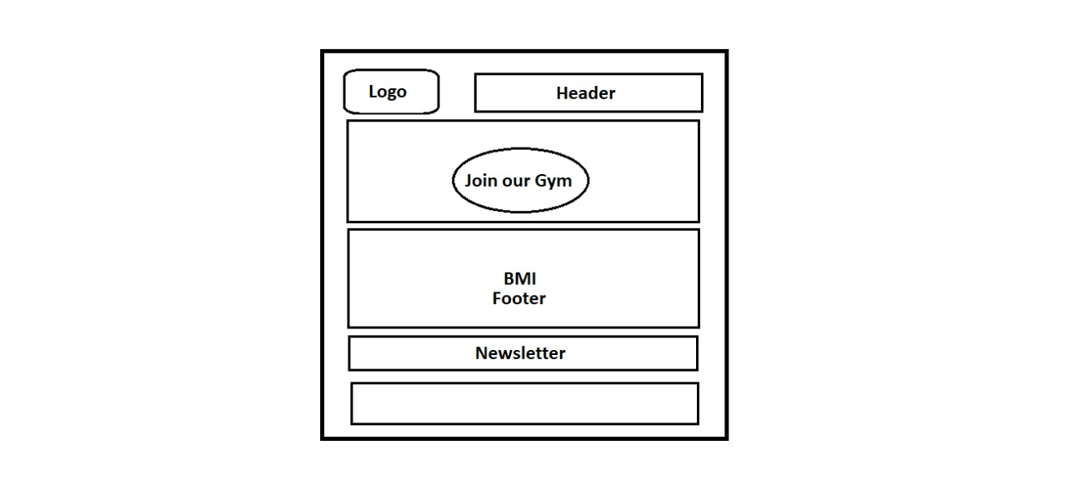
Footer

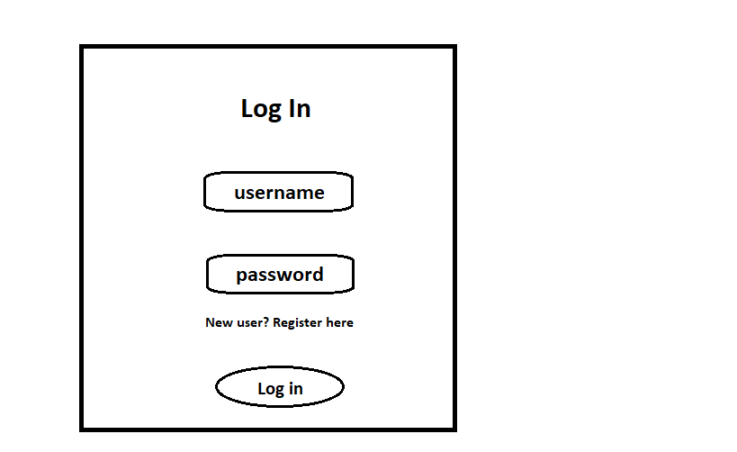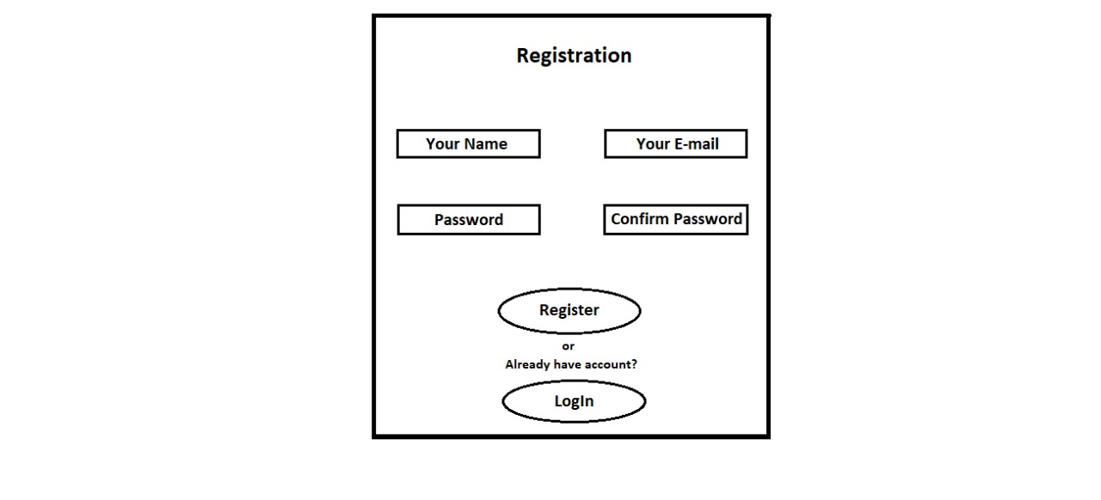

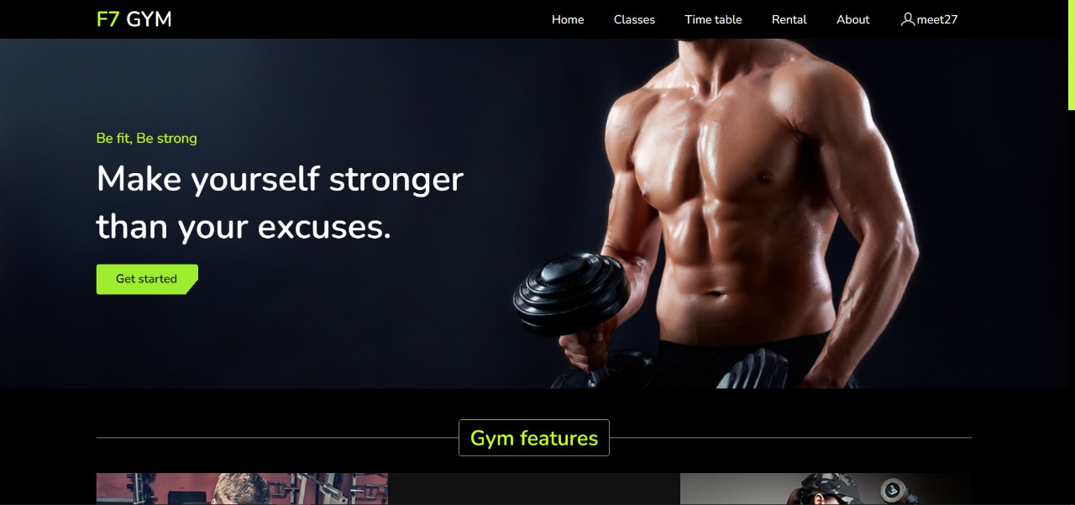

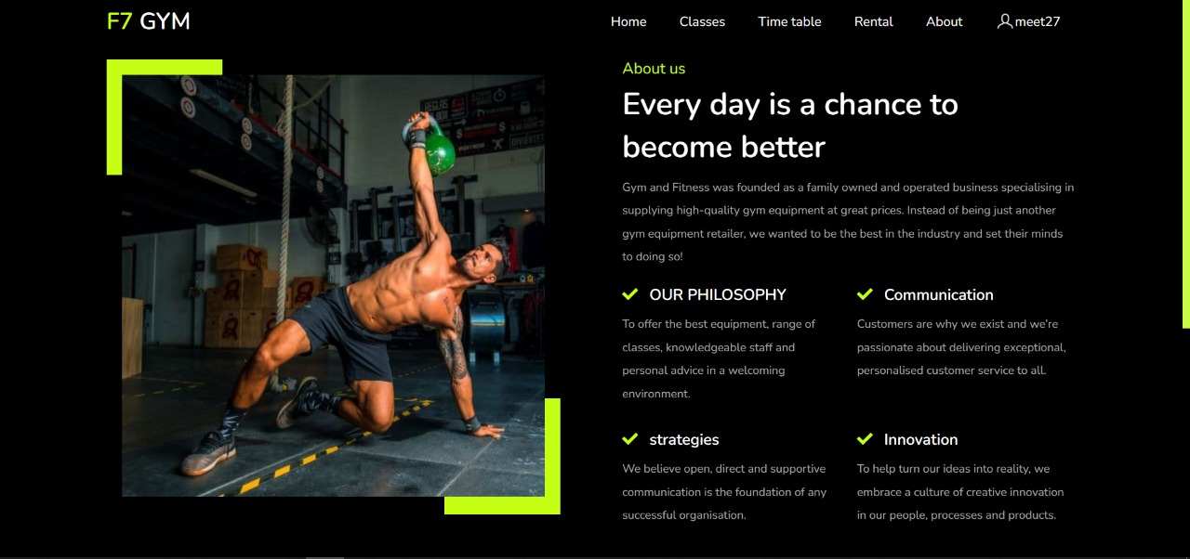

4.2) Hardware Interfaces
Windows
Browser which supports HTML, CSS JavaScript, PHP.

4.3) Software Interfaces
Following are the software that we have used for our Gym and Fitness website.
Software used | Description
Operating system | We have chosen Windows operating system for its best support and user-friendliness.
Database | To store the details of the customers we have used MySQL to store data using PHP and XAMPP.
Visual Studio Code | To implement the project we have chosen HTML, CSS, JavaScript language for its more interactive support.

4.4) Communications Interfaces
This project supports all types of web browsers like Google Chrome, Firefox, MacOS, etc.

5) Other Nonfunctional Requirements

5.1) Performance Requirements
As the project is web based so there are no specifications for performance but in further updates of the project the user will be able to select the plans they wish to buy and will also be able to apply for becoming an Trainer.

5.2) Safety Requirements
1) If there is extensive damage to a wide portion of the database due to catastrophic failure, such as a disk crash, the recovery method restores a past copy of the database that was backed up to archival storage (typically tape).
2) Data on the server should be protected from power loss but data in transit from server to requester could be lost. To prevent this loss, such failures will be monitored and the uploading process will be repeated
3) Database- Data from the database will never be transmitted to unauthenticated sources
4) Application- The website will never disclose customer information to users that are not authorized to see it.

5.3) Security Requirements
The client need to login or signup accordingly. We take responsibility of the problems that may delay the services or client not happy with the services. For the trainer who want to apply have to show their credibility which will be judged by the team from our side.

5.4) Software Quality Attributes
- Availability: Our Gym and Fitness website is available 24*7 to everyone.
- Adaptability: Adaptable with any device and any operating system with minimum requirement of ram.
- Correctness: Correct memberships must be received by the client or it will may or can have a bad client-seller experience.
- Maintainability: The administrators will maintain the schedule and on time sessions

