Task 1(Permutation & Combination)

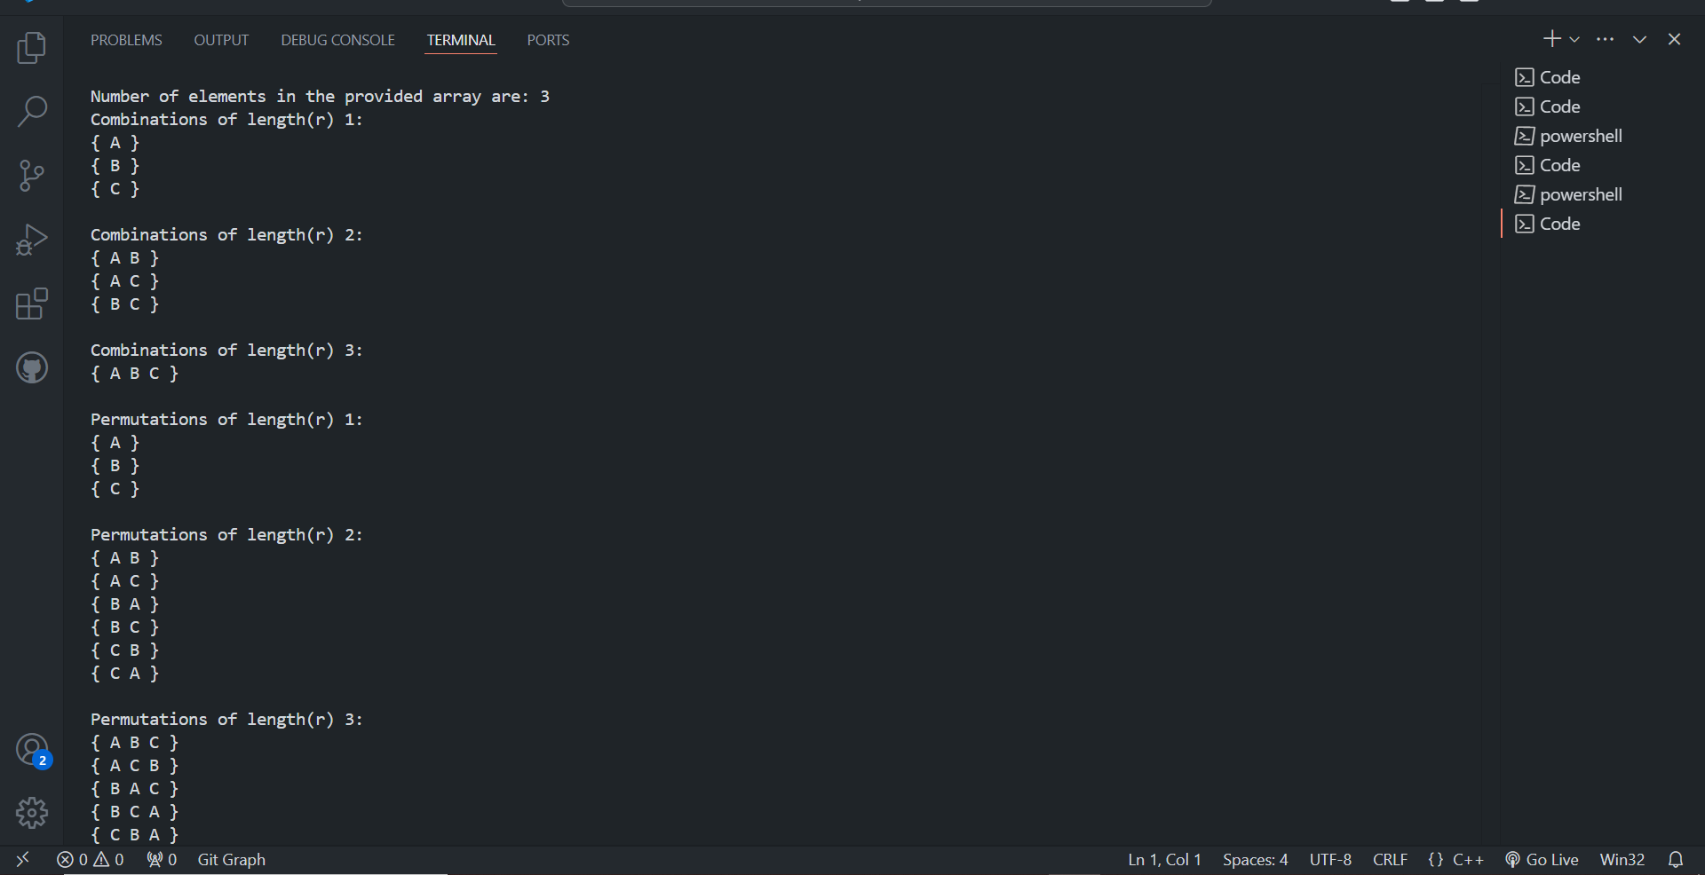

Task 3(RC Major)

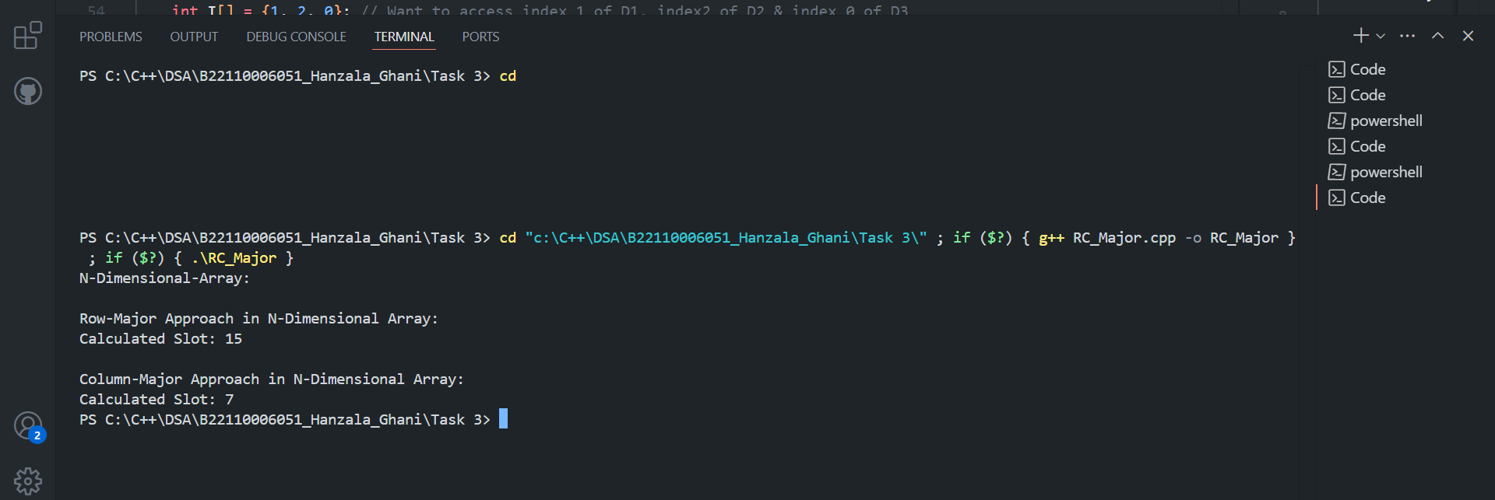

Task 4(Linked List)

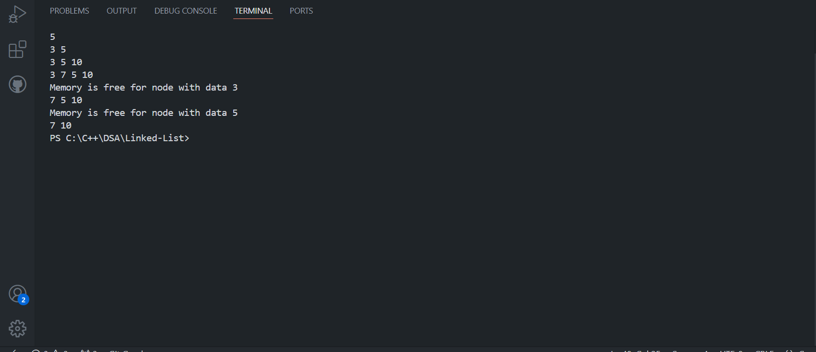

Task 6

(Queue_Using_Array)

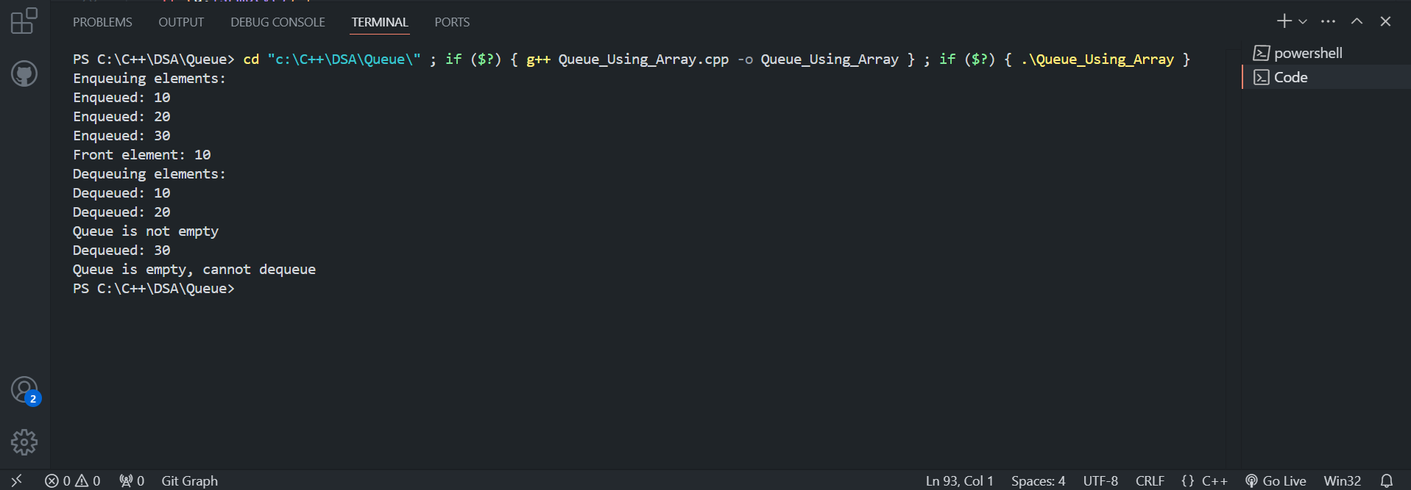

(Queue_Using_Linked_List)

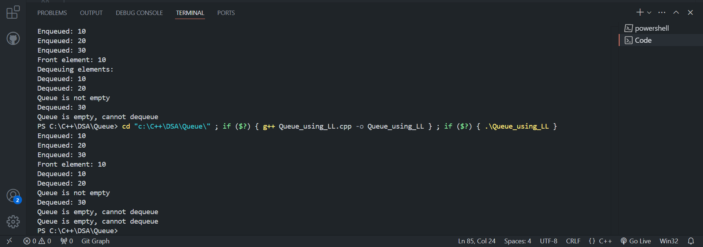

(Stack_Using_Array)

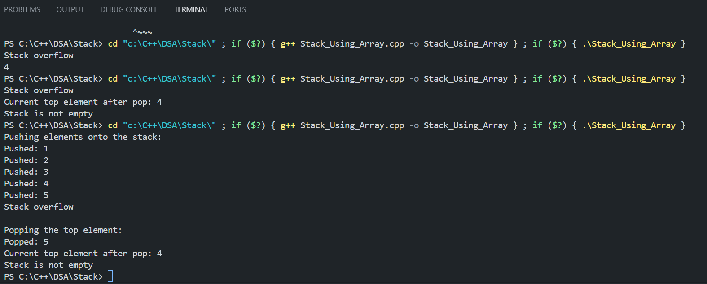

(Stack_Using_Linked_List)

