Portal – CCMS ID Handoff
How a portal user id relates to CCMS person records, and how application data is pushed and retrieved across the two databases

1 — Sending the user: write / push path
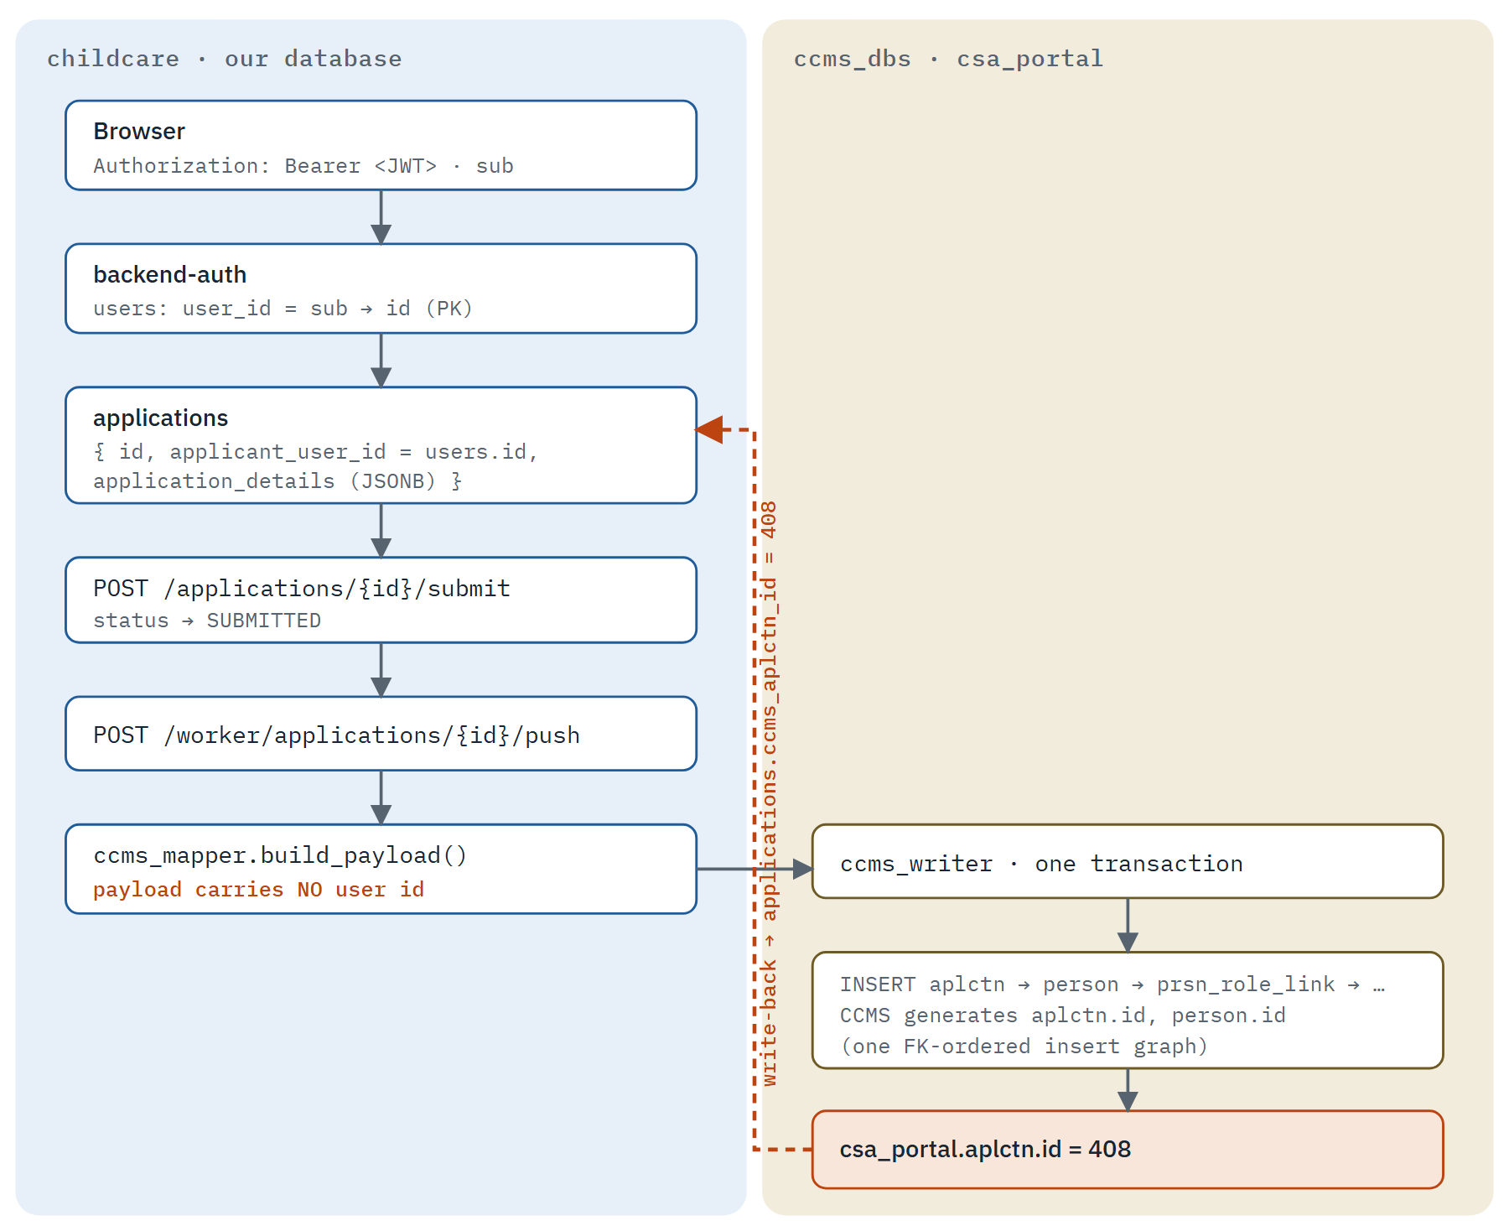
The bearer token identifies the caller; users.id scopes the row; the worker addresses the application by applications.id. CCMS mints its own aplctn.id and the worker writes it back into applications.ccms_aplctn_id — the single act that ties the two records together.

2 — What maps to what: the identifiers across the boundary
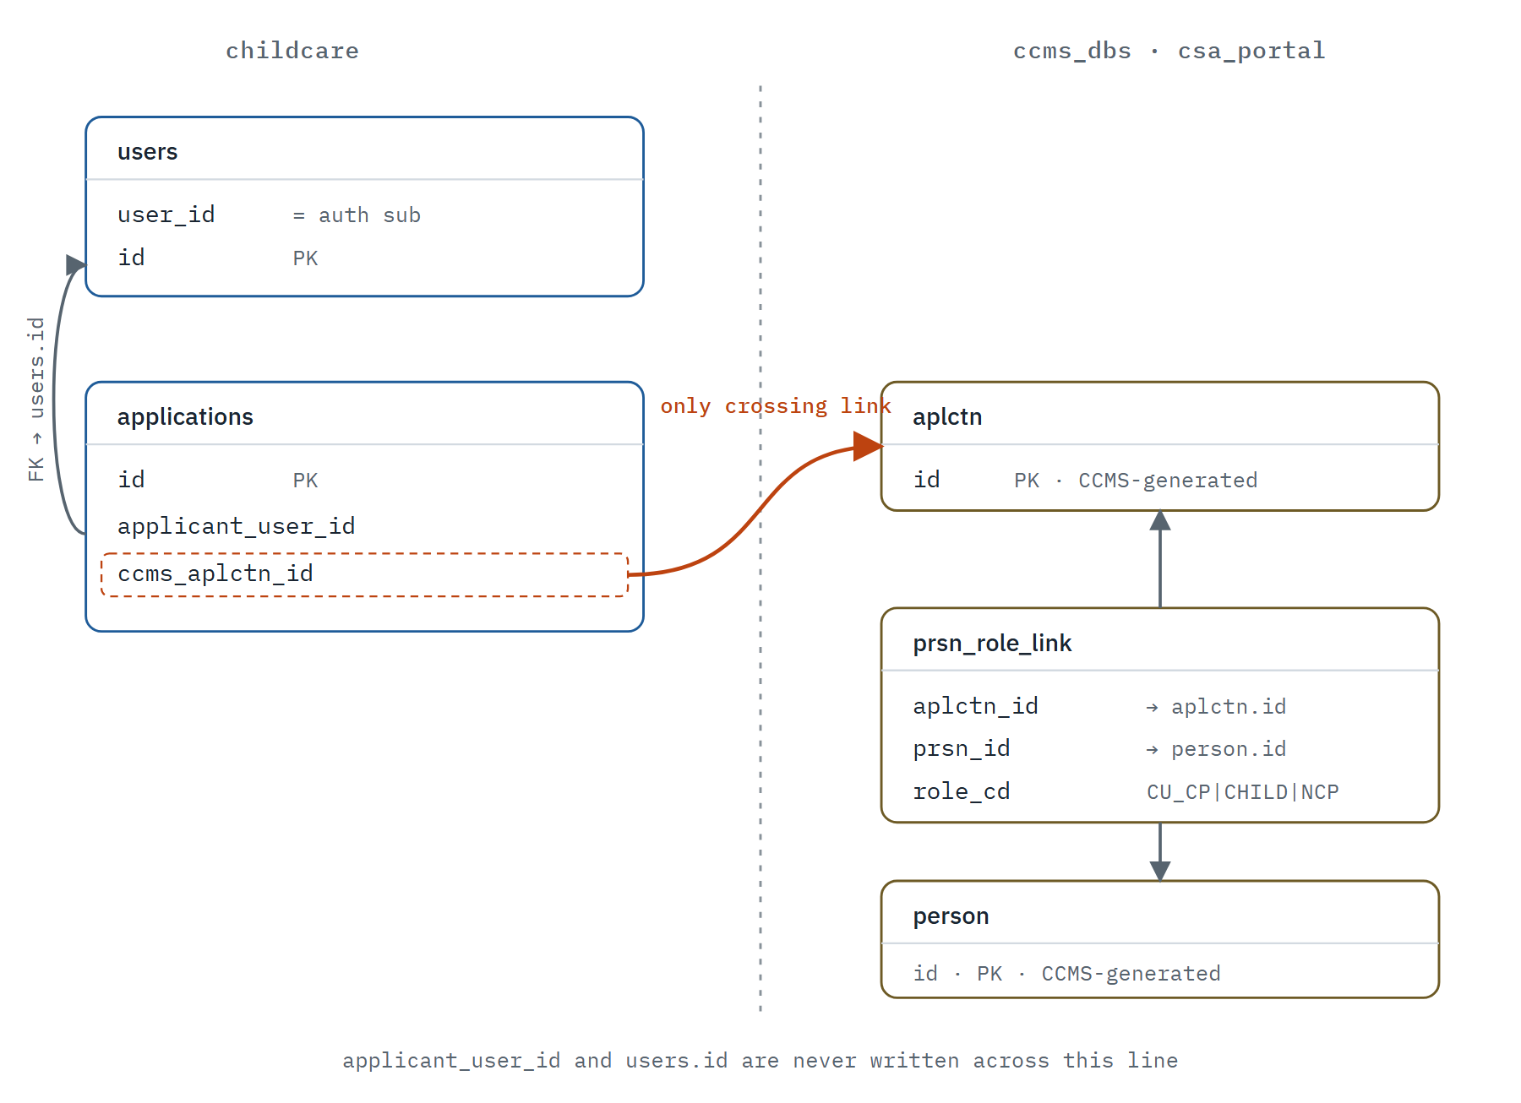
Only applications.ccms_aplctn_id crosses between the databases. To resolve a portal user to a CCMS person: users.id → applications.applicant_user_id → applications.ccms_aplctn_id → aplctn.id → prsn_role_link (role_cd='CU_CP') → person.id.

3 — Retrieving application data for a user
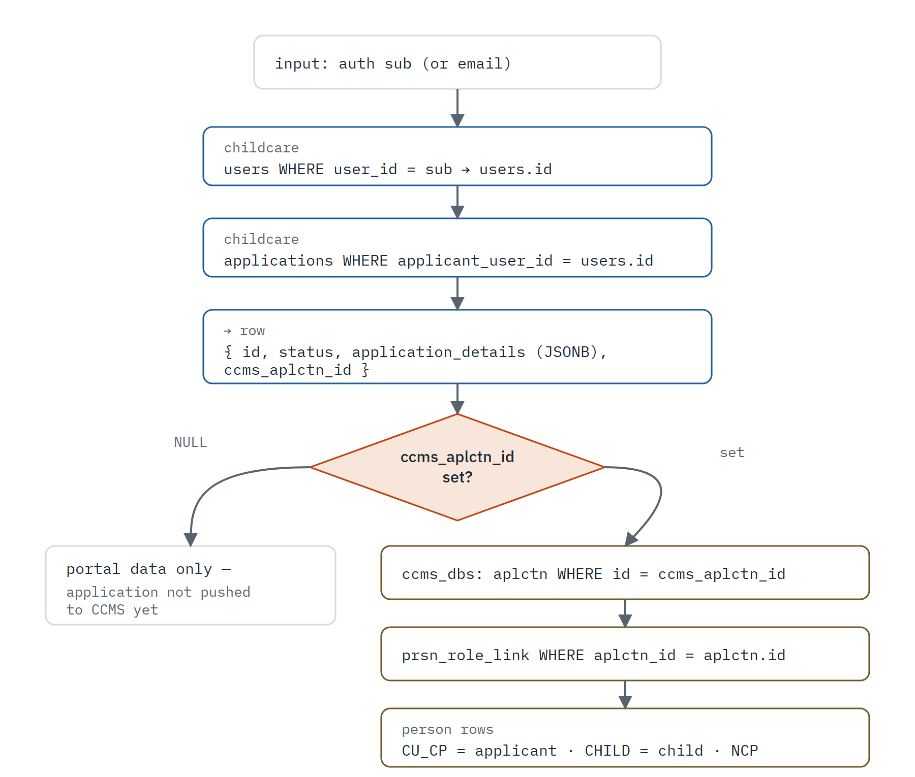
The wizard form always comes from our own application_details JSONB. The CCMS branch is only reachable once a push has stamped ccms_aplctn_id; while it is NULL, only portal data exists.

