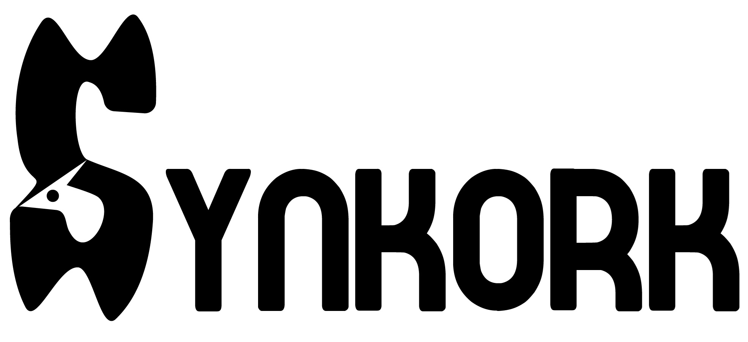
Synkork — Enterprise Platform Documentation
All-in-One Team Collaboration & Intelligent SaaS Workspace Platform
Live System: https://synkork.id.vn • GitHub: https://github.com/DevHieu/Synkork
Graduation Project • FPT POLYTECHNIC COLLEGE (FPL) • Java 21 • Spring Boot 3.5 • Vue 3 • WebRTC • Spring AI

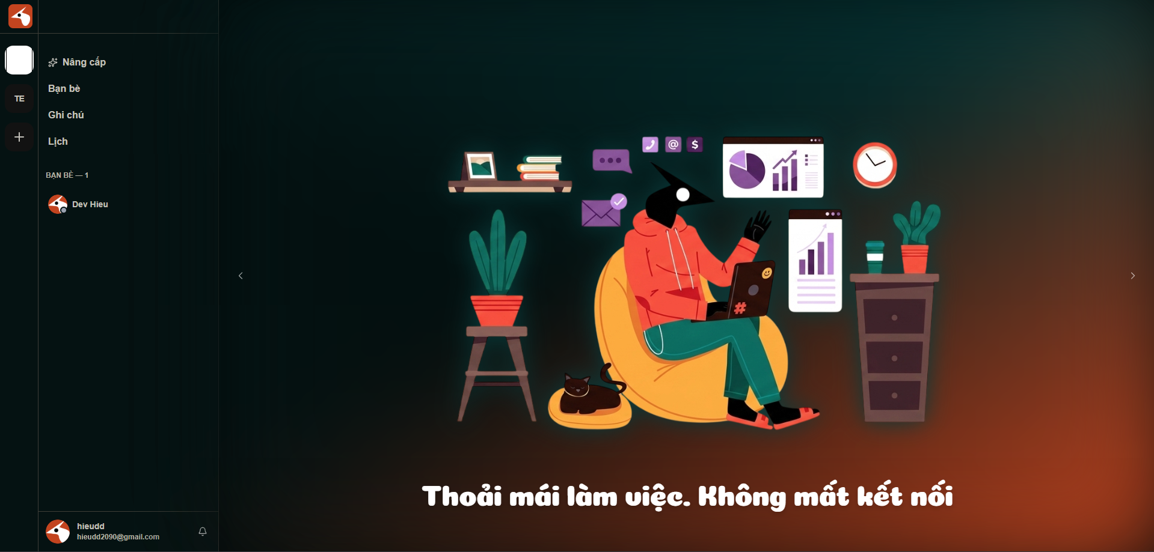
Figure 1: Synkork Unified Workspace Interface (Real-Time Channels, Calendar, Kanban & Wiki)
1. Executive Summary & Problem Statement
Modern knowledge workers and software development teams suffer from severe workflow fragmentation. Teams routinely context-switch across 5 to 7 disconnected applications: Discord or Slack for ad-hoc communication, Zoom or Google Meet for video calls, Google Calendar for scheduling, Trello for sprint tasks, and Notion for engineering wikis. This tool sprawl results in information silos, lost action items, missed meetings, and high software subscription overhead.
Synkork solves this by consolidating all essential collaboration tools into a single, cohesive, cloud-native workspace platform. Built on an enterprise-grade Spring Boot 3 backend and modern Vue 3 web clients, Synkork combines fluid real-time messaging, low-latency WebRTC video conferencing, two-way Google Calendar synchronization, AI-powered meeting transcription and summarization, agile Kanban task tracking, rich-text wiki documentation, and a complete SaaS multi-tenant billing and administration portal.
2. Five-Tier System Architecture & Engineering Flowchart
The Synkork platform is architected according to a clean 5-tier separation of concerns, ensuring high throughput, fault isolation, and horizontal scalability. The diagram below depicts the component topology and protocol interactions:
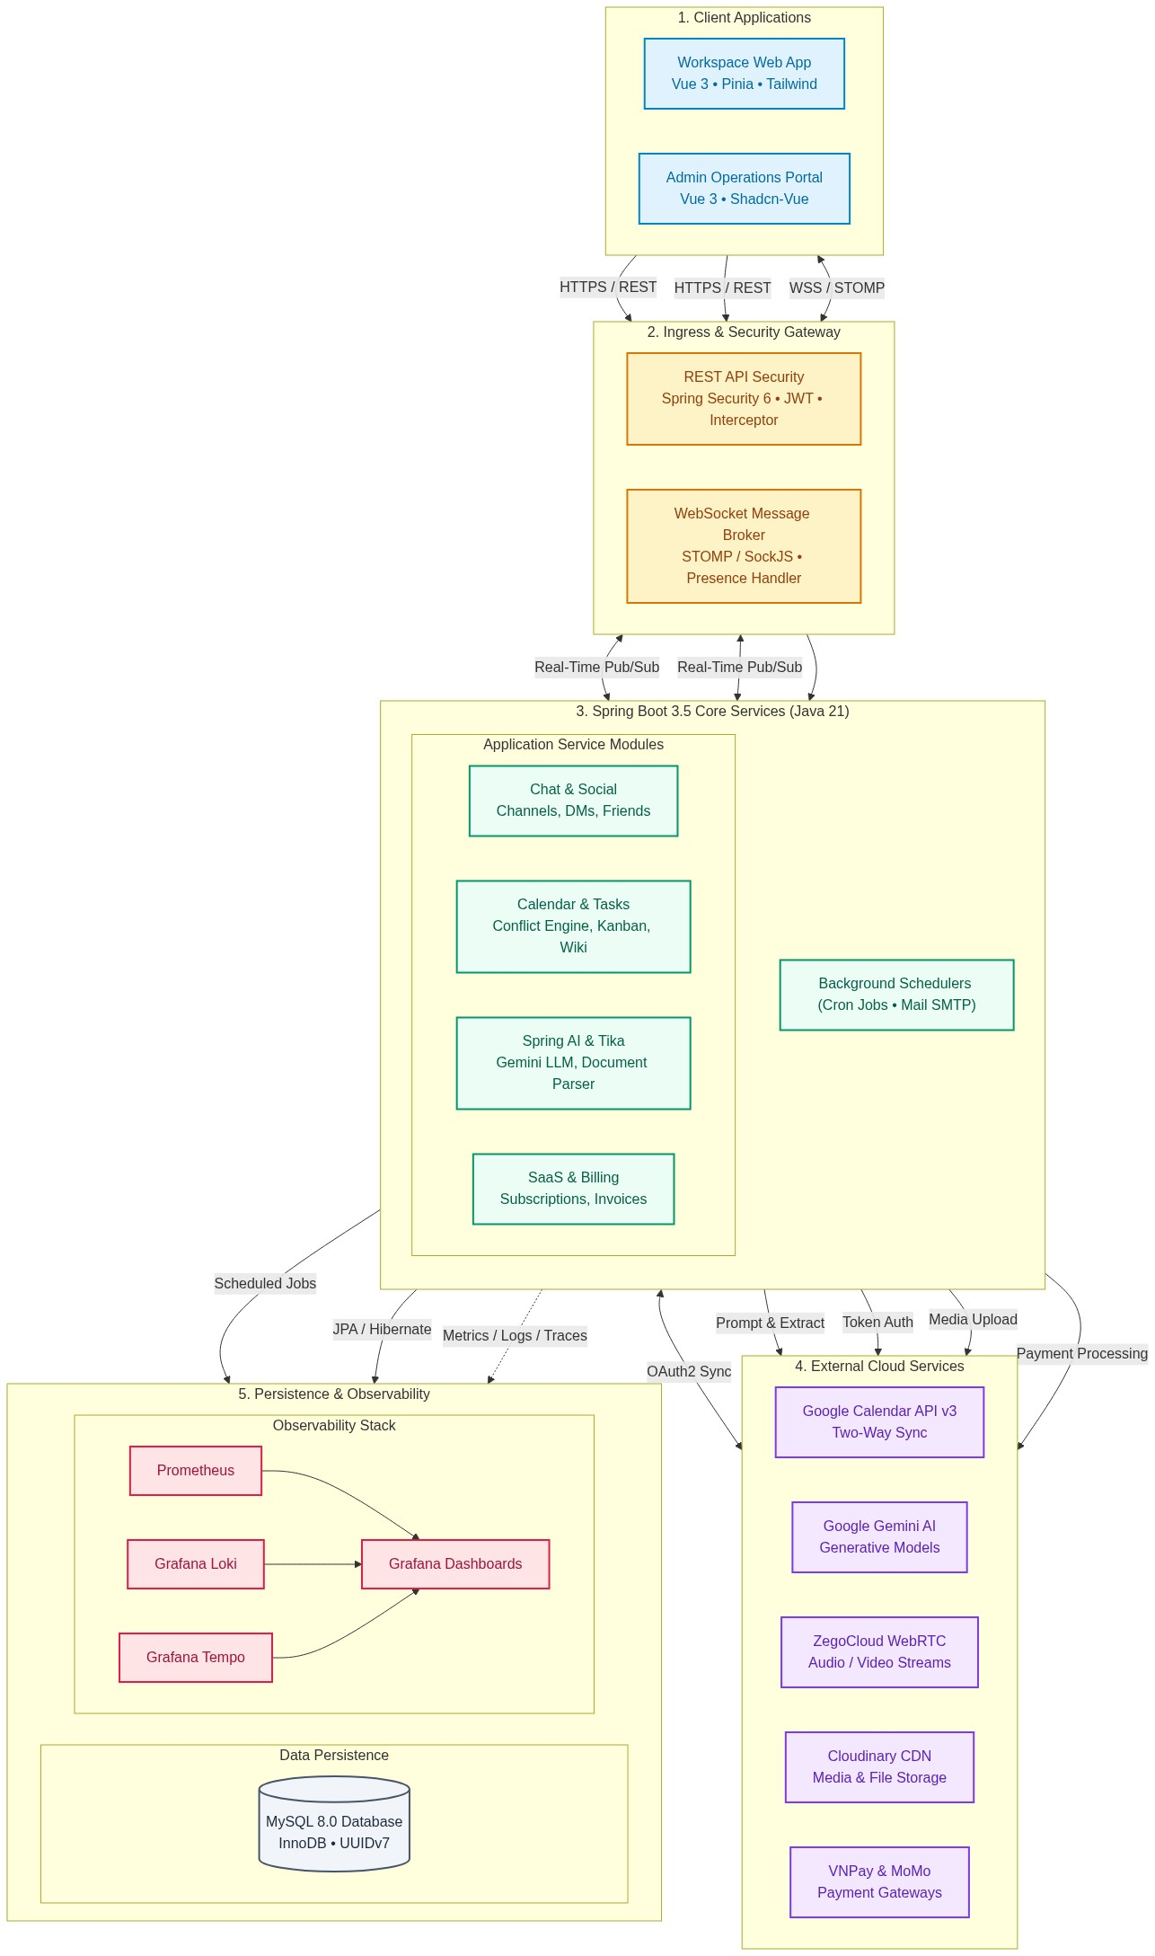
Figure 2: Synkork Five-Tier Orthogonal System Architecture Flowchart
- Tier 1 - Presentation Layer (Frontend Clients): Comprises two distinct Vue 3 web applications: the Workspace Client Web App for general users (built with Vite, Pinia, Tailwind CSS, Lucide icons, and StompJS) and the SaaS Admin Portal for system administrators (built with Shadcn-Vue Admin and pnpm).
- Tier 2 - Ingress, Security & Message Broker: Dual ingress gateways built into Spring Boot: Spring Security 6 provides stateless JWT authentication, OAuth2 login handlers, and fine-grained space access interceptors; while the STOMP WebSocket Message Broker (over SockJS) manages real-time event broadcasting and user online presence.
- Tier 3 - Core Backend Application Services (Spring Boot 3.5 & Java 21): Decoupled microservice-style domain modules including Chat & Social Engine, Collaboration & Conflict Detection Calendar Engine, Spring AI & Apache Tika Document Parsing Engine, WebRTC Signaling Assistant, SaaS Commerce & Subscription Engine, and Background Schedulers.
- Tier 4 - External Cloud Services & Provider Integrations: Seamless integration with Google Calendar API v3 (bidirectional OAuth2 sync), Google Gemini GenAI via Spring AI (NLP & meeting transcripts), ZegoCloud RTC (low-latency audio/video media relays), Cloudinary CDN (media and attachment storage), and VNPay / MoMo (payment processing).
- Tier 5 - Persistence & Observability Tier: MySQL 8.0 relational database with Hibernate ORM, HikariCP connection pooling, and UUIDv7 time-ordered primary keys. Instrumented with a complete LGTM telemetry stack: Prometheus metrics via Micrometer, Grafana Loki structured JSON logs via Logback appenders, and Grafana Tempo distributed tracing via Brave/Zipkin.
3. Comprehensive Feature Suite & Technical Workflows
3.1. Spaces, Channels & Role-Based Access Control
- Discord-Inspired Workspace Hierarchy: Workspaces are structured into Spaces, which are further divided into topic-specific text channels and audio/video voice rooms.
- Granular Permissions & Community Moderation: Space owners and administrators can assign custom roles, delegate administrative privileges, mute unruly members with automated timeouts, kick, or ban violators.
3.2. Real-Time Messaging & WebRTC Voice/Video Calling Flow
Communication in Synkork is split between high-frequency textual messages (handled via WebSocket STOMP) and low-latency media streams (negotiated through backend token generation and rendered via WebRTC):
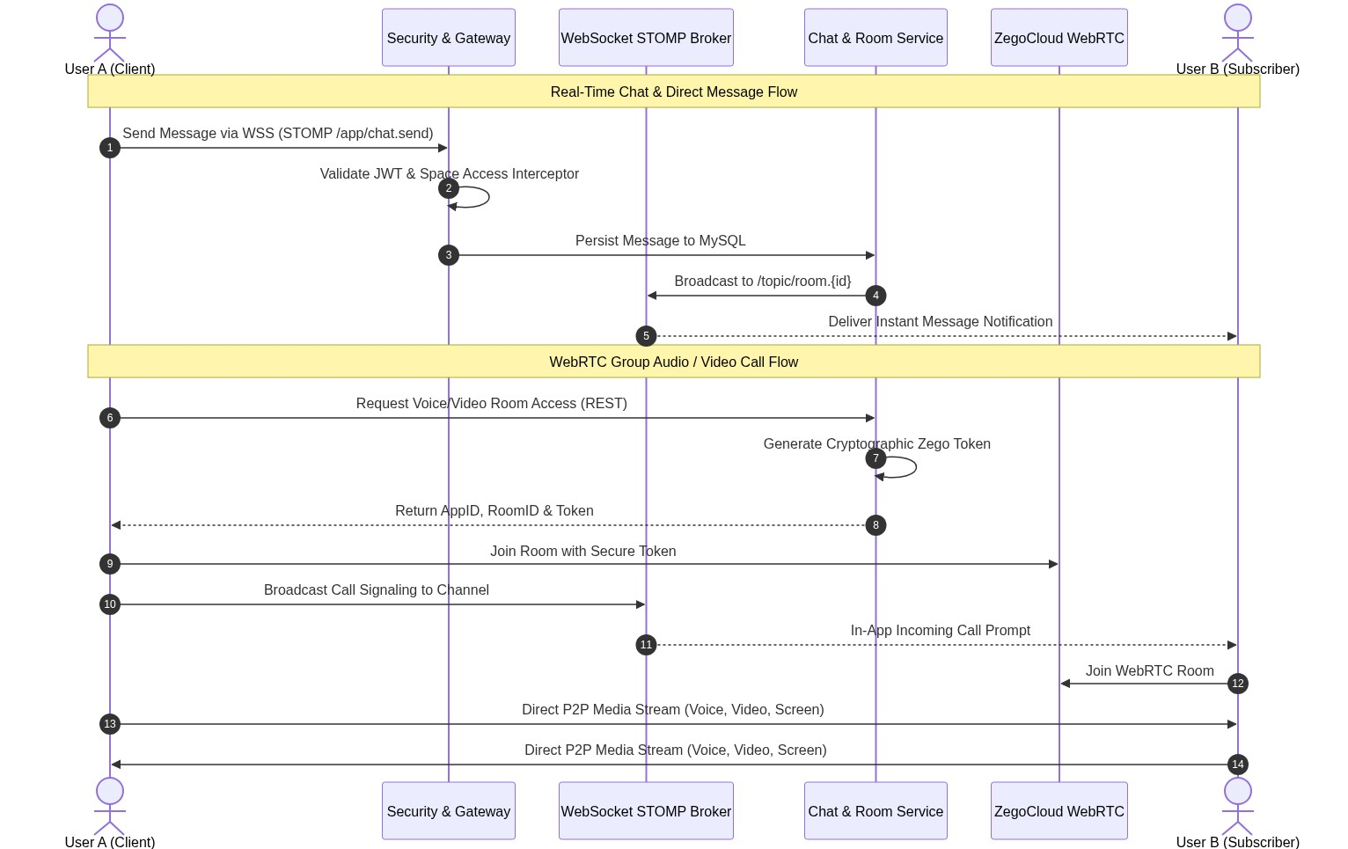
Figure 3: Real-Time WebSocket Messaging & WebRTC Calling Sequence Flow
- Sub-Second WebSocket Delivery: Full-duplex real-time communication via STOMP over SockJS, featuring message threads, emoji reactions, user mentions (@name), and live typing indicators.
- Direct Messages (DMs) & Social Friends: Private 1-on-1 conversations, a comprehensive friend request workflow (send, accept, decline), and instant online/offline presence status updates.
- Embedded Multi-Party Video Calls: Powered by ZegoCloud WebRTC SDK with backend-generated cryptographic token authorization, allowing users to join voice and video rooms directly inside channels with screen sharing.
3.3. Agile Kanban Boards & Task Management
- Interactive Drag-and-Drop Boards: Visual workflow management with customizable status columns (To Do, In Progress, In Review, Done).
- Comprehensive Card Metadata: Cards support multiple assigned team members, priority badges (Urgent, High, Normal, Low), custom tags, due dates, and completion status.
3.4. Collaborative Team Wiki & Knowledge Base
- Centralized Documentation System: Built-in rich text and markdown editor tailored for engineering specs, onboarding runbooks, and meeting notes.
- Revision History & Version Tracking: Automatic document versioning maintains a clear audit trail of changes, ensuring team documentation never gets overwritten accidentally.
3.5. Intelligent Scheduling, Two-Way Google Calendar Sync & AI Pipeline
Synkork connects team discussions directly with calendar scheduling. When members discuss meetings in channel chats, the AI pipeline extracts time entities and suggests one-click event creation, which checks for schedule conflicts and synchronizes with Google Calendar:
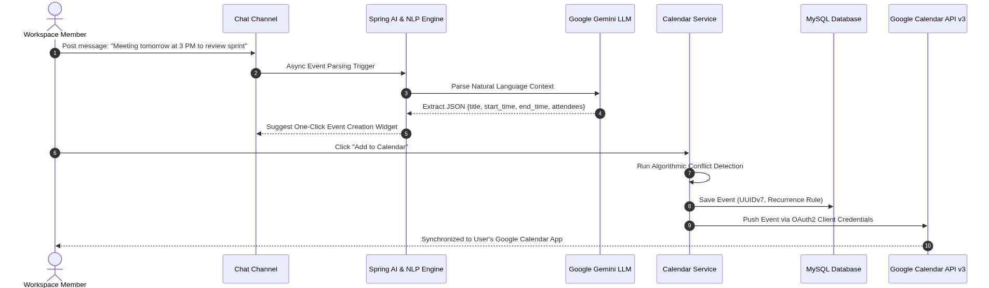
Figure 4: Chat NLP Suggestion, Conflict Detection & Google Calendar Sync Flowchart
- Multi-View Interactive Calendar: Full support for Month, Week, and Day calendar views with automated expansion of recurring events.
- Algorithmic Conflict Detection: Backend scheduling engine checks time boundaries to detect and prevent double-booking across team members.
- Bi-Directional Google Calendar Sync: Integrated with Google Calendar API v3 via OAuth2 client token lifecycle management, keeping Synkork schedules synchronized with external personal calendars.
- Spring AI & Generative Summaries: Utilizes Google Gemini GenAI via Spring AI to transcribe meeting voice recordings, generate executive summaries, and automatically extract action items.
- Apache Tika Document Ingestion: Embedded Apache Tika engine extracts text from uploaded `.pdf`, `.docx`, and `.xlsx` files, enabling context-aware AI question-answering and content summarization.
3.6. Multi-Tenant SaaS Billing & Payment Integration
- Tiered Subscription Architecture: Supports Free, Pro, and Enterprise subscription plans with automated feature-gate enforcement.
- Integrated Local & Global Payments: Direct integration with VNPay and MoMo payment gateways, automated invoice generation, billing cycle renewals, and email notifications via Spring Mail.
3.7. Dedicated SaaS Admin Portal (portal-admin)
- Real-Time Operations Telemetry: Live dashboard tracking active spaces, registered users, monthly recurring revenue (MRR), and system resource consumption.
- Moderation & Dynamic JPA Specifications: Administrators can review content violation reports, audit system logs, and manage user credentials using dynamic multi-criteria database queries.
3.8. Production-Grade Observability (LGTM Stack)
- Comprehensive Telemetry: Application metrics exposed via `/actuator/prometheus` to Prometheus, structured JSON logs streamed to Grafana Loki via Logback appenders, and distributed traces routed through Brave/Zipkin to Grafana Tempo.
4. Technical Stack Matrix
Domain | Technologies & Frameworks
Backend Framework | Java 21, Spring Boot 3.5.9, Spring MVC, Spring Data JPA, Spring Validation
Security & Auth | Spring Security 6, OAuth2 Client / Resource Server, JJWT 0.12.6, BCrypt
Real-Time & Media | Spring WebSocket (STOMP), SockJS, ZegoCloud WebRTC SDK, Cloudinary CDN
Artificial Intelligence | Spring AI, Google GenAI SDK (Gemini), Apache Tika 2.9.2
Payment & Email | VNPay SDK, MoMo API, Spring Mail, Spring Task Scheduler
Primary Client App | Vue 3.5 (Composition API, script setup), Vite, Pinia, Vue Router, Tailwind CSS, Lucide Icons
Admin Portal App | Vue 3, Shadcn-Vue Admin, Radix Vue / Reka UI, Tailwind CSS, pnpm
Database & ORM | MySQL 8.0, Hibernate ORM, Dynamic JPA Specifications, UUIDv7
DevOps & Observability | Docker, Docker Compose, Micrometer, Prometheus, Grafana Loki, Grafana Tempo
API Documentation | Springdoc OpenAPI 2.8.x (Swagger UI)

5. Monorepo Organization & Directory Layout
The repository is organized as a clean multi-project monorepo:
Synkork/
├── backend/ # Spring Boot 3 microservice backend
│ ├── docker/ # Observability configs (Prometheus, Grafana, Loki, Tempo)
│ ├── src/main/java/ # Business logic, Controllers, WebSocket & JPA specs
│ └── pom.xml # Java 21 & Maven dependency definitions
├── frontend/ # Primary Vue 3 user workspace client
│ ├── src/ # Channel chat, Calendar, Kanban boards, WebRTC calls
│ └── package.json # Frontend dependencies (Pinia, Tailwind CSS, ZegoCloud)
├── portal-admin/ # Enterprise SaaS management & administration portal
│ ├── src/ # Subscription management, revenue analytics, audit logs
│ └── package.json # Admin dependencies (Shadcn-Vue, pnpm)
└── assets/ # Brand assets, logos, screenshots, and flowcharts

6. Local Development & Deployment Guide
Follow the instructions below to configure and run the full Synkork ecosystem locally:
- Prerequisites: JDK 21, Node.js v20+ or v22 LTS, pnpm, MySQL 8.0+, and Docker / Docker Compose.
Step 1: Clone Repository
git clone https://github.com/DevHieu/Synkork.git
cd Synkork

Step 2: Start Backend Service
cd backend
cp .env.example .env
./mvnw spring-boot:run

Swagger UI is available at: http://localhost:8080/swagger-ui.html
Step 3: Start Frontend Workspace Client
cd ../frontend
npm install
npm run dev

Workspace Client runs at: http://localhost:5173
Step 4: Start SaaS Admin Portal
cd ../portal-admin
pnpm install
pnpm dev

Admin Management Portal runs at: http://localhost:5174
Step 5: Start Observability Suite (Optional)
cd ../backend
docker-compose -f docker-compose.yml up -d

Prometheus runs on :9090, Grafana runs on :3000, and Tempo runs on :3200.
7. Core Engineering Team (FPT POLYTECHNIC COLLEGE - FPL)
Synkork was engineered and delivered as a Capstone Graduation Project by the student development team at FPT POLYTECHNIC COLLEGE (FPL):
Member | Role | Key Contributions | Contact
Bùi Minh Hiếu | Team Lead / Full-Stack Engineer | System Architecture, Real-Time Messaging, WebRTC Calling, Security Ingress | hieudd2090@gmail.com
Nguyễn Thái Học | Backend & AI Engineer | Interactive Calendar, Google Calendar API v3 2-Way Sync, Spring AI & Tika, SaaS Billing | ngthaihoc.vn@gmail.com
Nguyễn Thúy Vy | Frontend & Admin Portal Engineer | Admin Management Portal (portal-admin), Revenue & Analytics Reports, UI Components | thuyvy25012006@gmail.com
Phương Trâm | Frontend / UI-UX Engineer | Workspace UI/UX Design, Kanban Boards, Wiki & Note Editor Components | phuongtram300606@gmail.com

8. Official Project Links
- Live Production Deployment: https://synkork.id.vn
- GitHub Source Code: https://github.com/DevHieu/Synkork
- Issue & Bug Tracker: https://github.com/DevHieu/Synkork/issues

