**Polar Introduces the Polar M430, a Running Watch Built for Accuracy and Actionable Data**

*Polar’s latest running watch features wrist-based heart rate, integrated GPS and personalized and adaptive training guidance for serious, goal-driven runners*

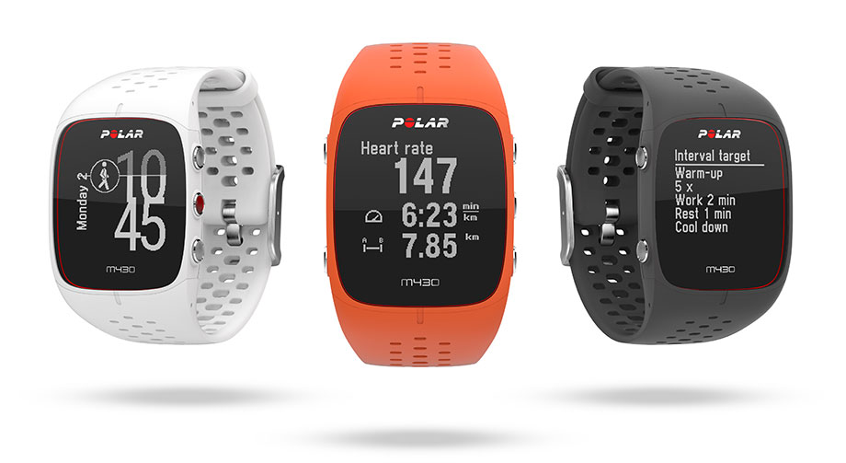

**KEMPELE, FINLAND – April 6, 2017 –** [Polar](http://www.polar.com/), the leader in wearable sports and fitness technology for 40 years, announces an exciting addition to their running portfolio, the [Polar M430](https://www.polar.com/en/products/sport/M430-gps-running-watch). Equipped with Polar’s proprietary wrist-based heart rate technology, integrated GPS, and personalized, adaptive training guidance, Polar M430 is the ideal tool for runners aiming to reach their personal best. The design is fully waterproof and features a lightweight, breathable wristband and vibration alerts to inform runners exactly when they’re hitting goals during training. Polar M430 will soon be available for pre-order at www.polar.com for $229/€229.

[Learn more about the new Polar M430 here.](https://www.polar.com/blog/polar-m430-smart-coaching-running)

“In the growing market of running products that can track heart rate, pace and several other performance metrics, Polar M430 stands out for two major reasons,” says Marco Suvilaakso, Chief Strategy Officer at Polar. “First, Polar has put 40 years of research and development into creating highly accurate technology, which is why so many athletes continue to seek our products. What makes Polar even more unique is that we then go beyond just providing accurate data; we turn it into actionable guidance. Our Smart Coaching features can show users how they benefitted a single training or over time, how their performance translates into an expected race finish time, and even provide adaptive running training programs that sync to the watch. Combined, these elements make Polar M430 a distinguished running watch in the category.”

Polar’s industry-leading accuracy, paired with the company’s proprietary Smart Coaching and adaptive Polar Running Program, make Polar M430 the stand-out running watch in the category. An all-in-one device, Polar M430 provides wrist-based heart rate measurement during training, integrated GPS and core running metrics, and sleep tracking and recovery metrics. Reliable heart rate technology and hardware is not something Polar takes lightly, which is why their latest running watch features Polar’s industry-leading heart rate algorithms, designed and tested for reliability, as well as a proprietary optical heart rate solution with 6-LEDs optimized for Polar M430.

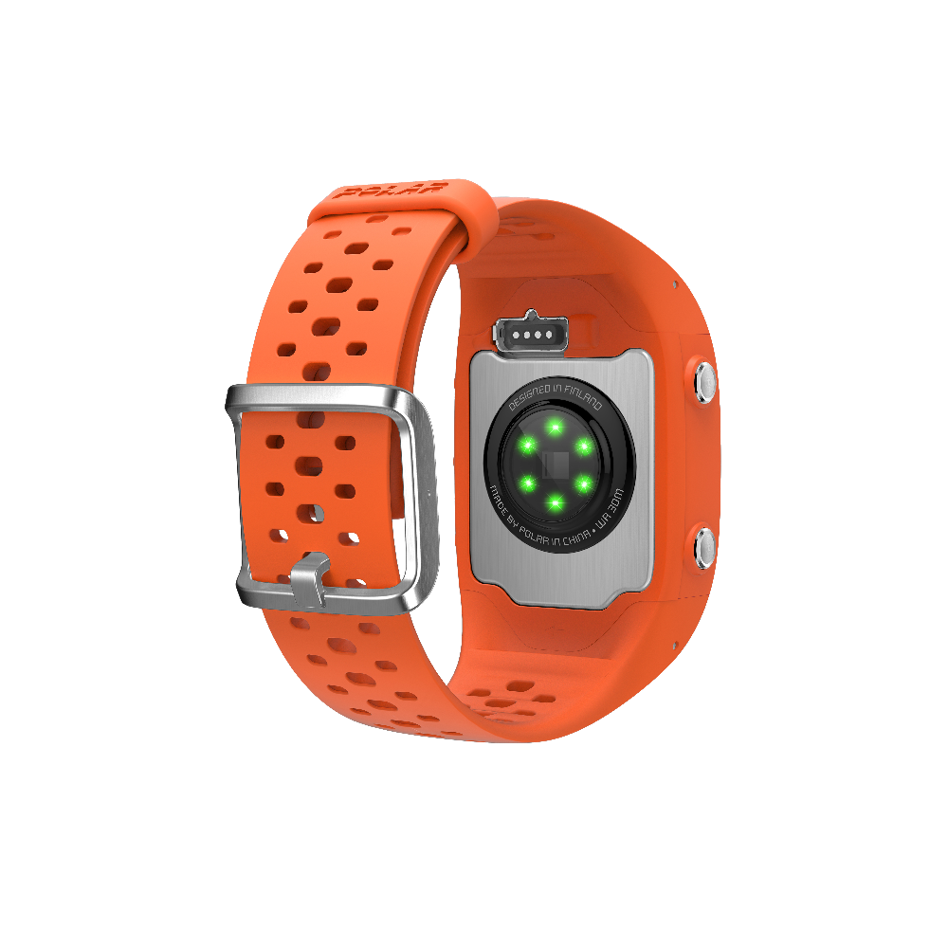Providing trusted metrics is only a piece of the experience; what truly sets Polar M430 apart is Polar’s ability to take running data and make it actionable. Paired with [Polar Flow](https://flow.polar.com), Polar M430 is transformed into a reliable running coach that can provide personalized feedback, an adaptive training plan, and live guidance for athletes during various stages of their training sessions. Polar’s [Running Program](http://www.polar.com/en/running/running-program) considers training history, gauges current activity levels, accounts for a final goal date and then builds a personal running program in seconds. Runners can upload daily training plans to Polar M430 to follow, for example, interval guidance and heart rate zones during runs, and access Polar’s strength and core training videos in the Polar Flow app to incorporate in weekly training. Other advanced [Smart Coaching](http://www.polar.com/en/smart_coaching) features include [Running Index](http://www.polar.com/en/smart_coaching/features/running_index), which uses data to show the efficiency of an athlete’s running; [Fitness Test](https://www.polar.com/en/smart_coaching/features/fitness_test), which enables athletes to gauge their current fitness levels and see progress along the way; and [Training Benefit](http://www.polar.com/en/smart_coaching/features/training_benefit), which provides feedback immediately after a training session to explain the benefits of a workout.

“I recently joined Polar’s team of endurance athletes, and what immediately drew me to the brand was not only their consistent and reliable running data, but also their passion for making that data understandable to anyone,” said Molly Huddle, Olympic runner and American record holder. “As a pro, I have coaches guiding me through trainings, reviewing my data, and tracking how I’m performing daily as well as over time. But most runners, even many international class runners, don’t have that luxury. These athletes need the proper training guidance and the Polar M430 delivers just that. It becomes your coach, keeping you on track during a session and, post-workout, making training and recovery easy to understand.”

Polar M430 offers a selection of GPS power modes that extend battery life to nearly 30 hours. The running watch can also connect to [Polar Balance](https://www.polar.com/en/products/lifestyle/balance) for holistic weight management tracking and guidance.

[Polar M430](https://www.polar.com/en/products/sport/M430-gps-running-watch) is $229/€229 and available for pre-order soon in dark grey, white and orange at [www.polar.com](http://www.polar.com). Polar M430 will begin shipping in May. Learn more about [Polar](http://www.polar.com), access [running tips](https://www.polar.com/blog/tag/running/), or learn [how to set up a personalized training plan](https://www.polar.com/en/running/running-program).

**About Polar:**

Polar is the innovator in heart rate monitoring, activity trackers and training computers. With 40 years of experience and a proud heritage in physiological and sports medical research, we cater to all levels of fitness by offering a comprehensive product range including cycling computers, wearable sports devices and activity trackers, training apps and online services. Our award-winning training computers are the number one choice among consumers worldwide, being sold through over 35,000 retailers globally. Headquartered in Finland, Polar is a privately held company that operates in more than 80 countries including U.S. headquarters in Lake Success, NY. For more information, please visit [polar.com](http://www.polar.com).

# # #

**Media Contact:**