**Polar Announces Powerful, Compact Polar OH1 Optical Heart Rate Sensor**

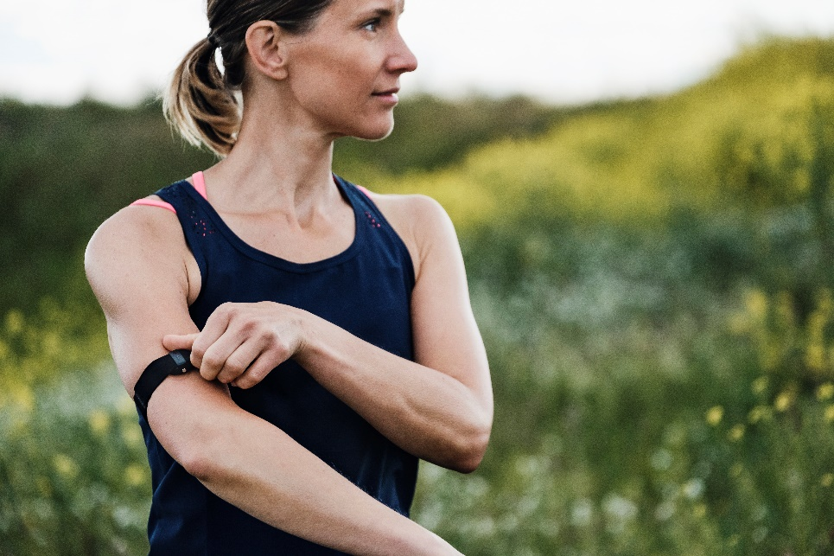

*Polar OH1 features Polar’s scientifically developed, proprietary optical heart rate solution to accurately track heart rate via an easy to use, comfortable armband for the upper or lower arm*

**KEMPELE, FINLAND – August 30, 2017 –** [Polar](http://www.polar.com/), the leader in wearable sports and fitness technology for 40 years, introduces [Polar OH1](https://www.polar.com/en/products/accessories/oh1-optical-heart-rate-sensor), a versatile [optical heart rate](https://www.polar.com/blog/optical-heart-rate-tracking-polar/) sensor for the upper or lower arm featuring an internal memory capable of storing up to 200 hours of HR training and a battery life of up to 12 hours. [Polar OH1](https://www.polar.com/en/products/accessories/oh1-optical-heart-rate-sensor) is $79.95/€79,90 and available for pre-order now and will begin shipping in mid-September.

Main Features include:

* **Accuracy:** equipped with Polar’s scientifically developed, proprietary optical heart rate solution for accurate heart rate tracking.
* **Versatility:** for users who prefer not to wear a chest strap or wrist-based heart rate device, Polar OH1 may be worn on the forearm or upper arm during any sports activity and is waterproof up to 30m.
* **Diversity:** users may follow their heart rate in real-time on compatible Polar and Bluetooth devices, [Polar Beat](https://www.polar.com/us-en/products/polar_beat) mobile app and other third-party fitness apps. Following training sessions, users can transfer their data to [Polar Flow](https://flow.polar.com/). When paired with [Polar Beat](https://www.polar.com/us-en/products/polar_beat), Polar’s free fitness and training app, users can access real-time heart rate data and training guidance, while a more detailed daily overview is available in Polar Flow, where Polar’s [Smart Coaching](https://www.polar.com/en/smart_coaching/features/training_benefit) features offer additional guidance and feedback on specific activities.
* **Convenience:** internal memory stores up to 200 hours of HR training, long battery life boasts up to 12 hours (USB rechargeable battery) of operating time, and firmware updates offer feature updates.
* **Comfort:** small sensor and soft, textile armband fits snugly and comfortably around the arm.
* **Ease of use:** no need to moisten the strap or lift the shirt.

**Learn more about Polar OH1** [**here**](https://www.polar.com/blog/polar-oh1-vs-polar-h10/)**.**

“Polar OH1 delivers a compelling alternative to wrist and chest-based heart rate measurement,” said Tom Fowler, President of Polar U.S.A. “We know that comfort and accuracy are key drivers of high performance, both of which were paramount when we engineered the details of the OH1.”

“In the gym and on the road, no matter which sport you choose, the OH1 can be trusted to deliver accurate, stable data in a remarkably comfortable form factor,” said Jani Juntunen, Product Manager.

**About Polar:**

Polar is the innovator in heart rate monitoring, activity and sleep tracking and GPS sports training solutions for elite athletes, coaches and active fitness enthusiasts. For over 40 years, we have helped athletes understand, track and improve their performance. Our award-winning product range includes pioneering sports wearables that work elegantly with Polar training apps and cloud services.

Headquartered in Finland, Polar is a privately held company that operates in more than 80 countries. Polar products are sold through over 35,000 retailers globally. For more information, please visit polar.com.

# # #

**Media Contact:**

Max Borges Agency for POLAR

P: 305-374-4404 ext. 171

[polar@maxborgesagency.com](mailto:polar@maxborgesagency.com)

