Brdgr
WIREFRAMES & BUILD SPECIFICATION
Every screen, drawn before it is built.
Brdgr discovers, recruits, and manages performance-driven partnerships — and these are the skeletons of the screens that deliver that service. This document is the visual companion to the Product Requirements Document. It maps the platform as a tree, draws the flows that govern it, and lays out every core screen as an annotated wireframe — so the Developer builds the right thing, the COO can verify the workflows, and the Creative Director has a structural base to design on. Wireframes show structure and behaviour, not final visual design.
The Bridge to Better Partnerships
Three interfaces, one engine. The client portal sells the outcome, the partner portal earns the trust, and the administrative console runs the machine. Every screen in this document exists to move a partnership along VET → MATCH → CONTRACT → TRACK → PAY.

FIELD | DETAIL
Document | Wireframes and build specification — the full product map, the governing flows, and seventeen annotated screen skeletons, from the public landing page to the payout manifest
Owners | Creative Director (interface standard) · Developer (build fidelity) · COO (workflow acceptance) · Founder (scope)
Companions | Product Requirements Document (requirement IDs referenced throughout) · Company Overview
Fidelity | Skeletons by intent: every screen is drawn as labelled regions and placeholder bars — layout, hierarchy, and behaviour, with no copy, numbers, or styling. Colour, type, and final visual design follow from the brand system, produced by the creative unit.
Reading a skeleton | Each dashed region carries an uppercase label naming what lives there; grey bars stand for text, blocks for cards and charts, and gold badges tie regions to the annotation table beneath. Money is USD (decided); every price and share remains — until concluded.
Date | July 2026
Confidential — not for external distribution
Read-only. Anything shown as — has not been decided — including the domain shown as a dash in every browser bar. Open decisions live in the registers of the Company Overview and the PRD.

Contents
# | SECTION | # | SECTION
A | STRUCTURE | B | SCREEN SKELETONS
01 | Conventions — how to read a skeleton | 05 | Public — landing page
02 | The full product map | 06 | Public — sign in & sign up
03 | The engine and the lifecycle | 07 | Client — dashboard
04 | How money moves | 08 | Client — new brief
 |  | 09 | Client — match proposals
 |  | 10 | Client — partnership detail
 |  | 11 | Client — plan & billing
 |  | 12 | Client — onboard your partners
 |  | 13 | Partner — sign-up & vetting status
 |  | 14 | Partner — dashboard
 |  | 15 | Partner — offers
C | COVERAGE | 16 | Partner — earnings & statements
21 | Screen-to-requirement traceability | 17 | Admin — work queue
22 | Open items that shape the interface | 18 | Admin — vetting review
23 | Document control | 19 | Admin — match builder
 |  | 20 | Admin — payout manifest

PART A
Structure
The platform as a tree, and the flows that govern every screen

01 Conventions
- Skeletons are structural contracts. Every screen is drawn as dashed, labelled regions: the uppercase label names what lives there, grey bars stand for text, blocks stand for cards, charts, and inputs. Nothing decorative, no copy, no invented content — the developer reads structure and behaviour; the creative unit supplies the finished look from the brand system.
- Gold numbered badges on each wireframe match the annotation table beneath it: region, purpose, and the PRD requirement IDs the region implements.
- The browser bar shows a dash because the domain is not yet decided — the wireframes refuse to invent one, exactly as the documents do.
- No numbers anywhere — by design. Skeletons carry no amounts, counts, or prices at all. Money is USD (decided) and the payout cycle is monthly (decided); every price, the trial length, and the commission share remain — in the registers, and all values bind to configuration so conclusions drop in without redesign.
- Language rules apply inside the interface: a directory entry is a contact, never a partner; nobody is called vetted before passing vetting; and no screen promises a service time, because none is in force until measured.

02 The platform map
The full Brdgr product map on one page — every ecosystem we plan, and the one we are in. The top band is the ecosystem layer: Trading carries the live focus, and the tree states plainly what starts after it — SaaS next, then Fintech, then Creator & E-commerce, each a configuration of the same platform, with the under-evaluation sectors (education, gaming, crypto, web infrastructure, insurance and lending, travel) drawn in dashes behind them and betting-adjacent sectors excluded until a compliance layer exists. Between the ecosystem layer and the portals sits the public entry band — landing page, sign in, and sign up with role selection (drawn in Sections 05–06). Below it, the three portals — the client portal now including the onboard-your-partners branch, where a company brings its existing network onto the rails: client, partner, and the administrative console operated by the Operations department. The Academy appears in the partner portal from Phase 2, and the payout manifests screen carries the decided monthly cycle.
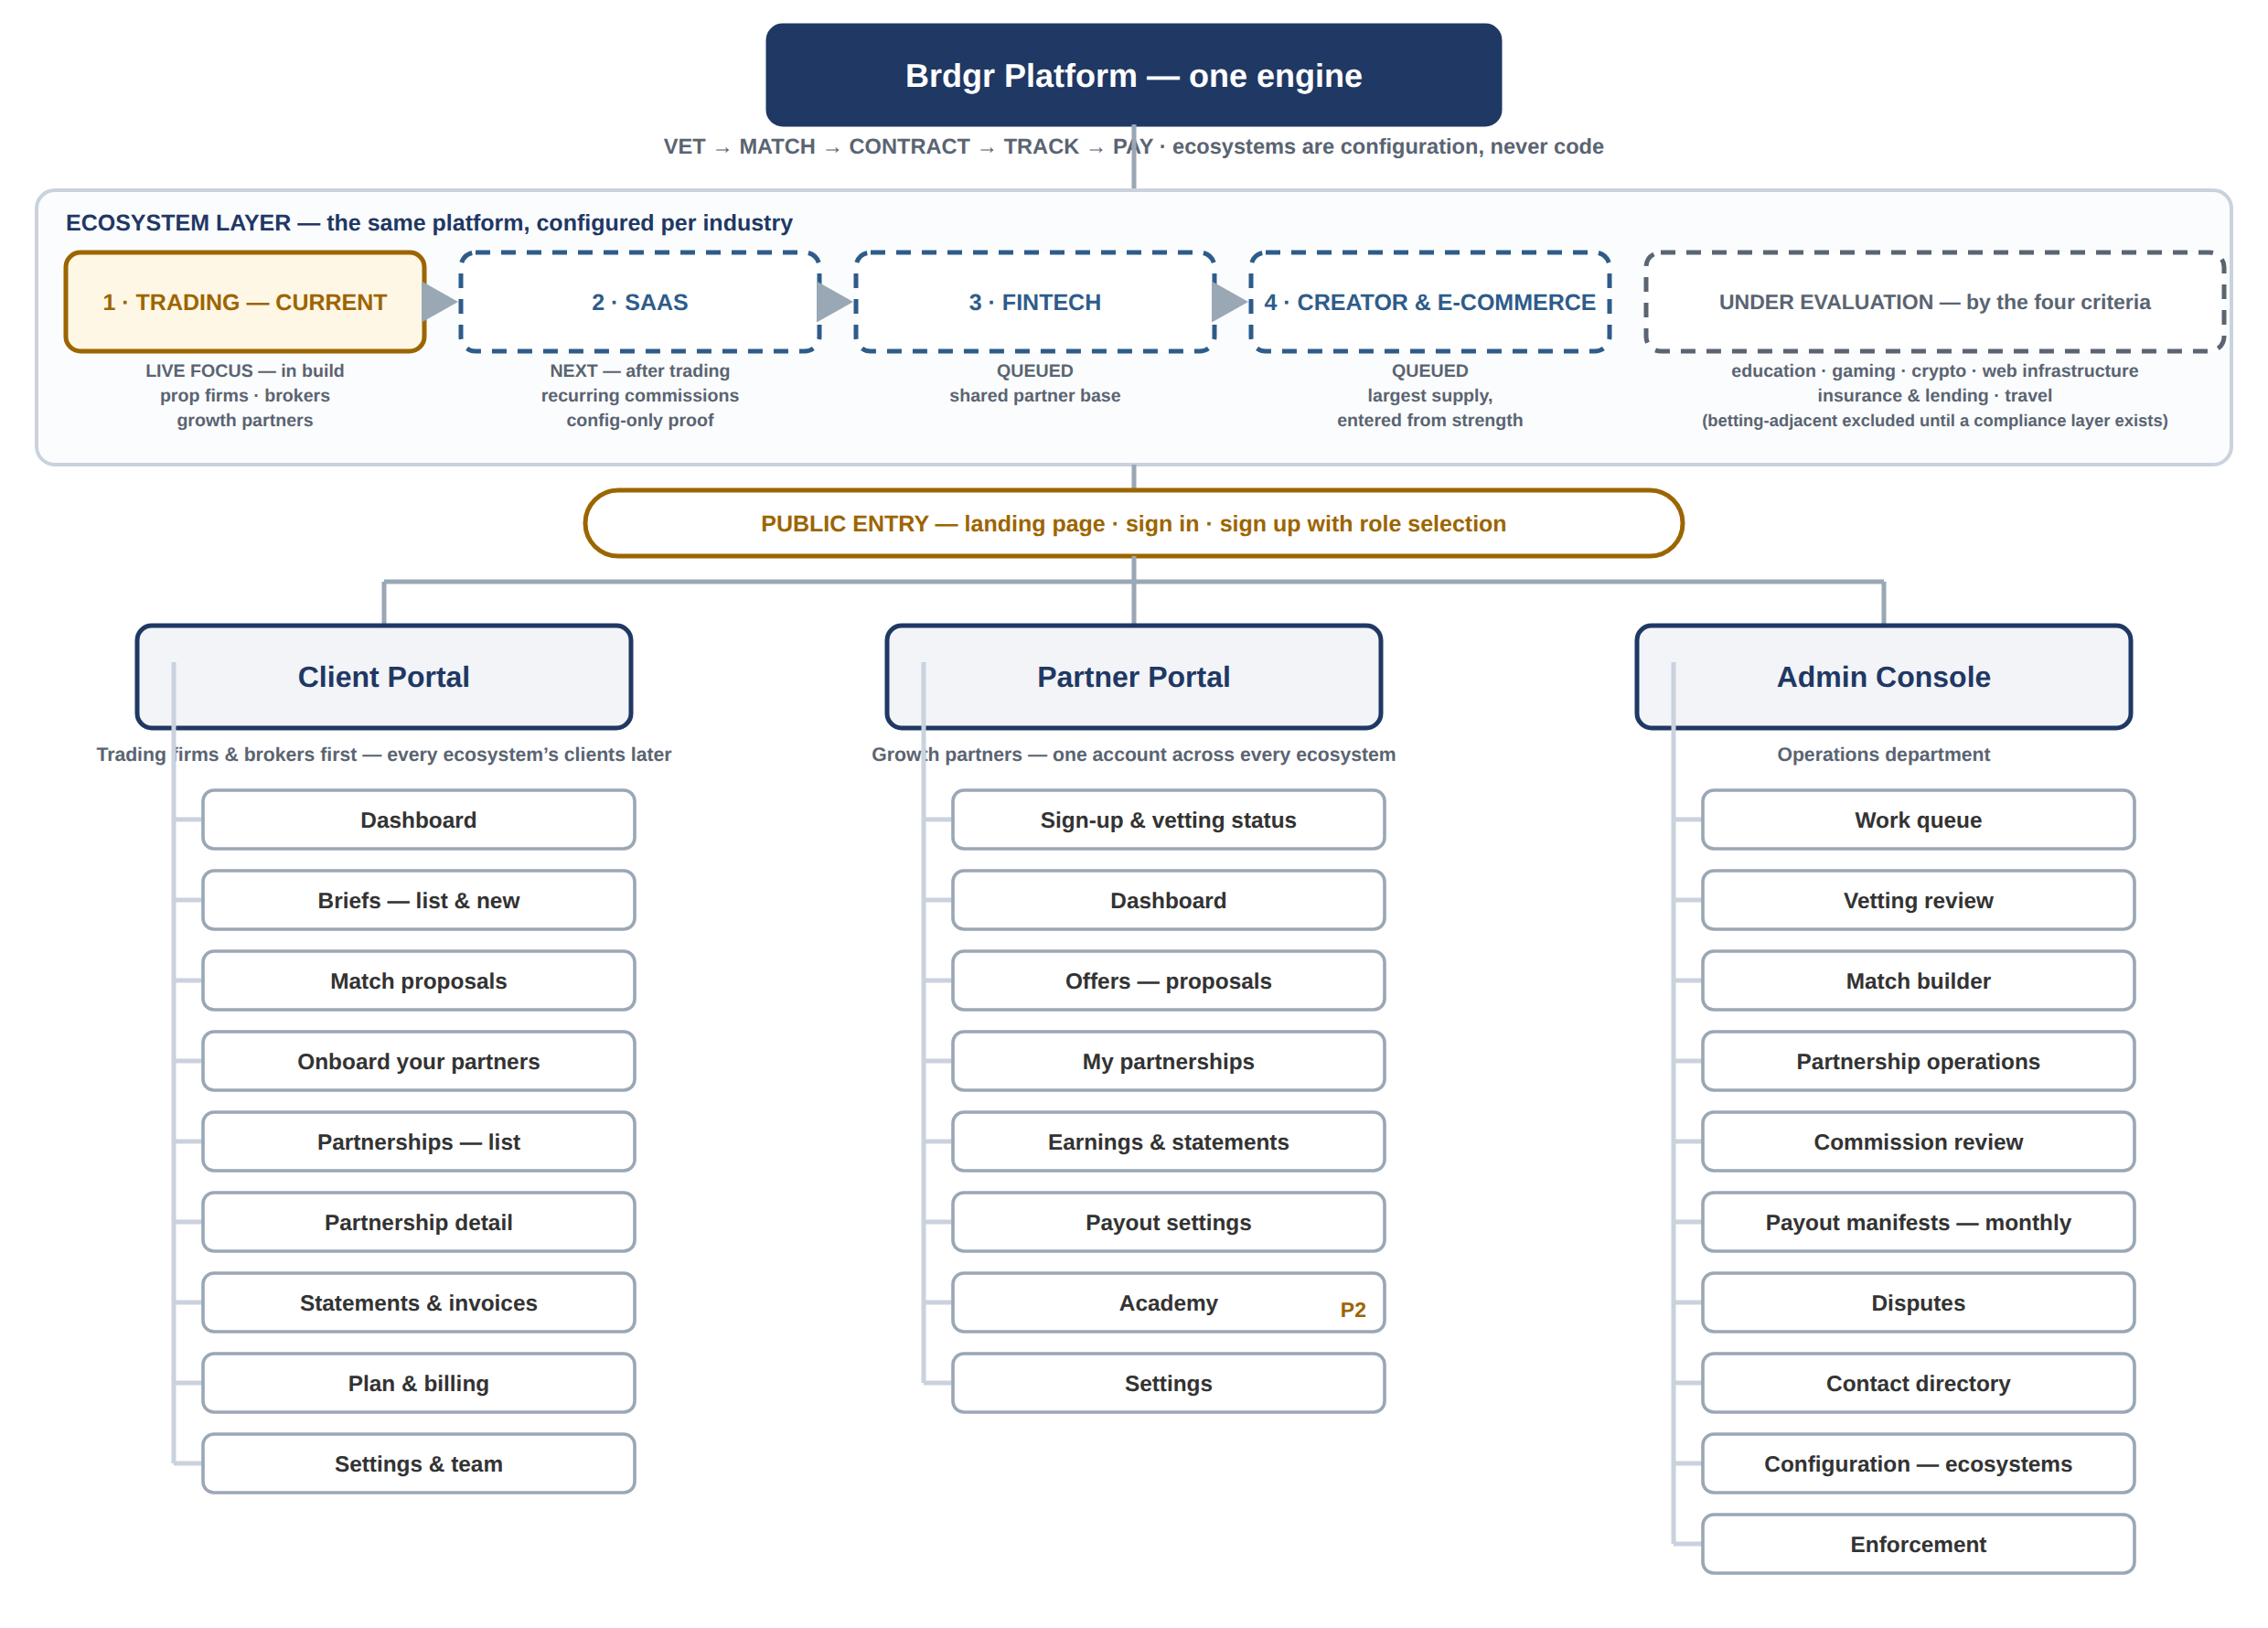
Reading the tree: solid means live focus or specified; dashed means sequenced or under evaluation with no detail invented yet. Each portal leaf is a screen or screen family specified in this document or scheduled by phase in the PRD. Sign-in, account management, and the notification centre are shared surfaces across all three portals and are not repeated per branch. When a new ecosystem opens, this map gains configuration — not branches: the portals and screens stay the same.

03 The engine and the lifecycle
The five steps every screen serves:
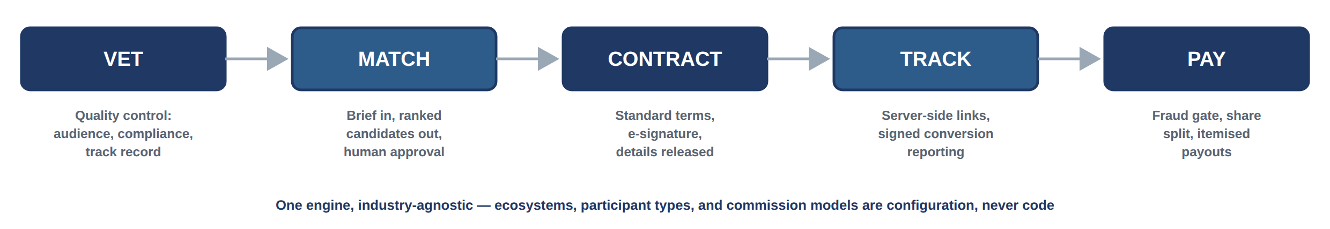
And the state machine every partnership follows. These states appear verbatim as status labels across all three portals; no interface may invent a state that is not on this diagram, and every transition is logged with actor and timestamp.
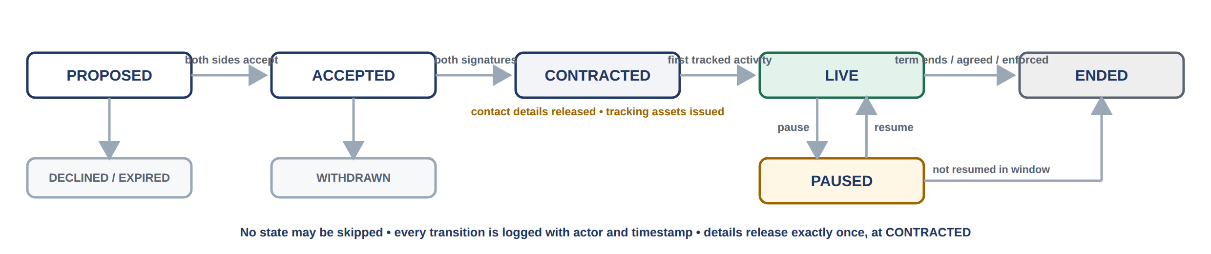
The two rules the diagrams enforce
No state may be skipped, and counterparty contact details release exactly once — at the ACCEPTED → CONTRACTED transition, after both signatures. Screens in Part B show how both rules surface to users: anonymised cards before contract, released details and tracking assets after.

04 How money moves
From tracked conversion to paid-out balance. A conversion is not money: it becomes money only after the fraud gate passes it and the programme’s confirmation rule completes. The platform share (—) is stamped at confirmation, the split posts to the double-entry USD ledger, and payouts execute from an approved manifest on the monthly cycle — closed each calendar month and executed by the fifth business day. Every stage below has a screen in Part B.
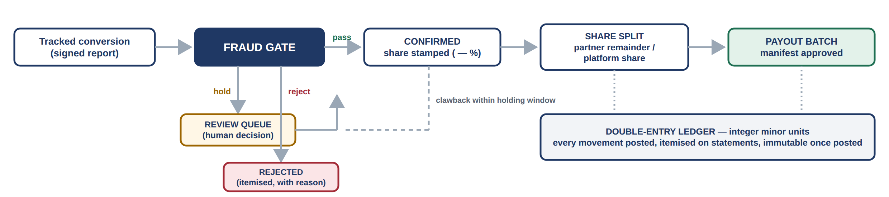
Why this order is fixed: screening before confirmation protects clients from paying for fraud; confirmation before payout protects partners from silent reversals; and the manifest approval step keeps a human accountable for every batch that leaves. The partner-facing names for these stages — pending review, confirmed, scheduled for payout, paid — appear on the partner dashboard and statements exactly as drawn later.

PART B
Screen Skeletons
Seventeen screens — public entry, client, partner, and admin — annotated against the PRD

05 Public — landing page
The first thing anyone sees — and the vocabulary rule made visible. The hero states the service in our exact words; the page sells the specific problem for each side, shows the five-step engine, presents both ways in, and names the roadmap — no growth promises, no numbers we cannot defend.
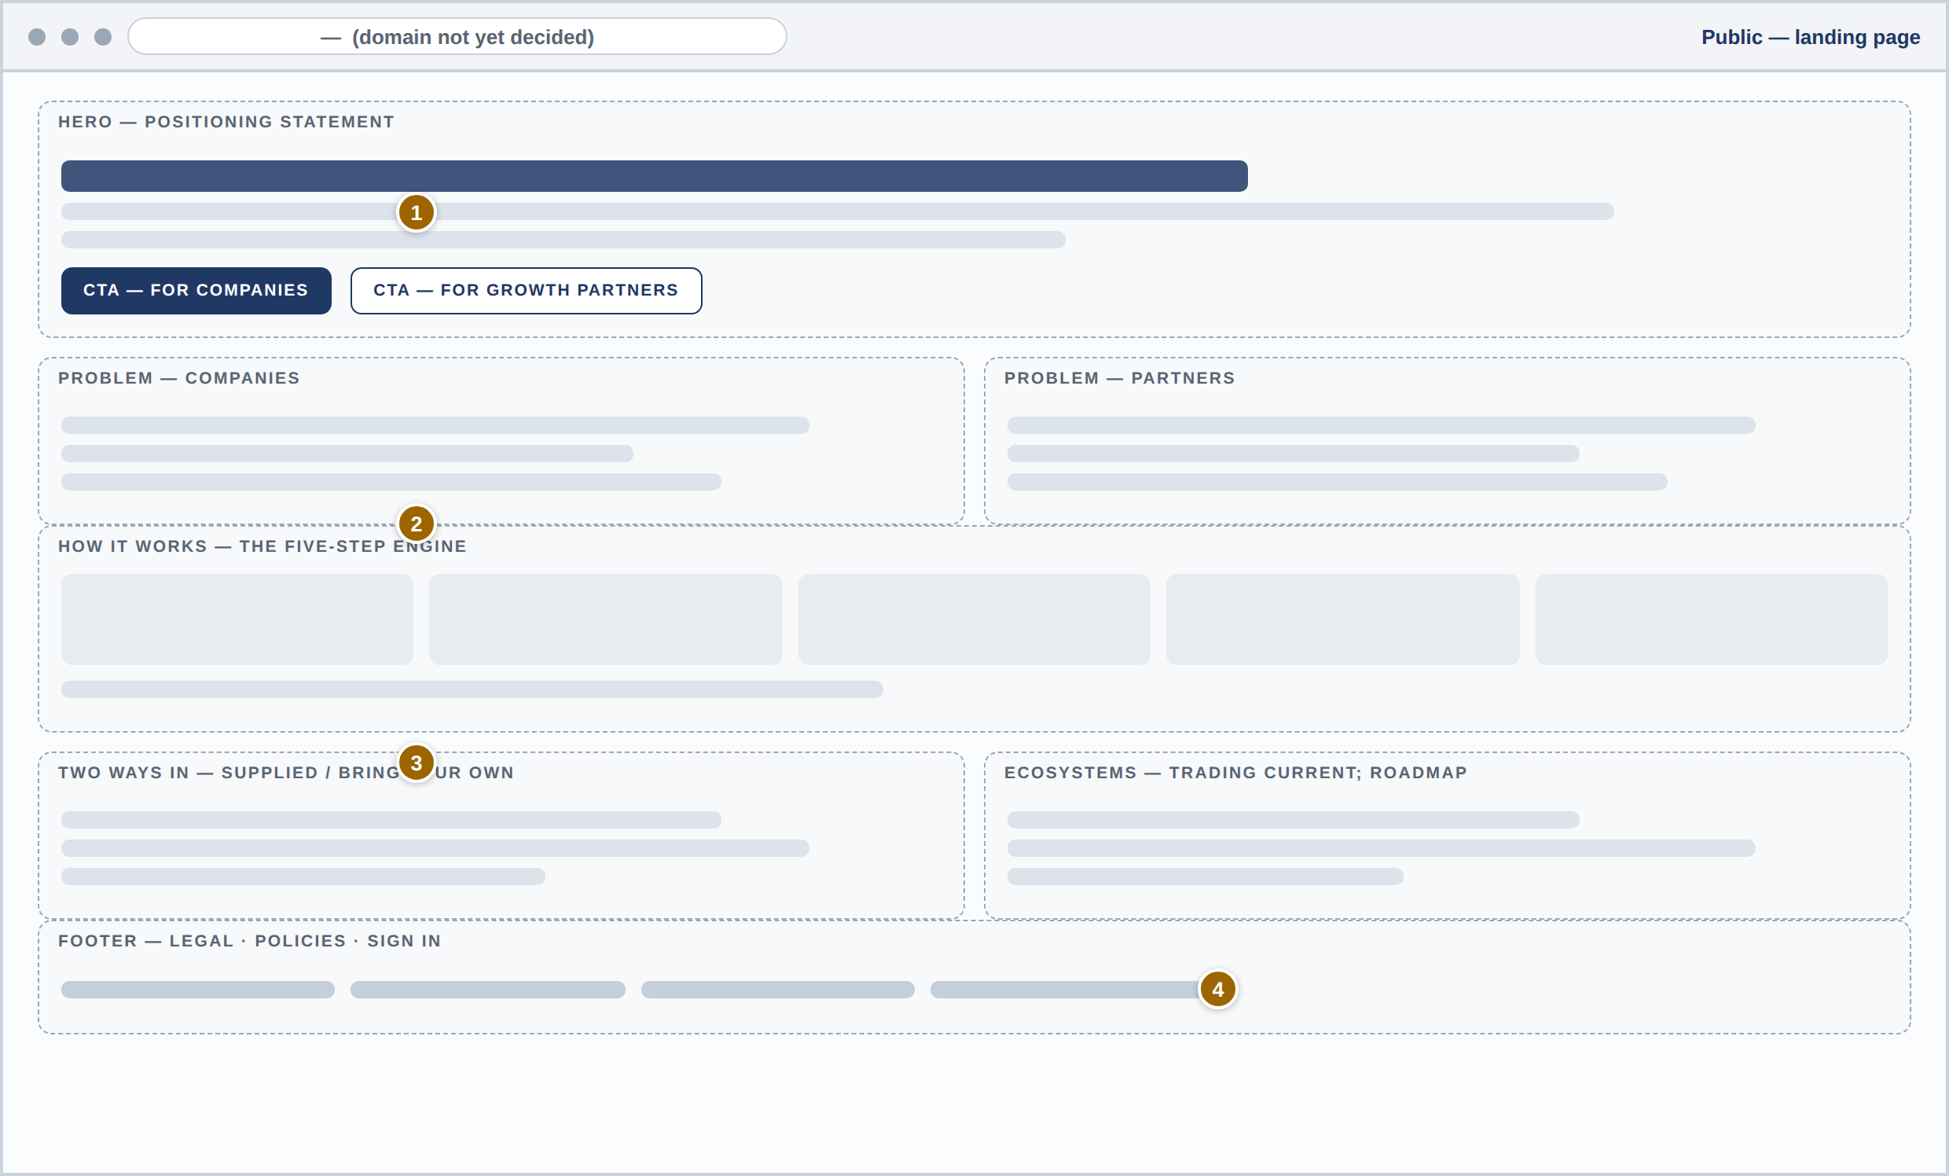
# | REGION | PURPOSE | PRD REFS
1 | Hero + dual CTA | The positioning statement — Brdgr discovers, recruits, and manages performance-driven partnerships — with one call to action per side of the marketplace. | Overview Principle 7 · ACC-01
2 | How it works | The five-step engine as the page’s spine — the same VET → MATCH → CONTRACT → TRACK → PAY drawn in Section 03. | Section 03
3 | Two ways in | Supplied partners and bring-your-own, stated side by side with the ecosystem roadmap — trading current, the rest sequenced. | MATCH · PRF-07 · map (02)
4 | Footer | Legal, policies, and the sign-in route; domain shown as — until registered. | Open items

06 Public — sign in & sign up
One door in, then two paths. Sign-in serves both sides with second-factor support (mandatory for internal roles). Sign-up selects a side first, then branches: companies choose a plan and start the free trial; partners build a profile and enter the vetting queue — with the rules stated on screen (ACC-01/03, BIL-01, VET-01).
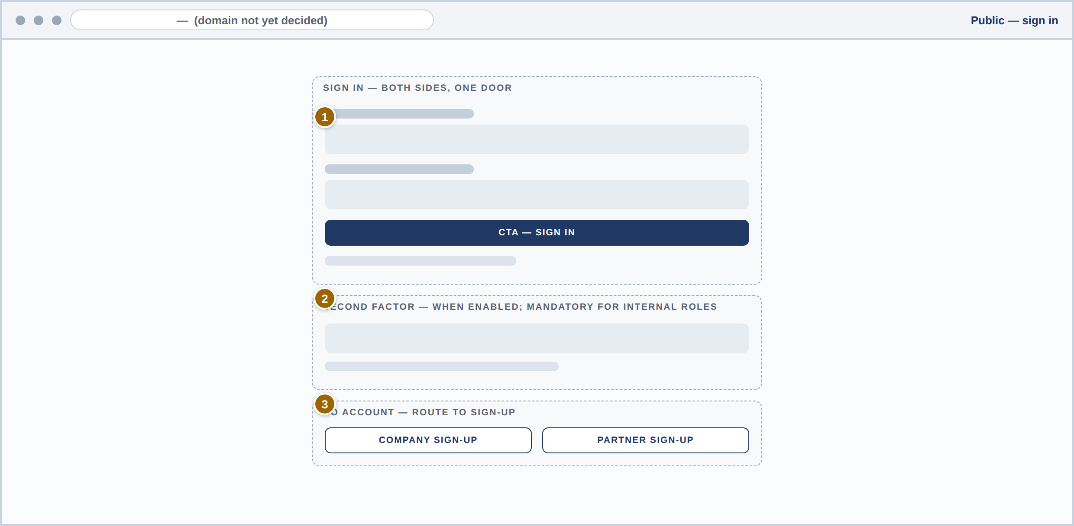
# | REGION | PURPOSE | PRD REFS
1 | Sign-in form | One entry point for clients and partners; sessions and password rules per the security standards. | ACC-03
2 | Second factor | Supported for all, mandatory for Operations Administrators. | ACC-03
3 | Sign-up routing | No account yet — explicit company and partner routes into the flow below. | ACC-01
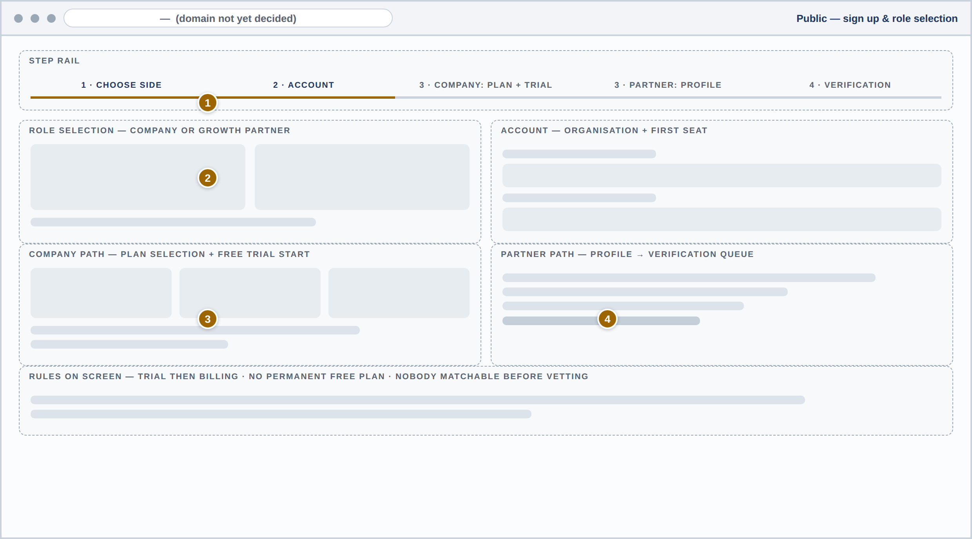
# | REGION | PURPOSE | PRD REFS
1 | Step rail | Choose side → account → side-specific path → (partner) verification — the whole flow visible at once. | ACC-01
2 | Role selection + account | Organisation and first seat created; seat limits are plan configuration. | ACC-01 · BIL-04
3 | Company path | Plan selection (prices — ) and the free trial start — billing begins when the trial ends. | BIL-01 · BIL-05
4 | Partner path + rules | Profile then the vetting queue, with the platform’s rules stated where they are read: trial then billing, no permanent free plan, nobody matchable before vetting. | PRF-01 · VET-01 · BIL-01

07 Client — dashboard
The Partnerships Lead’s daily answer to "is this channel working?" Every figure traces to the ledger and event stream — one source of truth shared with statements (DSH-03).
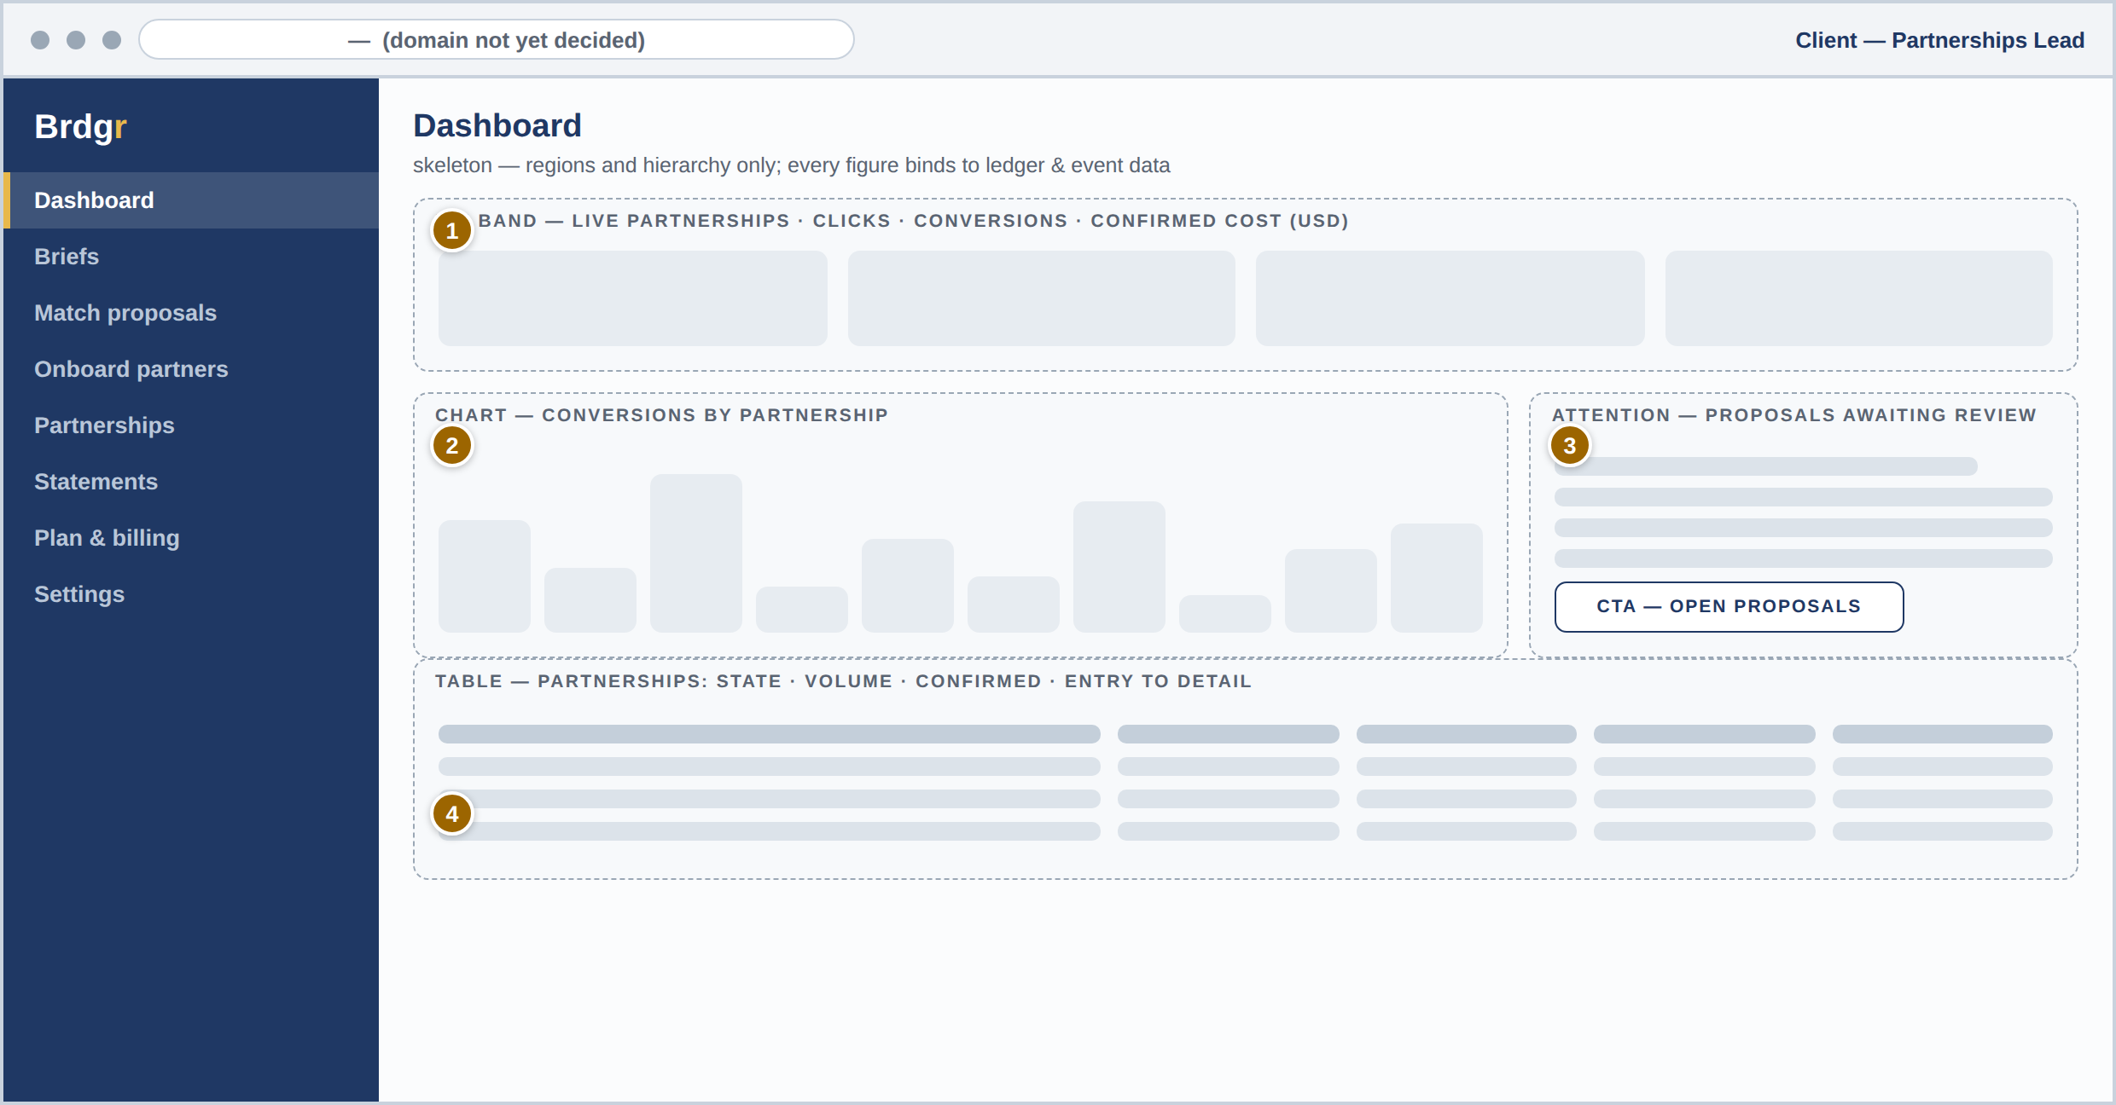
# | REGION | PURPOSE | PRD REFS
1 | KPI band | Live partnerships, clicks, conversions, and confirmed commission cost (USD) for the selected range. | DSH-01
2 | Conversions by partnership | Comparative bars so a weak partnership is visible at a glance; feeds the re-match conversation. | DSH-01 · MATCH-07
3 | Needs your attention | Proposals awaiting review and anything blocking — the client’s slice of the work queue. | MATCH-05
4 | Partnership table | State, volume, and confirmed cost per partnership with one-click entry to detail; CSV export lives here. | DSH-01 · ADM-02

08 Client — new brief
A brief is structured, not a free-text wish. Five steps gather objective, audience, model, and constraints; drafts keep change history until submitted (MATCH-01).
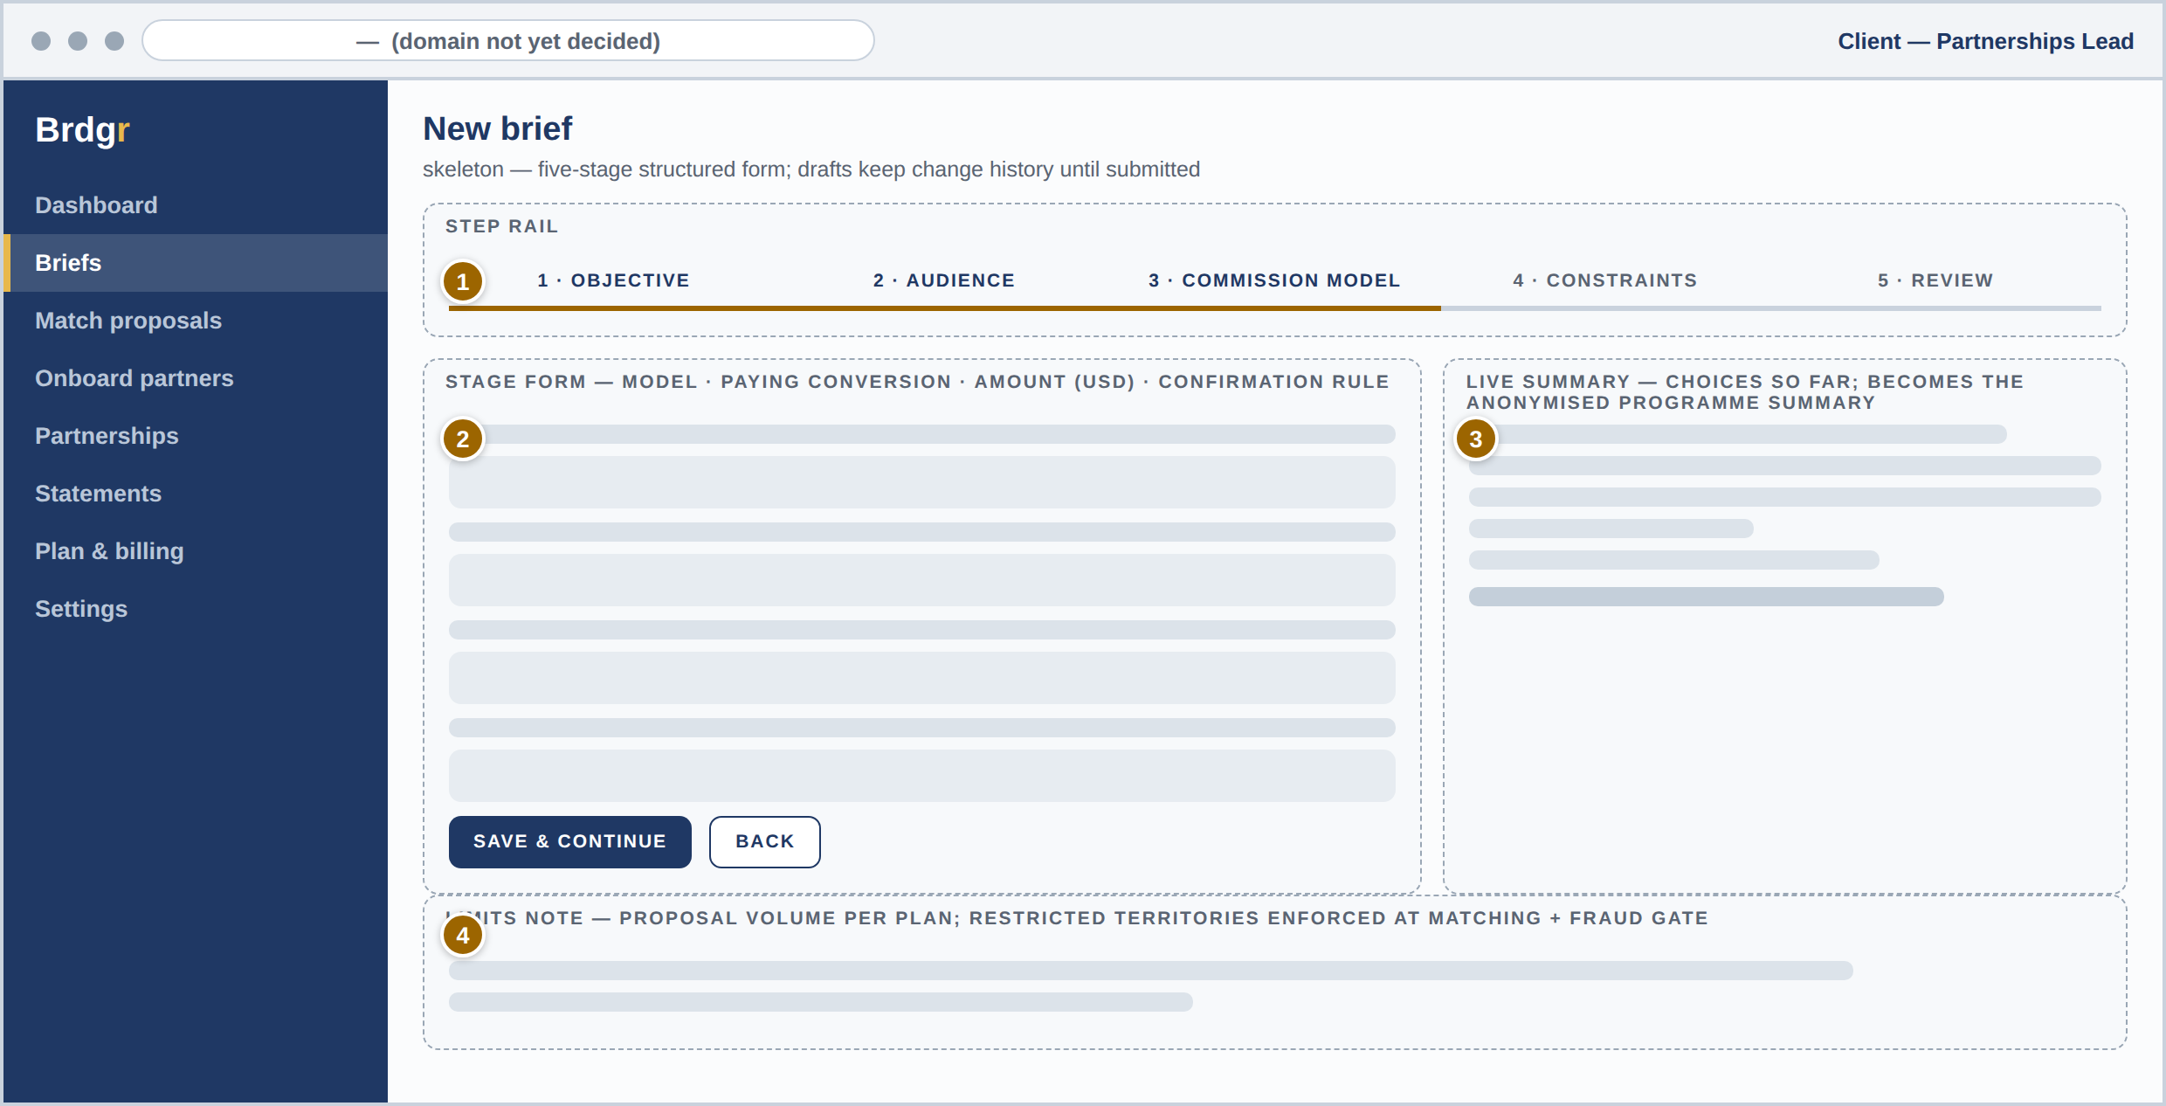
# | REGION | PURPOSE | PRD REFS
1 | Step rail | Five stages with clear progress; a brief cannot submit with a required stage incomplete. | MATCH-01
2 | Commission model stage | Model, paying conversion, amount, and confirmation rule — all configuration-driven so new models need no redesign. | COM-01 · COM-04 · Section 06 of the PRD
3 | Brief summary | Always-visible summary of choices so far; becomes the anonymised programme summary partners see. | MATCH-03
4 | Limits note | Proposal volume follows plan configuration; restricted territories are enforced at matching and the fraud gate. | MATCH-06 · COM-02

09 Client — match proposals
Vetted candidates, anonymised until contract. The client judges fit signals and terms — never identities. Accept or decline within the window; declines carry reasons that improve matching (MATCH-05).
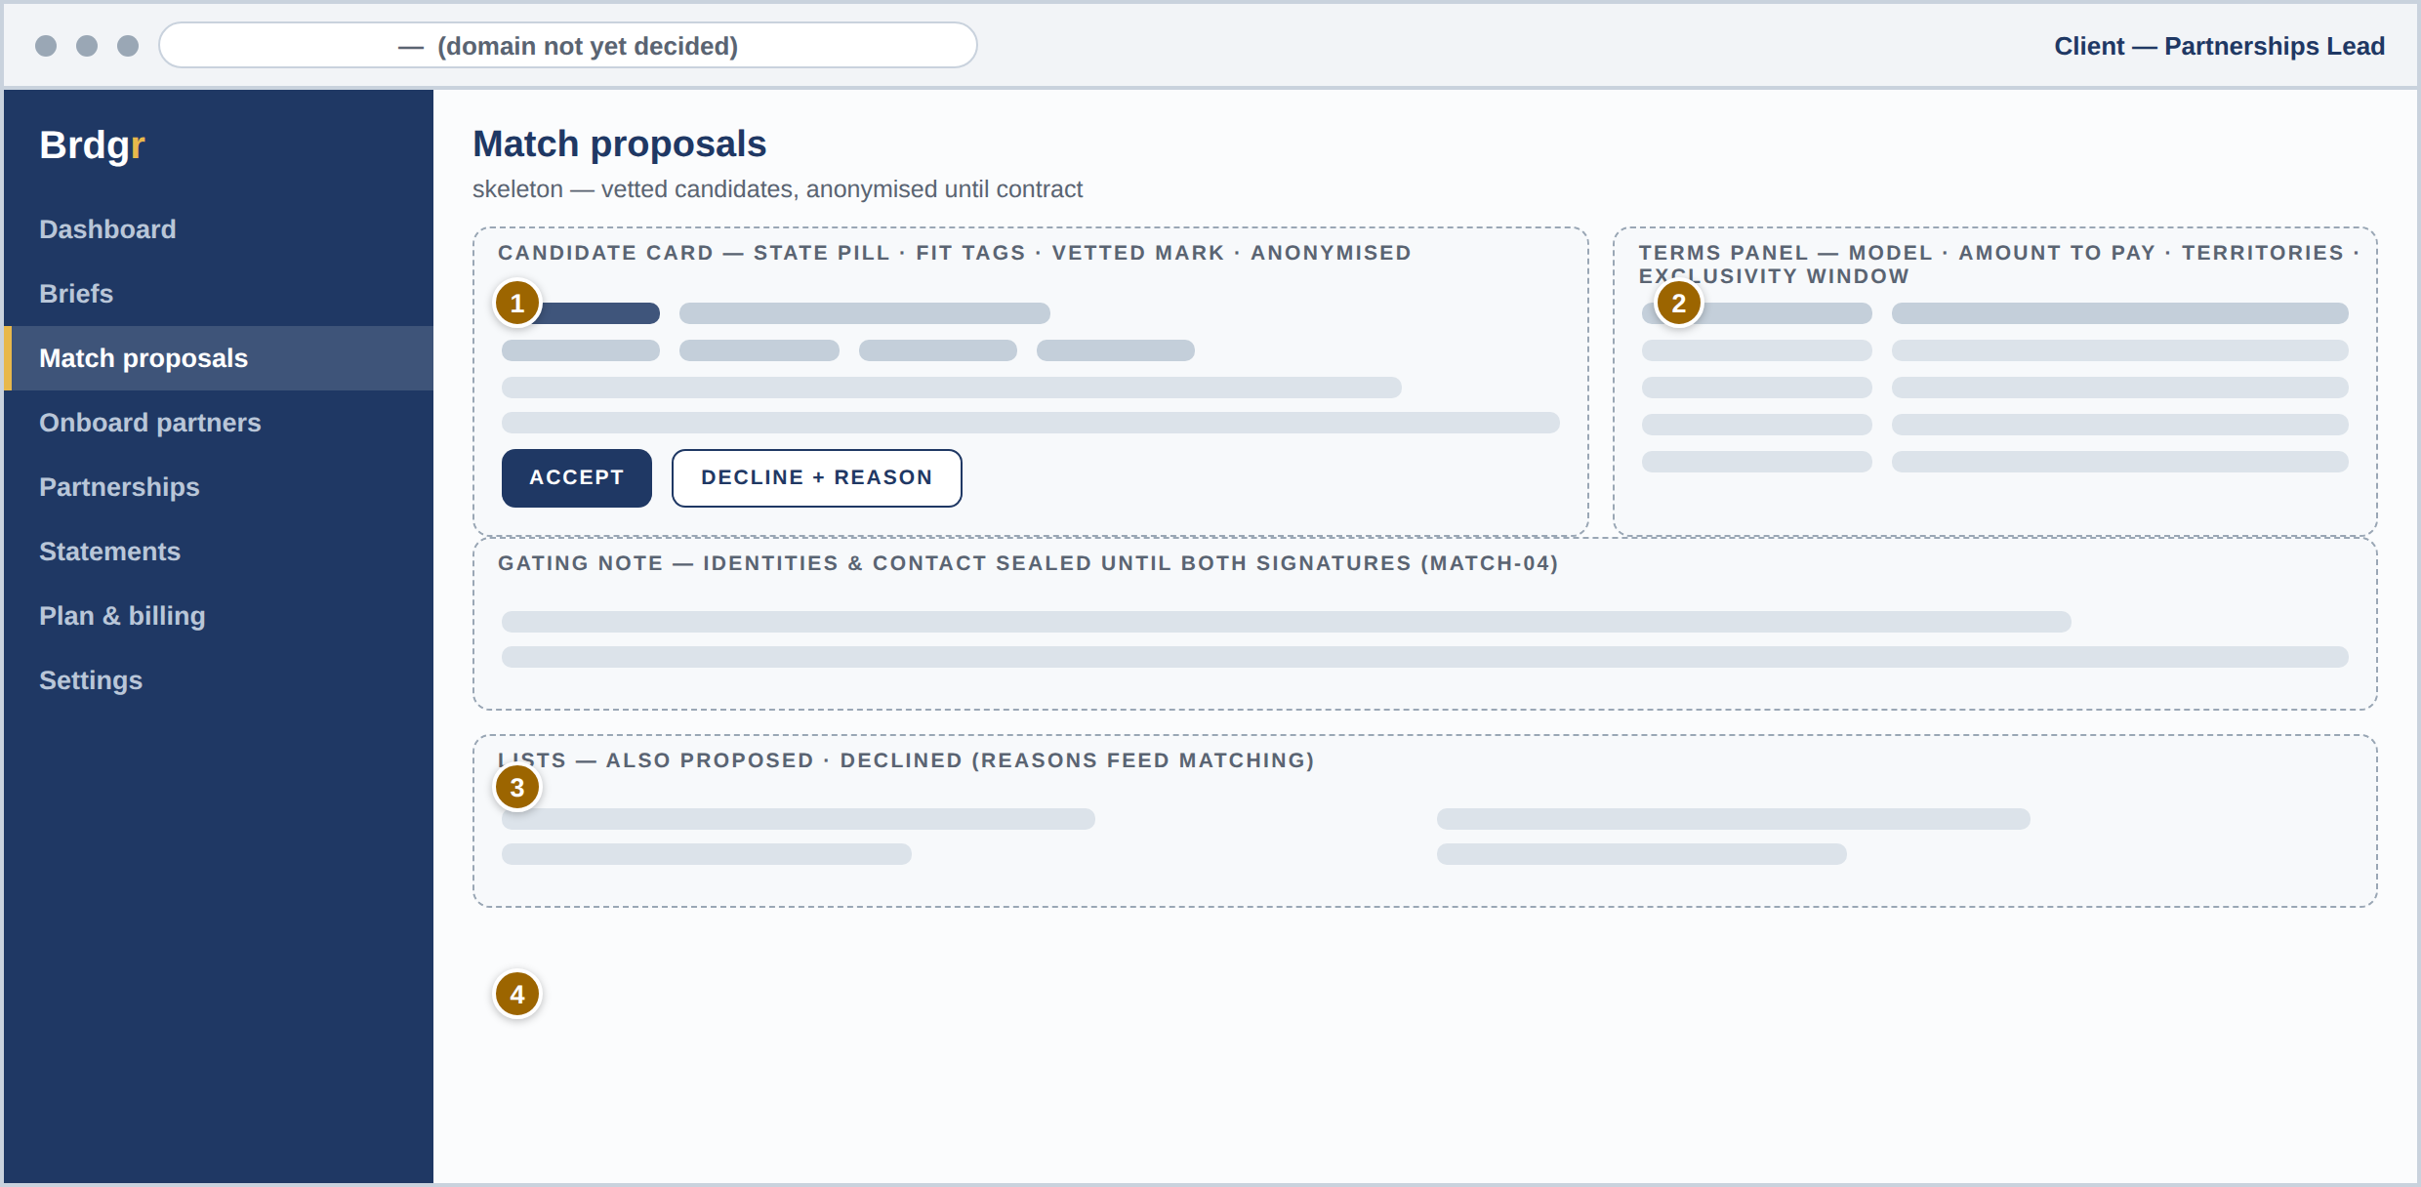
# | REGION | PURPOSE | PRD REFS
1 | Anonymised candidate card | State pill, fit signals as tags, and a vetted mark — identity and channels withheld until CONTRACTED. | MATCH-03 · MATCH-04
2 | Gating note | Plain-language statement of the contact rule, so the behaviour never surprises a client. | MATCH-04 · DEF-01
3 | Accept / decline | Both actions in one place; decline requires a reason code; expiry closes silently unanswered proposals. | MATCH-05
4 | Proposal terms | Model, amount, territories, exclusivity window — the exact terms that will merge into the contract. | CON-01 · MATCH-09

10 Client — partnership detail
One record, whole life. Tabs cover overview, contract, tracking, commissions, and messages — the same record the Operations Administrator sees in the console (ADM-02).
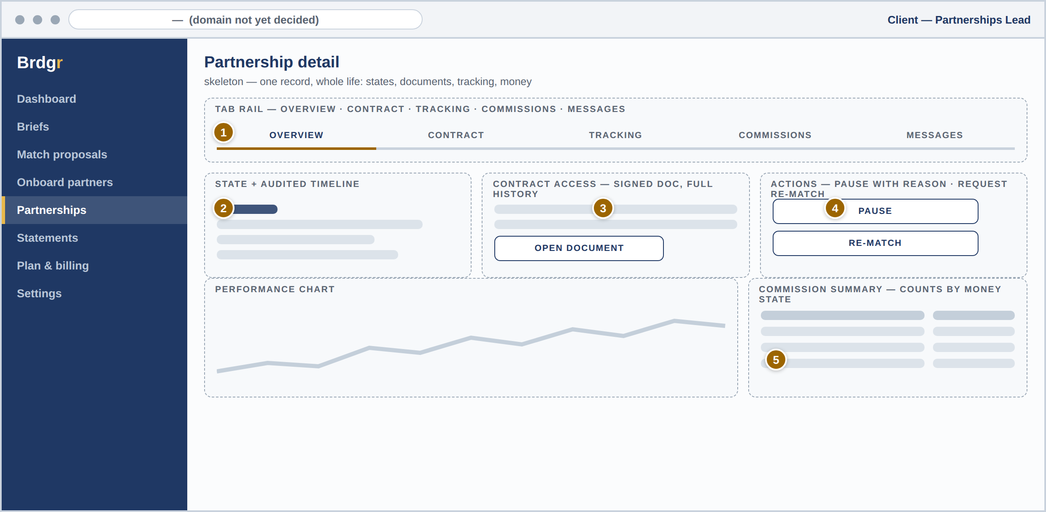
# | REGION | PURPOSE | PRD REFS
1 | Tab rail | Overview, contract, tracking, commissions, messages — the full partnership in one place. | ADM-02
2 | State + timeline | Current lifecycle state with the audited transition history: who, what, when. | Section 05 of the PRD
3 | Contract access | The signed document, stored with complete history, downloadable for the life of the account. | CON-03
4 | Actions | Pause with reason, and request re-match when performance disappoints — routed to the Operations Administrator. | MATCH-07 · ADM-02
5 | Commission summary | Counts by money state, matching the partner-side names exactly — both sides see the same truth. | COM-06

11 Client — plan & billing
Trial first, then a decision. The banner counts the trial down ( — days: 7 or 14, undecided); plans show dashes until pricing is concluded; the locked state and retry sequence are specified even though nobody wants to meet them (BIL-01..06).
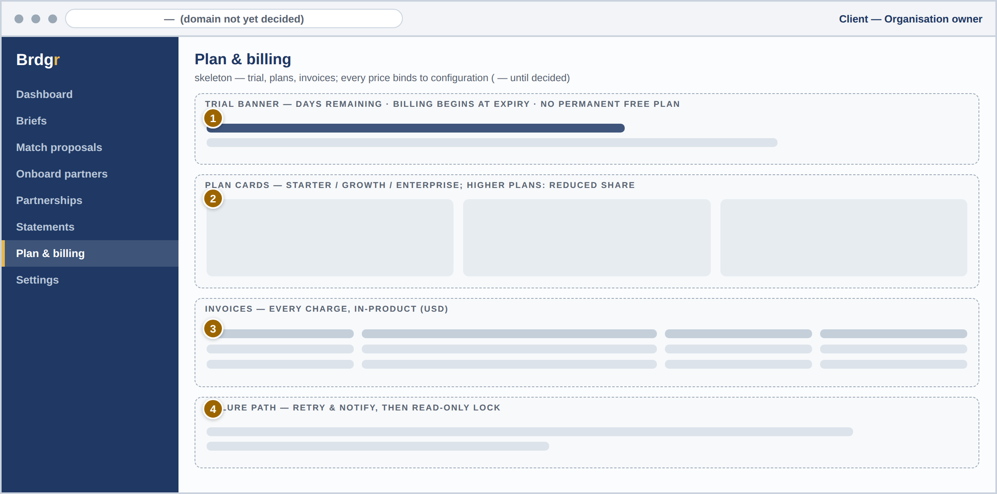
# | REGION | PURPOSE | PRD REFS
1 | Trial banner | Days remaining and what happens at expiry — billing begins, no permanent free plan. | BIL-01 · BIL-02
2 | Plan cards | Starter / Growth / Enterprise with dash prices; higher plans show the reduced commission share ( — ). | BIL-05 · BIL-08
3 | Invoices | Every charge produces an invoice, available in-product. | BIL-06
4 | Failure note | Failed payments retry and notify before the account locks read-only — stated where the client will look for it. | BIL-03 · BIL-06

12 Client — onboard your partners
The option that meets companies where they are. Existing partners are invited singly or in bulk, pass streamlined verification, and land on the same contracts, tracking, fraud gate, and monthly USD payouts — with the client’s ownership of the relationship stated on the screen itself (PRF-07/08, VET-09, MATCH-10).
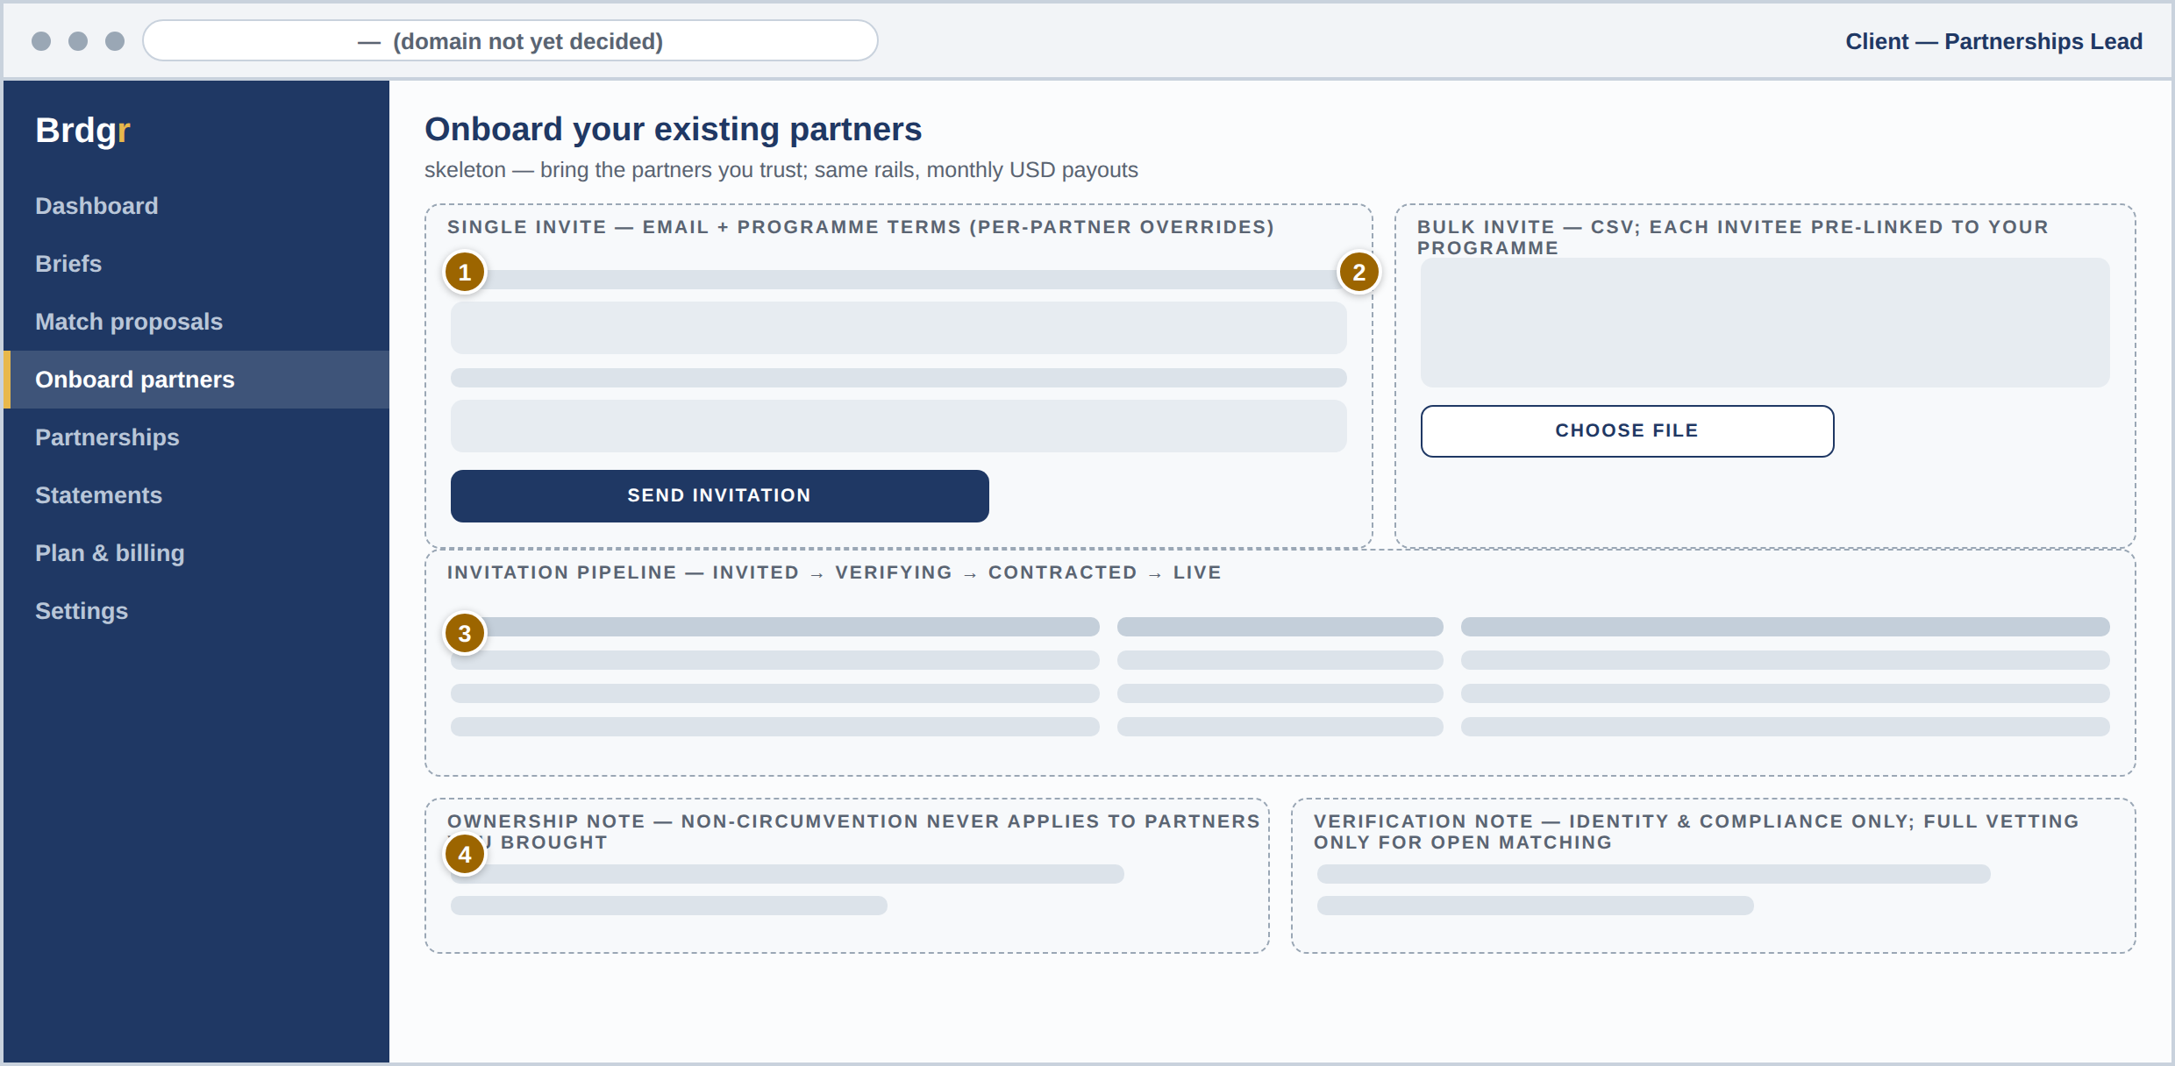
# | REGION | PURPOSE | PRD REFS
1 | Single invitation | Email invitation carrying the client’s programme terms, with per-partner overrides. | PRF-07 · COM-01
2 | Bulk invitation | CSV upload; every invitee is pre-linked to this client’s programme on sign-up. | PRF-07
3 | Invitation pipeline | Invited → signed up → verifying → contracted → live — the client watches their own network come onto the rails. | PRF-08 · VET-09 · MATCH-10
4 | Ownership & verification notes | Plainly stated: non-circumvention never applies to partners the client brought, and invited partners pass identity-and-compliance checks only — full vetting applies only if they opt into open matching. | DEF-08 · CON-05 · VET-09

13 Partner — sign-up & vetting status
The honest waiting room. An applicant sees the three dimensions under review, any evidence request, and the rules — without ever being called vetted early (VET-01..06).
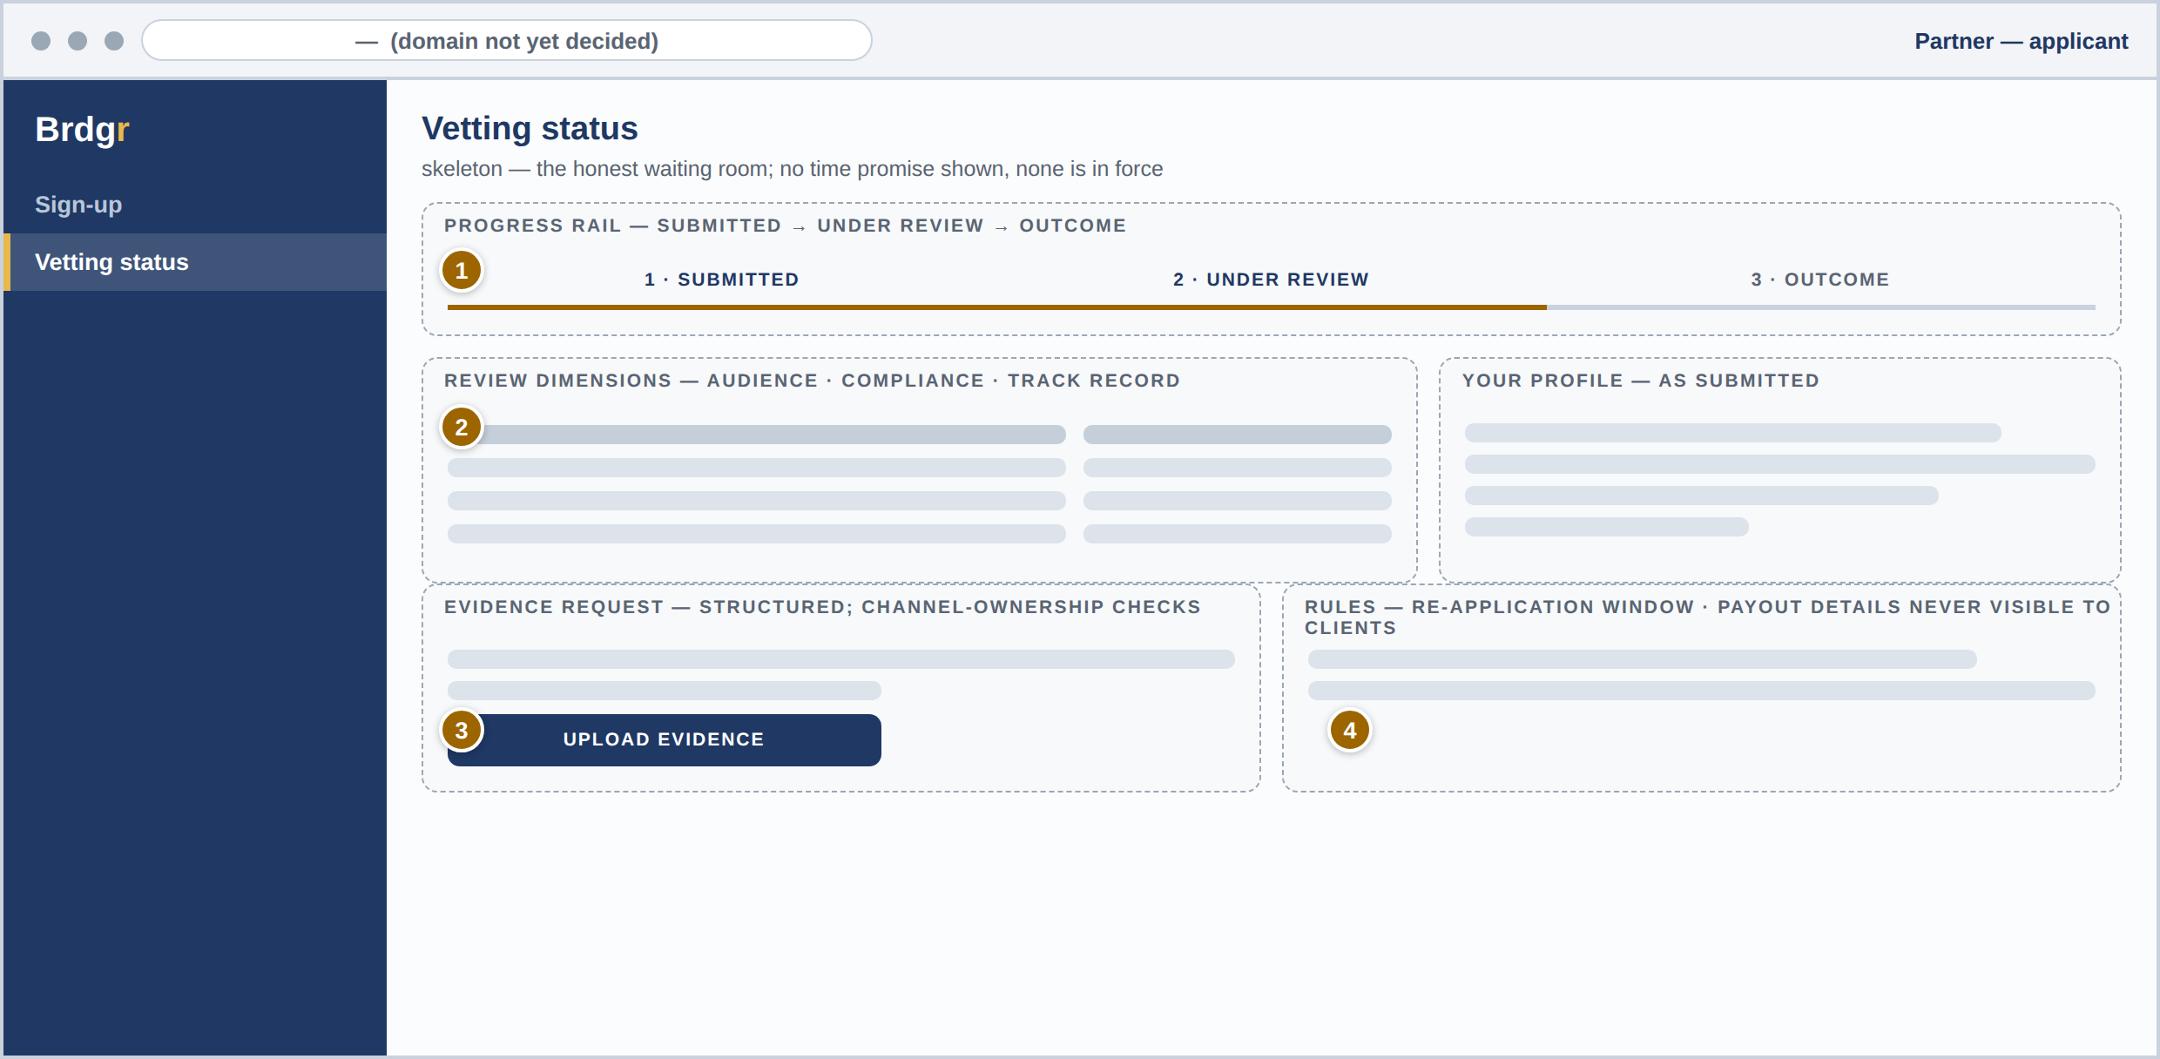
# | REGION | PURPOSE | PRD REFS
1 | Progress rail | Profile submitted → under review → outcome; no time promise is shown, because none is in force. | VET-01 · Principle 7
2 | Review dimensions | Audience authenticity, compliance history, track record — each with live status. | VET-02
3 | Evidence request | Structured more-information flow, including channel-ownership checks. | VET-03 · PRF-06
4 | Rules panel | Re-application after decline, and the guarantee that payout details never reach clients. | VET-04 · PRF-01

14 Partner — dashboard
What am I earning, and what should I do next? Money states in plain language across every partnership, plus the tracking links that make credit survive ad blockers (COM-06, TRK-01).
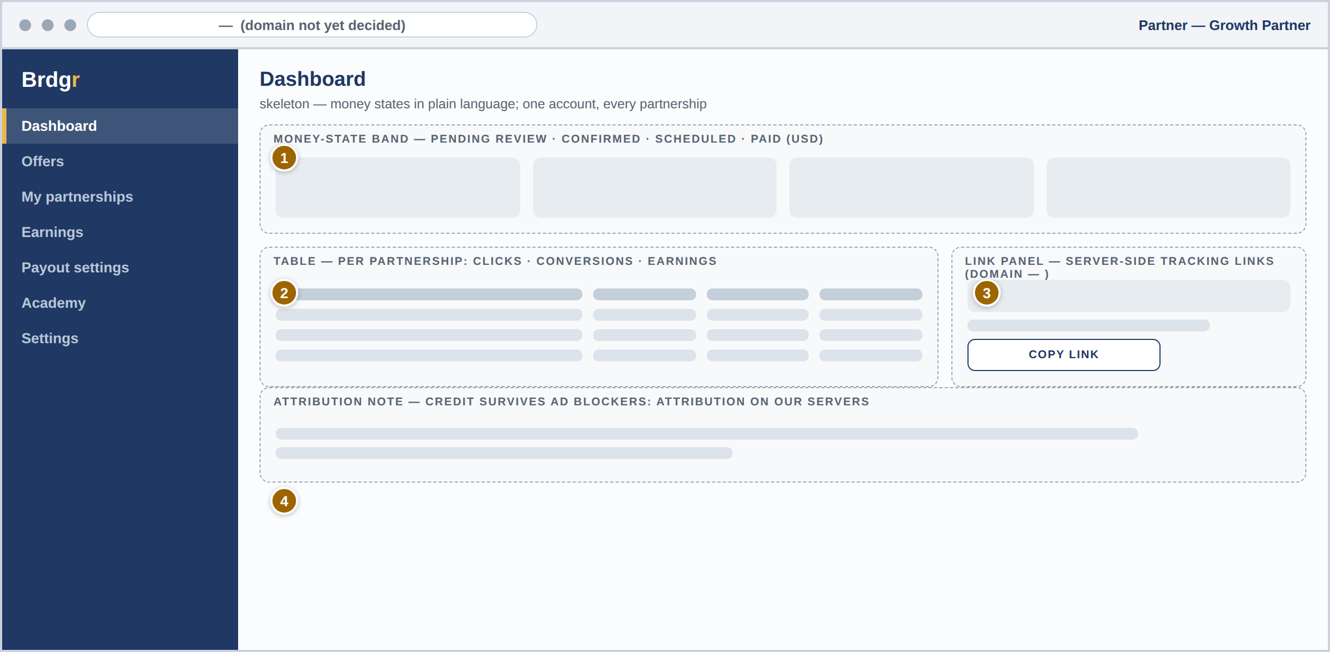
# | REGION | PURPOSE | PRD REFS
1 | Money-state cards | Pending review → confirmed → scheduled → paid — the exact states from the money-flow diagram, named identically everywhere. | COM-06 · MNY-04
2 | Per-partnership table | Clicks, conversions, and earnings per programme — one account, every partnership. | DSH-02
3 | Link panel | Server-side tracking links on the platform domain ( — until decided); copy in one click. | TRK-01
4 | Attribution note | Why credit is safe: attribution happens on our servers, not the visitor’s browser. | TRK-01 · TRK-02

15 Partner — offers
Programmes come to the partner. Anonymised client, plain terms, a response window, and messaging that stays on-platform until contract (MATCH-04, DEF-02).
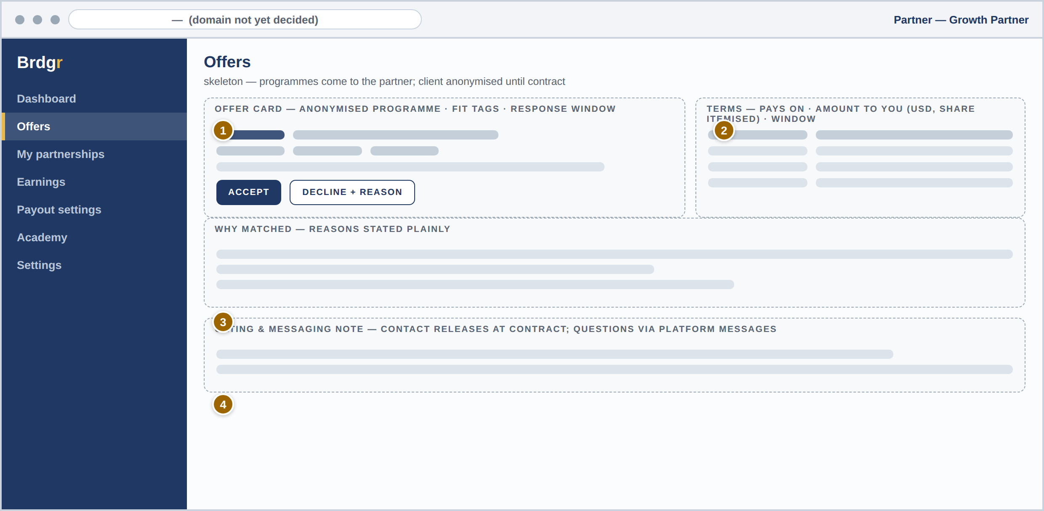
# | REGION | PURPOSE | PRD REFS
1 | Offer card | Anonymised programme with fit tags — why this partner, stated plainly. | MATCH-03 · MATCH-08
2 | Terms table | What pays, how much reaches the partner, and the response window — no hidden mechanics. | COM-01 · MATCH-05
3 | Accept / decline | Same consent mechanics as the client side; declining with a reason improves future matches. | MATCH-05
4 | Gating & messaging note | Contact releases only at contract; pre-contract questions go through platform messages. | CON-04 · DEF-01 · DEF-02

16 Partner — earnings & statements
The screen the motto answers to. Every line itemised — commissions, the platform share ( — ), clawbacks with reasons, payouts with provider references — with running balances (MNY-04).
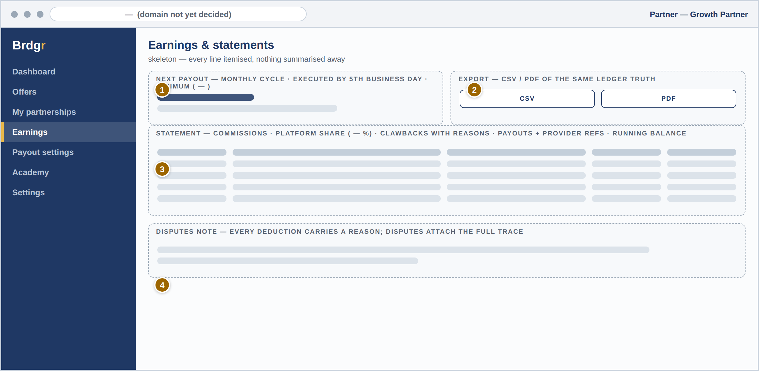
# | REGION | PURPOSE | PRD REFS
1 | Next payout | The monthly cycle made visible: amount, execution by the fifth business day, and the minimum ( — ). | MNY-03
2 | Statement export | CSV and PDF of the same ledger truth the dashboard shows. | MNY-04 · DSH-03
3 | Itemised lines | Confirmations, the share, clawbacks with reasons, payouts — nothing summarised away. | MNY-04 · COM-05
4 | Disputes note | Every deduction carries a reason; disputes attach the full trace. | ADM-03 · MNY-04

17 Admin — work queue
The console’s front page: everything waiting, oldest and riskiest first. Vetting, match approvals, held commissions, payout manifests, and disputes in one queue with assignment (ADM-01).
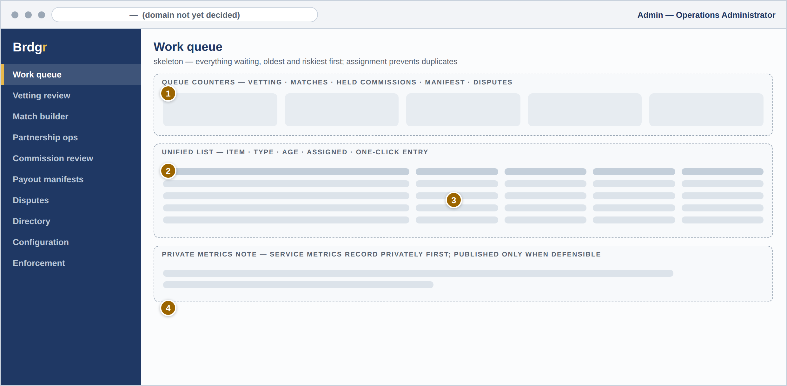
# | REGION | PURPOSE | PRD REFS
1 | Queue counters | Live counts per workflow with the oldest item’s age — the COO’s morning view. | ADM-01
2 | Unified list | Every waiting item, typed and aged, one click from its workflow; assignment prevents duplicate review. | ADM-01 · VET-01
3 | Held commission entry | Fraud-gate holds surface here with the rule that fired. | COM-02 · COM-03
4 | Private metrics note | Service metrics record privately first — published only when they can be stood behind. | ADM-06 · Principle 7

18 Admin — vetting review
Careful made fast. Evidence on the left, three verdicts on the right, audited notes, and three outcomes — with no path that skips the review record (VET-05).
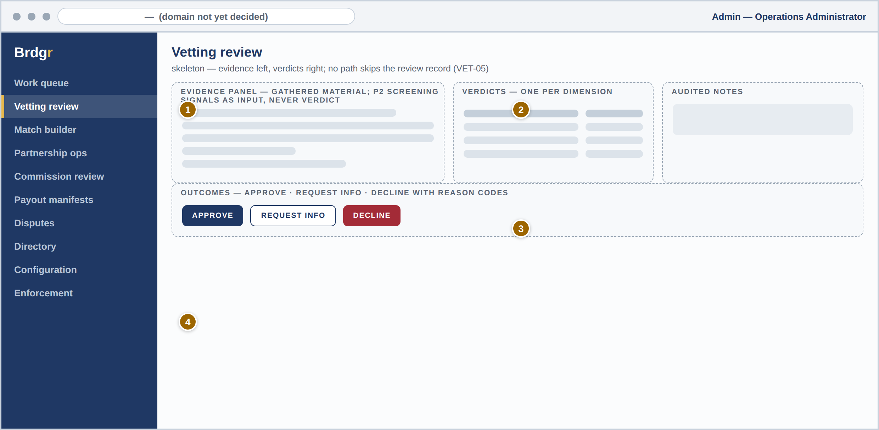
# | REGION | PURPOSE | PRD REFS
1 | Evidence panel | Everything gathered for this application; Phase 2 screening signals appear here as reviewer input, never as a verdict. | VET-01 · VET-07
2 | Dimension verdicts | Audience authenticity, compliance history, track record — one verdict each. | VET-02
3 | Audited notes | Reviewer reasoning captured with the verdict; every outcome is an audited event. | VET-06
4 | Outcomes | Approve, request information, or decline with reason codes; declined applicants can re-apply after the set period. | VET-03 · VET-04

19 Admin — match builder
Where matching actually happens. The brief on the left, ranked vetted candidates with visible reasons on the right, and a human approval before anything is sent (MATCH-02, MATCH-03).
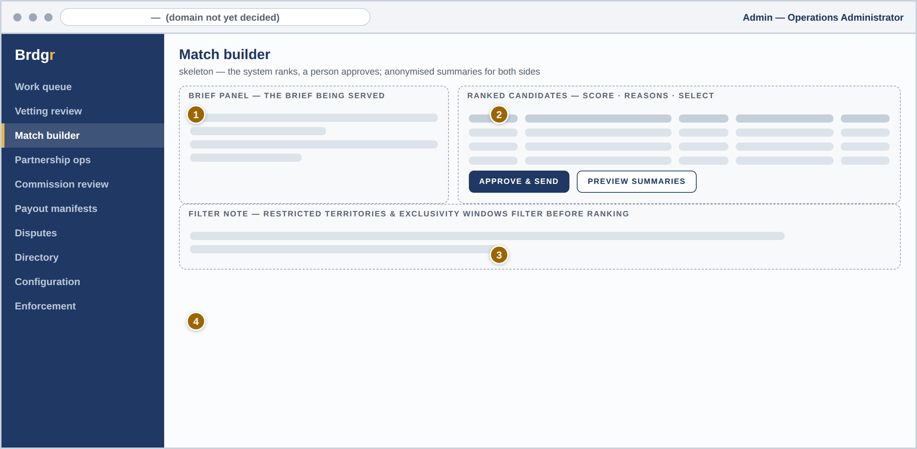
# | REGION | PURPOSE | PRD REFS
1 | Brief panel | The structured brief being served, with its constraints. | MATCH-01
2 | Ranked candidates | Scores with reasons — the system ranks, the person decides. | MATCH-02
3 | Approve & send | Proposals go out only on explicit approval, carrying anonymised summaries for both sides. | MATCH-03
4 | Filter note | Restricted territories and exclusivity windows filter candidates before ranking ever runs. | MATCH-09 · COM-02

20 Admin — payout manifest
The accountable moment. The monthly payout run is a reviewable manifest — lines, USD totals in integer minor units, ledger check — approved by a person before a unit moves, and executed by the fifth business day (MNY-03).
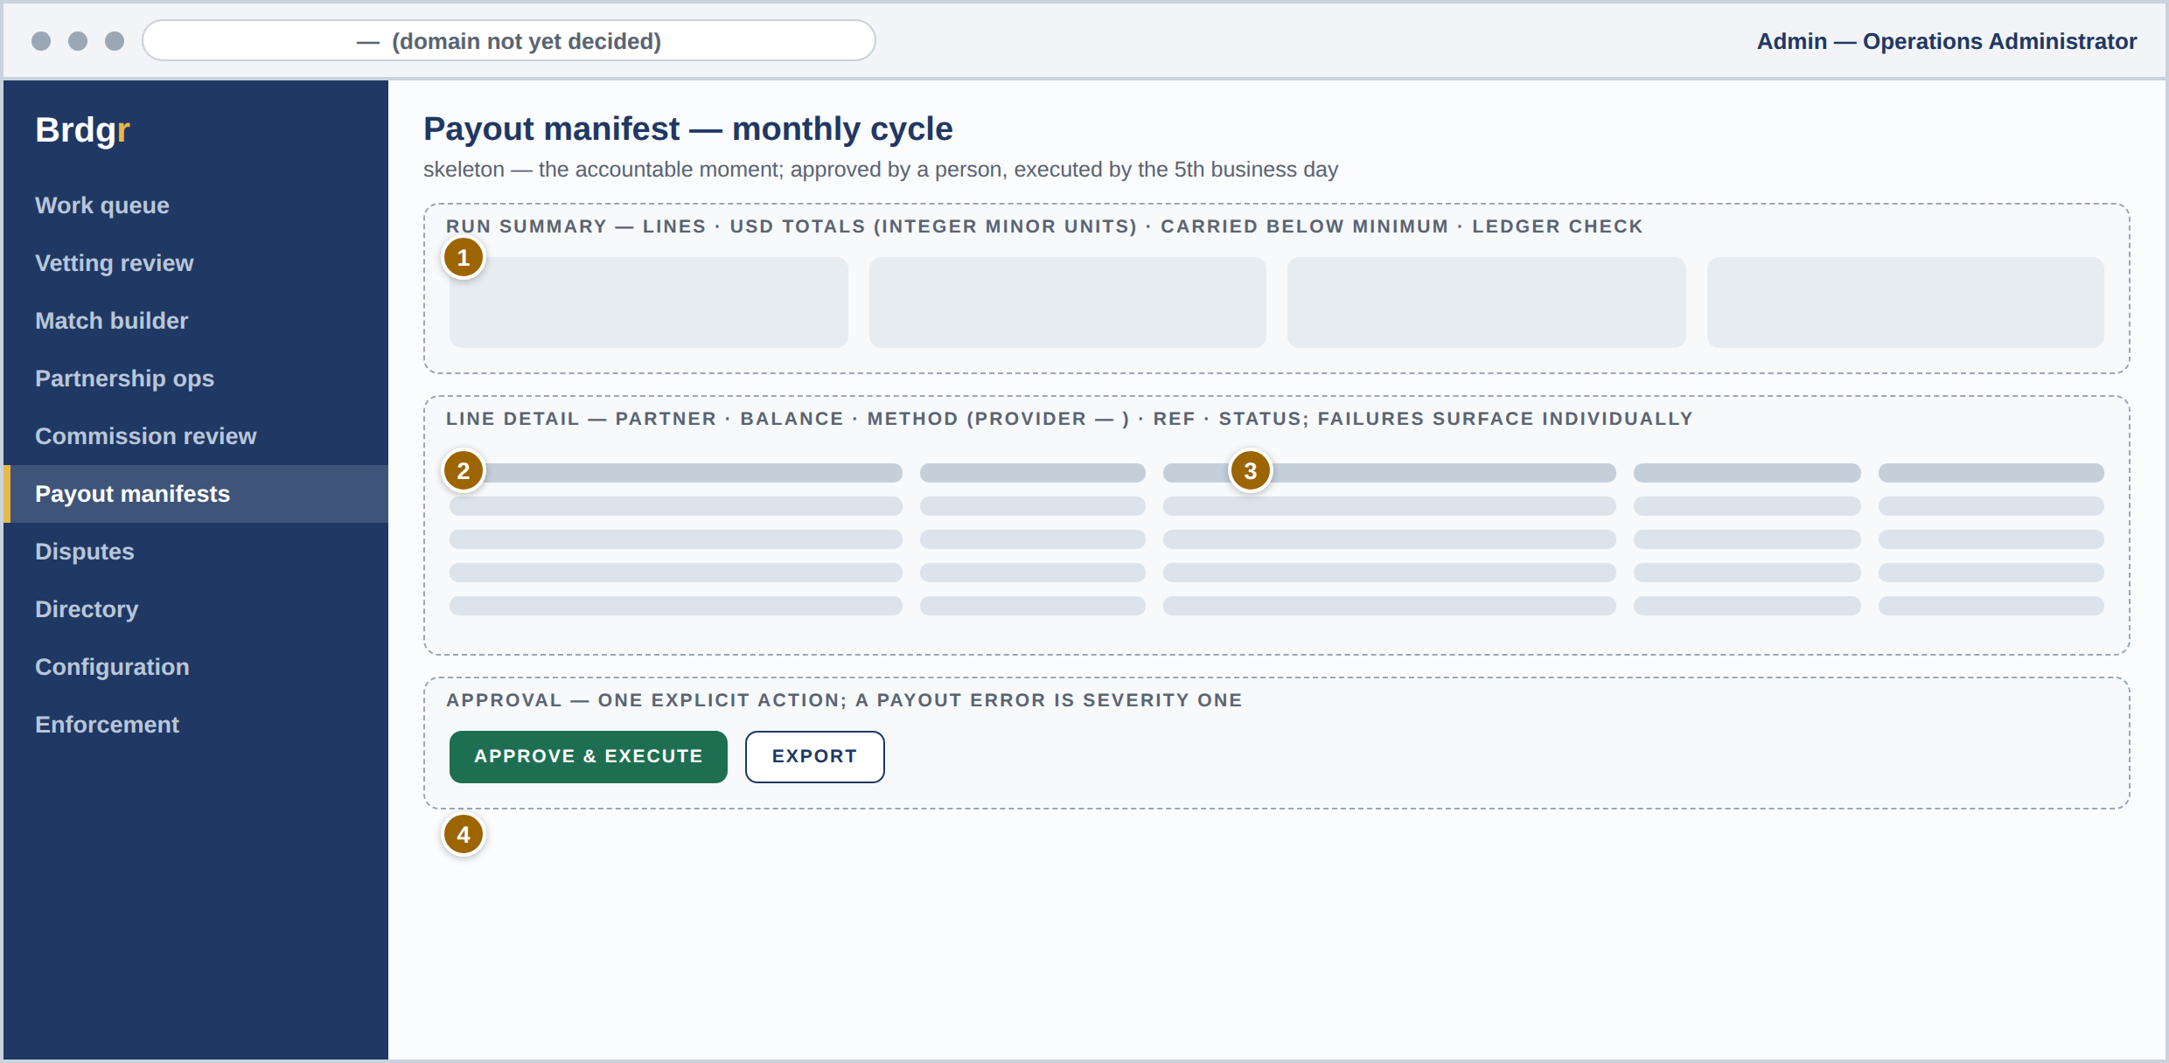
# | REGION | PURPOSE | PRD REFS
1 | Run summary | The monthly run: line count, USD totals in integer minor units, and balances carried below the minimum. | MNY-03 · MNY-01
2 | Ledger check | Balance invariants verified before approval is even offered. | MNY-06
3 | Line detail | Per-partner balances, methods per provider ( — ), references, and statuses — failures retry per policy and surface individually. | MNY-05
4 | Approve & execute | One explicit approval; a payout error is a severity-one incident, and this screen is why it stays rare. | MNY-03 · Section 21 of the PRD

PART C
Coverage
Every screen tied to its requirements, and the open items that shape the interface

21 Screen-to-requirement traceability
Proof of coverage. Every Phase 1 module in the PRD has a home in these wireframes. Where a module’s screen is not drawn in Part B, the table says where it lives instead — nothing is silently unspecified.
PRD MODULE | PRIMARY SCREENS | WHERE DRAWN / NOTED
Accounts & access (ACC) | Landing, sign-in, sign-up & role selection; account and seats | Sections 05 and 06 — drawn as skeletons; seats as standard patterns
Profiles & directory (PRF) | Partner profile; admin contact directory; partner invitations | Partner sign-up (13) and sign-up flow (06); invitations (12); directory as console branch (02, 17)
Vetting (VET) | Applicant status; admin review; streamlined BYO verification | Sections 13 and 18; the partner path in 06; BYO notes in 12
Matching (MATCH) | Brief; proposals both sides; match builder; BYO partnership creation | Sections 08, 09, 15, 19; BYO in 12
Contracts (CON) | Contract tab; signature step | Section 10; e-sign flow follows provider selection ( — )
Tracking (TRK) | Link panel; tracking tab | Sections 14 and 10
Commissions & fraud gate (COM) | Money states; held-commission review | Sections 14, 16, 17
Money (MNY) | Statements; payout manifest | Sections 16 and 20
Billing & trial (BIL) | Plan selection at sign-up; plan & billing; trial banner; locked state | Sections 06 and 11
Dashboards (DSH) | Client and partner dashboards | Sections 07 and 14
Notifications (NTF) | Notification centre — shared surface | Platform map (02); templates content-managed
Admin console (ADM) | Queue; partnership ops; disputes; configuration | Sections 17–20; remaining branches on the map (02)
Defensibility (DEF) | Gating notes; platform messages; report path; the BYO exclusion | Sections 09, 10, 15; the exclusion stated in 12; screening and anomaly views are Phase 2
Academy (ACA) | Partner portal branch — Phase 2 | Platform map (02), tagged P2; drawn when Phase 2 is specified
Phase discipline in the drawings
Part B draws the launch build. Phase 2 and Phase 3 surfaces — Academy tracks, screening assistance, anomaly review, benchmarks, white-label, API — are placed on the map and tagged, and will be wireframed against their PRD requirements when their phase begins. Drawing them now would invent detail ahead of decisions.

22 Open items that shape the interface
These decisions change pixels. Each is owned in the Company Overview or PRD register; this table records only what the interface does about them meanwhile.
OPEN ITEM | WHERE IT APPEARS | INTERFACE BEHAVIOUR UNTIL DECIDED
Domain name | Browser bar of every screen; partner link panel | Shown as a dash; tracking-link layout accepts any domain length
Trial length (7 or 14 days) | Billing banner (11) and sign-up (06) | Banner reads " — days remaining"; countdown binds to configuration
All plan prices, both sides | Plan cards (11); plan step at sign-up (06) | Dash prices; card layout fixed so numbers drop in without redesign
Commission share % and plan reductions | Statements (16); plan cards (11); money flow (04) | Share line prints " — %"; statement math renders from configuration
Payout providers & minimum | Manifest (20); partner payout settings | Method column reads "per provider ( — )"; the cycle itself is decided — monthly — and amounts are USD; the minimum stays configuration
E-signature provider | Contract step (10) | Signature step drawn as a handoff; detailed flow follows selection
Service-time targets | Vetting status (13); queue (17) | No countdowns or promises rendered; ages shown, targets absent
Non-circumvention terms | Contract tab; offer notes | Referenced as "per agreement"; clause text follows legal review

23 Document control
DOCUMENT CONTROL | DETAIL
Date | July 2026
Status | Read-only. Confidential — not for external distribution. Approved as the structural base for build and visual design.
Owners | Creative Director (interface standard) · Developer (build fidelity) · COO (workflow acceptance) · Founder (scope)
Companions | Product Requirements Document · Company Overview · brand system
Maintenance | Updated when an open item lands, when a phase begins, or when scope changes are approved by the Founder

The Bridge to Better Partnerships
Three portals. Seventeen screens. One engine — drawn as skeletons before it is built.

