Devon James November 19th, 2018

CSI 431

Prof. Petkov

***HW #3 Solution***

Part A

***Question:*** Is smaller or larger margin better for this dataset (need to explain which

C values are likely to produce smaller vs. larger values and then which end up being better in cross validation.)

***Answer:*** As shown in my results, after doing cross validation, the C values do not affect the average F measure of the dataset with the exception of C=.01, which has the lowest (and only non-equivalent) average. With that being said, the smaller margin (larger C values) may be better for this dataset due to the fact that when C is smaller, the dataset is at its lowest point.

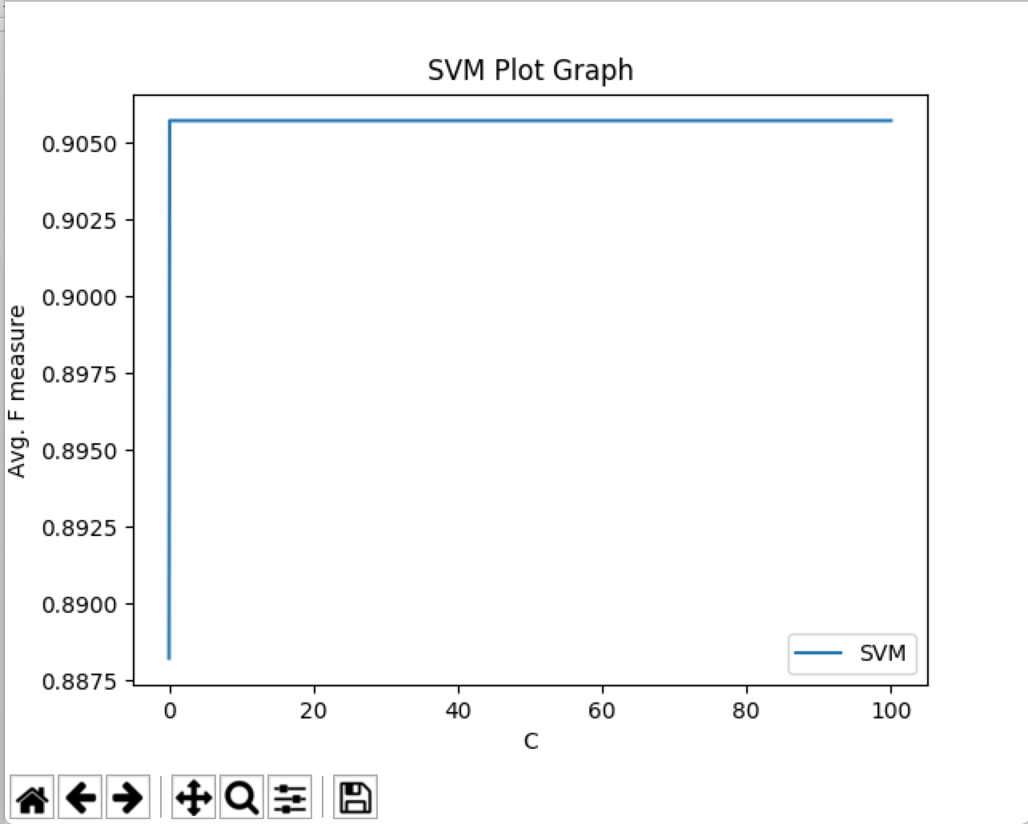

*Part B*

***Question:*** Does larger tree mean better F-measure? Which criterion is better?

***Answer:*** After a series of instances of trial and error, I was unable to get this part of the program working properly. When plotting Decision Trees, the graphs looked different from each other each time I reran that part of the program as shown below:

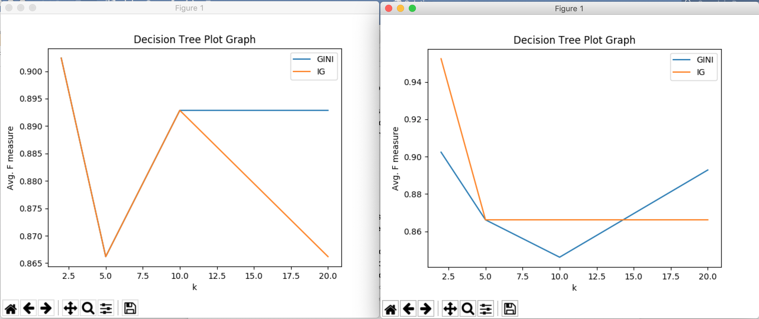

However, through all iterations, k=2 had the highest average F measure for the IG and k=20 had the highest average F measure for the GINI Index.

*Part C*

***Question:*** Which are the best classifiers when you consider the different metrics? Is there a single winner for this dataset?

***Answer:*** When looking at the metrics provided through my program, I can say that both Decision Tree (IG and GINI Index) classifiers are the best classifiers, with Random Forest (GINI Index) coming in as a close second due to their high F-scores. These three classes consistently have the highest Precision and Recall compared to the other classifiers. With that being said, there is no single winner for this dataset.

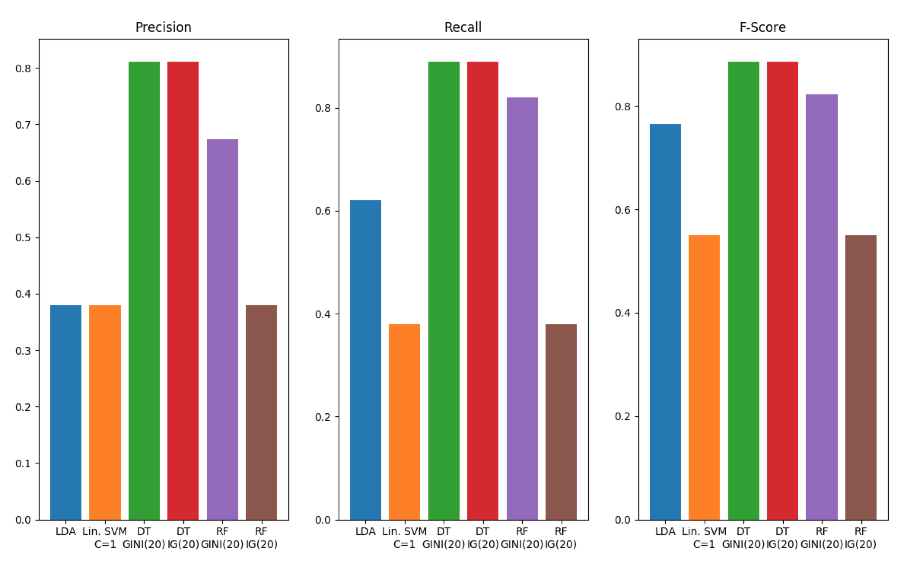

*Part D*

***Question:*** Explain results (of Random Forest Classifier)

***Answer:***  After a series of instances of trial and error, I was unable to get this part of the program working properly. When plotting Decision Trees, the graphs looked different from each other each time I reran that part of the program as shown below:

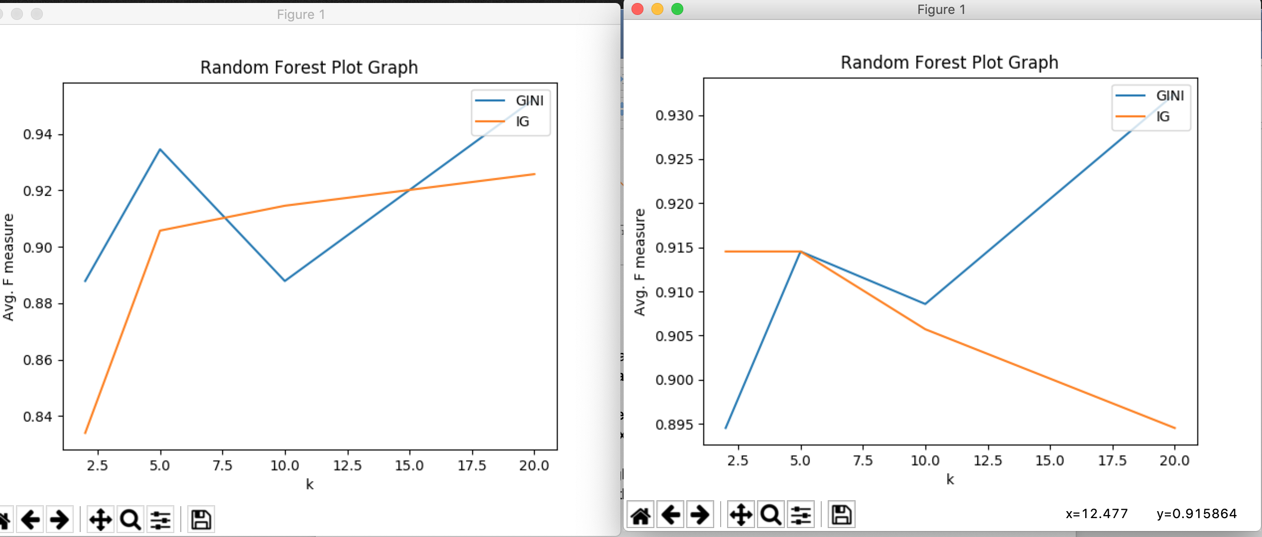

However, through all iterations, k=5 had the highest average F measure for the IG and k=20 had the highest average F measure for the GINI Index.