Devon James December 3rd, 2018

CSI 431

Prof. Petkov

***Homework #4 Solutions***

* 1. 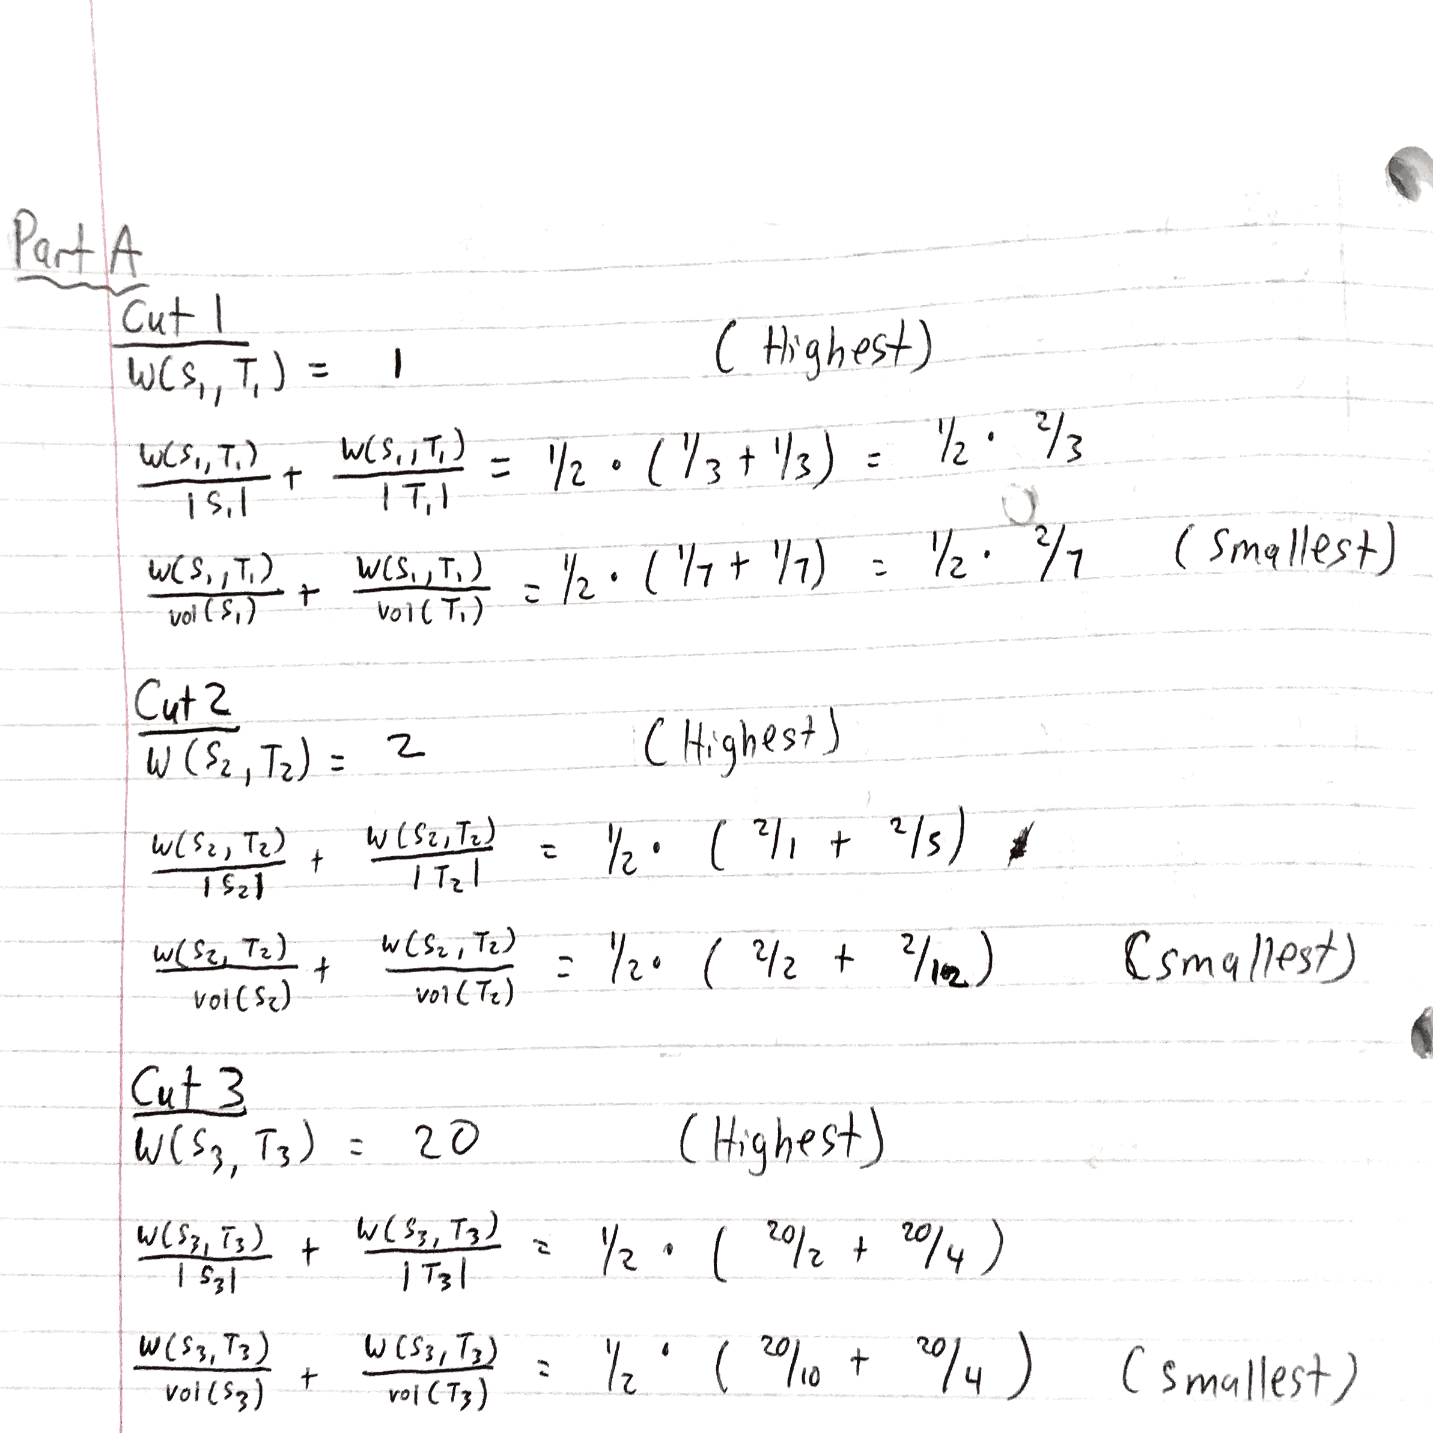
  2. 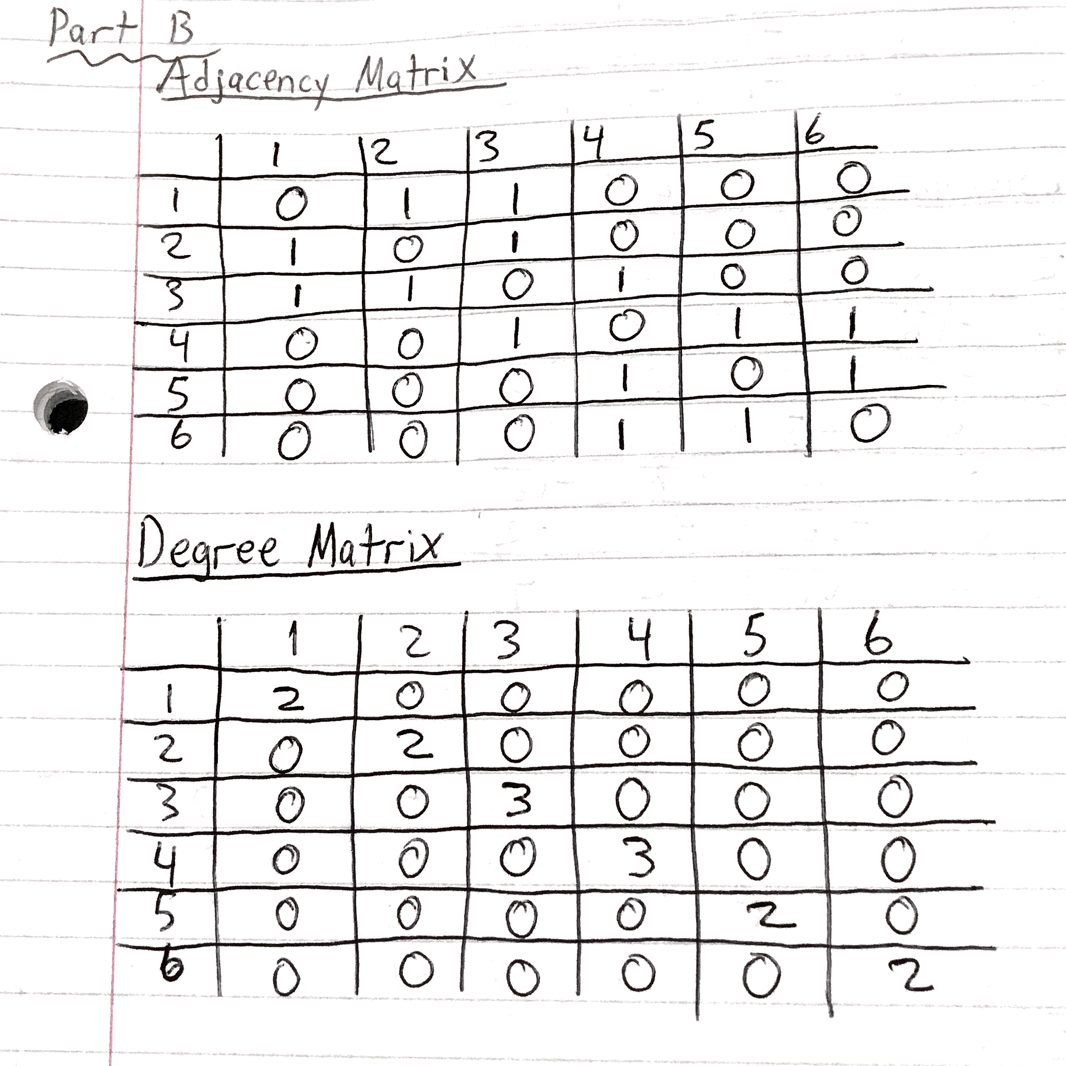  
     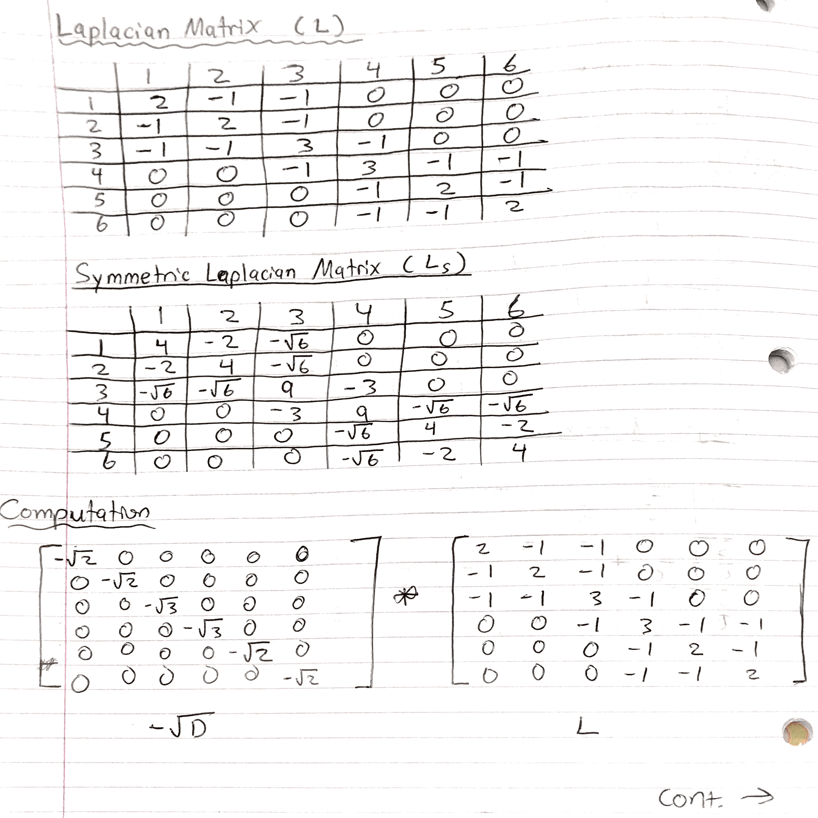  
     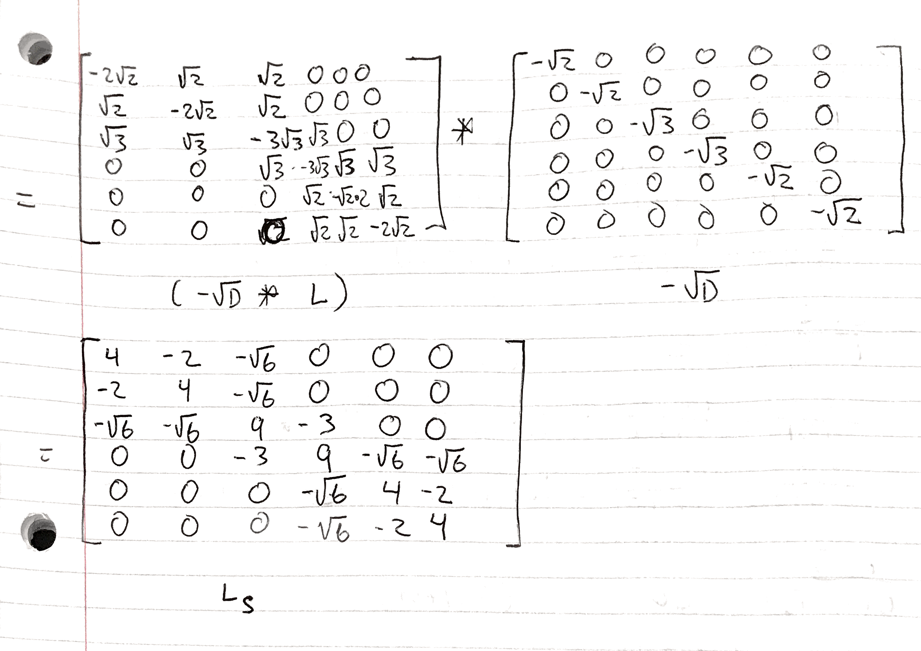
  3. Found in Code.zip  
       
     Plot:  
     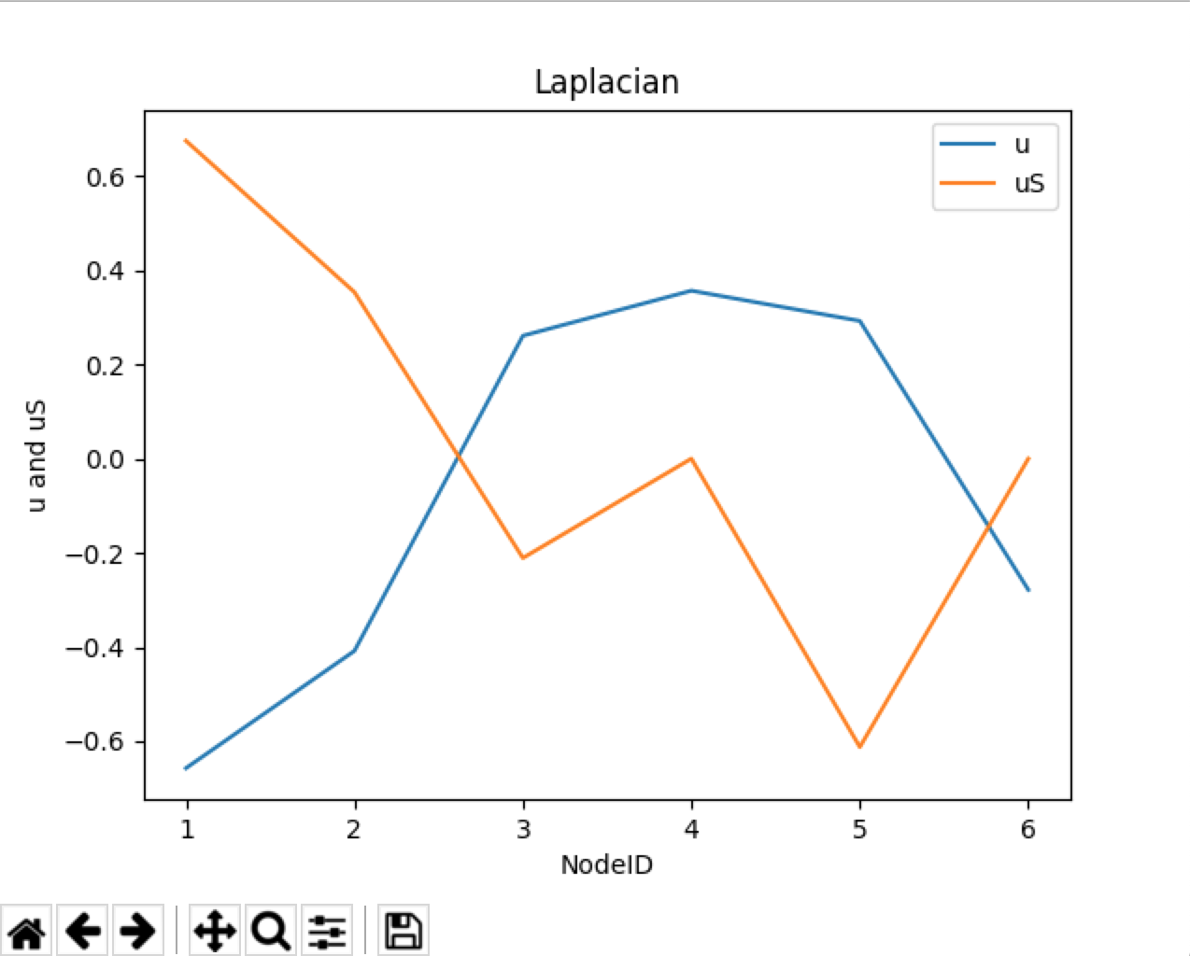
  4. 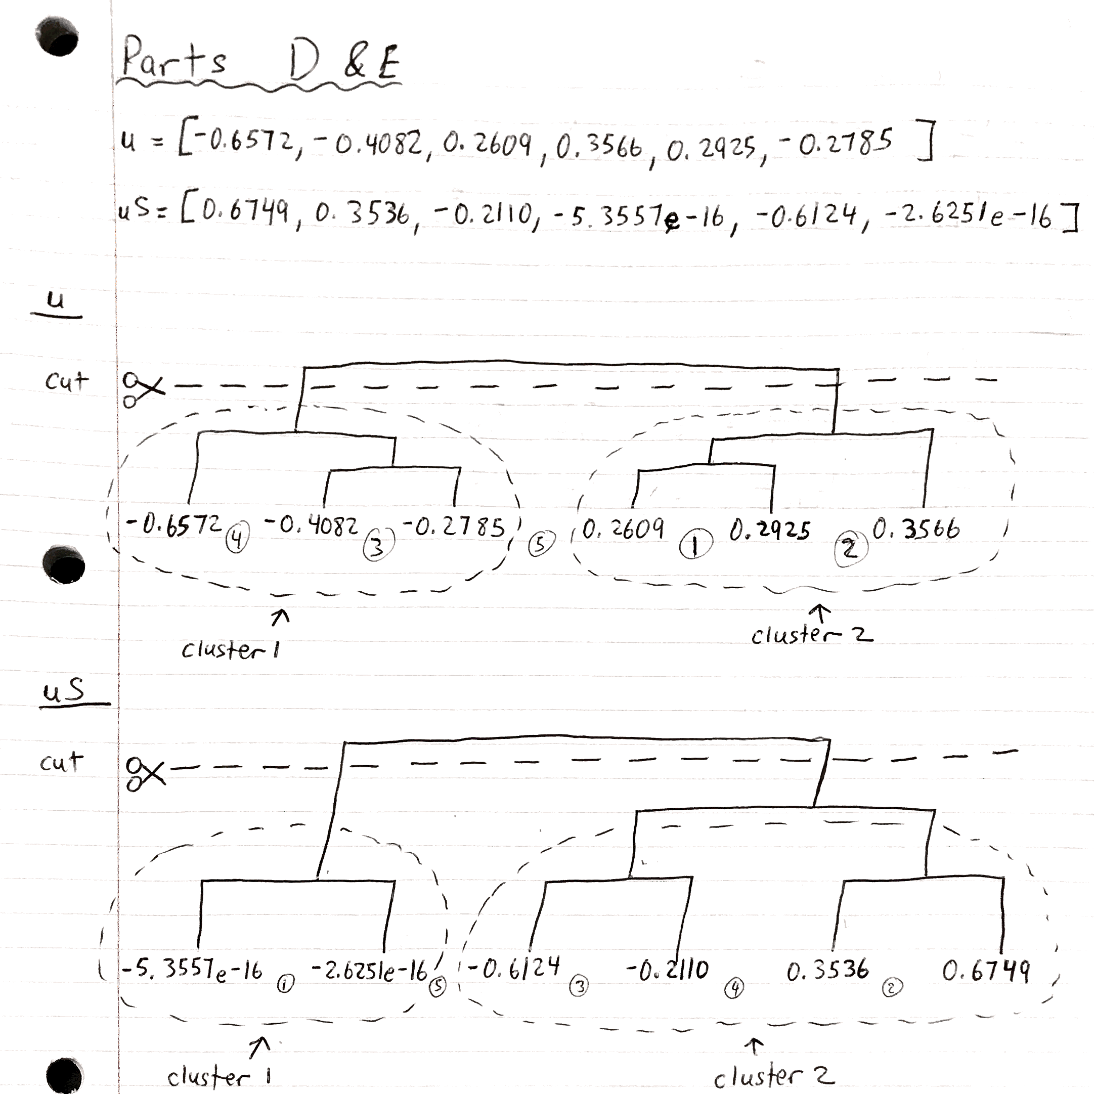
  5. 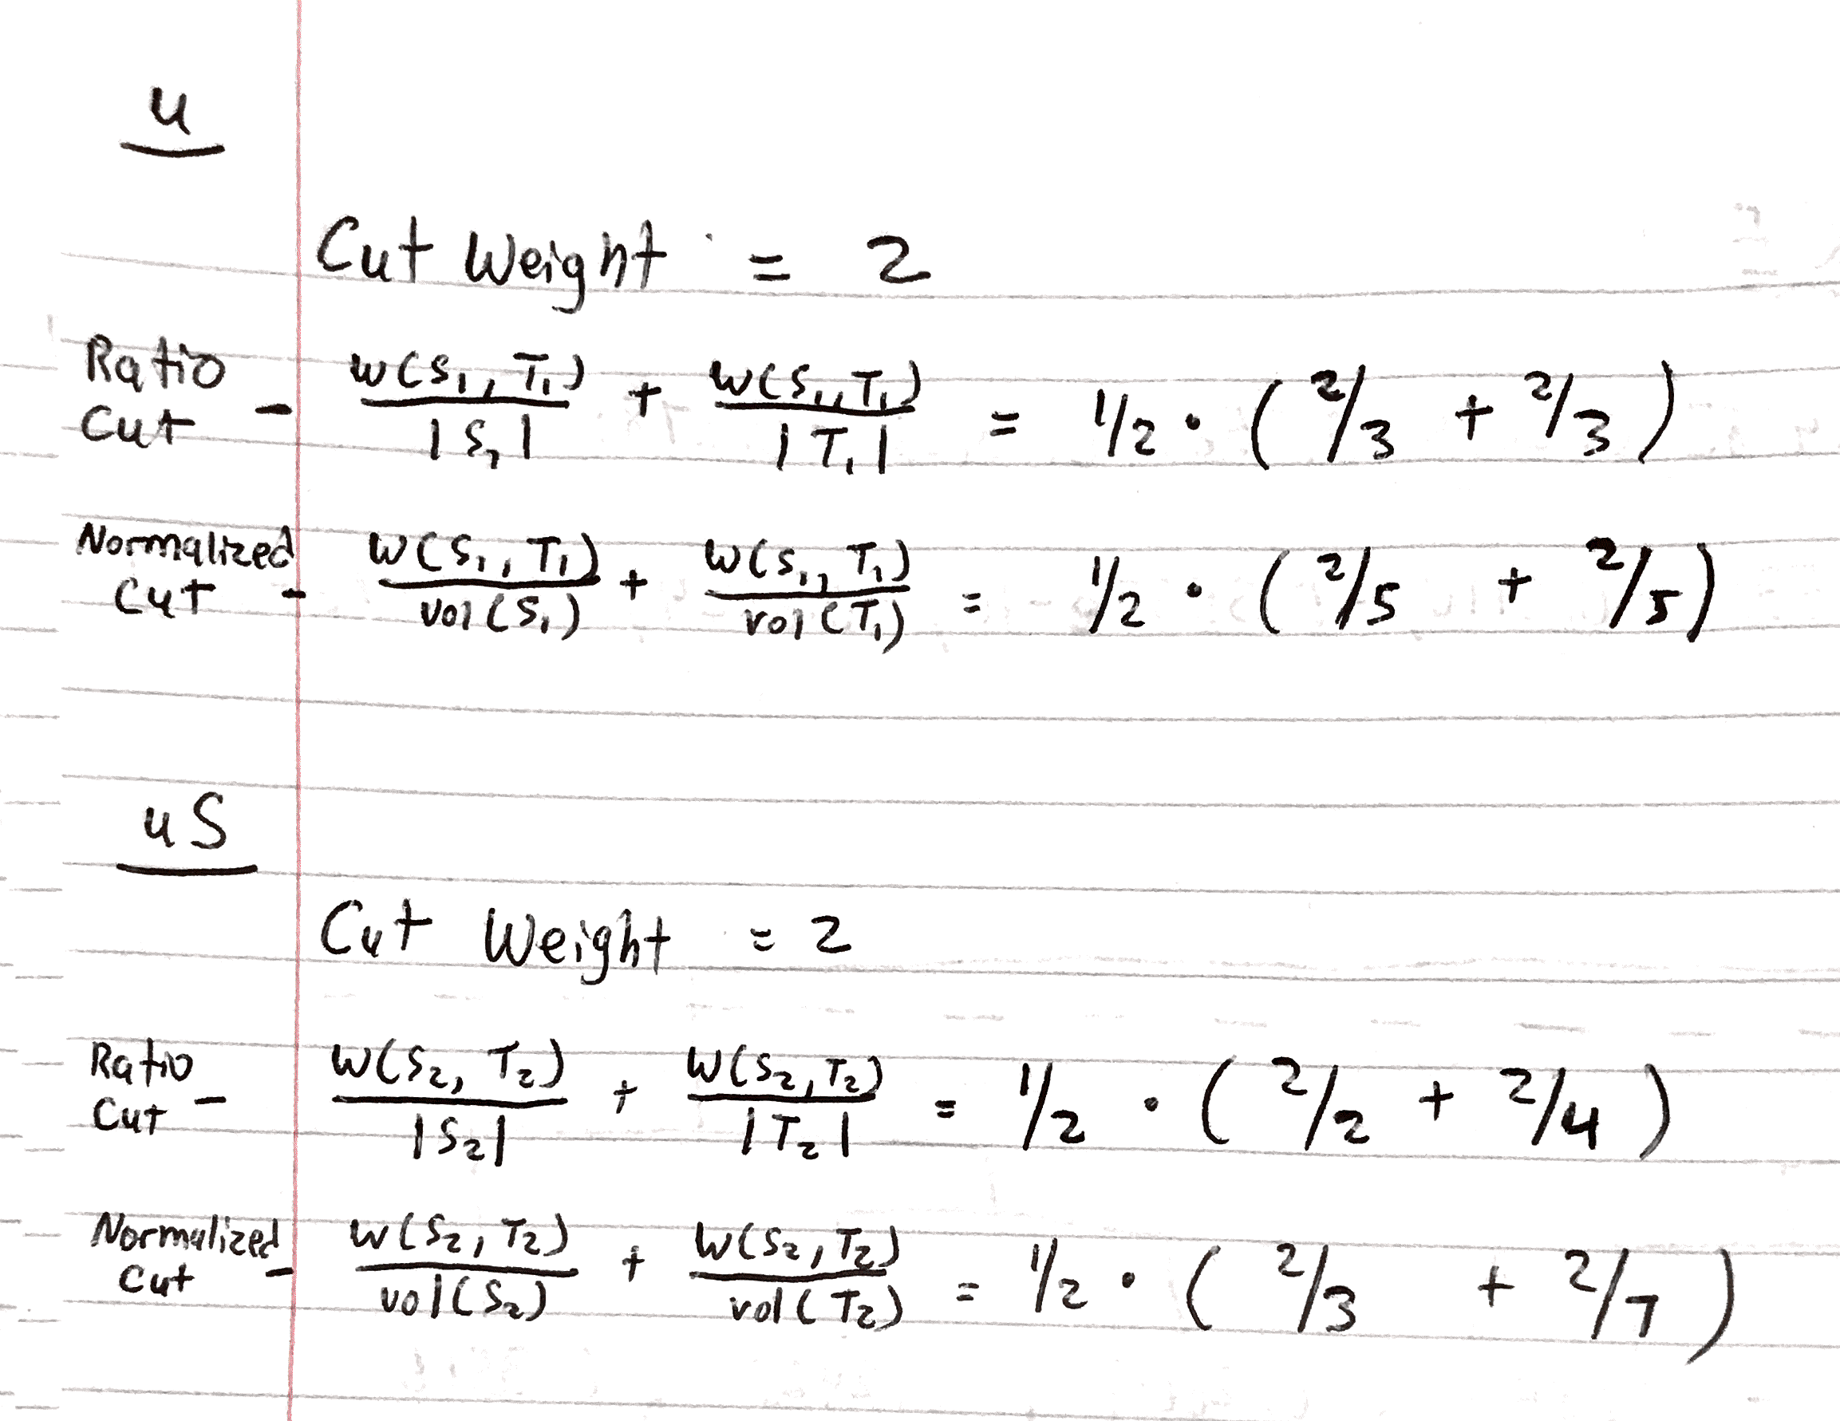
  6. 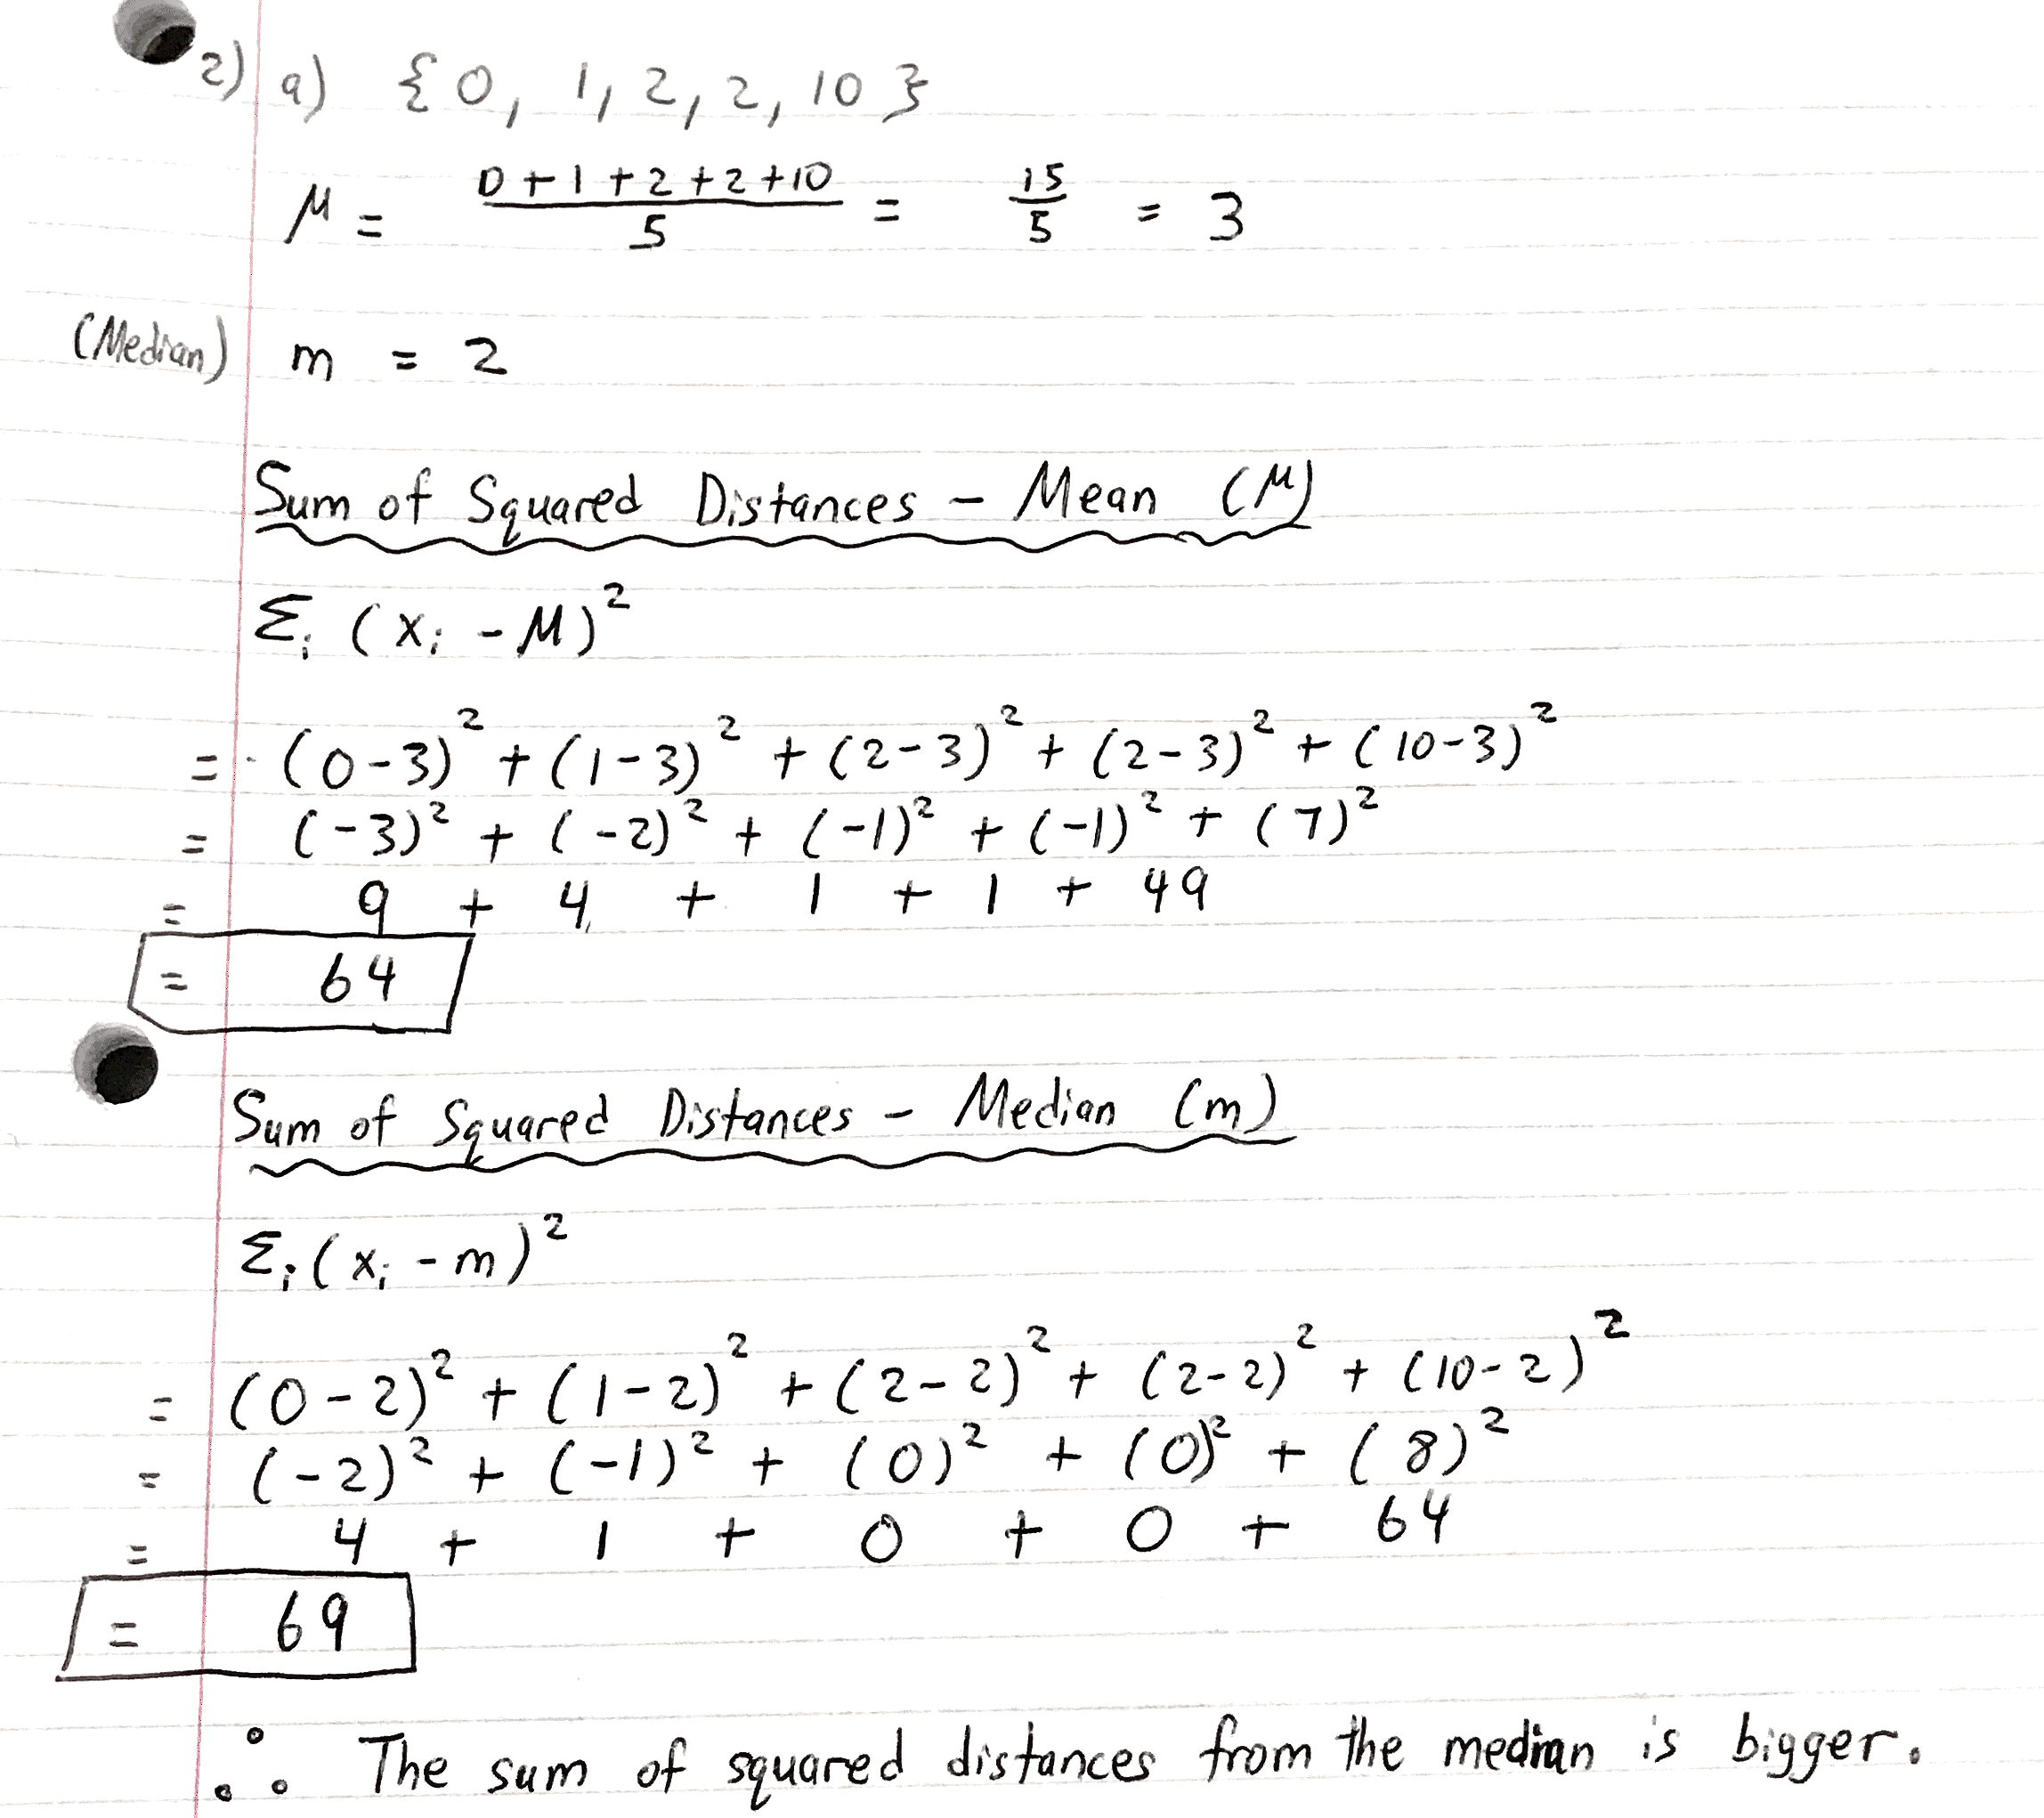
  7. 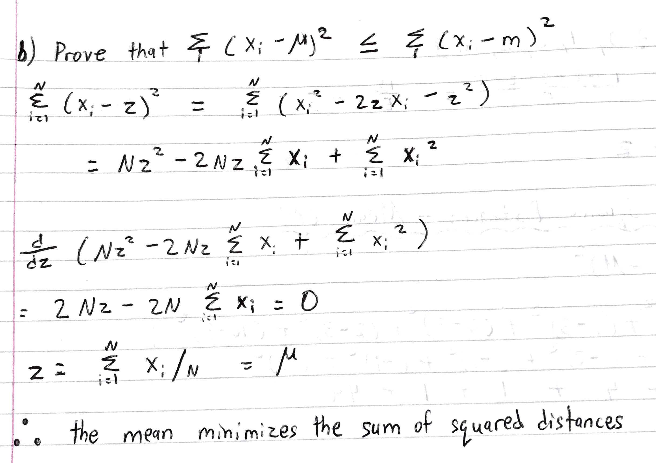

1. Red – Core Points , Green – Border Points and Blue – Outlier Points  
   Black – DBSCAN clusters
   1. 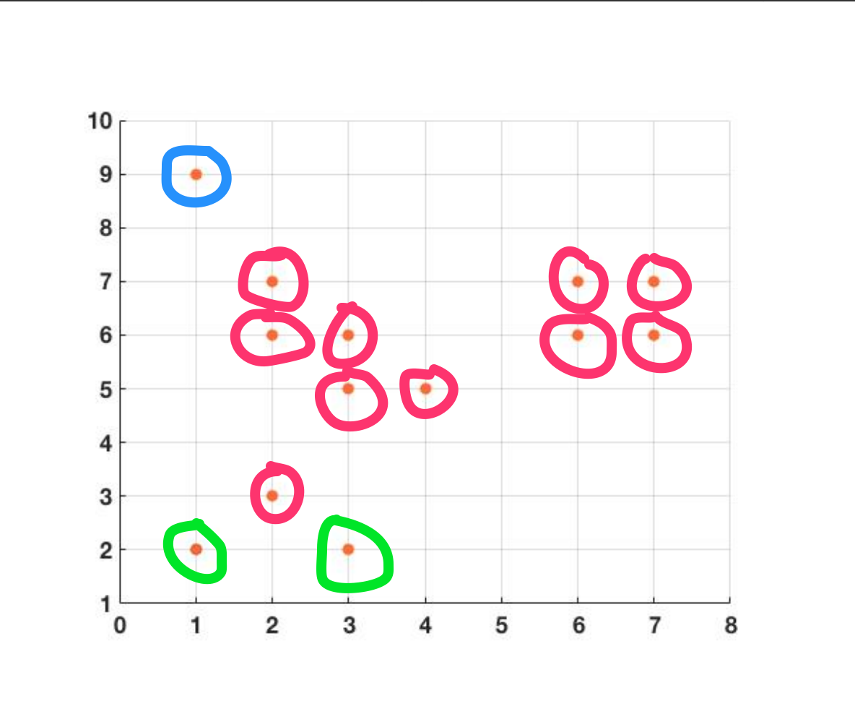
   2. 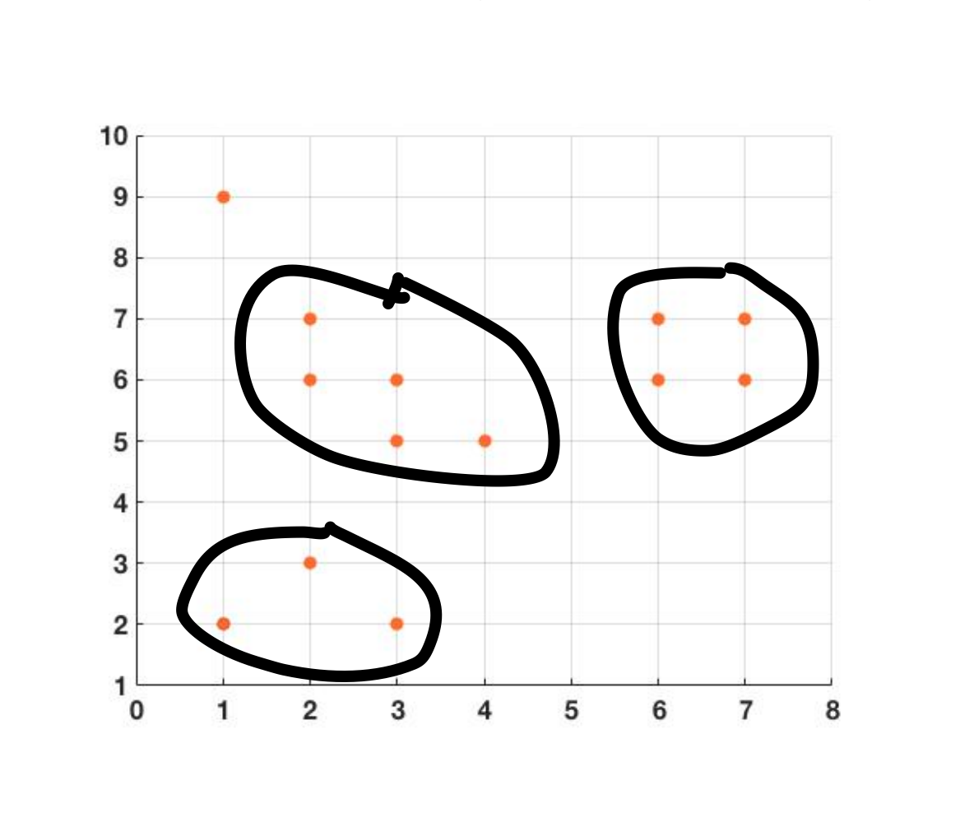
   3. 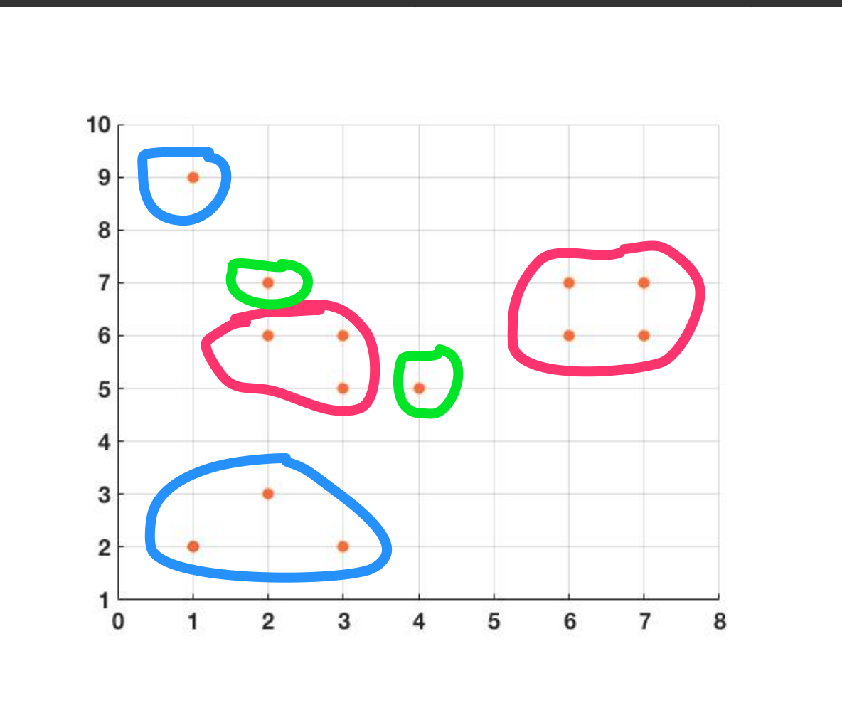  
      When compared with Part A, you can see that Points (1,2), (2,3), and (3,2) become outliers. You also notice that Points (2,7) and (4,5) change from being core points to border points. Because we are using L2 distance, Point (2,3) is not a core point anymore since when you compute the L2 distance for, example, (2,3) and (3,2), you get √(1+1), which is greater than 1 (our epsilon value). With that being said, these points cannot match up with each other and so they all become outliers. (2,7) cannot match up with (3,6) and (4,5) cannot match up with (3,6) for the same reason. So, they become border points.
   4. 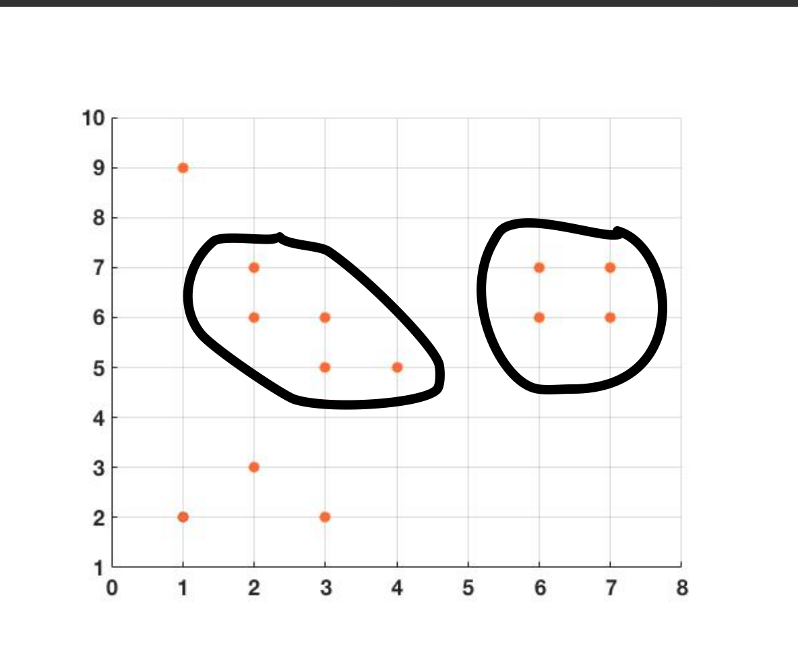  
      When compared with Part B, you can see that DBSCAN would find 2 clusters instead of 3. This is because Point (2,3) is no longer a core point surrounded by border points; they are all outliers. Since DBSCAN only recognizes clusters of core and border points, the cluster around Point (2,3) is no longer recognized. The other two clusters remain the same because although Points (2,7) and (4,5) are now border points, they can still be included in the cluster found by DBSCAN.