Orchestrix
Multi-Agent Orchestration Platform
Project documentation: use cases, scope, requirements, tech stack, architecture, functional and technical workflows, operations and status
Version: commit 91b60c4 (main), 8 November 2026
Repository: github.com/DevJarvis11/Orchestrix (private)
Source of truth: SPEC.md; build record: docs/BUILD_LOG.md

Contents
1. Executive summary
2. Use cases
2.1 Problem
2.2 Users and roles
2.3 User journeys
2.4 Showcase scenario (SPEC 5.6)
2.5 Example applications
3. Scope
3.1 Goals (v1.0)
3.2 Out of scope
4. Requirements
4.1 Functional requirements
4.2 Non-functional requirements
5. Tech stack
6. Architecture
6.1 Blocks
6.2 Repository structure
7. Functional workflow
7.1 Steps
7.2 Task status lifecycle
8. Technical workflows
8.1 Request to running graph
8.2 Specialist tool call pipeline
8.3 Human approval: pause and resume
8.4 Crash recovery
8.5 Policy
8.6 Memory
8.7 Model routing and cost
8.8 Replay
8.9 Observability
9. Data model and API
9.1 Main tables
9.2 API endpoints
10. Security and governance
11. Running and operating
11.1 Run locally
11.2 Changing the model
11.3 Services and ports
11.4 Make targets
12. Testing and status
12.1 Test layers and results
12.2 Milestones
12.3 Defects found and fixed during live verification

If the table of contents is empty, right-click it in Word and choose Update Field.

1. Executive summary
Orchestrix turns one complex request, such as "compare the four most popular open-source vector databases, analyse our latency CSV, write a recommendation and email the summary", into a planned, executed, reviewed and human-approved deliverable, with a full audit trail of every agent decision.
A supervisor agent plans the work as a typed graph of subtasks. Specialist agents (research, data analyst, writer, coder) run the subtasks in parallel, calling tools through MCP servers. A reviewer agent scores every result and the final deliverable. The run pauses for a person before risky steps: sending email, low plan confidence, low review scores, a budget cap. Long-term memory carries lessons into future plans. Every step is checkpointed in PostgreSQL, so a run survives a crashed worker and can be replayed from any checkpoint.
The platform is model-agnostic: agents ask for a role, and one setting maps each role to a model in the LiteLLM gateway catalogue. The current deployment uses gpt-oss-120b (chat), qwen3-embed and qwen3-rerank on the Yotta GPU cluster over VPN.

Current state
- All nine milestones (M0 to M8) are implemented and committed; make ci passes (262 automated tests, 17 policy tests, frontend build, image builds, secret scan).
- The SPEC 5.6 showcase completed end to end on gpt-oss-120b in 646 seconds: 4 of 4 subtasks approved, 6 human decisions applied, 78 model calls accounted, 3 long-term memories written.
- A worker killed mid-run (SIGKILL) has its run finished by another worker with no duplicated steps or tool calls.
- Still to verify live: browser journeys (Playwright), the observability profile, the email-approval journey, Keycloak login in a browser, and an evaluation run.

2. Use cases

2.1 Problem
Single-agent demos fail on long, multi-step work: they lose context, call the wrong tools, cannot be paused for approval, and leave no explanation of what happened. Orchestrix is production infrastructure for autonomous workflows: durable execution, typed plans, tool governance, memory, human approval gates and observability.

2.2 Users and roles
Role | Who | Can do | Cannot do
requester | Analyst or engineer submitting work | Create tasks, watch progress, answer clarifying questions on own tasks, see own traces and memory | Approve escalations, change policies, see other users' tasks
reviewer | Team lead or domain expert | Everything a requester can, plus approve, edit, reject or take over escalations for their team; see team tasks | Change policies, tools or model routing
operator | Platform engineer on call | See all tasks, traces and costs; cancel tasks; replay runs; manage the tool registry and budgets | Approve escalations (separation of duties)
admin | Platform owner | Everything, including model defaults, the audit log and user data deletion | Bypass the audit log

A user never approves an escalation on a task they requested (the four-eyes rule, enforced in OPA). Every human or admin action writes an audit row.

2.3 User journeys
Journey | What happens
Submit and watch | A requester submits a request with a CSV. The task page opens with a live event feed; the plan appears as a graph; subtasks light up; the final Markdown report appears with the reviewer's score.
Handle an escalation | The inbox and Slack show "Approval needed: send summary email". A reviewer sees the proposed tool call, the agent's reasoning and related memories, asks the agent a question in the side chat, edits one recipient and approves. The run resumes.
Approve a plan | A vague, costly task produces a plan with low confidence. The run pauses; a reviewer removes one subtask and approves the edited plan.
Debug a failure | An operator opens the Trace Explorer, finds the failing subtask and the reviewer's issue, then replays from a checkpoint with a raised tool-call limit and compares the two runs.
Manage memory | A user views memories by kind, deletes a wrong preference (hard delete, audited), and the next similar task shows the retrieved lessons in its plan.

2.4 Showcase scenario (SPEC 5.6)
Request: "Compare the 4 most popular open-source vector databases on license, GitHub activity and published benchmark claims. Analyse the attached CSV of our query latencies. Write a 2-page recommendation, then email the summary to the platform team."
- A seeded lesson ("benchmarks need the vendor's own source plus one independent source") is retrieved and informs the plan.
- The supervisor plans research subtasks in parallel, a sandboxed data analysis of the CSV, writing and email.
- Specialists run in parallel; tool calls stream to the feed.
- The reviewer rejects work with unsourced claims; the specialist revises.
- The simulated email tool is sensitive, so the run pauses; a different user approves with an edited recipient list.
- The deliverable is stored and the memory writer saves new lessons.

2.5 Example applications
- Research and recommendation reports with cited sources and an independent review step.
- Data analysis of uploaded spreadsheets and read-only database tables in an isolated Python sandbox.
- Document drafting where outbound communication requires a second person's approval.
- Small code tasks written and tested in the sandbox.
- Any multi-step workflow that needs an audit trail, cost accounting and the ability to pause for days and resume exactly where it stopped.

3. Scope

3.1 Goals (v1.0)
- Decompose a natural-language task into a validated execution plan (a DAG of subtasks).
- Execute subtasks with specialist agents that call tools through MCP, in parallel where dependencies allow.
- Validate every deliverable with a reviewer agent and send rejected work back with feedback.
- Pause for human input at defined points and resume exactly where it stopped, even after a restart or days later.
- Remember what worked across tasks and use it in future planning.
- Trace, cost-account and replay every run.

3.2 Out of scope
- A general chat assistant or a no-code agent builder.
- Model training or fine-tuning.
- Real external side effects: email and other actions are simulated tools behind approval gates.
- Multi-tenant SaaS billing (one organisation, many users).
- Deployment to Kubernetes (Helm, kind, GHCR releases) is deferred until requested; the platform runs on Docker Compose.

4. Requirements

4.1 Functional requirements
Area | Requirement (IDs from SPEC.md)
Task intake | FR-01 validated status machine; FR-02 title, description (8,000 chars), up to 5 attachments (10 MB: pdf, md, txt, csv, xlsx), budget override, plan-approval flag; FR-03 HTTP 202 with task and run ids; FR-04 cancel; FR-05 Idempotency-Key for 24 h; FR-06 live progress over SSE.
Planning | FR-10 typed plan of 1-12 subtasks; FR-11 deterministic validation with one repair, then a person; FR-12 memories in the planning prompt; FR-13 confidence below 0.6 asks for plan approval; FR-15 up to 3 clarifying questions.
Execution | FR-20 parallel subtasks (max 4); FR-21 bounded tool loop (8 calls) returning a typed result; FR-22 allow-lists enforced by the orchestrator; FR-23 policy check and a tool_calls row per call; FR-24 retryable errors retried with backoff (3 attempts), two failures escalate; FR-25 tool output treated as untrusted; FR-26 code only in the sandbox.
Review | FR-30 score 0-10 with verdict and issues; FR-31 up to 2 revisions; FR-32 reviewer model configurable; FR-33 final review; FR-34 unsourced claims are high-severity issues.
Human-in-the-loop | FR-40 triggers (low confidence, failures, low score, sensitive tool, budget 80%/100%, user request, policy); FR-41 levels notify, clarify, approve_action, approve_plan, take_over; FR-42 interrupt with full context; FR-43 approve, approve with edits, reject, take over; FR-44 reviewer chat; FR-45 SLA 24 h re-notify, 72 h fail; FR-46 inbox and Slack.
Memory | FR-50 working memory in checkpoints; FR-51 up to 10 memories per task (episode, lesson, preference, fact); FR-52 hybrid search top 8; FR-53 decay unless used; FR-54 nightly consolidation; FR-55 view, edit, hard delete; FR-56 facts cite a source, preferences quote the user.
Observability | FR-60 spans for nodes, model and tool calls, memory, policy, escalations; FR-61 trace explorer; FR-62 per-run cost record; FR-63 budgets (400k tokens, USD 2, 30 min, 60 tool calls, 150 steps); FR-70 replay; FR-71 replay diff; FR-72 metrics and dashboards.
Governance | FR-90 OPA on every tool call and escalation decision; FR-91 admins manage tools, models and budgets without redeploying; FR-92 immutable, exportable audit log; FR-93 PII redaction before memory and traces.

4.2 Non-functional requirements
ID | Area | Requirement
NFR-01 | Durability | A worker killed mid-run resumes from the last checkpoint on another worker with no duplicated side effects.
NFR-02 | Latency | API p95 under 150 ms for non-model endpoints; resume within 2 s of an approval; SSE delivery under 500 ms.
NFR-03 | Throughput | 20 concurrent runs on one dev machine (model throughput is the limit).
NFR-04 | Availability | Stateless API and workers; all state in PostgreSQL and Redis; graceful shutdown drains in-flight steps.
NFR-05 | Security | OIDC login, JWT validation, RBAC, policy on every tool call, sandboxed code, secrets only from the environment.
NFR-06 | Privacy | PII redaction; hard delete of memories; retention: traces 30 days, runs 180 days, audit 1 year.
NFR-07 | Cost | Every run accounted in USD; budgets enforced before each model call.
NFR-08 | Portability | Runs on any OpenAI-compatible endpoint; switching providers is configuration only.
NFR-09 | Observability | Every run traced; JSON logs carry trace_id, run_id and task_id.
NFR-11 | Accessibility | WCAG 2.2 AA: keyboard navigable, visible focus, colour never the only status signal.

5. Tech stack
Layer | Choice | Why
Language and packaging | Python 3.13, uv workspace (14 packages); Node 26, pnpm | Reproducible lockfiles; packages hold logic, apps only wire them
API | FastAPI, Uvicorn, Pydantic v2, pydantic-settings | Async, typed request and response models, generated OpenAPI
Orchestration | LangGraph 1.2 (StateGraph, Send fan-out, interrupt), PostgreSQL checkpointer | Durable state, human-in-the-loop and time travel
Agents | LangChain create_agent with custom middleware | Bounded tool loop with hooks for budget, policy, injection guard, accounting
Jobs | Taskiq on Redis Streams; run leases in PostgreSQL | Async workers; explicit, testable crash recovery
Data | PostgreSQL 18 + pgvector (halfvec 2560, HNSW), Redis 8, S3 (MinIO) | One database for app data, checkpoints, memory and full-text search
Models | LiteLLM proxy; Yotta gpt-oss-120b, qwen3-embed, qwen3-rerank over VPN; optional Ollama fallback | One OpenAI-compatible endpoint; models are configuration
Tools | MCP (FastMCP servers, langchain-mcp-adapters client, Streamable HTTP); SearXNG; trafilatura; sqlglot | Standard, isolated, swappable tools
Policy | Open Policy Agent, Rego v1 | Policy as code with unit tests; fails closed
Identity | Keycloak 26 (OIDC, PKCE); dev JWTs for local work | SSO with realm roles mapped to RBAC
Observability | OpenTelemetry + Langfuse 4, Prometheus, Grafana | LLM traces, platform metrics, dashboards and alerts
Frontend | React 19, Vite, TypeScript strict, TanStack Router and Query, Tailwind v4, React Flow + elkjs, Recharts, oidc-client-ts | Typed SPA with a generated API client and live SSE updates
Quality | ruff, pyright strict, Biome, tsc, pytest, testcontainers, respx, Vitest, opa test, gitleaks, Trivy | Every change is linted, type-checked, tested and scanned
Delivery | Docker multi-stage images (non-root), Docker Compose profiles, GitHub Actions | Start only what a task needs on a 16 GB machine

6. Architecture
The API and workers are stateless. PostgreSQL holds every durable fact: app data, LangGraph checkpoints, memories and the event log. Any worker can pick up any run. Redis moves jobs and live events, and losing Redis never loses work. The diagram reads top to bottom along the path of a request.
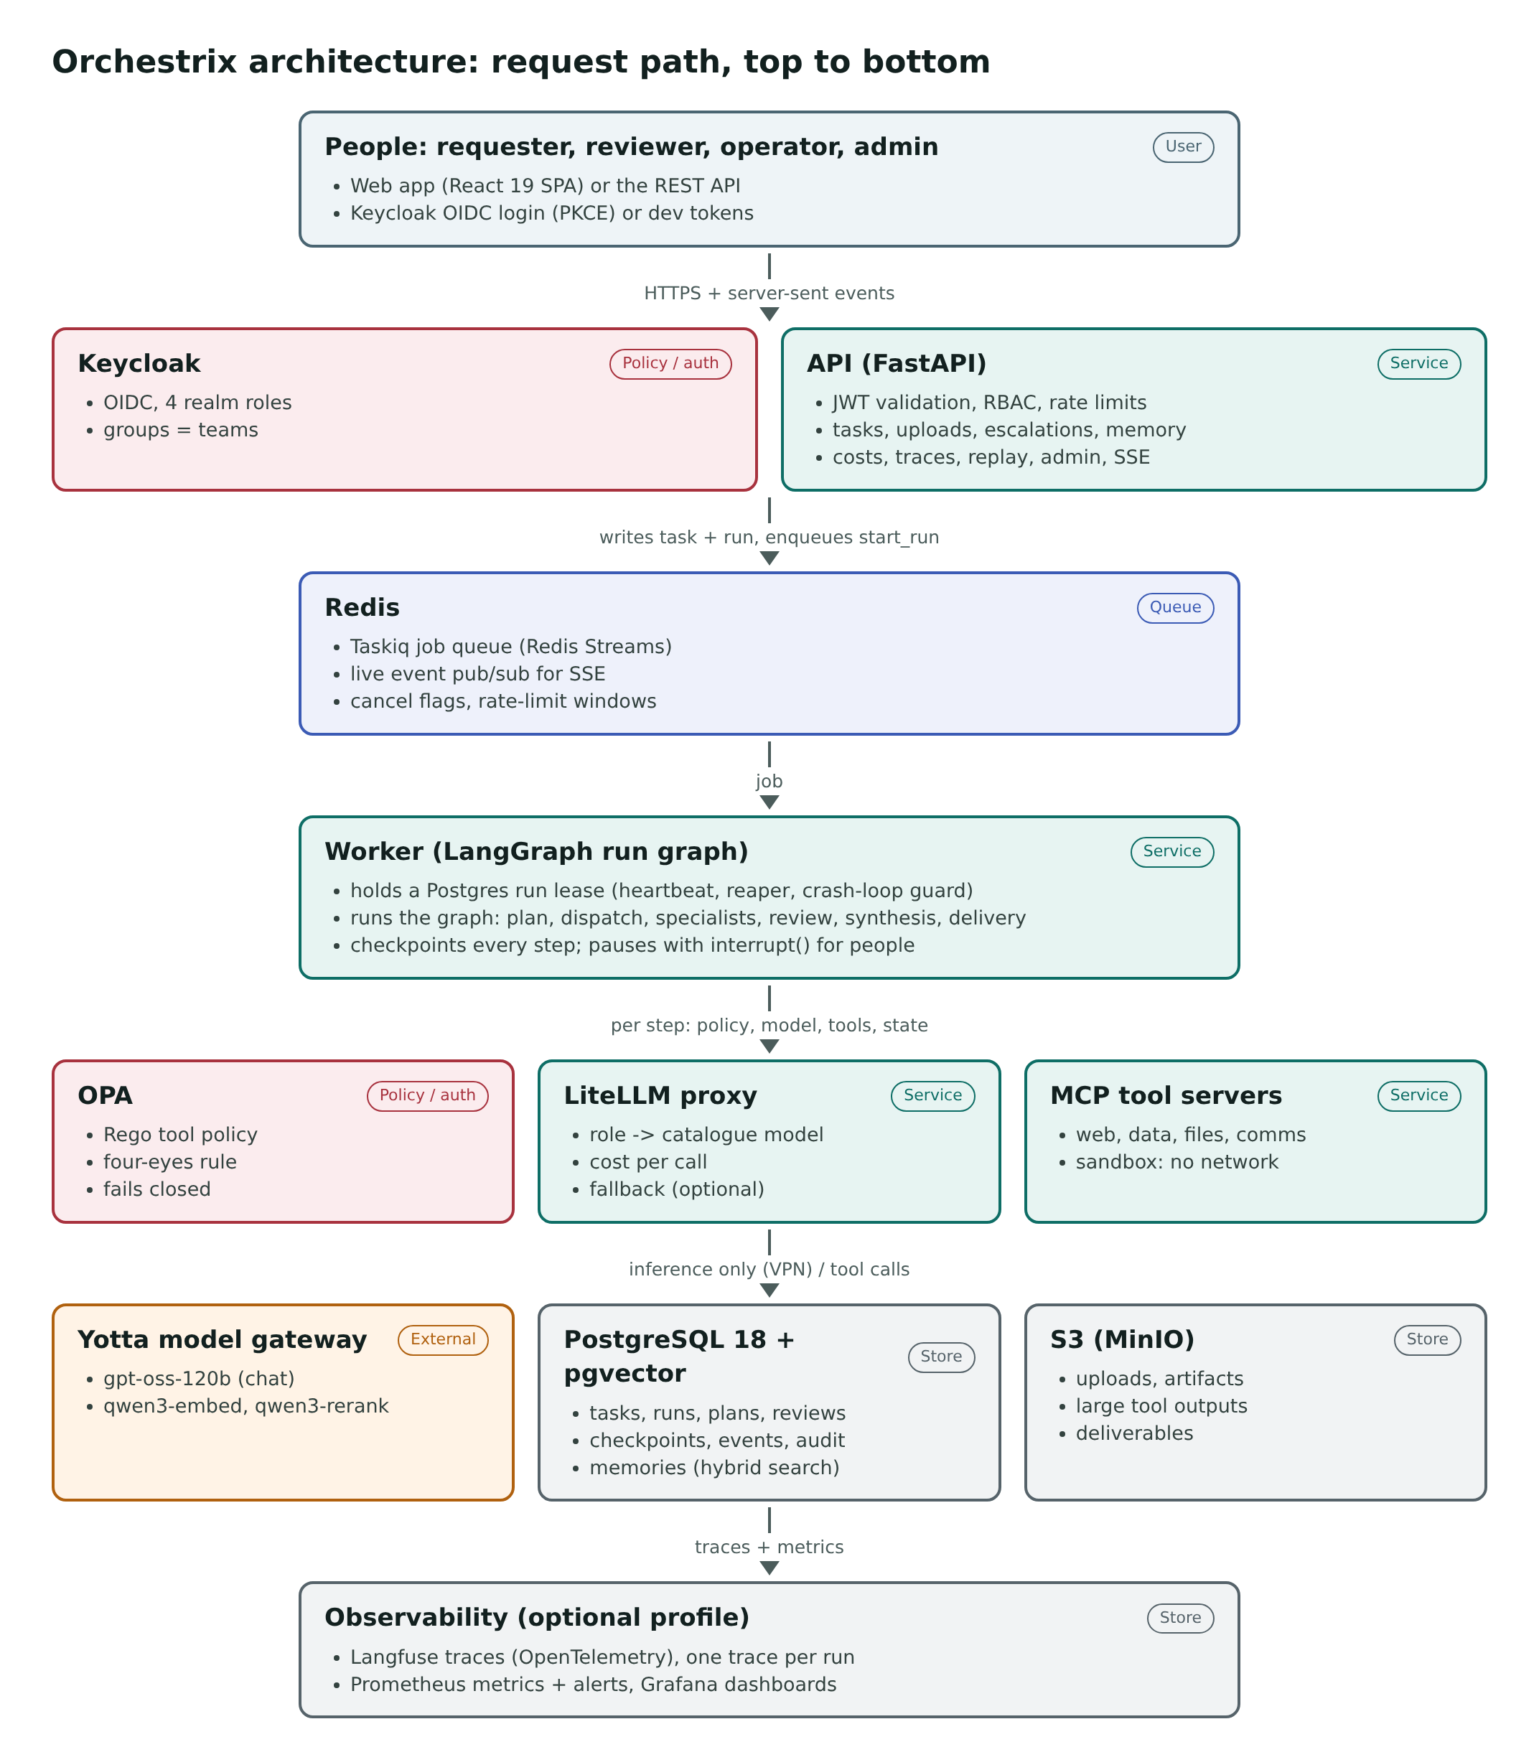
Figure 1. Architecture as a vertical block flow

6.1 Blocks
Block | Responsibility | Scales by
Web app | Ten screens: tasks, new task, task detail with live plan graph, escalation inbox and decision view, trace explorer, replay, memory, costs, admin | Static files
Keycloak | OIDC login with PKCE; four realm roles; groups become teams | Replicas
API | JWT validation, RBAC, rate limits, uploads, task intake, SSE relay, escalation decisions, memory, costs, traces, replay, admin | Replicas
Redis | Taskiq job queue, pub/sub for live events, cancel flags, rate-limit windows | Managed Redis
Worker | Runs graph steps for runs it holds a lease on; checkpoints every step; publishes events; mirrors interrupts into escalations | Replicas, each running several runs
Scheduler | Lease reaper, event relay, SLA checks, memory backfill and consolidation, retention, metric gauges | One active instance
OPA | Tool-call and escalation-decision policy; tool registry held as data | Sidecar
LiteLLM proxy | Maps catalogue model names to providers; per-call cost; optional fallback; cooldown on outages | Replicas
MCP servers | web (search, fetch), sandbox (Python), data (read-only SQL), files (artifacts), comms (simulated email); service-token auth | Replicas per server
PostgreSQL | Tasks, runs, plans, subtasks, reviews, tool and model calls, escalations, memories, artifacts, events, audit log, checkpoints | Managed PostgreSQL
S3 | Uploads, artifacts, large tool outputs, deliverables | Object store
Observability | Langfuse traces, Prometheus metrics and alerts, Grafana dashboards (optional profile) | Optional

6.2 Repository structure
Path | Contents
apps/api | FastAPI service: routers, security (dev JWT, OIDC, headers, rate limits), reviewer chat
apps/worker | Taskiq jobs, runner (lease, stream, pause, resume, replay), services (SQL recorder, policy gate, artifact bridge, accounting), scheduler, observability
apps/web | React SPA with the generated OpenAPI client
packages/core | Settings, SQLAlchemy models and repositories, schemas, FR-01 state machine, budgets, event bus, storage, PII redaction, tracing, metrics
packages/agents | Run graph, nodes, subtask worker, specialists, middleware, prompts, model access and accounting
packages/memory | Embedding and rerank clients, retrieval, write path, consolidation, deletion
packages/tools | Tool catalogue, MCP client with run headers and sandbox file bridge, MCP server conventions
packages/policy | OPA client and escalation policy (trigger to level, SLA)
packages/evals | Datasets, harness, judge, statistics, reports
mcp_servers/* | The five MCP servers
policies | Rego policies and their tests
infra | Compose file, LiteLLM catalogue, Keycloak realm, Prometheus, Grafana, SearXNG, Dockerfile
migrations | Alembic migrations 0001-0004
tests | unit, graph, integration (testcontainers), e2e (stack and resilience)
docs | Implementation plan, build log, run guide, diagrams

7. Functional workflow
One task from submission to delivery. Teal blocks are automated steps; amber blocks are human gates, where the run pauses with LangGraph interrupt() and resumes when a person decides.
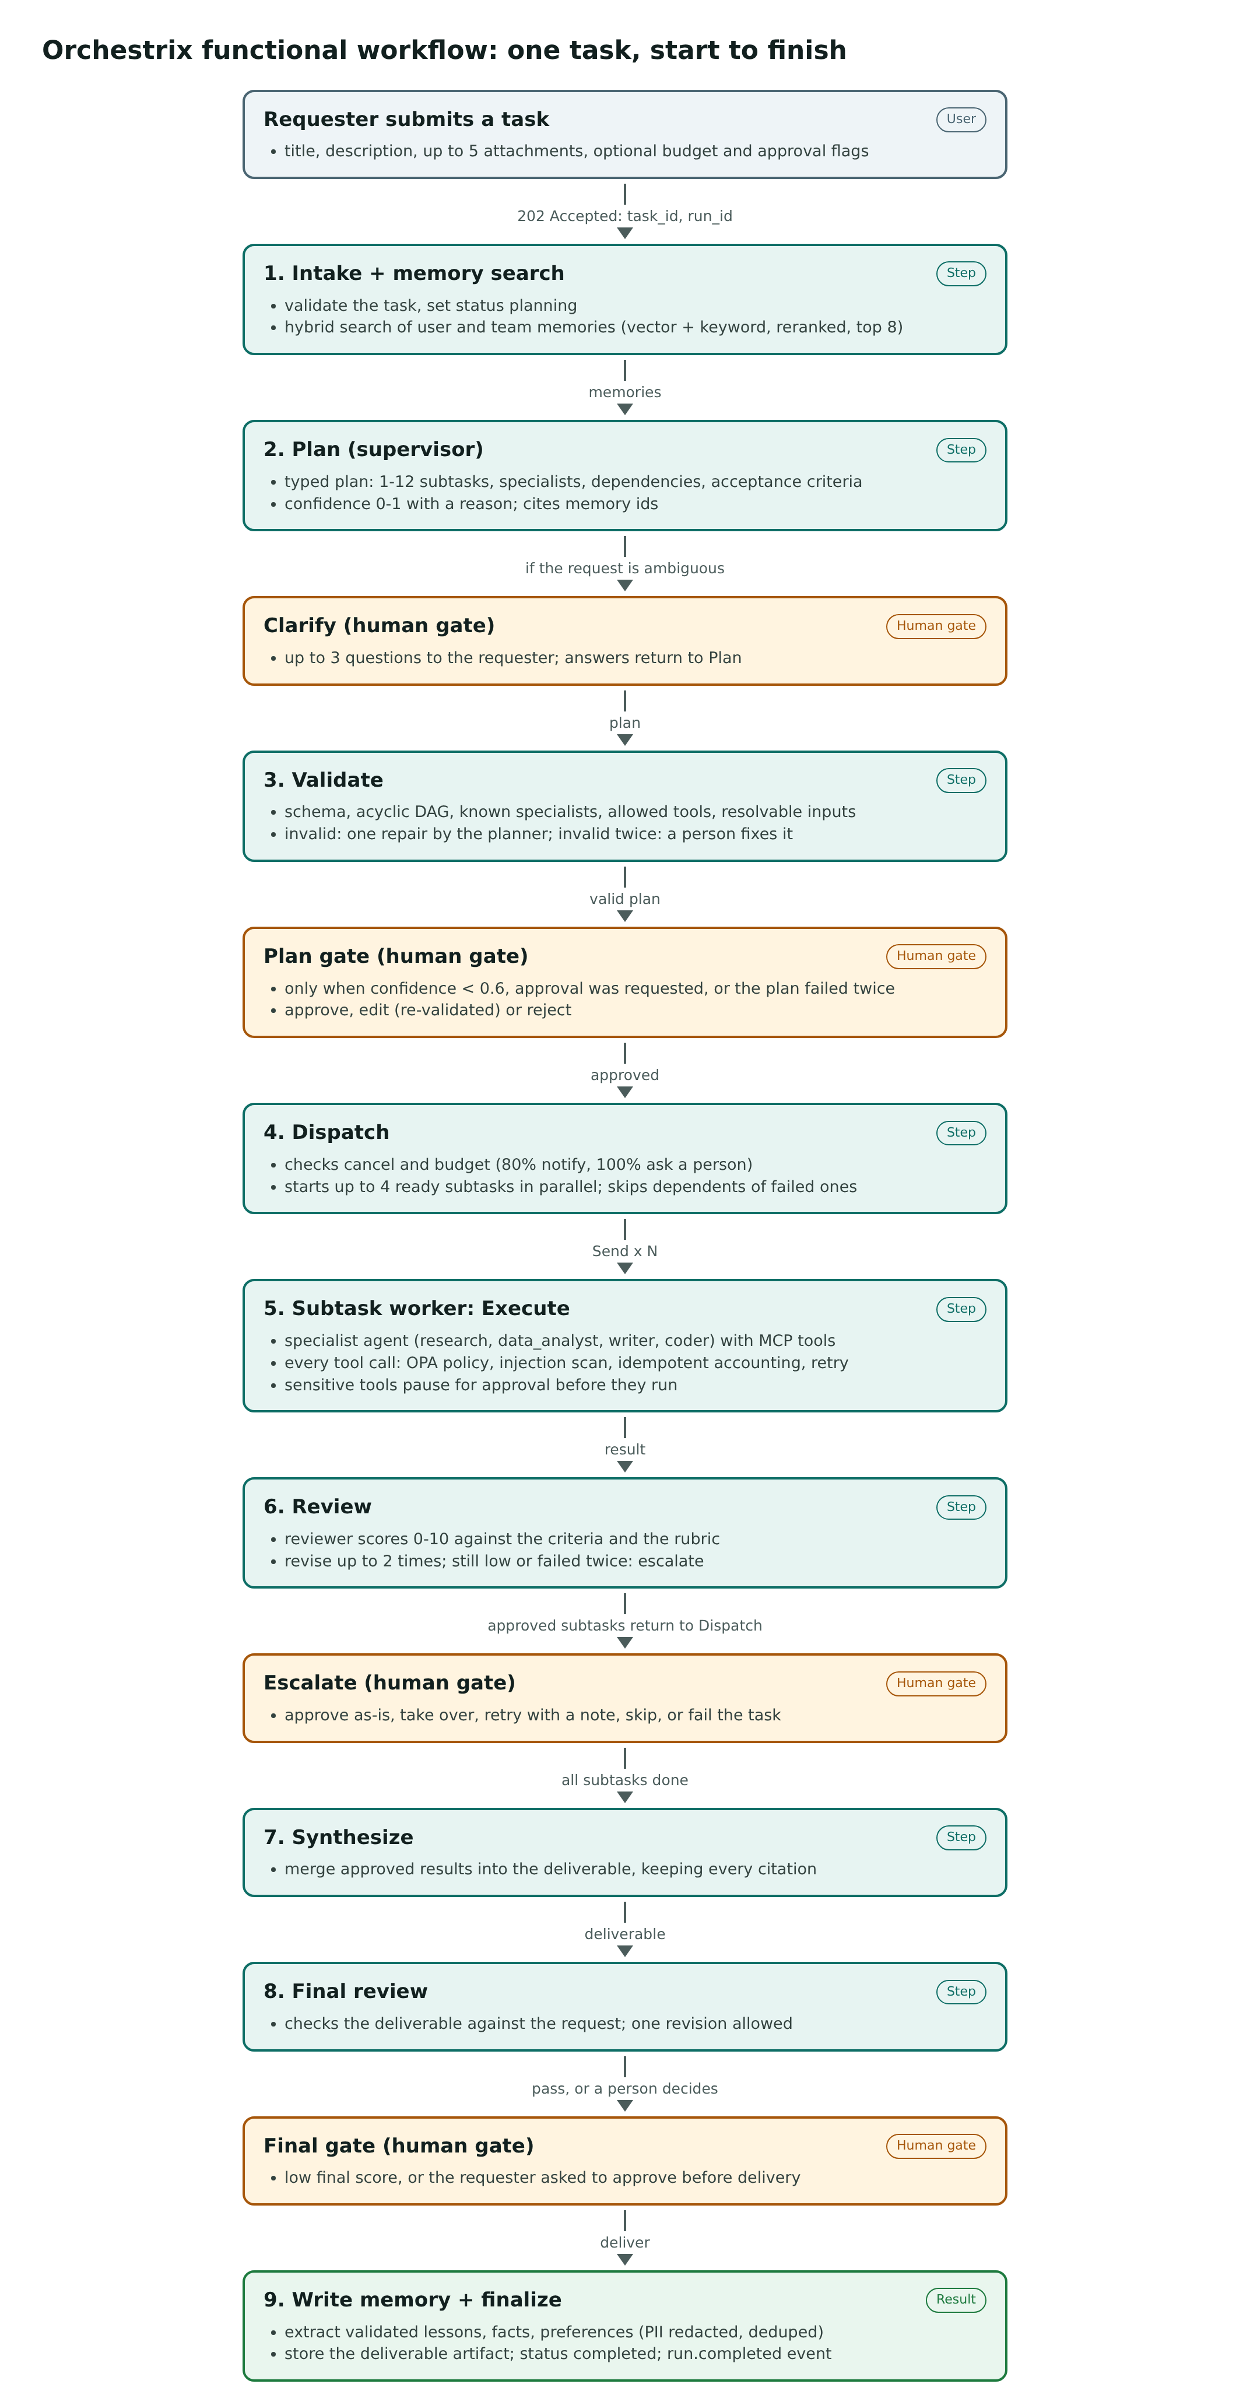
Figure 2. Functional workflow as a vertical block flow

7.1 Steps
Step | What happens | Model role
Intake | Validates the task, sets status planning, emits run.started | -
Memory search | Hybrid search of the user's and team's memories; top 8 after rerank and decay | embed, rerank
Clarify (gate) | If the request is ambiguous, up to 3 questions to the requester; answers become part of the user's own words | planner
Plan | Typed plan: subtasks, specialists, dependencies, inputs, acceptance criteria, complexity, confidence | planner
Validate | Schema, acyclic graph (Kahn's algorithm), known specialists, allowed tools, resolvable inputs; one repair, then a person | -
Plan gate | Pauses when confidence is below 0.6, approval was requested, or the plan failed twice | -
Dispatch | Checks cancel and budget; skips dependents of failed subtasks; starts up to 4 ready subtasks | -
Execute | The specialist runs its tool loop under budget, policy, injection guard, accounting and retry | specialist
Review | Scores the result; revise up to 2 times; still low or failed twice escalates | reviewer
Escalate (gate) | A person approves, takes over, retries with a note, skips or fails the task | -
Synthesize | Merges approved results into the deliverable, keeping citations | planner
Final review | Checks the deliverable against the request; one revision | reviewer
Final gate | Pauses for a low final score, or when the requester asked to approve delivery | -
Write memory, finalize | Validated, redacted, deduplicated memories; deliverable stored; status completed | fast, embed

7.2 Task status lifecycle
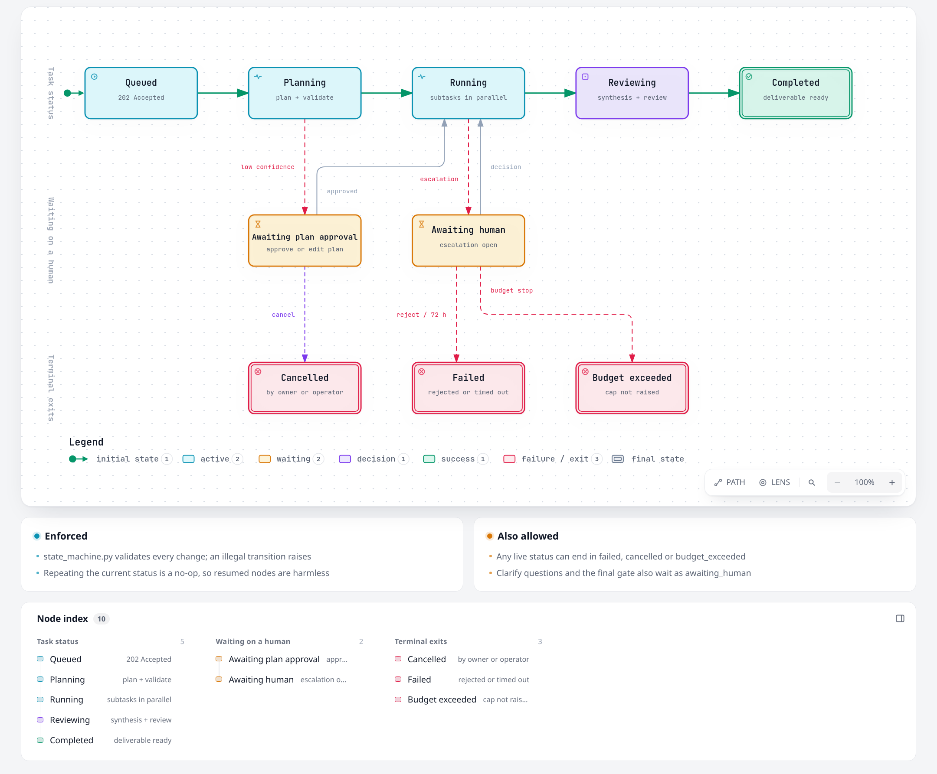
Figure 3. Task status lifecycle (FR-01), rendered with Archify
Every status change goes through the state machine; an illegal transition raises. After a human decision, the gate that paused the run returns the task to its phase (planning, running or reviewing) before continuing.

8. Technical workflows

8.1 Request to running graph
- The browser calls POST /v1/tasks with a bearer token. The API validates the JWT (Keycloak JWKS or the dev key), applies the rate limit, checks the role and the team's budget cap.
- One transaction inserts the task and its main run (thread_id = run id) and attaches the user's uploads; the API returns 202 and enqueues start_run on Redis.
- A worker takes the job and acquires the run lease in PostgreSQL (UPDATE runs ... WHERE lease free), then heartbeats every 15 s.
- The worker resolves each role to a model (task override, then admin default, then ORCHESTRIX_DEFAULT_MODELS) and snapshots the result on the run.
- It streams the graph with durability="sync": every custom event is written to run_events and published on Redis; the SSE endpoint replays from PostgreSQL and then relays Redis, de-duplicated by event id.
- When the stream stops, the worker saves the branch head, reconciles escalations with the graph's pending interrupts, and releases the lease (completed, failed or paused).

8.2 Specialist tool call pipeline
Each specialist is a create_agent loop. Middleware wraps every model and tool call, outermost first:
Order | Middleware | What it guarantees
1 | Budget (before each model call) | Estimates the next call; at 80% emits a warning (notify); at 100% pauses for a person to raise the cap or stop
2 | Tool-call limit | At most N tool calls per subtask (default 8); the model must then answer
3 | Injection guard | Wraps output as untrusted data, scans for override, role-play, fake tool calls, hidden text, encoded payloads; marks the subtask tainted
4 | Accounting | One tool_calls row per call keyed by hash(run, checkpoint namespace, tool call id); a replayed key returns the stored result instead of calling again
5 | Policy | Asks OPA: deny returns a refusal; require_approval pauses before the tool runs; edited arguments are checked again
6 | Retry | Retryable errors (timeouts, 429, 5xx, transport) get 3 attempts with backoff and jitter
7 | MCP client | Adds X-Run-Id, the idempotency key and traceparent; the sandbox bridge moves file bytes so the sandbox needs no storage access

If a model ends the loop in prose instead of returning the structured result, the runner asks once more for the typed SubtaskResult, so behaviour does not depend on one model's habits.

8.3 Human approval: pause and resume
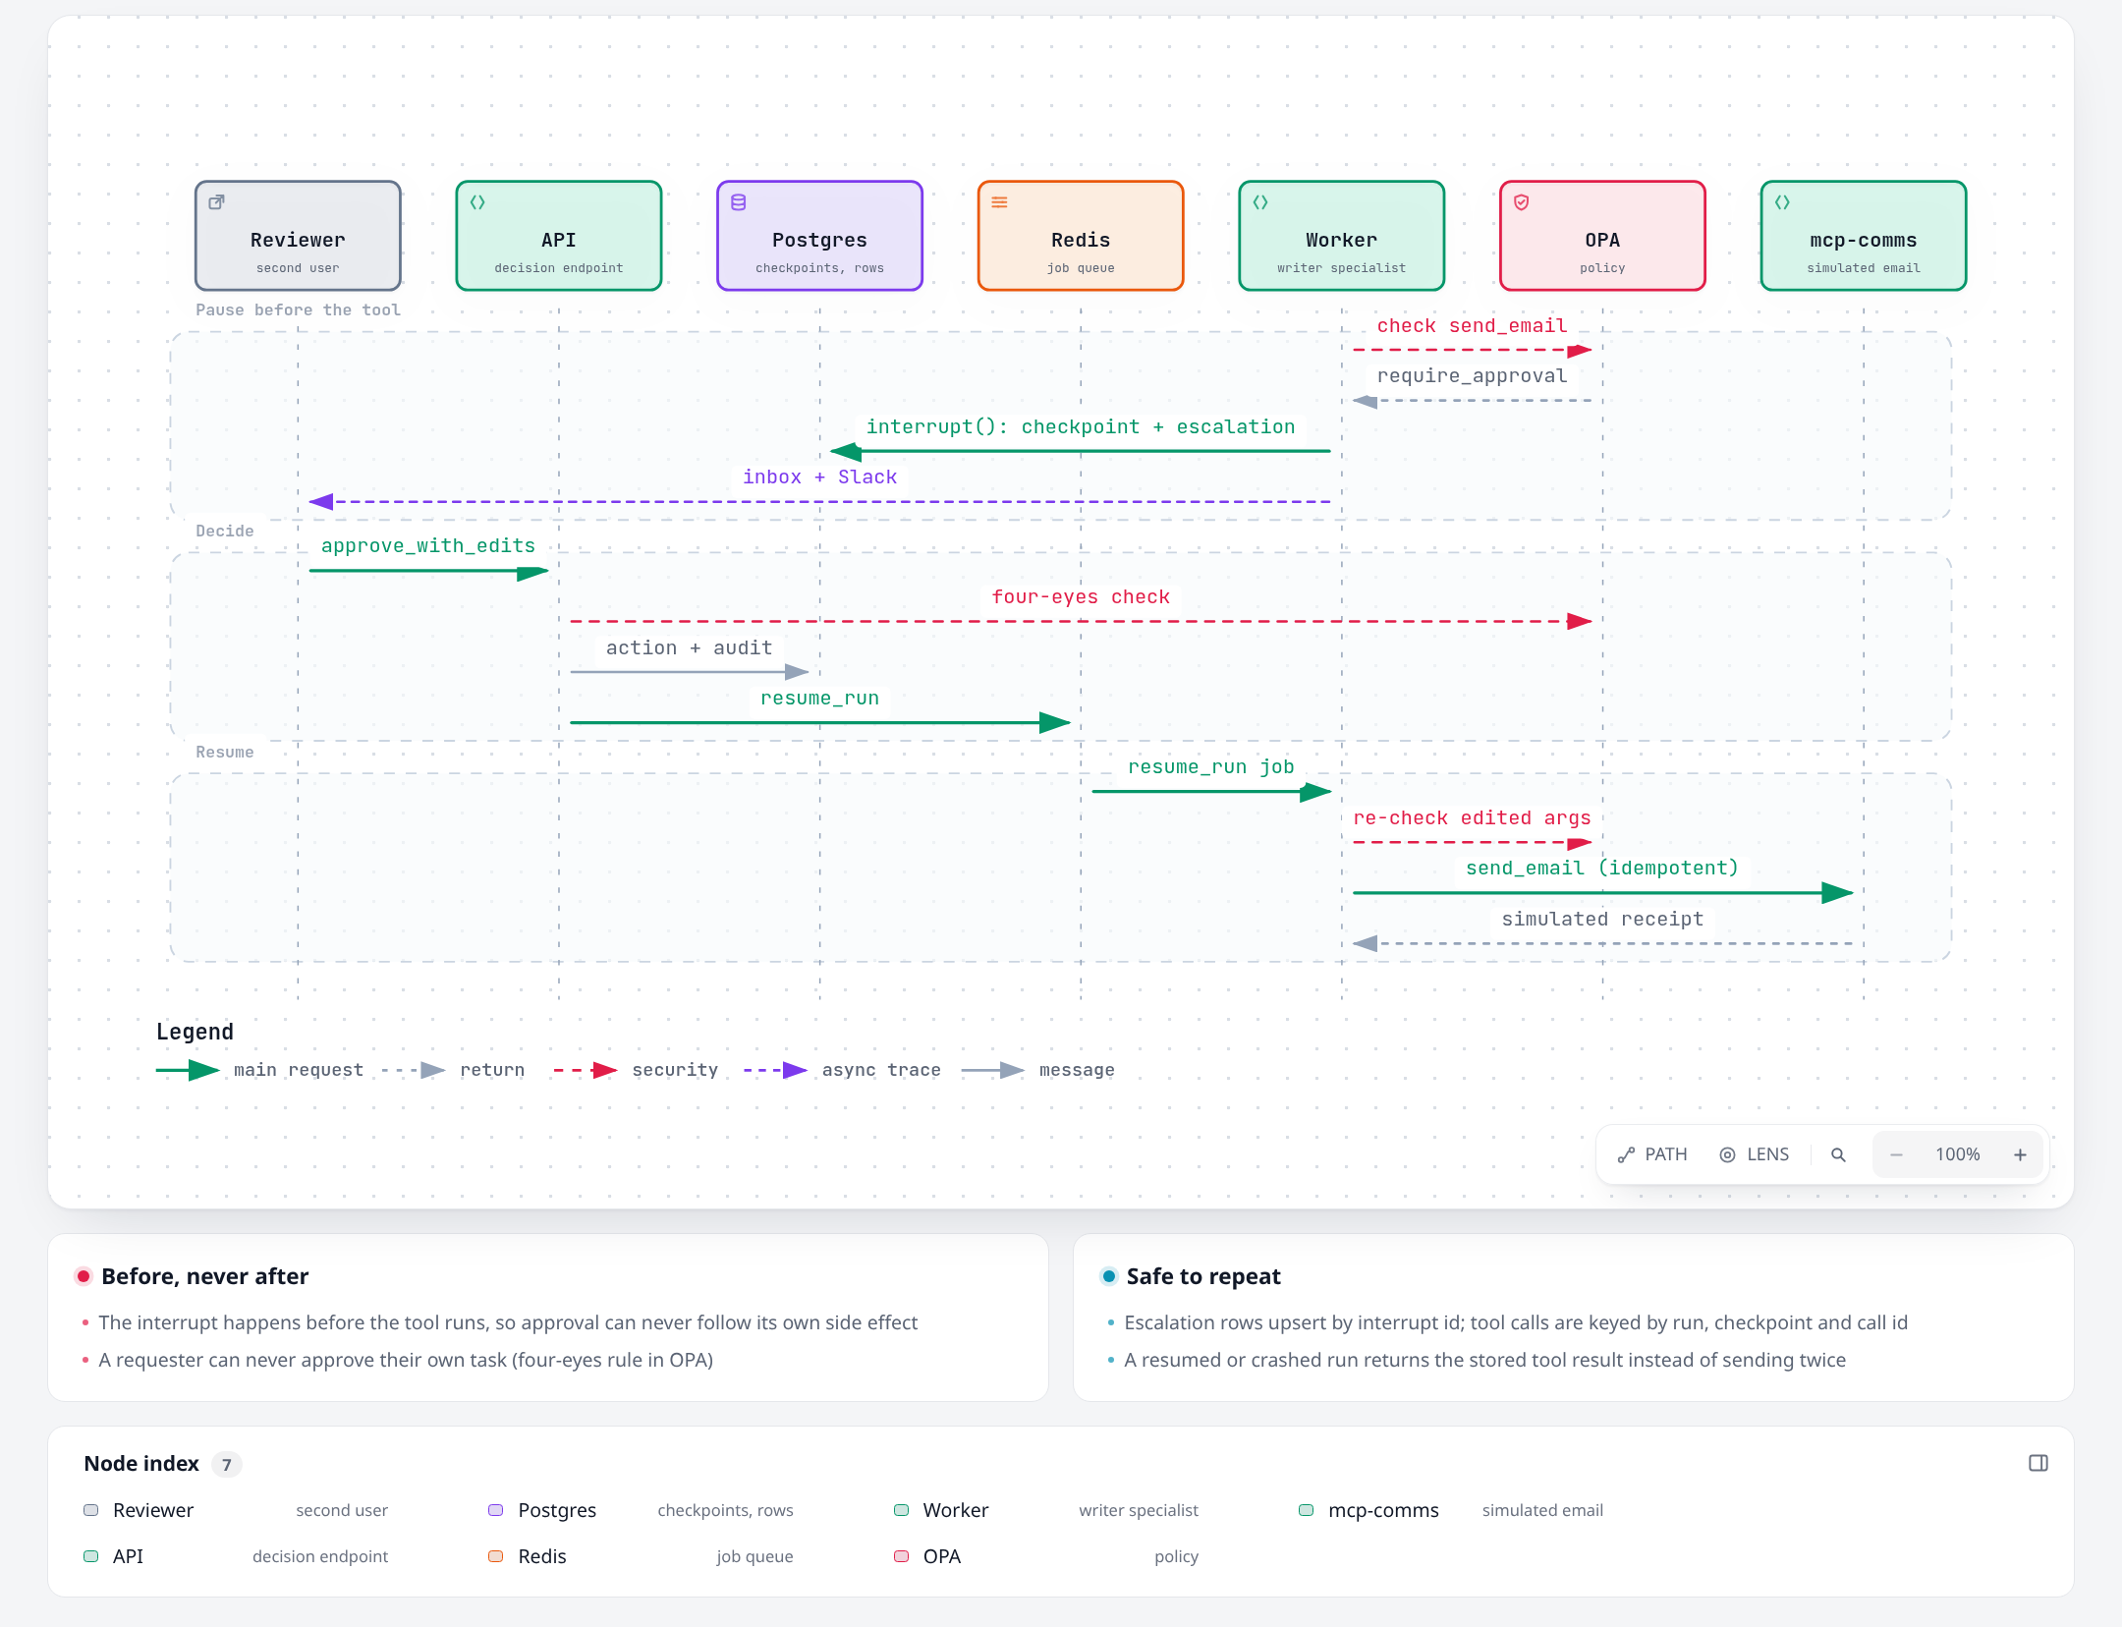
Figure 4. Human approval of a sensitive tool, rendered with Archify
- A node or middleware calls interrupt(payload) before any side effect. The checkpoint is written.
- The worker upserts an escalation row per interrupt (keyed by run and interrupt id), sets the task to awaiting_plan_approval or awaiting_human, notifies the inbox and Slack, and releases the lease.
- A reviewer posts a decision. The API asks OPA (role, team, four-eyes rule), validates the action against the payload's allowed actions, writes the action and an audit row in one transaction, marks the escalation resolved (409 if it already was) and enqueues resume_run.
- The worker takes the lease and resumes with Command(resume={interrupt_id: decision}). Code before the interrupt re-runs, so every write there is an upsert.

8.4 Crash recovery
Every 30 s the scheduler finds running runs whose lease expired, clears the lease, increments reclaim_count and enqueues resume_run. The next worker continues from the run's head checkpoint (saved as each step is written). A run reclaimed 3 times fails with crash_loop. Idempotency keys stop a re-run step from repeating tool side effects.

8.5 Policy
- Tool policy (policies/tool.rego): unknown or disabled tool, specialist not allowed, or rate limit exceeded means deny; a sensitive tool, an email recipient outside the organisation, or a side-effecting tool in a tainted subtask means require_approval; otherwise allow.
- Escalation policy (policies/escalation.rego): reviewers and admins of the assigned team may decide, never on their own task; clarify questions are answered by the requester.
- The client uses a 200 ms timeout and treats any failure or undefined result as deny. OPA keeps the tool registry in memory; the worker pushes it at start and again if OPA restarted.

8.6 Memory
- Write: the fast model proposes up to 10 candidates; facts must cite a source the run used and preferences must quote the user exactly; PII is redacted; near-duplicates (cosine at least 0.92) strengthen the existing memory instead; ids are deterministic per run.
- Retrieve: Reciprocal Rank Fusion of a vector search (embedded rows) and a full-text search, reranked, then scored as rerank x (0.7 + 0.3 x importance x 0.5^(days/30)); top 8.
- Maintain: rows written while the embedding endpoint was down are backfilled; near-duplicates are consolidated nightly; deleting a memory also deletes summaries derived from it.

8.7 Model routing and cost
- infra/litellm/config.yaml is the single catalogue of models, each with provider and price. ORCHESTRIX_DEFAULT_MODELS maps roles to catalogue names. No code names a model.
- Per-role parameters such as reasoning effort are sent to every model; the gateway drops parameters a model does not support.
- Every call writes an llm_calls row: agent, purpose, subtask, attempt, revision, requested and served model, tokens, cost (from the gateway's cost header), latency.
- ORCHESTRIX_LOCAL_FALLBACK=false disables the local fallback, so only the VPN models are used.

8.8 Replay
An operator lists a run's checkpoints, optionally patches the state at one of them, and starts a replay run on the same thread. The replay forks from that checkpoint, records its own branch head, runs with simulated side effects and never changes the original task. A diff endpoint compares plans, subtask outputs, review scores, tool calls and cost.

8.9 Observability
With the observability profile, each run is one Langfuse trace (session = task), with nested spans for graph nodes, model calls, tool calls, policy checks, memory, MCP calls and escalations; PII is masked before export. Prometheus collects request, run, node, token, cost, tool, policy, escalation and queue metrics; three Grafana dashboards and four alerts cover operations, agents and cost, and human-in-the-loop.

9. Data model and API

9.1 Main tables
Table | Purpose
users, teams, team_members | Identity mirrored from Keycloak; teams synced from token groups
tasks, runs | The request and each execution attempt (main or replay), with lease, head checkpoint, model snapshot and active time
plans, subtasks, reviews | Versioned plans, subtask status and results, reviewer verdicts
tool_calls, llm_calls | Every tool and model call with cost, latency and trace ids
escalations, escalation_actions, escalation_messages | Human decision points, decisions and reviewer chat
memories | Long-term memory with halfvec(2560) embedding and full-text vector
artifacts | Uploads, sandbox outputs and deliverables in S3
run_events | Durable event log and outbox for SSE
audit_log | Append-only record of human and admin actions and policy denials
tools, model_defaults, app_meta, email_outbox | Tool registry, admin model defaults, settings such as the embedding model, simulated email

9.2 API endpoints
Endpoint | Purpose
POST /v1/uploads | Upload one attachment (10 MB, type sniffed)
POST /v1/tasks, GET /v1/tasks, GET /v1/tasks/{id} | Create, list and read tasks
POST /v1/tasks/{id}/cancel, GET /v1/tasks/{id}/deliverable | Cancel; download the deliverable (presigned URL)
GET /v1/runs/{id}/events | Live server-sent events with Last-Event-ID
GET /v1/runs/{id}/graph, /trace, /efficiency, /subtasks/{key} | Plan graph, trace tree, cost breakdown, subtask detail
GET /v1/runs/{id}/checkpoints, POST /replay, GET /diff/{other} | Replay (operator)
GET /v1/escalations, GET /{id}, POST /{id}/decision, POST /{id}/chat | Inbox, detail, decision, reviewer chat
GET/PATCH/DELETE /v1/memories | Memory management
GET /v1/costs | Cost aggregates by day, agent, model, team or task type
/v1/admin/tools, /budgets, /model-defaults, /audit, /users/{id}/erase | Administration
GET /v1/models, /healthz, /readyz, /metrics | Model catalogue, health, metrics

10. Security and governance
Control | Implementation
Authentication | Keycloak OIDC with PKCE; the API validates signature, issuer, audience and expiry against cached JWKS
Authorisation | Role checks per endpoint, ownership and team checks in repositories, OPA for escalation decisions
Tool governance | Allow-lists, OPA on every call, approval before sensitive or tainted side effects, audited denials
Prompt injection | Untrusted-output wrapping, pattern scanning, taint propagation to dependent subtasks
Sandbox | No network, read-only root, tmpfs per call, non-root, no capabilities, pid/CPU/memory/time limits, no storage credentials
SSRF | web.fetch checks every resolved address is public, connects to that exact address with the real host for TLS, and re-checks each of up to 3 redirects
SQL | One SELECT parsed with sqlglot, forced LIMIT, 10 s timeout, read-only role on the demo_data schema
Service-to-service | MCP servers accept only the worker's bearer token
API hardening | Strict CORS, CSP, HSTS, nosniff, 1 MB body limit, 600 requests/min and 30 tasks/hour per user
Secrets | Only in .env (gitignored); gitleaks in CI; Trivy for images and dependencies
Privacy | PII redaction for memory and traces; hard delete; full-user erase; retention jobs

11. Running and operating

11.1 Run locally
Requirements: WSL Ubuntu 22.04 with Docker Desktop, uv, Node 26 with pnpm, and the VPN to the Yotta gateway. The full guide is docs/RUN_LOCALLY.md.
uv sync --all-packages --frozen
pnpm install --frozen-lockfile
make env # then set REMOTE_LLM_API_KEY in .env
make gateway-check # VPN on: probe every catalogue model
make dev # core stack, migrations, health checks
make seed # demo users, showcase lesson, demo_data
pnpm --filter @orchestrix/web dev # http://localhost:5173
make dev-token # paste the token to sign in
uv run python scripts/showcase.py # the SPEC 5.6 showcase

11.2 Changing the model
# infra/litellm/config.yaml: add the model (provider and price)
# .env: point roles at it, then restart with make dev
ORCHESTRIX_DEFAULT_MODELS={"planner":"gpt-oss-120b","specialist":"gpt-oss-120b","reviewer":"gpt-oss-120b","fast":"gpt-oss-120b"}
ORCHESTRIX_LOCAL_FALLBACK=false # VPN models only

11.3 Services and ports
Service | Address
API (OpenAPI at /docs) | http://localhost:58100
Web app | http://localhost:5173
LiteLLM gateway | http://localhost:54000
PostgreSQL, Redis, S3, OPA, SearXNG | 55432, 56379, 59000-59001, 58181, 58888
Langfuse, Grafana, Prometheus (make obs) | 3100, 3101, 59090
Keycloak (make dev-full) | 8180

11.4 Make targets
Target | Runs
make dev / obs / dev-full / down | Start the core stack, add observability, add auth, stop
make test / test-integration / opa-test | Unit and graph tests, integration tests with containers, Rego tests
make lint / typecheck | ruff, Biome, pyright strict, tsc
make test-stack / test-resilience | Live sandbox and MCP checks; worker kill and recovery
make ci | Everything CI runs
make eval-smoke / eval-full / eval-calibrate | Evaluation suite (VPN needed for headline numbers)
make demo / seed / record-fixtures / scan | Offline showcase, demo data, fixture recording, security scans

12. Testing and status

12.1 Test layers and results
Layer | What it covers | Result
Unit and graph (212) | Plan validation, state machine, reducers, budgets, injection patterns, SSRF guard, PII, memory scoring, policy client, middleware, every graph route with scripted models | Pass
Integration (50) | Repositories, migrations, checkpointer, worker runs, SSE, MCP servers, escalation decisions on a real OPA, admin, costs, memories, replay | Pass
Policy (17) | Every Rego rule, including deny-wins and the four-eyes rule | Pass
Stack (6) | Sandbox: no network, read-only root, time limit, credential isolation; web search | Pass
Resilience (2) | SIGKILL a worker mid-run; API end-to-end stream | Pass
Frontend | Biome, tsc, Vitest, production build | Pass
Live showcase | SPEC 5.6 on gpt-oss-120b, VPN models only | Completed (646 s)
Browser journeys | Playwright 5.1-5.5 | Not yet written
Evaluation | 40 golden tasks and 4 more datasets, 3 runs each, bootstrap confidence intervals | Built; not yet run

12.2 Milestones
Milestone | State
M0-M2 Foundation, graph core | Done and verified
M3 MCP tools and specialists | Done; showcase completed live
M4 Human-in-the-loop and policy | Done; email-approval journey to run live
M5 Observability and cost | Code complete; observability profile to run live
M6 Long-term memory | Done; memory evaluation to run
M7 Frontend and authentication | Code complete; browser journeys and Keycloak login to run
M8 Replay, evals, hardening, demo | Code complete; evaluation and offline demo to run

12.3 Defects found and fixed during live verification
- The gateway benched the only VPN model for 5 minutes after one slow answer; timeouts no longer trigger cooldown, and the client waits longer than the gateway's retry budget.
- A specialist that ended in prose produced no typed result; the runner now asks once more for structured output.
- Human decisions left the task in awaiting_human, so delivery failed at the last step; each gate now returns the task to its phase, and the test doubles enforce the state machine.
- web.fetch decoded gzip pages twice and failed on most of the web; the decoded copy no longer claims an encoding.
- Security review: an unknown run could read unattached uploads; the sandbox server held storage credentials readable by user code; DNS rebinding could bypass the SSRF check. All closed with tests.

