IDSystem Requirements Specification

Version 2.2 ● 14 DEC 2018

**SYSTEM REQUIREMENTS SPECIFICATION**

**[Team 1]**

**SDEV-450 Password Manager**

|  |  |
| --- | --- |
| VERSION:2.2 | REVISION DATE: Dec 12, 2018 |

|  |  |  |  |
| --- | --- | --- | --- |
| **Approver Name** | **Title** | **Signature** | **Date** |
| Jenney Chang | Student |  | 10-02-2018 |
| Jeremy DeHay | Student |  | Oct 2, 2018 |
|  |  |  |  |
|  |  |  |  |
|  |  |  |  |

Contents

Section 1. Introduction 1

1.1 Purpose 1

1.2 Scope 1

1.3 User Characteristics 1

Section 2. General System Description 2

2.1 System Context 2

2.2 System Modes and States 2

2.3 Major System Constraints 2

2.4 Assumptions & Dependencies 2

2.5 Operational Scenarios 3

Section 3. System Capabilities, Conditions, and Constraints 4

3.1 Business Requirements 4

3.2 Functional Requirements 4

3.3 Physical Requirements 5

3.4 Logical Data Requirements 5

3.5 User Requirements 6

3.6 Information Management Requirements 6

3.7 Systems Requirements 6

3.8 Policy and Regulation Requirements 6

3.9 System Life Cycle Sustainment Requirements 6

Section 4. System Interfaces 7

Section 5. Requirements Traceability Matrix 8

Section 6. References 9

Section 7. Glossary 10

Section 8. Revision History 11

Section 9. Appendices 12

# Section 1. Introduction

## **1.1 Purpose**

⇒ Create a user-friendly password manager software. The software can be accessed through a User Interface(UI) and connects to a local database instance. The database will be a background and abstracted element. It should allow the average user to securely store, manage, and generate passwords for multiple accounts (i.e. social media or bank accounts).

## **1.**2 **Scope**

⇒ Securely store, manage, and generate passwords for multiple accounts

⇒ Ability to add and manage accounts for various platforms

⇒ Ability to backup managed account data to an encrypted file

⇒ A secure and customizable password generator

⇒ Time stamps for created passwords for future updates

## **1.**3 **User Characteristics**

Home User (Future update)

⇒ The software will be made executable for desktop and personal computers in a future update. The software is designed to be utilized for average home user who need assistance to keep track of passwords across multiple accounts. The software comes with a user-friendly UI that is intuitive and self-explanatory. All interaction with the database will be made through the UI. The average user does not need additional training or education to utilize the software.

# 

# Section 2. General System Description

## **2.1 System Context**

* Appendix A: ERD
* Appendix B: Data Dictionary
* Appendix C: UI Diagram

## **2.2 System Modes and States**

Startup

⇒ An established User logs in through a display to gain access to account information and password generator capabilities. New User creates an account through the secondary display to access program capabilities. Successful login initializes database and loads other data structures to be utilized by the user

View and Input data

⇒ Main window allows the user to view current account data held in the database. User can also choose to add new accounts or edit and delete currently existing account data. Add, edit, and delete options will prompt user to input information from mouse and keyboard. Once input is validated and accepted, the main window is refreshed.

Exit

⇒ Resources allocated will be released and user is returned to the OS

## **2.**4 **Major System Constraints**

Hardware Constraints

⇒ Access to Desktop or laptop with working OS

Software Constraints

⇒ Operating System capable of running a JVM

## **2.**5 **Assumptions &** Dependencies

⇒ The program will be developed using JavaFX, Scene Builder, and MySQL

⇒ The first version will be developed within 2 months.

⇒ The program will be developed for at home users

## **2.**6 **Operational Scenarios**

User Login

⇒ Enter valid user email and password, click sign in to complete process. If, invalid combination is entered, an error message is initiated.

Account Creation

⇒ Click New Account to load Create Account window: enter email, password, and re-enter password, and click Create Account to complete or Cancel to return to main Sign-in page. If email is invalid an error message is initiated. If passwords is less than six characters or doesn’t match, then error message is initiated.

Add Account

⇒ Click Add button to load Add Account popup window. Enter in desired user information: Account Name, User ID, Password, and account notes. Click Add Account to save information to database. Click Close to exit or cancel Add Account window.

⇒ Click Password Generator to create a customized and more complex password. User can choose password length, desired character sets, and click generate to create passwords. Generated passwords will appear in a list view; user can select desired password from list and click Save add it to account.

Edit Account

⇒ Click Edit button to load Edit Account popup window. Enter in desired Account Name you want to edit, and information to be changed. Click Save to commit changes to database. Close to exit from Edit Account window.

⇒ Click Password Generator to create a customized and more complex password. User can choose password length, desired character sets, and click generate to create passwords. Generated passwords will appear in a list view; user can select desired password from list and click Save add it to account.

Delete Account

⇒ Click Delete button to load Delete Account popup window. Enter Account Name of the account to be deleted. Click Delete Account

# 

# Section 3. System Capabilities, Conditions, and Constraints

## **3.1 Functional Requirements**

### **3.**1**.**1.0Database Operations

⇒ *Create, read, update, and delete information concerning accounts to include:*

* *Account Name*
* *Account Password*
* *Account Notes*
* *Account Type*
* *Account creation timestamp*
* *Account modified timestamp*

#### **3.2.***1.1*Database Security

* Account information will be stored in an encrypted file.
* Account information must be unlocked by an appropriate username and password
* Administrator accounts will only be able to view user information (excluding passwords)
* User input scrubbed to protect against SQL injection

#### **3.2.2** Password Generator

⇒ Included with the password manager will be a password generator. This will provide the user with a customizable password that fits their complexity requirements. Customizations include:

* Password length
* Add special characters
* Add capital letters
* Add numbers

#### **3.**1**.3** U/I **Operations**

⇒ User Login

⇒ Create Account

⇒ Main window: Menu bar, button bar, table

⇒ Add, Edit, and Delete Account popup windows

⇒ Password Generator popup

⇒ Settings

# Section 4. System Interfaces

User Interface

⇒ Created UI the User utilizes with input devices (i.e. keyboard and mouse)

Software Interface

⇒ MySQL database

⇒ IDE that runs Java

Future Development

⇒ Process of making program executable for installation onto User operating systems (include package for actual software and database)

# 

# Section 5. Requirements Traceability Matrix

⇒ Shared Group 1 Task Plan located at: <https://docs.google.com/spreadsheets/d/1YdOktOtE818yiN4pX7Rb5tKGvnRAbkFwce8CD4PQ2Fk/edit#gid=1804910706>

# Section 6. References

*Provide a list of all documents and other sources of information referenced in the SyRS and utilized in developing the SyRS. Include for each the document number, title, date, and author.*

|  |  |  |  |
| --- | --- | --- | --- |
| **Document No.** | **Document Title** | **Date** | **Author** |
|  |  |  |  |
|  |  |  |  |
|  |  |  |  |
|  |  |  |  |
|  |  |  |  |

# Section 7. Glossary

⇒ Entity-Relationship Diagram (ERD) -- shows the relationship of entity or data objects stored in a database.

⇒ User Interface (UI) -- means by how user and computer system interact

⇒ Graphical User Interface (GUI) -- user interface that includes graphical elements (such as windows, icons, and buttons).

# 

# Section 8. Revision History

*Identify changes to the SyRS.*

|  |  |  |  |
| --- | --- | --- | --- |
| **Version** | **Date** | **Name** | **Description** |
| 1.0 | 10/7/2018 | Initial Submission | First Draft |
| 2.0 | 10/28/2018 | Implementation Submission | Second Draft - Updates to Diagrams |
| 2.1 | 10/28/2018 | Update Appendices | Update Data Diagram and ERD |
| 2.2 | 12/14/2017 | Overview and Update | Update and clarification of document before software review |
|  |  |  |  |
|  |  |  |  |

# 

# Section 9. Appendices

Appendix A - ERD

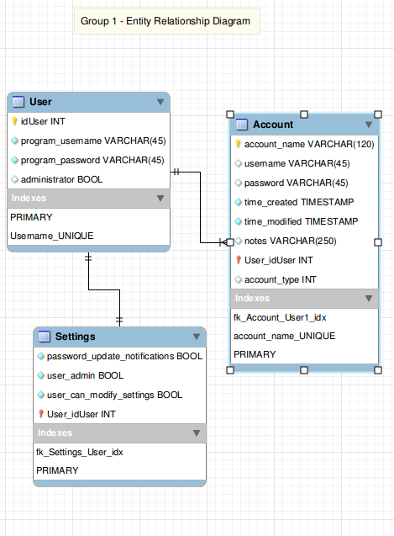

Appendix B - Data Dictionary

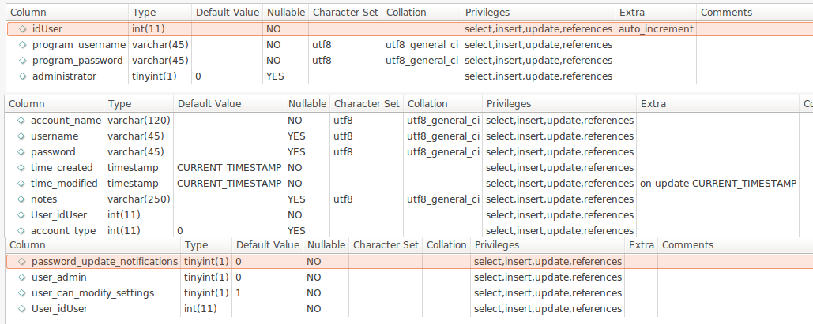

https://docs.google.com/document/d/1SO0AGIreLzMAxDpZZCKk1z-MqKTuB-Rg-XG48I72pSk/edit?usp=sharingAppendix C - U/I Diagram

