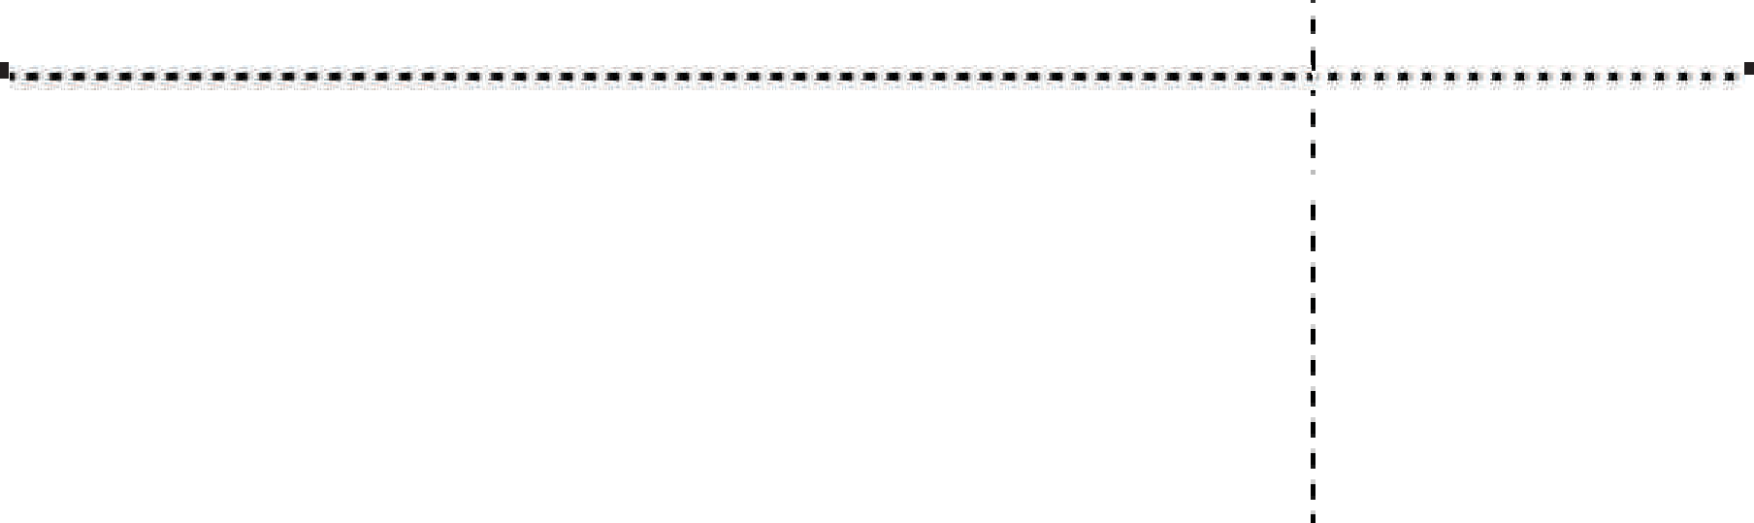
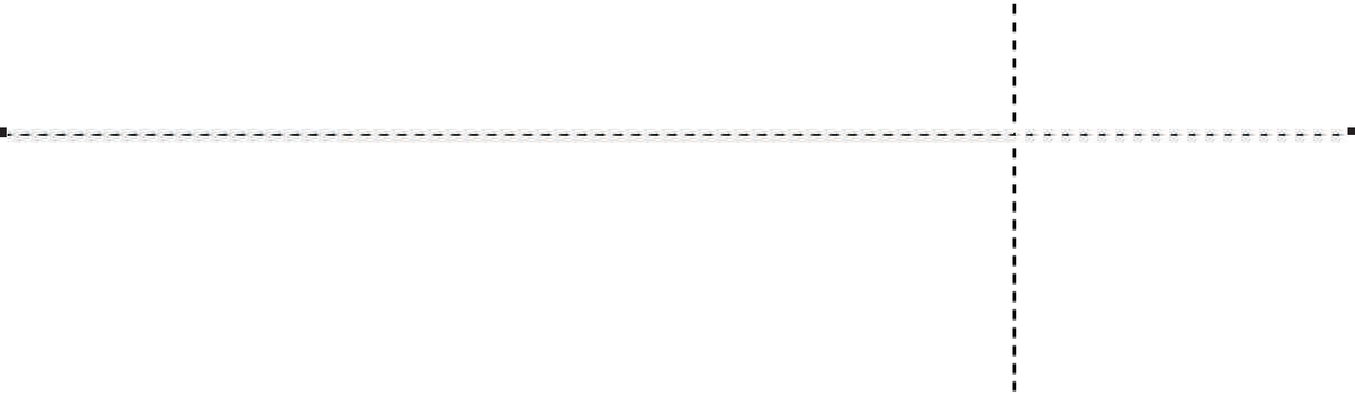

Prescription
# {{PrescriptionId}}

Veterinary Clinic PetCare
123 Vet Street, Animal City
Phone: (555) 123-4567
Email: contact@petcare.com
Service provider
Patient
{{PetName}}

Owner
{{OwnerName}}

Rp

{{MedicationName}}
{{Dosage}}
{{Frequency}}

Instructions
{{Instructions}}
Date:  {{Date}} | Veterinarian  {{CreatedBy}}  
Start date:
{{StartDate}}
End date:
{{EndDate}}

