Name: Dev Kumar Sonkar
University Roll No: 202401100200126
Github repository URL : https://github.com/DevKumarSonkar/github-skills-challenge
Pull Request URL : https://github.com/DebbieAUG/github-skills-challenge/pull/149

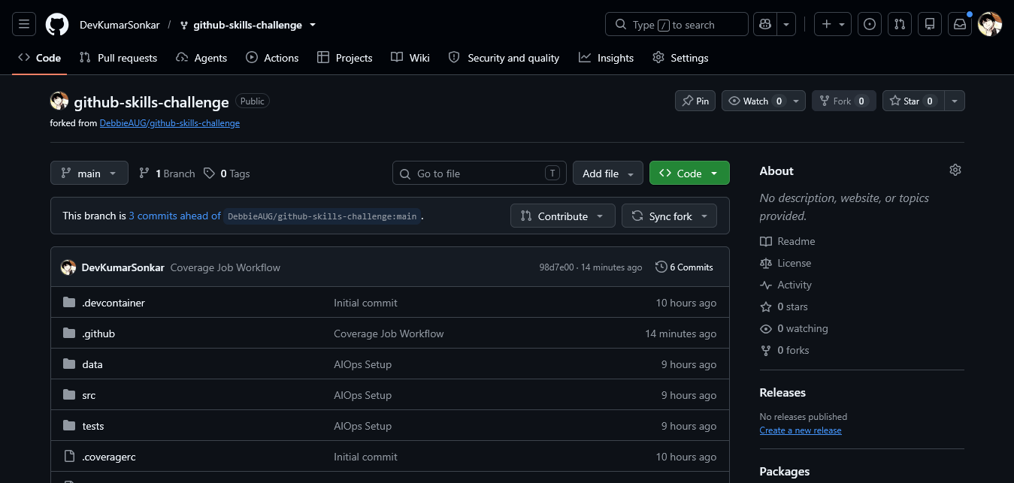
Final Github Repository

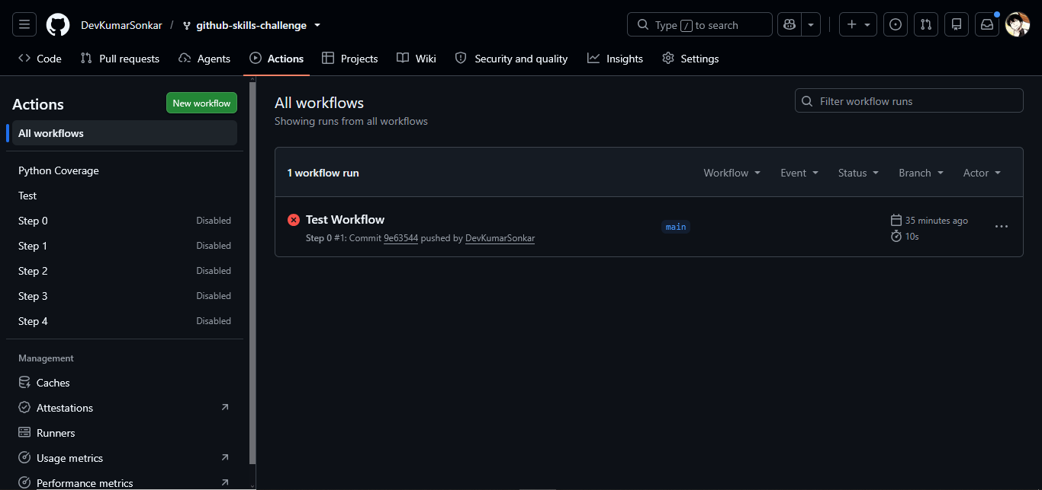
GitHub Actions workflows
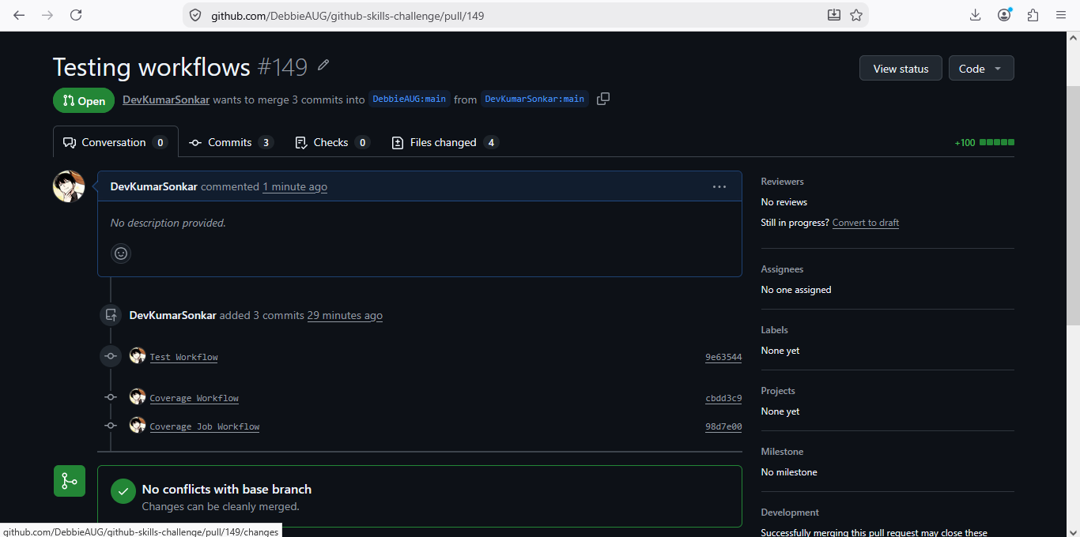
Test Workflow Execution
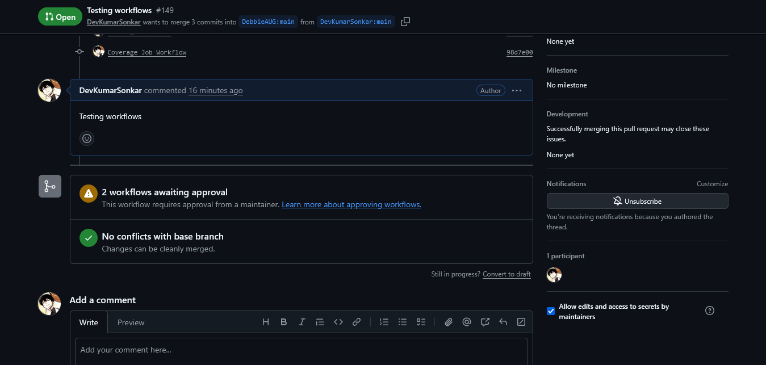
Comment on the pull request

