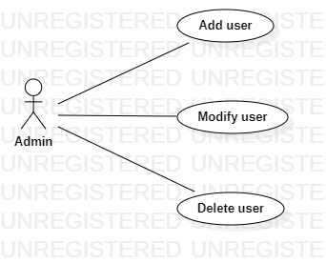

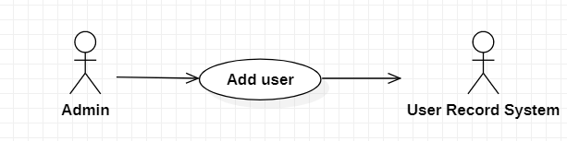

|  |  |
| --- | --- |
| **Add new user** | |
| Actors | Admin, user record system |
| Description | Admin send the new user object to the user record system with the command that insert a new user into the database. |
| Data | Id, username, password, phone, address,… |
| Stimulus | Interface that include new user information form and add button |
| Response | Message that: insert successful or fail (kind of error) |
| Comments |  |