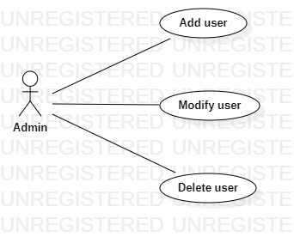

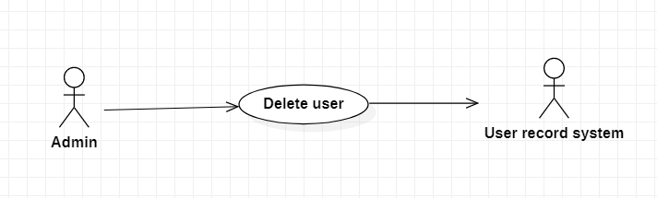

|  |  |
| --- | --- |
| **Delete user** | |
| Actors | Admin, user record system |
| Description | Admin send the user name to the user record system with the command that delete this user from the database. |
| Data | Id, username, password, phone, … |
| Stimulus | Interface that include new user information form and delete button |
| Response | Message that: confirm delete and delete successful or fail (kind of error) |
| Comments | The receptionist must have appropriate security permissions to access the patient information and the PRS |